Assignment 1

Name: Haiyue Wang

Email: wanhy149@mymail.unisa.edu.au

Contents

Abstract 3

1. Research 3

2. Naïve Bayes Model 4

2.1. Numerical variables. 4

2.2. Categorical variables 4

3. Appendix 5

3.1 Full Training Set 5

3.2 Cross Validation using 10 fold (Numerical variables) 7

3.3 Cross Validation using 5 fold (Categorical variables) 9

# Abstract

# Research

# Naïve Bayes Model

In this part, the Naïve Bayes Model will be used to make a classifier on the UCI Breast Cancer Wisconsin dataset. The Weka will be selected as the tool for implementation.

## Numerical variables.

### Distribution of Variables

The dataset has 10 valid variables, one of the variables is class variable. The distribution for all the variables like the ***Image 2.1.1***.

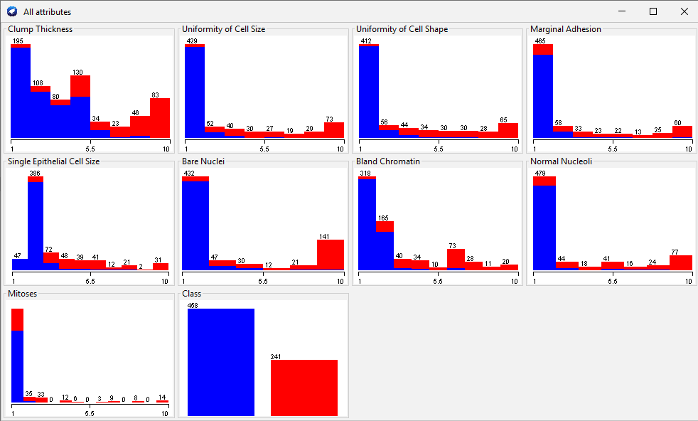

***Image 2.1.1: Distribution for numerical input variables and class***

### Classifier model with full training set

In this part, the whole dataset will be used for training the Naïve Bayes model. Get a Naïve Bayes Model after training like the ***Image 2.1.2***. More details for the model please refer to 4.1 Full Training Set.

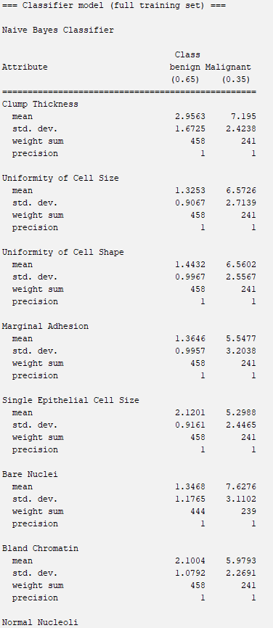

***Image 2.1.2: A Naïve Bayes Model using full dataset***

### Explanation for one record

Select one record like the ***Image 2.1.3*** as the test record, and show how the model works on this record.



***Image 2.1.3.1: One test record***

According to ***Image 2.1.3.1***, it’s easy to know the value of each variable. The variables need to rename for easy using, like ***Image 2.1.4.2***.

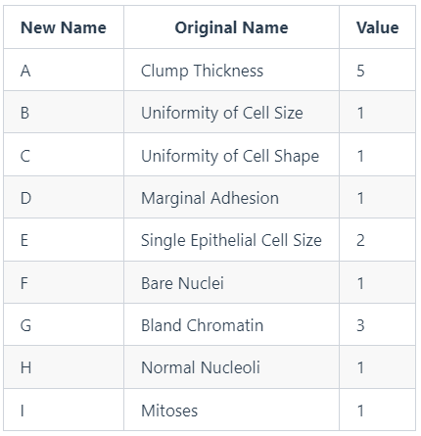

***Image 2.1.4.2: Rename table***

Now, assign ***Input = (A,B,C,D,E,F,G,H,I)***, only need to calculate ***P(Class= benign | Input)*** and ***P(Class= malignant | Input)*** , then use MAP rule to select a bigger probability as the final result.

The target formulas could be transformed to the formulas below.

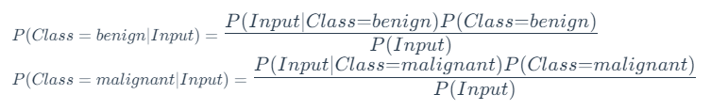

Because of ***Input=(A,B,C,D,E,F,G,H,I)***, so



The conditional probability for continuous-valued features equals to

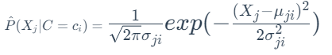

According to the model, it could easily to know the mean and standard deviation for each variable, then to calculate the conditional probabilities, a table could be got like ***Image 2.1.4.3***.

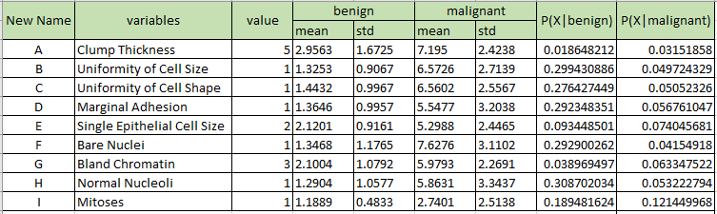

***Image 2.1.4.3: Conditional probabilities***

According to model, ***P(Class=benign) = 0.65, P(Class=malignant) = 0.35***, it could easily calculate that



It's obviously that

**

According to MAP rule, the final result for this record is benign, which has been classified correctly.

### Cross validation using 10-fold approach

Using 10-fold approach with Weka, a cross validation summary will get, like ***Image 2.1.4.1***.

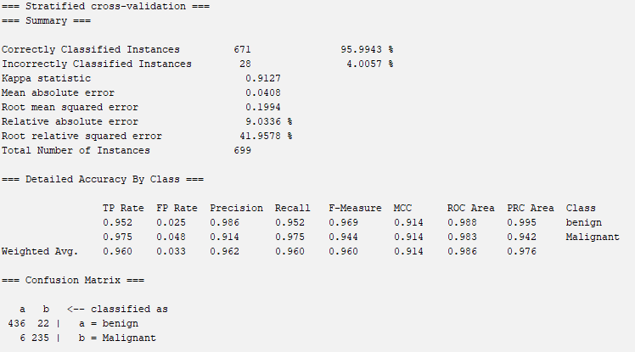

***Image 2.1.4.1: The summary for 10-fold approach***

According to the summary, it is easy to get the confusion matrix and other performance indicators.

The accuracy of the model is about 95.9943%.

***Precision(benign) = 98.6%*** means there is 98.6% benign predication cases are correct.

***Precision(malignant) = 91.4%*** means there is 91.4% malignant predication cases are correct.

***Recall(benign)=95.52%*** means there is 95.52% benign data has been classified correctly.

***Recall(malignant)=97.5%*** means there is 97.5% malignant data has been classified correctly.

## Categorical variables

In this part, the numerical data will be discretized using equal-frequency technique to split data into 3 bins. Then to train a Naïve Bayes Model and test the performance.

### Distribution of Discretized Dataset

After discretization, the data distribution will like the ***Image 2.2.1.1***.

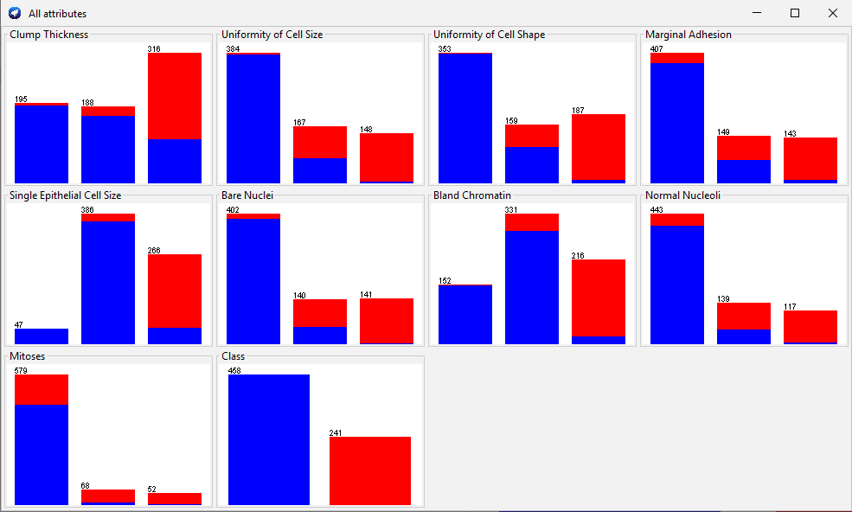

***Image 2.2.1.1: Distribution for Discretized Dataset***

### Model and Cross Validation

In this part, the discretized dataset will be used for training a Naïve Bayes model, then using 5-fold approach to evaluate it. For the part of the model please refer to ***Image 2.2.2.1***, more details please refer to chapter 4.3.

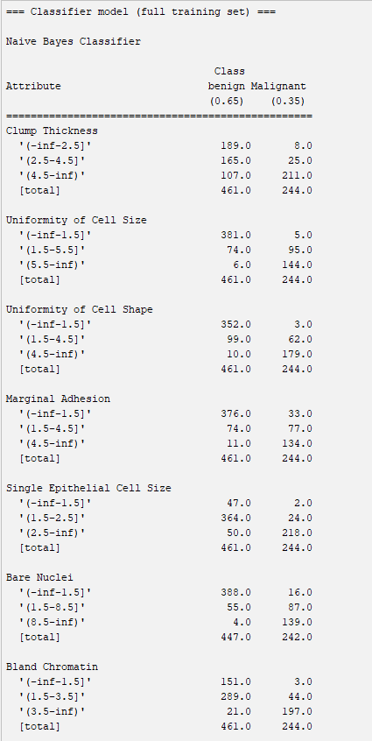

***Image 2.2.2.1: Part of Naïve Bayes Model (Model details refer to*** ***Chapter 4.3******)***

After evaluation using 5-fold approach, a summary will get, like ***Image 2.2.2.2***.

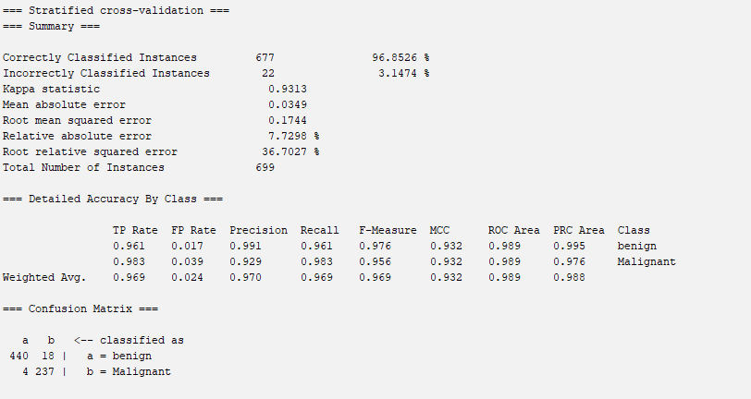

***Image 2.2.2.2: Summary for 5-fold approach***

It’s easy to get the confusion matrix and other performance indicators for the model. According to ***Image 2.2.2.2***, the accuracy is 96.8526%. There are four number, which are 440, 18, 4, 237. 440 means that there are 440 real benign cases are classified as benign class correctly. 18 means there are 18 benign cases are classified into malignant class incorrectly. 237 means that there are 237 real malignant cases are classified as malignant class correctly. 4 means there are 4 malignant cases are classified into benign class incorrectly.

### Explanation

This part will explain how the model works using one record, here select the same record with 2.1.3, like ***Image 2.2.3.1***.

Test Record

***Image 2.2.3.1: The record for explanation***

The 3 bins of the discretized dataset will be renamed as x, y, z, then a table will get a table, like ***Image 2.2.3.2***.

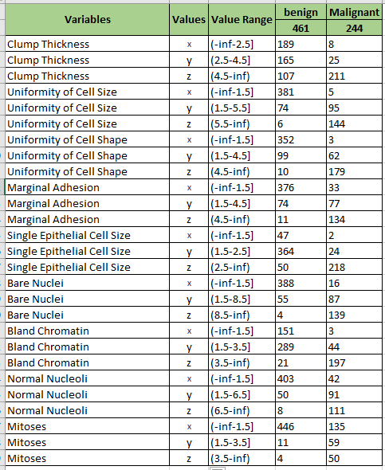According to ***Image 2.2.3.1*** and ***Image 2.2.3.2***, we could know the value of each variable. For easily to use, the variables need to rename. Another table will get, like Image 2.2.3.3, rename table.

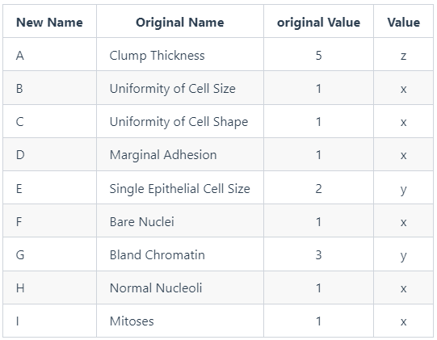

***Image 2.2.3.2: Value table***

***Image 2.2.3.3: Value table***

Next, we need to do some steps. Firstly, assign ***Input = (A,B,C,D,E,F,G,H,I)***, then to calculate ***P(Class= benign | Input)*** and  ***P(Class= malignant | Input)***, then use MAP rule to select a bigger probability as the final result.

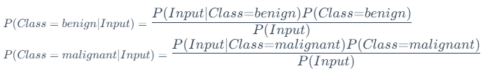Transform the formulas above, then get the formulas on the right.

Because of ***Input=(A,B,C,D,E,F,G,H,I)***, so



According to the data above we could get the probability table for each variable, like ***Image 2.2.3.4***.

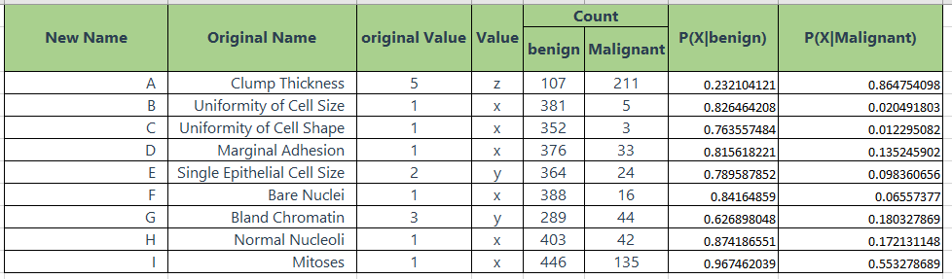

***Image 2.2.3.4: Probability Table***

It’s easy to get other possibilities from the model.

***P(Class=benign) = 0.65***  
***P(Class=malignant) = 0.35***

Finally, calculate the probabilities are 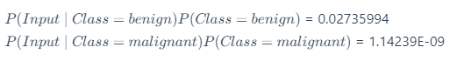

It's obviously that

So, the final result for this record is benign, it has been classified correctly.

# References

# Appendix



## Full Training Set

=== Run information ===

Scheme: weka.classifiers.bayes.NaiveBayes

Relation: breast-cancer-wisconsin-weka.filters.unsupervised.attribute.Remove-R1

Instances: 699

Attributes: 10

Clump Thickness

Uniformity of Cell Size

Uniformity of Cell Shape

Marginal Adhesion

Single Epithelial Cell Size

Bare Nuclei

Bland Chromatin

Normal Nucleoli

Mitoses

Class

Test mode: evaluate on training data

=== Classifier model (full training set) ===

Naive Bayes Classifier

Class

Attribute benign Malignant

(0.65) (0.35)

==================================================

Clump Thickness

mean 2.9563 7.195

std. dev. 1.6725 2.4238

weight sum 458 241

precision 1 1

Uniformity of Cell Size

mean 1.3253 6.5726

std. dev. 0.9067 2.7139

weight sum 458 241

precision 1 1

Uniformity of Cell Shape

mean 1.4432 6.5602

std. dev. 0.9967 2.5567

weight sum 458 241

precision 1 1

Marginal Adhesion

mean 1.3646 5.5477

std. dev. 0.9957 3.2038

weight sum 458 241

precision 1 1

Single Epithelial Cell Size

mean 2.1201 5.2988

std. dev. 0.9161 2.4465

weight sum 458 241

precision 1 1

Bare Nuclei

mean 1.3468 7.6276

std. dev. 1.1765 3.1102

weight sum 444 239

precision 1 1

Bland Chromatin

mean 2.1004 5.9793

std. dev. 1.0792 2.2691

weight sum 458 241

precision 1 1

Normal Nucleoli

mean 1.2904 5.8631

std. dev. 1.0577 3.3437

weight sum 458 241

precision 1 1

Mitoses

mean 1.1889 2.7401

std. dev. 0.4833 2.5138

weight sum 458 241

precision 1.125 1.125

Time taken to build model: 0.01 seconds

=== Evaluation on training set ===

Time taken to test model on training data: 0.01 seconds

=== Summary ===

Correctly Classified Instances 672 96.1373 %

Incorrectly Classified Instances 27 3.8627 %

Kappa statistic 0.9157

Mean absolute error 0.0389

Root mean squared error 0.1945

Relative absolute error 8.6172 %

Root relative squared error 40.9266 %

Total Number of Instances 699

=== Detailed Accuracy By Class ===

TP Rate FP Rate Precision Recall F-Measure MCC ROC Area PRC Area Class

0.954 0.025 0.986 0.954 0.970 0.917 0.991 0.996 benign

0.975 0.046 0.918 0.975 0.946 0.917 0.986 0.951 Malignant

Weighted Avg. 0.961 0.032 0.963 0.961 0.962 0.917 0.989 0.980

=== Confusion Matrix ===

a b <-- classified as

437 21 | a = benign

6 235 **|** b = Malignant

## Cross Validation using 10-fold approach (Numerical variables)

=== Run information ===

Scheme: weka.classifiers.bayes.NaiveBayes

Relation: breast-cancer-wisconsin-weka.filters.unsupervised.attribute.Remove-R1

Instances: 699

Attributes: 10

Clump Thickness

Uniformity of Cell Size

Uniformity of Cell Shape

Marginal Adhesion

Single Epithelial Cell Size

Bare Nuclei

Bland Chromatin

Normal Nucleoli

Mitoses

Class

Test mode: 10-fold cross-validation

=== Classifier model **(**full training **set)** ===

Naive Bayes Classifier

Class

Attribute benign Malignant

**(**0.65**)** **(**0.35**)**

==================================================

Clump Thickness

mean 2.9563 7.195

std. dev. 1.6725 2.4238

weight **sum** 458 241

precision 1 1

Uniformity of Cell Size

mean 1.3253 6.5726

std. dev. 0.9067 2.7139

weight **sum** 458 241

precision 1 1

Uniformity of Cell Shape

mean 1.4432 6.5602

std. dev. 0.9967 2.5567

weight **sum** 458 241

precision 1 1

Marginal Adhesion

mean 1.3646 5.5477

std. dev. 0.9957 3.2038

weight **sum** 458 241

precision 1 1

Single Epithelial Cell Size

mean 2.1201 5.2988

std. dev. 0.9161 2.4465

weight **sum** 458 241

precision 1 1

Bare Nuclei

mean 1.3468 7.6276

std. dev. 1.1765 3.1102

weight **sum** 444 239

precision 1 1

Bland Chromatin

mean 2.1004 5.9793

std. dev. 1.0792 2.2691

weight **sum** 458 241

precision 1 1

Normal Nucleoli

mean 1.2904 5.8631

std. dev. 1.0577 3.3437

weight **sum** 458 241

precision 1 1

Mitoses

mean 1.1889 2.7401

std. dev. 0.4833 2.5138

weight **sum** 458 241

precision 1.125 1.125

Time taken to build model: 0 seconds

=== Stratified cross-validation ===

=== Summary ===

Correctly Classified Instances 671 95.9943 **%**

Incorrectly Classified Instances 28 4.0057 **%**

Kappa statistic 0.9127

Mean absolute error 0.0408

Root mean squared error 0.1994

Relative absolute error 9.0336 **%**

Root relative squared error 41.9578 **%**

Total Number of Instances 699

=== Detailed Accuracy By Class ===

TP Rate FP Rate Precision Recall F-Measure MCC ROC Area PRC Area Class

0.952 0.025 0.986 0.952 0.969 0.914 0.988 0.995 benign

0.975 0.048 0.914 0.975 0.944 0.914 0.983 0.942 Malignant

Weighted Avg. 0.960 0.033 0.962 0.960 0.960 0.914 0.986 0.976

=== Confusion Matrix ===

a b **<**-- classified **as**

436 22 **|** a = benign

6 235 **|** b = Malignant

## Cross Validation using 5-fold approach (Categorical variables)

=== Run information ===

Scheme: weka.classifiers.bayes.NaiveBayes

Relation: breast-cancer-wisconsin-weka.filters.unsupervised.attribute.Remove-R1-weka.filters.unsupervised.attribute.Discretize-F-B3-M-1.0-Rfirst-last-precision6

Instances: 699

Attributes: 10

Clump Thickness

Uniformity of Cell Size

Uniformity of Cell Shape

Marginal Adhesion

Single Epithelial Cell Size

Bare Nuclei

Bland Chromatin

Normal Nucleoli

Mitoses

Class

Test mode: 5-fold cross-validation

=== Classifier model **(**full training **set)** ===

Naive Bayes Classifier

Class

Attribute benign Malignant

**(**0.65**)** **(**0.35**)**

==================================================

Clump Thickness

'(-inf-2.5]' 189.0 8.0

'(2.5-4.5]' 165.0 25.0

'(4.5-inf)' 107.0 211.0

**[**total**]** 461.0 244.0

Uniformity of Cell Size

'(-inf-1.5]' 381.0 5.0

'(1.5-5.5]' 74.0 95.0

'(5.5-inf)' 6.0 144.0

**[**total**]** 461.0 244.0

Uniformity of Cell Shape

'(-inf-1.5]' 352.0 3.0

'(1.5-4.5]' 99.0 62.0

'(4.5-inf)' 10.0 179.0

**[**total**]** 461.0 244.0

Marginal Adhesion

'(-inf-1.5]' 376.0 33.0

'(1.5-4.5]' 74.0 77.0

'(4.5-inf)' 11.0 134.0

**[**total**]** 461.0 244.0

Single Epithelial Cell Size

'(-inf-1.5]' 47.0 2.0

'(1.5-2.5]' 364.0 24.0

'(2.5-inf)' 50.0 218.0

**[**total**]** 461.0 244.0

Bare Nuclei

'(-inf-1.5]' 388.0 16.0

'(1.5-8.5]' 55.0 87.0

'(8.5-inf)' 4.0 139.0

**[**total**]** 447.0 242.0

Bland Chromatin

'(-inf-1.5]' 151.0 3.0

'(1.5-3.5]' 289.0 44.0

'(3.5-inf)' 21.0 197.0

**[**total**]** 461.0 244.0

Normal Nucleoli

'(-inf-1.5]' 403.0 42.0

'(1.5-6.5]' 50.0 91.0

'(6.5-inf)' 8.0 111.0

**[**total**]** 461.0 244.0

Mitoses

'(-inf-1.5]' 446.0 135.0

'(1.5-3.5]' 11.0 59.0

'(3.5-inf)' 4.0 50.0

**[**total**]** 461.0 244.0

Time taken to build model: 0 seconds

=== Stratified cross-validation ===

=== Summary ===

Correctly Classified Instances 677 96.8526 **%**

Incorrectly Classified Instances 22 3.1474 **%**

Kappa statistic 0.9313

Mean absolute error 0.0349

Root mean squared error 0.1744

Relative absolute error 7.7298 **%**

Root relative squared error 36.7027 **%**

Total Number of Instances 699

=== Detailed Accuracy By Class ===

TP Rate FP Rate Precision Recall F-Measure MCC ROC Area PRC Area Class

0.961 0.017 0.991 0.961 0.976 0.932 0.989 0.995 benign

0.983 0.039 0.929 0.983 0.956 0.932 0.989 0.976 Malignant

Weighted Avg. 0.969 0.024 0.970 0.969 0.969 0.932 0.989 0.988

=== Confusion Matrix ===

a b **<**-- classified **as**

440 18 **|** a = benign

4 237 **|** b = Malignant