1.下载kenlm.tar.gz，并copy到目录下并解压

tar -zvxf kenlm.tar.gz

1. 在解压好的kenlm目录下创建build目录

cd kenlm

mkdir -p build

cd build

cmake ..

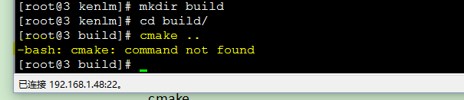

3.安装cmake

sudo yum install cmake

cmake -version可查看版本号

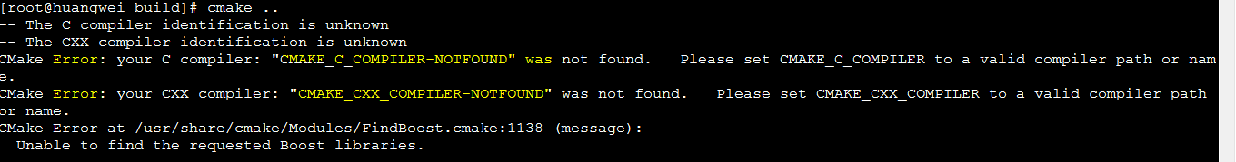

cmake ..

make -j4

4.安装编译器

sudo yum install gcc

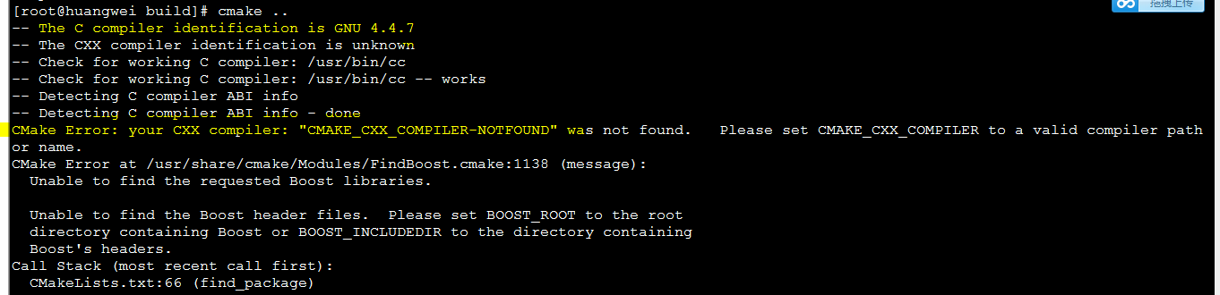

sudo yum install gcc-c++

1. 安装boost库

将boost_1_66_0.tar.gz解压

mkdir -p boost

cd boost_1_66_0

./bootstrap.sh --prefix=/root/huangwei/boost

./b2 install --with=all

1. 安装zlib库

将zlib-1.2.8.tar.gz解压

mkdir -p zlib

cd zlib-1.2.8

./configure --prefix=/root/huangwei/zlib

make

make install

vim ../CMakeLists.txt 在CMakeLists.txt设置

# add boost path

set(BOOST_INCLUDEDIR /root/huangwei/boost/include)

set(BOOST_LIBRARYDIR /root/huangwei/boost/lib)

#add zlib path

set(ZLIB_INCLUDE_DIR /root/huangwei/zlib/include)

set(ZLIB_LIBRARY /root/huangwei/zlib/lib)

${BOOST_INCLUDEDIR}

${BOOST_LIBRARYDIR}

${ZLIB_INCLUDE_DIR}

${ZLIB_LIBRARY}

link_libraries("/root/huangwei/zlib/lib/libz.a")

link_libraries("/root/huangwei/zlib/lib/libz.so")

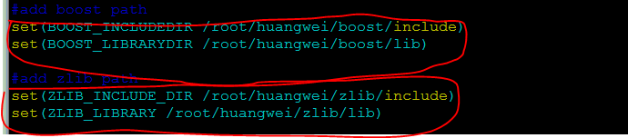

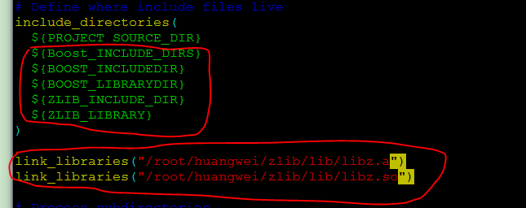

cd txt

iconv -f UTF-8 -t GBK process.txt -o process1.txt

cd ../kenlm/build

bin/lmplz -o 3 --text ../../txt/process1.txt --arpa /root/huangwei/log.arpa

以下暂时不用

1. 安装bzip2库

将bzip2-1.0.6.tar.gz解压

mkdir -p bzip2

cd bzip2-1.0.6

make

make install PREFIX=/root/huangwei/bzip2

1. 安装xz库

将xz-5.2.3.tar.gz解压

mkdir -p xz

cd xz-5.2.3

./configure --prefix=/root/huangwei/xz

make

make install LIBLZMA_INCLUDE_DIR LIBLZMA_LIBRARY

sudo yum install libeigen3-dev

BZIP2_LIBRARIES BZIP2_INCLUDE_DIR

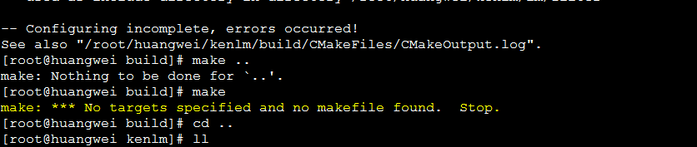

link_libraries("/root/huangwei/bzip2/lib/libbz2.a")

link_libraries("/root/huangwei/zlib/lib/libz.a")

link_libraries("/root/huangwei/zlib/lib/libz.so")

iconv -f UTF-8 -t GBK process.txt -o process1.txt

bin/lmplz -o 3 --text ../../txt/process1.txt --arpa /root/huangwei/log.arpa