Jetanin Naitho 67070501011

**Lab 00: Setup Lab Environmental**

1.Goal Setting

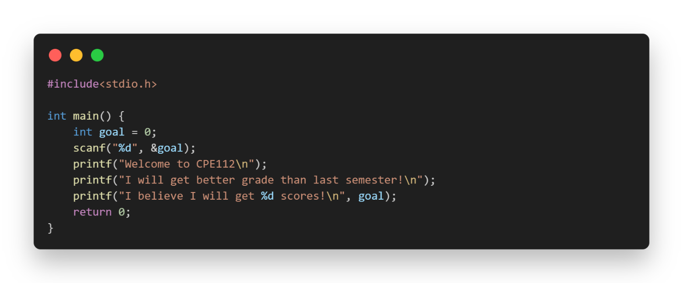

2. IsPrime

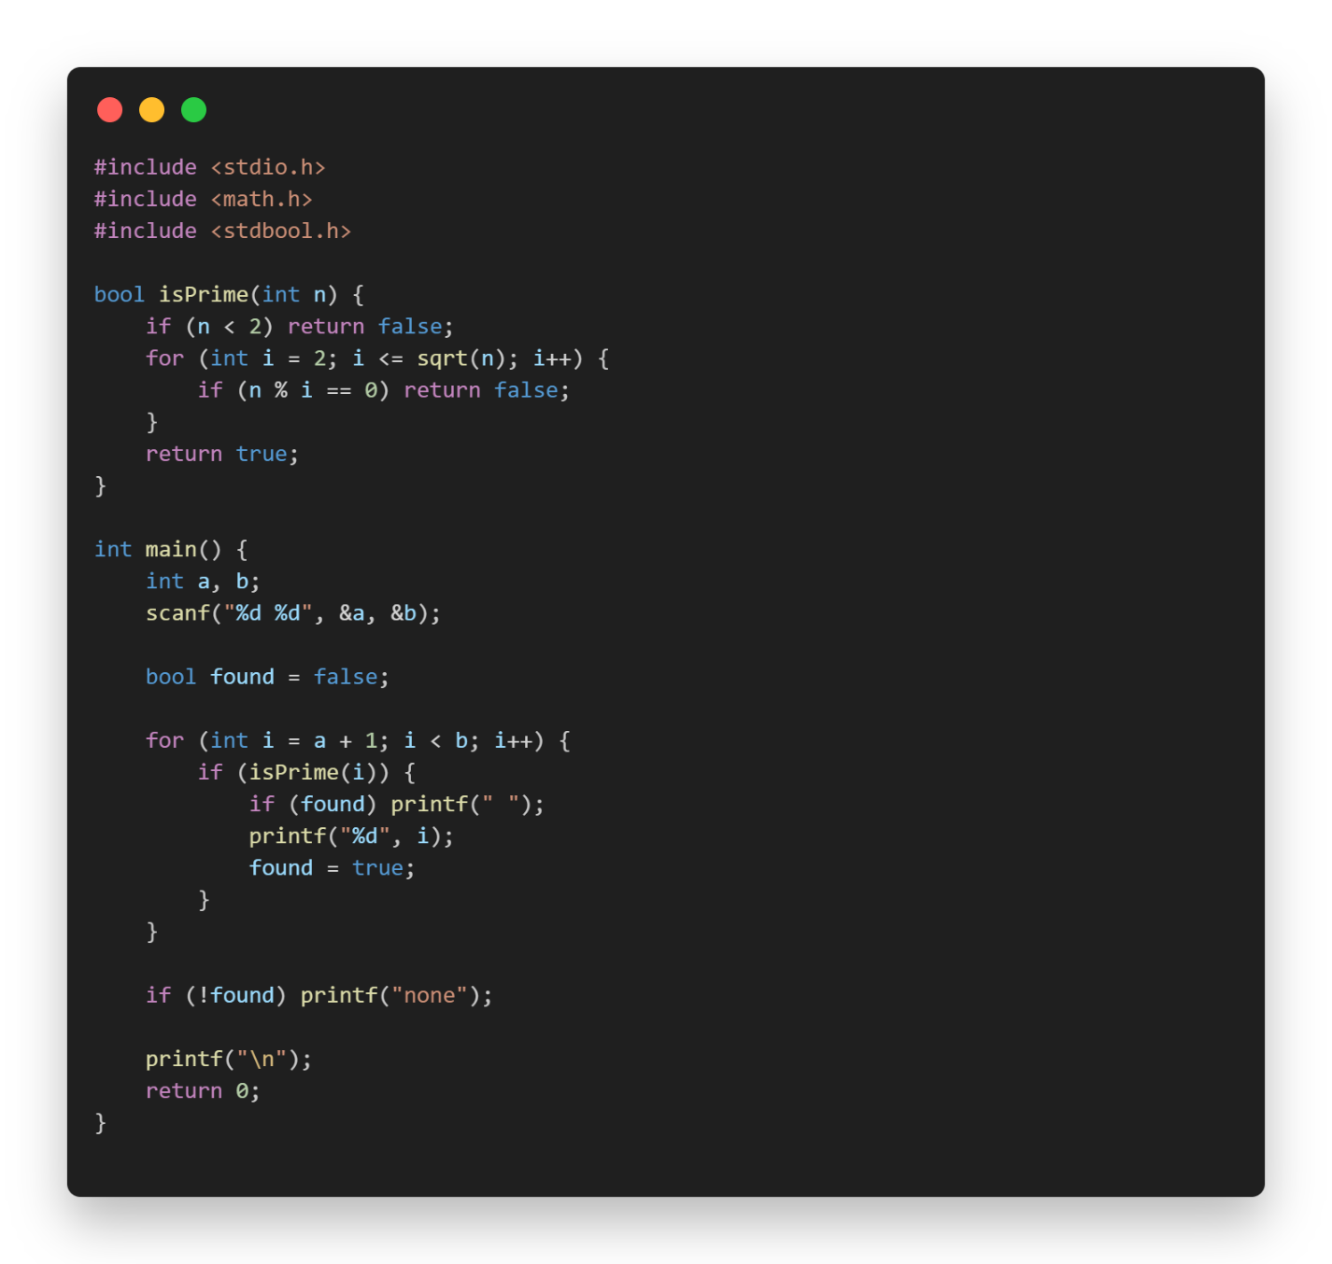

3. Max and Min

