**1. Make a Circuit.**

**What is a Circuit?**

An electronic circuit is a circular path of conductors by which electric current can flow. A closed circuit is like a circle because it starts and ends at the same point forming a complete loop. Furthermore, a closed circuit allows electricity to flow from the (+) power to the (-) ground uninterrupted.

[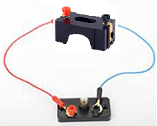](https://github.com/jetbotml/2021SummerLibrary/blob/main/01_Make_a_Curcuit/simplecircuit.png)[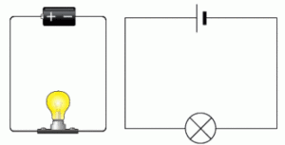](https://github.com/jetbotml/2021SummerLibrary/blob/main/01_Make_a_Curcuit/simplecircuitimages.png)

All circuits need to have three basic elements. These elements are a voltage source, conductive path and a load.

[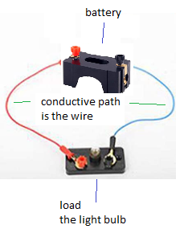](https://github.com/jetbotml/2021SummerLibrary/blob/main/01_Make_a_Curcuit/simplecircuitlabeled.png)

The voltage source, such as a battery, is needed in order to cause the current to flow through the circuit. In addition, there needs to be a conductive path that provides a route for the electricity to flow. Finally, a proper circuit needs a load that consumes the power. The load in the above circuit is the light bulb.

**Make a Circuit using an electrical circuit experiment kit**

**To Do:**

Using the electrical circuit experiment Kit:

1. Build a simple circuit using 2 wires, a battery and a light bulb.
2. Add a switch to your circuit.

](https://github.com/jetbotml/2021SummerLibrary/blob/main/01_Make_a_Curcuit/71u03d4KVlL._SL1500_.jpg)

**Make an LED Flashlight**

**To Do:**

You will need an LED, a coin battery, a button and electrical tape.

1. Create a simple circuit by placing the coin battery between the two wires of the LED. NOTE: the long wire should be on the positive side of the battery

](https://github.com/jetbotml/2021SummerLibrary/blob/main/01_Make_a_Curcuit/2021-06-27-171431.jpg)

1. Add a button to the circuit.

* Start the tape on the + side of the battery.
* then wrap the tape around the to the other side. This will tape the short end of the LED wire to the battery.
* Make sure a little of the tire of the long wire extends over the tape on the + side. (add the button here)

](https://github.com/jetbotml/2021SummerLibrary/blob/main/01_Make_a_Curcuit/coincircuit.png)

Further Reading

1. <https://learn.sparkfun.com/tutorials/what-is-a-circuit/all>