# 1. My First Circuit

## What is a Circuit?

An electronic circuit is a circular path of conductors by which electric current can flow. A closed circuit is like a circle because it starts and ends at the same point forming a complete loop. Furthermore, a closed circuit allows electricity to flow from the (+) power to the (-) ground uninterrupted.

[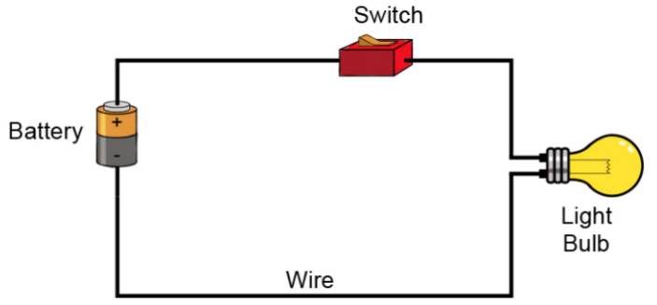](https://github.com/jetbotml/2021SummerLibrary/blob/main/01_MyFirstCircuit/Circuit.png)

All circuits need to have three basic elements. These elements are a voltage source, conductive path and a load.

The voltage source, such as a battery, is needed in order to cause the current to flow through the circuit. In addition, there needs to be a conductive path that provides a route for the electricity to flow. Finally, a proper circuit needs a load that consumes the power. The load in the above circuit is the light bulb.

Further Reading

1. <https://www.makerspaces.com/basic-electronics/>
2. <https://learn.sparkfun.com/tutorials/what-is-a-circuit/all>

## Create Your First Circuit

To create our first circuit, we will be using an LED, a coin battery.

Next, we will add an on/off switch using some electrical tape.

