Raspberry Pi Camp (6/23, 6/30, 7/7, 7/14) 2:00 to 4:00 PM

Name __________________________

Introduction to Circuits

1. My First Circuit
2. Lighting an LED
3. Adding a Button
4. Using a Buzzer

Introduction to Raspberry Pi

1. A picture containing text, indoor, different

   Description automatically generatedDiagram, schematic

   Description automatically generated with medium confidencePython "Hello World"
2. Programming an LED
3. Programming a Button
4. Creating a Reaction Game
5. Programming a Buzzer
6. Creating Traffic Lights

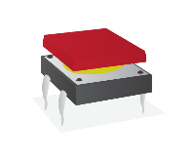Intermediate Physical Computing

1. Motion Sensor
2. Distance Sensor
3. Light Sensor
4. RGB LED
5. Motor
6. 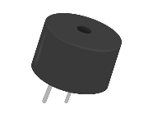Servo
7. Potentiometer

Advanced - Create Your Own Build