# Report

## Application details

The login for the application is [jacob@gmail.com](mailto:jacob@gmail.com) (this is not my real email), you can additionally log in with users specified in the DataManager, or create a user. For convenience, there are memories build in for jacob@gmail.com. The application is built for android.

## Story board

## UI design justification

### Splash screen

The splash screen is a short non-skippable screen that appears when the user first opens the application. This has two main purposes, 1) familiarise the user with the logo which improves their attitude toward the logo and its associations, 2) associate the logo with the application. The aptly named ‘mere-exposure’ effect poses that unconscious familiarity alone can enhance the user’s perception of a brand (Hansen and Wänke, 2009); we can take advantage of this by showing the logo regularly so that the user learns to unconsciously identify it. By showing logo when the application opens, this positive perception of the brand partially carries over to the user’s perception of the application, which has its own, mostly separate, mere-exposure familiarity.

### Tabs

Tabs are a commonly used and widely understood navigation paradigm that has proliferated through technology. More than just a fad or trend (especially on mobile devices), the interface lies in the optimal zone of mobile phone usage which means users find it comfortable to use and can easily reach the navigation component with either hand. We can further optimize the tab layout by considering Xiong and Muraki (2016) and design principles from Samantha Ingrams article ‘The Thumb Zone: Designing For Mobile Users’ (figure 1). By placing the most frequently used tabs closest to the centre (optimising for both left and right handed people), then less used tabs to the left, and finally the least frequently used tabs on the right, we can optimise for comfortability.

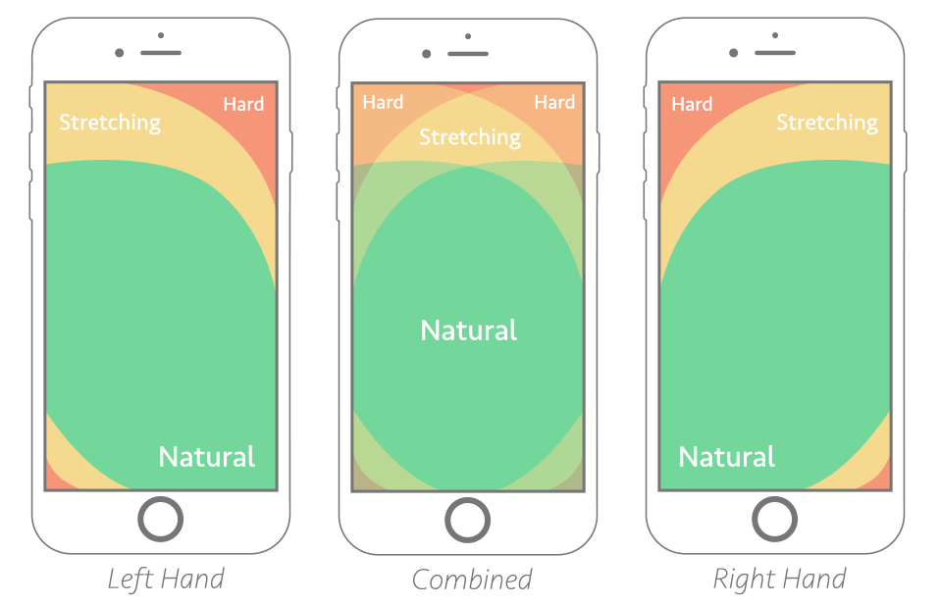

Figure 1. Usage patterns for thumbs stratified by user handedness (Ingram, 2016).

### Buttons

Three important criteria were considered when designing the buttons for this application, shape (more specifically rounding corners), colour, and clutter. Considering the shape first, all the buttons have fully rounded corners. This isn’t just because they look nice (although I think they do), subconsciously our attention is drawn to sharp corners, which is juxta positioned by rounded corners which draws our attention to the centre of an object. Placing a label at the centre of the button, and maximally rounding the corners, we can guide the user’s attention to the label (usually what the button does, figure 2), and to the most optimal press position (at the centre). Additionally, we are generally averse to touching objects that have sharp edges, like knives or table corners which may bleed into a subconscious aversion to sharp buttons (there is however no research on this, and I am purely speculating).

Figure 2. The comparison of 2 buttons, one with rounded and one with sharp corners.

The colours were also carefully selected to stand out and give some indication of the function. Buttons that accept, submit, or progress the user through the app functions were coloured blue, and buttons that cancel, delete, or navigate backwards are coloured red. The saturation of the colour is important, because users associate greyed out buttons with being ‘inactive’ or ‘turned off’, therefor buttons that we want the user to press have high saturation to further indicate they are pressable (figure 3).

Figure 3. The comparison of two buttons of different saturation, which is intuited as the button being active or inactive.

### Categories

Similar principles that are applied to buttons were applied to memory categories. The category card is not a button per se, but has similar functions. If we were to fully round the corners, then a large portion of the image would excluded. To compromise, I have rounded only a portion of the image, indicating that the card is pressable, and the text is outside the image to give it an ‘app-icon’ like feel which further encourages the user to press.

Figure 4. A partially rounded category card that encourages the user to press.

### Input fields

Every input field has the same layout (figure 5): an icon indicating the function, placeholder text explicitly stating function, all with rounded corners to encourage interaction. This has all the characteristics of a button but the icon has the duel purpose of drawing attention the start of the field and indicating function. The colour is also far less saturated than standard buttons to indicate that touching this element will not drastically alter the screen, but still has some interactivity.

Figure 5. An example of an input field.

### Memory view

The memory view allows the user to see full size images without cutting out any content by leaving card as a sharp rectangle. Pressing the image allows the user to see all the details and edit, but the design had the conflict of needing to show the full image, but also indicate interactivity. I couldn’t find a satisfactory conclusion to this design challenge.

### Incomplete elements

I feel I need to note that the like buttons (heart icons) are not functioning, but I had the intention of making them pressable, consistent with other rounded objects. Also a few non-crucial elements were cut out for lack of time, like change password, and change email , otherwise their design would be consistent with the rest of the project. Additionally the registra

# References

Hansen, J., & Wänke, M. (2009). Liking What's Familiar: The Importance of Unconscious Familiarity in the Mere-Exposure Effect. Social Cognition, 27(2), 161-182. doi: 10.1521/soco.2009.27.2.161

Xiong, J., & Muraki, S. (2016). Effects of age, thumb length and screen size on thumb movement coverage on smartphone touchscreens. International Journal Of Industrial Ergonomics, 53, 140-148. doi: 10.1016/j.ergon.2015.11.004

Ingram, S. (2016). The Thumb Zone: Designing For Mobile Users. Smashing Magazine. https://www.smashingmagazine.com/2016/09/the-thumb-zone-designing-for-mobile-users/