Programming Assignment of Unit2

<ER diagram of hospital systems>

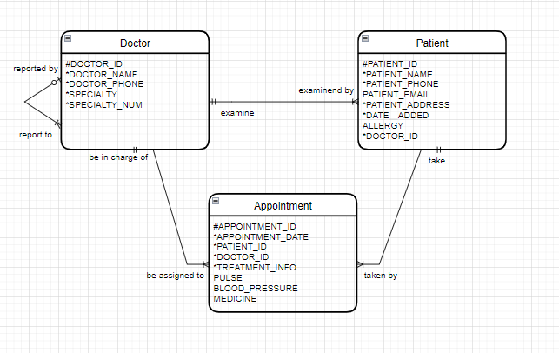

References:

Sharma, N., Perniu, L., Chong, R. F., Iyer, A., Nandan, C., Mitea, A. C., Nonvinkere, M. & Danubianu, M. (2010). Database fundamentals. IBM Canada.