

Module Title: MSc Project
Module Code: CSIP5501

Topic: An Explainable AI Framework for Credit Card Fraud Detection using Machine Learning and SHAP-Based Interpretability

Student Name: Jethiben Lakhabhai Vinzuda
Student ID: P2940410

Table of Contents
Chapter 1: Introduction 5
1.1 Background of the Study 5
1.2 Problem Statement 5
1.3 Research Aim 6
1.4 Research Objectives 6
1.5 Research Questions 7
1.6 Justification of Research Questions 7
1.7 Research Scope 8
1.8 Research Significance 8
1.9 Dissertation Structure 8
1.10 Chapter Summary 9
Chapter 2: Literature Review 10
2.1 Overview 10
2.2 Review of Existing Studies 10
2.2.1 Inclusion and Exclusion Criteria 10
2.2.2 Literature Sources 10
2.2.3 ML Approaches to fraud detection and focus on class imbalance management 18
2.2.4 Deep Learning versus Classical Models: A Performance-Interpretability Trade-Off 20
2.3 Explainable Artificial Intelligence in Fraud Detection 21
2.3.1 The Interpretability Imperative: Aspiration Without Action 21
2.3.2 SHAP-Based Interpretability: Supporting Evidence and Contrasting Scope 21
2.4 Literature Gap 23
2.5 Research Methodology Decisions Derived from Literature 23
2.6 Comparative Summary of Reviewed Studies 24
Chapter 3: Research Methodology 28
3.1 Overview 28
3.2 Practical Experimentation Methodology 28
3.2.1 Data Collection 28
3.2.2 Pre-processing and EDA Considerations 28
3.2.3 Machine Learning Model Development Approach 31
3.2.3.1 Models Selected and Rationale 31
3.2.3.2 Model Training Approach and Evaluation Framework to be Used 32
3.3 Qualitative Research Component Methodology 33
3.3.1 Research Philosophy 33
3.3.2 Research Approach 33
3.3.3 Research Design 33
3.3.4 Data Collection Method 33
3.3.5 Data Analysis Method 34
3.4 Ethical Considerations 34
Chapter 4: Implementation and Testing 35
4.1 Machine Learning Model Implementation 35
4.1.1 Practical Resources 35
4.1.1.1 Tools and Technologies 35
4.1.1.2 Python Libraries 35
4.1.1.3 IDE 38
4.1.1.4 Implementation Pipeline 39
4.1.2 Testing Framework 48
4.1.2.1 Metrics Used 48
4.2 Systematic Literature Review 50
4.2.1 PRISMA Model 50
Chapter 5: Results, Evaluation and Discussion 52
5.1 Practical Results 52
5.1.1 EDA Results 52
5.1.2 Pre-processing and Transformation 60
5.1.3 ML Modelling Results 63
5.2 Results from Existing Research Paper 71
5.2.1 SLR Theme 71
5.2.2 SLR Summary Table 72
5.3 Collective Synthesis: Evaluation and Discussion 74
5.3.1 Discussion of Quantitative Results 74
5.3.2 Discussion of Qualitative Results 74
Chapter 6: Conclusion and Future Scope 76
6.1 Conclusive Remarks 76
6.2 Limitations of the study 76
6.2.1 Limitations from Quantitative Analysis 76
6.2.2 Limitations from Qualitative Analysis 76
6.3 Future Scope 77
6.4 Recommendations 77
6.5 Critical Review and Reflection 77
References 80

Chapter 1: Introduction

1.1 Background of the Study
Credit card fraud is amongst one of the most challenging and persistent financial threats in the modern age. With these electronic transaction volumes growing exponentially, the extent of fraudulent attempts has also increased to multiple folds, and the existing or traditional rule-based detection systems have proven to be increasingly inadequate to control this threat. As reported in Khanom et al. (2024), there are approximately 440,000 credit card fraud cases in the United States alone in 2022, with the financial value of those exceeding the $12 billion mark.
Machine learning has been adopted as a more adaptive and scalable alternative to the existing traditional rule-based systems to curb this challenge. Ensemble methods such as Random Forest or Boosting Algorithms such as XGBoost have demonstrated significant capabilities towards predicting such fraudulent transactions, even under high class imbalance conditions, which is typically common with such frauds. Despite their capabilities, a major challenge with the application of these methods is the inherent black-box prediction logic and the lack of explainability and transparency in how the predictions are deduced. These limitations are critical to be resolved in a financial environment where transparency in decision-making is a forefront pillar. As correctly outlined by Varatharajoo et al. (2024), model interpretability is a critical requirement for regulatory adherence and stakeholder confidence in such an environment. The current project intends to address this gap using Explainable AI (XAI) methods such as SHAP-based interpretability, thus creating an improved value proposition.

1.2 Problem Statement
The problem statement for the current project can be established in the form of an existing critical gap that persists between model performance and model interpretability. Considering the sensitive nature of the environment and regulatory expectations related to transparency in the financial industry, financial organisations are obligated to explain automated decisions to regulators, customers, and internal audit teams (Varatharajoo et al., 2024). There have been different researches and studies that have highlighted and recommended interpretability as a deployment prerequisite but have failed to or skipped integration of relevant XAI mechanisms. Consider the example of Asaad et al. (2026), where the study concludes that compliance requires explainable models yet integrates no XAI mechanism into their pipeline. Similar issues can be observed in Ango et al. (2024), where the author acknowledges this necessity, but the research and experimental operations have no resolution implemented. Another common challenge existing with XAI implementation is the computationally expensive architectures which are typically inaccessible to most practitioners (Sathiyamoorthy et al., 2025). The current study intends to bridge this practice vs literature gap through practical experimentation.

1.3 Research Aim
The central aim guiding the current project can be documented as below:
To design and evaluate an explainable AI-driven framework for a credit-card fraud detection system. The framework should integrate machine learning classification algorithms with the explainability concept using SHAP-based interpretability, thereby enabling high predictive accuracy as well as human-understandable decision explanations to be used by commercial institutes in real-world compliance scenarios.

1.4 Research Objectives
The Project execution will be guided by the following specific project objectives:
- To collect and pre-process the credit card fraud detection (transactional) dataset.
- To conduct an exploratory data analysis on the structured dataset, evaluating the existing class imbalance issues, feature distributions, and data anomalies (missing and duplicated values).
- To apply relevant data structuring and transformation methods such as data normalisation, data encoding, and SMOTE-based over-sampling to produce a model-ready dataset.
- To develop and train multiple supervised classification algorithms including Logistic Regression (baseline), Random Forest, Decision Tree, and XGBoost, for credit card fraud detection.
- To evaluate the developed models using a range of different evaluation metrics such as Precision, Recall, F1-score, and accuracy, given class imbalance and the need for a comprehensive analysis.
- To apply SHAP-based interpretability and explainability considerations to the best-performing model and quantify the feature-level contribution.
- To devise and generate summary plots for explainability on the best-performing model.
- To synthesise the practical pipeline, including predictive modelling and interpretability components, into a structure explainable AI framework.
- To study the existing trade-offs between model complexity, predictive capabilities and explainability to identify limitations and directions for real-world deployment.
- To implement a Systematic Literature Review to support the practical experimentation covering credit card fraud detection, SHAP-based explainability, and trade-offs.

1.5 Research Questions
The central research question guiding the project includes:
How can supervised machine learning models be integrated with SHAP-based interpretability models to structure a reliable and interpretable framework enabling efficient credit-card fraud detection and explainable predictions?
The research project will also be guided by certain sub-questions targeting individual elements such as performance, Explainability, and existing trade-offs.
RQ1- Performance Oriented
Which supervised machine learning classification algorithm amongst Logistic Regression, Random Forest, and XGBoost has the highest predictive capabilities towards credit card fraud detection performance? How do these performance standards vary as measured using multiple accuracy metrics such as F1-score, AUC-PR, and recall and precision scores?
RQ2- Explainability-Oriented
Which transactional features or attributes have the most significant impact on the fraud predictions? How do the SHAP-based explanations characterise these attributes’ contributions across correctly and incorrectly classified instances?
RQ3- Trade-offs Oriented
What trade-offs exist and impact the practical applicability of the proposed/recommended machine learning models in terms of predictive performance and fidelity and comprehensibility of SHAP-based explanations?

1.6 Justification of Research Questions
The structured research questions aim to assess the entire project lifecycle in the current case. RQ 1 focuses on ensuring a rigorous model selection process supported with empirical evidence from the literature, thereby supporting objectives 4 and 5. RQ2 focuses on the explainability aspect of the project and, in turn, addresses the challenge and problem statement related to the black-box nature of ML predictions. This helps address objective 6 with a more controlled approach. RQ3, on the other hand, focuses on exploring and acknowledging the existing tension between ML predictive performance and interpretability. This will ensure that the proposed framework's (from the current project) practical limitations are critically evaluated.

1.7 Research Scope
The scope of the current study includes development of an ML model framework and algorithmic considerations for binary credit card fraud classification using the publicly available Kaggle Credit Card Fraud Detection dataset. The scope will include development and evaluation of multiple supervised learning models, including Logistic Regression, Random Forest, Decision Tree and XGBoost. These models will be further subjected to XAI-based explainability as part of the assessment. The XAI component is limited to SHAP implementation, using TreeExplainer and LinearExplainer as appropriate across the selected models. The scope of the current project will also include a literature-based research study to support, validate and contextualise the findings related to the explainable fraud detection framework, its ML algorithmic design choices and the financial compliance context.

1.8 Research Significance
The current research project/study intends to contribute towards both academic and practical knowledge. From an academic perspective, the current project initially focuses on establishing a potential literature gap (from initial literature study), stating the tension between explainability and ML predictive performance and how the trade-off often results in competing and conflicting expectations. Further, on practical grounds, the current work focuses on creating a reproducible and accessible ML pipeline for explainable fraud detection that can help financial institutions address regulatory transparency requirements and expectations without compromising on the predictive strength. This can help establish an industrial standard framework that can be used for real-world usage.

1.9 Dissertation Structure
The current dissertation will be organised across seven chapters including:
- Chapter 1 targeting the initial context establishment via clear formulation of aim, objectives, research questions, problem statement, background research context, scope, and significance.
- Chapter Two will further delve into a critical literature review examining different existing studies and author perspectives related to machine learning-based fraud detection, class imbalance handling, and SHAP-based explainability.
- Chapter Three will focus on detailing the research methodology, covering dataset acquisition, pre-processing pipeline, model training and evaluation design, and SHAP analysis approach, followed by the research component methodology discussion.
- Chapters Four will collectively focus on presenting implementation and testing plan for both machine learning experimentation and SLR approach.
- Chapter 5 will critically analyse the experimentation results and the research results (SLR approach). The focus will be on discussing model performance comparisons, SHAP feature importance rankings, evaluation of the interpretability-accuracy trade-offs, Evaluation of the models and the practical results, SLR results, collective discussion and synthesis answering the research questions and objectives.
- Chapter Six will conclude the dissertation by summarising the key contributions, acknowledging limitations, and proposing future research directions.

1.10 Chapter Summary
The current chapter has established the foundational context for the study by discussing the research background and problem statement. From outlining the growing threat of credit card fraud, the limitations of current machine learning approaches in balancing detection performance with interpretability, to identifying the need for SHAP-based experimentation, the project scope and context have been clearly established. Additionally, the research aim, objectives, and questions have been documented formally with mention of the study's academic and practical significance and focus area. The next chapter will now focus on a critical review of the existing literature to further contextualise and justify the proposed research framework.

Chapter 2: Literature Review

2.1 Overview
Credit card fraud causes significant financial threat globally, and while machine learning has exhibited strong predictive potential, the high-performing models generally sacrifice transparency for accuracy. This opacity presents a range of compliance, trust, and operational challenges, hence limiting real-world usability. This oversight of the models has been scarcely addressed by researchers in the literature, and the current review critically examines different peer-reviewed studies published between 2023 and 2026 to bridge this gap. The literature review focuses on critical analysis of the findings on classifier performance, class imbalance handling, and SHAP-based explainability to identify where the literature converges and where it conflicts.

2.2 Review of Existing Studies

2.2.1 Inclusion and Exclusion Criteria
Inclusion Criteria | Exclusion Criteria
Studies published in the last 7 years, starting from 2020. | Studies published before 2020.
Records should be in the English language. | Other regional languages except English.
Studies need to be aligned with the research topic. | Irrelevant studies, not focusing on the research topic.
Studies should be full-text reviews. | Incomplete studies regarding the topic.
Table 2.1: Selection criteria
(Source: Self-developed)

2.2.2 Literature Sources
Citation | Why selected | Technical Methodology Scope | Limitations | Key findings (summarised)
Salim et al. (2026), IEEE ICMLAS | The source is the closest methodological match to my research  It directly compares SHAP, LIME, and DiCE on RF  It provides fidelity/comprehensibility criteria mapping to my Research question and objectives. | SHAP, LIME, and DiCE were applied to Random Forest;  European dataset was used;  SMOTE applied to the training set only;  Stratified 70/15/15 split;  TreeSHAP application on RF;  Paired t-tests for statistical significance. | SMOTE sensitivity not tested;  AUC=1.0 raises overfitting concern. | SHAP achieves near-exact fidelity (MAE<1e-8);  LIME achieve moderate (R²=0.82, stability 0.79);  DiCE has the highest comprehensibility (4.1 features avg).  No single method identified as universally best.
Khanom et al. (2024), IEEE ICUIS | Highlights LSTM-based temporal contrast;  Explicitly cites SHAP as a future direction | LSTM-RNN-based 2-layer model, RF, Gradient Boosting, and XGBoost comparison was performed  SMOTE and Random Under-Sampler-based data imbalance management;  Study applied on two different datasets from Kaggle | Single dataset generalisability issues were highlighted  LSTM precision was lower than RF despite higher recall; hence, results are questionable | LSTM achieves the highest recall (~94% and ~89%) on both datasets, outperforming RF, GB, and XGBoost  RF was highlighted as most accurate overall.  Explicitly identify SHAP integration as future work.
Hardayani & Widiantoro (2025), IEEE ICIC | Comparison across 11 algorithms  XGBoost dominance and reliability were highlighted, hence aligning with the research project model selection. | 11 ML classifiers (DT, AdaBoost, XGBoost, CatBoost, GBM, RF, Extra Trees, SGB, SVM, KNN, LGBM) were compared using a Sparkov dataset containing 550K records; | No data imbalance handling was applied  SVM/KNN macro F1~0.50, making them unsuitable baselines for the study;  Global accuracy was used as main metric, but the same was misleading under imbalance consideration. | XGBoost and Decision Tree achieve macro F1=0.87 -best precision-recall balance.  SVM, KNN, LGBM fail on the fraud class (F1≈0.50).  Boosting-based ensembles recommended for imbalanced fraud data.
Asaad et al. (2026), IEEE ICERAI | Clean classical ML baseline  Explicitly states interpretability as a deployment requirement | SVM, LR, KNN, XGBoost were applied across a European dataset;  Random-Under-Sampling was used  Multi-metric comparison using Precision, Recall, F1, and AUC-ROC evaluation. | No SHAP/XAI; under-sampling was applied | XGBoost was identified as the model with the highest AUC (0.98).  KNN was identified as the model with the best accuracy-recall balance (95.95%, recall 0.91).  The study outlines the importance of interpretability within deployment considerations.
Kumar et al. (2025), IEEE ICCCA | The article considers the application of SHAP to RF, XGBoost, SVM, and Voting Classifier, hence having high similarity with the current project. | ML pipeline with comparison across RF, XGBoost, SVM, and Voting Classifiers;  SHAP was used for interpretability;  SMOTE was applied for class imbalance management  Multi-metric mapping of performance using Precision, Recall, F1, ROC-AUC. | SVM recall was low, with a score of 0.22; hence, the overall comparison may be misleading;  There was no cross-validation attempted;  No SHAP fidelity metric was used. | XGBoost (F1=0.84, AUC=0.974) and Voting Classifier (Precision=0.91) outperform RF and SVM.  SHAP identifies Amount as the top fraud predictor.  SVM fails under class imbalance.
Abisha et al. (2025), IEEE ICSSAS | Combines SHAP + LIME on the same models  Targets work on XGBoost, which achieves 98.1% as a benchmark accuracy, which can support our research with baseline or foundational values. | Multi-model comparison: LR, DT, XGBoost, SVM;  SHAP applied on global + local level and LIME on instance-level.  SMOTE application  GridSearch/Bayesian hyperparameter tuning approaches are applied. | The developed models are not scalable to larger datasets;  The used datasets differ from standard European benchmark datasets  No SHAP fidelity scoring hence limited SHAP evaluation | XGBoost achieves 98.1% accuracy, AUC-ROC 97.5%, Recall 92.3%.  SHAP identifies transaction value, device ID, merchant location, and prior fraud history as top features impacting the predictive performance.  SHAP + LIME combination reduces false positives and improves analyst trust through explainability.
Varatharajoo et al. (2024), IEEE NETAPPS | A literature review cataloguing approach has been used  Discuss key areas like scalability issues and the interpretability-accuracy trade-off, hence supporting multiple research questions and objectives for current study. | A critical systematic literature review has been used, combined with qualitative content analysis;  Key sources for journals include Scopus/IEEE/Google Scholar; | Secondary-only research with no empirical experimentation  The study primarily focused on a Malaysia-specific context, hence limiting its generalisability; | The study confirms that no universal XAI benchmark exists for fraud detection, and there are multiple gaps for performance in terms of scalability in real-time systems, fairness/bias concerns, and an unresolved interpretability-accuracy trade-off.
Ango et al. (2024), IEEE ICICNIS | Clean XGBoost benchmark-based research that uses a multi-metric suite for performance baseline mapping. | Practical experimentation with XGBoost; SMOTE + scale_pos_weight; Min-Max scaling; 5-fold cross-validation;  European dataset; compared across multiple models including RF, LightGBM, LR, Neural Networks, Ensemble Methods. | No feature importance analysis performed;  Evolving fraud patterns not addressed in the study | XGBoost achieves an accuracy of 98.6%, precision of 95.4%, recall of 92.3%, F1 of 93.2%, AUC-ROC of 99.7%.  The performance was best across all six model types ompared.
Biswas et al. (2023), IEEE ICEICT | SHAP analysis was evaluated on non-PCA behavioural features, hence creating a unique perspective  The article confirms that SHAP works across dataset types  The study further outlined how RF + AdaBoost dominance with SHAP on interpretable features, hence giving a strong foundation for research. | Practical experimentation with comparison of multiple models including LR, SVM, RF, AdaBoost,  SMOTE applied for under-sampling issues;  SHAP summary plots were created;  Kaggle synthetic dataset (1M transactions, 8 behavioural features), hence giving a large dataset pool | Different dataset -not directly comparable to the European benchmark, as it is of synthetic nature as well.  Near-perfect accuracy suggests possible overfitting on synthetic data; | RF and AdaBoost+RF achieve 99.999% accuracy.  SHAP identifies 'ratio to median purchase price' and 'online order' as dominant predictors.  Confirms SHAP viability on behavioural (non-PCA) features.
Sathiyamoorthy et al. (2025), IEEE ICITEICS | The most advanced configuration hybrid with SHAP-Autoencoder+BiLSTM+XGBoost+SHAP, was discussed in the article | Practical experimentation with a complex configuration of  Autoencoder (dimensionality reduction) + BiLSTM (temporal) + XGBoost (classification) + SHAP; | High computational cost for the complex system;  Real-time latency concerns are significant; | Accuracy 99.92%, precision 98.34%, recall 97.89%, F1 98.11%, AUC-ROC 99.96%. Outperforms LR, RF, LSTM baselines.  SHAP identifies transaction amount, temporal intervals, and behavioural patterns as primary fraud determinants  False positive rate 0.13%, which is highly considerate.
Table 2.1: Summary table of selected sources
Citation | Why not selected
Bhaskar et al. (2026), IEEE ICIPCN | Overlaps heavily with Abisha et al. (2025)  Both sources use SMOTE-ENN + SHAP/LIME + ensemble method configurations  The other source is more rigorous, with better-documented methodology and a directly relevant dataset, and this source offers no additional insight to the Abisha source.
Vihurskyi (2024), IEEE ICDCECE | The source uses LIME only and not SHAP, which is a major targeted scope for the current study.  The model achieves 100% accuracy through full SMOTE balancing and duplicate removal.  Hence, the source is methodologically weaker, and results are not credible.
Kumar et al. (2023), IEEE ICAIA | This paper is comparatively weak, with a basic RF/DT/LR comparison with ROSE oversampling  No unique contribution which was not already covered in other sources.
Irfan (2026), IEEE AIEI | The paper focuses on Deep learning (LSTM), and there is no direct focus on explainability.
Gupta et al. (2022), IEEE NKCon | DT vs RF comparison with under-sampling but no focus on explainability and interpretability.  No focus on SMOTE or any unique value contribution that is not covered in other selected papers above.  Oldest source from the pool.
Table 2.2: Summary table of exclued sources

2.2.3 ML Approaches to fraud detection and focus on class imbalance management
Multiple literature sources have outlined how boosting-based ensemble methods, particularly XGBoost, outperform classical alternatives for imbalanced fraud detection. Hardayani and Widiantoro (2025) provide similar evidence with their study, where they tested and evaluated eleven algorithms. The evaluation was conducted using the Sparkov synthetic dataset that consisted of approximately 550,000 records and included the development and testing of multiple classifiers, including XGBoost, Decision Tree, SVM, KNN, LightGBM, and Random Forest. The study outlined that XGBoost and Decision Tree achieved macro F1-scores of 0.87, while SVM, KNN, and LightGBM produced scores as low as 0.50. Ango et al. (2024) support this conclusion with focused research into XGBoost as a benchmark model that achieves 98.6% accuracy and an AUC-ROC of 99.7%. This study’s findings were benchmarked using the European PCA-transformed dataset, which included a large volume of 284,807 transactions. The evaluation included testing Random Forest, LightGBM, Logistic Regression, Neural Networks, and an Ensemble model, with XGBoost outperforming all of them. However, a contrasting view emerges on how these studies measure success. Hardayani and Widiantoro (2025) emphasise the use of macro F1-score over accuracy, arguing that global accuracy is misleading in cases of class imbalance. Whereas Ango et al. (2024) foreground accuracy and AUC-ROC as primary metrics, hence presenting conflicting and contrasting viewpoints that reflect unresolved disagreement in the field over appropriate evaluation standards. Asaad et al. (2026) offer a bridge, outlining AUC, recall, and F1 together as a more comprehensive metric. The study benchmarked a range of models included SVM, Logistic Regression, KNN, and XGBoost, on the same European PCA-transformed dataset with 284,807 transactions. The study reported XGBoost achieving the highest AUC of 0.98, reinforcing the case for interpretability at the point of deployment. All three studies, however, offer consistent findings in terms of the policy significance, i.e. interpretability is a deployment prerequisite, yet none operationalises it experimentally.
From a methodological perspective, these studies differ considerably. Hardayani and Widiantoro (2025) applied a no-resampling strategy where they tested the models on naturally imbalanced data across a stratified split. This design choice allowed them to make their SVM and KNN model failures highly informative and value-adding, giving clear evidence of how, without imbalance correction, ML predictive model performance is compromised. In contrast, Ango et al. (2024) implemented a more rigorous experimental design where they focused on cross-validation using SMOTE oversampling as well as using XGBoost's internal scale_pos_weight parameter, thus establishing a more structured benchmark for analysis. Further, Asaad et al. (2026) adopted a Random Undersampling approach using a 1:2 ratio, where they applied StandardScaler to normalise the Amount and Time features within the dataset across all the models and used a comprehensive evaluation framework using four distinct metrics. These differences outline how there is a clear absence of a methodological consensus that needs to be bridged within the current research project. The current project approach will take inspiration from these arguments by adopting SMOTE on training data only while also using a multi-metric evaluation framework encompassing F1-score, AUC-PR, Precision, and Recall.
Further, on the question of class imbalance, the literature heavily converges on the application of SMOTE to training data. Ango et al. (2024), Asaad et al. (2026), Salim et al. (2026), Abisha et al. (2025), and Sathiyamoorthy et al. (2025) all adopted the same approach, ensuring that the test set integrity was preserved and data leakage was avoided. Biswas et al. (2023), however, applied SMOTE to a substantially different dataset structure (a one-million-record synthetic dataset with raw behavioural features) to demonstrate scalability but introduced a comparability challenge. The target dataset comprised eight behavioural features. The target models, Random Forest and an AdaBoost+Random Forest ensemble, each achieved 99.999% accuracy, thus highlighting their near-perfect accuracy for the target datasets.
The approach used by Ango et al. (2024) and Asaad et al. (2026) has already been discussed above. Moving further, Salim et al. (2026) applied Min-Max normalisation exclusively to Amount and Time prior to SMOTE on the training set, maintaining the original feature space of the PCA-transformed European dataset. This preprocessing pipeline supported a Random Forest model trained on the 284,807-transaction dataset with a 70/15/15 train-validation-test split. Sathiyamoorthy et al. (2025), on the other hand, adopted the most complex preprocessing pipeline, embedding SMOTE within a multi-stage process that also incorporates Autoencoder-based dimensionality reduction and Recursive Feature Elimination with Mutual Information scoring. This complex approach raises further important questions related to whether preprocessing complexity should be considered as a crucial methodological decision, its impact on mitigating or amplifying the interpretability challenge and how the same can be addressed. The current study will attempt to draw a parallel in this direction by adopting SMOTE on training data only, combined with StandardScaler normalisation as commonly observed in the literature.

2.2.4 Deep Learning versus Classical Models: A Performance-Interpretability Trade-Off
Khanom et al. (2024) outline the importance and potential of LSTM-based models in their study, where the model achieves a recall rate of 94% and 89% across two datasets, including the European PCA-transformed dataset and the Sparkov synthetic dataset. The model used a combined SMOTE and RandomUnderSampler strategy, with performance measured across Accuracy, Precision, Recall, F1, and AUC. This dual-dataset approach strengthens generalisability claims but simultaneously introduces a comparability challenge, as the two datasets differ structurally. The LSTM model structurally outperforms Random Forest, Gradient Boosting, and XGBoost on fraud detection. However, the Random Forest was reported as the most accurate model overall across the two datasets. This indicated that, despite its architecturally superior nature. LSTM's recall advantage did not translate into superior accuracy overall. This view contrasts with Hardayani and Widiantoro (2025), who outlined classical models as reliable options with a 0.87 macro F1 score. Khanom et al. (2024) outlined how this advantage becomes a critical cost with no interpretable output. Further, the study explicitly acknowledged that SHAP integration represents essential future work, which will be critical to the current project choice related to applying the interpretability layer that Khanom et al. (2024) identify as missing.

2.3 Explainable Artificial Intelligence in Fraud Detection

2.3.1 The Interpretability Imperative: Aspiration Without Action
Varatharajoo et al. (2024) offered a critical assessment of explainability progress, identifying three persistent gaps in the form of the absence of a standardised XAI evaluation benchmark, unproven scalability of explanation methods under real-time transaction volumes, and the unquantified interpretability-accuracy trade-off. The study evaluated Random Forest, XGBoost, and deep learning models against different parameters such as fidelity, comprehensibility, and scalability criteria. The viewpoint of Varatharajoo et al. (2024) can be used further to establish that the absence of interpretability in financial AI systems is more than a technical limitation. It is a major legal consideration, with regulatory compliance increasingly mandating explainable automated decision-making. Both Asaad et al. (2026) and Ango et al. (2024) further highlighted the compliance requirements in explainable models, but neither integrated any XAI mechanism into their experiments. These arguments collectively outline the presence of a clear gap between performance-focused studies and XAI-integrated thus making the integration of SHAP a critical value-adding activity and thereby serving as the foundation for this research.

2.3.2 SHAP-Based Interpretability: Supporting Evidence and Contrasting Scope
Across different studies, SHAP emerges as a dominant method, but this is challenged by notable differences in scope and conclusion. As per the work of Salim et al. (2026) where the authors compared SHAP against LIME and DiCE, the SHAP configuration achieved a near-exact fidelity (additivity error below 1×10⁻⁸), while LIME exhibits moderate stability (R²=0.82, stability score 0.79). Features V14, V17, and V4 consistently emerged as the top predictors across all three explainability methods. The results are critical to establish SHAP as the more reliable choice for compliance contexts and how it further requires a focus on reproducible explanations. Kumar et al. (2025), applied SHAP across four classifiers, including Random Forest, XGBoost, SVM, and a Voting Classifier, trained on the European PCA-transformed dataset (284,807 transactions) and supported the same finding as Salim related to SHAP’s superior nature. Within the study, XGBoost achieved the strongest result with F1=0.84, AUC=0.974. The research source further outlined different dominant fraud predictors, including transaction amount, alongside V17 and V14.
Abisha et al. (2025) outlined a viewpoint that SHAP and LIME serve complementary rather than competing purposes due to the existing global versus instance-level reasoning. The study further established XGBoost's superiority over other models. Working with a Sparkov-style dataset and applying SMOTE alongside GridSearch/Bayesian hyperparameter tuning across Logistic Regression, Decision Tree, XGBoost, and SVM, XGBoost achieved 98.1% accuracy. This finding and argument, though, contrast with Salim et al.'s (2026) implicit recommendations of SHAP as the primary tool. Another key aspect was added to the contrasting views with Biswas et al. (2023), further outlining how SHAP works on interpretable behavioural features rather than PCA-transformed components. It can help produce comprehensive explanations directly, hence enabling improved productivity.
Considering the XAI methodological integration, Salim et al. (2026) adopt the most rigorous XAI evaluation designs as evidenced by the current literature study. The research applied TreeSHAP using a background dataset of 100 representative samples obtained via k-means clustering, and assessed fidelity through the additivity condition with a near-zero tolerance threshold. Other sources such as Kumar et al. (2025) and Abisha et al. (2025) did not exhibit such a complex and rigorous methodological approach. Neither of the sources considered the development of a formal SHAP fidelity metric, thereby making the interpretability claims questionable. Biswas et al. (2023), on the other hand, applied a SHAP-based approach with StandardScaler normalisation and 10-fold cross-validation on a synthetic behavioural dataset. The approach demonstrated that SHAP's application can go beyond PCA-transformed feature spaces and will be considered when selecting the feature variables and the predictors for the current study.
In terms of XAI-based methodological choices, Sathiyamoorthy et al. (2025) used a hybrid Autoencoder-BiLSTM-XGBoost architecture. The model achieved high accuracy and reliability with scores of 99.92% accuracy and an AUC-ROC of 99.96%. Applied to the same European PCA-transformed dataset (284,807 transactions) with Min-Max normalisation incorporated into the preprocessing pipeline, the model also recorded a false positive rate of just 0.13%. From a SHAP analysis perspective, features like transaction amount, temporal intervals, and inferred behavioural patterns were observed as the primary fraud determinants. However, a major limitation was flagged in terms of the substantial GPU infrastructure requirements, which is consistent with the arguments established earlier in the problem statement, thus questioning the practical deployability and motivating the current study’s simpler ML pipeline with end-to-end SHAP integration.

2.4 Literature Gap
The current literature review has revealed distinctive arguments related to the financial industry and fraud management using ML advancements. The industry has achieved considerable progress in optimising fraud detection performance, but a consistent challenge has arisen in the form of interpretability and the black-box nature of decision-making. Across the studies examined, there is broad agreement on which algorithms have the highest performance threshold, but no consensus has been achieved towards making models explainable and on the methodological decision-making to support the same. In a few studies, the idea of interpretability has been considered as a supplementary exercise rather than a primary focus area. Another critical tension identified from the study is related to the computational cost of studying interpretability and how it makes the concept beyond reach. Although there is no standardised basis for the focus area but requires attention from a research perspective. This, combined with the trade-off between predictive performance and explanation, needs to be acknowledged to achieve a reliable framework.

2.5 Research Methodology Decisions Derived from Literature
The Kaggle based Western United States dataset was collected based on the consistent focus on reviewed literature on similar dataset attributes or features i.e. including anonymised PCA-transformed features, binary fraud classification labels and so on (Choudhury, 2024). This dataset has the required variables for this research such as customer details, transaction details and whether the transaction is fraud or normal. Further, the selection of the models for the current study, i.e. Logistic Regression, Random Forest, Decision Tree, and XGBoost, is also rooted in existing literature studies where these models have been established as algorithms with baseline to high performance standards, i.e. baseline to ensemble-based methods. The focus on the same was actively observed across different literature, including Hardayani and Widiantoro (2025) and Asaad et al. (2026). The decision related to the application of SMOTE to the training data was also based on a similar literature focus, followed by the application of scaler tools based normalisation, as observed in the studies by Asaad et al. (2026) and Kumar et al. (2025).
The project also intends to use a comprehensive evaluation framework including F1-score, Precision, and Recall, etc., based on the identified focus area across Hardayani and Widiantoro (2025) and Ango et al. (2024). The presence of such a thorough and comprehensive multi-metric framework will enable more in-depth evaluation of the model or algorithms. Lastly, SHAP was selected for the interpretability study based on findings from sources such as Salim et al. (2026), Kumar et al. (2025) and Biswas et al. (2023), who identified it as a superior choice over other XAI model choices.

2.6 Comparative Summary of Reviewed Studies
The table below presents a comparative view and structured representation of all 10 sources used in the current Literature Review and key analytical dimensions, including type of dataset used, machine learning models applied, pre-processing techniques employed, evaluation metrics used, XAI method implemented, and the key finding(s).
Study | Dataset | Models Used | Preprocessing | Evaluation Metrics | XAI Method | Key Finding
Khanom et al. (2024) | Kaggle (European PCA + Sparkov) | LSTM-RNN, RF, GB, XGBoost | SMOTE + RandomUnderSampler; no feature scaling details | Accuracy, Precision, Recall, F1, AUC | None (SHAP cited as future work) | LSTM achieves highest recall (~94%); RF most accurate overall
Hardayani & Widiantoro (2025) | Sparkov (~550K) | 11 classifiers incl. XGBoost, DT, RF, SVM, KNN, LGBM | No resampling applied; stratified split | Accuracy, Macro F1, Precision, Recall | None | XGBoost & DT: macro F1=0.87; SVM/KNN/LGBM fail on fraud class
Asaad et al. (2026) | European PCA (284,807) | SVM, LR, KNN, XGBoost | Random UnderSampling (1:2); StandardScaler on Amount/Time | Accuracy, Precision, Recall, F1, AUC-ROC | None | XGBoost: AUC=0.98; interpretability flagged as a deployment need
Ango et al. (2024) | European PCA (284,807) | XGBoost, RF, LightGBM, LR, Neural Networks, Ensemble | SMOTE; Min-Max Scaling; 5-fold CV; scale_pos_weight | Accuracy, Precision, Recall, F1, AUC-ROC | None | XGBoost: 98.6% accuracy, AUC-ROC 99.7% -best across all models
Salim et al. (2026) | European PCA (284,807) | Random Forest | SMOTE (training only); Min-Max scaling; 70/15/15 split | AUC-ROC, Precision, Recall, F1; SHAP fidelity | SHAP, LIME, DiCE | SHAP: fidelity MAE<1e-8; V14, V17, V4 top features across all XAI methods
Kumar et al. (2025) | European PCA (284,807) | RF, XGBoost, SVM, Voting Classifier | SMOTE; StandardScaler | Precision, Recall, F1, ROC-AUC | SHAP | XGBoost F1=0.84, AUC=0.974; SHAP: V17, V14, Amount as top predictors
Abisha et al. (2025) | Sparkov-style dataset | LR, DT, XGBoost, SVM | SMOTE; GridSearch/Bayesian hyperparameter tuning | Accuracy, AUC-ROC, Recall, F1 | SHAP + LIME | XGBoost: 98.1% accuracy; SHAP+LIME complement global/local explanation
Varatharajoo et al. (2024) | Review study (no dataset) | Review of RF, XGBoost, DL models | N/A -literature review | Fidelity, comprehensibility, scalability (review) | SHAP, LIME reviewed | No universal XAI benchmark; interpretability-accuracy trade-off unresolved
Biswas et al. (2023) | Kaggle synthetic (1M, 8 features) | LR, SVM, RF, AdaBoost, AdaBoost+RF | SMOTE; StandardScaler; 10-fold CV | Accuracy, Precision, Recall, F1, Specificity | SHAP | RF & AdaBoost+RF: 99.999%; SHAP on behavioural features viable
Sathiyamoorthy et al. (2025) | European PCA (284,807) | Autoencoder + BiLSTM + XGBoost (hybrid) | SMOTE; RFE + Mutual Info; Min-Max Normalisation | Accuracy, Precision, Recall, F1, AUC-ROC, FPR | SHAP | 99.92% accuracy; AUC-ROC 99.96%; FPR 0.13%; high computational cost

Chapter 3: Research Methodology

3.1 Overview
The methodology chapter provides an overview of the research process followed to complete the project. This research follows a multi-method approach, including machine learning model implementation, discussion of results and performing qualitative analysis. This chapter focuses on the discussion of different machine learning models, selected from the reviewed literature, that help in credit card fraud detection. In addition, this methodology chapter also sheds light on the evaluation framework to analyse the performance of the selected machine learning models. Similarly, for qualitative analysis, a detailed discussion about the philosophy, approach, design and strategy used has also been provided in this section. The method to analyse the collected qualitative data has also been discussed in the methodology chapter. The ethical considerations regarding data collection and avoiding data misrepresentation have also been described in this methodology chapter.

3.2 Practical Experimentation Methodology

3.2.1 Data Collection
This project on credit card fraud detection using machine learning algorithms uses a secondary quantitative data collection method. In order to collect the secondary quantitative data, the Kaggle website has been used, which is an open-source database. The credit card fraud data includes credit card transactions in the Western United States (Choudhury, 2024). This dataset consists of information regarding customer details, transaction details and whether the transaction is fraud or normal.

3.2.2 Pre-processing and EDA Considerations
Data Pre-processing
Data pre-processing is a crucial step in performing machine learning data analysis to filter and transform the raw dataset into a clean and optimised format. As per the discussion of Rane et al. (2024), data pre-processing is not only beneficial for improving the accuracy and efficiency of machine learning models but also helps in uncovering deeper insights by understanding the data. The credit card fraud detection dataset includes float and integer variables, along with object variables that need to be converted into integer format for proceeding with further analysis. Data pre-processing operations that have been performed for credit card fraud detection are:
- Cleaning the is_fraud column
It has been identified that the fraud column includes two rows with date and time variables. Since the fraud column should only have the binary output, 0 and 1, it is important to remove the unnecessary values from this column.
- Checking basic data structure
The basic data structure of the entire fraud dataset has been checked using the .info() function. This function helps to identify the variable names, presence of null values and data types of the variables.
- Checking null or missing values
The .isna().sum() function has been used to check the presence of null values in the dataset.
- Performing class imbalance check
In order to check class imbalance in the is_fraud column, the count() function has been used to check the values of fraudulent and genuine transactions.
- Selecting final feature set from the dataset
Unnecessary columns have been dropped to select the final feature set for performing machine learning algorithms to check fraudulent or genuine transactions.
- Encoding categorical features into numerical variables
Some variables, such as category, state and trans_dayofweek, include categorical data, which needs to be transformed into numerical variables.
- Separating features and target variable
The is_fraud variable has been selected as the target variable, and the others as features from the final feature set of the fraud detection dataset.
- Splitting the entire dataset into train and test sets
The entire dataset has been split into train and test sets with an 80:20 ratio, where 80% of the dataset would be used to fit the model, and 20% would be used to predict fraud.
- Scaling numerical features
The RobustScaler() function has been used to scale the numerical features using the median and interquartile range. In order to remove extreme outliers in the dataset, this method is used.
In addition, class imbalance handling has also been performed as part of data pre-processing to identify different ways for managing the imbalance in fraud cases. No imbalance handling, class weighting, Synthetic Minority Over-sampling (SMOTE) and Adaptive Synthetic Sampling (ADASYN) are the applied techniques for handling class imbalance in the train and test datasets. Bakirarar and Elhan (2023) stated that class weighting is a significant machine learning technique that is used to handle imbalanced datasets by adjusting the loss function during training. This model assigns a higher penalty for the mistakes made on the minority fraud classes so that equal attention can be paid to both fraud and non-fraud classes. On the other hand, Elreedy et al. (2023) opined that SMOTE is a very popular class imbalance handling technique, which works by creating new artificial data points for minority classes to fix the bias in the dataset. This method does not copy existing records, but uses linear interpolation between a minority data point for fraud cases and its k-nearest neighbours to create new variations. Similarly, Mustafa et al. (2025) pointed out that ADASYN is also an important class imbalance handling technique that generate artificial data for the minority class. Therefore, it can be stated that all the mentioned class imbalance handling methods are appropriate for balancing fraud cases in the credit card fraud detection dataset.
EDA Considerations
Exploratory Data Analysis (EDA) is the initial stage performed after data preprocessing to summarise and visualise the main characteristics of the dataset. According to RV et al. (2025), EDA in machine learning is beneficial for identifying hidden patterns, spotting anomalies, checking assumptions and fixing data errors. The techniques applied in the EDA stage in this research are:
- Countplot: A countplot has been developed to visualise the class imbalance present in the is_fraud column.
- Descriptive statistics: Descriptive statistics have been used to compare transaction amounts for fraud and normal transactions.
- Histogram plot: Two histogram plots have been developed to visualise the amount distribution for both fraud and normal transactions. Moreover, city population distribution for both fraudulent and normal transactions has been visualised through two different histogram plots.
- Bar plot: A bar plot has been created to identify the fraud rate by different merchant categories. Similarly, another bar plot has visualised the fraud rate by different states to identify any regional pattern. Moreover, the fraud rate in banking transactions has been visualised using the job title so that any pattern can be identified for fraudulent transactions.
- Datetime conversion: Datetime conversion is important to identify the exact hour, time and days of the week for uncovering transaction time patterns. After that, two separate bar plots have been developed to visualise the fraud rate by hour and day of the week.
- Age distribution: From the DOB of customers, their age has been calculated at the time of their transaction to compare the amount of fraudulent transactions across different ages. Two separate histogram plots also help to visualise the distribution pattern of age for fraudulent and normal transactions.
- Customer-merchant distance calculation: The Haversine formula has been used to calculate the distance between customer and merchant for identifying the average distance in fraudulent transactions. After that, two different histogram plots have been developed for normal and fraudulent transactions based on the result of customer-merchant distance.
- Box plot: A box plot has been developed to visualise the transaction amount by class to have a cleaner view compared to the histogram plot.
- Correlation heatmap: The correlation heatmap helps to visualise the inter-relationship among several factors with the is_fraud variable in the credit card fraud detection dataset.

3.2.3 Machine Learning Model Development Approach

3.2.3.1 Models Selected and Rationale
This project uses supervised machine learning algorithms to design and develop a system for credit card fraud detection. From the reviewed literature and based on the characteristics of the dataset, Logistic Regression, Decision Tree Classification, Random Forest Classification and XGBoost models have been selected for predicting fraudulent transactions.
- Logistic Regression:
Logistic Regression is a supervised machine learning algorithm which is used for identifying linear relationships among feature and target variables. As per the discussion of Zaidi and Al Luhayb (2023), Logistic Regression is beneficial for predicting binary outputs (“Yes” or “No”). Since the target variable in the credit card fraud detection research is is_fraud (0 or 1), the selection of this machine learning model is appropriate. Logistic Regression applies the sigma(x) = 1/(1 + e^(-x)) sigmoid function, where x refers to the output of the logistic regression model. This sigmoid function is beneficial for mapping simple and linear relationships with the is_fraud variable for predicting the probability of fraud detection.
- Decision Tree Classification:
Decision Tree Classifier is another supervised machine learning algorithm, which focuses on data point categorisation with the help of making sequential and rule-based decisions through an upside-down tree structure. Alnuaimi and Albaldawi (2024) stated that the Decision Tree Classifier is beneficial for breaking down a complex dataset into smaller and similar subsets. This model develops several blocks by asking different yes-or-no questions according to feature values. This research focuses on fraudulent activities in banking transactions, and as a result, the application of this classification model is appropriate in this project. This model follows a structure with the root node, internal nodes, branches and final leaf nodes.
- Random Forest Classification:
Similarly, the Random Forest Classifier is also a powerful supervised machine learning algorithm, which combines the predictions of different decision trees to make a highly accurate decision. According to Salman et al. (2024), Random Forest Classification belongs to the ensemble learning model, which focuses on the collection of weak models and combining them to make a stronger model. Therefore, the selection of this model is appropriate for this research to predict fraudulent activities in banking transactions through credit cards.
- eXtreme Gradient Boosting (XGBoost):
eXtreme Gradient Boosting (XGBoost) is a highly optimised gradient boosting machine learning model, which combines several weak models to make a stronger and highly predictive model. Fatima et al. (2023) claimed that XGBoost is an ensemble learning model, which builds a group of small and simple trees together in a sequential manner. As a result, XGBoost is an appropriate machine learning model for credit card fraud detection by reducing error rates and increasing accuracy in prediction.
- SHapley Additive exPlanations (SHAP):
SHapley Additive exPlanations (SHAP) is a theoretical approach that is beneficial for explaining the output of any machine learning model. Gebreyesus et al. (2023) stated that SHAP focuses on the connection between optimal allocation and explanations by calculating how much each feature contributes to making the decision. After selecting the best model for credit card fraud detection, the SHAP technique has been used to provide an explanation of the decision.

3.2.3.2 Model Training Approach and Evaluation Framework to be Used
The model training approach in the supervised machine learning algorithms includes a detailed pipeline starting from data splitting. After splitting the dataset into train and test subsets, features and the target variable are specified. After that, the selected models are trained to test the unseen data for making a decision. Rainio et al. (2024) explained that an evaluation framework in machine learning is a structured system that follows several metrics to test the performance of any model. The classification report includes precision, recall, F1-score, and accuracy values in both normal and fraud cases in credit card transactions. On the other hand, Markoulidakis and Markoulidakis (2024) stated that the confusion matrix provides a table for model performance based on actual and predicted values. This matrix has four variables:
- True Positive (TP): TP is calculated if the model predicted yes and the actual answer is yes.
- True Negative (TN): TN is calculated if the model predicted no, and the actual answer is no.
- False Positive (FP): FP is calculated if the model predicted yes, but the actual answer is no, and it refers to a false alarm in prediction cases.
- False Negative (FN): FN is calculated if the model predicted no, but the actual answer is yes, and it refers to a missed case in decision-making.

3.3 Qualitative Research Component Methodology

3.3.1 Research Philosophy
In order to perform qualitative analysis on predicting fraudulent activities in credit card transactions, the interpretivism research philosophy has been selected. Interpretivism philosophy focuses on subjective understanding in social contexts rather than measuring objective variables (Pervin, 2022). Since it is important to identify root causes of credit card fraud transactions, a detailed discussion is necessary, which can be done through interpretivism philosophy.

3.3.2 Research Approach
The selection of the inductive research approach is appropriate for this research to perform credit card fraud detection. The inductive approach analyses the collected information to identify patterns and then develops the theory (Pearson et al. 2025). The purpose of qualitative analysis is to identify the root cause of credit card fraud; hence, this research approach is appropriate.

3.3.3 Research Design
The explanatory research design has been selected for performing qualitative analysis to detect credit card fraudulent activities. The explanatory design focuses on cause-and-effect relationships to identify the reasons for any phenomenon (Benites et al. 2025). Therefore, this design would provide a detailed discussion on the reasons for credit card fraudulent activities.

3.3.4 Data Collection Method
The secondary data collection method has been selected to perform qualitative analysis in this research. Google Scholar, PubMed, Sciencedirect, Researchgate and MDPI sources have been used to collect required journals and articles aligning to the research topic.

3.3.5 Data Analysis Method
A Systematic Literature Review (SLR) method has been selected to analyse the collected qualitative information. The SLR approach helps in analysing data based on a focused research question related to the research problem (Azarian et al. 2023). Therefore, to discuss the reasons for credit card fraud activities, the SLR data analysis method would be appropriate.

3.4 Ethical Considerations
The research follows the ethical guidelines properly to provide an accurate and unbiased result in credit card fraud detection. The data collection ensures that no sensitive and personal information has been collected for this research on predicting fraudulent activities in banking transactions. The collected data have been stored in a secure and password-protected dataset, where no unauthorised person can access it. Moreover, class imbalance methods have been applied to avoid generating biased outcomes from the machine learning models. In addition, proper citation ensures that credit is given to the original authors and data creators to avoid plagiarism (Lalwani, 2025). Transparency has been maintained throughout the entire project, starting from data collection to data analysis. These ethical guidelines are necessary in this project to provide unbiased and accurate predictions of fraudulent activities in banking transactions.

Chapter 4: Implementation and Testing

4.1 Machine Learning Model Implementation

4.1.1 Practical Resources

4.1.1.1 Tools and Technologies
Credit card fraud detection using machine learning algorithms was developed using the Python language because it provides a flexible environment for this project. According to Castro et al. (2023), the Python programming language is beneficial for providing simple syntax and useful libraries to make machine learning easy to implement. This language provides several libraries that help with data importing, preprocessing, splitting, model building and evaluating model performance. Therefore, the selection of the Python language is appropriate for developing a system to predict fraudulent activities in banking transactions.

4.1.1.2 Python Libraries
Python libraries are a set of code modules that are suitable for performing complex tasks without writing everything in the code. Grotov et al. (2022) stated that Python libraries are a set of code modules that include functions, classes and methods, which can be used whenever required in the code. In order to develop the code for credit card fraud detection using machine learning algorithms, several Python libraries were used:
- Pandas
Pandas is a fast, powerful and open-source Python library, which is used for data manipulation, analysis and cleaning. As per the discussion of Elia et al. (2023), Pandas provides high-performance data structures that are beneficial for handling tabular, structured or labelled data such as Excel and CSV. This library was used in this project on credit card fraud detection for importing the CSV dataset into the work environment.
- NumPy
NumPy is the core Python library which focuses on performing scientific, mathematical and data-driven tasks in Python. According to Villarroya and Baumann (2023), NumPy provides a high-performance N-dimensional array object, which helps in processing massive amounts of numerical data. This library was used in this project on credit card fraud detection to perform several numerical and mathematical calculations.
- Matplotlib
Matplotlib is the fundamental and widely used Python library for performing data visualisation to represent analytical findings. Kravchuk (2025) stated that the Matplotlib library assists in transforming raw numerical data into graphical presentations for the ease of understanding a complex situation. Therefore, this Matplotlib library is significant for this project on credit card fraud detection to analyse relationships among different variables through data visualisation.
- Seaborn
Seaborn is an additional Python library for providing high-level data visualisation with attractive and informative statistical graphics. Kravchuk (2025) stated that the Seaborn library resolves the problems of the plain styling features in the Matplotlib library by offering visually appealing themes and professional colour palettes. In order to visualise different complex relationships among variables in the credit card fraud detection dataset, this library plays a crucial role.
- Scikit-learn
Scikit-learn, or sklearn, is a powerful and open-source Python library for machine learning to simplify data analysis and predictive modelling. Salama (2024) stated that the Scikit-learn library provides a clean and consistent interface for implementing a wide range of statistical and machine learning algorithms without writing complex functions in the code. This library plays an important role in this project by assisting in data preprocessing, dataset splitting, machine learning algorithms and evaluation metrics. This library consists of several models for performing different tasks, such as model_selection, preprocessing, linear_model, tree and ensemble. From the model_selection feature, the train_test_split function was important, and the RobustScaler function was imported to perform data preprocessing. On the other hand, LogisticRegression, DecisionTreeClassifier and RandomForestClassifier models are also included in the Scikit-learn Python library (Owoade and Ode, 2025). Therefore, it can be stated that this library reduces the complexity in developing machine learning algorithms to predict fraudulent activities in banking transactions.
- Imbalanced-learn
The imbalanced-learn, or imblearn, library is crucial in Python to handle class imbalance by preventing machine learning models from ignoring the minority class. The imblearn library includes several categories for handling oversampling and undersampling issues in the dataset. For example, SMOTE and ADASYN methods are effective in reducing oversampling issues by creating artificial data points for the minority class (Mustafa et al. 2025). On the other hand, the Tomek Links method helps in reducing undersampling issues by removing majority class instances so that the dataset can be shrunk down to a balanced size. Since the fraud case is the minority group in this research, SMOTE and ADASYN techniques were deployed to overcome the oversampling issue in the credit card fraud detection dataset.
- XGBoost
The XGBoost library is a popular machine learning algorithm which is used to solve complex problems with large datasets. As per the discussion of Hakkal and Ait Lahcen (2024), XGBoost is an optimised gradient boosting library, which helps in transforming weak models into a single and highly accurate predictive model. This library is beneficial for this research on credit card fraud detection as it provides a tree-based boosting architecture for identifying nonlinear relationships among transaction characteristics.
- SHAP
SHapley Additive exPlanations, or the SHAP library, is crucial in Python to transform complex machine learning models into transparent and explainable systems. According to Bernal et al. (2025), the SHAP library is beneficial for understanding how a machine learning model makes decisions. Therefore, it can be stated that this SHAP library played a significant role in strengthening interpretability by connecting the prediction of the machine learning model with input features.
- Scikit-learn Evaluation Metrics
The scikit-learn library provides a set of different functions for evaluation metrics to evaluate the performance of machine learning models. Salama (2024) stated that the sklearn.metrics module consists of several evaluation functions, such as accuracy_score, f1_score, classification_report and confusion_matrix. These functions are beneficial for evaluating model performance for credictcard fraud detection because only the accuracy score can mislead the result since fraudulent transactions are a minority class.
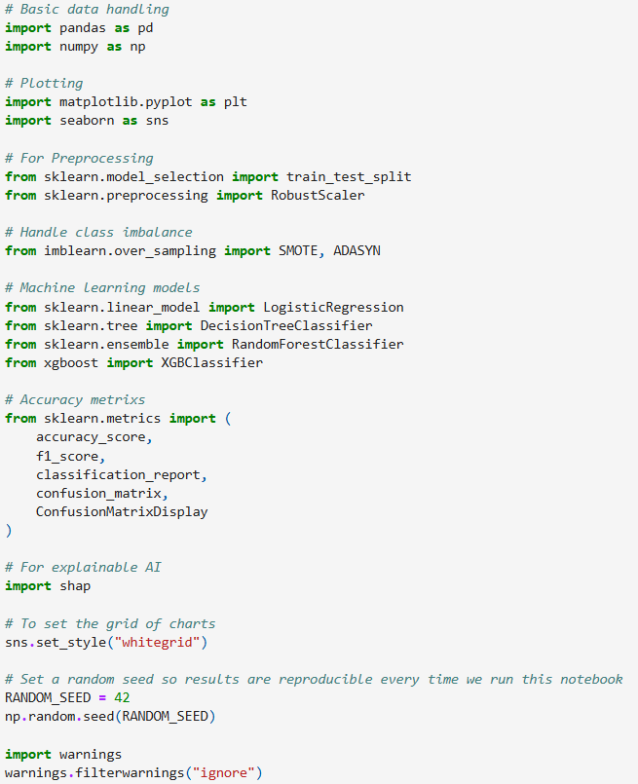
Figure 3.1: Importing required libraries

4.1.1.3 IDE
An Integrated Development Environment (IDE) refers to a software application that helps to write, test and run code in a single screen. Welc et al. (2026) stated that an IDE is beneficial for providing a single space to write code, run commands and fix bugs. In order to develop machine learning algorithms for credit card fraud detection, the Jupyter Notebook environment was used. The Jupyter Notebook helps programmers to not only write code and test the output, but also provide spaces for markdown explanations. In addition, Grotov et al. (2022) stated that the Jupyter Notebook also helps in breaking down complex code into small and independent sections for iterative testing and feedback. As a result, the programmers can separately run a single block of code one after another and reduce existing errors easily.

4.1.1.4 Implementation Pipeline
The project on credit card fraud detection using machine learning algorithms includes a structured pipeline. This structured pipeline consisted of data importing, data preprocessing, performing exploratory data analysis, model development, model evaluation, selecting the best model and explainability through the SHAP method. This approach was beneficial for this research to generate the required output for the next stage to proceed with further data analysis.
- Data loading
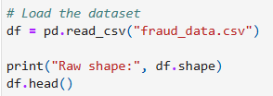
Figure 4.2: Dataset loading
The first stage in the implementation pipeline for credit card fraud detection was importing the credit card dataset. The read.csv function from the Pandas library was used to import the credit card fraud detection dataset. This is the initial stage for proceeding with further data analysis and performing any statistical operations to get accurate results.
- Data information
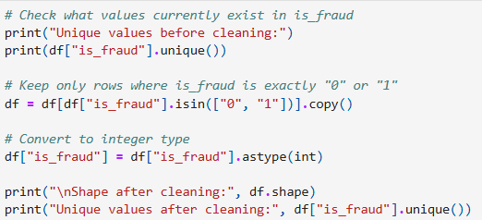
Figure 4.3: Removing corrupted values
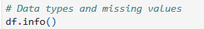
Figure 4.4: Dataset information
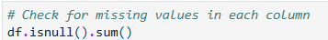
Figure 4.5: Checking null values
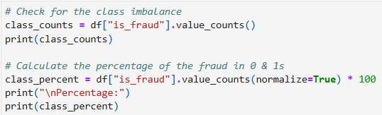
Figure 4.6: Checking class imbalance
The second stage in the implementation pipeline in this project was evaluating different information from the credit card fraud detection dataset. At first, the shape of the raw dataset was calculated to identify the total number of rows and columns present in the dataset. After that, the corrupted values in the is_fraud column were removed to make the values uniform in this column for the ease of data analysis, which led to a reduction in the number of rows. Next, the basic structure of the data was identified by checking the null values and data types of each of the columns present in the dataset. Class imbalance was also checked at this stage to identify the difference between the fraudulent and normal transactions.
- Exploratory data analysis
The EDA mainly includes several graphical representations of the credit card fraud detection dataset to visualise the relationships with transaction variables. The applied data analysis techniques in the EDA stage are:
- Countplot to check class imbalance
- Descriptive statistics to compare transaction amounts for fraudulent and normal activities.
- Histogram plots for amount distribution for fraudulent and normal transactions
- Horizontal Bar chart to identify fraud rate by different merchant categories
- Bar chart to identify fraud rate by states
- Discovering transaction time patterns by converting data to datetime format
- Bar charts for the visualisation of fraud rate by hour of day and day of weeks
- Calculating customer age to identify fraud and normal transactions according to their age
- Histogram plots for fraudulent and normal transactions based on customers’ age
- Calculating the customer-merchant distance for fraud and normal transactions
- Histogram plots for customer-merchant distance in normal and fraudulent transactions
- Histogram plots to visualise city population distribution for fraud and normal transactions
- Horizontal bar chart to identify the top 15 jobs according to the fraud rate
- Box plot to identify transaction amount by fraud and normal classes
- Correlation heatmap to identify relationships among numerical variables
- Feature engineering and preprocessing
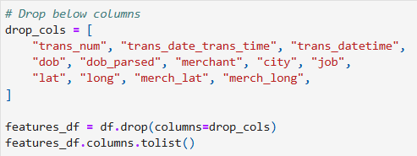
Figure 4.7: Dropping unnecessary columns
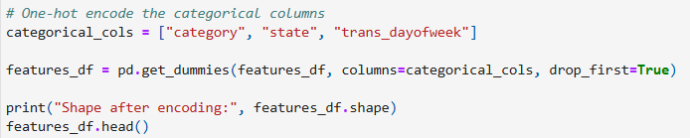
Figure 4.8: Applying one-hot encoding
The unnecessary columns such as trans_num, trans_date_trans_time, trans_datetime, dob, dob_parsed, lat, long and others were removed from the dataset to select the required variables for further data analysis. After that, categorical features were encoded to transform them into numerical variables for machine learning model development.
- Train-test splitting and scaling numerical features
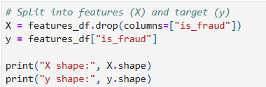
Figure 4.9: Selecting features and target variable
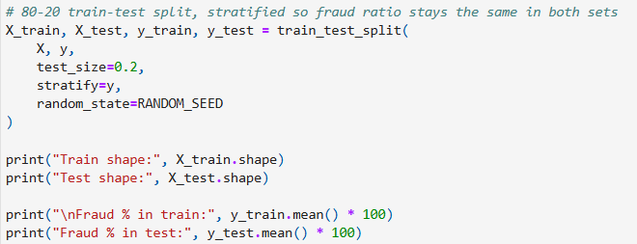
Figure 4.10: Splitting into train and test datasets 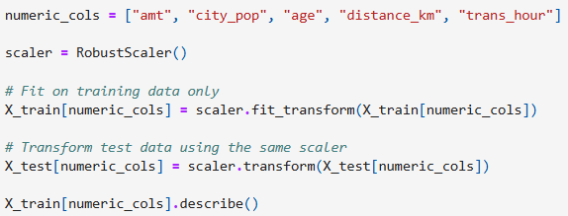
Figure 4.11: Handling outliers
The next stage in the implemented pipeline was train-test splitting to separate the features and the target variable. The is_fraud column has been selected as the target variable and the others as features. The entire credit card fraud detection dataset was split into train and test subsets using an 80:20 ratio. This indicated that 80% of the data would be used for training machine learning models and 20% would be used for testing the model. In order to scale numerical features, the RobustScaler function was used instead of StandardScaler to handle extreme outliers in some variables.
- Handling class imbalance
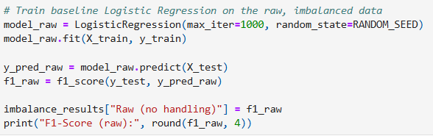
Figure 4.12: Using raw and imbalanced data
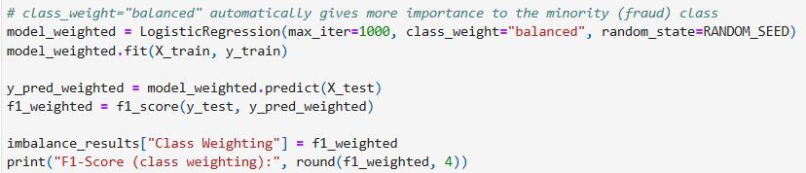
Figure 4.13: Applying class-weighting technique
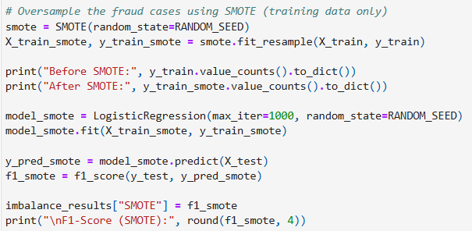
Figure 4.14: Applying SMOTE technique
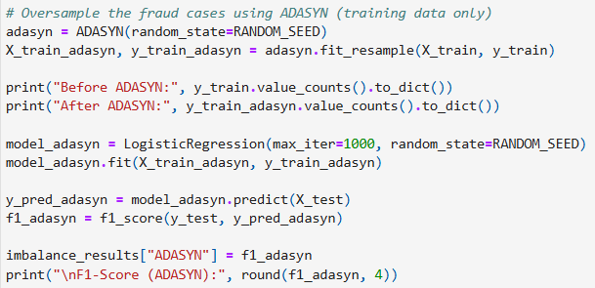
Figure 4.15: Applying ADASYN technique
Handling class imbalance was the next step in the implemented pipeline for credit card fraud detection using machine learning algorithms. Baseline method, class weighting, SMOTE, and ADASYN were some implemented techniques for handling class imbalance in the training dataset. This stage played a significant role in this project, as the fraud class was the minority case and handling class imbalance was necessary to get accurate and unbiased predictions.
- Machine learning model development
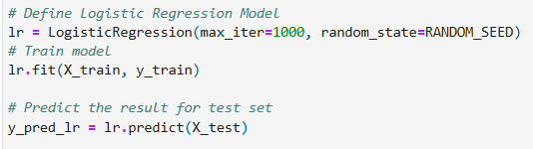
Figure 4.16: Training Logistic Regression model
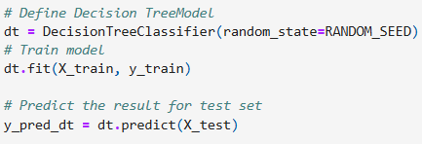
Figure 4.17: Training Decision Tree model
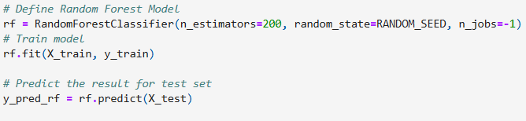
Figure 4.18: Training Random Forest model
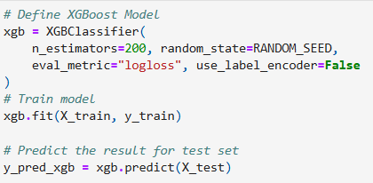
Figure 4.19: Training XGBoost model
The next stage in the implemented pipeline for this research was the development of machine learning models. Logistic Regression, Decision Tree Classification, Random Forest Classification and XGBoost models were implemented in this stage to predict the rate of credit card fraud detection.
- Model evaluation
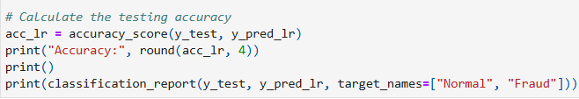
Figure 4.20: Classification report for Logistic Regression model
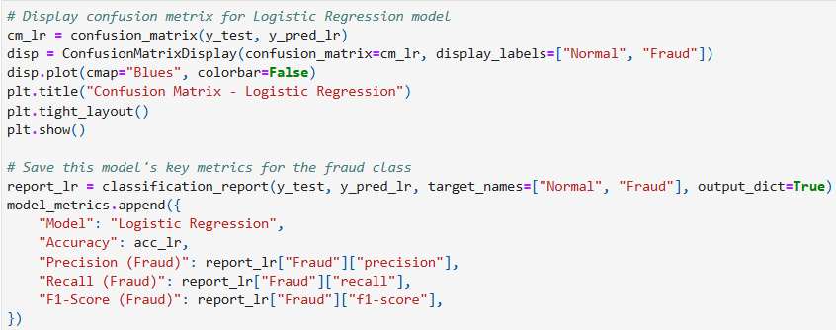
Figure 4.21: Confusion matrix for Logistic Regression model
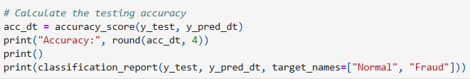
Figure 4.22: Classification report for Decision Tree model 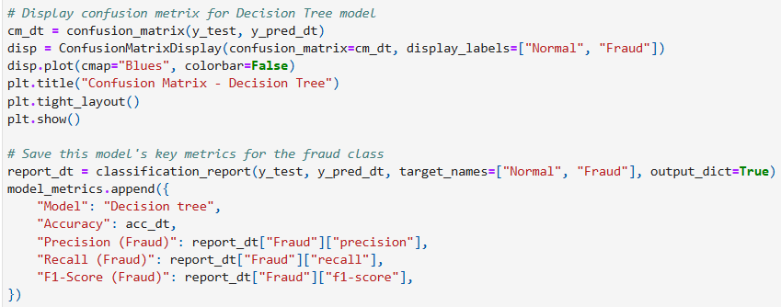
Figure 4.23: Confusion matrix for Decision Tree model
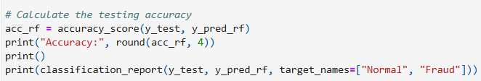
Figure 4.24: Classification report for Random Forest model
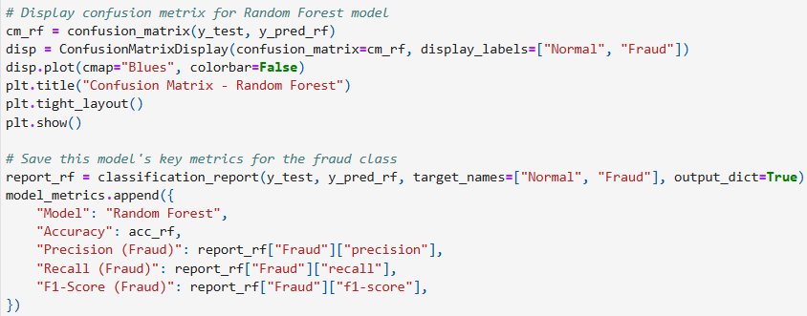
Figure 4.25: Confusion matrix for Random Forest model
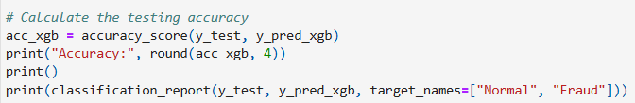
Figure 4.26: Classification report for XGBoost model
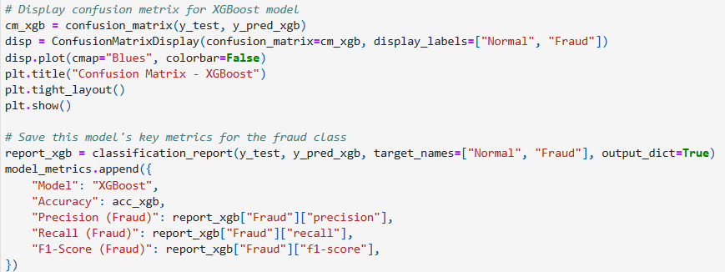
Figure 4.27: Confusion matrix for XGBoost model
The performance of the four developed models was then evaluated through the classification report and confusion matrix. The classification report provided precision, recall and F1-score, along with the accuracy score of each model. On the other hand, the confusion matrix was also beneficial for identifying true positive and true negative cases for accurate predictions. This stage was crucial for this research to identify the best model for credit card fraud detection.
- Result explanation using SHAP
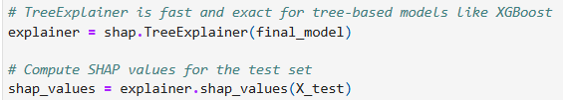
Figure 4.28: SHAP model implementation
The final stage of the implemented pipeline for credit card fraud detection through machine learning algorithms was result explanation through the SHAP method. This method helped in developing different diagrams to visualise which features affected most for the fraud detection.

4.1.2 Testing Framework

4.1.2.1 Metrics Used
The project on credit card fraud detection using machine learning algorithms included several evaluation metrics such as precision, recall and F1-score. In addition, a confusion matrix was also used to identify true positive, true negative, false positive and false negative cases.
- Precision
Precision is one of the important evaluation metrics that helps in measuring the accuracy of positive predictions for any machine learning model. As per the discussion of Carrington et al. (2022), precision is beneficial for calculating the ratio of true positive results to all the positive results predicted by the model. Therefore, this evaluation metric provides the percentage of predicted “yes” cases that are actually true. The formula used to calculate the precision value is:
Precision = True Positives (TP) / [True Positives (TP) + False Positives (FP)]
As a result, this precision metric helped identify the actual true outcomes of predicting results for both normal and fraud cases.
- Recall
Recall is another important evaluation metric that focuses on the measurement of the ability of any machine learning model to identify all positive instances in the dataset. Recall has an inverse relationship with the precision metric because it calculates the true positive rate. The formula used to calculate the recall metric is:
Recall = True Positives (TP) / [True Positives (TP) + False Negatives (FN)]
Therefore, it can be stated that the metric was significant in calculating the true positive rate for both normal and fraudulent transactions.
- F1-score
F1-score is also a crucial evaluation metric that combines both precision and recall values into a single mean value for any machine learning model. This evaluation metric is useful for uneven, imbalanced datasets to provide accurate prediction results. The formula used to calculate the F1-score is:
F1-score = 2 * [(Precision * Recall) / (Precision + Recall)]
As a result, this evaluation metric provided a balanced result for both normal and fraudulent transactions in credit card fraud detection.
- Accuracy
The accuracy evaluation metric is significant in calculating how well any machine learning model makes appropriate predictions. This metric calculates the ratio of correct predictions to total predictions (both correct and incorrect). The formula used to calculate the accuracy of any model is:
Accuracy = [True Positives (TP) + True Negatives (TN)] / Total
Therefore, this evaluation metric provides the actual prediction rate for the machine learning models to predict credit card fraud transactions.
- Confusion matrix
A confusion matrix is an important framework for evaluating the performance of any machine learning model with four cases: true positive, true negative, false positive and false negative. The four cases were predicted for each of the selected machine learning models for both true and predicted labels. Therefore, this evaluation framework provided a transparent result to identify the exact area of occurring classification errors in the credit card fraud detection project.

4.2 Systematic Literature Review

4.2.1 PRISMA Model
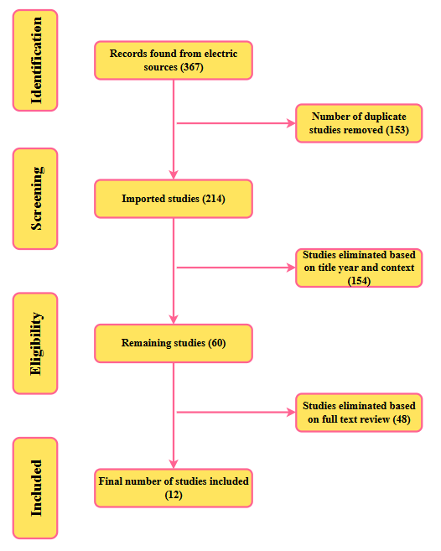
Figure 4.29: PRISMA model
(Source: Self-developed)
The above figure depicts the PRISMA diagram used to collect qualitative information from existing studies to perform an SLR. It is clear from the above figure that, at first, a total of 367 records were collected from different sources. After that, 153 duplicate records were removed, and 214 studies were imported. However, 154 studies were again excluded after the screening stage based on title, year and context. Again, 48 studies were eliminated from the remaining 60 records to make the final selection. Finally, 12 records were included in this research to perform an SLR to identify reasons for credit card fraudulent activities.

Chapter 5: Results, Evaluation and Discussion

5.1 Practical Results

5.1.1 EDA Results
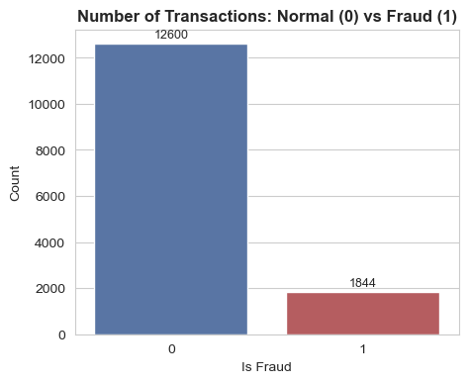
Figure 5.1: Visualisation of normal and fraud transactions
The above chart indicates that among 14,444 transactions, 12,600 are normal and 1,844 are fraud. This highlights the class imbalance, so accuracy alone would not be a reliable metric to select the best model.
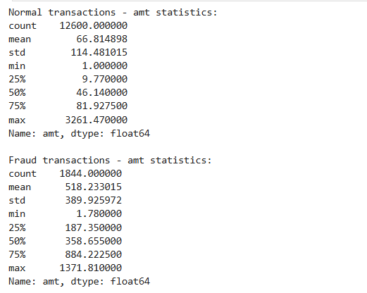
Figure 5.2: Statistics for fraud and normal transactions
Normal transactions have a mean amount of 66.8, and fraud transactions have a mean of 518.2. As a result, it can be stated that transaction amount is an important feature for the model.
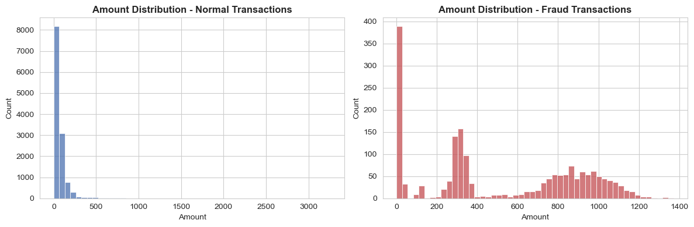
Figure 5.3: Visualisation of fraud and normal transactions
The histogram plots were developed to visualise the shape of the amount difference between the normal and fraudulent transactions.
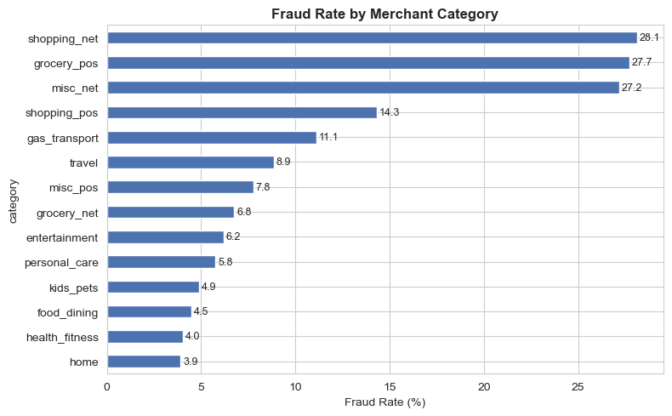
Figure 5.4: Fraud rate by merchant category
The shopping_net, grocery_pos, and misc_net variables have the highest fraud rates of more than 27%. On the other hand, home, health_fitness, and food_dining have the lowest fraud rates of below 5%. Therefore, category is a useful feature for identifying fraud and normal transactions.
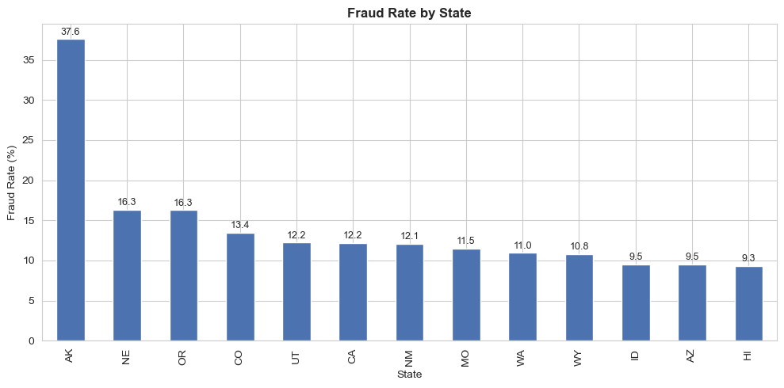
Figure 5.5: Fraud rate by state
From the above figure, it is clear that Alaska represents a higher fraud rate (37.6%) than any other state, followed by Nebraska and Oregon (16%).
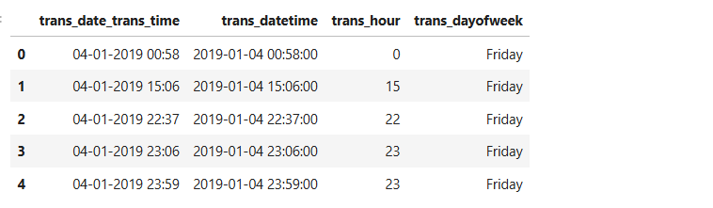
Figure 5.6: Calculating hours and days
The transaction date/time column was parsed so the hour and day of the week could be used as separate features.
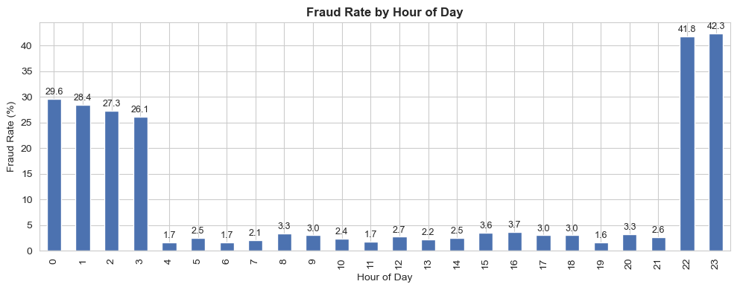
Figure 5.7: Fraud rate by hour of day
Late-night hours, such as 11 PM and 10 PM, have the highest fraud rate, with more than 40%. On the other hand, daytime hours like 6 AM-7 AM and 11 AM have the lowest fraud rate, between 1.5% and 2%. Therefore, it can be stated that fraud is far more common at night.
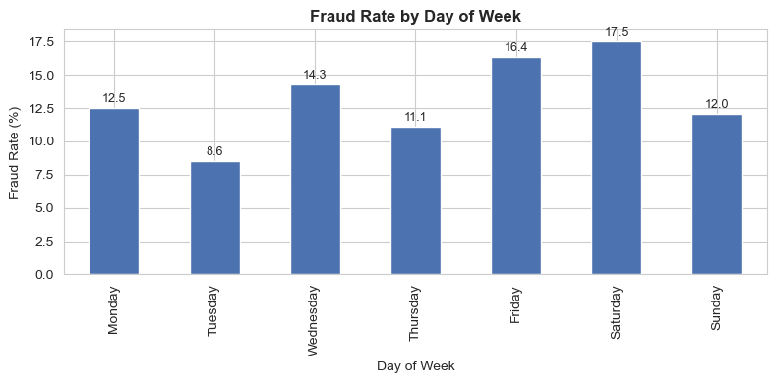
Figure 5.8: Fraud rate by day of week
It is clear from the above figure that Saturday and Friday showed the highest fraud rates, with 17.5% and 16.4%, respectively. On the other hand, Tuesday showed the lowest fraud rate of 8.6%.
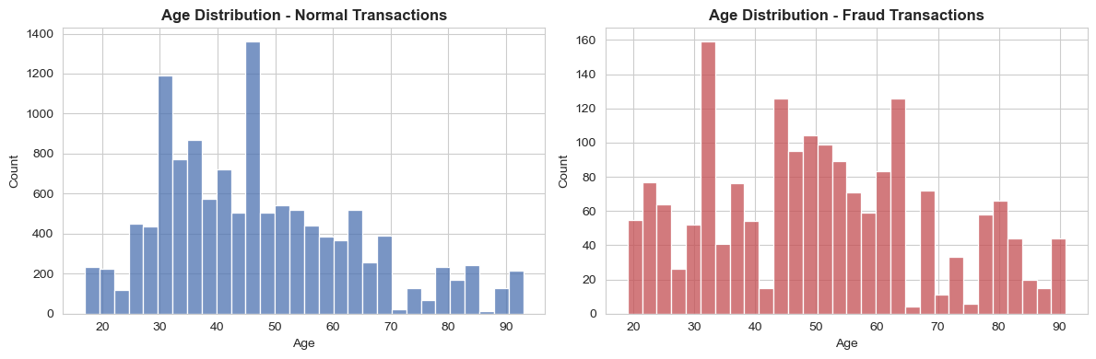
Figure 5.9: Age distribution for normal and fraud transactions
The customer age was calculated at the time of the transaction using their date of birth. Fraud transactions have a higher average age of almost 50 years compared to normal transactions of almost 47 years.
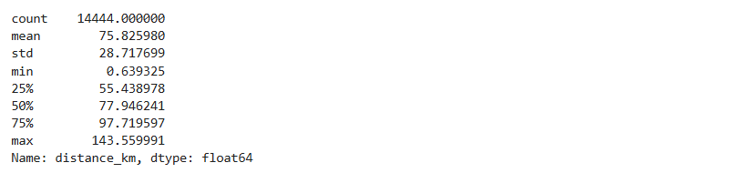
Figure 5.10: Distance between customer and merchant
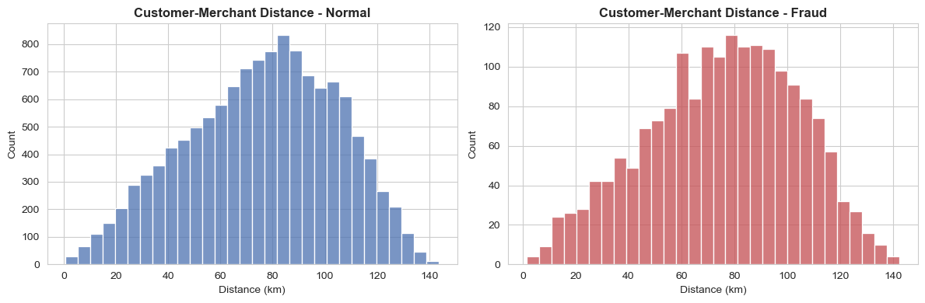
Figure 5.11: Customer-merchant distance for normal and fraud transactions
The distance between the customer's location and the merchant's location was calculated using the Haversine formula. The average distance is almost the same for both classes: 75.9 km for normal and 75.5 km for fraud.
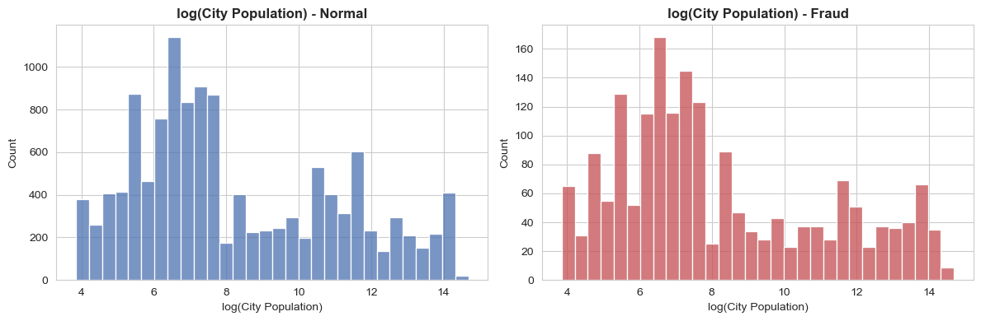
Figure 5.12: Log(city) population for normal and fraud transactions
The city population between the two classes was compared using a log scale since population is heavily skewed. However, the distributions look similar overall, with only a slightly higher average population for fraud cases.
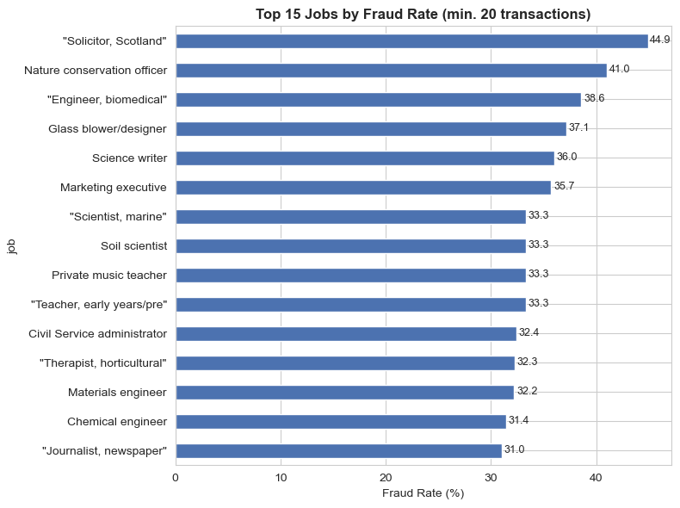
Figure 5.13: Top 15 jobs by fraud rate
From the above chart, it can be stated that jobs like “Solicitor, Scotland” and “Nature conservation officer” showed a high fraud rate of above 40%.
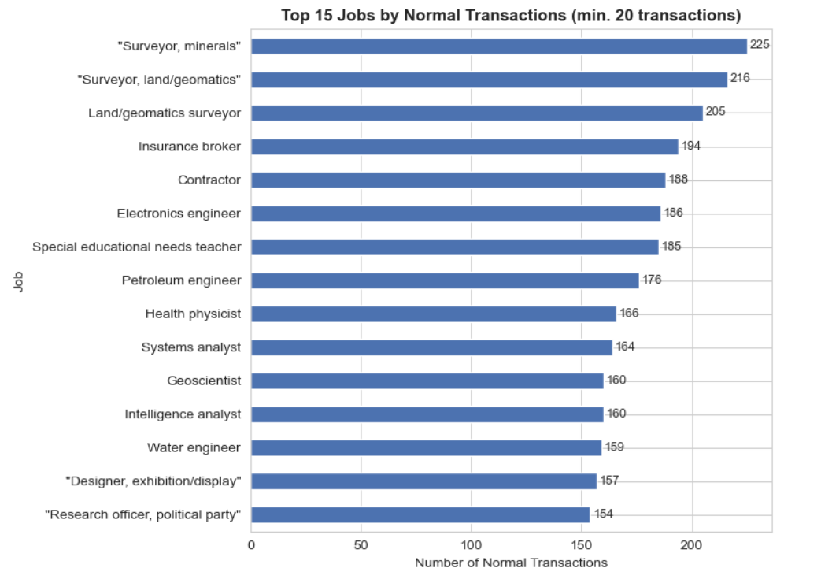
Figure 5.14: Top 15 jobs by normal transactions
From the above chart, it is clear that jobs like “Surveyor, minerals”, “Surveyor, land/geomatrics” and “Land/geomatrics surveyor” showed a high number normal transaction with more than 200.

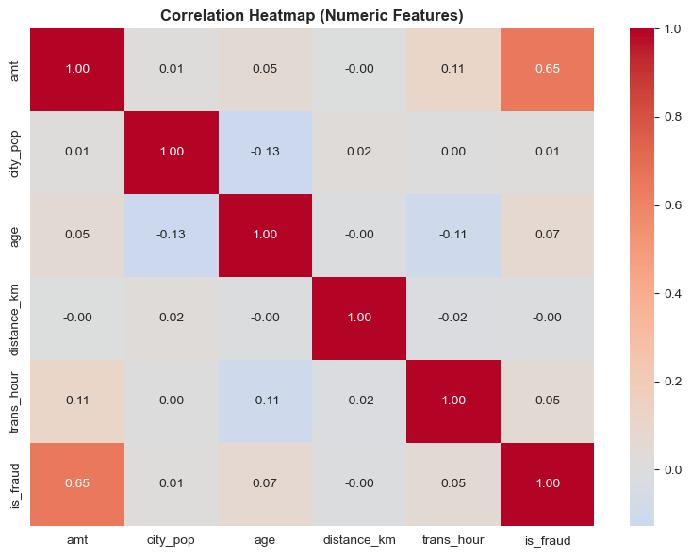
Figure 5.15: Correlation heatmap
The correlation heatmap indicated that there is a strong relationship between the amt and is_fraud variables, with a correlation coefficient of 0.65.

5.1.2 Pre-processing and Transformation
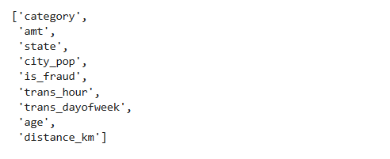
Figure 5.16: Dropping unnecessary columns
The above figure indicates the dropping of unnecessary columns and selecting category, amt, state, age, is_fraud and others as the final variables for fraud detection.
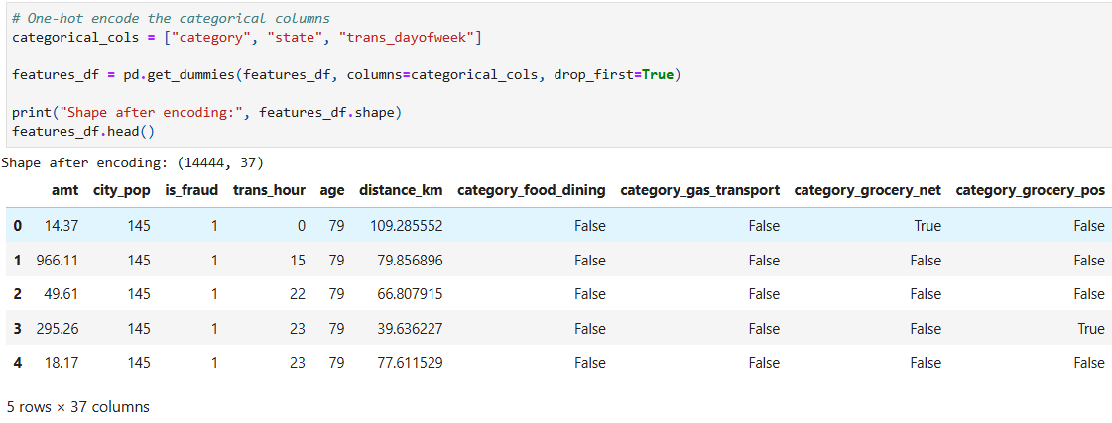
Figure 5.17: Encoding variables
The one-hot encoding technique was used on category, state, and trans_dayofweek variables to convert categorical data into numerical formats to reduce the complexity of machine learning models.
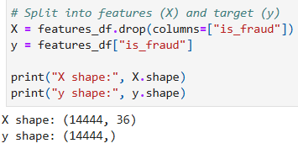
Figure 5.18: Selecting features and target
The is_fraud variable was selected as target and remaining variables were as features.
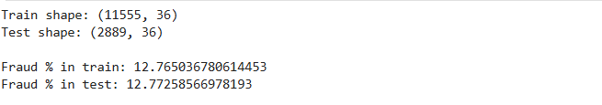
Figure 5.19: Splitting dataset
The entire dataset has been split into training and testing datasets with an 80:20 ratio. 80% of the dataset would be used to fit the model and the remaining 20% for testing the accuracy with unseen data. Though the existing research used 70:30 split ratio for training and testing datasets, the 80:20 ratio was used in this research to get some different and unique output.
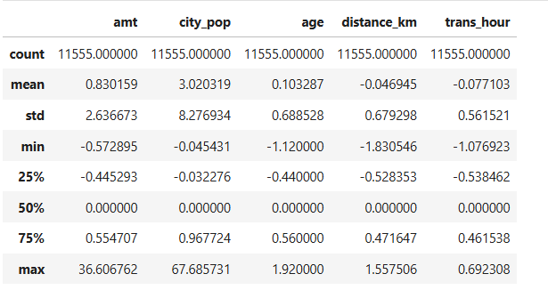
Figure 5.20: Applying RobustScaler
In order to scale amt, city_pop, age, distance_km, and trans_hour variables, the RobustScaler function was used. It helped to avoid any data leakage from the test to the train datasets.
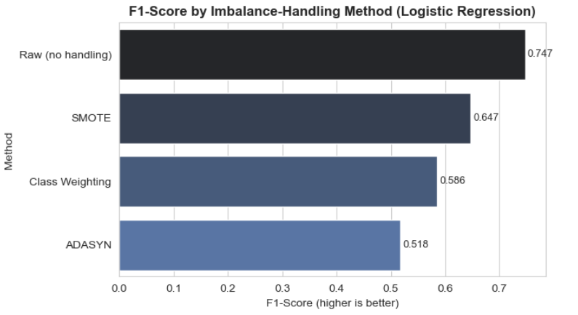
Figure 5.21: Handling class imbalance
Since the data was highly imbalanced, several techniques, such as SMOTE, class weighting and ADASYN, were applied to handle class imbalance. However, the raw data achieved the highest F1-score of 74.7%, and hence no imbalance-handling method was used in the machine learning models.

5.1.3 ML Modelling Results
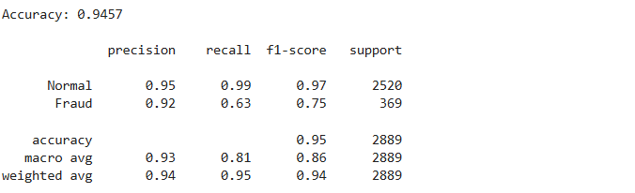
Figure 5.22: Classification report of Logistic Regression
The accuracy of the Logistic Regression was 94.57%, with an F1-Score of 0.75 for the fraud class.
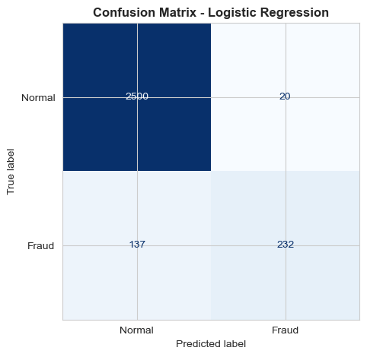
Figure 5.23: Confusion matrix of Logistic Regression
The result indicates that the Logistic Regression model correctly classified 2,500 normal and 232 fraudulent transactions, with 157 misclassifications.
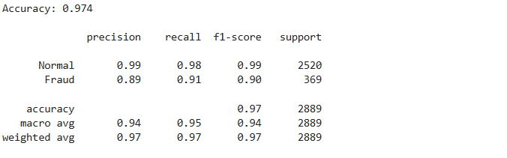
Figure 5.24: Classification report of Decision Tree
The Decision Tree model achieved a higher accuracy compared to the Logistic Regression model of 97.4%, with a 0.90 F1-score for fraud transactions.
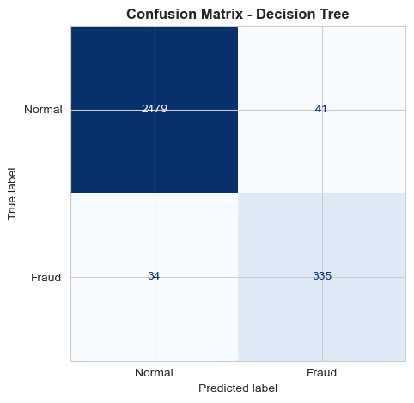
Figure 5.25: Confusion matrix of Decision Tree
The above figure indicates that the Decision Tree model correctly classified 2,479 normal and 335 fraudulent transactions, with 75 misclassifications.
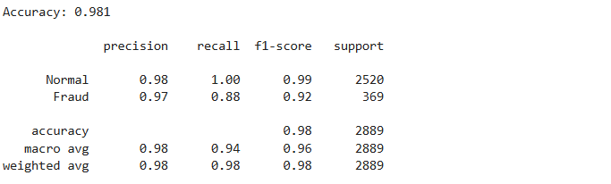
Figure 5.26: Classification report of Random Forest
The accuracy of the Random Forest was 98.1%, with an F1-Score of 0.92 for the fraud class.
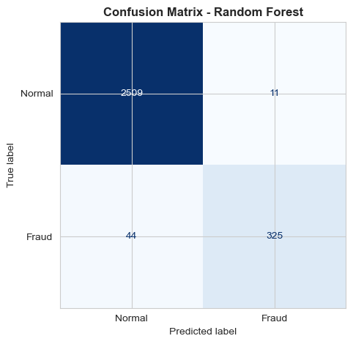
Figure 5.27: Confusion matrix of Random Forest
It is clear from the above figure that the Random Forest model correctly classified 2,509 normal and 325 fraudulent transactions, with only 55 misclassifications.
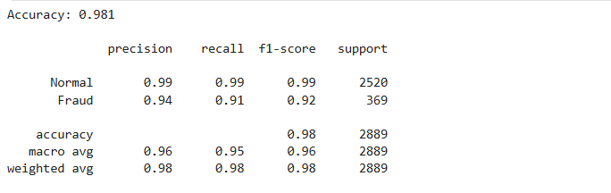
Figure 5.28: Classification report of XGBoost
The Decision Tree model achieved an accuracy of 97.4%, with a 0.92 F1-score for fraud transactions.
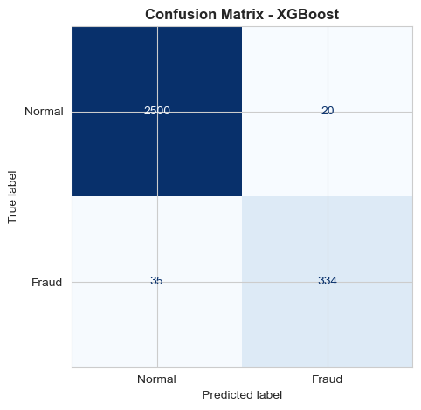
Figure 5.29: Confusion matrix of XGBoost model
The XGBoost model correctly classified 2,500 normal and 334 fraudulent transactions, with only 55 misclassifications.
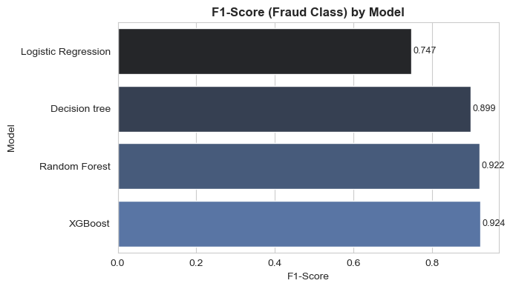
Figure 5.30: Result comparison
After comparing all the machine learning models, it can be stated that the XGBoost model is the best model for credit card fraud detection, as the fraud F1-score for this model is 92.4%. However, the confusion-matrix metrics are similar because all models were trained and tested on the same dataset, features, and stratified split. The predictive patterns helped each model to correctly classify transactions. However, false positives and false negatives differences reflect variations in model decision.
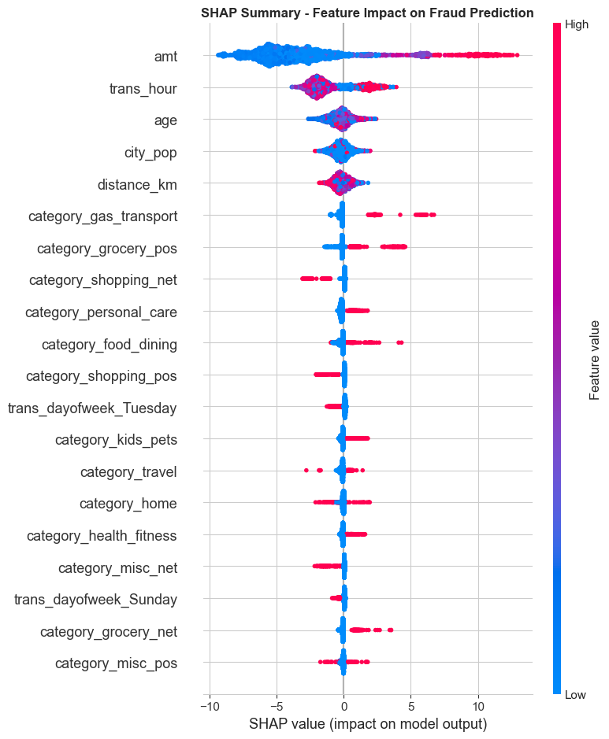
Figure 5.31: Feature impact on fraud prediction using SHAP
The SHAP model showed that amt has the highest impact for fraud detection, followed by trans_hour, age and city_pop.
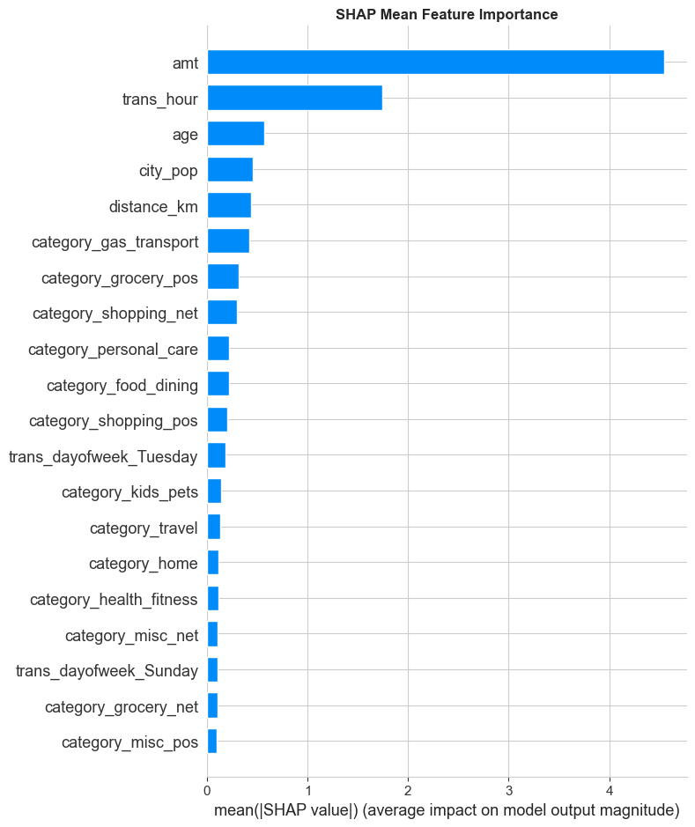
Figure 5.32: Mean feature importance using SHAP
The above figure indicates the mean feature importance for fraud detection using SHAP. The highest mean feature importance was achieved by amt, followed by trans_hour, age and city_pop.
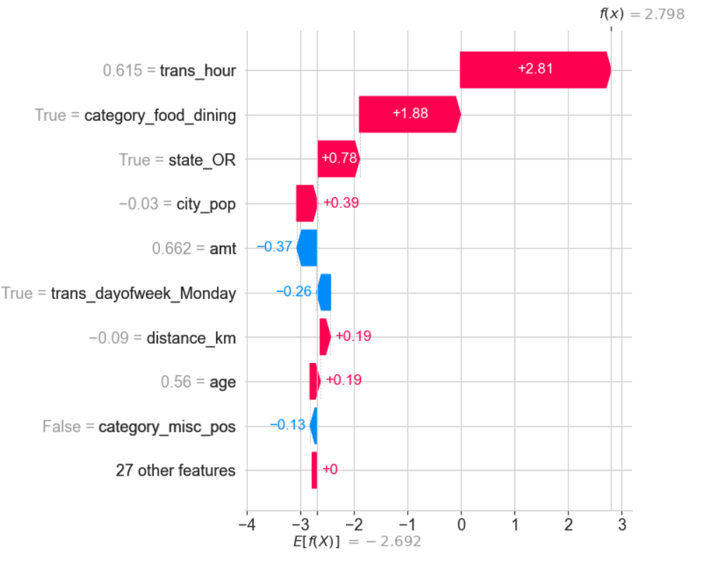
Figure 5.33: False positives by SHAP model
The waterfall plot shows the false positives results, which indicate transaction hour and merchant category (food_dining) pushed the prediction towards fraud for similar to a fraud pattern.
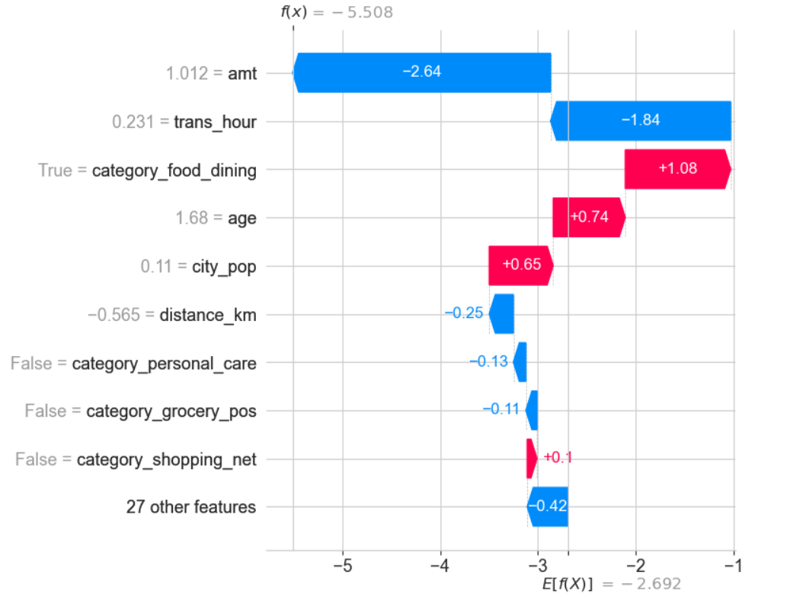
Figure 5.34: False negatives by SHAP model
The waterfall plot shows the results of false negative where amt and transaction hour were both typical for this transaction, so the model did not get a strong enough signal to flag it.

5.2 Results from Existing Research Paper

5.2.1 SLR Theme
Theme 1: Predictive Performance of Supervised Machine Learning Models for Credit Card Fraud Detection
Supervised machine learning methods are effective in detecting credit-card fraud, but the success of each method varies depending on the specific dataset, algorithm, and handling methods for the imbalance. The study by Afriyie et al. (2023) demonstrated that Random Forest performed well for accuracy (96%) and AUC (98.9%), which makes it a significant benchmark comparison model. Khalid et al. (2024) also showed that incorporating SVM with KNN, RF, Bagging and Boosting could enhance accuracy, precision, recall and F1-score for handling class imbalance. Similarly, Gupta et al. (2023) reflected the need for balancing techniques to improve model accuracy. Alarfaj et al. (2022) expanded the comparison into deep learning, where traditional ML faced challenges in extreme imbalance. Therefore, these studies showed the importance of ensemble learning, but exhibit variability in different dataset generalisability and evaluation criteria.
Theme 2: SHAP-Based Explainability and Feature Contributions in Explaining Fraud Predictions
SHAP is an effective tool that enhances the transparency of fraud detection, especially when a complex model is used. Erasmus and Paepae (2026) extended this idea by combining SHAP attribution with ensemble weights, but their insurance-oriented model has not been demonstrated for credit-card models. However, Thanathamathee et al. (2024) reinforced model learning and interpretability by merging SHAP-instance weighting and Anchor explanations. Kumar (2026) presented a comparison of the transparency and imbalance of SHAP and LIME for detecting credit-card fraud. Galahartlambang et al. (2025) demonstrated SHAP’s practical value, although explanations remain largely post-hoc. Therefore, it can be stated that all of these studies indicate a demand for more appropriate and accessible levels of explanation.
Theme 3: Performance–Explainability Trade-offs and Practical Applicability to Balance Predictive Performance and SHAP Explanation Fidelity
High levels of prediction accuracy are not enough to depend on for financial decision-making. Wang et al. (2025) highlighted the importance of interpretability with model accuracy when using XAI methods such as SHAP and LIME. Mapaila and Senekane (2026) added that explainability helps deal with ambiguity and uncertainty among fraud cases to aid in the human review process. Alessi and Fugini (2026) highlighted practical challenges including class imbalance, concept importance and delayed feedback in real-time fraud detection. Similarly, Shahnawaj et al. (2025) discussed the conflicts of predictive performance and transparency and regulatory trust in financial applications. Therefore, it can be stated that these studies demonstrate the need for balanced, operationally reliable and interpretable fraud-detection frameworks.

5.2.2 SLR Summary Table
Authors and Year | Methods | Key Findings | Research Gap
Afriyie et al. (2023) | Logistic Regression, Random Forest, Decision Tree | Random Forest achieved 96% accuracy and 98.9% AUC. | Limited comparison with XGBoost and SHAP explainability.
Khalid et al. (2024) | Ensemble machine-learning approach | Demonstrated ensemble learning's potential for improving fraud detection. | Greater emphasis needed on interpretable ensemble predictions.
Gupta et al. (2023) | XGBoost, classifiers, SMOTE and sampling | XGBoost performed strongly; Random Oversampling improved performance. | Balancing strategies require broader explainability evaluation.
Alarfaj et al. (2022) | ML and deep-learning algorithms | Compared state-of-the-art approaches for credit-card fraud detection. | Limited integration of predictive performance with SHAP-based explanations.
Erasmus and Paepae (2026) | SHAP-weighted ensemble | Integrates SHAP attribution directly into ensemble weighting. | Practical comprehensibility and comparison with conventional models need further analysis.
Thanathamathee et al. (2024) | SHAP-instance weighting, Anchor XAI, XGBoost | Combines SHAP weighting with interpretable if–then explanations. | Requires wider validation across datasets and prediction errors.
Kumar (2026) | Comparative ML, SHAP and LIME | Compares explainability approaches for credit-card fraud models. | Limited evidence on explanation fidelity and operational usefulness.
Galahartlambang et al. (2025) | Logistic Regression, Random Forest, SHAP | Random Forest outperformed Logistic Regression using precision, F1 and PR-AUC. | Limited examination of explanations across incorrect predictions.
Wang et al. (2025) | XAI techniques including SHAP and LIME | Highlights the need to balance accuracy with interpretability in financial risk management. | Limited fraud-specific measurement of explanation fidelity.
Mapaila and Senekane (2026) | Explainability and uncertainty quantification | Identifies interpretability and uncertainty as barriers to trustworthy fraud detection. | Further practical validation of trustworthy deployment is required.
Alessi and Fugini (2026) | Adaptive real-time fraud detection with XAI | Addresses class imbalance, concept drift and delayed feedback in operational environments. | More evaluation is needed on explanation comprehensibility during real-time detection.
Shahnawaj et al. (2025) | Explainable AI for financial risk assessment | Highlights transparency, trust and regulatory concerns surrounding high-performing black-box models. | Credit-card fraud-specific SHAP evaluation remains limited.
Table 5.1: Systematic literature review
(Source: Self-developed)

5.3 Collective Synthesis: Evaluation and Discussion

5.3.1 Discussion of Quantitative Results
The quantitative results show that the model that achieved the best performance across all the categories of classifiers is XGBoost, which supports the literature on ensemble learning by Hardayani and Widiantoro (2025). This finding also aligns with Ango et al. (2024), who found XGBoost to be the top-performing model. However, raw data outperforms the other techniques promoting imbalance correction by using SMOTE, with the highest F1-score. This is in contrast with Ango et al. (2024) and Asaad et al. (2026) that recommended SMOTE. SHAP findings suggest transaction amount is dominant and support the transaction-level interpretability requirements discussed by Salim et al. (2026). Thus, quantitative outcomes not only help to increase prediction, but also illustrate the necessity of interpretable choices regarding fraud detection.

5.3.2 Discussion of Qualitative Results
The qualitative results show a clear level of agreement on the effectiveness of machine learning to detect fraud. However, there is a difference in the viewpoints of researchers on imbalance management and suitable priorities for assessment (Afriyie et al. 2023; Gupta et al. 2023). The results from the thematic analysis indicate the application of SHAP-based interpretability and explainability helps to quantify the feature-level contribution. According to existing literature, SHAP is consistently enhancing transparency, especially for complex ensemble models and financial choices (Erasmus and Paepae, 2026; Thanathamathee et al. 2024). However, the current explanation is still mainly post-hoc, which has poor operational availability (Galahartlambang et al. 2025). In addition, there are deep conflicts between the goals of predicting accuracy, interpretability, uncertainty, and regulatory trust (Wang et al. 2025; Mapaila and Senekane, 2026). Thus, qualitative results support the application of SHAP method to identify feature-level contribution for credit card fraud detection.

Chapter 6: Conclusion and Future Scope

6.1 Conclusive Remarks
This study shows that supervised machine learning is capable of helping in the reliable detection of credit card fraud. Different machine learning models were trained to get the best model for credit card fraud detection. After performing a comparative analysis, the quantitative results have shown that XGBoost is the most effective model, with the highest fraud F1-score of 92.4% and a high overall classification rate. The EDA also highlighted key fraud-related patterns, such as the amount of transactions, their timing, merchant category, and specific customer attributes. The preprocessing stage helped to handle class imbalance by selecting the best technique from raw data, class weighting, SMOTE and ADASYN. However, the comparative result indicated that the raw data achieved the highest F1-score for credit card fraud detection. Qualitative findings from the literature also confirmed that ensemble models can deliver significant predictions, but class imbalance and assessment standards are methodological problems. SHAP made interpretation of XGBoost clearer and attributable to the key features which explained their impact on particular forecasts. This result ensured the application of SHAP-based interpretability and explainability to the best-performing model for quantifying the feature-level contribution. Therefore, it can be concluded that using predictive modelling with explanations using the SHAP method offers a practical solution to improve effectiveness and transparency in financial fraud detection.

6.2 Limitations of the study

6.2.1 Limitations from Quantitative Analysis
Analysis was based on only one dataset, limiting generalisability for different banking contexts. Model performance was affected by class imbalance, and careful selection of the metrics was necessary. It was limited to comparisons of selected supervised models only, not to a broader comparison of algorithmic approaches.

6.2.2 Limitations from Qualitative Analysis
A literature review was done by collecting evidence from 2022–2026, which may have excluded earlier foundational evidence. The actual comparability was limited due to differences between datasets, evaluation measures and methodologies. Explainability is captured conceptually without attempting to examine the fidelity or practical usability of SHAP.

6.3 Future Scope
- Dataset Expansion: The framework can be validated with larger and real-world banking data for future research.
- Model Development: Additional deep-learning and ensemble algorithm techniques could benefit detection of fraud.
- Explainability: The fidelity and understanding of the explanations should be assessed more systematically in SHAP.
- Real-Time Detection: Real-time fraud detection under concept drift can be explored in future studies.
- Uncertainty Analysis: Incorporating uncertainty quantification would enhance trustworthy decision-making and human review.

6.4 Recommendations
- Recommendation 1: Integrate XGBoost with SHAP
Banks need to use XGBoost models with SHAP explanations to make fraud detection more accurate by maintaining transparency for analysts’ decisions. For example, JPMorgan Chase implemented advanced analytics and machine learning algorithms for detecting fraudulent transactions, which underscores the value of data in financial risk monitoring (Lyu, 2025).
- Recommendation 2: Establish continuous model monitoring
Financial institutions should periodically check model performance, false positives, concept drift, and explanation consistency. For example, Mastercard uses AI-powered fraud detection throughout its payment infrastructure (Lezghed and Boulkedra, 2025). It shows how continuously updated analytics can help remove emerging risks in transactions.

6.5 Critical Review and Reflection
In order to ensure that I made steady progress on my research, I divided it into distinct steps. At first, I dedicated some time to literature search and source evaluation, as well as research question development. Then I began to work with the dataset, exploratory analysis, preprocessing and implementation of machine learning. The following time frame included model quality control, model interpretation, SHAP analysis, and results development. Finally, I allocated time for the critical editing, referencing and finalisation of my thesis. My research timeline helped me to make the sequence and monitor these activities throughout the research process.
Research Activity | Week  1 - 3 | Week  4 - 6 | Week  7 - 9 | Week  10 - 12
Background research and problem identification
Literature searching and review
Research methodology development
Dataset collection and understanding
Data cleaning and EDA
Data preprocessing and transformation
Class imbalance analysis
Machine-learning model development
Model evaluation and comparison
SHAP explainability analysis
Systematic literature Review
Results interpretation
Discussion and critical analysis
Recommendations and conclusion
Editing, referencing and proofreading
Final submission
Table 6.1: Research timeline
I faced several challenges during this work that forced me to change the way I applied the research technique. Initially, there was some confusion about the best modelling strategy due to the severe class imbalance. Then, I contrasted several approaches, including SMOTE, ADASYN, class weighting, and raw data, to select the best approach. Another difficulty was that various performance measures were used, which might give misleading results in isolation. Therefore, I used F1-score, precision, recall and the confusion matrix when evaluating models.
One of the challenges I faced was connecting predictive performance with meaningful model explanations. From my literature search, I found that there are several works that solely focus on accuracy and do not integrate explainability experimentally. As a result, I chose to use XGBoost and SHAP for those reasons and I wanted to add to the discussion of explainability. This allowed me to study prediction accuracy as well as contributions at the feature level in a unified manner.
Overall, I was more critical towards methodology and evidence choices. I have discovered that more accuracy is not the best indicator of more effectiveness in fraud detection. I also understood the importance of reproducibility, data leakage and evaluation transparency in research. Throughout the thesis, my method became more systematic, based on evidence and to be critically reflective.

References
Abisha, M.B., Kathrine, J.W., Taurshia, A., Silas, S. and Kirubakaran, S.S. (2025) 'Explainable Artificial Intelligence for Credit Card Fraud Detection', in Proceedings of the 3rd International Conference on Self Sustainable Artificial Intelligence Systems (ICSSAS-2025). IEEE. DOI: 10.1109/ICSSAS66150.2025.11081350.
Afriyie, J.K., Tawiah, K., Pels, W.A., Addai-Henne, S., Dwamena, H.A., Owiredu, E.O., Ayeh, S.A. and Eshun, J., (2023). A supervised machine learning algorithm for detecting and predicting fraud in credit card transactions. Decision Analytics Journal, 6, p.100163. https://www.sciencedirect.com/science/article/pii/S2772662223000036
Alarfaj, F.K., Malik, I., Khan, H.U., Almusallam, N., Ramzan, M. and Ahmed, M., (2022). Credit card fraud detection using state-of-the-art machine learning and deep learning algorithms. Ieee Access, 10, pp.39700-39715. https://ieeexplore.ieee.org/iel7/6287639/9668973/09755930.pdf
Alessi, G. and Fugini, M., (2026). Adaptive real-time financial fraud detection with explainable AI tools. Digital Threats: Research and Practice, 7(1), pp.1-31. https://dl.acm.org/doi/pdf/10.1145/3794859
Alnuaimi, A.F. and Albaldawi, T.H., (2024, April). An overview of machine learning classification techniques. In BIO Web of Conferences (Vol. 97, p. 00133). EDP Sciences. https://doi.org/10.1051/bioconf/20249700133
Ango, R., Reddy, C.K.K., Singh, T.M., Masih, R.K., Shuaib, M. and Alam, S. (2024) 'Fraud Detection in Banking using the Kaggle Credit Card Dataset and XGBoost Model', in Proceedings of the International Conference on IoT Based Control Networks and Intelligent Systems (ICICNIS-2024). IEEE. DOI: 10.1109/ICICNIS64247.2024.10823227.
Asaad, S., Farooq, O., Al Muntaser, A. and Al-Betar, M.A. (2026) 'Credit Card Fraud Detection Using Machine Learning Techniques', in Proceedings of the 2026 International Conference on Electrical/Electronics, Robotics, Artificial Intelligence, and Informatics (ICERAI). IEEE. DOI: 10.1109/ICERAI69511.2026.11494596.
Azarian, M., Yu, H., Shiferaw, A.T. and Stevik, T.K., (2023). Do we perform systematic literature review right? A scientific mapping and methodological assessment. Logistics, 7(4), p.89. https://www.mdpi.com/2305-6290/7/4/89
Bakirarar, B. and Elhan, A.H., (2023). Class weighting technique to deal with imbalanced class problem in machine learning: methodological research. Türkiye Klinikleri Biyoistatistik, 15(1), pp.19-29. https://www.researchgate.net/profile/Batuhan-Bakirarar/publication/369458562_Class_Weighting_Technique_to_Deal_with_Imbalanced_Class_Problem_in_Machine_Learning_Methodological_Research/links/641f27e4315dfb4cceaafaee/Class-Weighting-Technique-to-Deal-with-Imbalanced-Class-Problem-in-Machine-Learning-Methodological-Research.pdf
Benites, H.F.B., Rosales, J.L.M., Montalvan, D., Alburqueque, M.P.M.L., Linares, V.L.A., Luz, M., Peña, M., Muro, E.S.P., Flores, A.G., Colonia, C.U. and Cáceres, Y.S., (2025). Research Methodology Applied to the Exact Sciences: Cause and Effec. Editorial Mar Caribe—EMC, Colonia del Sacramento, Uruguay. https://editorialmarcaribe.es/ark:/10951/isbn.9789915698069/ebook.pdf
Bernal, L., Rastelli, G. and Pinzi, L., (2025). Improving machine learning classification predictions through SHAP and features analysis interpretation. Journal of Chemical Information and Modeling, 65(21), pp.11716-11732. https://doi.org/10.1021/acs.jcim.5c02015
Biswas, J., Mridha, A.A., Hossain, M.S., Trisha, A.S., Ahmed, M.S. and Hossain, M.I. (2023) 'Interpretable Credit Card Fraud Detection Using Machine Learning Leveraging SHAP', in Proceedings of the 2023 IEEE 6th International Conference on Electronic Information and Communication Technology (ICEICT). IEEE. DOI: 10.1109/ICEICT57916.2023.10245439.
Carrington, A.M., Manuel, D.G., Fieguth, P.W., Ramsay, T., Osmani, V., Wernly, B., Bennett, C., Hawken, S., Magwood, O., Sheikh, Y. and McInnes, M., (2022). Deep ROC analysis and AUC as balanced average accuracy, for improved classifier selection, audit and explanation. IEEE Transactions on Pattern Analysis and Machine Intelligence, 45(1), pp.329-341. https://ieeexplore.ieee.org/iel7/34/9970415/09693294.pdf
Castro, O., Bruneau, P., Sottet, J.S. and Torregrossa, D., (2023). Landscape of high-performance Python to develop data science and machine learning applications. ACM Computing Surveys, 56(3), pp.1-30. https://doi.org/10.1145/3617588
Choudhury, N.R. (2024). Credit Card Fraud data. Available at: https://www.kaggle.com/datasets/neharoychoudhury/credit-card-fraud-data [Accessed 20 Aug. 2026].
Elia, D., Palazzo, C., Fiore, S., D’Anca, A., Mariello, A. and Aloisio, G., (2023). Pyophidia: a python library for high performance data analytics at scale. SoftwareX, 24, p.101538. https://doi.org/10.1016/j.softx.2023.101538
Elreedy, D., Atiya, A.F. and Kamalov, F., (2024). A theoretical distribution analysis of synthetic minority oversampling technique (SMOTE) for imbalanced learning. Machine Learning, 113(7), pp.4903-4923. https://link.springer.com/article/10.1007/s10994-022-06296-4
Erasmus, N.C. and Paepae, T., (2026). An Explainability-Driven SHAP-Weighted Ensemble Framework for Fraud Detection: Insights into Model Contribution Dynamics. Information, 17(6), p.607. https://www.mdpi.com/2078-2489/17/6/607
Fatima, S., Hussain, A., Amir, S.B., Ahmed, S.H. and Aslam, S.M.H., (2023). Xgboost and random forest algorithms: an in depth analysis. Pakistan Journal of Scientific Research (PJOSR), 3(1), pp.26-31. https://pdfs.semanticscholar.org/8abb/99db16d6ccc080e3c2a2bb207c9ea20cd5e6.pdf
Galahartlambang, Y., Khotiah, T. and Anwar, M., (2025). Explainable AI (XAI) Analysis Using SHAP for Credit Card Fraud. Journal of Engineering and Applied Technology, 1(2), pp.333-344. http://scriptaintelektual.com/scripta-technica/article/download/602/474
Gebreyesus, Y., Dalton, D., Nixon, S., De Chiara, D. and Chinnici, M., (2023). Machine learning for data center optimizations: feature selection using Shapley additive exPlanation (SHAP). Future Internet, 15(3), p.88. https://doi.org/10.3390/fi15030088
Grotov, K., Titov, S., Sotnikov, V., Golubev, Y. and Bryksin, T., (2022, May). A large-scale comparison of Python code in Jupyter notebooks and scripts. In Proceedings of the 19th international conference on mining software repositories (pp. 353-364). https://doi.org/10.1145/3524842.3528447
Gupta, P., Varshney, A., Khan, M.R., Ahmed, R., Shuaib, M. and Alam, S., (2023). Unbalanced credit card fraud detection data: A machine learning-oriented comparative study of balancing techniques. Procedia Computer Science, 218, pp.2575-2584. https://www.sciencedirect.com/science/article/pii/S1877050923002314/pdf?md5=d70b2a364554a1326a9a3856f4f3f114&pid=1-s2.0-S1877050923002314-main.pdf
Hakkal, S. and Ait Lahcen, A., (2024). XGBoost to enhance learner performance prediction. Computers and Education: Artificial Intelligence, 7, p.100254. https://doi.org/10.1016/j.caeai.2024.100254
Hardayani, B.D.K. and Widiantoro, A.D. (2025) 'Credit Card Fraud Detection in the Era of Digital Finance: A Comparative Machine Learning Approach', in Proceedings of the 10th International Conference on Informatics and Computing (ICIC-2025). IEEE. DOI: 10.1109/ICIC68054.2025.11309420.
Khalid, A.R., Owoh, N., Uthmani, O., Ashawas, M., Osamor, J. and Adejoh, J., (2024). Enhancing credit card fraud detection: an ensemble machine learning approach. Big Data and Cognitive Computing, 8(1), p.6. https://www.mdpi.com/2504-2289/8/1/6
Khanom, K., Jannat, M., Masum, A.K.M., Connolly, R. and Azad, M.A.K. (2024) 'A Novel Approach to Credit Card Fraud Detection: Optimizing Recurrent Neural Networks', in Proceedings of the 4th International Conference on Ubiquitous Computing and Intelligent Information Systems (ICUIS-2024). IEEE. DOI: 10.1109/ICUIS64676.2024.10867025.
Kravchuk, O., (2025). Programming basics: python for data processing. Herald of Khmelnytskyi National University. Technical sciences, 357(5.1), pp.268-272. https://doi.org/10.31891/2307-5732-2025-357-33
Kumar, A., (2026). Explainable Credit Card Fraud Detection: Comparative Evaluation of Machine Learning Models Using SHAP and LIME. International Journal of Engineering, Science and Environment (IJESE), 1(1). https://ijese.in/journal/article/download/45/16
Kumar, D., Rana, S.K., Kour, S., Singh, G. and Nikash (2025) 'Enhancing Credit Card Fraud Detection with Explainable AI: A SHAP-Based Approach', in Proceedings of the 2025 IEEE 7th International Conference on Computing, Communication and Automation (ICCCA). IEEE. DOI: 10.1109/ICCCA66364.2025.11325261.
Lalwani, N., (2025). Plagiarism in Publications: All about Being Fair!. Indian Journal of Radiology and Imaging, 35(S 01), pp.S36-S45. 10.4103/ijph.ijph_1071_23
Lezghed, S.E. and Boulkedra, N., (2025). Leveraging Artificial Intelligence to Improve Digital Banking Services: The Case of MasterCard. Annals of the University Dunarea de Jos of Galati: Fascicle: I, Economics & Applied Informatics, 31(2), p.5. https://www.researchgate.net/profile/Naziha-Boulkedra/publication/397726394_Leveraging_Artificial_Intelligence_to_Improve_Digital_Banking_Services_The_Case_of_MasterCard/links/69786f9920c0a92260f562ec/Leveraging-Artificial-Intelligence-to-Improve-Digital-Banking-Services-The-Case-of-MasterCard.pdf
Lyu, Z., (2025). Analysis of the Business Strategy in the Banking Industry: A Case Study of JPMorgan Chase & Co. Journal of Education, Humanities and Social Sciences, 61, pp.390-394. https://drpehss.com/index.php/ojs/article/download/59/57
Mapaila, T.F. and Senekane, M., (2026). Integrating Model Explainability and Uncertainty Quantification for Trustworthy Fraud Detection. Technologies, 14(4), p.212. https://www.mdpi.com/2227-7080/14/4/212
Markoulidakis, I. and Markoulidakis, G., (2024). Probabilistic confusion matrix: A novel method for machine learning algorithm generalized performance analysis. Technologies, 12(7), p.113. https://doi.org/10.3390/technologies12070113
Mustafa, A.A., Hussein, H.M., Kadhim, M.M. and Hussein, M.J., (2025). A Hybrid Oversampling Approach for Fraud Detection: Integrating SMOTE-ENN and ADASYN. International Journal of Safety and Security Engineering, 15(06), pp.1243-1250. https://doi.org/10.18280/ijsse.150614
Owoade, A.A. and Ode, I., (2025). Identifying Financial Fraud Transactions Using Decision Tree Classifier Algorithm. Dutse Journal of Pure and Applied Sciences, 11(1a), pp.338-352. https://www.ajol.info/index.php/dujopas/article/download/290785/273579
Pearson, H., Myall, M., Darlington, A.S. and Gibson, F., (2025). The approach and application of analysing inductive and deductive datasets: a worked example using reflexive thematic analysis. Qualitative Research in Psychology, 22(4), pp.842-886. https://www.tandfonline.com/doi/abs/10.1080/14780887.2025.2499265
Pervin, N., (2022). The interpretivist research paradigm: A subjective notion of a social context. International journal of academic research in progressive education and development. https://www.academia.edu/download/89382083/the-interpretivist-research-paradigm-a-subjective-notion-of-a-social-context.pdf
Rainio, O., Teuho, J. and Klén, R., (2024). Evaluation metrics and statistical tests for machine learning. Scientific reports, 14(1), p.6086. https://www.nature.com/articles/s41598-024-56706-x.pdf
Rane, N.L., Paramesha, M., Choudhary, S.P. and Rane, J., (2024). Machine learning and deep learning for big data analytics: A review of methods and applications. Partners Universal International Innovation Journal, 2(3), pp.172-197. https://doi.org/10.5281/zenodo.12271006
RV, K., Ganesh, S., GR, B. and Thiruvengadam, M., (2025). Credit card fraud data analysis and prediction using machine learning algorithms. Security and Privacy, 8(3), p.e70043. https://doi.org/10.1002/spy2.70043
Salama, M., (2024). Optimization of regression models using machine learning: A comprehensive study with scikit-learn. Optimization of Regression Models Using Machine Learning: A Comprehensive Study with Scikit-learn| IUSRJ, 5. https://doi.org/10.59271/s45500.024.0624.16
Salim, R., Kusnadi, T.J. and Wiputra, R. (2026) 'Comparative Analysis of Explainable Artificial Intelligence (XAI) for the Interpretability of Random Forest Models in Credit Card Fraud Detection', in Proceedings of the International Conference on Machine Learning and Autonomous Systems (ICMLAS-2026). IEEE. DOI: 10.1109/ICMLAS67792.2026.11483677.
Salman, H.A., Kalakech, A. and Steiti, A., (2024). Random forest algorithm overview. Babylonian Journal of Machine Learning, 2024, pp.69-79. https://doi.org/10.58496/BJML/2024/007
Sathiyamoorthy, C., Hariharan, K.S., Parveen Banu, S., Ayushi, Mandal, P. and Kalra, G. (2025) 'Multilayer Credit Card Fraud Detection Using a Hybrid Autoencoder-BiLSTM-XGBoost Framework with XAI', in Proceedings of the 2025 IEEE 2nd International Conference on Information Technology, Electronics and Intelligent Communication Systems (ICITEICS). IEEE. DOI: 10.1109/ICITEICS64870.2025.11340870.
Shahnawaj, M., Biswas, D., Hellol, H.I., Al Ridwan, M., Kafi, A., Zakaria, R.M. and Rahman, H., (2025). Explainable artificial intelligence for credit risk assessment: Balancing transparency and predictive performance. Journal of Economics, Finance and Accounting Studies, 7(6), pp.14-27. https://alkindipublisher.com/index.php/jefas/article/download/11042/9810
Thanathamathee, P., Sawangarreerak, S., Chantamunee, S. and Nizam, D.M., (2024). SHAP-instance weighted and anchor explainable AI: enhancing XGBoost for financial fraud detection. Emerg. Sci. J, 8(6), pp.2404-2430. https://www.researchgate.net/profile/Siriporn-Sawangarreerak/publication/386537440_SHAP-Instance_Weighted_and_Anchor_Explainable_AI_Enhancing_XGBoost_for_Financial_Fraud_Detection/links/67ee24ab76d4923a1af218e8/SHAP-Instance-Weighted-and-Anchor-Explainable-AI-Enhancing-XGBoost-for-Financial-Fraud-Detection.pdf
Varatharajoo, P.M., Zakaria, N.H., Abu Bakar, J. and Mahmuddin, M. (2024) 'Explainable Artificial Intelligence (XAI) Model for Online Fraud Detection: A Critical Review in Malaysia's Digital Economy', in Proceedings of the 2024 7th International Conference on Internet Applications, Protocols, and Services (NETAPPS). IEEE. DOI: 10.1109/NETAPPS63333.2024.10823585.
Villarroya, S. and Baumann, P., (2023). A survey on machine learning in array databases. Applied Intelligence, 53(9), pp.9799-9822. https://link.springer.com/content/pdf/10.1007/s10489-022-03979-2.pdf
Wang, M., Zhang, X., Yang, Y. and Wang, J., (2025). Explainable machine learning in risk management: Balancing accuracy and interpretability. Journal of Financial Risk Management, 14(3), pp.185-198. https://www.researchgate.net/profile/Xuguang-Zhang-14/publication/398609944_Explainable_Machine_Learning_in_Risk_Management_Balancing_Accuracy_and_Interpretability/links/693bb428a1fd017989074555/Explainable-Machine-Learning-in-Risk-Management-Balancing-Accuracy-and-Interpretability.pdf
Welc, A., Nowacki, T., Russi, D., Swords, C. and Zakian, T.A., (2026, April). Optimizing an IDE for an Evolving Language Ecosystem. In Proceedings of the 3rd ACM/IEEE International Workshop on Integrated Development Environments (pp. 18-23). https://doi.org/10.1145/3786151.3788600
Zaidi, A. and Al Luhayb, A.S.M., (2023). Two statistical approaches to justify the use of the logistic function in binary logistic regression. Mathematical Problems in Engineering, 2023(1), p.5525675. https://doi.org/10.1155/2023/5525675
Sources Reviewed but Not Selected in the Literature Review (5)
Bhaskar, P., Tharanya, G., Subbarao, P., Chandana, K., Rohini, B. and Mounika, I. (2026) 'Credit Card Fraud Detection using Machine Learning and Behavioral Pattern Analysis', in Proceedings of the 6th International Conference on Image Processing and Capsule Networks (ICIPCN-2026). IEEE. DOI: 10.1109/ICIPCN67432.2026.11438686.
Gupta, A., Singh, K., Rakhra, M. and Sharma, N. (2022) 'Machine Learning for Detecting Credit Card Fraud', in Proceedings of the 2022 IEEE North Karnataka Subsection Flagship International Conference (NKCon). IEEE. DOI: 10.1109/NKCON56289.2022.10126861.
Irfan, S. (2026) 'Identification of Financial Fraud Transactions: A Cybersecurity via Machine Learning Methods', in Proceedings of the 2026 IEEE International Conference on AI Engineering and Innovations (AIEI). IEEE. DOI: 10.1109/AIEI69164.2026.11497127.
Kumar, N., Tomar, K., Sharma, T., Jyala, P., Malik, D. and Dawar, I. (2023) 'Customer Behavior-Based Fraud Detection of Credit Card Using a Random Forest Algorithm', in Proceedings of the 2023 International Conference on Artificial Intelligence and Applications (ICAIA) Alliance Technology Conference (ATCON-1). IEEE. DOI: 10.1109/ICAIA57370.2023.10169484.
Vihurskyi, B. (2024) 'Credit Card Fraud Detection with XAI: Improving Interpretability and Trust', in Proceedings of the 2024 Third International Conference on Distributed Computing and Electrical Circuits and Electronics (ICDCECE). IEEE. DOI: 10.1109/ICDCECE60827.2024.10548159.

