
PREPRINT · RESEARCH SOFTWARE & METHODS · v1.0 · 29 SEPTEMBER 2026

Carrying the Harvest by Hand
The Threshing Floor, a provenance-first, human-in-the-loop instrument for studying public Reddit discourse — with a worked example from r/politics in the first weeks of the 2026 Iran war
Jacob E. Thomas, PhD
Independent researcher · Austin, Texas, USA
Correspondence: jethomasphd@gmail.com · Software: github.com/jethomasphd/The_Threshing_Floor
ABSTRACT
Background. Researchers who study public discourse on Reddit have lost most of their routes to the data. API repricing (2023), a contract-only Public Content Policy (2024), and the blocking of automated requests from datacenter networks leave non-specialists choosing between institutional data programs, contested archives, and scraping.
Instrument. The Threshing Floor (Thresh) is a free, open-source, browser-only instrument that inverts the collection pipeline. Thresh builds the exact Reddit .json URL for a query; the researcher opens it in their own browser and pastes the result back; parsing, analysis, and export happen client-side. Every export is sealed with a provenance record. No Thresh server touches Reddit data and no credentials are required.
Worked example. We analyze a Thresh export of the top 100 r/politics posts mentioning Iran in the 30 days to 20 March 2026 (4,956 comments), situated within a pre-specified 18-community sampling frame for studying war discourse under moderation and influence-operation constraints.
Results. Provenance made the sample’s shape auditable. The export held 5.7% of the 86,564 comments Reddit reported; AutoModerator wrote the first comment in every thread; commenting followed a North American day (8.8% of comments between 01:00 and 06:59 Eastern versus 25% under uniformity). Partisan and leadership framing (26.9% of comments) outweighed every war-substantive frame; sentiment was negative (mean VADER −0.18) and showed no trend. No Persian- or Spanish-language content and no coordinated duplication were detected. A harness executing Thresh’s own code showed its pseudonyms are deterministic—enabling cross-community linkage—and reversible by dictionary, a limitation we disclose.
Conclusion. Human-in-the-loop collection trades scale for legitimacy and transparency. For bounded, question-driven studies of public discourse, the trade is favorable, provided moderation and ranking are treated as part of the data.
Keywords Reddit · computational social science · research software · data provenance · human-in-the-loop · content moderation · information operations · 2026 Iran war

1 Introduction
Reddit is unusual among large platforms: it is organized into tens of thousands of topical communities, it is public by default, and its unit of speech is text. For more than a decade those properties made it one of the most studied sources in computational social science, public health, and communication research (Medvedev et al., 2019; Proferes et al., 2021), and for most of that decade the free API and the Pushshift archive (Baumgartner et al., 2020) put the data within reach of anyone who could write a script.
That period has ended. Freelon (2018) named the “post-API age” and Bruns (2019) the “APIcalypse”; Reddit has since provided a textbook case. In 2023 the company moved to charge for API access (Isaac, 2023); in 2024 its Public Content Policy made bulk access contractual (Perez, 2024), with non-commercial academic access routed through a Reddit for Researchers program open to accredited-university researchers with ethics approval (Reddit, 2026). By 2026 Reddit was also refusing automated requests for its public .json pages from datacenter networks. We observed this directly: the server relay in version 1 of the instrument described here began receiving HTTP 403 and 429 responses from cloud IP ranges, and a request issued from a cloud container while preparing this paper was likewise refused.
The researchers left outside are not marginal. They are journalists on deadline, public-health practitioners, students, civic technologists, and scholars without an accredited-university affiliation—exactly the people for whom “what are people saying in this community?” is a practical question. The routes that remain open to them are often the least defensible: residential-proxy scraping and IP rotation defeat a platform’s stated wishes and put the legitimacy of any finding at risk.
This paper describes The Threshing Floor (Thresh), an instrument built for that gap, and makes five contributions. (i) A design: human-in-the-loop collection, which returns the network request to a person using an ordinary browser, and an account of what that design gives up and gains. (ii) Provenance as a first-class output rather than an afterthought. (iii) A study design for contested discourse, developed for research on the 2026 Iran war, that pre-specifies a multi-community sampling frame and treats community governance as data. (iv) A worked example on a real Thresh export, analyzed with a pipeline in which every number is regenerated from the data. (v) A verification harness that executes the instrument’s own code, and a candid list of limitations it surfaced. The name is literal: a threshing floor is where grain is separated from chaff by deliberate labor. The instrument is built on the premise that attention, paid deliberately, is a methodological virtue.

2 Background

2.1 Routes to Reddit data in 2026
Table 1 summarizes the routes available at the time of writing. They differ less in the data they return—the underlying objects are the same—than in who performs the request, under what authority, and what record of the request survives.
Table 1. Routes to public Reddit data in 2026, compared on the dimensions that matter for defensible research.
Route | Who makes the request | Credentials / gatekeeping | Scale | What survives for reviewers
Official Data API | Registered application (server) | OAuth app; rate limits; commercial terms for volume | High | Code and API logs, if kept
Reddit for Researchers | Reddit, on approval | Accredited university; IRB/ethics letter; application | High | Programme documentation
Third-party archives / dumps | An archive operator, historically | Varies; policy status contested since 2023 | Very high, historical | Depends on the archive
Automated scraping | Researcher’s server or script | None; datacenter IPs blocked; ToS exposure | High, fragile | Rarely documented
Thresh v2 (this paper) | The researcher’s own browser | None; public pages only, at human pace | Bounded (≤100 posts/page; ≤500/collection) | Exact URL, counts, UTC time and method in provenance.txt

2.2 What Reddit data can and cannot answer
Reddit users are not a sample of any general population. In 2025, 26% of U.S. adults reported using Reddit; use was far higher among adults under 30 (48%) and among college graduates (about four in ten) than among older or less-educated adults, higher among men, and higher among Democrats (32%) than Republicans (22%) (Gottfried & Park, 2025). Within the platform, those who post are a small minority of those who read. Reddit data therefore cannot estimate the attitudes of Iranians, Iranian-Americans, or Americans. What it can support are questions about framing, shifts over time, comparison across communities, and narrative propagation—claims about what is said, where, and how, rather than about what a population believes.

2.3 Governance is part of the data
Every subreddit is a governed space. Sidebar rules, flair requirements, automated moderation, and removal norms shape what can be said and who may say it (Chandrasekharan et al., 2018). Reddit’s AutoModerator performs a large share of that work at scale (Jhaver et al., 2019), and analysis of removals across 1.2 million users found that moderators are more likely to remove content opposing their own political orientation (Huang et al., 2024). Moderation is not a contaminant to be controlled away: it can raise signal-to-noise and draw ideological boundaries at the same time. A comparison of two communities is therefore also a comparison of two governance regimes, and the regime must be documented alongside the text.

2.4 Contested information environments
Communities that discuss Iran are documented targets of state influence. In August 2018 FireEye reported an Iranian operation running inauthentic news sites across platforms (FireEye, 2018); Reddit removed 143 associated accounts, and NBC News reported that volunteer moderators had warned the company for a year and that r/worldnews had been the operation’s most effective target (Collins, 2018). During the 2026 conflict, researchers documented an IRGC-affiliated network using Spanish-language personas claiming to be in Texas, California, Venezuela, and Chile (Murray & Linvill, 2026), and networks distributing AI-generated war footage (Cyabra, 2026). State-sponsored accounts move across platforms and communities (Zannettou et al., 2019), and communities themselves are porous: users mobilize across them (Kumar et al., 2018; Datta & Adar, 2019) and participate in sets of communities that together express social position (Waller & Anderson, 2021). The appropriate unit of analysis is often the network of communities, not any one of them.

3 The Threshing Floor

3.1 Design principles
Thresh is a single-page application served as static files from Cloudflare Pages. It has no build step, no framework, no database, and no accounts; collections persist only in the user’s browser (localStorage). Five principles govern it: no code (the user never touches a terminal); local-first (Reddit data never passes through a Thresh server); provenance is non-negotiable (no export leaves without its record); privacy by default (usernames are pseudonymized unless the user opts out, and the opt-out is recorded); and truthfulness about limits (the interface states what it cannot do, including that collection is impractical on phones). Pages carry both a metaphor and a plain label: The Floor (dashboard), Thresh (collection), Harvest (inspection), Winnow (analysis), and Glean (export).

3.2 Human-in-the-loop collection
Version 2 of Thresh makes no requests to Reddit. Instead it hands the request to the researcher (Figure 1). (1) The researcher sets a query—subreddit(s), sort, time window, optional keyword, and a target of up to 500 posts—and Thresh constructs the exact URL, displayed in full. For the worked example’s query this is reddit.com/r/politics/search.json?limit=100&raw_json=1&q=Iran&restrict_sr=on&sort=top&t=month. (2) The researcher opens the URL in an ordinary browser tab, which Reddit serves as it would to any reader, selects all, and copies. (3) The researcher pastes the text into Thresh, which parses it locally. Reddit returns at most 100 posts per page; for larger collections Thresh reads the after cursor from each paste and hands over the next URL. Comments are gathered per post, deliberately, from the Harvest page. Mistakes produce specific, plain-language guidance rather than stack traces: pasting a rendered web page, a truncated selection, a comment thread into the posts box, or the error object of a private subreddit each yields its own message (Supplement S2).
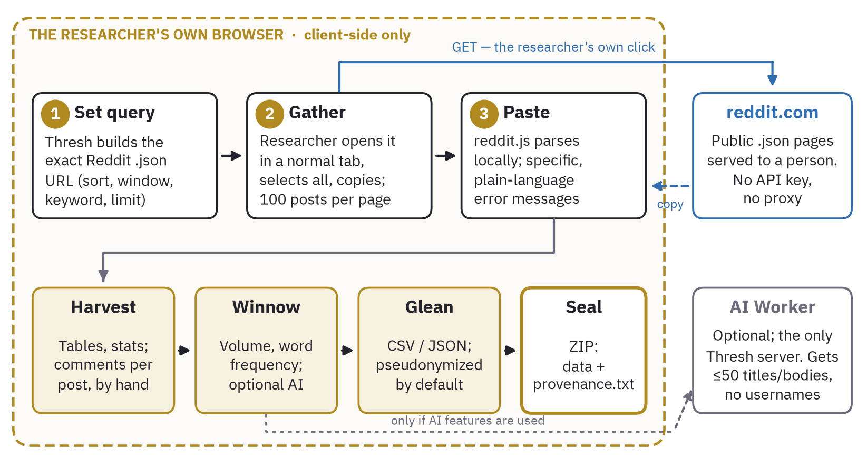
Figure 1. The Thresh v2 data path. The only request to Reddit is the researcher’s own click (blue); parsing, analysis, and export occur inside the browser (dashed boundary). The optional AI Worker is the only Thresh-operated server; it receives at most 50 post titles and bodies—never usernames—and only when AI features are used.
Three consequences follow. There is nothing to rate-limit, because Thresh makes no automated requests; the interface instead asks users to browse courteously. Collection is a desktop activity, stated as such in the interface. And the procedure is transparent in a way automated pipelines are not: the researcher sees every request leave and every byte arrive, and a reviewer can repeat any page of the collection by opening the recorded URL. Thresh uses no IP rotation, header spoofing, or other evasion; a person reading public pages at human pace is the entire mechanism.

3.3 The provenance seal
Each export is a ZIP archive containing the data (CSV with a UTF-8 byte-order mark for spreadsheet compatibility, or JSON) and provenance.txt. Table 2 lists its fields with the worked example’s values; the record is written to be pasted into a methods section.
Table 2. Fields of the provenance record, with values from the worked example’s export.
Section | Fields | Worked-example value
Tool | Name, version, collection method | Thresh 1.0.0 (collected before v2); public JSON endpoints, no authentication
Parameters | Subreddit(s), sort, time filter, max posts requested, keyword, comments | r/politics; top; month; 500; “Iran”; yes
Results | Posts and comments collected; collection time (UTC) | 100 posts; 4,956 comments; 2026-03-20 20:48 UTC
Export | Format; authors anonymized; export time (UTC) | CSV; yes; 2026-03-20 20:54 UTC
Source | Endpoint template; access method; intermediaries | reddit.com/r/{subreddit}/{sort}.json; public JSON; v1 relay (v2: none)
Limitations | Page ceiling, point-in-time scores, exclusions, depth | ~100 posts per request; snapshot; comments to depth 2
Ethics | Re-identification, IRB, platform terms | Standard reminders and link to Reddit’s terms

3.4 Analysis, AI assistance, and privacy
Harvest provides sortable tables, search, and summary statistics; Winnow provides post volume over time and word frequencies computed in the browser. Optional AI features (themes, sentiment, summaries, extracted questions, and a draft research report exported as .docx) route a sample of at most 50 post titles and bodies, without usernames, through a Cloudflare Worker to Anthropic’s Claude; outputs are labelled as AI-generated. We regard these outputs as hypothesis-generating aids, not measurements, and the worked example below uses none of them. Thresh collects no analytics or telemetry.

3.5 Verification
A harness (analysis/verify_tool.js) loads Thresh’s production modules into a Node.js sandbox, with no network access, and checks URL construction, parsing of synthetic fixtures (nested replies, “more” stubs, each error class), CSV quoting, and pseudonymization. All 12 checks pass. Critically for this paper, the v2 paste parser and exporter emit exactly the column set, in the same order, as the v1-collected exemplar (15 post fields; 9 comment fields), so the exemplar is analytically interchangeable with a v2 harvest.

4 A study design for contested discourse
Thresh was put to work on a question with every difficulty described in Section 2: how different Reddit communities framed the 2026 war with Iran. A methodological memorandum prepared for that project set four commitments, which we adopt as general guidance. First, ask only what Reddit can answer—framing, change, comparison, propagation—never population attitudes. Second, treat influence operations as an object of study rather than a confound; detection of strategic communication may be the primary contribution. Third, prefer the network of communities to the single community as the unit of analysis. Fourth, audit each community’s governance—rules, posting restrictions, flair, moderator transparency—before collection, and preserve the audit as a research artifact.
Table 3 condenses the resulting 18-community sampling frame. Tiers separate the core comparative set from r/worldnews, which is analyzed separately as a site of narrative amplification and a test case for coordination detection; from two diaspora anchors whose inclusion is conditional on the governance audit; and from a reserve set drawn on for specific questions. Characterizations are hypotheses for the audit, not established facts. Supplement S1 gives, for every community, the exact Thresh URLs for the first and subsequent pages, generated by executing Thresh’s own URL builder; a governance-audit template is provided with the data.
Table 3. Pre-specified sampling frame for comparative research on Reddit discourse about the 2026 Iran war (condensed; full frame with Thresh URLs in Supplement S1).
Tier | Community | Register and analytic role | Governance hypothesis / principal caveat
Core comparative set
C1 | r/MiddleEast | Regional discourse; broad regional framing | Moderation unverified; self-selected regional audience
C2 | r/geopolitics | Analytical register; high signal-to-noise | Quality rules likely; low volume
C3 | r/politics | U.S. left-leaning baseline (worked example) | Civility moderation; what appears is the moderated subset
C4 | r/Libertarian | War-powers and constitutional framing | Ideologically specific; rules unverified
C5 | r/CredibleDefense | Military and strategic analysis | Strict sourcing norms; heavily curated
Special case and conditional anchors
S1 | r/worldnews | Narrative amplification; coordination test case | Documented 2018 Iranian operation target; analyze separately
A1–A2 | r/iran, r/iranian | Diaspora and inside-Iran voices | Political posting may be reputation-gated; include only after audit
Reserve and excluded
R1–R9 | r/exmuslim, r/persianculture, r/tehran, r/arabs, r/Conservative, r/AskMiddleEast, r/war, r/IsraelPalestine, r/syriancivilwar | Deliberately partial perspectives, counterparts, and comparison cases | e.g., r/Conservative may gate comments to flaired users (not symmetric with r/politics); r/IsraelPalestine heavily brigaded
X1 | r/iranian_diaspora | Proposed | No evidence of an active community; dropped unless confirmed

The memorandum’s watch-list of signals—user overlap, account age, posting-time rhythm, cross-language content, synchronized sentiment shifts—must be matched against what a Thresh export actually contains. Table 4 does so and reports the worked example’s result for each measurable signal. Account age is the notable gap: listings do not carry it, and obtaining it would require one additional request per account, a per-person lookup we judged inconsistent with the instrument’s privacy posture.
Table 4. From watch-list to measurement: which coordination and framing signals a Thresh export supports, and what the worked example found.
Signal | In a Thresh export? | Operationalization | Worked example (r/politics)
User overlap | Yes (within and across exports) | Deterministic pseudonyms; threads or collections per account; Jaccard overlap | 526 of 3,803 commenters (13.8%) in ≥2 threads; max 19
Account age | No | Requires per-account lookups; out of scope by design | Not measured
Posting-time rhythm | Yes | Hour-of-day distribution; Rayleigh test | Peak 11:00, trough 04:00 ET; 8.8% overnight
Cross-language content | Yes | Script detection (Arabic/Persian, Hebrew, Cyrillic, CJK); Spanish function-word test | 0 Arabic/Persian-script, 0 Spanish-dominant comments
Synchronized bursts | Partial | Verbatim duplicate texts (≥40 characters) across accounts and threads | 4 duplicate groups, 2 multi-account; organic quotation
Sentiment time series | Yes | Daily mean VADER with bootstrap intervals | Mean −0.18; daily range −0.25 to −0.09; no trend
Governance footprint | Yes | Bot notices, removed/deleted content, moderator flair | Bot notice first in 100% of threads; 1.9% removed or deleted

5 Worked example: r/politics and Iran, February–March 2026

5.1 Data
On 28 February 2026 the United States and Israel began strikes on Iran (House of Commons Library, 2026; Congressional Research Service, 2026). On 20 March 2026, three weeks into the war, a Thresh export was taken of r/politics with the keyword “Iran”, sort “top”, and time window “month”. The export contains 100 posts (of 500 requested; Reddit’s search endpoint returned one page) and 4,956 comments. Posts span 2026-02-21 to 2026-03-20; every title contains the keyword and every post is a link to an external article. The export predates v2: it was collected with Thresh 1.0.0 through the since-retired relay, which captured the first 50 comments of each thread to depth 2. Because the verification harness establishes schema identity, the export is analyzed exactly as a v2 harvest would be. Files are distributed with SHA-256 checksums.

5.2 Measures
Bot notices were identified by the AutoModerator signature and, independently, by recomputing Thresh’s pseudonym for the username “AutoModerator”; both methods identify the same 100 comments. Comments whose body was “[removed]” or “[deleted]”, and bot notices, were excluded from text measures, leaving 4,764 analyzable comments. Diurnal structure was assessed in U.S. Eastern time with a Rayleigh test. Participation concentration was summarized with the Gini coefficient over comments per pseudonymous account. Framing used a transparent dictionary of 11 frames (Supplement S3), matched case-insensitively at word boundaries; frames index topic, not stance, and a comment may carry several. Sentiment used VADER (Hutto & Gilbert, 2014), with daily means reported for days with at least 30 comments and 95% percentile-bootstrap intervals (2,000 resamples, fixed seed). Proportions carry Wilson intervals. No verbatim user comment is reproduced in this paper or its outputs.

5.3 Results
The shape of the sample. Provenance and data agreed exactly: 100 posts and 4,956 comments claimed and observed, with no duplicate identifiers and no orphaned comments. The export nonetheless holds a small, specific slice of the conversation. Reddit reported 86,564 comments on these posts; the export contains 5.7% of them (median per thread 8.2%, interquartile range 4.5%–14.2%), because capture stopped near 50 comments per thread regardless of thread size (Figure 3B). Comments are split between top-level replies (2,540) and first-level replies (2,416). Posts had been live for a median of 14 days at collection, so scores are late-stage snapshots. These are properties of the ranking and the collector, not of r/politics, and they bound every result that follows.
Governance footprint. AutoModerator wrote the first comment in 100% of threads (100 comments, 2.0% of the export), in each case restating the civility rules and the paywall-flair policy. Every post carried moderator flair classifying the linked article’s paywall status (No Paywall 52, Possible Paywall 43, Paywall 5), and 5 were flagged “Site Altered Headline.” 37 comments were visibly removed and 55 deleted, with 121 from since-deleted accounts; removals invisible in the listing cannot be counted. Agreement was near-unanimous: mean upvote ratio 0.967, with 86% of posts at or above 0.95 and none below 0.91. Post score and comment volume were strongly correlated (Spearman ρ = 0.62, p < 0.001).
Temporal structure. A single post preceded the war; the busiest day was 28 February, the day strikes began (12 posts), and 26 posts (26%) date from its first 72 hours (Figure 2A). Commenting followed a pronounced North American day (Figure 2B): the peak hour was 11:00 and the trough 04:00 Eastern, only 8.8% of comments fell between 01:00 and 06:59 against 25% expected under uniformity, and the distribution departed strongly from uniform (Rayleigh R̄ = 0.38, z = 674.4, p < 0.001).
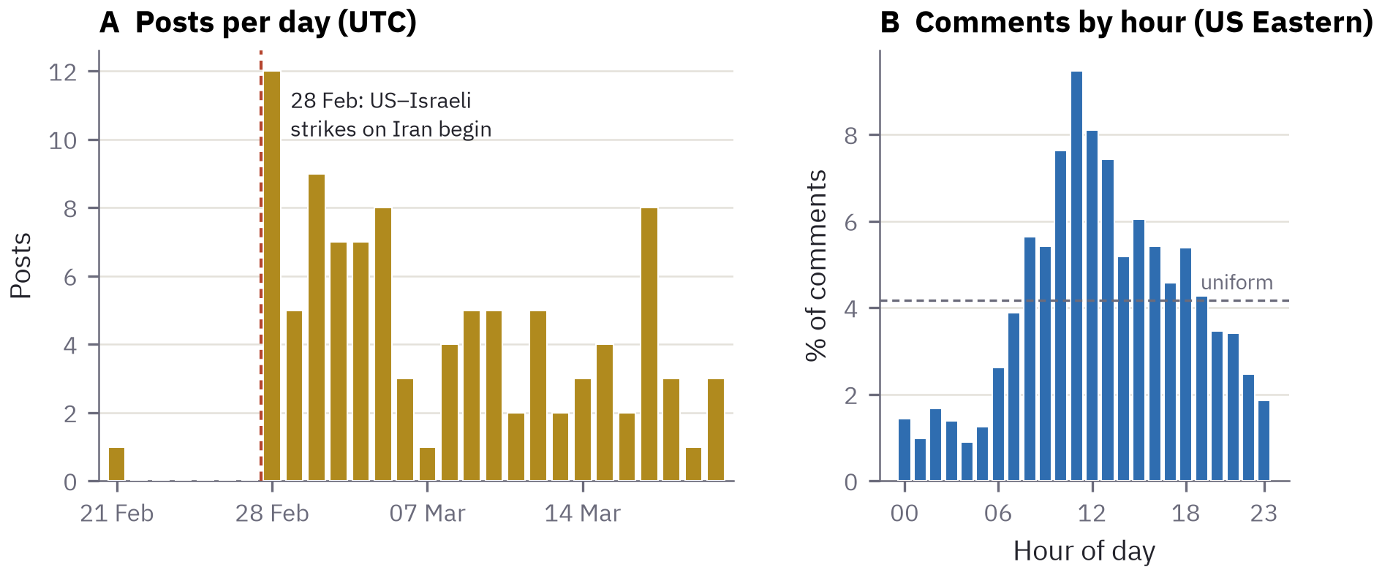
Figure 2. Temporal structure of the exemplar. (A) Posts per day; the dashed line marks the start of U.S.–Israeli strikes on 28 February 2026. (B) Share of analyzable comments by hour of day in U.S. Eastern time; the dashed line is the uniform expectation (4.2% per hour).
Source ecology. The 100 posts linked to 39 outlets, but two dominated: newrepublic.com (21% of posts) and commondreams.org (11%); the five most-linked outlets supplied 52% of posts, and the effective number of outlets was 12.5 (Herfindahl 0.080; Figure 3A). Among the top-ranked posts, then, the war reached r/politics largely through a handful of progressive and opinion-forward outlets.
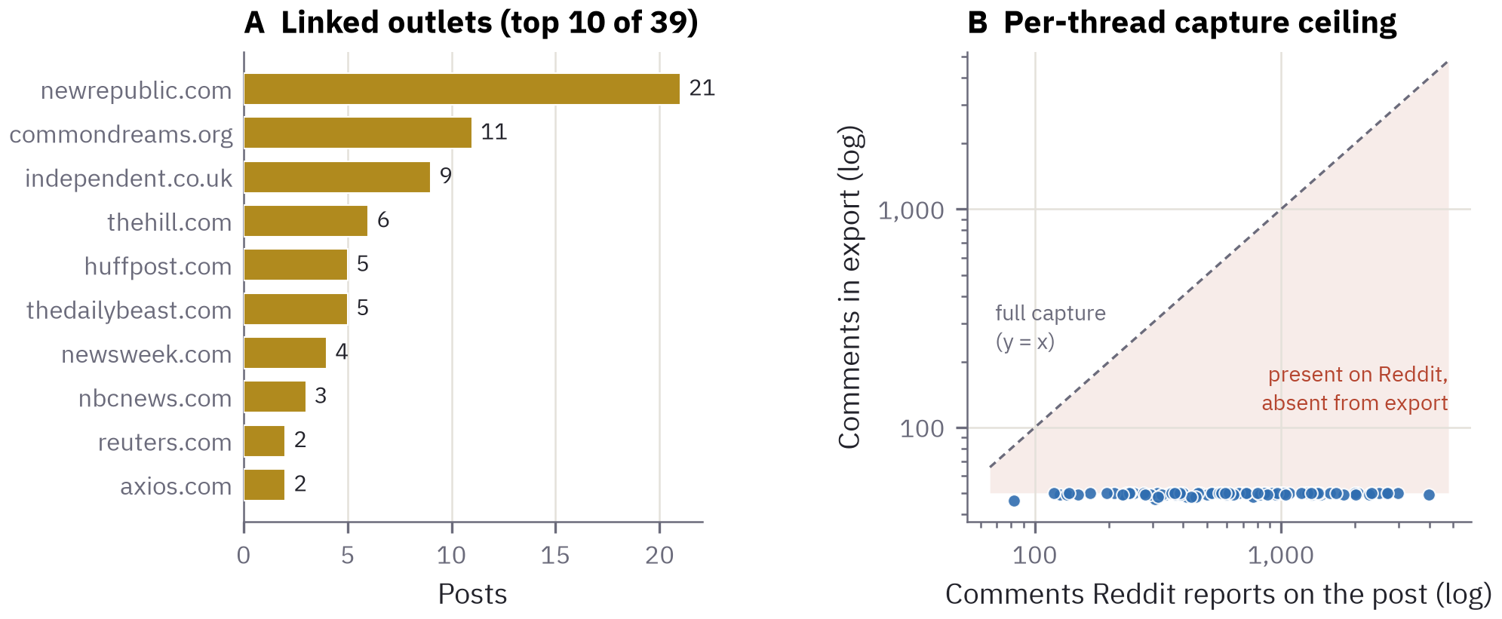
Figure 3. Sources and capture. (A) Outlets linked by the 100 posts (top 10 of 39; two hostnames of The Independent are merged). (B) Comments in the export against comments Reddit reported for each thread, on log scales. Capture stopped near 50 per thread, so the shaded region—the unobserved conversation—grows with thread size.
Participation. 3,803 pseudonymous accounts wrote the 4,735 attributable comments. Concentration was low (Gini 0.18; the most active 10% of accounts wrote 24% of comments), and 85% of accounts appear exactly once (Figure 4A). Still, 526 accounts (13.8%) commented in two or more threads, 25 in five or more, and one in 19 (Figure 4B). 69 accounts submitted the 100 posts; 18 submitted more than one (maximum 4). Because only the top of each thread was captured, low concentration here describes who reaches the visible top of a thread, not overall activity.
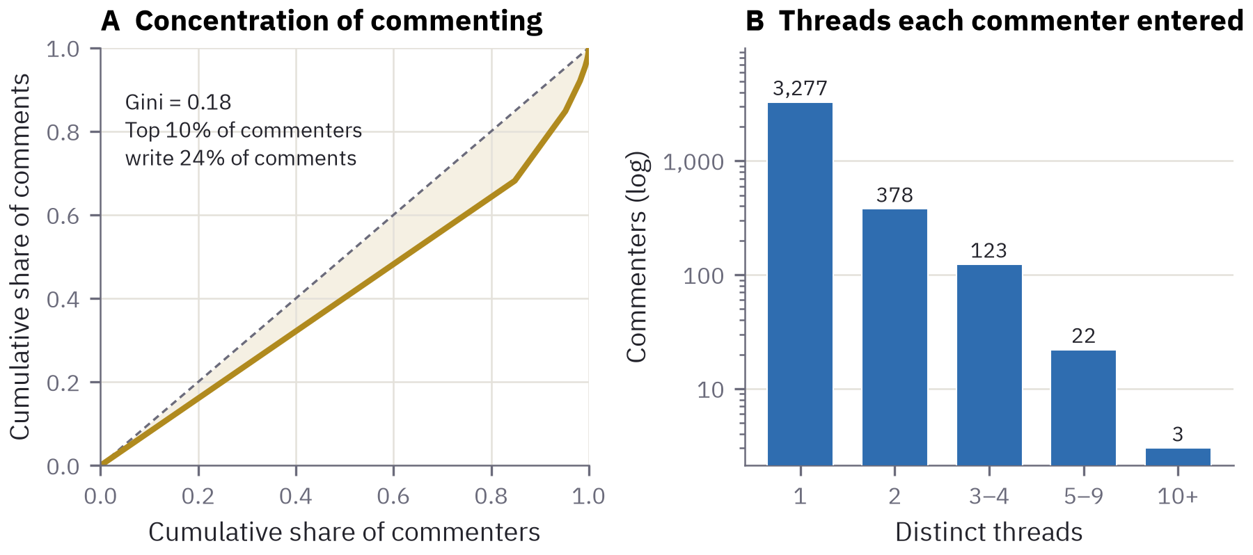
Figure 4. Participation structure. (A) Lorenz curve of comments per pseudonymous account; the dashed diagonal is perfect equality. (B) Number of distinct threads each account commented in (log scale). Bot notices, deleted accounts, and removed or deleted comments are excluded.
Framing and sentiment. 47% of analyzable comments matched at least one frame (Figure 5A). Partisan and leadership references dominated (26.9%), roughly three times the most common war-substantive frame, military operations (9.2%), followed by Israel (6.6%), casualties and humanitarian consequences (5.1%), and war powers and Congress (4.4%). Explicit discussion of propaganda, bots, or disinformation was rare (0.8%). Sentiment was negative overall (mean −0.18, median −0.11; 52% of comments negative, 28% positive), most negative in casualty-framed comments (mean −0.53) and least negative in diplomacy-framed comments (−0.03). Daily means ranged from −0.25 to −0.09 with no monotonic trend (Spearman ρ = −0.22, p = 0.33; Figure 5B), and sentiment was essentially unrelated to comment score (ρ = −0.031).
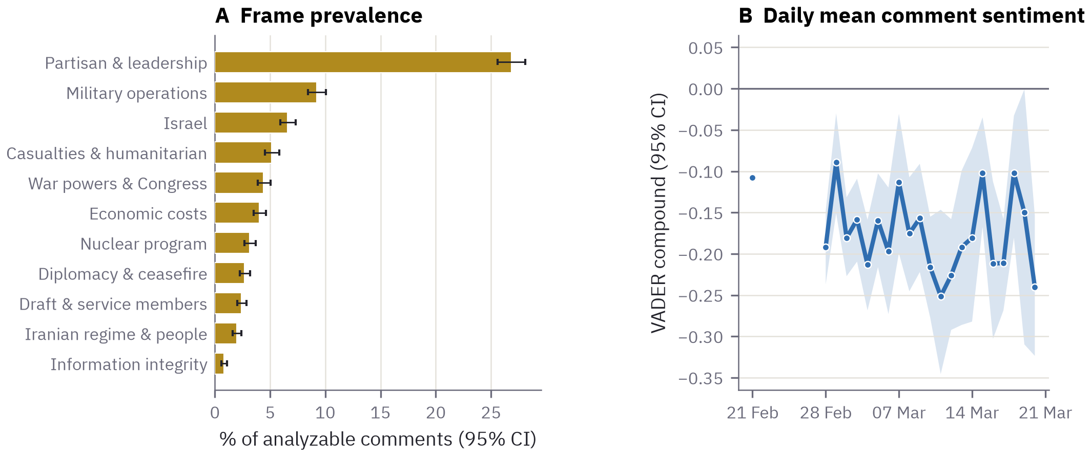
Figure 5. Framing and sentiment. (A) Share of analyzable comments matching each dictionary frame, with Wilson 95% intervals; frames are not mutually exclusive. (B) Daily mean VADER compound score with 95% bootstrap intervals, for days with at least 30 comments; the isolated point is the single pre-war thread.
Coordination and language signals. No comment contained Arabic or Persian script, Hebrew, or Cyrillic; one contained CJK characters; none was Spanish-dominant. Among 4,029 comments of at least 40 characters, 4 texts appeared more than once (at most 3 copies). Two recurred across different accounts; on inspection both reproduce a public figure’s widely circulated 2011–2012 statements predicting that a president would start a war with Iran—quotation as rebuttal, a familiar organic pattern, rather than coordination. In the visible top of the r/politics conversation, the watch-list signals were quiet.

6 Discussion

6.1 What the exemplar shows about the instrument
The most important results above are not about Iran. They are the facts a careless reading would miss and a provenance-first instrument makes difficult to miss: that the export held about one comment in eighteen; that its selection followed Reddit’s ranking of posts and of comments within threads; that a moderator bot opened every thread; that near-unanimous upvote ratios describe a consensus space; and that two outlets set much of the agenda. Each is recoverable from the provenance record and the export alone, by anyone, without access to the collector’s machine. That is the practical meaning of provenance: the shape of the sample travels with the sample.

6.2 A bounded substantive reading
Within those bounds, the top of the r/politics conversation about the war’s first three weeks was principally a conversation about domestic political leadership: partisan and leadership references outnumbered every war-substantive frame, discussion of war powers and Congress was present but secondary, and the mood was steadily negative. This is what the memorandum anticipated for a left-leaning, civility-moderated U.S. baseline—and it is precisely why a single community cannot carry comparative claims. Whether this domestic register is distinctive to r/politics, or shared by r/Libertarian’s constitutional framing and r/CredibleDefense’s operational analysis, is a question for the full frame, collected under the same parameters and audited for governance first.

6.3 Limitations
Ranking and truncation. “Top” listings and comment ordering select for resonance; the exemplar is the most-upvoted slice, not a random sample. Point in time. Scores, comment counts, and removals change after collection. Collector version. The exemplar was collected with v1, which truncated threads at about 50 comments; v2 captures whatever the pasted page contains. One community. The worked example demonstrates the pipeline, not the comparative design. Instruments. Dictionary frames index topic, not stance; VADER is not tuned to political sarcasm. No account metadata. Account age and history are unavailable by design. Scale. Manual collection is bounded by human labor (100 posts per paste; at most 500 per collection) and is impractical on mobile devices. Pseudonyms. The harness confirmed that Thresh’s default pseudonyms are a 32-bit, unsalted string hash: deterministic, which usefully links the same account across exports, but reversible by anyone who hashes candidate usernames—recomputing the hash of “AutoModerator” recovers its pseudonym exactly (user_wzj0fq)—and subject to collisions in large datasets (by the birthday bound, about 90% probability of at least one collision among 100,000 distinct usernames). Exports should therefore be treated as pseudonymized, not anonymized. Provenance wording. The audit also found that the provenance template stated that deleted and removed items are excluded, whereas Reddit’s “[deleted]” and “[removed]” placeholders are retained (Supplement S4); the template is corrected in the release accompanying this paper.

6.4 Ethics
Public availability does not settle the ethics of use (Zimmer, 2010), and users often do not expect research use of their posts (Fiesler & Proferes, 2018). Verbatim quotation can re-identify authors through search (Ayers et al., 2018). This study used only public posts, involved no interaction with users, analyzed pseudonymized exports, reports only aggregates and news headlines, and reproduces no user comment. The pseudonym weakness above strengthens the case for treating Thresh exports as sensitive research data and for institutional review where required.

6.5 Roadmap
Four changes follow directly from this paper: (1) salted, per-project pseudonyms with an explicit option to preserve cross-collection linkage; (2) provenance that records every pasted URL and a SHA-256 hash of each raw paste, so a collection can be verified byte for byte; (3) an in-tool governance-audit capture that archives sidebar rules with the export; and (4) collection of the full sampling frame in Table 3 under the parameters of Supplement S1, with the cross-collection overlap analysis the pipeline already supports.

7 Conclusion
Reddit’s closure to automated access removed the easy path to its data. Thresh takes the remaining honest one: a person, reading public pages as any person may, carrying what they gather to a place where it can be separated, weighed, and sealed. That path is slower and smaller than a pipeline. In exchange it is legitimate, transparent to reviewers, and open to anyone with a browser and a question. For the bounded, question-driven studies that make up much of public-interest research, that is the better trade—so long as the researcher treats ranking, truncation, and governance as part of what was harvested.

Data and code availability
Everything needed to reproduce this paper is in the preprint/ directory of the Thresh repository: the exemplar export with SHA-256 checksums; the sampling frame, governance-audit template, and frame dictionary; the verification harness; the analysis pipeline, which regenerates every figure, table, and number (results/stats.json) from the data in seconds; and the script that typesets this manuscript from those results. One command (reproduce.sh) runs the full chain. Thresh is MIT-licensed (Thomas, 2026); this manuscript is released under CC BY 4.0.
Ethics statement
Analysis of publicly available, pseudonymized Reddit content without interaction with users. No verbatim user comments are reproduced. Researchers extending this work should consult their institution’s review board.
Author contributions, competing interests, and funding
J.E.T. conceived and built The Threshing Floor, designed the study, conducted the analysis, and wrote the manuscript. The author is the developer of the software described and receives no income from it. The work received no dedicated funding.
Use of AI tools
Claude (Anthropic) assisted with drafting the manuscript and writing the analysis and verification code. The author directed the work, reviewed all code and text, and takes responsibility for the content. No AI-generated analysis of the data is reported.
Acknowledgements
The author thanks the IranWar.ai project collaborators whose methodological memorandum shaped the study design in Section 4.

References
Ayers, J. W., Caputi, T. L., Nebeker, C., & Dredze, M. (2018). Don’t quote me: Reverse identification of research participants in social media studies. npj Digital Medicine, 1, 30. https://doi.org/10.1038/s41746-018-0036-2
Baumgartner, J., Zannettou, S., Keegan, B., Squire, M., & Blackburn, J. (2020). The Pushshift Reddit dataset. Proceedings of the International AAAI Conference on Web and Social Media, 14, 830–839.
Bruns, A. (2019). After the ‘APIcalypse’: Social media platforms and their fight against critical scholarly research. Information, Communication & Society, 22(11), 1544–1566. https://doi.org/10.1080/1369118X.2019.1637447
Chandrasekharan, E., Samory, M., Jhaver, S., Charvat, H., Bruckman, A., Lampe, C., Eisenstein, J., & Gilbert, E. (2018). The Internet’s hidden rules: An empirical study of Reddit norm violations at micro, meso, and macro scales. Proceedings of the ACM on Human-Computer Interaction, 2(CSCW), Article 32.
Collins, B. (2018, August 24). Volunteers found Iran’s propaganda effort on Reddit — but their warnings were ignored. NBC News. https://www.nbcnews.com/tech/tech-news/volunteers-found-iran-s-propaganda-effort-reddit-their-warnings-were-n903486
Congressional Research Service. (2026, March 26). U.S. conflict with Iran (CRS Report R48887). https://www.congress.gov/crs_external_products/R/PDF/R48887/R48887.1.pdf
Cyabra. (2026, March 9). The AI propaganda war: Iran’s digital battlefield. https://www.inss.org.il/he/wp-content/uploads/sites/2/2026/03/Cyabra-Research-Iran-AI-Driven-Information-Warfare-Epic-Fury.pdf
Datta, S., & Adar, E. (2019). Extracting inter-community conflicts in Reddit. Proceedings of the International AAAI Conference on Web and Social Media, 13, 146–157.
Fiesler, C., & Proferes, N. (2018). “Participant” perceptions of Twitter research ethics. Social Media + Society, 4(1). https://doi.org/10.1177/2056305118763366
FireEye. (2018, August 21). Suspected Iranian influence operation leverages network of inauthentic news sites & social media targeting audiences in U.S., UK, Latin America, Middle East. https://cloud.google.com/blog/topics/threat-intelligence/suspected-iranian-influence-operation
Freelon, D. (2018). Computational research in the post-API age. Political Communication, 35(4), 665–668. https://doi.org/10.1080/10584609.2018.1477506
Gottfried, J., & Park, E. (2025, November 20). Americans’ social media use 2025. Pew Research Center. https://www.pewresearch.org/internet/2025/11/20/americans-social-media-use-2025/
House of Commons Library. (2026). Israel/US–Iran conflict 2026: Background and UK response (Research Briefing CBP-10521). https://commonslibrary.parliament.uk/research-briefings/cbp-10521/
Huang, J. T., Choi, J., & Wan, Y. (2024). Politically biased moderation drives echo chamber formation: An analysis of user-driven content removals on Reddit [Working paper]. SSRN. https://papers.ssrn.com/sol3/papers.cfm?abstract_id=4990476
Hutto, C. J., & Gilbert, E. (2014). VADER: A parsimonious rule-based model for sentiment analysis of social media text. Proceedings of the International AAAI Conference on Web and Social Media, 8(1), 216–225.
Isaac, M. (2023, April 18). Reddit wants to get paid for helping to teach big A.I. systems. The New York Times.
Jhaver, S., Birman, I., Gilbert, E., & Bruckman, A. (2019). Human-machine collaboration for content regulation: The case of Reddit Automoderator. ACM Transactions on Computer-Human Interaction, 26(5), Article 31.
Kumar, S., Hamilton, W. L., Leskovec, J., & Jurafsky, D. (2018). Community interaction and conflict on the web. Proceedings of the 2018 World Wide Web Conference, 933–943.
Medvedev, A. N., Lambiotte, R., & Delvenne, J.-C. (2019). The anatomy of Reddit: An overview of academic research. In Dynamics on and of Complex Networks III (pp. 183–204). Springer.
Murray, E., & Linvill, D. (2026, March 11). From Texas to Tehran: A multilingual, IRGC-affiliated influence operation on X, Instagram, and Bluesky (Media Forensics Hub Report No. 10). Clemson University. https://open.clemson.edu/mfh_reports/10/
Perez, S. (2024, May 9). Reddit locks down its public data in new content policy, says use now requires a contract. TechCrunch. https://techcrunch.com/2024/05/09/reddit-locks-down-its-public-data-in-new-content-policy-says-use-now-requires-a-contract
Proferes, N., Jones, N., Gilbert, S., Fiesler, C., & Zimmer, M. (2021). Studying Reddit: A systematic overview of disciplines, approaches, methods, and ethics. Social Media + Society, 7(2). https://doi.org/10.1177/20563051211019004
Reddit. (2026). Reddit for Researchers program. Reddit Help. Retrieved September 29, 2026, from https://support.reddithelp.com/hc/en-us/articles/49381918834964-Reddit-for-Researchers-Program
Thomas, J. E. (2026). The Threshing Floor (Version 2.0.0) [Computer software]. https://github.com/jethomasphd/The_Threshing_Floor
Waller, I., & Anderson, A. (2021). Quantifying social organization and political polarization in online platforms. Nature, 600, 264–268. https://doi.org/10.1038/s41586-021-04167-x
Zannettou, S., Caulfield, T., De Cristofaro, E., Sirivianos, M., Stringhini, G., & Blackburn, J. (2019). Disinformation warfare: Understanding state-sponsored trolls on Twitter and their influence on the Web. Companion Proceedings of the 2019 World Wide Web Conference, 218–226.
Zimmer, M. (2010). “But the data is already public”: On the ethics of research in Facebook. Ethics and Information Technology, 12(4), 313–325.
Supplementary materials
S1 Sampling frame with Thresh-generated URLs for every community (data/protocol/sampling_frame.csv) and the collection protocol.
S2 Tool verification report: all harness checks, the error messages for each malformed-paste class, and pseudonym properties (results/tool_verification.json).
S3 Frame dictionary (data/protocol/frame_lexicon.json), per-frame statistics, and top terms.
S4 Complete statistics (results/stats.json) and all figure source tables (results/tables/).
Supplementary document: Thomas_2026_The_Threshing_Floor_supplement.docx

