Killed Fast, Left Fragile, Counted Short: Front-Loaded Mortality, Health-System Resilience Erosion, and the Uncounted Indirect Toll in the First 170 Days of the 2026 US–Iran War
Working paper — Paper 2 (v2, student-findings edition) of the IranWar.ai research-agenda series
First author: Eugene Osei Mensah
Prepared from the IranWar.ai Event-Level Research Dataset, v1.2 (Days 1–170; 2026-02-28 to 2026-08-16)
All results reproduce from ResearchData/Paper2/v2/ (bash run_all.sh; seeded, ~30 seconds)

About this version
The parent paper (../manuscript/paper2_healthcare_collapse.md) reports eight findings across the full behavioral-statistics toolkit. This version narrows to three — the parent paper's Findings 1, 5, and 6 — because they form a single argument that reads clearly from the clinical side of the health system, which is where its first author works:
> The war killed fast and early; the health system gradually lost its ability > to absorb further shocks; and the deaths we can count may only represent part > of the real human toll.
Nothing in the analysis is re-estimated: the panel, the audited health-system register, the facility-damage curve, the moderation model, and the projection arithmetic are the parent paper's, run against the same frozen v1.2 release, so every statistic below matches the parent exactly. What is new here is the framing — the three findings assembled into one causal-sounding story about how a health system fails under sustained air war, and read the way a nurse on a ward reads it. (One number is corrected against the regenerated tables: the effect size for the per-strike-lethality collapse is Hedges g = 1.33, not the 2.16 printed in an earlier draft of the parent; the underlying 95% decline and Mann–Whitney U = 623 are unchanged.)

Abstract
Background. Wars kill twice — once by blast, and again, more quietly and usually in far greater numbers, through the systems people survive on: healthcare, water, power, supply chains. Across modern conflicts, indirect deaths have run three to fifteen times direct battle deaths. This paper follows the machinery of that second killing through the first 170 days of the 2026 US–Iran war, the first sustained interstate air war tracked openly at daily, event-level resolution.
Methods. Retrospective ecological time-series study of 170 conflict-days. From 4,612 event records we built a daily panel of strike tempo, an audited 21-event health-system insult register, a benchmark-anchored facility-damage curve (31 → 307 → 309 damaged facilities), and daily estimated deaths by faction. Three standard tools answer three questions. Means comparison (ANOVA family, effect sizes, per-strike lethality): how was mortality distributed in time? Moderation (strike × degradation interaction with Newey–West standard errors, simple slopes, Johnson–Neyman): did the cost of a strike change as the system was damaged? Scenario projection (literature indirect:direct ratios applied to the documented toll): how large is the uncounted tail? All computation is seeded and reproduces in about half a minute.
Results. Mortality was front-loaded: the 40 days of Major Combat (23.5% of the war) carried 79.6% of all documented deaths (phase η² = 0.76; combat vs. ceasefire Hedges g = 3.4); the cumulative toll crossed half by Day 21. Yet as facility damage accumulated, the marginal cost of each strike rose: the slope of civilian deaths on strike tempo steepened from 0.18 (not significant) at low damage, to 0.63 at mean damage, to 1.07 at high damage (interaction p = .006) — a roughly sixfold steepening consistent with resilience erosion, and specific to the damage curve rather than a generic late-war shift (phase-interaction p = .89). Finally, the documented direct toll (Iran 3,166–3,636; Lebanon 2,993–4,308) is a floor: at the literature-average 4:1 indirect:direct ratio it implies roughly 15,800–18,200 total deaths in Iran and 15,000–21,500 in Lebanon.
Conclusions. The war did most of its visible killing in its first six weeks, against an unprepared population and an intact health system. The system then spent the remaining months absorbing the consequences of that opening damage, with less capacity to keep each new strike's victims alive. And the counted dead are only the part of the toll that reaches a tally — the indirect deaths, which this design cannot observe, are where conflict epidemiology expects most of the dying to be. Tolls from wars like this should be published as floors, with the tail made explicit.
Keywords: armed conflict, civilian mortality, attacks on healthcare, health-system resilience, indirect mortality, WASH, front-loading, OSINT event data, US–Iran

1. Introduction
Wars kill twice. The first killing is visible: the strike, the collapsed building, the number in the evening briefing. The second is quiet and usually much larger — the surgery postponed because the operating theatre is damaged, the delivery that goes wrong two hours from the nearest working theatre, the dialysis patient who misses three sessions in a row, the cholera that follows a destroyed water intake. Across late-20th- and 21st-century conflicts, this indirect mortality has repeatedly been found to exceed direct battle deaths by factors of three to fifteen (Guha-Sapir & van Panhuis 2004; Geneva Declaration Secretariat 2008; Checchi & Roberts 2008). The mechanism is not mysterious: people survive on systems, and air campaigns degrade systems efficiently. Health-system resilience theory (Kruk et al. 2015, 2017) names the capacities a system needs to absorb a shock and keep functioning; sustained bombardment attacks exactly those capacities.
The 2026 US–Iran war is an unusual chance to watch that process unfold. It is the first sustained interstate air war of its scale tracked openly, daily, and at event-level resolution from its opening hours (Thomas et al. 2026). The dataset records, alongside strikes and casualties, a granular trail of harm to the machinery of survival: a Tehran hospital's IVF department destroyed by blast on Day 3; the ICRC's Day-11 assessment that 30–40% of Iranian power generation was degraded; a pharmaceutical factory strike that killed ten nurses on Day 33; the WHO's Day-39 count of 307 damaged health facilities; 152 verified attacks on healthcare in Lebanon by Day 69; the destruction of the Bonji desalination intake on Day 140, cutting drinking water to some 10,000 people across 20 villages; and, by Day 170, an Iranian Red Crescent inventory of 309 damaged health facilities, 42 damaged ambulances, and 7 evacuated hospitals.
This paper reads that record as one argument in three movements, each with a single, standard statistical tool:
1. The war killed fast and early. Most of the documented dying happened in the first six weeks, before the health system could adapt — a claim about the distribution of mortality in time (means comparison). 2. The system then lost its ability to absorb further shocks. As facility damage accumulated, each additional strike was associated with more deaths, not fewer — a claim about how the cost of a strike changed as the system degraded (moderation). 3. The deaths we can count are only a floor. Everything the first two movements measure is direct, reported death; the literature is unanimous that the indirect tail — the ward-side dying that never enters a strike-day tally — is several times larger (scenario projection).
The three are not independent observations that happen to sit in the same paper. They are the same story told from three distances. The front-loading (movement 1) is what placed an enormous, sudden burden on the health system before it had any opportunity to adapt. The resilience erosion (movement 2) is what that system did over the following months — gradually running out of the slack that lets a hospital absorb a bad night. And the indirect floor (movement 3) is the toll of those two processes together, most of which never reaches a count. Read in that order, the projection in movement 3 stops looking like a theoretical estimate and starts looking like the expected consequence of the mechanism the first two movements document.
Two results from earlier in the series discipline the reading. The dataset's own methods paper argues that in this war's information environment, casualty figures are contested political facts, not clean measurements (Thomas et al. 2026, §6.4–6.5); we therefore treat every direct toll as an interval, never a point, and carry both internal accountings forward. And Paper 1 established that raw daily tempo is a poor proxy for lethality; we take that seriously by never resting the argument on tempo alone. What follows is deliberately built from the plainest tools in the behavioral-statistics kit — a means comparison, an interaction, and an arithmetic projection — because the point is not statistical sophistication but legibility: an argument a health ministry, a journalist, or a ward nurse can follow number by number and check line by line.

2. Data and methods
Source and unit. All analyses use the frozen v1.2 research release of the IranWar.ai Event-Level Research Dataset (4,612 event rows; Days 0–170; Thomas et al. 2026), pinned so the paper reproduces byte-for-byte. The unit of analysis is the conflict-day (N = 170; Day 1 = 2026-02-28). The four-phase structure follows Paper 1: Major Combat (Days 1–40), First Ceasefire (41–129), Resumption (130–152), and Diplomatic Pause (153–170).
Outcomes. Daily estimated deaths by faction come from the dataset's casualty file (170 days × 5 factions; daily, not cumulative): Iranian civilian (primary; 543 total), Iranian military (2,623), Lebanese all-category (2,993), US military (20), Israeli military (34). Cumulative dashboard snapshots (Iranian killed, Lebanese killed, children killed, displaced) provide reference series. The two internal accountings disagree — the summed daily series runs 14.8% (Iran) and 43.9% (Lebanon) below the terminal snapshots — and we carry both forward as bounds (Section 5).
Exposure and degradation. Strike tempo is the count of distinct strike-file locations active per day plus discrete timeline events. Health-system degradation is operationalized two ways. The Health-System Stress Index (HSSI) is the cumulative count of 21 audited, discretely reported insult events (facility attacks, workforce harm, WASH disruptions, supply and access insults), built by keyword screen and then read and corrected row by row, with the full audit trail (17 documented corrections) shipping in data/health_system_events.csv. Because surveillance benchmarks show true facility damage two orders of magnitude larger than 21 events, a second operationalization anchors a piecewise-linear facility-damage curve to institutional reports verified in the event stream: 31 hospitals damaged by Day 15 (Iran Health Ministry-linked), 307 health facilities by Day 39 (WHO), 309 by Day 170 (IRCS). Every degradation model runs on both curves; the facility-damage curve is the primary moderator and the coarse HSSI the sensitivity check.
The three tools. Means comparison (Finding 1): one-way ANOVA, Welch's ANOVA, and Kruskal–Wallis across the four phases, with Holm-corrected pairwise Welch t-tests, η²/ω², and Hedges' g; plus deaths-per-strike-location by phase (Mann–Whitney). Moderation (Finding 5): centered strike tempo interacted with each centered degradation curve, Y = Iranian civilian deaths, Newey–West (HAC, 7-day) standard errors because war days are serially dependent; probed by simple slopes at ±1 SD and Johnson–Neyman boundaries, with kinetic-days-only and phase-interaction sensitivity checks. Scenario projection (Finding 6): literature indirect:direct ratios (1:1 floor, 3:1, 4:1 average, 15:1 upper; Geneva Declaration Secretariat 2008) applied to both direct-toll bounds. All computation is seeded (SEED = 42) and reproduces from run_all.sh in about thirty seconds; α = .05 two-sided throughout. Full variable definitions are in docs/CODEBOOK_panel.md; every design decision is in docs/METHODS.md.

3. Finding 1 — The war killed fast and early
The distribution of mortality in time.
By the daily series' account, the war killed 6,213 people across the five tracked factions in 170 days — and 4,944 of them (79.6%) fell in the 40 days of Major Combat, which is 23.5% of the war's duration (Table 1, Figure 1). Mortality was not a smooth function of how long the war lasted. The cumulative toll crossed half of its 170-day total by Day 21 and 80% by Day 42; a temporal-concentration ratio of 0.64 (0 would be a perfectly even war, 1 would be every death on the first day) puts the front-loading in a single number. Iranian deaths averaged 78 per day during Major Combat and then fell to zero for the entire 89-day First Ceasefire; the Lebanon front kept absorbing about 13 deaths per day through that same ceasefire before the fronts inverted at the Resumption. The deadliest single day of the war was its first.
Table 1. Per-phase summary (daily means; totals in parentheses).
Phase | Days | Strikes/d | Iran civ/d (tot) | Iran mil (tot) | Lebanon/d (tot) | All killed
Major Combat | 1-40 | 7.02 | 13.08 (523) | (2,602) | 44.52 (1,781) | 4,944
First Ceasefire | 41-129 | 0.57 | 0.00 (0) | (3) | 13.48 (1,200) | 1,215
Resumption | 130-152 | 2.35 | 0.87 (20) | (18) | 0.04 (1) | 43
Diplomatic Pause | 153-170 | 0.00 | 0.00 (0) | (0) | 0.61 (11) | 11
Full war | 1-170 | 2.27 | 3.19 (543) | (2,623) | 17.61 (2,993) | 6,213

The phase differences are enormous by behavioral-science standards, not a close call dressed up with stars. For all-faction daily killed, F(3,166) = 172.3, p < .001, η² = 0.76 (ω² = 0.75) — phase alone explains three-quarters of the day-to-day variance in mortality; Welch's F and Kruskal–Wallis agree. Holm-corrected pairwise contrasts put Major Combat above every other phase at Hedges' g = 3.1–3.4 (all p < .001), a gulf several times what clinical trials are built to detect. And the yield of each strike collapsed across regimes: on strike days, Iranian deaths per distinct strike location averaged 15.4 during Major Combat and 0.7 at the Resumption — a 95% decline (Mann–Whitney U = 623, p < .0001, g = 1.33). The opening campaign, against an unprepared population and an intact urban target set, did almost all of the war's direct killing.
Why this matters for what follows. Front-loading is not only a fact about the fighting; it is a fact about the burden placed on the health system. The system met the single largest wave of casualties of the entire war in its first six weeks — before there was any opportunity to reinforce, disperse, resupply, or adapt. Everything the health system did for the remaining 130 days, it did while already absorbing the damage of that opening blow. That is the setup for Finding 5.
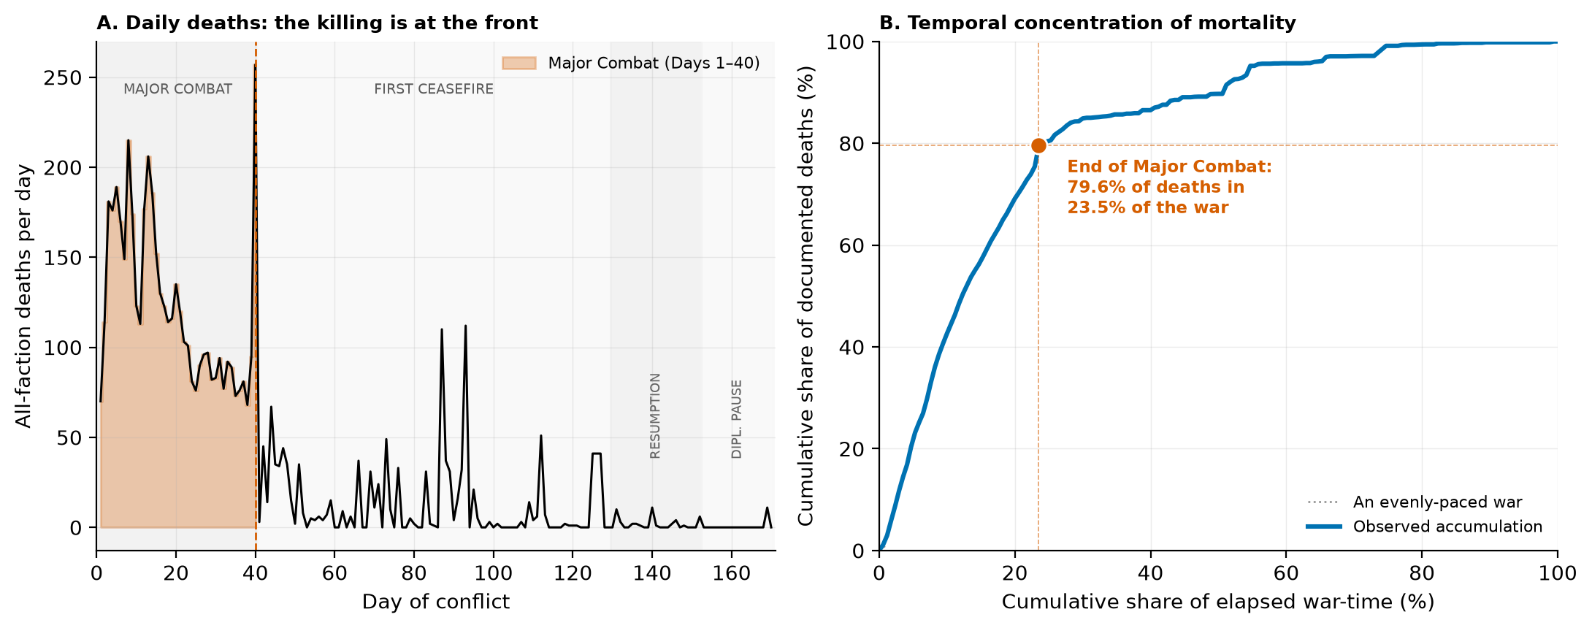
Figure 1. (A) Daily all-faction deaths across the four phases; Major Combat (shaded) carries the bulk. (B) The temporal concentration of mortality: 79.6% of documented deaths had accrued by the end of Major Combat — 23.5% of the war.

4. Finding 5 — The system lost its ability to absorb shocks
How the cost of a strike changed as the system degraded.
There are two ways to ask whether strikes got "more deadly" over the war, and they have opposite answers because they are different questions. The average yield per strike fell 95% (Finding 1) — early strikes caught an unprepared, densely settled population, and over time people sheltered, fled, and the intact high-value target set was depleted. But the clinically important question is marginal: holding the moment fixed, at a given level of accumulated damage, what did one more strike cost in lives? The resilience-erosion hypothesis (Kruk et al. 2015) predicts that answer should grow as the system degrades, because surviving a blast injury depends on intact trauma care — a functioning theatre, blood, power, staff — and each of those is exactly what sustained bombardment removes.
We test it with an interaction model: Iranian civilian deaths regressed on centered strike tempo, centered facility damage, and their product, with Newey–West standard errors. The interaction is positive and significant (b₃ = 0.0145, HAC p = .006). Read through simple slopes, the association between one more strike location and same-day civilian deaths steepens as damage accumulates (Table 2, Figure 2):
Table 2. Simple slope of Iranian civilian deaths on strike tempo at accumulated facility damage = mean ± 1 SD (full sample, HAC covariance).
Accumulated facility damage | Slope (deaths / strike location) | p
Low (−1 SD; early war) | 0.18 | 0.439 (n.s.)
Mean | 0.63 | 0.025 *
High (+1 SD; late war) | 1.07 | 0.006 **

The marginal cost of a strike roughly sextuples across the observed damage range, from a slope indistinguishable from zero when the system was intact to about one civilian death per additional strike location once it was heavily degraded; the Johnson–Neyman boundary indicates significance for all but the lowest-damage early days. This is the clinical intuition made quantitative: a functioning hospital can absorb one bad night, but after enough bad nights it cannot absorb much more. The same strike that a health system shrugs off on Day 10 can become catastrophic on Day 90, because the buffer is gone.
Two checks guard the reading. First, the coarse 21-event HSSI moderator points the same way but does not reach significance (interaction p = .32; slopes 0.45 → 0.82) — we report both operationalizations rather than selecting the favorable one, and the honest summary is "consistent, one specification significant." Second, and more important: is this just a generic late-war regime shift dressed as damage? A phase-interaction variant says no. Once the Resumption's far lower baseline is absorbed (−10.7 deaths/day, p < .001), the strike slope does not differ between Major Combat and the Resumption (interaction p = .89). The steepening tracks the damage curve specifically, not merely the passage into a later phase — which is what the resilience account, and not a bare time-trend, predicts.
This is effect-modification evidence, not mechanism proof. Accumulated damage is confounded with everything else that changed over 170 days — munitions, tactics, sheltering, reporting practices — and no observational model can fully separate them. But its practical reading deserves emphasis: late-war "low-intensity" operations were not low-cost per event. By the Resumption, each strike was landing on a system with almost no slack left to keep its victims alive. And the direct-death series we are modeling is structurally blind to the mechanism's main predicted effect — the indirect dying that follows a degraded system, which is Finding 6.
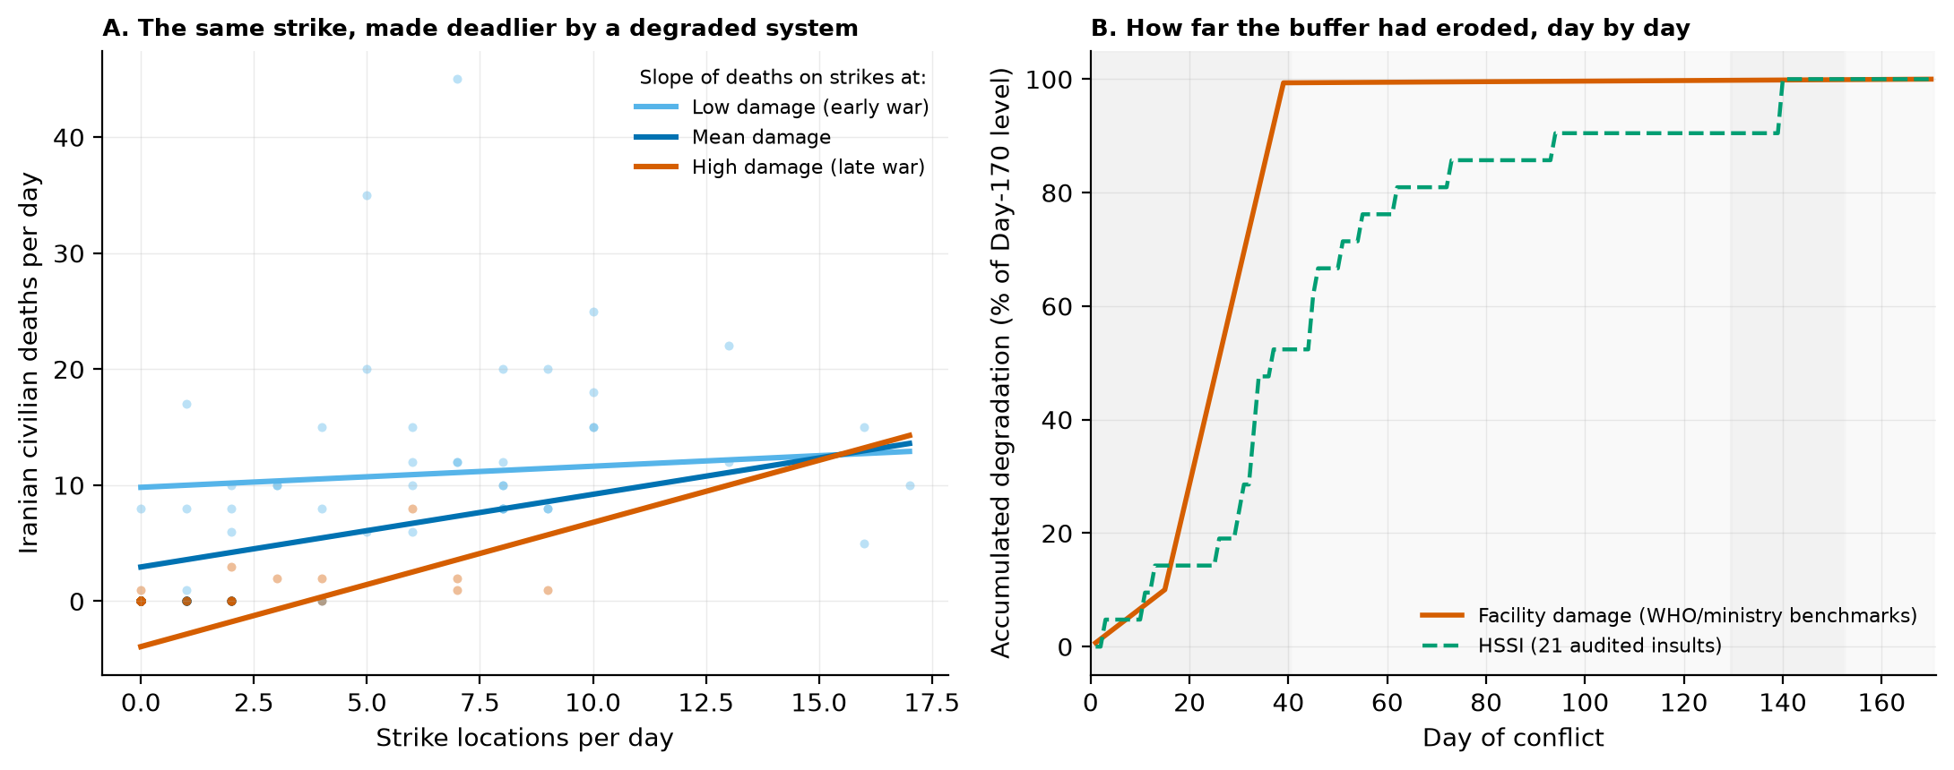
Figure 2. (A) The strike–death slope fans open as accumulated facility damage rises: flat when the system was intact, roughly one death per additional strike location once it was heavily degraded. (B) The two degradation operationalizations over the war.

5. Finding 6 — The counted dead are only a floor
The uncounted tail.
Everything in Findings 1 and 5 concerns direct, reported deaths. Conflict epidemiology is unanimous that such counts are a floor, not a total: across studied conflicts, indirect deaths — from disrupted care, displacement, water failure, and disease — have exceeded direct deaths by roughly 3:1 to 15:1, with ~4:1 an often-cited cross-conflict average (Geneva Declaration Secretariat 2008; Guha-Sapir & van Panhuis 2004; Checchi & Roberts 2008). This war's documented degradation profile sits squarely in the class where the higher ratios appear: 309 damaged health facilities, 12 hospitals rendered inactive by Day 15 and 7 evacuated by Day 170, 127 healthcare workers killed in Lebanon by Day 93, three destroyed desalination plants, 30–40% of power generation degraded by Day 11, a blockade that seized medical supplies and idled the WHO's regional logistics hub.
We therefore project — explicitly as scenario arithmetic, not as an estimate from these data. The documented direct toll at Day 170 is itself an interval (the two internal accountings disagree), and we carry that interval through each ratio (Table 3, Figure 3):
Table 3. Projected total conflict deaths at Day 170 under literature indirect:direct ratios. Ranges span the two internal direct-toll bases (daily series / terminal snapshot). Scenario arithmetic, not estimates from these data.
Ratio (indirect:direct) | Iran — indirect | Iran — total | Lebanon — indirect | Lebanon — total
1:1 (floor) | 3,166–3,636 | 6,332–7,272 | 2,993–4,308 | 5,986–8,616
3:1 (low) | 9,498–10,908 | 12,664–14,544 | 8,979–12,924 | 11,972–17,232
4:1 (average) | 12,664–14,544 | 15,830–18,180 | 11,972–17,232 | 14,965–21,540
15:1 (upper) | 47,490–54,540 | 50,656–58,176 | 44,895–64,620 | 47,888–68,928

At the 4:1 literature average, a documented Iranian floor of 3,166–3,636 implies on the order of 15,800–18,200 total deaths; Lebanon's 2,993–4,308 implies 15,000–21,500. The projection's job is communicative discipline, not precision: any public rendering of "about 3,600 dead in Iran" that does not mark the number as a floor misrepresents what conflict epidemiology knows.
The WASH record makes the mechanism concrete at household scale — the level a ward nurse recognizes. The Bonji intake's destruction alone removed drinking water from ~10,000 people across 20 villages; Kuwait, struck twice at its Mina Abdullah power-and-desalination complex, draws ~90% of its potable water from desalination. These are not abstractions. A region that loses its water treatment does not record its dead at the strike; it records them weeks later, as diarrhoeal disease in infants and the frail, in facilities that may themselves be damaged. The four people who die for every one killed directly are the patient whose operation is postponed because the theatre is gone, the mother who delivers without a skilled attendant because the midwife has evacuated, and the dialysis patient who misses session after session. They do not appear in the strike count. Finding 6 is the paper's estimate of how many of them there are — and its argument that leaving them unstated is itself a failure of public-health communication.
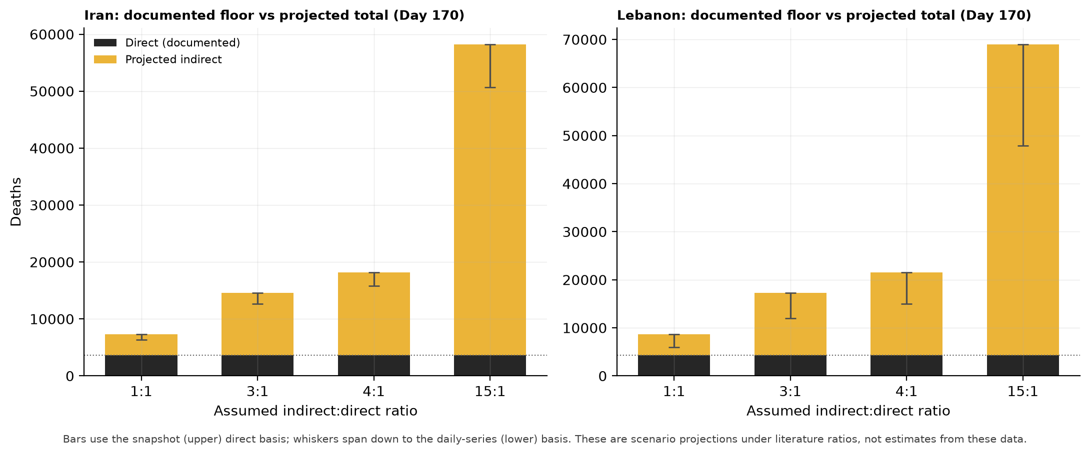
Figure 3. The documented direct toll (dark, dotted line) against the projected total under each ratio (gold); whiskers span the two internal direct-toll bounds. The counted dead are the floor.

6. The three findings as one argument
The three findings are one story seen from three distances, and each makes the next more legible.
Front-loading set the terms. The health system met the war's single largest casualty wave in its first six weeks (Finding 1), against an intact target set and an unprepared population. That is why the opening did most of the visible killing — and why the system spent the rest of the war working through the consequences of damage it absorbed before it could adapt.
Resilience erosion is what happened next. Through the long tail after Major Combat, accumulated facility damage made each additional strike costlier at the margin (Finding 5): the strike–death slope steepened roughly sixfold as the buffer eroded. Average yields fell while marginal coupling tightened — not a contradiction, but the two halves of one epidemiological process. The system was being asked to do more with less exactly as its capacity to absorb shocks ran down.
The indirect floor is the toll of both. A system that is hit hardest before it can adapt, and then loses its slack as damage accumulates, produces indirect mortality — the ward-side dying that follows disrupted care and destroyed water (Finding 6). Because that dying never enters a strike-day tally, the documented count is a floor, and the literature's ratios put the true total several times higher. Seen after Findings 1 and 5, the 4:1 projection is not a free-floating guess; it is the expected shape of the tail that front-loading and resilience erosion together predict.
Put in one sentence: the war killed fast and early, the health system gradually lost its ability to absorb further shocks, and the deaths we can count may only represent part of the real human toll. Each clause is a finding; the sentence is the paper.
Three operational implications follow, in the order the argument builds them. First, the window for protecting civilians in an air war of this type is measured in days, not months — most of the direct dying was over before Day 40, so protection that arrives later arrives for a different, smaller problem. Second, because the marginal cost of a strike rises as the system degrades, sustaining trauma-care and surveillance capacity during active war has direct life-saving value, not merely reconstructive value afterward; the WHO SSA-style benchmarks that made our better degradation curve possible are themselves a protective instrument. Third, WASH events are early-warning markers of a predictable morbidity tail — destroyed desalination in a region that draws most of its water from it defines a coming wave of indirect mortality that demands pre-positioned response before the deaths arrive.

7. Limitations
(1) Ecological, day-level design: associations, not individual-level causal effects. (2) The casualty series are contested estimates passing through internet blackouts and strategic reporting; the parent paper quantifies the cross-source spread (up to 3.8×). We run on the conservative daily series and carry both internal bases through every cumulative figure, but no method manufactures ground truth. (3) The 21-event insult register captures reported, salient insults, not a facility census (WHO counted 307 by Day 39) — which is why every degradation model also runs on the benchmark-anchored curve. (4) Degradation is confounded with time; Finding 5 is effect-modification evidence consistent with resilience erosion, not mechanism proof, and its coarser operationalization does not reach significance. (5) No spatial analysis: strike coordinates exist but hospital coordinates do not. (6) The indirect-mortality figures are projections under stated ratios, falsifiable only by post-war mortality surveys — which we hope this paper helps motivate.

8. Conclusion
Across 170 days, the 2026 US–Iran war did most of its documented killing in its first six weeks, against a health system that had no chance to prepare; that system then lost its capacity to absorb further shocks as its infrastructure accumulated damage, so that each late strike cost more at the margin than an early one; and the dead we can count are a floor several times below what conflict epidemiology expects the war's full toll to be. None of this required anything more exotic than a means comparison, an interaction, and an arithmetic projection — three plain tools, read in order, against a dataset built to keep its uncertainty visible. That legibility is the point. Against an information environment designed to overwhelm, the useful response is not sophistication but a chain of numbers a health worker can follow from the ward back to the data and forward again to the sentence a ministry, a journalist, or a planner will repeat.

Reproducibility
cd ResearchData/Paper2/v2 && python3 -m pip install -r requirements.txt && bash run_all.sh — regenerates the panel, the audited health-system register, all focused tables, and the three figures from the frozen v1.2 dataset release in about thirty seconds. src/04_synthesis.py re-derives every headline number in this manuscript and asserts each against its reported value, so the pipeline fails loudly on any drift. Bootstraps are seeded (SEED = 42). Design decisions: docs/METHODS.md. Variable definitions: docs/CODEBOOK_panel.md. Plain-language walkthrough for the first author: docs/STUDENT_GUIDE.md.

References
Checchi, F., & Roberts, L. (2008). Documenting mortality in crises: What keeps us from doing better? PLoS Medicine, 5(7), e146.
Geneva Declaration Secretariat. (2008). Global Burden of Armed Violence. Geneva.
Guha-Sapir, D., & van Panhuis, W. G. (2004). Conflict-related mortality: An analysis of 37 datasets. Disasters, 28(4), 418–428.
Hedges, L. V. (1981). Distribution theory for Glass's estimator of effect size and related estimators. Journal of Educational Statistics, 6(2), 107–128.
Holm, S. (1979). A simple sequentially rejective multiple test procedure. Scandinavian Journal of Statistics, 6(2), 65–70.
Jawad, M., Hone, T., Vamos, E. P., Cetorelli, V., & Millett, C. (2020). Implications of armed conflict for maternal and child health. PLoS Medicine, 18(9), e1003810.
Kruk, M. E., Myers, M., Varpilah, S. T., & Dahn, B. T. (2015). What is a resilient health system? Lessons from Ebola. The Lancet, 385(9980), 1910–1912.
Kruk, M. E., et al. (2017). Building resilient health systems: A proposal for a resilience index. BMJ, 357, j2323.
Levy, B. S., & Sidel, V. W. (2008). War and Public Health (2nd ed.). Oxford University Press.
Newey, W. K., & West, K. D. (1987). A simple, positive semi-definite, heteroskedasticity and autocorrelation consistent covariance matrix. Econometrica, 55(3), 703–708.
Thomas, J. E., Alpysbekova, A., Osei Mensah, E., Masara, N., & Sharma, P. (2026). IranWar.ai: An open-source event-level dataset of the 2026 US–Iran conflict. Preprint, github.com/jethomasphd/WarTheater.
IranWar.ai Research Agenda, Paper 2. (2026). The Direct Toll Is a Floor. github.com/jethomasphd/WarTheater, ResearchData/Paper2/ (the parent paper).
World Health Organization. Surveillance System for Attacks on Health Care (SSA). Geneva: WHO.
Dataset citation: IranWar.ai Event-Level Research Dataset, v1.2 (2026). Days 1–170. github.com/jethomasphd/WarTheater, ResearchData/releases/v1.2/.

