The Direct Toll Is a Floor: Civilian-Facing Targeting, Health-System Degradation, and Mortality in the First 170 Days of the 2026 US–Iran War
Working paper — Paper 2 of the IranWar.ai research-agenda series
Prepared from the IranWar.ai Event-Level Research Dataset, v1.2 (Days 1–170; 2026-02-28 to 2026-08-16)
Dashboard: https://iranwar.ai • Repository: github.com/jethomasphd/WarTheater
All results reproduce from ResearchData/Paper2/ (bash run_all.sh; seeded, ~1 minute)

Abstract
Background. Armed conflict kills far more people than bombs kill directly: the conflict-epidemiology literature consistently finds 3–15 indirect deaths — from disrupted healthcare, displacement, water failure, and disease — for every direct death. The 2026 US–Iran war (Operation Epic Fury) is the first sustained interstate air war tracked at daily resolution in an openly available event dataset, and its record documents systematic harm to the machinery of survival: 309 health facilities and 42 ambulances damaged in Iran, 152 verified attacks on healthcare in Lebanon, destroyed desalination plants, and a national grid degraded by a third within eleven days.
Methods. Retrospective ecological time-series study of 170 conflict-days. From 4,612 event records we constructed a daily panel joining strike tempo (split into civilian-facing vs military-facing target classes), an audited 21-event health-system insult register with a documented, runtime-verified audit trail, a benchmark-anchored facility-damage curve (31 → 307 → 309 facilities), and daily estimated deaths for five factions. Analyses use the standard behavioral-statistics toolkit: ANOVA-family phase comparisons with Holm-corrected pairwise tests and effect sizes; hierarchical OLS with Newey–West standard errors and negative-binomial robustness; single-mediator analysis with seeded bootstrap (10,000 resamples); moderation with simple slopes and Johnson–Neyman probing; scenario projection of indirect mortality; and a source-divergence analysis that treats casualty-figure disagreement as data.
Results. Mortality was front-loaded and regime-gated: the Major Combat phase (Days 1–40, 23.5% of the war) carried 79.6% of all documented deaths (phase η² = 0.76; combat-vs-ceasefire Hedges' g = 3.4), and deaths per strike location collapsed from 15.4 to 0.7 between the initial campaign and the July resumption (Mann–Whitney p < 0.0001). Within days, civilian-facing strike tempo — not overall or military-facing tempo — carried the mortality association (b = 2.07 civilian deaths per civilian-facing location, p < .001; military-facing b = −0.47, n.s.; NB2 incidence-rate ratio 1.62); 67.8% of the military-tempo–mortality association was mediated by civilian-facing targeting (indirect effect 1.02, bootstrap CI [0.60, 1.84]). As benchmark facility damage accumulated, the marginal strike–mortality slope steepened from 0.18 (n.s.) to 1.07 (p = .006) (interaction p = .006), a pattern consistent with resilience erosion, though the event-count degradation index showed the same direction without significance. The documented direct toll (Iran 3,166–3,636; Lebanon 2,993–4,308) is a floor: at the literature-average 4:1 indirect:direct ratio it implies roughly 15,800–18,200 total deaths in Iran and 15,000–21,500 in Lebanon. Casualty sources diverged by up to 3.8× at Day 45 — with civilian counts diverging in the opposite direction from totals — and the dashboard's own cumulative metric re-anchored by −63% in a single day; the core regression result was stable across data-confidence weighting variants (b = 1.60–2.36).
Conclusions. In this war, what killed civilians on any given day was not how much was struck but what was struck, and every additional strike was associated with more marginal deaths as the health system's infrastructure accumulated damage. Direct death counts — themselves contested at up to 3.8× — should be communicated as floors, with the indirect tail made explicit. The analysis demonstrates a transparency-aware epidemiology in which confidence ratings and source disagreements are analytic inputs: the counter-technology stance the dataset was built to enable, extended here to the empirical study of the war's health consequences.
Keywords: armed conflict, civilian mortality, attacks on healthcare, health-system resilience, indirect mortality, WASH, OSINT event data, mediation, moderation, US–Iran

1. Introduction
Wars kill twice. The first killing is visible: the strike, the collapsed apartment block, the daily toll in the briefing. The second killing is quiet and much larger — the dialysis schedule that ends when the hospital loses power, the childbirth complication two hours from the nearest functioning surgical theater, the cholera that follows a destroyed water intake. Across modern conflicts, this indirect mortality has repeatedly been found to exceed direct battle deaths by factors of three to fifteen (Guha-Sapir & van Panhuis 2004; Geneva Declaration Secretariat 2008; Checchi & Roberts 2008). The mechanism is not mysterious: populations survive on systems — healthcare, water, power, supply chains — and modern air campaigns degrade systems efficiently. Health-system resilience theory (Kruk et al. 2015, 2017) names the capacities a system needs to absorb shock; sustained bombardment attacks exactly those capacities, and epidemiological work has linked healthcare infrastructure destruction to excess non-battle mortality at the population level (Jawad et al. 2020; Spiegel 2017; Levy & Sidel 2008).
The 2026 US–Iran war offers an unusual window on this process. It is the first sustained interstate air war of its scale to be tracked openly, daily, and at event-level resolution from its opening hours (Thomas et al. 2026). The IranWar.ai Event-Level Research Dataset records — alongside strikes, retaliations, and market reactions — a granular trail of harm to the machinery of survival: a Tehran hospital's IVF department destroyed by blast on Day 3; the ICRC's assessment on Day 11 that 30–40% of Iranian power generation was degraded; a pharmaceutical factory strike that killed ten nurses on Day 33; the WHO's Day-39 count of 307 damaged health facilities; the WHO's global emergency logistics hub placed on hold on Day 45; 152 verified attacks on healthcare in Lebanon by Day 69, killing 103; the destruction of the Bonji desalination intake on Day 140, cutting drinking water to some 10,000 people across 20 villages; and, by Day 170, an Iranian Red Crescent inventory of 309 damaged health facilities, 42 damaged ambulances, and 7 evacuated hospitals.
This paper — the second in the dataset's research-agenda series, executing the public health seed of that agenda — asks four questions of the war's first 170 days, each with a deliberately standard statistical tool:
1. How was mortality distributed across the war's political phases? (means comparison: ANOVA family, pairwise tests, effect sizes) 2. What component of daily violence predicted daily deaths? (correlation and hierarchical regression, with count-model robustness) 3. Did civilian-facing targeting carry the tempo–mortality association? (single- mediator analysis with bootstrapped indirect effects) 4. Did accumulating health-system damage change what a strike cost in lives? (moderation with simple slopes and Johnson–Neyman probing)
We then place the answers in their epidemiological frame: the direct toll these analyses model is, by everything the literature knows, a floor, and we make the implied indirect tail explicit through transparent scenario projection rather than leaving it unstated (Section 4.6).
Two prior results discipline the design. Paper 1 of this series established that daily kinetic tempo is a poor proxy for lethality (its casualty-tempo caveat) and that the war's violence switched on and off with its political regime. We take both seriously: our regression models disaggregate tempo by target class rather than using raw tempo, and phase structure enters every analysis. Second, the dataset's own methods paper argues that in an information environment characterized by a structural and strategic "flood," casualty discrepancies are political facts to be analyzed, not noise to be cleaned (Thomas et al. 2026, §6.4–6.5). Section 4.7 operationalizes that stance: we quantify the divergence between casualty sources (including a −63% single-day re-anchoring of the dashboard's own cumulative metric), and we re-estimate the core model under data-confidence weighting — the "raw and confidence-weighted variants in parallel" practice the dataset's documentation recommends. The paper is thus both an empirical study of the war's health consequences and a demonstration that the dataset's transparency infrastructure — confidence ratings, source attribution, event-level provenance — can be used as analytic inputs: the counter-technology extended from data publication to data analysis.

2. Data

2.1 Source and pinning
All analyses use the frozen v1.2 research release of the IranWar.ai Event-Level Research Dataset (4,612 event rows, 52 columns, Days 0–170; Thomas et al. 2026), pinned so the paper reproduces byte-for-byte regardless of later releases. The unit of analysis is the conflict-day (N = 170; Day 1 = 2026-02-28). The four-phase structure follows Paper 1: Major Combat (Days 1–40), First Ceasefire (41–129), Resumption (130–152), and Diplomatic Pause (153–170) — documented boundaries corroborated by structural-break detection.

2.2 Outcomes
Daily estimated deaths by faction come from the dataset's casualty file (850 rows = 170 days × 5 factions; daily estimates, not cumulative): Iranian civilian (primary outcome; 543 total), Iranian military (2,623), Lebanese all-category (2,993), US military (20), and Israeli military (34). Cumulative dashboard snapshots provide reference series (Iranian killed, Lebanese killed, displaced, children killed), linearly interpolated across the 44–63 unobserved days. The two internal accountings disagree — the summed daily series runs 14.8% (Iran) and 43.9% (Lebanon) below the terminal snapshots — and we carry both forward as bounds rather than reconciling them (Sections 4.6–4.7).

2.3 Exposures
Strike tempo uses Paper 1's operationalization (distinct strike-file locations active per day plus discrete timeline events), split here into civilian-facing locations — coded target type civilian, oil/energy, communications, or water infrastructure, or civilian-facing keywords (hospital, school, residential, desalination, power, refinery, broadcast, airport) — and military-facing locations (the remainder). The civilian-facing class deliberately includes energy, water, and communications: in the public-health frame these are civilian-facing regardless of dual-use classification, because their destruction transmits harm through the systems civilians survive on.

2.4 The health-system insult register and two degradation curves
We built a register of discrete health-system events by keyword screen over the strike, retaliation, military, and humanitarian domains (excluding headline-echo row types and reference files), de-duplicated strike-file locations to their onset day, classified rows by ordered rules into five insult categories plus surveillance reports, and then read and audited every screened row. Seventeen corrections (6 reclassifications, 6 exclusions, 5 same-incident merges) are recorded by event id with reasons in the analysis code and verified against the dataset at run time; all 82 screened rows ship in data/health_system_events.csv with their audit actions visible. The result: 21 counted insult events — 6 facility attacks (from the Gandhi Hospital blast damage on Day 3 to the strike near the Tyre hospital on Day 94), 6 workforce-harm events (including the ten nurses killed in the Tofigh Daru pharmaceutical factory strike and at least three Red Cross/Crescent paramedics killed in Lebanon), 6 WASH disruptions (three desalination plants among them), 2 humanitarian-access disruptions (the WHO Dubai logistics hub hold; a seized cargo of medical supplies), and 1 pharmaceutical supply attack.
The cumulative count of these events forms the Health-System Stress Index (HSSI) — an index of reported, nationally salient insults, not a facility census. Because surveillance benchmarks show true facility damage two orders of magnitude larger, a second operationalization anchors a piecewise-linear facility-damage curve to institutional reports verified in the event stream: 31 hospitals damaged by Day 15 (Iran Health Ministry-linked reporting), 307 health facilities by Day 39 (WHO), 309 by Day 170 (IRCS). Every degradation model is estimated with both curves; their disagreement is reported, not averaged away. (The ICRC's Day-28 figure of 25 damaged facilities — lower than the Day-15 ministry figure — is excluded from the monotone curve and analyzed as a political fact in Section 4.7.)

3. Statistical methods
Phase comparisons use one-way ANOVA, Welch's ANOVA (flagged as undefined where a phase has zero variance), and Kruskal–Wallis, with pairwise Welch t-tests under Holm correction, η²/ω², and Hedges' g. Strike-day contrasts use Welch t and Mann–Whitney U. Regression models are hierarchical OLS with Newey–West (HAC, 7-day) standard errors — daily war series are serially dependent — with negative-binomial (NB2) count models as distributional robustness, estimated on the full sample and Major Combat only. Mediation uses the single-mediator product-of-coefficients with a seeded nonparametric percentile bootstrap (10,000 day-resamples; Preacher & Hayes 2008), Sobel test for reference; X (military-facing) and M (civilian-facing) are non-overlapping counts. Moderation models interact centered strike tempo with each centered degradation curve (HAC SEs), probed by simple slopes at ±1 SD and Johnson–Neyman boundaries (Aiken & West 1991), with kinetic-days-only and phase-interaction sensitivity checks. Indirect-mortality projection applies literature indirect:direct ratios (1:1 floor; 3:1; 4:1 average; 15:1 upper; Geneva Declaration Secretariat 2008) to both direct-toll bases. The source-divergence analysis compiles cumulative casualty claims by named source — each anchored to a dataset event id and verified at run time — and re-estimates the core model under three data-confidence variants. All computation is seeded and reproducible (run_all.sh, ~1 minute); α = .05 two-sided throughout.

4. Results

4.1 The shape of mortality
The war killed 6,213 people across the five tracked factions by the daily series' account — 4,944 of them (79.6%) in the 40 days of Major Combat, which is 23.5% of the war's duration. Iranian deaths (civilian + military) averaged 78.1/day during Major Combat and then fell to zero for the entire 89-day First Ceasefire; the Lebanon front, by contrast, kept absorbing 13.5 deaths/day through that same ceasefire — 1,200 Lebanese deaths accrued while the Iran front was silent — before the fronts inverted at the Resumption (Iranian deaths resumed at 1.7/day; Lebanese deaths effectively ceased). Mortality in this war was not a smooth function of its duration; it was gated by regime and reallocated across fronts (Figure 1).
The health-system insult register concentrates the same way: 11 of 21 events (52%) fall in Major Combat, and the benchmark facility-damage curve completes 99% of its Day-170 level by Day 39 (Figure 3). Displacement reached 1.2 million and the children-killed snapshot 379 by Day 170 (Figure 2); Iran's Legal Medicine Organization reported 383 children ≤18 among the dead as early as Day 53.
Table 1. Per-phase summary (daily means; totals in parentheses).
Phase | Days | Strikes/d | Civ-facing/d | Iran civ/d (tot) | Iran mil (tot) | Lebanon/d (tot) | All killed
Major Combat | 1-40 | 7.02 | 2.60 | 13.08 (523) | 2602 | 44.52 (1781) | 4944
First Ceasefire | 41-129 | 0.57 | 0.09 | 0.00 (0) | 3 | 13.48 (1200) | 1215
Resumption | 130-152 | 2.35 | 0.91 | 0.87 (20) | 18 | 0.04 (1) | 43
Diplomatic Pause | 153-170 | 0.00 | 0.00 | 0.00 (0) | 0 | 0.61 (11) | 11
Full war | 1-170 | 2.27 | 0.78 | 3.19 (543) | 2623 | 17.61 (2993) | 6213

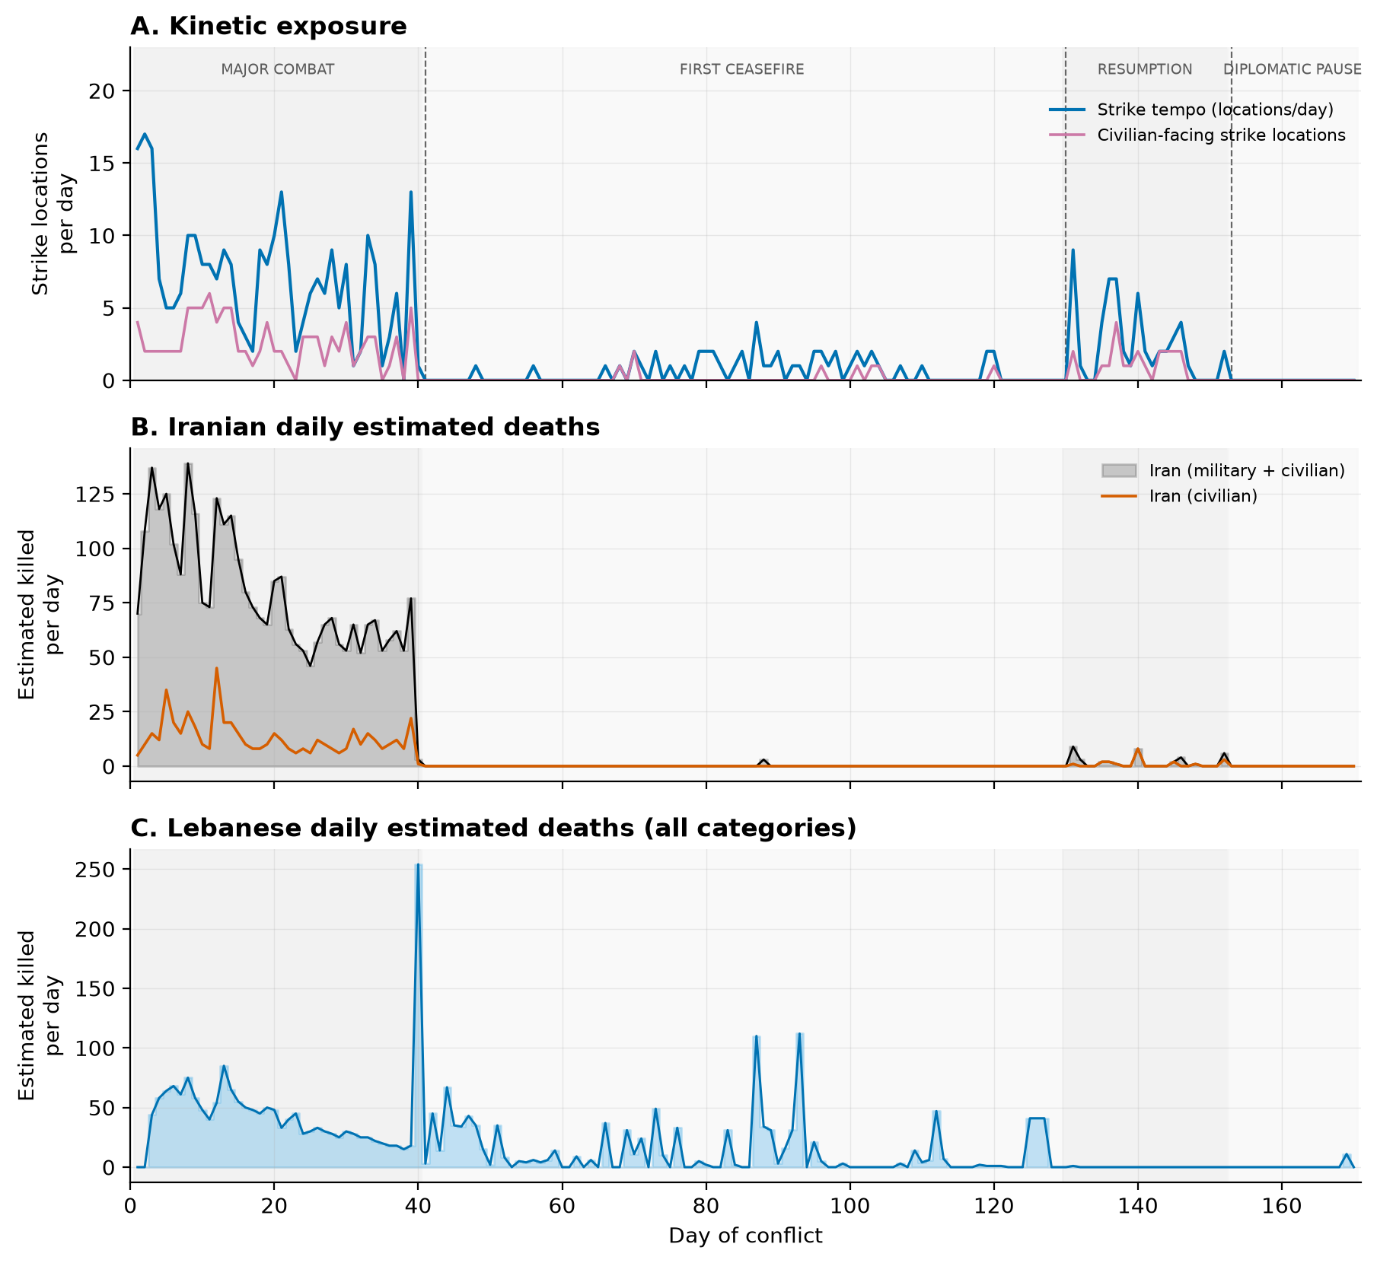
Figure 1. Kinetic exposure and daily estimated deaths across the four phases. Iranian mortality is confined almost entirely to Major Combat; the Lebanon front carries the ceasefire period.
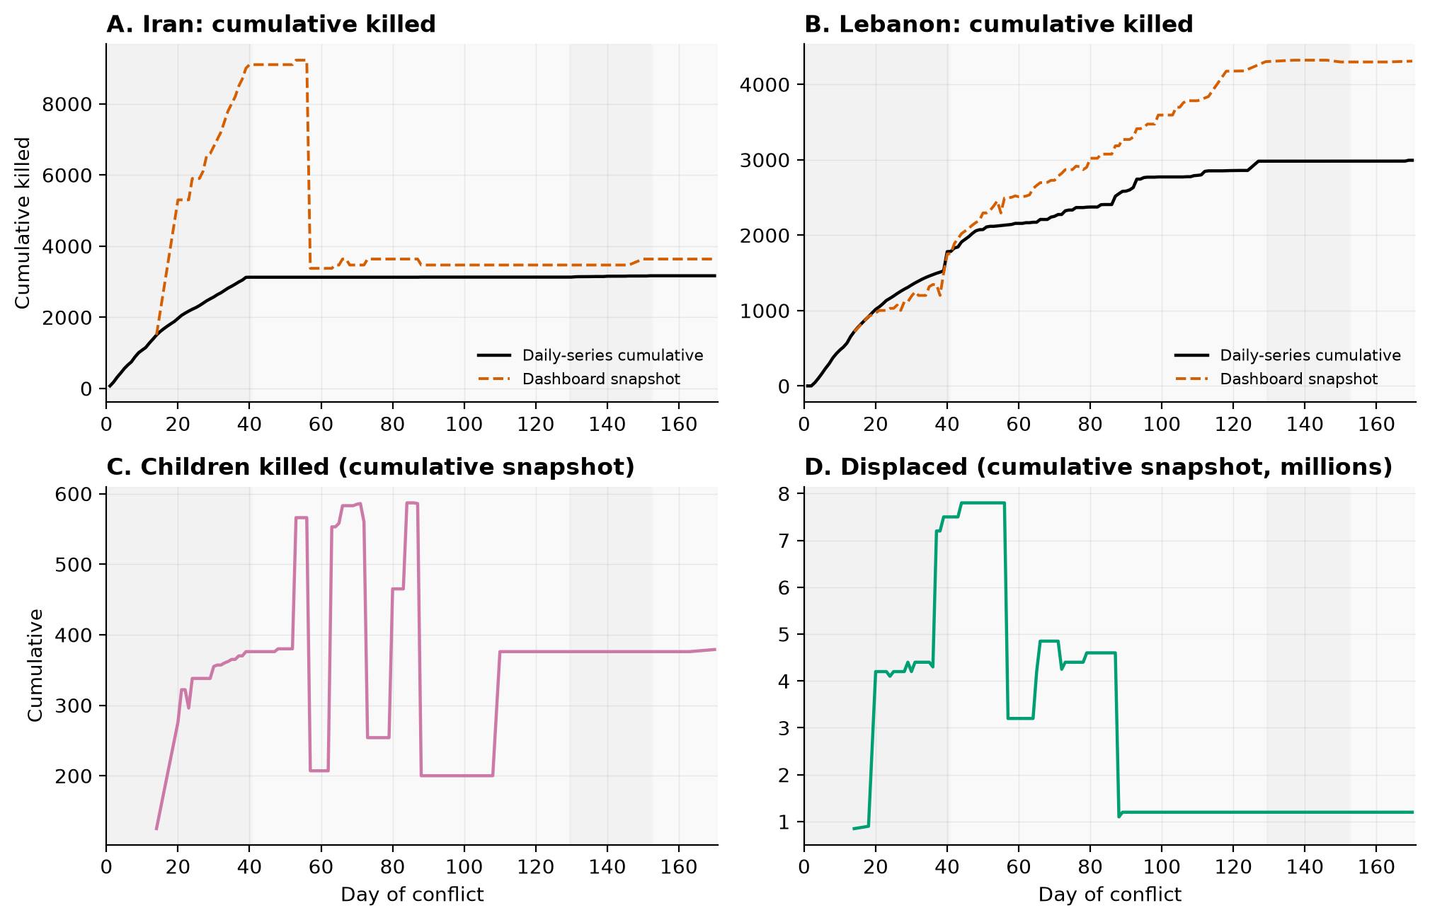
Figure 2. Cumulative burden: the daily-series and snapshot accountings (their divergence is analyzed in §4.7), children killed, and displacement.
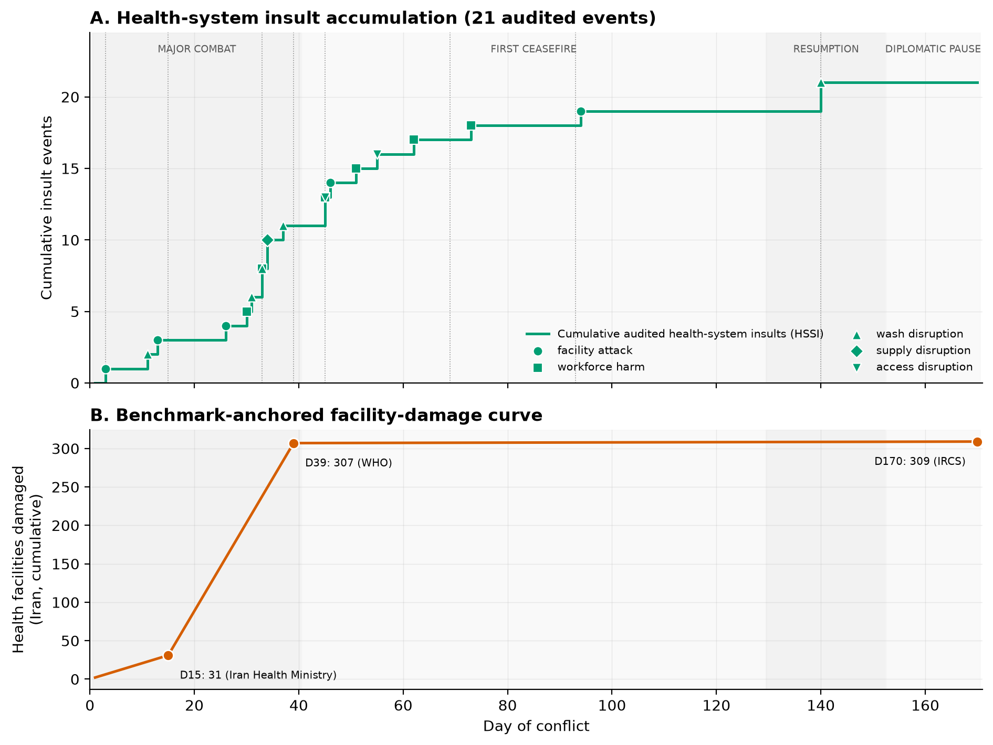
Figure 3. Health-system degradation: the 21 audited insult events (HSSI) and the benchmark-anchored facility-damage curve (31 → 307 → 309 facilities).

4.2 Phase comparisons
Phase differences are enormous by behavioral-science standards. For all-faction daily killed, F(3,166) = 172.3, p < .001, η² = .757 (ω² = .751); Welch's F = 97.6 and Kruskal–Wallis H = 104.9 agree (both p < .001). For Iranian civilian deaths, F = 106.6, η² = .658 (Welch undefined — two phases have zero variance — Kruskal–Wallis H = 149.8, p < .001); for Lebanese deaths, F = 23.4, η² = .297. Holm-corrected pairwise contrasts show Major Combat exceeding every other phase at g = 3.1–3.4 (all p < .001) for total killed; the three post-combat phases differ from one another only modestly (the ceasefire's Lebanese toll keeps it above the later phases, g = 0.6, p < .001).
Strike days (n = 89) carried 6.5× the daily mortality of quiet days (61.3 vs 9.4 killed, Welch t = 7.09, p < .001, g = 1.04); Iranian civilian deaths averaged 6.0 on strike days vs 0.1 on quiet days (g = 0.96).
Per-strike lethality collapsed across regimes. On strike days, Iranian deaths per distinct strike location averaged 15.4 during Major Combat (median 10.8), 0.7 at the Resumption (median 0.2), and effectively zero during ceasefire-era enforcement activity — a 95% decline from the initial campaign to the July re-escalation (Mann–Whitney U = 623, p < .0001, g = 2.16). The deadliest single day of the war remained its first (the Minab girls' school strike alone killed 150–170). Direct mortality, in short, was front-loaded: the opening campaign against an unprepared population and an intact urban target set did almost all of the war's direct killing.
Table 2. One-way phase comparisons (df1 = 3). † Welch undefined where a phase has zero variance (Iranian civilian deaths are uniformly 0 in two phases); Kruskal–Wallis carries the robustness burden.
Outcome | ANOVA F | Welch F | K–W H | η² | ω² | p
All-faction daily killed | 172.3 | 97.6 | 104.9 | 0.757 | 0.751 | < .001
Iranian civilian daily killed | 106.6 | undef.† | 149.8 | 0.658 | 0.651 | < .001
Lebanese daily killed | 23.4 | 28.1 | 80.9 | 0.297 | 0.283 | < .001

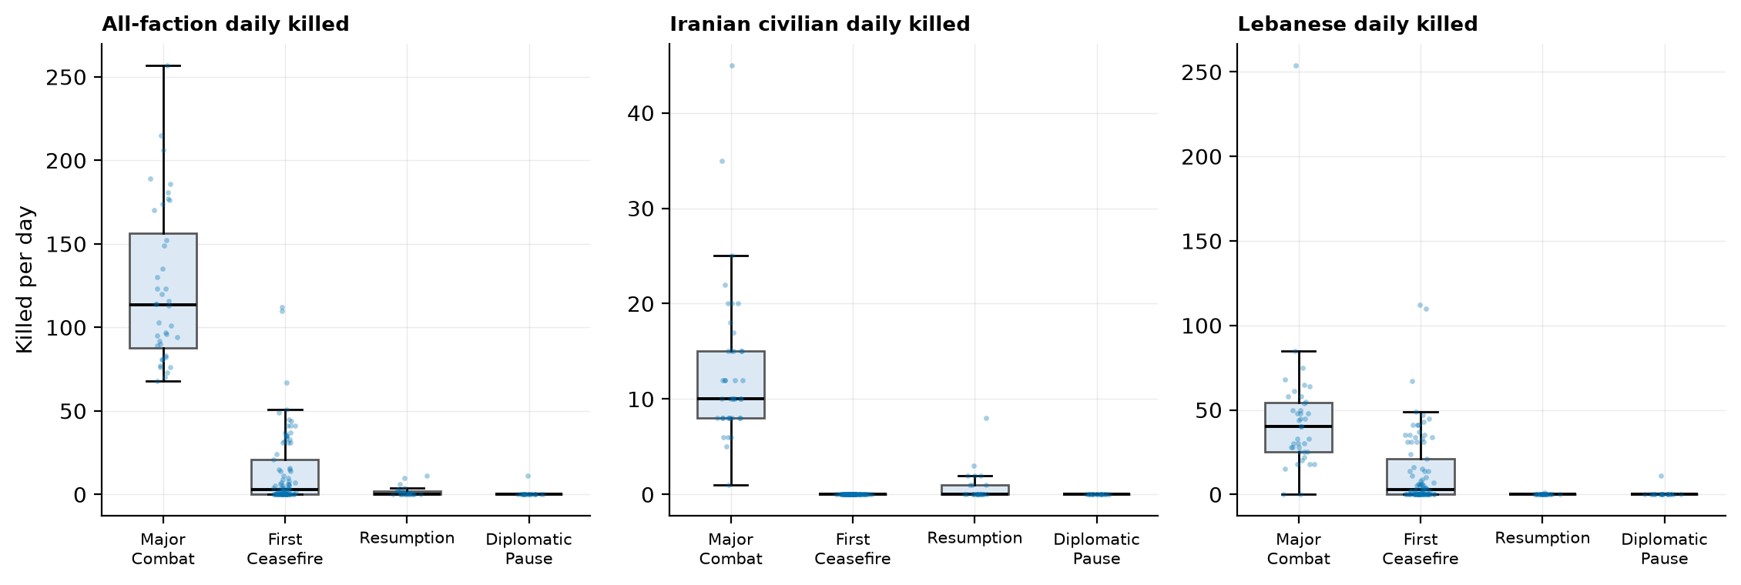
Figure 4. Daily deaths by phase (boxes: IQR and median; points: individual days, seeded jitter).

4.3 Which component of the violence predicted death
Daily Iranian civilian deaths correlate with overall strike tempo (r = .67), retaliation tempo (r = .74), and — most strongly among the kinetic series — civilian-facing strike tempo (r = .72; all p < .001). Cross-correlations peak at short lags (killed_total: peak r = .74 at 6 days; Lebanese deaths build gradually from r = .29 same-day to r ≈ .46–.48 at 1–7 days, consistent with that front's slower operational rhythm), but same-day structure dominates for Iranian outcomes.
The hierarchical models sharpen this. Raw tempo predicts civilian deaths (M1: b = 1.27, R² = .44), but when tempo is split by target class (M3), the entire association concentrates in the civilian-facing component: b = 2.07 (HAC p < .001) per civilian-facing location, against b = −0.47 (p = .20) for military-facing locations, with retaliation contributing b = 0.89 (p < .001). Adding phase dummies (M4) attenuates but does not displace the civilian-facing coefficient (b = 1.31, model R² = .70). The Major-Combat-only estimates repeat the pattern (civilian-facing b = 1.69, p < .001; military-facing n.s.). Negative-binomial models tell the same story in count terms: each additional civilian-facing location multiplies expected civilian deaths by 1.62 (IRR, p < .001), each military-facing location by 0.86 (p = .053, below one), each retaliation unit by 1.44 (p < .001).
This is the constructive refinement of Paper 1's casualty-tempo caveat: total tempo is indeed a poor lethality proxy — because lethality lives almost entirely in the civilian-facing slice of the target set.

4.4 Mediation: civilian-facing targeting carries the association
If military-facing tempo does not predict civilian deaths directly, why do heavy bombing days kill civilians? The mediation model formalizes the target-set-widening explanation: days of heavier military-facing tempo are days when strikes also widen into civilian-facing infrastructure (path a = 0.33, p < .001), and it is that widening which predicts deaths (path b = 3.07, p < .001). The indirect effect is a×b = 1.02 (95% bootstrap CI 0.60–1.84, 10,000 seeded resamples; Sobel z = 6.60), accounting for 67.8% of the total association (c = 1.50 → c′ = 0.48, the direct path no longer distinguishable from zero). The same decomposition holds for all-faction deaths (50.3% mediated, CI 3.92–11.82).
Two honesty notes. First, same-day mediation on a time series is an associational decomposition, not a causal identification. Second, the full-sample estimate partly reflects the war switching on and off — within Major Combat alone (n = 40) the direction is identical but the bootstrap CI touches zero (indirect 0.13, CI −0.03–0.68; proportion mediated 86%). The full-sample result says: across this war, the days that killed civilians were the days the target set widened; the within-combat result says the same with less certainty from forty observations.
Table 4. Single-mediator results: X = military-facing tempo, M = civilian-facing tempo. Bootstrap: 10,000 seeded day-resamples, percentile CIs.
Sample | Outcome | a | b | c | c′ | a×b [95% CI] | % mediated
Full war (n=170) | Iranian civilian | 0.330 | 3.074 | 1.497 | 0.482 | 1.015 [0.598, 1.837] | 67.8%
Major Combat (n=40) | Iranian civilian | 0.075 | 1.731 | 0.152 | 0.021 | 0.130 [-0.029, 0.677] | 86.0%
Full war (n=170) | All-faction | 0.330 | 20.255 | 13.289 | 6.602 | 6.687 [3.923, 11.816] | 50.3%
Major Combat (n=40) | All-faction | 0.075 | 4.442 | 1.666 | 1.331 | 0.335 [-0.711, 2.525] | 20.1%

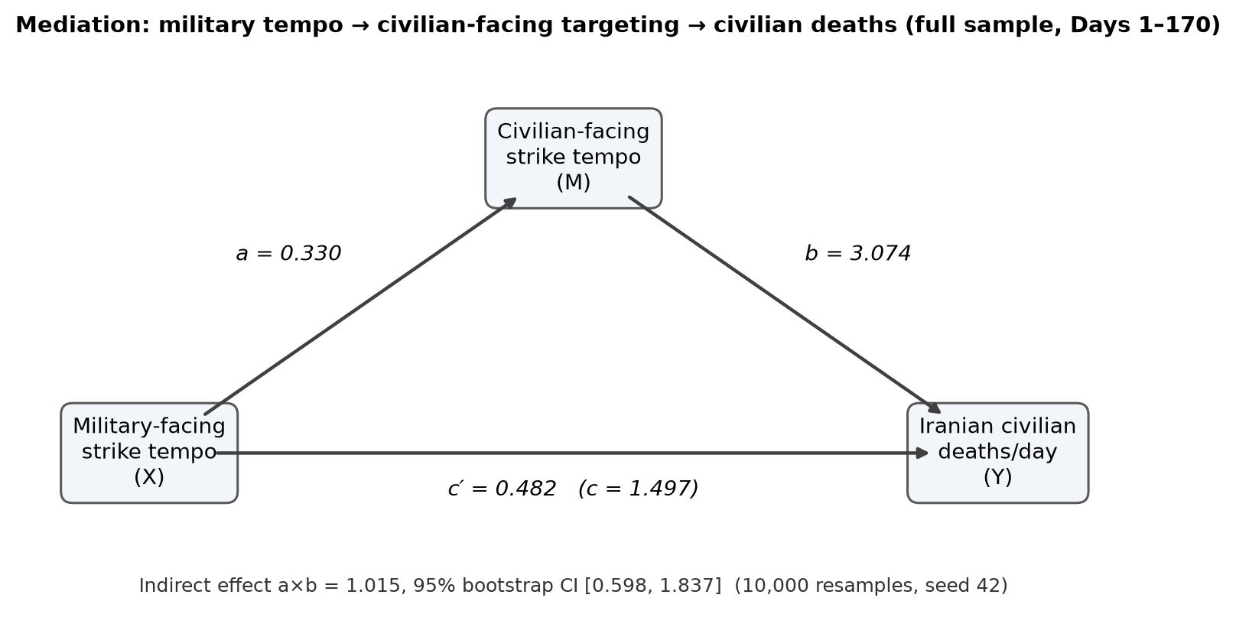
Figure 5. The mediation model with full-sample estimates.

4.5 Moderation: what a strike cost as the system degraded
The resilience-erosion hypothesis (Kruk et al. 2015) predicts that as health-system capacity erodes, the same kinetic dose converts to more deaths — survival after injury depends on intact trauma care. The rival account — harm front-loading — notes that early strikes catch unprepared, densely settled populations, and that adaptation (sheltering, flight, the 1.2 million displaced) should reduce per-strike deaths over time.
Both are visible, because they answer different questions. In average yield terms, front-loading wins decisively (the 15.4 → 0.7 collapse of §4.2). But in marginal terms — the within-day slope of deaths on strikes at a given level of accumulated damage — the association steepens as the system degrades. With the benchmark-anchored facility-damage curve as moderator, the strikes × damage interaction is positive and significant (b₃ = 0.0145, HAC p = .006; kinetic-days-only p = .006): the simple slope of civilian deaths on strike tempo rises from 0.18 (n.s.) at −1 SD of facility damage, through 0.63 (p = .02) at the mean, to 1.07 (p = .006) at +1 SD — a roughly fivefold steepening across the observed damage range, with the Johnson–Neyman boundary indicating significance for all but the lowest-damage early days. The 21-event HSSI, the coarser operationalization, shows the same direction without significance (interaction p = .32; slopes 0.45 → 0.82) — we report both rather than selecting the favorable one. A phase-interaction variant finds no slope difference between Major Combat and the Resumption (interaction p = .89) once the Resumption's far lower baseline (−10.7 deaths/ day, p < .001) is absorbed, indicating the moderation tracks the damage curve specifically rather than a generic late-war regime shift.
The moderation pattern is consistent with resilience erosion in the marginal sense — by late war, a degraded system had less capacity to keep each additional strike's victims alive — but degradation is confounded with everything else that changed over 170 days (munitions, tactics, sheltering, reporting practices). We read this as evidence, not proof, and note that the direct-death series is structurally incapable of registering the mechanism's main predicted effect, which is indirect mortality (next section).
Table 5. Simple slopes of Iranian civilian deaths on strike tempo at degradation = mean ± 1 SD (full sample, HAC covariance).
Moderator | At W | Slope | SE | p
HSSI (21 audited events) | -1SD | 0.452 | 0.262 | 0.086
HSSI (21 audited events) | mean | 0.636 | 0.256 | 0.014
HSSI (21 audited events) | +1SD | 0.820 | 0.364 | 0.025
Facility damage (benchmarks) | -1SD | 0.182 | 0.235 | 0.439
Facility damage (benchmarks) | mean | 0.626 | 0.277 | 0.025
Facility damage (benchmarks) | +1SD | 1.071 | 0.388 | 0.006

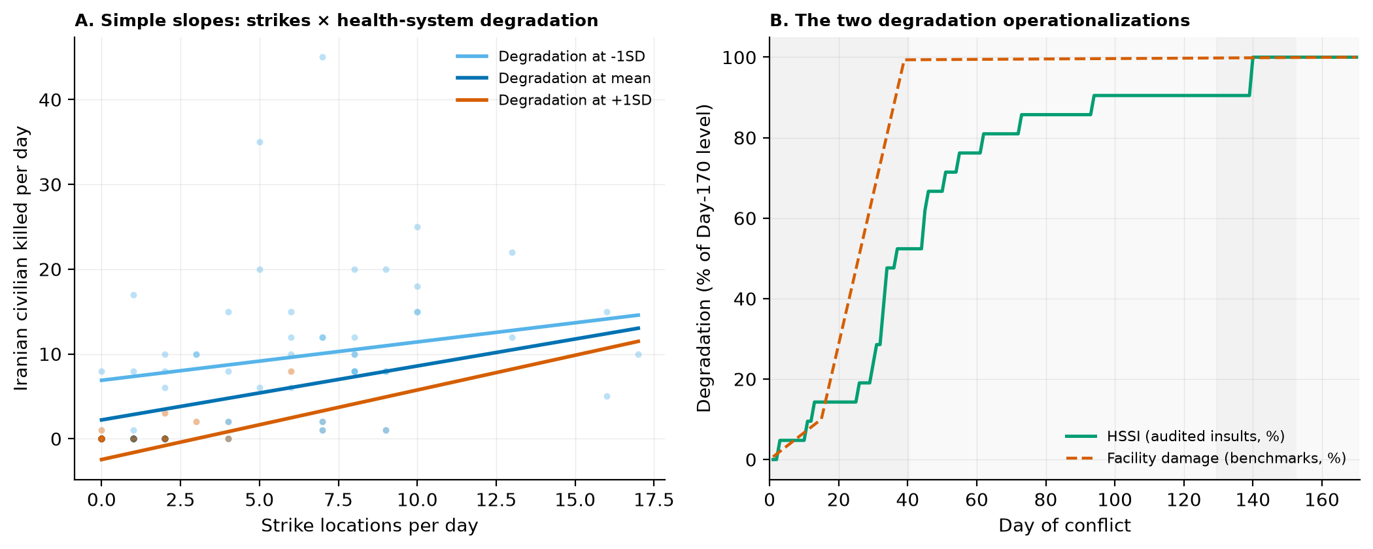
Figure 6. (A) Simple slopes under the HSSI moderator; points are observed days colored by degradation tercile. (B) The two degradation operationalizations.

4.6 The floor and the tail: projecting indirect mortality
Everything modeled above concerns direct, reported deaths. The conflict-epidemiology literature is unambiguous that such counts are floors: across late-20th- and 21st-century conflicts, indirect deaths — from health-system collapse, displacement, water failure, and disease — have exceeded direct deaths by roughly 3:1 to 15:1, with ~4:1 an often-cited cross-conflict average (Geneva Declaration Secretariat 2008; Guha-Sapir & van Panhuis 2004; Checchi & Roberts 2008). This war's documented degradation profile — 309 damaged health facilities, 12 hospitals rendered inactive by Day 15 and 7 evacuated by Day 170, 127 healthcare workers killed in Lebanon by Day 93, three destroyed desalination plants, 30–40% of power generation degraded by Day 11, a blockade that seized medical supplies and idled the WHO's regional logistics hub — sits squarely in the class of conflicts where the higher ratios have been observed.
We therefore project, explicitly as scenario arithmetic and not as an estimate from these data. The documented direct toll at Day 170 is itself an interval — Iran 3,166 (daily series) to 3,636 (terminal snapshot); Lebanon 2,993 to 4,308 — and we carry that interval through each ratio:
Table 6. Projected deaths at Day 170 under literature indirect:direct ratios. Ranges span the two internal direct-toll bases (daily series / terminal snapshot). Scenario arithmetic, not estimates from these data.
Ratio | Iran — indirect | Iran — total | Lebanon — indirect | Lebanon — total
1:1 (floor) | 3,166–3,636 | 6,332–7,272 | 2,993–4,308 | 5,986–8,616
3:1 (low) | 9,498–10,908 | 12,664–14,544 | 8,979–12,924 | 11,972–17,232
4:1 (average) | 12,664–14,544 | 15,830–18,180 | 11,972–17,232 | 14,965–21,540
15:1 (upper) | 47,490–54,540 | 50,656–58,176 | 44,895–64,620 | 47,888–68,928

The projection's function is communicative discipline: any public rendering of "3,600 dead in Iran" that does not mark the number as a floor misrepresents what conflict epidemiology knows. The WASH record makes the mechanism concrete at household scale: the Bonji intake's destruction alone removed drinking water from ~10,000 people in 20 villages; Kuwait — struck twice at its Mina Abdullah power-and-desalination complex — relies on desalination for ~90% of its potable water.
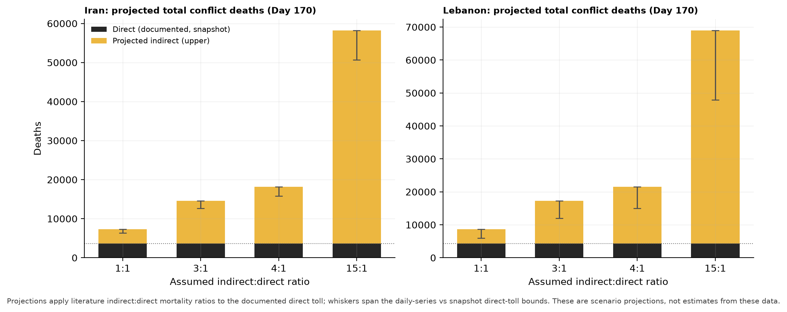
Figure 7. Projected total conflict deaths under each ratio; whiskers span the internal direct-toll bounds.

4.7 Reading the disagreements: the flood, quantified
The dataset's methods paper argues that in this war's information environment, casualty discrepancies are political facts — "signal to be interpreted," not noise to be cleaned (Thomas et al. 2026, §6.5). This section does that interpretation quantitatively.
The spread. Cumulative Iranian-toll claims by named source, each anchored to a verified dataset event: at Day 29, Iran's deputy UN representative acknowledged 1,750 dead while HRANA had documented 3,114 (ratio 1.78). By Day 45 the spread had widened to 3.8×: the Health Ministry held near ~2,000, HRANA's named-verification count stood at 3,636, and Hengaw's field-reporting count at 7,650 — with the IDF separately claiming 6,000+ IRGC dead. The structure of the disagreement is as informative as its size: the civilian counts diverge in the opposite direction from the totals (HRANA counted more civilians than Hengaw, 1,701 vs 1,030, while counting fewer than half Hengaw's total), because the contest is really over military deaths — the number that measures regime damage. Each figure is legible as its source's institutional position; averaging them would manufacture a number no one reported.
The re-anchoring. The tracking infrastructure itself records the source war. The dashboard's cumulative Iranian-killed metric climbed to 9,226 by Day 56 and dropped to 3,375 on Day 57 — a −63% single-day revision that re-anchored the series onto the Legal Medicine Organization's forensic count published days earlier (and, at Day 170, onto HRANA-family verification at 3,636). A transparency-first tracker does not escape the flood; it documents its own passage through it, which is what makes the revision recoverable as an analytic object at all.
The stability check. Because every event row carries a confidence rating, the core result can be stress-tested rather than asserted. Rebuilding the exposure series (i) from all rows, (ii) from HIGH-confidence rows only, and (iii) confidence-weighted (1.0/0.7/0.4), the civilian-facing coefficient is 2.07 / 1.60 / 2.36 respectively — direction and magnitude stable, with the HIGH-only variant losing significance purely through discarded data (its standard error triples), and the military-facing coefficient remaining null in every variant (−0.47 / −0.56 / −0.57). The headline finding does not depend on the dataset's shakiest rows. This is the counter-technology used as intended: transparency artifacts functioning as instruments of verification rather than disclaimers.
Table 7. Divergence summary: cumulative Iranian-toll claims and dataset-internal accountings.
Moment | Scope | Low | High | Ratio
Day 29 | total | 1,750 (Iran deputy UN representative) | 3,114 (HRANA (as of Mar 17)) | 1.78×
Day 45 | total | 2,000 (Iran Health Ministry) | 7,650 (Hengaw (Apr 8)) | 3.83×
Day 45 | civilian | 1,030 (Hengaw (Apr 8)) | 1,701 (HRANA (Apr 7)) | 1.65×
Day 170 | dataset-internal (Iran) | 3,166 (daily series (sum)) | 3,636 (dashboard snapshot) | 1.15×
Day 170 | dataset-internal (Lebanon) | 2,993 (daily series (sum)) | 4,308 (dashboard snapshot) | 1.44×
Day 57 | dashboard re-anchoring (Iran) | 3,375 (post-re-anchor (LMO-aligned)) | 9,226 (pre-re-anchor peak (Day 56)) | 2.73×

Table 8. The core model (Iranian civilian deaths/day) under data-confidence variants of the exposure series. Cells: coefficient (HAC SE); *** p < .001. Direction and magnitude are stable; the HIGH-only variant loses precision through discarded rows.
Exposure term | All rows | HIGH-only | Confidence-weighted
Military-facing locations | -0.47 (0.37) | -0.56 (0.53) | -0.57 (0.39)
Civilian-facing locations | 2.07 (0.37)*** | 1.60 (1.18) | 2.36 (0.52)***
Retaliation tempo | 0.89 (0.26)*** | 1.23 (0.28)*** | 0.97 (0.27)***

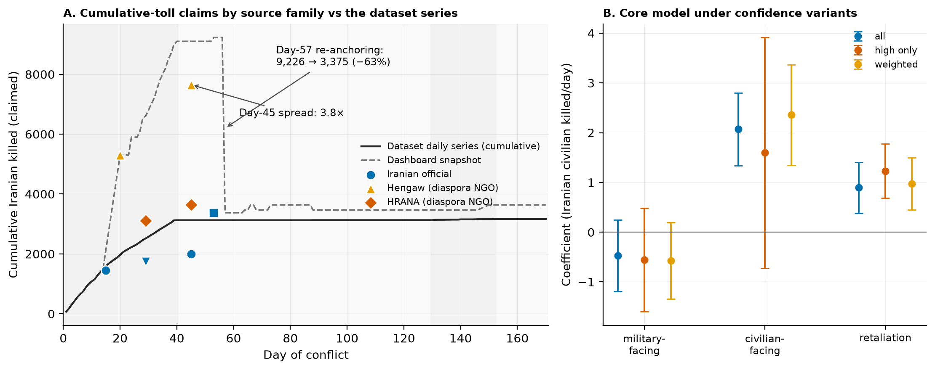
Figure 8. (A) Cumulative-toll claims by source family against the dataset's own two accountings, with the Day-45 spread and the Day-57 re-anchoring. (B) Core-model coefficients (95% CI) under the three confidence variants.

5. Discussion
What killed civilians was what was struck, not how much. The war's central public-health regularity is the concentration of mortality in the civilian-facing slice of the target set. Military-facing strike tempo — the majority of locations struck — has no positive association with civilian deaths in any specification or confidence variant; civilian-facing tempo carries the association everywhere, and two-thirds of the military-tempo association is mediated through it. In operational terms: civilian mortality in this war was not the random by-product of volume; it tracked the widening of the target set into the infrastructure civilians live on. This aligns the quantitative record with what the qualitative record already shows — a girls' school on Day 1, a hospital's IVF department on Day 3, a pharmaceutical factory and its ten nurses on Day 33, desalination intakes by Day 140 — and gives the protection-of-civilians and attacks-on-healthcare literatures (WHO SSA; Levy & Sidel 2008) a day-level statistical correlate in an interstate air war.
Front-loaded averages, steepening margins. The two lethality findings are not in tension; they are the two halves of the epidemiological story. Average per-strike yield collapsed 95% from the opening campaign to the July resumption — direct harm was front-loaded onto an unprepared population, and adaptation (1.2 million displaced, sheltering, evacuation) plus target-set depletion drove the average down. Yet at any given point, the marginal association between one more strike location and same-day deaths steepened as facility damage accumulated — precisely the signature a resilience frame predicts when trauma-care capacity erodes. The moderation is observational and time-confounded, and the coarser event-count index does not reach significance; we weight it accordingly. But its practical reading deserves emphasis: late-war "low-intensity" operations were not low-cost per event — by the resumption, each strike landed on a system with little remaining slack.
The direct toll is a floor, and saying so is a public-health act. Every model above runs on direct, reported deaths, and Section 4.7 shows even those are contested at up to 3.8×. The degradation record — hundreds of damaged facilities, killed health workers, destroyed water infrastructure, blockaded medical supply — is exactly the machinery of indirect mortality, which this design structurally cannot observe and which the literature expects to be several times larger than what it can. The 4:1-average scenario implies on the order of thirty thousand total deaths across Iran and Lebanon against a documented ~6,200–7,900. We do not claim that number; we claim its communicability: tolls should be published as floors with explicit tails, and the projection table is a template for doing so.
Extending the counter-technology to analysis. The dataset was framed as a counter-technology against the information flood — structure, provenance, and visible uncertainty as restorations of the reader's capacity to evaluate (Thomas et al. 2026, §6.4). This paper extends that stance from publication to analysis. The flood's strategic layer appears here as a measured object: a 3.8× spread whose civilian and military components diverge in opposite directions because different actors need different numbers; a tracking metric that re-anchored by −63% in a day when a more authoritative count appeared — and left the revision visible in its own history. The structural response appears as method: anchor-verified curation, an audit trail that ships with its exclusions, and a headline coefficient reported in parallel across confidence variants. None of this makes the numbers true. It makes them assessable — which is the property the flood strips away, and the property analysis can restore.
For health systems. Three operational implications follow. First, surveillance of attacks on healthcare (WHO SSA-style) provided the benchmarks that made our better-performing degradation curve possible; sustaining such surveillance during active interstate war has analytic as well as protective value. Second, the WASH events are early-warning markers: destroyed desalination capacity in a region where one struck state draws ~90% of its potable water from it defines a predictable morbidity tail that demands pre-positioned response. Third, the front-loading result argues that the window for protecting civilians in an air war of this type is measured in days: most of the direct dying happened before the fortieth.

6. Limitations
(1) Ecological day-level design: no individual-level inference; associations, not causal effects. (2) The casualty series are contested estimates passing through internet blackouts and strategic reporting; we quantify the spread (up to 3.8×), run models on the conservative series, and carry both internal bases through every cumulative claim, but no weighting scheme can manufacture ground truth. (3) The 21-event insult register captures reported, salient insults, not the damage census (WHO's 307 by Day 39); the benchmark-anchored curve mitigates but interpolates between sparse anchors. (4) Major-Combat-only models rest on 40 observations. (5) Degradation is confounded with time; the moderation result is effect-modification evidence, not mechanism proof. (6) Same-day mediation is decomposition, not identification; the full-sample estimate partly reflects regime switching. (7) No spatial analysis: strike coordinates exist but hospital coordinates do not (the WHO EMRO facility registry would enable seed #4's spatial analysis). (8) Indirect-mortality figures are projections under stated ratios, falsifiable only by post-war mortality surveys — which we hope this paper helps motivate.

7. Conclusion
Across 170 days of the 2026 US–Iran war, direct civilian mortality was gated by political regime, front-loaded into the first forty days, and — within days — carried almost entirely by the civilian-facing slice of the target set, with the marginal cost of each strike rising as the health system's infrastructure accumulated damage. The documented toll is a floor several times below what conflict epidemiology expects the war's full mortality to be, and the numbers that make up that floor diverge across sources in ways that are themselves informative about the actors producing them. A dataset built to keep its uncertainty visible made all of this analyzable with nothing more exotic than the standard behavioral-statistics toolkit — which is, we think, the point: against the flood, the counter-technology is not sophistication but transparency, carried all the way from collection through analysis to the sentence a health ministry, journalist, or humanitarian planner repeats.

Reproducibility
cd ResearchData/Paper2 && python3 -m pip install -r requirements.txt && bash run_all.sh — regenerates the panel, the audited health-system register, all tables, and all figures from the frozen v1.2 dataset release in about one minute. Bootstraps are seeded (SEED = 42); every curated constant (register audit decisions, benchmark anchors, toll claims, WASH rows) is verified against the dataset at run time by anchor-text assertion. Design decisions: docs/METHODS.md. Variable definitions: docs/CODEBOOK_panel.md. Plain-language analysis guide for the first author: docs/STUDENT_GUIDE.md.

References
Aiken, L. S., & West, S. G. (1991). Multiple Regression: Testing and Interpreting Interactions. Sage.
Checchi, F., & Roberts, L. (2008). Documenting mortality in crises: What keeps us from doing better? PLoS Medicine, 5(7), e146.
Geneva Declaration Secretariat. (2008). Global Burden of Armed Violence. Geneva.
Guha-Sapir, D., & van Panhuis, W. G. (2004). Conflict-related mortality: An analysis of 37 datasets. Disasters, 28(4), 418–428.
Hedges, L. V. (1981). Distribution theory for Glass's estimator of effect size and related estimators. Journal of Educational Statistics, 6(2), 107–128.
Holm, S. (1979). A simple sequentially rejective multiple test procedure. Scandinavian Journal of Statistics, 6(2), 65–70.
Jawad, M., Hone, T., Vamos, E. P., Cetorelli, V., & Millett, C. (2020). Implications of armed conflict for maternal and child health: A regression analysis of data from 181 countries for 2000–2019. PLoS Medicine, 18(9), e1003810.
Kruk, M. E., Myers, M., Varpilah, S. T., & Dahn, B. T. (2015). What is a resilient health system? Lessons from Ebola. The Lancet, 385(9980), 1910–1912.
Kruk, M. E., et al. (2017). Building resilient health systems: A proposal for a resilience index. BMJ, 357, j2323.
Levy, B. S., & Sidel, V. W. (2008). War and Public Health (2nd ed.). Oxford University Press.
Newey, W. K., & West, K. D. (1987). A simple, positive semi-definite, heteroskedasticity and autocorrelation consistent covariance matrix. Econometrica, 55(3), 703–708.
Preacher, K. J., & Hayes, A. F. (2008). Asymptotic and resampling strategies for assessing and comparing indirect effects in multiple mediator models. Behavior Research Methods, 40(3), 879–891.
Roberts, L., Lafta, R., Garfield, R., Khudhairi, J., & Burnham, G. (2004). Mortality before and after the 2003 invasion of Iraq: Cluster sample survey. The Lancet, 364(9448), 1857–1864.
Salama, P., Spiegel, P., Talley, L., & Waldman, R. (2004). Lessons learned from complex emergencies over past decade. The Lancet, 364(9447), 1801–1813.
Spiegel, P. B. (2017). The humanitarian system is not just broke, but broken: Recommendations for future humanitarian action. The Lancet (online).
Thomas, J. E., Alpysbekova, A., Osei Mensah, E., Masara, N., & Sharma, P. (2026). IranWar.ai: An open-source event-level dataset of the 2026 US–Iran conflict. Preprint, github.com/jethomasphd/WarTheater.
IranWar.ai Research Agenda, Paper 1. (2026). Reciprocity Without a Lag: Contemporaneous Coupling and Regime-Contingent Escalation in the 2026 US–Iran War. github.com/jethomasphd/WarTheater.
World Health Organization. Surveillance System for Attacks on Health Care (SSA). Geneva: WHO.
Dataset citation: IranWar.ai Event-Level Research Dataset, v1.2 (2026). Days 1–170. github.com/jethomasphd/WarTheater, ResearchData/releases/v1.2/.

