Jacob E. Thomas, MA, PhD
Principal Investigator | IranWar.ai Working Group
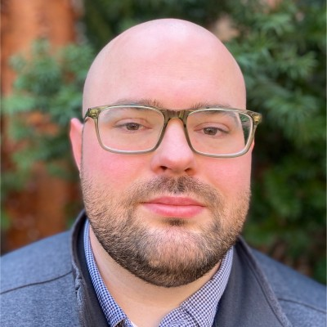
Jacob E. Thomas, MA, PhD studies how information environments shape mental health, behavior, and access to opportunity. His academic research interrogates how corporations that sell dangerous products (e.g., tobacco, alcohol, sugar-sweetened beverages) weaponize media against vulnerable populations, with particular focus on youth, communities in poverty, and historically subjugated identities. He has worked among the largest and most consequential hospitals in the country (i.e., Parkland Psychiatry in Dallas, Bellevue Emergency Department in Lower Manhattan, NewYork-Presbyterian Behavioral Medicine Division in Washington Heights) and in prestigious university laboratories at NYU, Columbia University, and across the University of Texas System, contributing to NIH-, CDC-, and DoD-funded research grants awarded to various principal investigators in sum of well over $50 million. He holds a PhD in Health Behavior from the University of Texas at Austin and an MA in Clinical Psychology from Columbia University. His research has ben recognized by numerous awards and fellowships including The Nathanel Wharton Fund, the UT-Austin College of Education, the Society for Prevention Research, the Society for Research on Nicotine and Tobacco, and Teachers College.
In the technology industry, he serves as a Data Scientist and AI Strategist at one of the worlds leading privately held recruitment marketing companies, where he directs a research lab studying the structural informational forces that degrade labor market conditions and, by extension, access to healthcare under the U.S. employer-mediated model. His work in this space has been recognized by the U.S. Army Recruiting Command and as a multi-time finalist for the Digital Job Advertising Excellence Award.
Dr. Thomas also develops open-source research tools and intelligence platforms that aim to make the noise of the Information Flood (i.e., the media crisis fueled by synthetic data and inhumane algorithms) less overwhelming while actively critiquing the environment itself. His publicly available projects span conflict intelligence, AI-mediated historical dialogue, and democratic data science, each built on the conviction that the populations most affected by information asymmetry deserve access to the same quality of analysis as those who manage it. The best part of his life is the hours spent at the park during open-sky Texas sunrises with his daughter, during watercolor Hill Country sunsets with his wife and dog, and in solitude reflecting on the spiritual dimensions of life.

Prakhar Sharma, PhD
Co-Investigator | IranWar.ai Working Group
Prakhar Sharma, PhD is a political scientist based in New York City. He holds a PhD in Political Science from the Maxwell School at Syracuse University (2025) and brings 18+ years of experience producing field-based political risk analysis and applied research for U.S. government, NATO, and allied partners across 28 countries.
Dr. Sharma built his career in conflict research starting at the International Centre for Political Violence & Terrorism Research (ICPVTR) in Singapore, before moving to Kabul where he led research at a local conflict analysis center, directing 15 initiatives on insurgent networks, Taliban governance, and political violence, with analysis cited in U.S. and UN strategic assessments. He subsequently directed DoD-funded research on terrorism support and government legitimacy across 14 Afghan provinces, delivering threat assessments and briefings directly to U.S. military commands in Afghanistan, and conducted field research for UNICEF and the World Bank across Afghanistan's most insecure provinces. He then managed DoD- and NSF-funded RCTs at Yale University's Political Violence FieldLab on insurgent influence and aid effectiveness, and served as a Stimson Center Visiting Fellow where he briefed the White House Deputy National Security Advisor, Congressional staff, and the State Department on Afghanistan insurgency dynamics. Most recently he served as Senior Specialist for Evaluation and Research at the International Republican Institute (IRI), directing CVE and conflict prevention research across 26 fragile states. Across his career he has led 30+ research initiatives in conflict and transitional settings.

Eugene Osei Mensah, BSN, RN
Associate Data Scientist | IranWar.ai Working Group
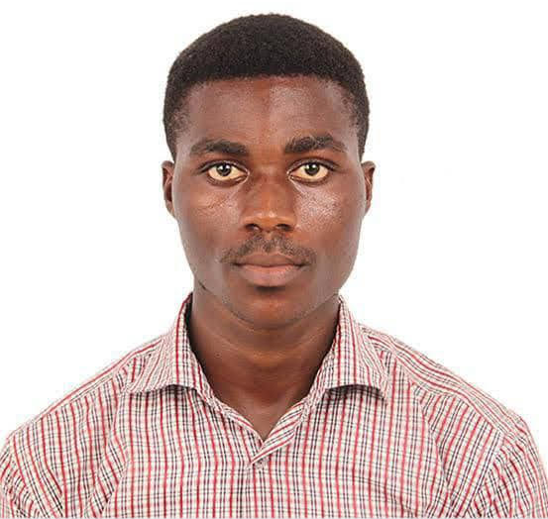
Eugene Osei Mensah, BSN, RN is a registered nurse and emerging researcher whose work bridges clinical practice, health systems, and the application of data science to humanitarian challenges. His clinical background with the Ghana health Service has grounded him in the realities of health system delivery, while his research interests in nursing informatics and machine learning orient him toward the structural and computational dimensions of healthcare that most clinicians never encounter.
He contributes to the IranWar.ai project as a research collaborator, performing data quality assurance, reference verification, and the analysis of conflict-related information through a clinical nursing and public health lens. He focuses on bringing clinical reasoning to bear on the problem of how civilian populations are affected by armed conflict directly and indirectly.
Eugene is building an interdisciplinary research portfolio at the intersection of nursing science, informatics, and applied health data science, with the goal of designing intelligent and equitable health systems, particularly in complicated humanitarian settings where traditional infrastructure has failed.

Nigel Masara, BSc, MBA
Associate Research Analyst | IranWar.ai Working Group

