
Amberdms Billing System Service Usage Collectors

This document contains information on collecting usage information for customer services and providing it to the Amberdms Billing System for billing purposes.

Copyright 2013 Amberdms Ltd

This document is licensed under the GNU AGPL software license as per the Amberdms Billing System application.

Version 9 June 2013 for Amberdms Billing System 2.0.0



Table of Contents
1. Introduction 3
2. Service Configuration Options 4
3. Usage Record Collectors 5
3.1. SOAP API 5
3.1.1. services_customers_id 5
3.1.2. Usage1 vs Usage2 6
3.2. Daily Records 6
3.3. Sample Collectors 6
3.3.1. send_usage_records.php 6
3.3.2. send_nacctd_records.php 6
4. Usage Monitoring 7
4.1. Alerts & Notifications 7
4.2. Manually Checking Usage 7

Introduction
The Amberdms Billing System provides powerful service billing features, which include support for service usage billing, which makes it ideal for use in hosting or ISP businesses.

In order to be able to track service usage, Amberdms have included a number of SOAP APIs which you can use to write your own programs or scripts to interact with the billing system.

This document provides information on how to setup usage collectors to report service usage information to the Amberdms Billing System to allow you to bill customers.

If you are looking for basic information on configuring new services in the Amberdms Billing System web interface, you should read the standard user guide manual.

This document does not go into the details of all the SOAP APIs that the Amberdms Billing System has. If you require the full SOAP API documentation, see the SOAP API manual.

Service Configuration Options
Services are widely configurable, to make them suitable for almost any purpose. The Amberdms Billing Sytem provides various service types, not just usage types.

The following services all support usage billing and the information in this document applies to them:
- generic_with_usage
- data_traffic
- time

These services are then either billed at the end of current billing period, or the end of the calender month – it is not possible to bill usage services in advance.

The usage data itself can also be charged in different ways:
- Bill for the total amount of usage during the period (incrementing)
- Only bill for the peak usage – ie: the largest amount of usage during the period.
- Bill for the average usage during the period.

Note: For more detailed information about service usage types & billing periods, please refer to the user guide documentation.

Usage Record Collectors
In order to be able to generate invoice, the usage records collected by your infrastructure (eg: netacct, netflow, radius, etc) need to be totalled into daily amounts and then sent to the Amberdms Billing System via a SOAP API.

The diagram below shows a graphical example of a collector deployment for an internet service provider.

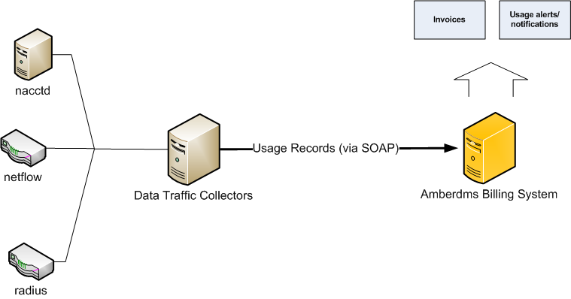

SOAP API
The following is a basic look at the set_usage_record function - refer to the SOAP API documentation for full details about the SOAP API.

The following inputs are required:

collector | string | Name of the collector (anything is acceptable)
services_customers_id | string | ID of the services_customers record for this customer/service assignment
date | date | YYYY-MM-DD
usage1 | int | Usage field #1
usage2 | int | Usage field #2

services_customers_id
This field identifies the customer and the service and must be sent with every usage record. You can discover this value by viewing the customer's service details.

Usage1 vs Usage2
The two separate usage fields exist to allow separation of usage information. A common use for this is with data_traffic, where you may wish to record upload and download traffic separately.

Note: When the usage is calculated, if the usage billing mode is set to average or peak, the average/peak is calculated for both usage1 & usage2, and then added together afterwards and billed.

Daily Records
The collector is permitted to upload as many records as it wants, however since the Amberdms Billing System will only generate invoices using whole days, it's only necessary to generate one record per day.

If you wish to file more frequent usage records (eg: every hour) you can, but be aware that this will expand the amount of database usage and may slow down queries against the usage tables – such as when generating invoices.

Sample Collectors
Amberdms provide a number of MIT-licensed collectors, some of which can be used as-is, others which are suitable for using as templates/sample code to write your own collectors.

To get the sample collectors, download the amberdms-bs-extras source package from the Amberdms Website at https://www.amberdms.com/index.php?page=products/billing_system/source.php

The following sample collectors have been supplied:

send_usage_records.php
This script is a template to allow you to write your own collectors. It performs authentication and uploads usage records. You just need to fill in the blanks with your code.

We encourage you to submit any collectors you write back to us, so we can include them for other users to also benefit from – please send any contributions to developers@amberdms.com, or to the amberdms-bs-devel mailing list on lists.amberdms.com

send_nacctd_records.php
Nacctd is a data traffic monitoring application, which stores regular usage records in a MySQL or Oracle database.

This collector needs to be configured with a mapping of IP addresses to services_customers_id. The collector will then read through the MySQL database and aggregate rows to form daily totals which are then uploaded into the Billing System.

Once the totals for a day have been uploaded, the collector will delete the rows out of the netacctd database.

Usage Monitoring

Alerts & Notifications
For some services, you may wish to alert customers when they start to reach the amount of included data in their service (eg: internet service data cap).

The Amberdms Billing System allows you to optionally set notifications at 80%, 100% or a specified number of units over that. Customers will receive an email informing them of their current usage, amount of included units remaining and the cost of additional units.

The notification/alerts check runs daily along with the service invoicing code, so the customer will not necessary receive messages at the exact time they go over their usage.

Manually Checking Usage
If you ever need to manually check data usage, you can use the customer's service page to check the usage for any billing period. See the usage guide manual for step-by-step details on how to do this.

