
Amberdms Billing System User Guide

This document provides usage information for the Amberdms Billing System

Copyright 2013 Amberdms Ltd

This document is licensed under the GNU AGPL software license as per the Amberdms Billing System application.



Version 10 June 2013 for Amberdms Billing System 2.0.0

Table of Contents
1. Introduction 7
2. Accessing the Amberdms Billing System Hosted Service 8
2.1. Logging In 8
2.2. Login Problems 8
3. Getting Support 9
3.1. Commercial Support 9
3.1.1. Technical Support 9
3.1.2. Development/Integration Assistance 9
3.1.3. Not a customer? 9
3.2. Community Support 9
4. Getting Started 10
5. Customer Management 11
5.1. Adding new Customers 11
5.2. Listing Customers 13
5.3. View Customers 13
5.3.1. Customer's Details 14
5.3.2. Portal Options 14
5.3.3. Customer's Journal 14
5.3.4. Customer's Attributes 14
5.3.5. Customer's Orders 16
5.3.6. Customer's Invoices 16
5.3.7. Customer's Services 16
5.4. Delete Customer 16
6. Customer Order Handling 18
6.1. Customer Orders Page 18
6.2. Adding Order Items 18
6.3. Turning Orders into Invoices 19
6.4. Quotations 19
6.5. Purchase Orders 19
7. Vendors/Suppliers 20
7.1. Add new Vendors 20
7.2. Listing Vendors 22
7.3. View Vendors 22
7.3.1. Vendor's Details 23
7.3.2. Vendor's Journal 23
7.3.3. Vendor's Invoices 23
7.4. Delete Vendor 24
8. Accounts: Chart of Accounts 25
8.1. Create a new Account 25
8.2. Listing Accounts (Chart of Accounts) 26
8.3. View Account 27
8.3.1. Account Details 27
8.3.2. Account Ledger 27
8.4. Delete Account 28
9. Accounts: Sales Taxes 29
9.1. Add Tax 29
9.2. Listing Taxes 30
9.3. View Tax 30
9.3.1. Tax Details 30
9.3.2. Tax Ledger / Tax Reports 30
9.4. Deleting Taxes 31
10. Accounts: General Ledger 32
10.1. Displaying the General Ledger 32
10.2. Creating General Ledger Transactions 32
10.2.1. Adding a new GL Transaction 33
10.2.2. Adjusting a GL Transaction 33
10.2.3. Deleting a GL Transaction 34
11. Accounts: Import 35
12. Human Resources 37
12.1. Add Employee 37
12.2. Listing Employees/Staff 37
12.3. View Staff 38
12.3.1. Employee's Details 38
12.3.2. Employee's Timesheet 38
12.3.3. Employee's Journal 38
12.4. Delete Employee 38
13. Products 40
13.1. Manage Product Groups 40
13.1.1. View Product Groups 40
13.1.2. Add Product Group 41
13.1.3. Delete Product Group 41
13.2. Adding a new Product 42
13.3. Listing Products 44
13.4. View Products 44
13.4.1. Product Details 44
13.4.2. Product Journal 44
13.5. Delete Product 45
14. Services: Capabilities & Billing Logic 46
14.1. Supported Billing Cycles 46
14.2. Supported Billing Modes 46
14.2.1. Available Modes 46
14.2.2. Configuration 47
14.2.3. Recommendations 47
14.2.4. Important Notes 47
14.3. Supported Service Types 48
14.4. Service Usage Record Collection 49
14.4.1. SOAP API Collection 49
14.4.2. Direct MySQL Query 49
15. Services: VoIP / Phone Billing 50
15.1. How CDR Rate Tables Work 50
15.2. About Overrides 50
15.3. Managing Rate Tables 51
15.3.1. Creating a Rate Table 51
15.3.2. Importing Rates 52
15.3.3. Viewing and Adjusting Rates 52
15.3.4. Deleting Rate Tables 53
16. Services: Data Traffic Services 54
16.1. About Traffic Types 54
16.2. Managing Traffic Types 54
16.2.1. Creating New Traffic Type 54
16.2.2. Adjusting Existing Traffic Types 54
16.2.3. Deleting Traffic Types 55
17. Services: Management 56
17.1. Manage Service Groups 56
17.1.1. View Service Groups 56
17.1.2. Add Service Group 57
17.1.3. Delete Service Group 57
17.2. Create a new Service 58
17.3. Adjusting Service Plan 60
17.3.1. All Services 60
17.3.2. bundle, generic_no_usage 60
17.3.3. generic_with_usage 60
17.3.4. TIME 61
17.3.5. data_traffic 61
17.3.6. licenses 62
17.3.7. phone_single, phone_tollfree, phone_trunk 62
17.4. Listing Services 64
17.5. View Services 64
17.5.1. Service Details 65
17.5.2. Service Plan 65
17.5.3. Service Journal 65
17.6. Adding a service to a customer account 65
17.7. Deleting Services 65
18. Services: Customer Assignment 66
18.1. Subscribing a customer to a new service 66
18.2. Adjusting Service Details/Plan 67
18.2.1. Generic Service Details 67
18.2.2. data_traffic special options 68
18.2.3. phone_* special options 68
18.2.4. Enabling or Disabling Customer Services 70
18.2.5. Important Notes 70
18.3. View customer service history/Periods 70
18.4. Manually Generating Service Invoices 72
19. Timekeeping 73
19.1. Staffaccess Permissions 73
19.1.1. Assigning Staffaccess Rights 73
19.1.2. Selecting the correct employee to enter time 74
19.2. Using the Timekeeping Functions 74
19.2.1. Viewing a Specific Day 74
19.2.2. Adding Time 75
19.2.3. Reoccurring Time 75
19.2.4. Booking Time in the Future 75
19.3. Getting Timesheet Information 75
19.3.1. Employee Timesheets 75
19.3.2. Project Timesheets 76
19.3.3. Unbilled Time Report 76
19.3.4. Exporting to CSV 77
19.4. Time Groups / Adding Time to Invoices 77
19.4.1. Creating a Time Group 78
19.4.2. Invoicing a Time Group 80
20. Projects 82
20.1. Create a new Project 82
20.2. Listing Projects 83
20.3. View Projects 83
20.3.1. Project Details 84
20.3.2. Project Phases 84
20.3.3. Timebooked 84
20.3.4. Timebilled/Grouped 85
20.3.5. Project Journal 85
20.4. Deleting Projects 85
21. Invoicing 86
21.1. Invoice List 86
21.2. Creating new Invoices 86
21.3. Adding items to Invoices 86
21.3.1. Basic Transactions 87
21.3.2. Time Items 88
21.3.3. Product Items 88
21.4. Adding Payments to Invoices 88
21.5. Invoice Journal 89
21.6. Export/Email Invoice 90
21.7. Deleting Invoices 90
22. Bulk Payments 92
23. Account Statements/Reminders 93
24. Quotations 94
24.1. Converting Quotes to Invoices 94
25. Discounting 95
25.1. Setting Discount Configuration 95
25.1.1. Setting Customer Discount 95
25.1.2. Setting Vendor Discount 96
25.1.3. Setting Product Discount 96
25.2. Adding Discounts to Invoices or Quotes 97
26. Accounting Reports 98
26.1. Sales Tax Reports 98
26.1.1. Accural/Invoice Mode 98
26.1.2. Cash Mode 98
26.2. Trial Balance 100
26.3. Income Statement 100
26.4. Balance Sheet 100
27. Support Tickets 101
27.1. Add Support Ticket 101
27.2. Listing Support Tickets 101
27.3. View Tickets 102
27.3.1. Support Ticket Details 102
27.3.2. Support Ticket Journal 102
27.4. Deleting Support Tickets 102
28. User Preferences 104
29. Templates & Emails 105
29.1. Invoice & Quote Templates 105
29.2. Report Templates 106
29.3. Email Templates 106
29.4. Backend Functionality 108
30. Audit Locking 109
31. Database Backup 110
32. General Application Configuration 111
32.1. Company Details 111
32.2. Application 112
32.2.1. Default Codes 112
32.2.2. Accounts Configuration 112
32.2.3. Automated Billing 113
32.2.4. Timekeeping/Timesheet Configuration 113
32.2.5. Audit Locking 113
32.2.6. Contributions 113
32.2.7. Security 114
32.2.8. Miscellaneous Configuration 114
32.2.9. Dangerous Configuration Options 114
32.3. Locale 116
32.3.1. Language 116
32.3.2. Application Appearance 116
32.3.3. Date Settings 116
32.3.4. Currency Configuration 116
32.4. Services 118
32.4.1. Services: UI Options 118
32.4.2. Services: External Data Sources 119
32.4.3. Services: Functionality Options 119
32.5. Integration 120
32.6. Dependencies 120
33. User Authentication Backend 121
33.1. Authentication Backend 121
33.2. Blacklisting 121
34. Translations & Languages 122
34.1. Supported Languages 122
34.2. Contribution 122
35. Troubleshooting 123
35.1. Authentication or User Issues 123
35.1.1. “I'm only able to login from one computer at any time” 123
35.1.2. “My SOAP application seems to randomly be denied access despite correct permissions” 123
35.1.3. “Even though I have authenticated, my SOAP applications are still constantly denied access” 123
35.2. Invoice/Report/PDF Generation Failure 123
35.3. Missing Dependencies/Components 124
35.4. Application Debugging 124
36. Legal & Licensing 126
36.1. Open Source / AGPL 126
36.2. Trademark Use 126
36.3. Community Links 126

Introduction
The Amberdms Billing System (ABS) is a powerful, user friendly, open-source billing system designed for small and medium businesses fully open source under the AGPL software license.

The Amberdms Billing System includes the following features:

Accounting
- Provides full double-entry accounting.
- Simple UI makes it easy to create invoices and handle finances
- Ability to export information to CSV or PDF formats

Time Keeping
- Provides timesheet features to allow employees to keep track of hours spent on different projects.
- Easy interface allows you to generate invoices from the hours entered.
- The easy UI and full integration between timekeeping and invoicing features mean you'll never forget to bill customers for hours worked

Service Billing & Management
- Capable of performing regular service billing
- Supports usage-based billing, making the Amberdms Billing System ideal for ISPs or hosting providers.
- Sample code supplied to collect usage information from a variety of applications.

Developer Friendly
- Fully open source product, licensed under the GNU AGPL. This allows you to customise the product to suit your requirements - or take advantage of our commercial developer services and have Amberdms do all the development work for you.
- Easy 3rd party integration via a fully documented SOAP API.

Commercial Backing
- High-availability geo-redundant hosted services available from Amberdms, eliminating the need for you to run your own servers and worry about backups and upgrades.
- Commercial support packages available from Amberdms.
- Customisation services available at fixed-price quotes.

This document provides a user guide for all the features of this application. If you are looking for installation information, developer documentation or other integration documentation, the following documents may be of use:

- Installation Manual.
- API Developer Manual.
- Service Usage Collector Manual.

Accessing the Amberdms Billing System Hosted Service

For customers of the Amberdms Billing System Hosted service, the following information explains how to login and get support for your product.

If you run the Amberdms Billing System on your own internal servers, this information does not apply to you.

Logging In
To login to the Amberdms Billing System, access the following URL:
www.amberdms.com/billing_system

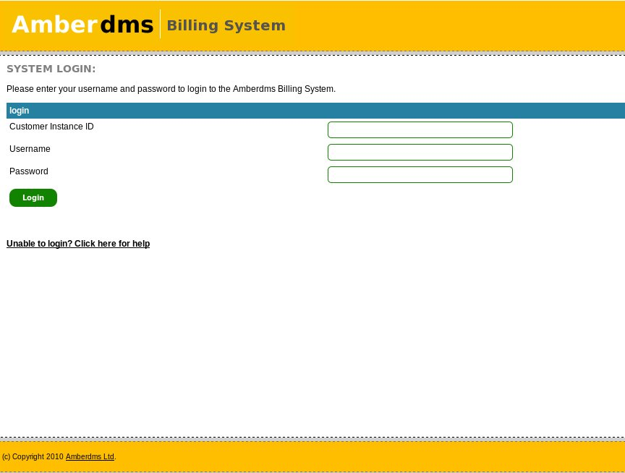
You must supply all three fields in order to be able to login.

Login Problems
If you are unable to login to the Amberdms Billing System, talk to your local system administrator who created your login account – it may be due to the brute force blacklisting if you have tried to login with the wrong password too many times.

If your system administrator is unable to help, please contact Amberdms Technical Support via email or phone and give them your customer number and username.

Contact details are available on the Amberdms website at:
www.amberdms.com/contact

Getting Support

Commercial Support
If you are a customer of the Amberdms Billing System Hosted Service or the Amberdms Billing System Subscription, Amberdms will provide free unlimited technical support for any issues you have with communicating with the SOAP API.

Technical Support
To receive technical support, contact us using one of the methods list at:
http://www.amberdms.com/?page=products/billing_system/support_basic.php

Please have your customer ID ready so that our staff may assist you effectively.

Development/Integration Assistance
Our free technical support service does not cover us supporting developers with coding issues in their own applications.

If you would like comprehensive support including phone or email assistance for developers or staff integrating the Amberdms Billing System with other applications, or for support with writing your own SOAP programs, you will need to either have a support package or be prepared to pay the hourly support rate.

If you already have a support package, you may contact us using the details available at:
http://www.amberdms.com/?page=products/billing_system/support_package.php

If you do not have a support package, but do have either a hosted service or subscription service with Amberdms, we can still support you but will charge for our time and add it to your monthly invoice. To make a support request, use the information at http://www.amberdms.com/?page=products/billing_system/support_basic.php

If you don't currently have a support package with Amberdms but would like to get one you can find out more about our offerings at http://www.amberdms.com/?page=products/billing_system/getsupport.php

Not a customer?
If you are not a customer, you can try and get support from the community via our mailing lists, however we recommend that you sign up for our subscription service.

The Amberdms Billing System Subscription Service lets you run the Amberdms Billing System on your own servers, but you get the advantage of priority updates, alerts to new fixes and our commercial support services.

Full details can be found at: http://www.amberdms.com/?page=products/billing_system/subscription.php

Community Support
If you are not a customer of Amberdms, you may be able to get assistance from other members of the community by using the Billing System mailing lists.

General Discussion List:
http://lists.amberdms.com/mailman/listinfo/amberdms-bs

Amberdms Billing System Developers Mailing List:
http://lists.amberdms.com/mailman/listinfo/amberdms-bs-devel

Getting Started
If this is the first time you have used the Amberdms Billing System, you will need to setup the following in order:

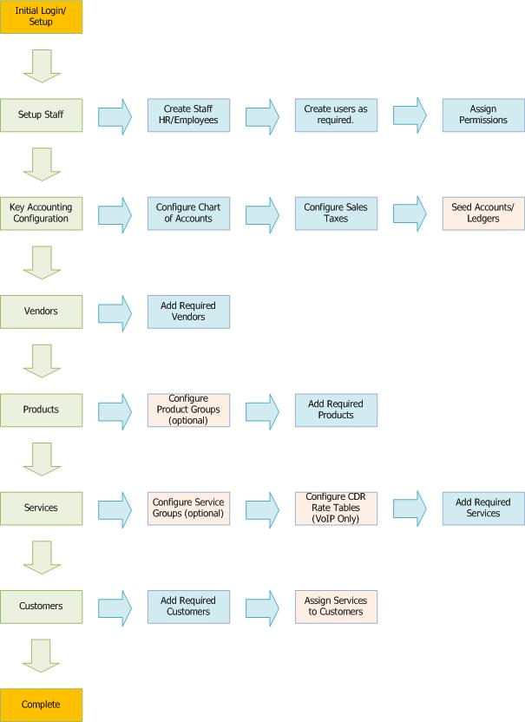

Customer Management
In order to be able to create invoices or configure services, you will need to add your customers to the billing system.

Adding new Customers
Select Customers -> Add Customer to access the page for adding new customers.

First set the basic customer's details and the dates when they first started or ceased business with your organisation – the customer ID field can be left blank for an automatic unique auto generated value.

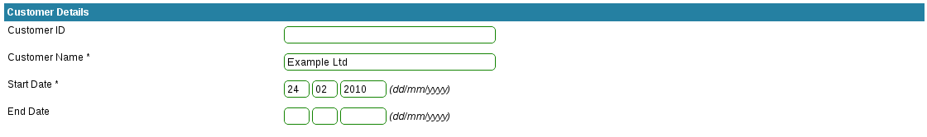

Add contacts to the customer – there will always be at least one “accounts” contact, but you can have any number of contacts with different contact methods.
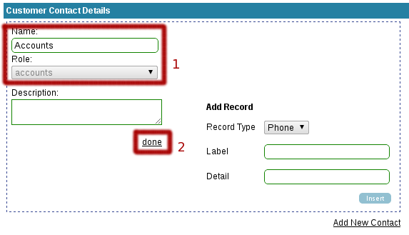
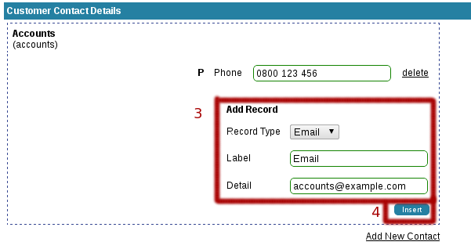
To add contacts, set the default accounts contact with required information – you can add any number of contact numbers or email addresses to the contact.

If you wish to create additional contacts – for example, management, a specific department, authorised purchasers – you can click the Add New Contact button to add additional contacts.

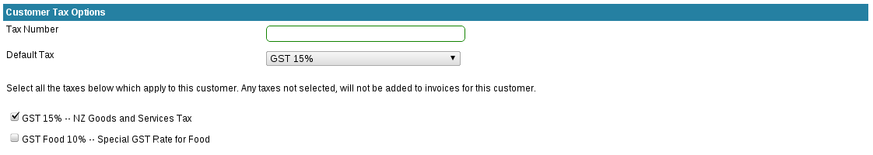

Assign the taxes that apply to this customer. If you have yet to add taxes, you can enable new taxes for all existing customers after creation.

Configure a discount if desired – the discount will be applied to all products or service base plans, unless the product or service has a higher discount already.
Finally configure the billing and postal addresses:

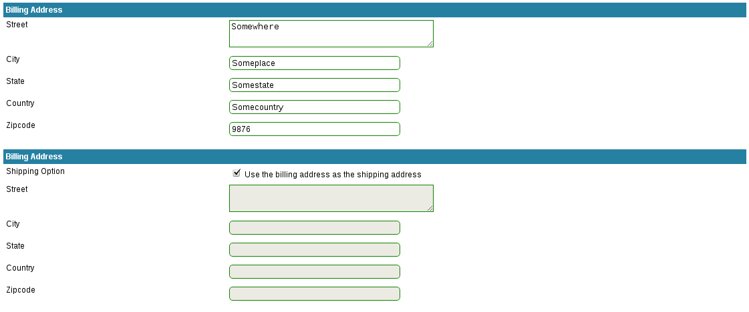

Once all fields have been entered, click “Create Customer” to add the customer to the billing system.

Listing Customers
Select “Customers -> View Customers” from the menu to display a list of all the customers in the billing system. You can use the options menu at the top of the page to configure what customers and fields to display:

You can also export the data in alternative formats, which will export the exact same data as currently displayed.
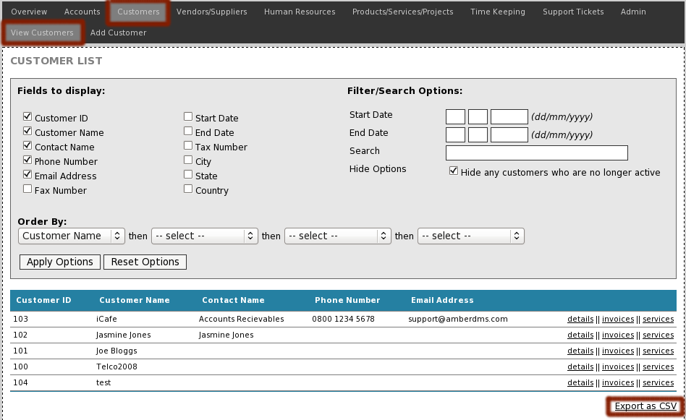

View Customers
There are multiple pages showing different customer details and providing you with the ability to edit the pages.

First, select the customer you wish to view, by accessing the customer list (see section above) and then select one of the options to the right of the customer list.

Once you have loaded one of the view pages, you can use the navigation menu to access other view pages.

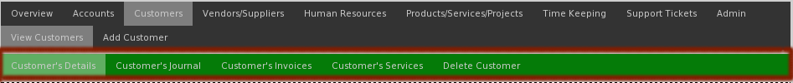

Customer's Details
The customer details page displays the basic details of the customer, billing address and shipping address, as well as providing the ability to adjust tax options for the customer.

Refer to the adding customer section above for details about the page options.

Portal Options
If the MODULE_CUSTOMER_PORTAL configuration option is set, the customer portal options page will appear, which allows a password to be set for a selected customer to enable their use of an external customer portal.

If you do not have any external applications using the portal SOAP API, then it is recommended that you disable this configuration option on the Configuration->Integration page to simplify usability for ABS users.

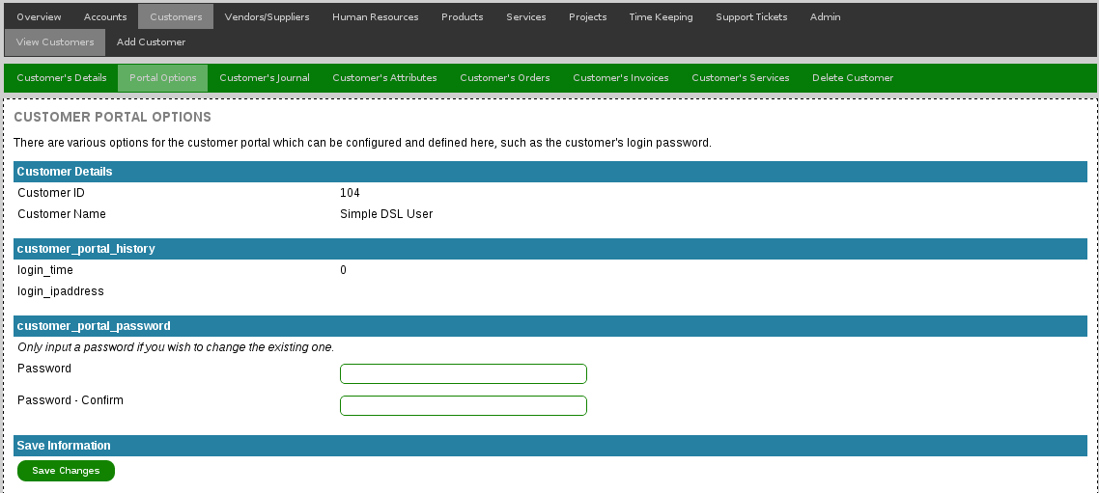

Customer's Journal
The customer journal is an area to attach notes and files to a customer. These notes are readable by all other uses with customers_view permissions.

Customer's Attributes
The customer journal is a great way to attach files and complex notes, but is less useful when wanting to provide a place to store attributes relating to the customer, such as serial numbers, secondary IDs,

The attributes page provides the ability to have different groups of attributes and easy addition/removal of the attributes – to get started, a default group is provided:

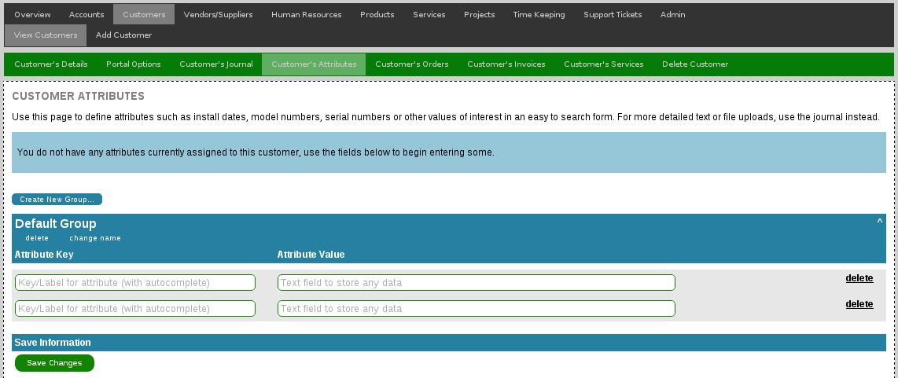

Additional attributes can be added, the attributes table will automatically expand with additional rows as needed:

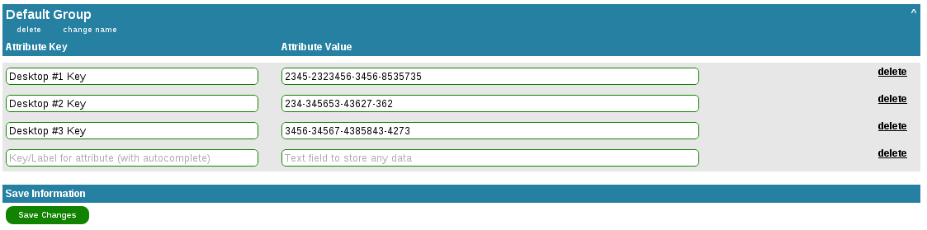

The attributes group can be renamed, deleted or a different group can be added – attributes can then be moved between the groups.

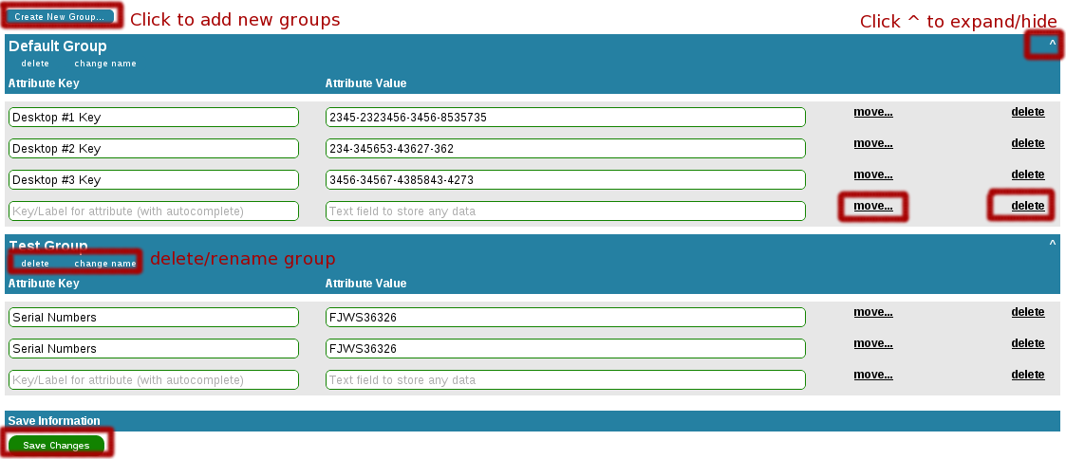

Customer's Orders
In order to provide more advanced billing options, ABS 1.5.0 introduced the ability to have customer orders – essentially products or service setup fees can be added to the customer's account, which are then invoiced on a monthly or service basis.

Customer order handling is detailed in more information in the section “Customer Order Handling”.

Customer's Invoices
The customer's invoices page displays all the invoices belonging to this customer and shows which invoices have or have not been paid, as well as providing various filter and search options.

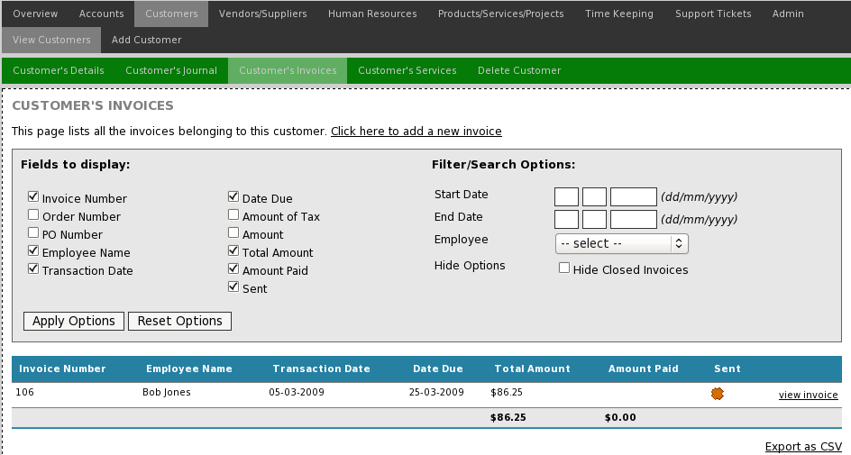

Customer's Services
The customer services page displays all the services the customer currently subscribes to, as well as allowing you to update, delete or add services.

Managing customer services is detailed in the “Services: Managing Customer Services” section of this document further down.

Delete Customer
When required, customers can be deleted from the billing system, provided that there are no invoices or services belonging to the customer.

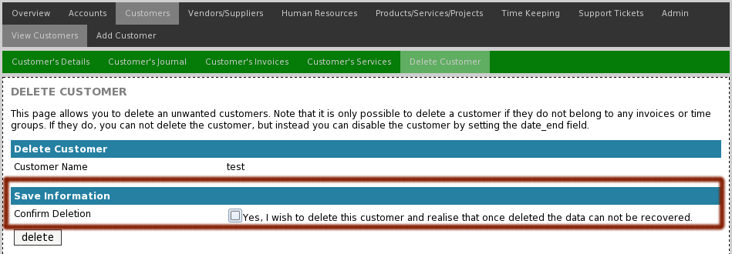
If the customer is unable to be deleted, the billing system will inform you of this and instead of deletion, you should set the end date field on the “Customer's Details” page.
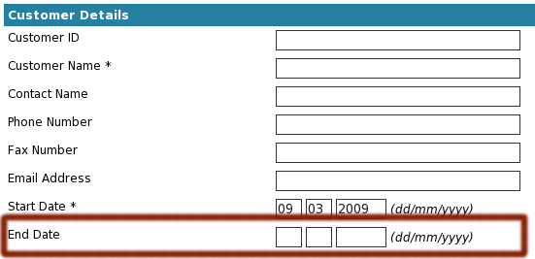
This will not delete the customer, but will hide them from the list of active customers.

You also need to check any services on the customer, the services may need to be disabled if they have not already been done.

Customer Order Handling
ABS 1.5.0 introduced new customer order handling functionality, where products or service setup fees could be added to a customer's account as orders, which would be turned into invoices at a later stage.

The primary intent of this feature is to enable the addition of setup fees and product items to service customers, so that all the initial setup components will be charged on the first service invoice, or optionally, at an earlier stage by manual intervention.

Customer Orders Page
The customer order's page can be accessed by viewing the customer and then selecting “Customer's Orders”.
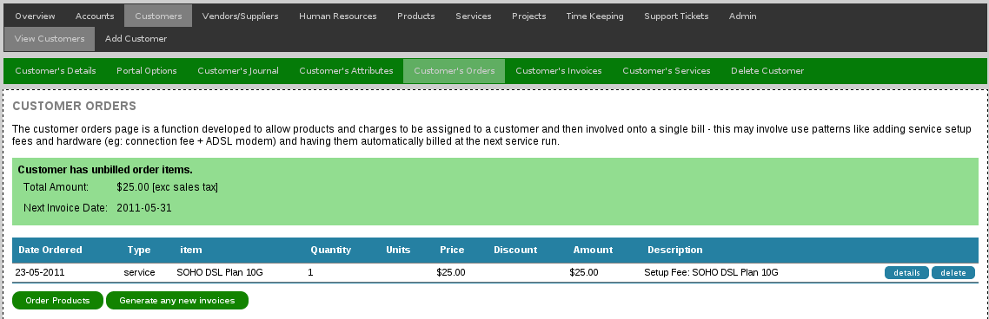

Adding Order Items
Service-setup fees are automatically added only, but products can be added manually:

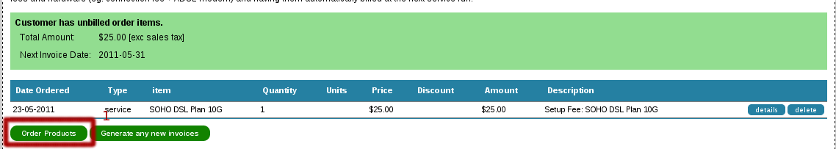
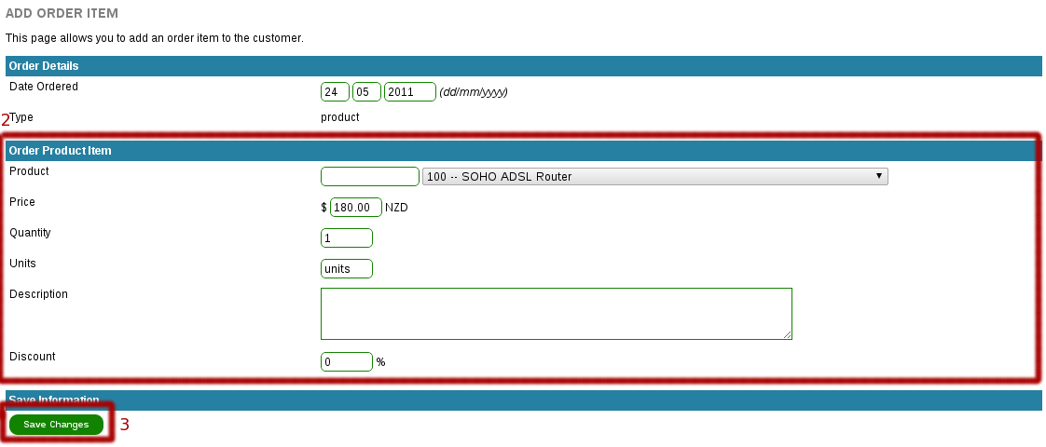

Turning Orders into Invoices
There are three methods for orders to be turned into invoices:
- Items will be added to the next service invoice (ORDERS_BILL_ONSERVICE configuration option).
- Items will be billed at the end of the calender month (ORDERS_BILL_ENDOFMONTH configuration option).
- Manual Command

The orders page interface will inform you of when the items will be invoiced:

Otherwise an invoice can be manually generated by clicking on “Generate any new Invoices”:

Once the invoice is generated, the order items will disappear – the invoice can now be found on the “Customer's Invoices” page or the general AR page.

Quotations
The orders function does not replace quotations, which can be made via Accounts -> Quotes -> Add Quote. Note that you can quote for products, but you can't quote for services due to their reoccurring and variable nature.

Purchase Orders
ABS does not have a purchase order handling system build into the customer order's page – instead you should:
- Creating a quote for the customer.
- Receiving the purchase order from the customer.
- Turning the quote into an invoice, attaching the PO and referencing it's number on the invoice.

The customer order's page is intended for simpler transactions like setup fees or casual supply of components, for example a business supplying services and sometimes some hardware components.

Vendors/Suppliers
It is important to define your vendors before adding services. products and of course before being able to make Accounts Payable invoice transactions.

Add new Vendors
Select Vendors -> Add Vendor to access the page for adding new vendors.

First set the basic vendor's details and the dates when they first started or ceased business with your organisation – the vendor ID field can be left blank for an automatic unique auto generated value.

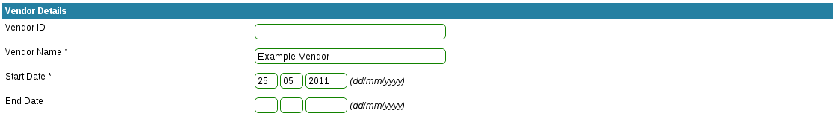

Add contacts to the vendor – there will always be at least one “accounts” contact, but you can have any number of contacts with different contact methods.
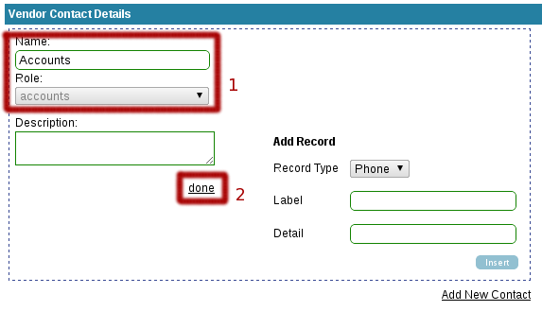
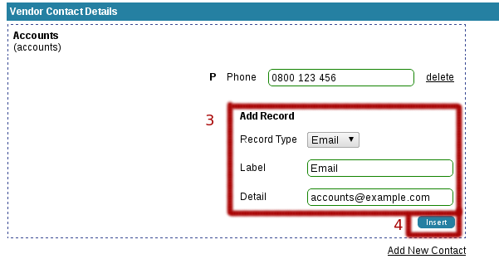
To add contacts, set the default accounts contact with required information – you can add any number of contact numbers or email addresses to the contact.

If you wish to create additional contacts – for example, management, a specific department, sales staff– you can click the Add New Contact button to add additional contacts.

Assign the taxes that apply to this vendor. If you have yet to add taxes, you can enable new taxes for all existing vendors after creation.
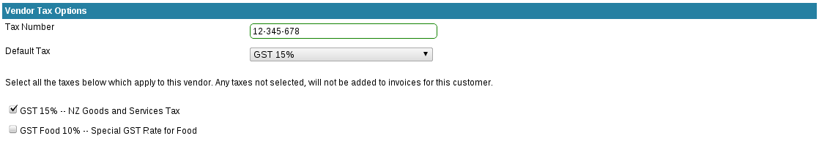

Configure a discount if desired – the discount will be applied to all products when purchased from that specific vendor – useful if the vendor offers a standard discount for all purchases, although per-product discounts should be set on the product or at ordering time instead.

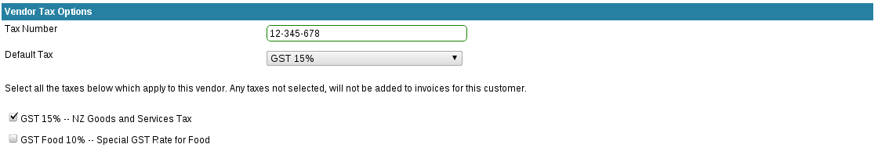

Finally configure the billing and postal addresses:

Once all fields have been entered, click “Create Vemdor” to add the vendor to the billing system.

Listing Vendors
Select “Vendors -> View Vendors” from the menu to display a list of all the vendors in the billing system. You can use the options menu at the top of the page to configure what vendors and fields to display:

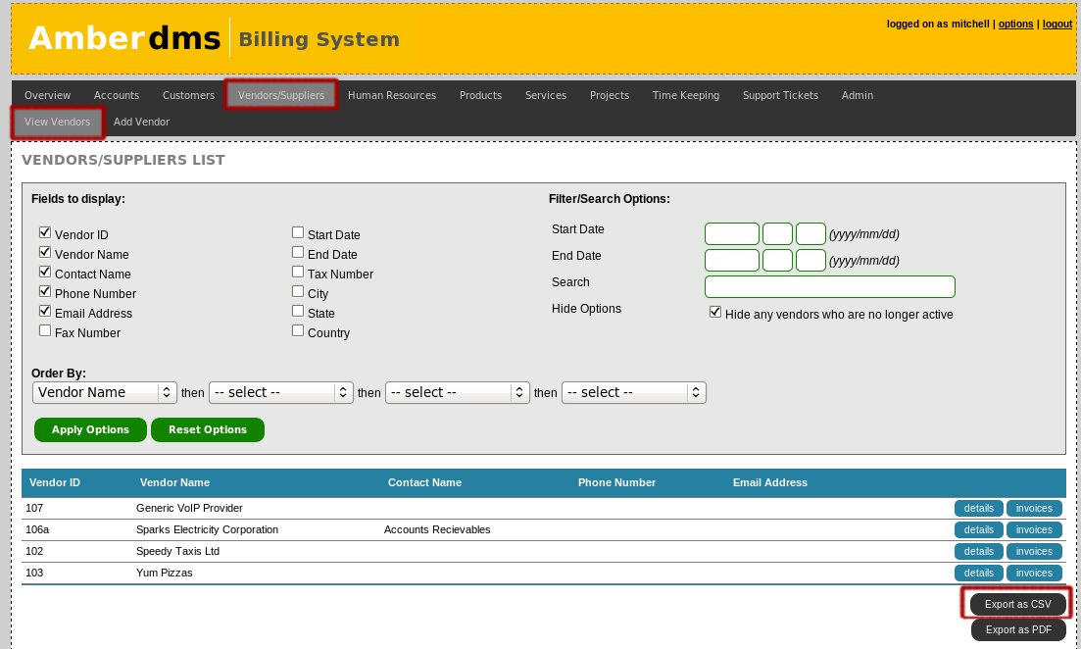

You can also export the data in alternative formats, which will export the displayed data (so you can export the results of a search) to CSV or PDF formats.

View Vendors
There are multiple pages showing different vendor details and to make changes.

First, select the vendor you wish to view, by accessing the vendor list (see section above) and then select one of the options to the right of the vendor name.

Once you have loaded one of the view pages, you can use the navigation menu to access other view pages.
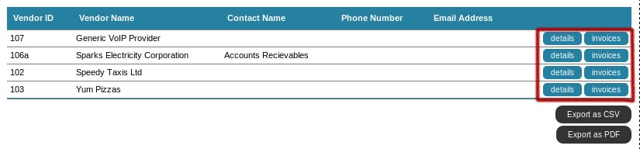
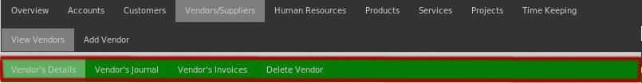

Vendor's Details
The vendor details page displays the basic details of the vendor such as their billing address, shipping address and tax options.

Vendor's Journal
The vendor journal is an area to attach notes and files to a vendor. These notes are readable by all other users with vendors_view permissions – typically information such as purchasing information, account manager details and price-lists for internal use.

Vendor's Invoices
The vendors invoices page displays all the invoices that have been sent to your company from the selected vendor. This page shows which invoices have been paid (or are outstanding) and also provides various filter and search options.

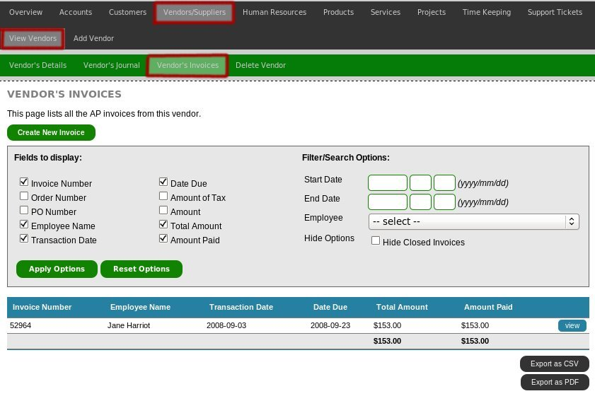

Delete Vendor
When required, vendors can be deleted from the billing system, provided that there are no invoices entered for this vendor.

If the vendor is unable to be deleted, the billing system will inform you of this and instead of deletion, you should set the end date field on the “Vendor's Details” page.

This will not delete the vendor, but will hide them from the list of active vendors.

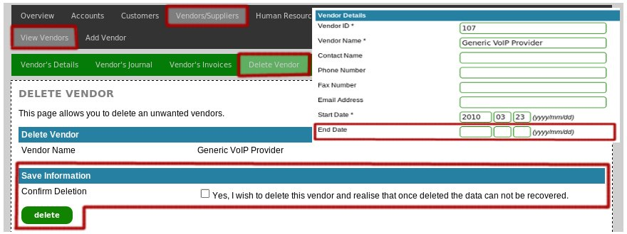

Accounts: Chart of Accounts
In double entry accounting, accounts are used to group related transactions together – accounts are not necessarily the same thing as an actual bank account (although they can be).

Before being able to add invoices, products or taxes, you need to create a number of accounts. The list below is an example:
- Chequeing bank account
- Accounts Receivables
- Account Payable
- Income
- Expenses
- Tax

The Amberdms Billing System is shipped pre-configured with a common account setup, but you may wish to add to, edit or remove these default accounts to suit the requirements of your business.

Create a new Account
Select “Accounts -> Chart of Accounts -> Add Account” to access create new account page.

Accounts need to be added in two stages – first, the account must be created and then the account menu options need to be chosen.

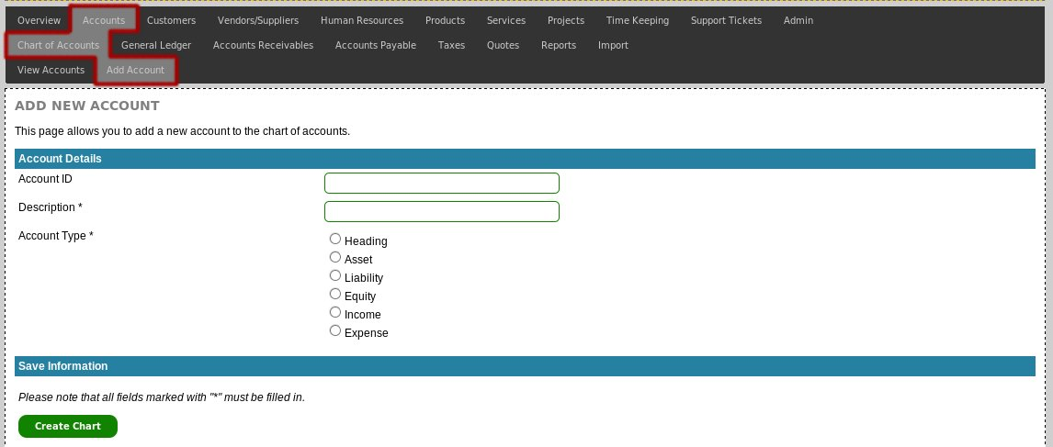

Required Fields:
- Account ID (Leave blank to receive an automatically generated ID)
- Description
- Account Type

Account Types

The Amberdms Billing System conforms to standard double-entry account account types. The table below has a brief description of what each account type is suitable for.

Type | Details
Heading | non-usable account – used for ordering the accounts on the chart of accounts page.
Asset | Use for bank accounts and also Accounts Receivables.
Liability | Use for sales taxes and also Accounts Payable
Equity | Use for investments into the business
Income | Use this account for all products/AR invoice line items
Expenses | Use this account for all expenses and AP invoice line items.

Once all fields have been entered, click “Create Account” button to add the new account. Once the new account has been created, you will be provided with further menu options for the account.

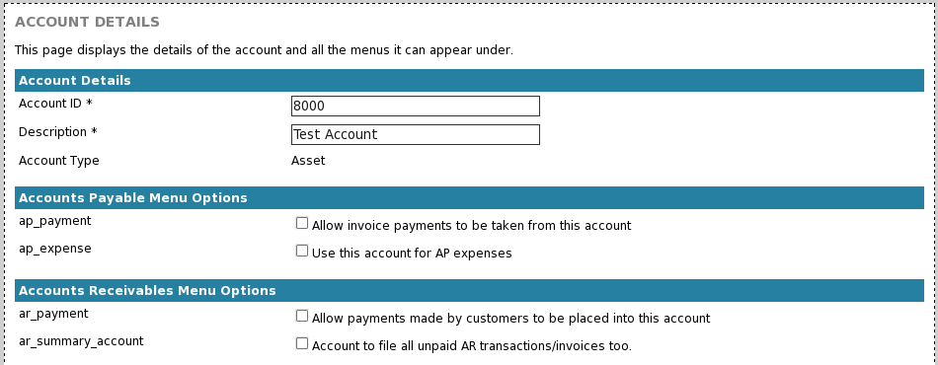

The account menu options are used to configure in what sections of the program each account should appear. The options are labelled with descriptions to show where each account will appear – use these options to configure the account to suit.

Note: Only menu options relevant to your account type will be displayed, so the available menu options will differ from account to account.

Listing Accounts (Chart of Accounts)
To display a list of all the accounts, use the “Chart of Accounts” feature, which can be accessed using the menu at “Accounts -> Chart of Accounts -> View Accounts”.

The Chart of Accounts page displays a table showing all accounts and their current balances.

If you wish to view the account settings, click the view link to the right of the account row, or click the “ledger” link to view the account ledger. (see the view account details in the section below)
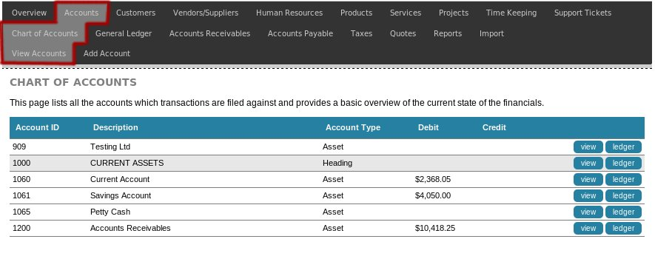
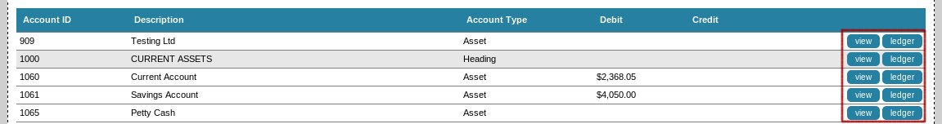
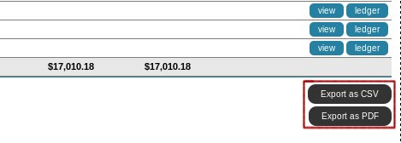
You can also export the data in alternative formats, which will export the exact same data as currently displayed.

View Account
To view or edit an account, use the details in the section above to display a list of all the accounts, then select the account using the options links on the right, to go to one of the various view pages.

Account Details
The account details page allows you to view all the account details/settings and if you have relevant permissions you may adjust them.

Account Ledger
The account ledger shows all transactions or invoices made to the account. You may use the options box at the top of the table to filter or search the ledger.

If you wish to view more information about each transaction, click on the transaction ID hyperlink to be taken to the full details.

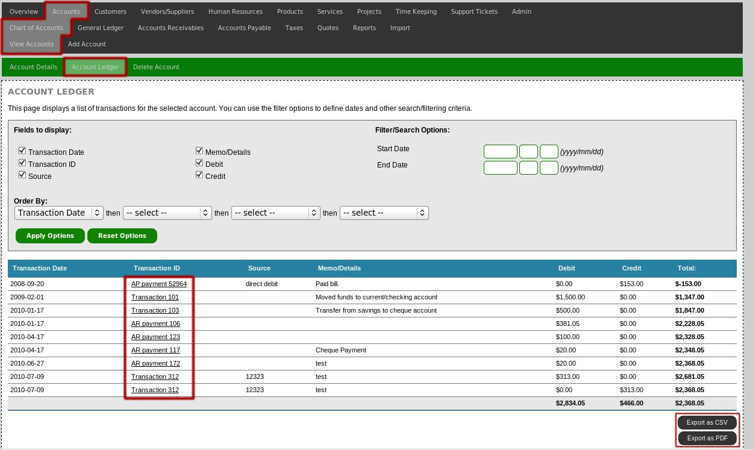
If you wish to export the ledger to another format, use the link at the bottom of the table to export as CSV output.

Delete Account
Unwanted accounts may be deleted, provided that there are no transactions in the account ledger.

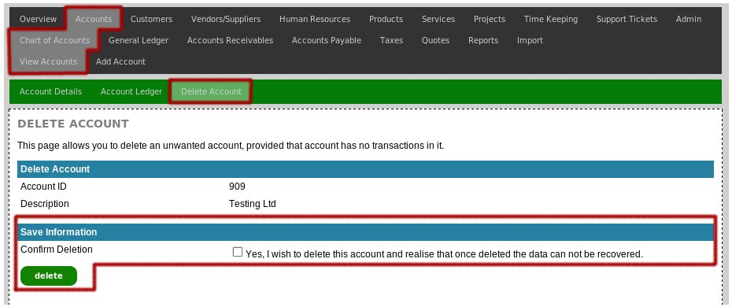

If there are transactions in the account ledger, there are two options:
- Modify the transactions to use a different account. Once the ledger has been emptied the account will be able to be deleted.
- Rename or adjust the account ID to suit your purposes.

Accounts: Sales Taxes

The Amberdms Billing System has support for multiple sales taxes (such as VAT or GST). You have fine-grained control over taxes on customer, vendor, product and service pages, however before you can configure taxes in any of those locations, you must first define what sales taxes exist.

Add Tax
Select “Accounts -> Taxes -> Add Taxes” to add a new tax to the billing system.

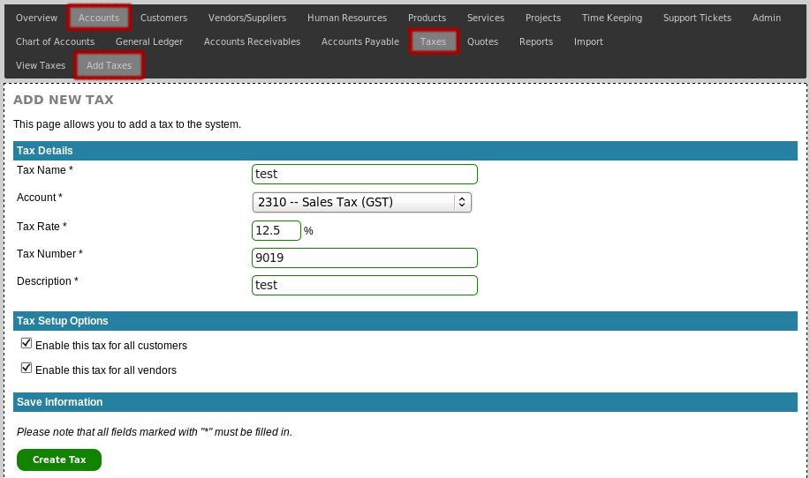

Required Fields:
- Tax Name
- Account
  - The account where tax transactions are assigned – this account needs to be a liability account which has the tax_summary_account menu option enabled.
- Tax Rate
  - Percentage of tax rate.
- Tax Number
  - Your business's tax number which which will be displayed on invoices.
- Description

When you create the tax, you can also decide whether you want to automatically enable the tax for all customers and/or vendors in the database.

Once all fields have been entered, click “Create Tax” to add the tax to the billing system.

Listing Taxes
Select “Accounts -> Taxes -> View Taxes” from the menu to display a list of all taxes. You can also export the data in alternative formats, which will export the exact same data as currently displayed.

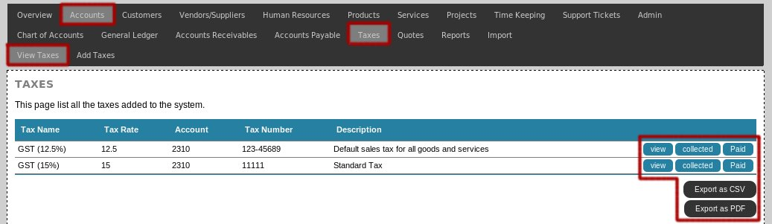

View Tax
There are multiple pages showing different details for the selected tax. First, select the tax you wish to view, by accessing the tax list (see section above) and then select one of the options to the right of the tax name.

Once you have loaded one of the view pages, you can use the navigation menu to access other view pages.

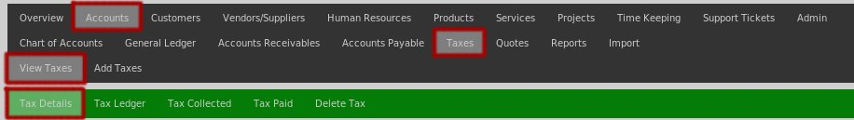

Tax Details
The tax details page displays the basic information about the tax, it's account and the tax rate and allows you to adjust the details.

Note: If you adjust a tax rate, it will only take affect on any new invoices you add – existing invoices will remain unchanged.

Tax Ledger / Tax Reports
The tax ledger provides all the information required for completing sale tax returns. This page allows three different view modes:
- Display tax collected.
- Display tax paid.
- Display account ledger.

The ”Tax Collected Report” and “Tax Paid Report” allow you to generate totals for specific periods and also provides options to either calculate on a cash basis or invoiced/accrual basis.

Please see the accounting reports section in this document for details and examples of the tax paid/collected reports.

Deleting Taxes
When required, taxes can be deleted from the billing system, provided that the tax has not been used by any invoices.

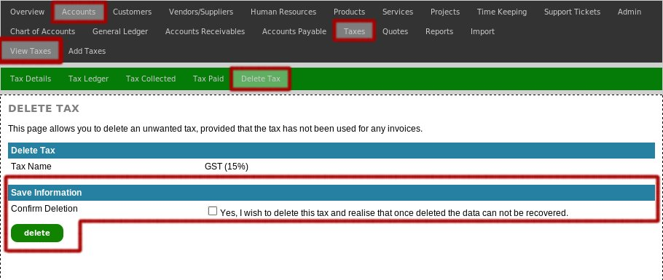

Accounts: General Ledger
The General Ledger is used to view all the transactions made for your organisation as well as allowing you to make transfers/transactions between different accounts.

Displaying the General Ledger
To display the general ledger, access the “Accounts -> General Ledger -> View GL Transactions” page. This will display all the transactions and provides links to view more details for each transaction.

Note: By default the General Ledger is set to filter the list to only transactions in the current month due to the typically large size of the ledger. You may change this using the filter options at the top of the ledger.
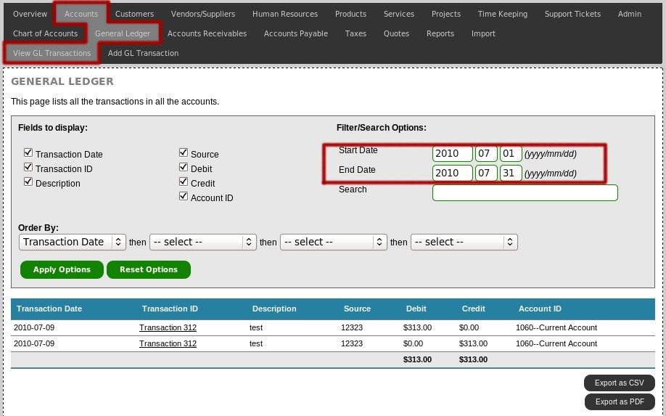

Creating General Ledger Transactions
You will want to create General Ledger Transactions when you need to transfer money from one account to another. You will want to use General Ledger Transactions for any of the following situations:

- Transferring funds between your own bank accounts.
- Paying your outstanding sales tax bill from your bank account.
- Paying back capital investment by business owners.

General Ledger Transactions can be identified in the General Ledger with the Transaction ID of “Transaction #”.
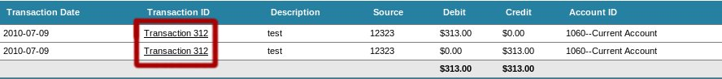

Adding a new GL Transaction
To add a new transaction, access the “Accounts -> General Ledger -> Add GL Transaction” page.
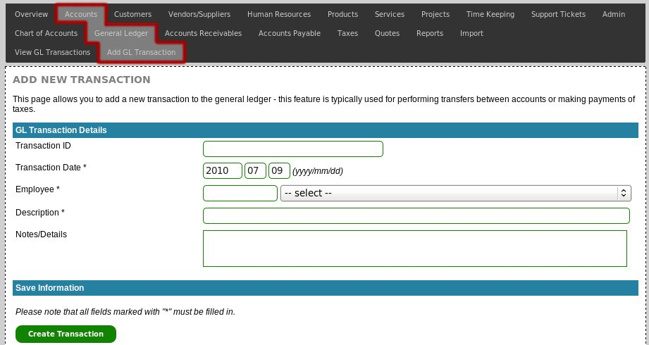

Required Fields:
- Transaction Date
- Employee
- Description

Click “Create Transaction” to create the new GL Transaction. You will then be given the screen to allow you to configure the transaction rows – see below for information about the transaction rows.

Adjusting a GL Transaction
To adjust an existing GL transaction, simply click the transaction ID in the General Ledger. This will display a single page showing the transaction and all of it's transaction rows.

The transaction rows allow you to define how much is taken from an account (credited) and how much is placed into an account (debited). GL transactions require that all the rows are balanced – so the total credited must always match the total debited.

When done, click “Save Changes” to save all the transaction rows – if the rows are unbalanced the billing system will inform you and allow you to correct them.

Note: Each transaction row can have a custom description, or you can just leave the default option “Description Useall” checked to use the general transaction description for all the transaction rows.

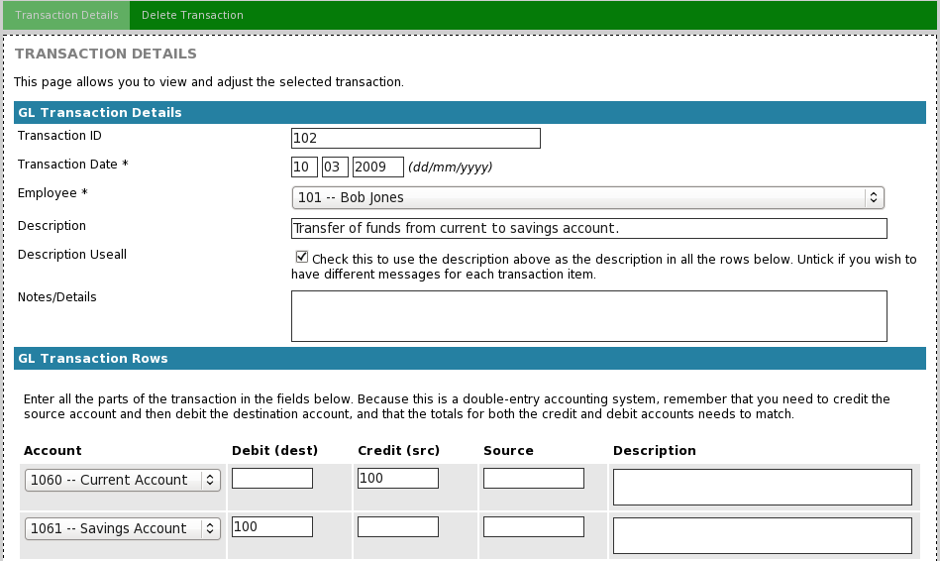

Deleting a GL Transaction
To delete a GL Transaction, first click the transaction ID in the General Ledger to display the transaction details.

Once open, select the “Delete Transaction” option from the navigation menu. This will display the delete transaction page, which will allow you to delete the transaction, provided that the transaction has not been locked by the audit locking feature.

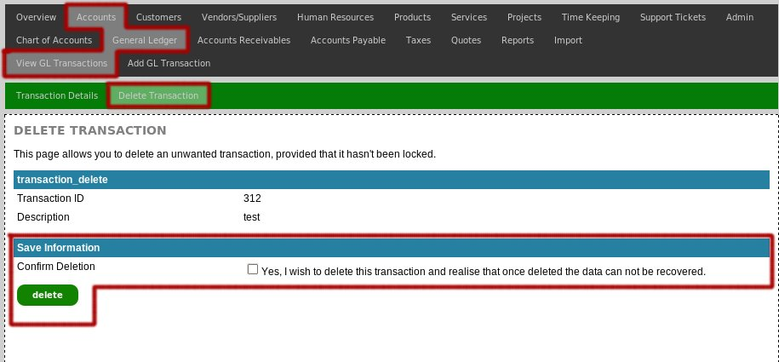

Accounts: Import
ABS includes a bank statement import function that allows a CSV file statement to be uploaded and imported as payments against invoices or general transactions.

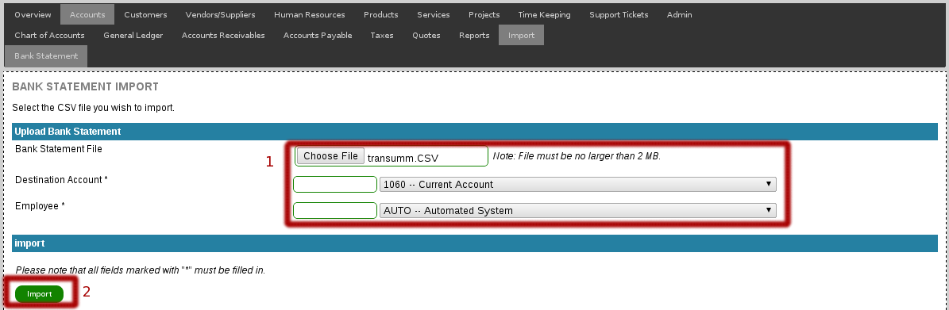
To import data, export the transactions as CSV from your bank/legacy system and upload in Accounts -> Import -> Bank Statement.

After uploading the file, various import options will be displayed – depending on your configuration, a number of pre-defined banks might exist [3], otherwise you will need to define the column/field configuration – due to the lack of a single standard, ABS provides an interface that allows custom configuration.

When setting up a new import configuration, example content will be displayed from the last row of the imported file (we choose the last row, since often files have incorrect header rows) to assist with column alignment.

Note that the Date Format field will accept / or – variations correctly, as long as you select the correct month, day, year arrangement.
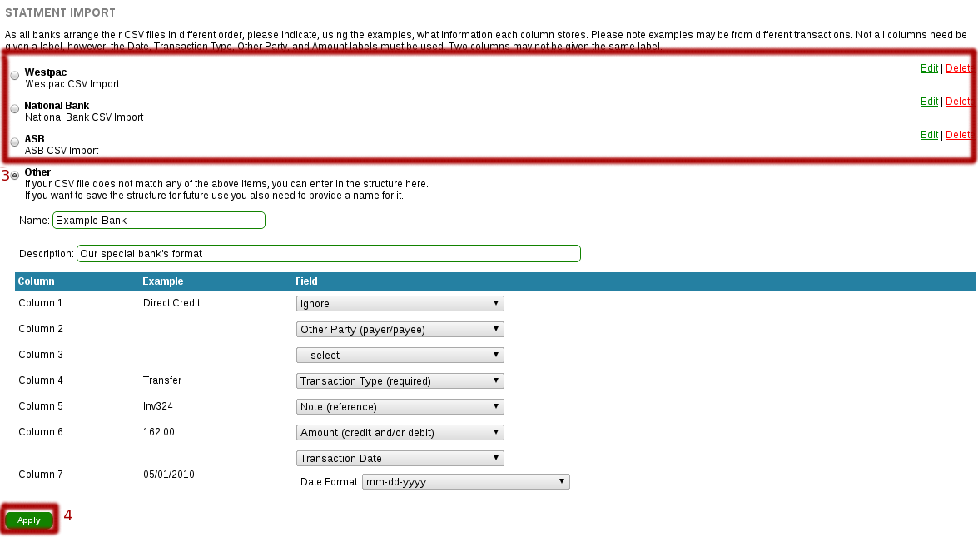
Once you apply [4], the page will reload with the imported bank statement on display – when the load takes place, ABS will try to automatically match transactions as well as it can – in particular:

- Checks other party name to determine if it's a vendor/customer payment.
- Checks payment reference for invoice or customer numbers. (having customers enter this will improve processing ease)
- Automatically matches transactions of specific value to matching invoice amounts.

Once automatic matching has taken place, it can be adjusted/corrected as required – changing the main transaction type [5a] provides additional type-specific options in additional dropdowns [5b].

Once a transaction has been correctly assigned, a tick will appear confirming that it has all the information needed [5d] – although if it doesn't and you want to process manually later, you can check the – symbol [5c] so that it grays out the transaction, thus excluding it from the import.

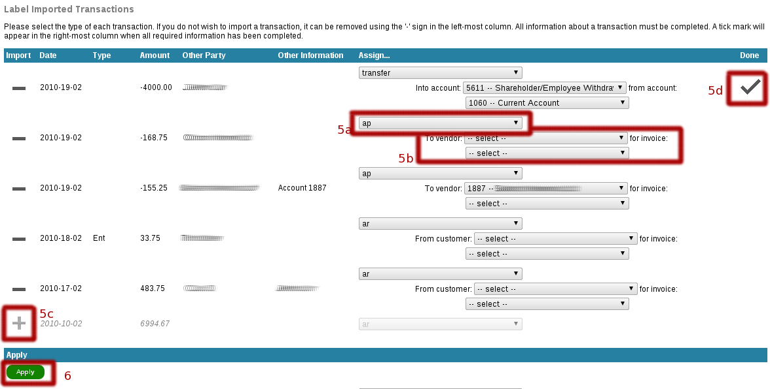
Once complete, click “Apply” to import the selected transactions – ABS will gracefully handle any errors by returning to the import screen if you've missed any information.

Once you've configured the import tool for your specific bank and have customers/vendor names correctly configured import will be fast and smooth

Human Resources
In order to be able to add invoices or perform time keeping, you must define all your staff in the HR section.

Add Employee
Select “Human Resources -> Add Staff” to add a new employee to the billing system.

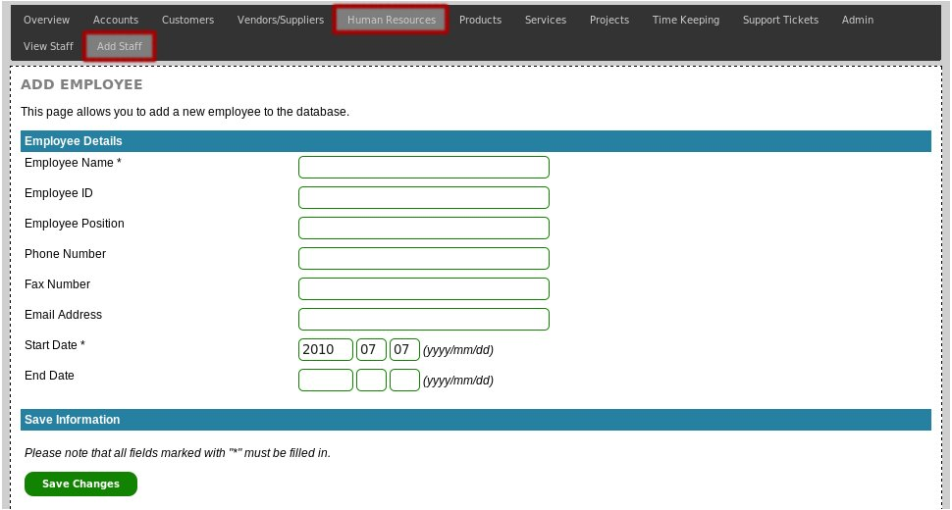

Required Fields:
- Employee Name
- Start Date

Once all fields have been entered, click “Save Changes” to add the employee to the billing system.

Listing Employees/Staff
Select “Human Resources -> View Staff” from the menu to display a list of all staff.

You can use the options at the top of the page to configure any filters or search strings. You can also export the data in alternative formats, which will export the exact same data as currently displayed.

View Staff
There are multiple pages showing different details for the selected employee. First, select the employee you wish to view, by accessing the employee list (see section above) and then select one of the options to the right of the employee name.
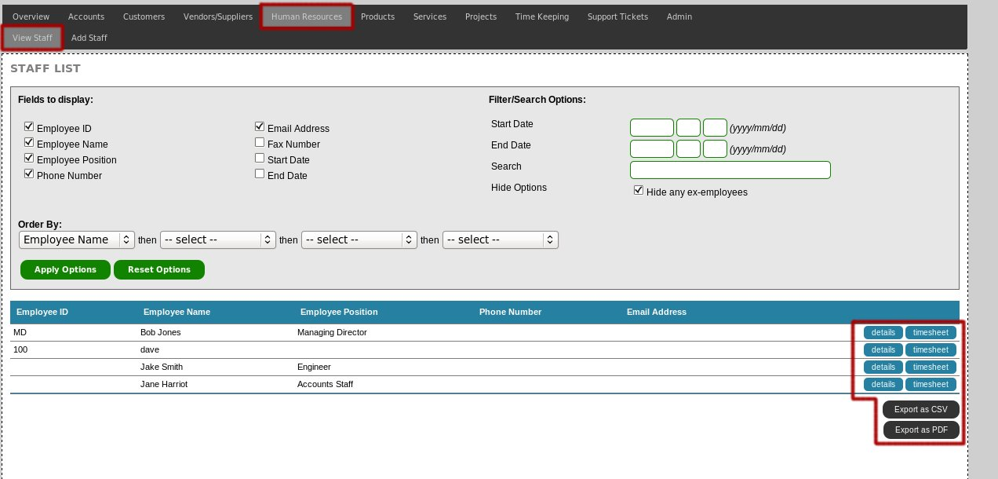

Once you have loaded one of the view pages, you can use the navigation menu to access other view pages.

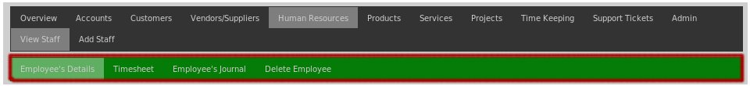

Employee's Details
The employee details page shows all the information and basic details for the selected employee.

Employee's Timesheet
You can view all the time the selected employee has booked to the system by accessing the employee's timesheet page.

You can use the options to only show unbilled time or time that has been booked between a specific date range.

Employee's Journal
The employee's journal is an area to attach notes and files to a employee. These notes are readable by all other users with staff_view permissions and can be a good location for storing documents such as employee tax records

Delete Employee
When required, employees can be deleted from the billing system, provided that there are no invoices, payslips or time booked by the employee.

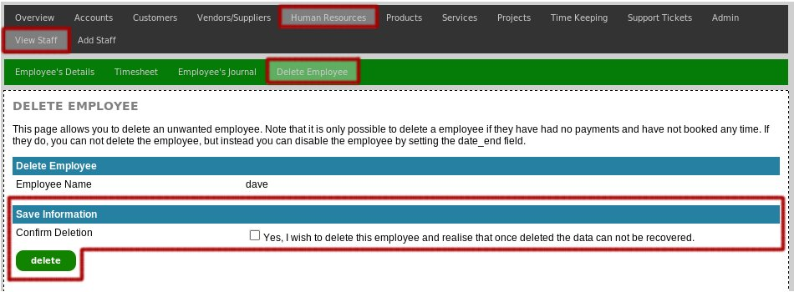
If the employee is unable to be deleted, the billing system will inform you of this and instead of deletion, you should set the end date field on the “Employee's Details” page.

This will not delete the employee, but will hide them from the list of active staff members.

Products

The Amberdms Billing System allows two types of items to be added to invoices:
- Basic Transaction
- Products.

Basic transactions are designed for quickly creating basic invoices, such as a taxi fare, where there is a varying amount and you simply wish to allocate the amount to a specific account.

For more advanced invoices you will want to use products, which allow you to define cost & sale prices, taxes and accounts in advance.

When you add a product to an invoice, all these defaults are then used to set the item (although they can be over-ridden) making it quick and easy to create invoices.

Consultancy or labour work is also classified as a product in the Amberdms Billing System. You define a product with the hourly rate of the labour and when you add a time group from the time sheet to the invoice, the product is used to calculate the charge.

Manage Product Groups
Products can be placed in different groups – this provides improve display of long lists of products in the ABS UI, but also provides subheaders on certain invoice templates when products are grouped.

Product groups and service groups are linked to some level on invoices, if groups have the same naming/structure product and service items will appear under the same headings on the invoice.

View Product Groups
Select Products -> Manage Product Groups to display all configured product groups.

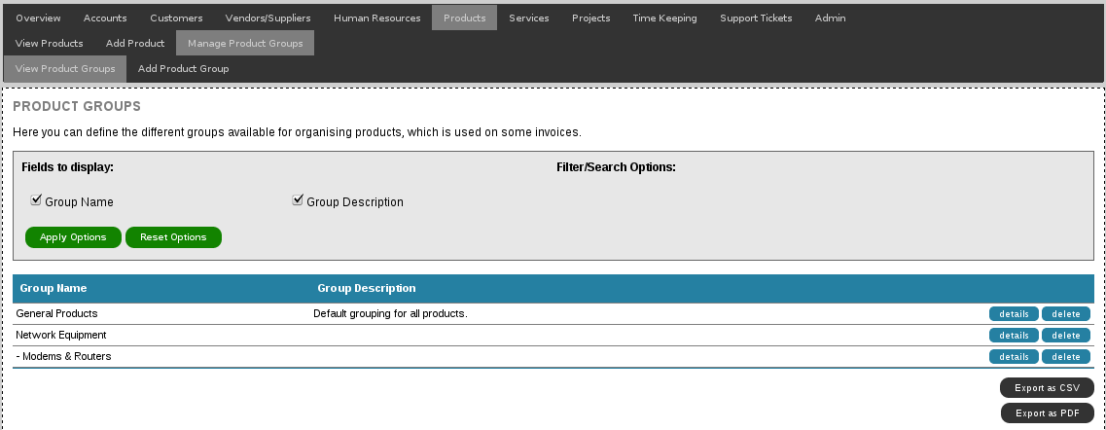

If you select a product group that has a number of member products, they will appear when viewing the product group details and provide the ability to access from within the group.
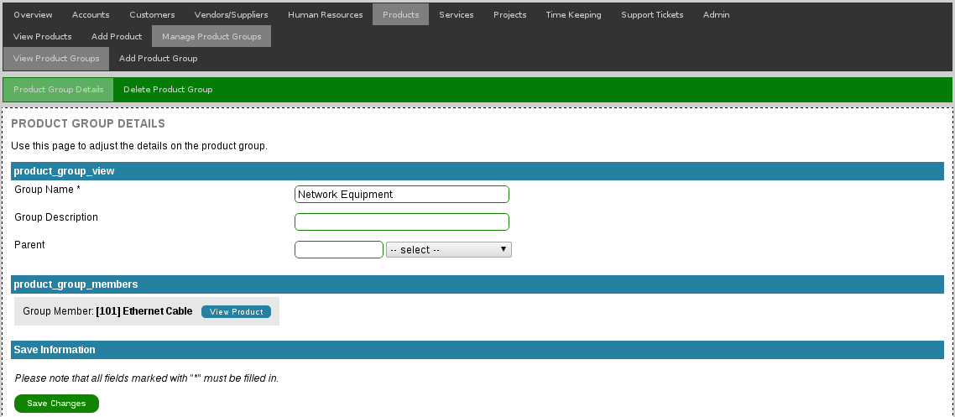

Add Product Group
Adding a product group involves going to Products -> Manage Product Groups -> Add Product Group and from there setting the group name, optional description and choosing which group is the parent (if any).

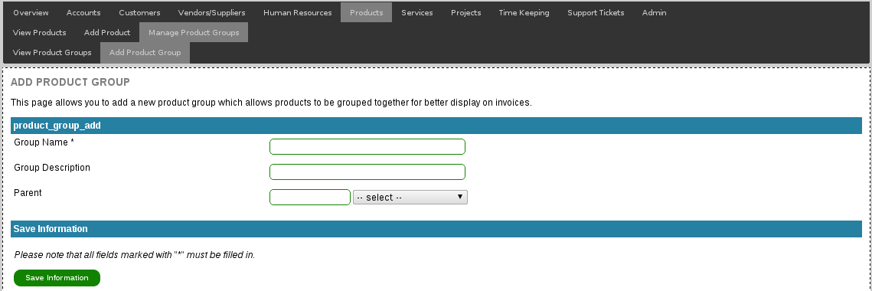

Delete Product Group
Product groups can be deleted, as long as they are not currently assigned to any products – if they are, use the product group details page to update each product first.

Adding a new Product
Select Products -> Add Product to add a new product to the billing system.

First enter the basic product details – the ID can be left blank for an automatically generated unique value, but you will need to set the product name, chose the groups it belongs to, the accounts used and the units the product is sold in (eg: “litres”, 'kgs” or just “units” or “items”).

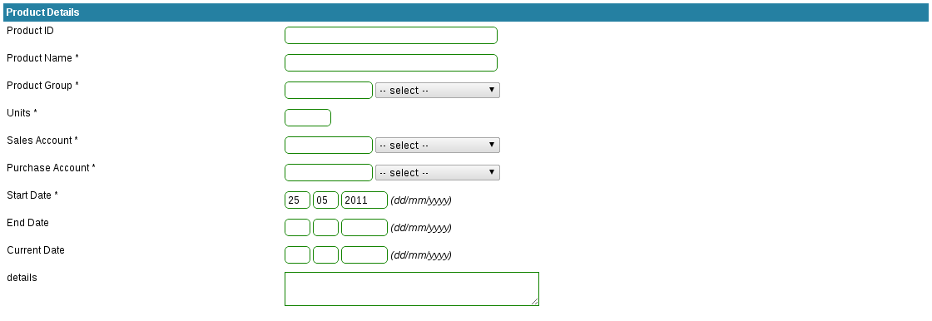
For product pricing, you need to define both the sale and the cost price – the cost price is used when the item is added to an AP invoice (when buying from a supplier), the sale price is used when adding the item to an AR invoice (when selling to a customer).

Discounts will apply to both purchase and sale.
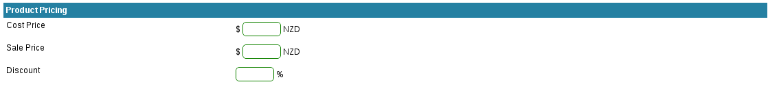

After setting the basic product details, it is important to also set the taxes that apply for the product – remember that a tax will only be applied to a product if the tax is enabled for both the product and the customer/vendor.

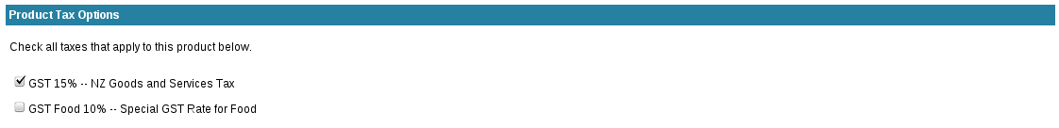

Finally, set the stock volume details (if any) and optionally detail information relating to the supplier – this information is currently stored as a reference only, in future versions of ABS there may be integration to allow for more accurate stock reporting based off sales data.

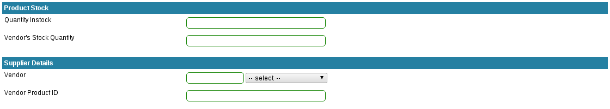

Once all fields have been entered, click “Save Changes” to add the product to the billing system. You can now bill products by creating an invoice and adding the product item or by adding the product to a customer's orders page.

Listing Products
Select “Products/Services/Projects -> Products -> View Products” from the menu to display a list of all products.

You can use the options at the top of the page to configure any filters or search strings. You can also export the data in alternative formats, which will export the exact same data as currently displayed.

View Products
There are multiple pages showing different details for the selected employee. First, select the product you wish to view, by accessing the product list (see section above) and then select one of the options to the right of the product name.

Once you have loaded one of the view pages, you can use the navigation menu to access other view pages.

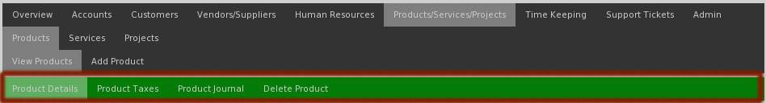

Product Details
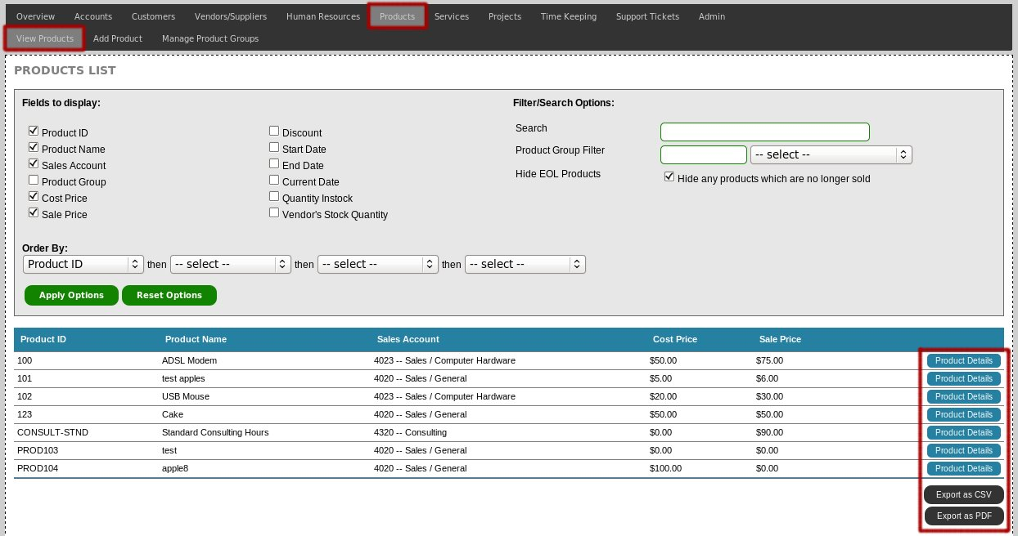
The product details page shows all the information and basic details for the selected product, such as price, accounts and supplier details.

Product Journal
The product journal is an area to attach notes and files to a product, which are then readable by any other user with products_view permissions.

The journal is an ideal location to add information about product ordering, attach copies of product specification documents or just general notes about how the product works.

Delete Product
When required, products can be deleted from the billing system, provided that no invoices have the product assigned to them.

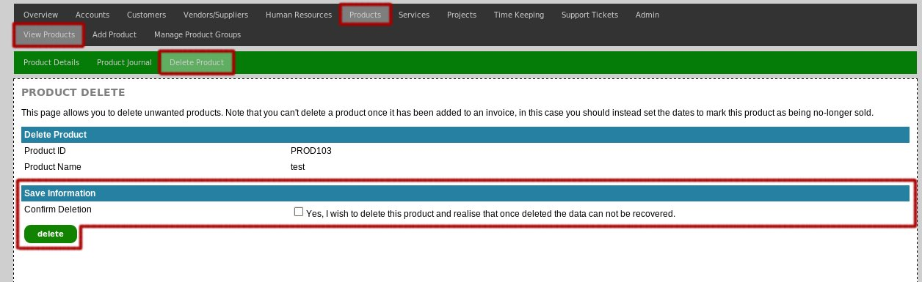
If the employee is unable to be deleted, the billing system will inform you of this and instead of deletion, you should set the end date field on the “Product Details” page.

This will not delete the product, but will hide the product from the list of active products.

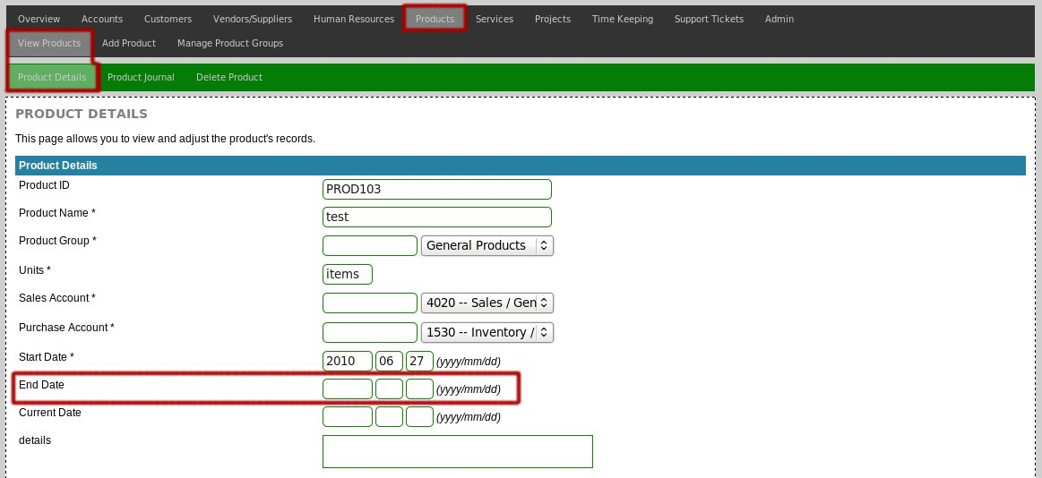

Services: Capabilities & Billing Logic
In the Amberdms Billing System, services are used for regular billing of a provided subscription service for a customer. An example use would be for billing of ISP internet connections, electricity usage, support desk hours or re-occuring software license subscription costs.

Amberdms has designed this application to make it ideal for use with usage-based services typically found in ISP or hosting environments.

Some of the features offered by the services functions in the Amberdms Billing System:
- Regular base-fee billing
- Billing of excess usage (for example, customer's data usage over their data cap)
- Different period billing modes (can bill on the calender month or just on the date of renewal, as well as telco-style billing)

Supported Billing Cycles
Services billing cycles are configured on a per-service basis, providing flexibility to handle different service offerings in the best way appropriate.

Billing Cycle | Details
weekly | Every week (7 days)
fortnightly | Every two weeks (14 days)
monthly | Every calender month.
quarterly | Every quarter (3 calender months)
6monthly | Twice a year.
yearly | Once a year.

Not all billing cycles are appropriate for all organisations, administrators have the ability to disable/hide undesired billing cycles on the Administration -> Configuration -> Services page, if a cycle is not in use it can be hidden from the user interface to simplify configuration.

Supported Billing Modes

Available Modes
All services can also have their billing modes configured – some services might need to be billed before delivery, some can only be billed after delivery and there are special use cases for telecommunications providers who often want to invoice the service in advance but the usage in arrears.

Billing Mode | Details
periodend | Only bill the service once the period has finished.
periodadvance | Bills the service in advance of the next service period beginning.
monthend | Always bill for the service at the end of the calender month. This means all customer service periods will start on the first of the month and end on the last day of the month.
monthadvance | Always bill for the service in advance, but the service periods will end at the end of the calender month.
periodtelco | Bill the plan portion of the service on the first date of the period and the usage for the previous period.
monthtelco | Bill the plan portion of the service on the first date of the calender month and the usage for the previous calender month.

Configuration
Refer to the Services: Configuration section below for information about configuration options that will impact service billing modes.

Recommendations
Amberdms has a number of recommendations/suggestions for service configuration to enable optimal billing – ABS provides a number of options, to enable users moving from legacy billing systems or with billing policies that need to be maintained, but these are the recommended options for new setups.

Note that we already recommend period-based billing, rather than monthly-based billing – by billing on a period basis, there is less load at month end and invoicing will be spread across the month as well as encouraging a more steady stream of cashflow rather than an end-of-month peak.

Typically you will want to obtain funds from customers as soon as possible, these recommendations are written accordingly, although periodend may sometimes be more attractive than periodtelco as the bills are simple and easy to understand.

Use Case | Recommendation
Fixed-price support contracts | periodadvance
License fees such as domain renewals or memberships. | periodadvance
Flatrate/fixed-fee ISP services such as flatrate internal connections. | periodadvance
Any other non-usage service | periodadvance
Usage based ISP services such as internet connectivity or call/VoIP billing services. | periodtelco or periodend
Any other usage service | periodtelco or periodend

Important Notes
There are a few points to be aware of:

- Any usage service can not use periodadvance or monthadvance modes, as we can not bill for usage in advance of the usage occurring, only periodtelco, monthtelco or periodend, monthend will be available

- When subscribing a customer to a new monthend or monthadvance service, the first billing period will be extended to cover the partial month when the customer is added and the full following month.

If the service is a usage service, the billing system will automatically re-calculate the customer's included units and base fee for the extended period and bill accordingly.

For example:
    - Customer is added to a new monthend service on 2008-01-15 which has the monthly cost of $100.
    - Their first billing period will run from 2008-01-15 until 2008-02-29.
    - Their first bill will be sent out on 2008-03-01 with the total cost of $151.61.
    - Their next bill will be sent out on 2008-04-01 with the total cost of $100. (normal billing pattern)

Supported Service Types
The services feature has a number of predefined service types for you to make use of:

Service Type | Details
bundle | A special service which allows multiple other services to be grouped together into a single bundle charge/fee.
data_traffic | Used for ISP billing of internet connections – supports billing by MB or GB and includes options to count by 1000 or 1024.  Multiple data caps can be defined (eg separate international vs national caps) and per cap data caps and excess charges can be configured.  Usage notifications to customers are also supported with notifications done on a per-cap basis.
generic_no_usage | Generic service with no usage billing – use this for a regularly occurring fixed-price service.
generic_with_usage | Generic usage service – this service type is very flexible and can bill usage information in three different ways:  - Bill for the total amount of usage during the period (incrementing)  - Only bill for the peak usage – ie: the largest amount of usage during the period.  - Bill for the average usage during the period.  You are also able to define the units to bill in, the number of units includes and the cost for any excess units.
licenses | The licenses service type is designed for use with software subscription services and allows billing per number of licenses.  This service type allows you to specify the number of licenses included and the cost of additional licenses above that – this is ideal for when you create a package with the first X number of licenses at a reduced cost.  When you add a license service to a customer, you are able to specify the quantity of licenses that the customer has.
time | Useful for either ISP billing of dialup services but can also be used for the number of hours in support agreements or service plans.
phone_single | Provides a phone/VoIP service for a single phone with a single DDI/phone number.
phone_trunk | Provides more advanced phone/VoIP services with multiple DDIs/phone number and multiple concurrrent calls/trunks.
phone_tollfree | Provides a single inbound DDI/phone number, with charging done on inbound calls rather than outbound.

Service Usage Record Collection

For usage-based services, ABS has two primary methods of collecting usage record information for billing.

- Usage records are mapped to the customer's service by an external application and then provided to ABS via the SOAP API.
- Usage records are stored in an external database which is then queried by ABS directly.

The former option is supported for all usage services, whereas the latter has been implemented for only data_traffic and phone_* services with specific MySQL database structures.

SOAP API Collection
To add usage records for usage based services you need to write an application capable of talking to the Amberdms billing system via the SOAP API.

Amberdms has made this easy by including sample source code under a permissive MIT license to allow you to easily develop your own usage reporting scripts.

Direct MySQL Query
Direct database queries have been implemented to allow ABS to work effectively with large usage record databases, typically DBs such as large netflow or CDR databases used by ISPs and service providers.

If the external database has decent indexing and ideally daily aggregation, performance will be fast and will keep the Amberdms Billing System's database at a minimal size.

The use of an external database also makes it easier to truncate older unnecessary billing records, such as records older than 2 months which are no longer required for billing purposes.

Service usage record collection is detailed more throughly including supported database schemas in the associated companion documentation “Amberdms Billing System Service Usage Collectors” which should be referred to for all usage collection related information.

Services: VoIP / Phone Billing
ABS ships with comprehensive VoIP/Phone billing services designed for VoIP providers offering a range of services.

A number of phone services have been defined and configuration information is detailed under Services: Management including instructions on setting up the plan.

This section of the documentation details how the billing logic and capabilities of VoIP components work, as well as configuration of CDR Rate Tables.

How CDR Rate Tables Work

Call pricing is set in rate tables, which are databases listing different numerical prefixes, regions and rates. When a call is billed, the call destination/source numbers are run against this database and determined from that.

A single rate table will contain all the different regional prefix for national calling as well as international prefixes, so can end up sometimes around several thousand entries.

For phone services, such as phone_single, phone_trunk or phone_tollfree, multiple call rate tables can be defined which can be assigned to different services or used across multiple services as desired.

When pricing a call, the following main checks are run:

- Prefix of the source and destination numbers are resolved from the CDR Rate Table – this works be shortening the numbers till they match a prefix.

- Is the call within the local prefix? The local prefix can be defined in two ways – either a specific number prefix or a region name, which we lookup and resolve to multiple prefixes. If the call is in the local prefix, we charge it at the “LOCAL” rate.

- Is the call going to one of the customer's own DDI numbers? If so, we should charge at LOCAL rate.

- If unbilled, match to the rate of the prefix identified by step 1.

- If the destination had no prefix match, then we fall back to the DEFAULT rate.

Also be aware that:

- It is possible to override the call prices on a per-service as well as per-customer basis, to enable the creation of specific package prices/deals.

- Discounts do not make any impact on call prices for a service, regardless of the discount on the service or customer.

About Overrides
Sometimes as a vendor, it may be necessary to adjust a specific customer's pricing in order to create an offering that better competes with other providers – this might include options like free calling between certain numbers or free calling.

In this situation, ABS has the ability to set customer-specific or service-specific rate overrides – after assigning a rate table to a service, rates can be adjusted or additional prefixes added with any rate desired, with customised rates clearly identifiable on the configuration pages for the service or for the customer, as per the below screenshot:
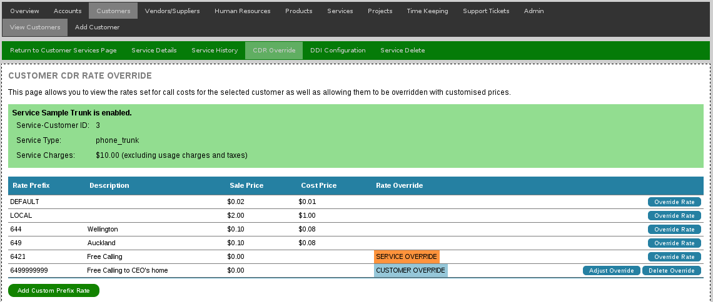

Managing Rate Tables
Before configuration of any call services can take place, at least one rate table must be defined. This can be done by accessing the Services -> CDR Rate Tables page.

Creating a Rate Table
To create a new rate table, access Services -> CDR Rate Tables -> Add Rate Table. Assign the rate table name and description, along with a usage mode.

The vendor option is currently only useful for reference purposes, but in future may be extended so that ABS will be able to match the total call history made with that supplier to check for billing mistakes.

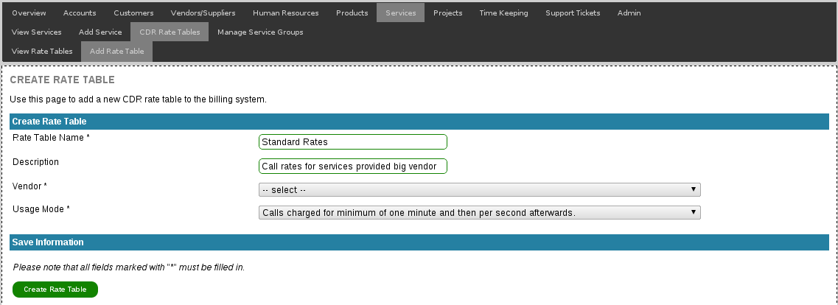

Importing Rates
Unless you are dealing with a very minimal set of calling prefixes, it will be easiest to entire regions via the import function from a CSV upload file.

To import, select the rate table and then Import Rates from the nav menu and select the type of import and the file you wish to upload for the import.

ABS currently supports two types of import:

- Generic CSV formatted file – requires 3 columns – prefix/number, region/description and cost or sale price.

The generic CSV import allows you to map the columns at import time, as well as having the ability to automatically calculate sale price off the purchase price by applying a margin percentage if desired.

Prefixes need to be the international dialcode as recorded by your PABX, either one per row, or multiple per row when separated by commas only.

The following are both acceptable examples:

TODO: picture: CSV simple

TODO: picture CSV advanced.

- New Zealand Number Administration Deed (NAD) format

NAD is a specific regional number format DB for New Zealand, which is found online at http://www.nad.org.nz/, with various formats of CSV file for different regions/number types.

The import function allows the upload of NAD Geographic files and the assignement of a national calling rate which will be applied to all numbers in that region.

TODO: screenshot NAD import options.

Viewing and Adjusting Rates
It is possible to directly adjust rates without having to use the import functions. To adjust, access Services -> CDR Rate Tables page and select Items to add or adjust existing rates.

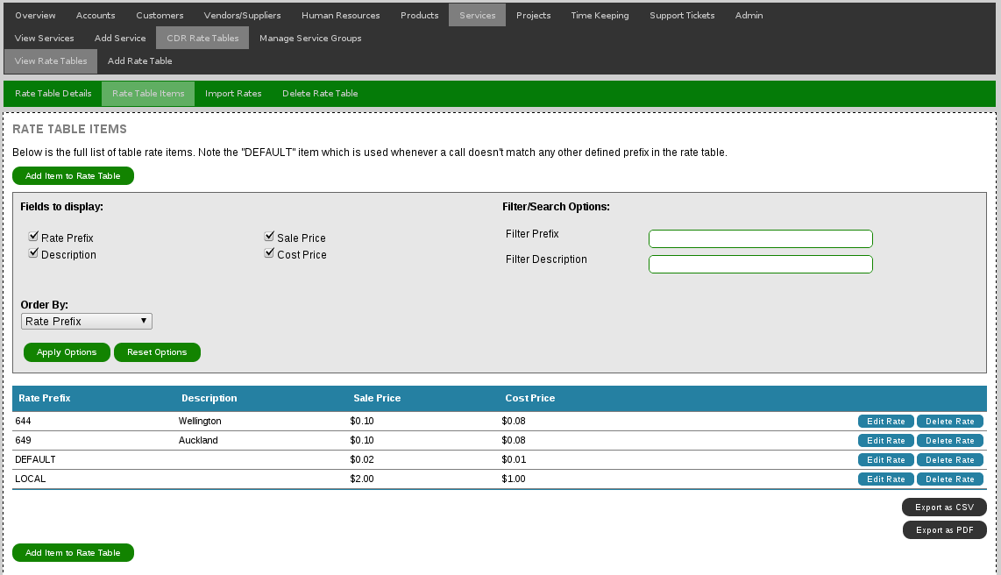
When adding a rate, make sure you use the full international code (or another prefix appropriate for your VoIP platform), if you use the wrong prefix digits, the rates won't match to calls.

Deleting Rate Tables
To delete a rate table, access Services -> CDR Rate Tables and click the delete button.

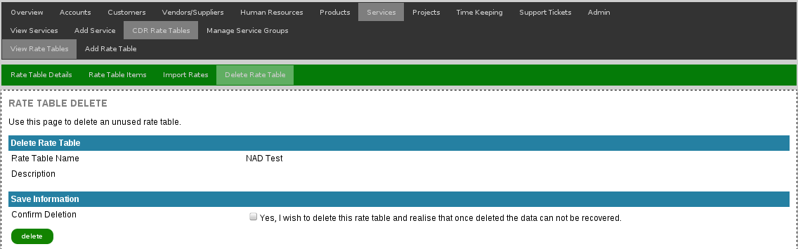
Before you can delete, confirm the action. If the rate table is being used by a service, you will be unable to delete the rate table until you update the services that are currently using it.

Services: Data Traffic Services

ABS includes a powerful and capable data traffic billing service designed for ISPs selling services that range for simple uncapped plan to services with varying regional caps and pricing models.

About Traffic Types
Traffic Types in ABS allow different traffic types to be defined – these types may refer to different regions of traffic (for example, national or international) or different types of traffic, such as unrated or ISP cached traffic.

ABS doesn't (as of 1.5.0) do route matching or identification of which traffic flows should fall into which region, rather ABS expects the data source to have matched the traffic type to the configured traffic type labels.

For more information about service usage data import, please refer to Service Usage Collectors documentation.

Managing Traffic Types
In order to define data caps other than All/Any, traffic types must be defined. To do so, first access the Services -> Traffic Types page.

Creating New Traffic Type
To create a new traffic type, go to Services -> Traffic Types -> Add Traffic Type and complete the form:
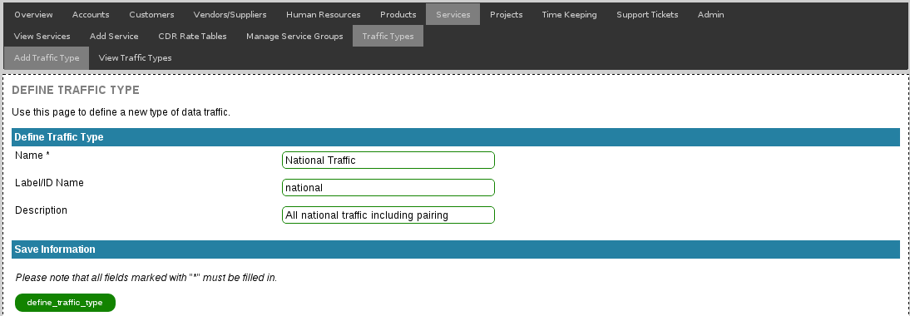

Note that the label is the most important field, this label is used when querying the traffic database to match the traffic types, however is not displayed anywhere to the customer – set the name field to the customer/service/invoice appropriate value.

Adjusting Existing Traffic Types
To adjust an existing traffic type, go to Services -> Traffic Types -> View Traffic Types and select “details” to adjust the traffic type or “delete” to (attempt) to delete the traffic type.

Deleting Traffic Types
Traffic types can only be deleted if they are not currently used by any services – if they are inuse, they can be adjusted but not deleted until the service itself is modified.

To delete, select Services -> Traffic Types -> View Traffic Types and select “delete” on the appropriate entry.

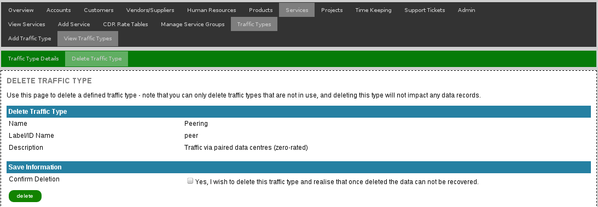
You must confirm deletion before any changes will be made – note that deleting the service type will not delete any data from the usage database nor will it impact any existing invoices.

Services: Management
This section of the documentation details how to create, adjust and manage services, so that they can then be added to a customer in the subsequent Services: Customer Assignment section of the documentation.

For information about the service billing concepts and functionality, please refer to the previous section, Services: Backend & Configuration.

Manage Service Groups
Services can be placed in different groups – this provides improve display of long lists of services in the ABS UI, but also provides subheaders on certain invoice templates when services are grouped.

A typical use case is the separation of call services from data services on an ISP invoice – service groups allow the different components to be clearly displayed on the invoice.

View Service Groups
Select Services -> Manage Service Groups to display all configured service groups.

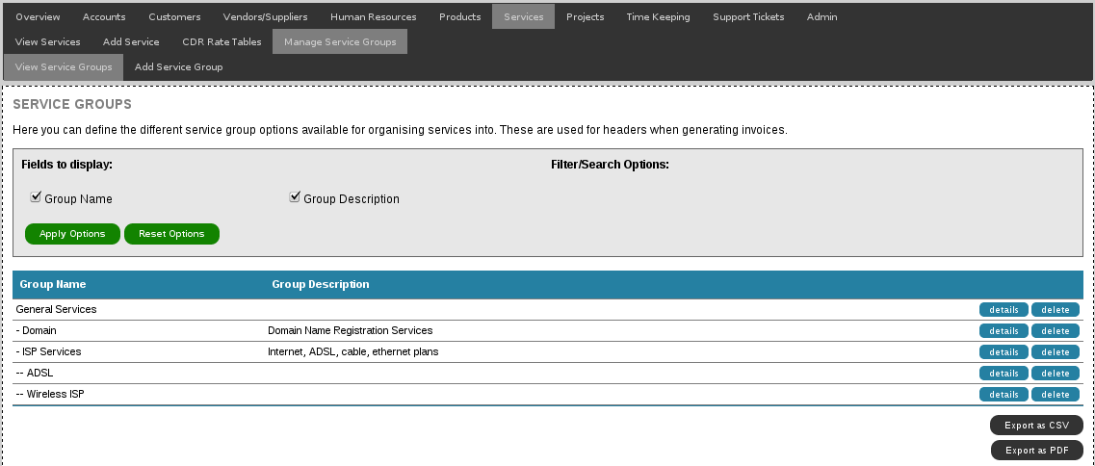
If you select a service group that has a number of member services, they will appear when viewing the service group details
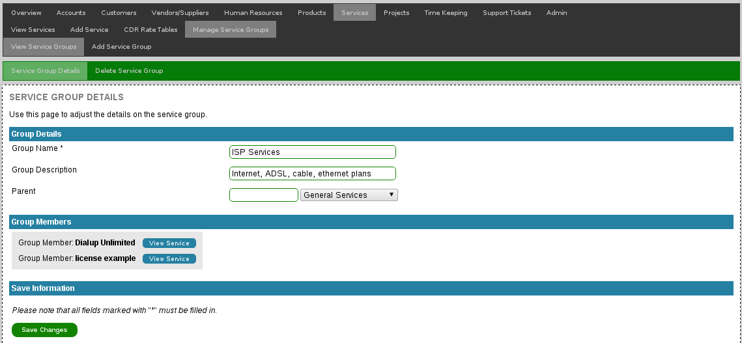

Add Service Group
Adding a service group involves going to Services -> Manage Service Groups -> Add Service Group and from there setting the group name, optional description and choosing which group is the parent (if any).

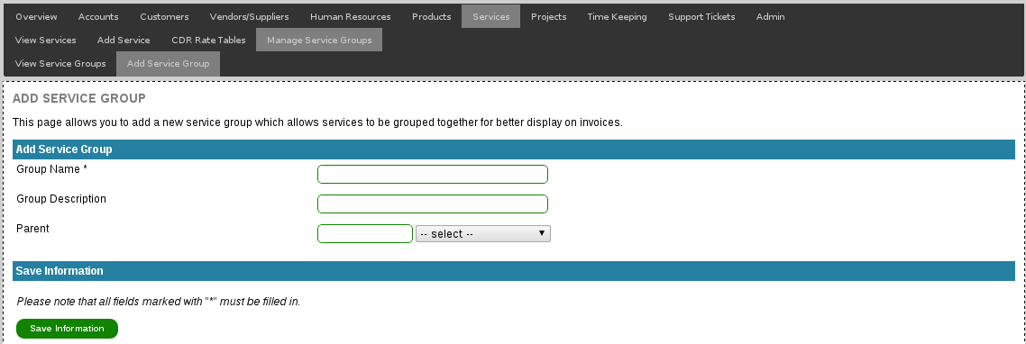

Delete Service Group
Service groups can be deleted, as long as they are not currently assigned to any services – if they are, use the service group details page to update each service first.

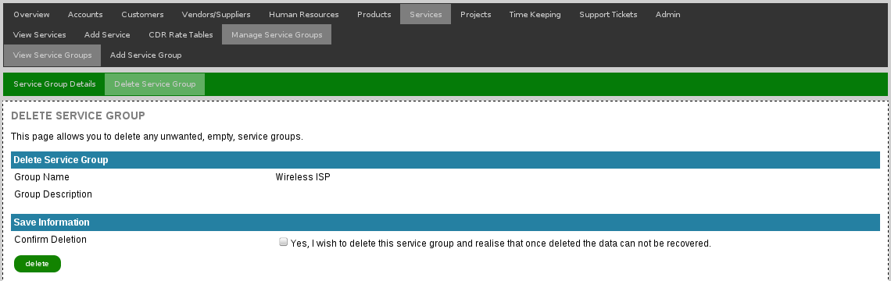

Create a new Service
Adding a service is a two step process – first you must define the base service attributes, such as the account, service group, type and name, followed by the second step which is to configure the service plan which includes pricing information.
To begin, select Services -> Add Service to add a new service to the billing system – from there you will need to set the basic service details.

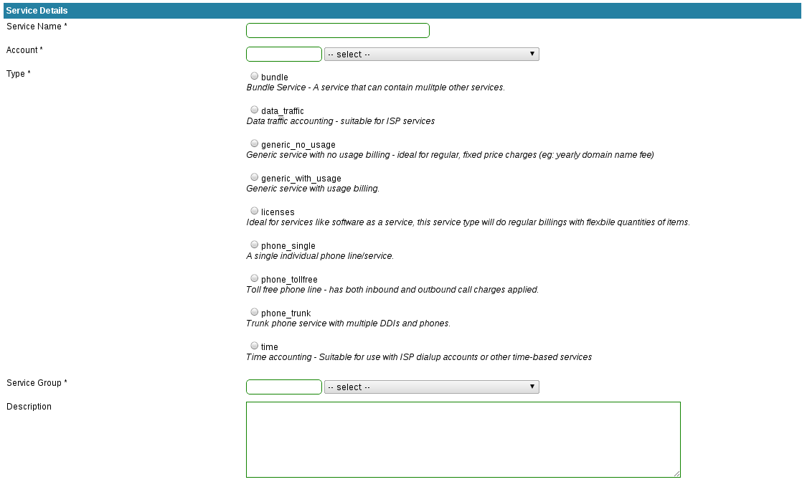

The specific income account associated with this services must be set for accounting purposes, you can use one account for as few or as many services as you desire, general recommendation is to have like services sharing an account aimed at those types.

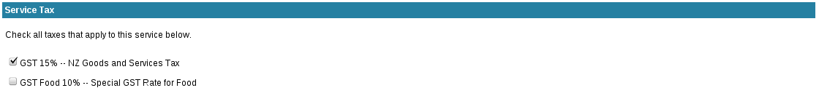
After setting the basic service details, it is important to also set the taxes that apply for the service – remember that a tax will only be applied to a service if the tax is enabled for both the customer and the service.

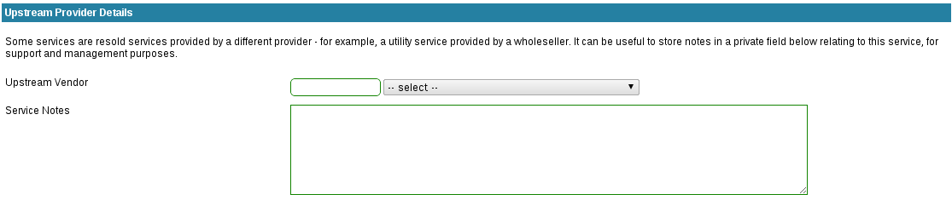
Finally you can optionally set details relating to the upstream vendor – this can be useful if you are reselling a service provided by another company

Once all fields have been entered, click “Save Changes” to add the service to the billing system – this will create the service and then take you to the service plan page, which is detailed in the following section.

Adjusting Service Plan
The Service Plan page allows to define all the attributes of the service – how much the base service fee is, the billing cycle & modes and any service-type specific options such as usage fields.

For information about the different service billing cycles/modes, please refer to the “Support Billing Modes & Cycles” section above.

All Services
All services have the following standard plan options:
- Service Price
- Service Setup Charge
- Discount
- Billing Cycle
- Billing Mode

The service price and discount can be set here and are passed through to the customer when the service is first assigned to them, subsequent changes to pricing will affect future unbilled periods for a customer, as long as they haven't had the price overridden.

The setup fee is charged via the customer's orders functionality – when the service is first added to the customer, the charge is added to the orders page and from there goes against the customer either at the first invoicing of the service or at the end of the calender month.

Note that discounts only apply to the base service fee, discounts do not change the excess usage charges.

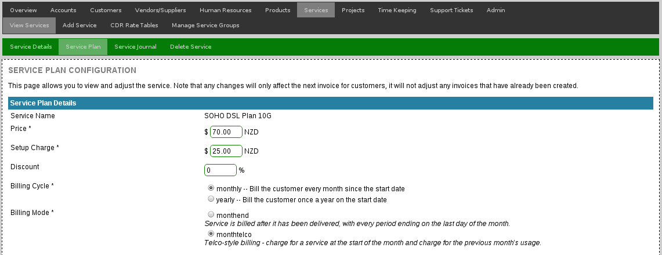

bundle, generic_no_usage
“bundle” and “generic_no_usage” services are simple and only require basic pricing and billing mode information to operate as per any other service.

generic_with_usage
A generic usage service has a number of options to be set:
- Basic Pricing Information & Billing Modes
- Usage units, amount included and cost for extra units.
- Customer usage notifications

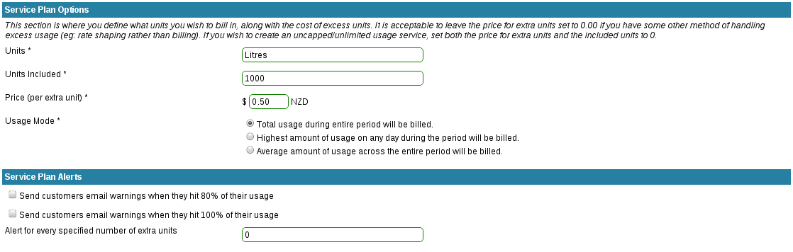
Note: usage notification emails will only be delivered to a customer if the customer has a correct accounts email address configured as well as the SERVICE_USAGEALERTS_ENABLE option being enabled.

TIME
Time based plan configuration is similar to the generic_with_usage service and still includes the three main sections:
- Basic Pricing Information & Billing Modes
- Data usage units, included units and excess pricing.
- Customer Usage Notifications

The primary difference is that instead of a free field, the units field is one of a fixed set of options, currently limited to hour count.

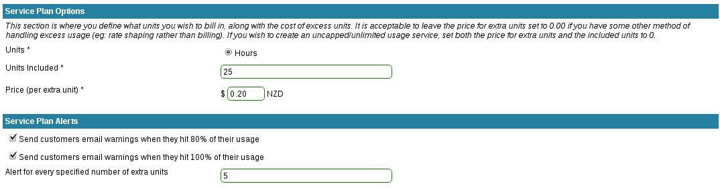

Note: usage notification emails will only be delivered to a customer if the customer has a correct accounts email address configured as well as the SERVICE_USAGEALERTS_ENABLE option being enabled.

data_traffic
Data Traffic services are very configurable and provide for a number of flexible models of billing for traffic, as well as adjustable options for usage notifications and excess billing.

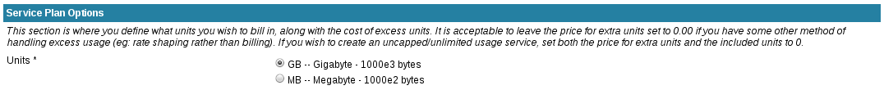
As with generic_with_usage and time services, the appropriate billing unit can be selected from a pre-defined list:

Where data_traffic services get more complex, is with their ability to define multiple traffic caps for all configured traffic types, with the ability for each type to have a different type as well as the cap amount and excess charges.
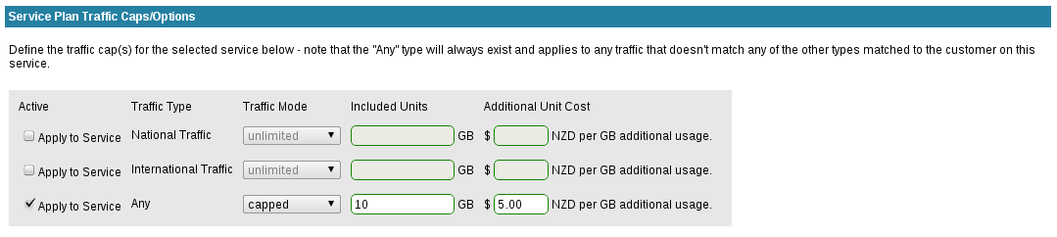
The traffic type options provided are configured in Services->Traffic Types, however each type only applies to the service if it is checked as active.

Once checked, options are available to define the traffic type as being capped or unlimited/uncapped, as well as the cost of any excess traffic.

It is possible to override the cap amounts, modes and additional unit costs on a per customer basis with service overriding.

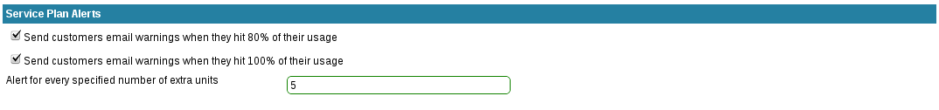
Note: usage notification emails will only be delivered to a customer if the customer has a correct accounts email address configured as well as the SERVICE_USAGEALERTS_ENABLE option being enabled.

licenses
“licenses” share some resemblance with usage services where the number of licenses will vary per customer and the price is based on the total number of licenses.

However the license quantity is based on the configured amount when the service is assigned to a customer rather than based off usage records.

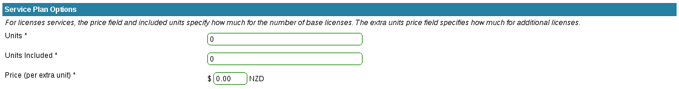

phone_single, phone_tollfree, phone_trunk
A phone_single or phone_tollfree service has the standard pricing options, as the service can only ever have a single call/trunk and one DDI.

For all phone services, a CDR Rate Table needs to be selected – the rate table defines the pricing for all calls, although once selected, this rate table can be overridden on a per-service or per-customer basis.

“phone_trunk” services are more complex and have the ability to have an included number of trunk services and DDI numbers as well as the ability for additional trunks;.

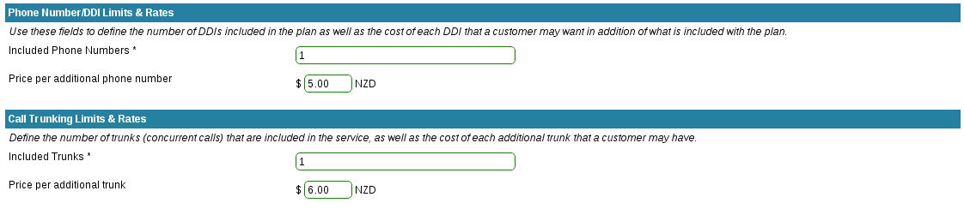
For information on configuring rate tables, see the Service: Phone/VoIP Billing section for more information.

Listing Services
Select Services -> View Services from the menu to display a list of all configured services.

You can use the options at the top of the page to configure any filters or search strings. You can also export the data in alternative formats, which will export the exact same data as currently displayed.

View Services
There are multiple pages showing different details for the selected service. First, select the service you wish to view, by accessing the service list (see section above) and then select one of the options to the right of the service name.

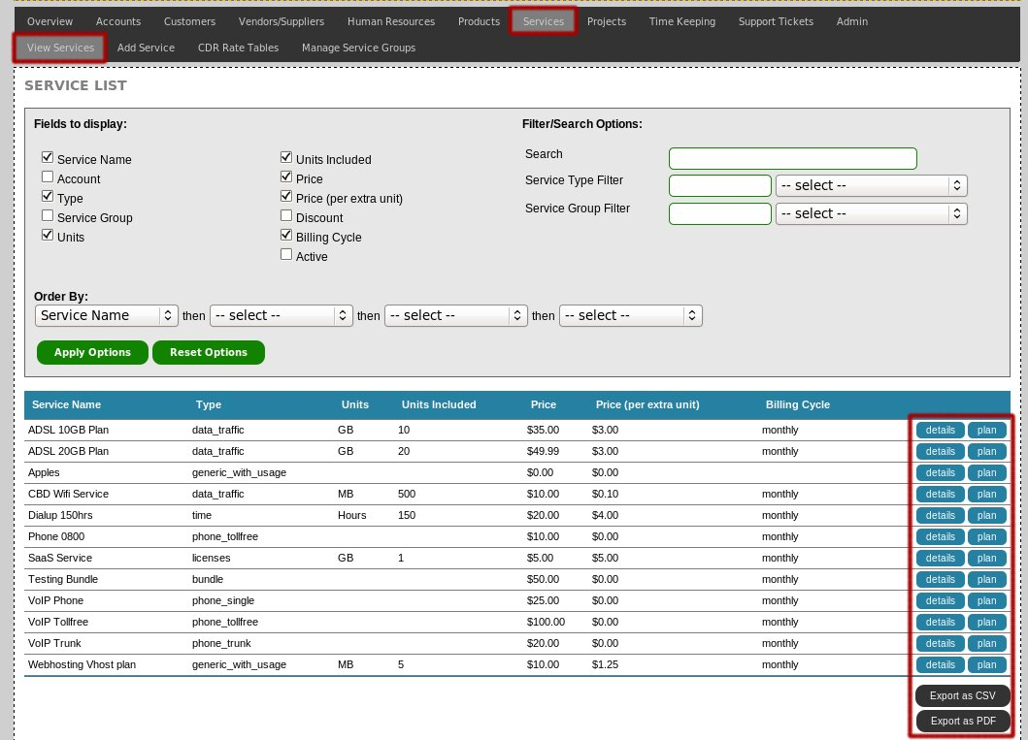

Once you have loaded one of the view pages, you can use the navigation menu to access other view pages, for example a phone_single service may have a navigation menu like:

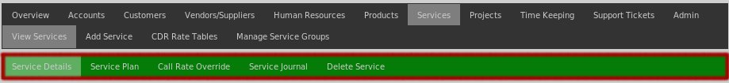

Service Details
The product details page shows all the information and basic details for the selected service, such as service type, name, description & applicable taxes.

Service Plan
The service plan defines the rates for the service and various options such as usage limits and settings – refer to the section above on service plan configuration & options for per-service type information.

Service Journal
The service journal is an area to attach notes and files to a service, which are then readable by any other user with services_view permissions, ideally information such as information on service provisioning, notes relating to the upstream service provider or other key bits of information.

Adding a service to a customer account
To add a service to a customer's account you need to view the customer and then access their services page. For full details on adding a service to a customer, please read the “Services: Customer Assignment” section of this document.

Deleting Services
When required, services can be deleted, provided that the service is not active on any customer accounts.

If the service is still active for some customers, you need to de-activate the service for these customers before the service can be deleted.
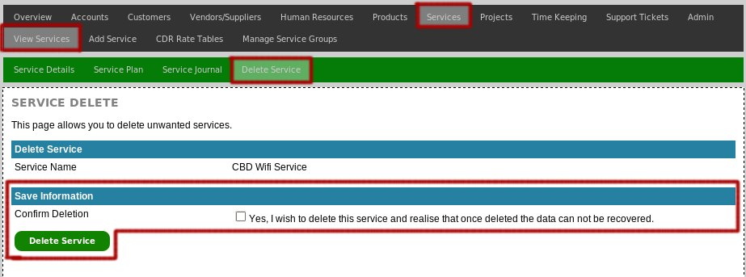
Note that when a service is deleted, all service period information and usage records for any customers whom used to use this service will be lost.

Services: Customer Assignment

The Amberdms Billing System provides a powerful service billing component, ideal for use with ISPs, hosting companies or software-as-a-service businesses.

Before a customer can be subscribed to a service, the service first needs to be configured using the service management section of the program. This is documented in details in the “Services” section of this document.

Once that is complete, access the customer's services page by doing the following:
- Select “Customers -> View Customers” from the main menu.
- Click on the “services” options link to the right of the desired customer.
- The “Customer's Services” page will load, which lists all the services the customer is currently subscribed too and provides links to add more services.

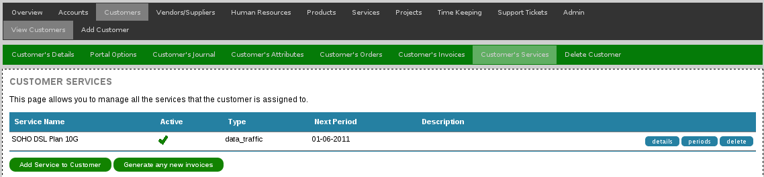

Subscribing a customer to a new service
To subscribe a customer to a new service, click the “Add a new service to the customer” link, to go to the service details page.

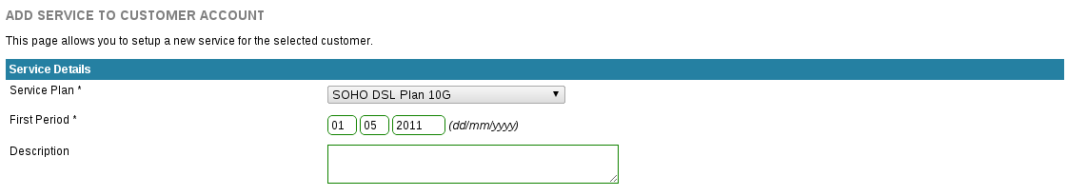
Once you have selected the desired service and billing start date, click “Add Service” to create the service and be taken to the service plan page.

If you have migration mode enabled, you will be provided with additional options for setting the start of the usage period to a date newer than the first period, if you want to pull in usage for a migrated service.
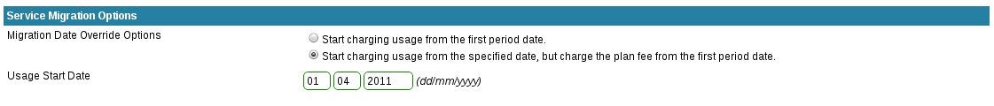

Adjusting Service Details/Plan
Once a service is assigned to a customer, more options are provided for configuring the service specifics, such as phone numbers, IP address or other attributes.

You will be automatically taken to the page after adding a new service, or you can access by selecting the service “details” on the main customer's services page to adjust an existing service:

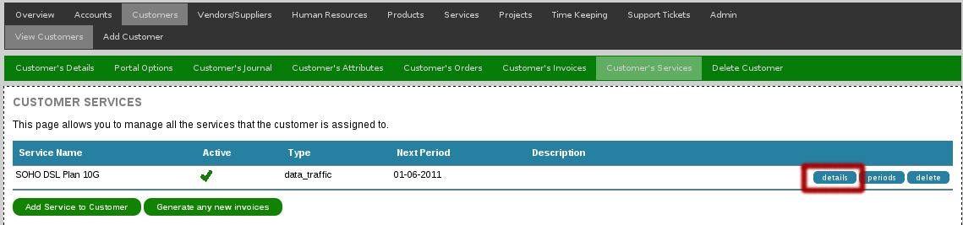
The service details page provides basic options which will vary depending on the service type, as well as providing the option for enabling/disabling the service information.

Generic Service Details
All services have the basic options of adjusting the service name/description on a per-customer basis, plan price, setup price and period information.
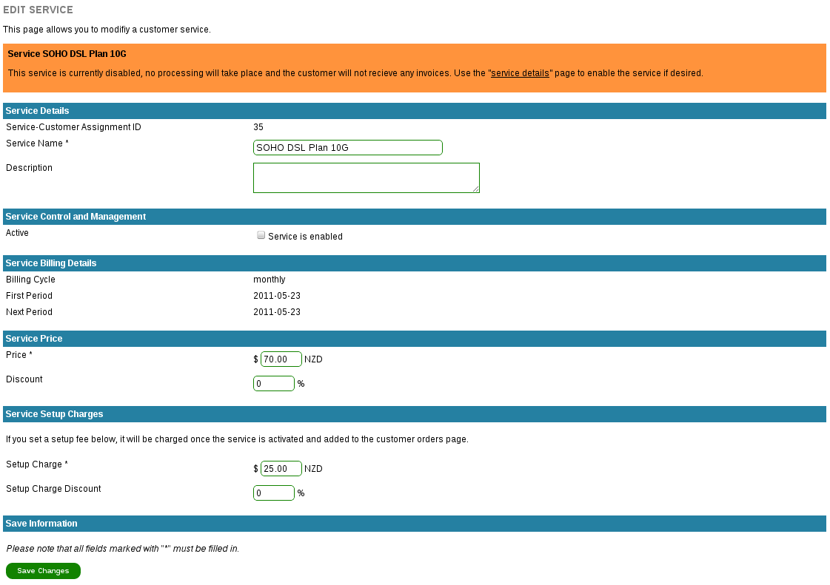

data_traffic special options
Data traffic services provide an additional option in the navigation menu for assigning IP addresses/subnets to the customer – these are then used to query the usage databases (if configured) for traffic records to bill.

To configure service IP addresses:
- First configure the service plan settings and save changes.
- Click on IPv4 Addresses in the navigation menu.

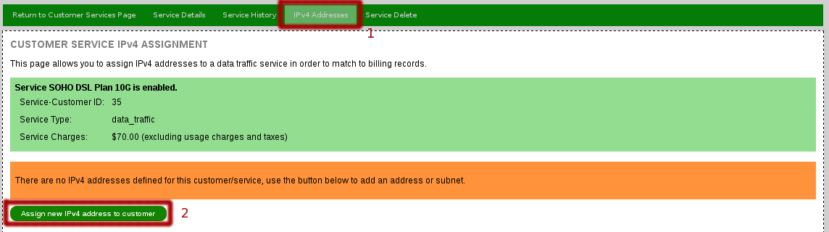

- Add required IP addess(es).

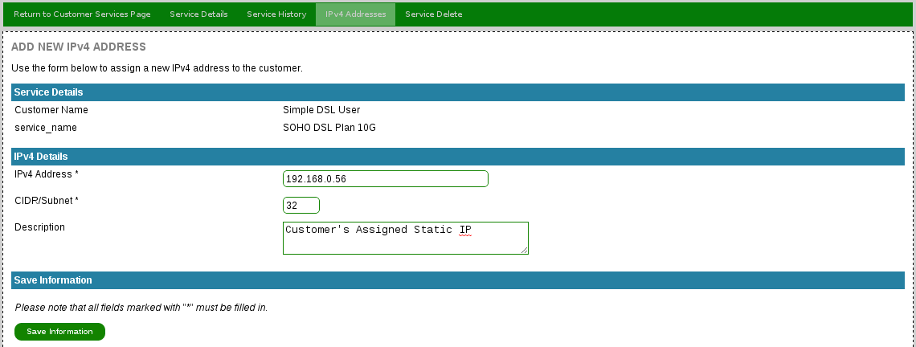

- Make sure the service is enabled – traffic accounting and service billing will take place automatically now.

phone_* special options
phone_single/phone_trunk services require the DDI and local calling region/prefix to be configured along with the standard service options.

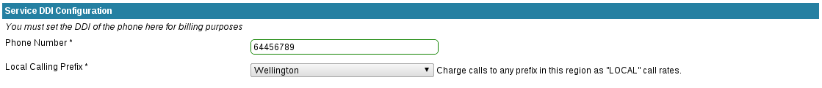

phone_trunk services are more complex and have a separate page for configuration of DDI numbers or ranges, as well as a requirement to set the number of trunks provided so that extra trunks can be billed.

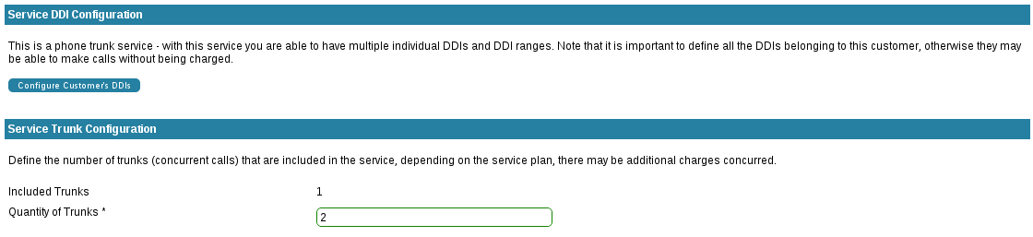

phone_trunk DDI configuration is more flexible, since phone_trunk services support DDI number ranges, which can be configured by selecting “DDI Configuration” from the navigation menu.

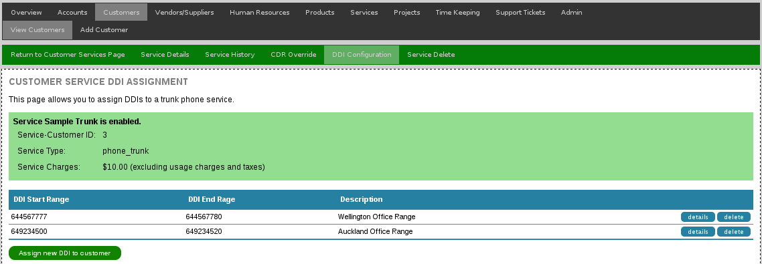

All phone services provide the additional CDR Override options, which allows custom calling rates to be added for a specific customer – for example, you may sell your customer a solution that included cheap/free calling to a specific number.

To override rates, select “CDR Override” from the navigation menu and either override an existing prefix or add a custom prefix. Overridden rates are clearly highlighted as either a customer override or a service override.

Enabling or Disabling Customer Services
Services can be enabled or disabled via the service details page using the check box. If the service is disabled, any currently active periods which have not been invoiced will not be charged.

At this stage the Amberdms Billing System does not allow you to configure a service to be disabled and only charged for the remainder of the last period – future releases plan to improve upon this limitation.

Important Notes

- The service will only be activated and billed once you have ticked the “Service is Enabled” tick box and clicked “Save Changes”.

- Any service setup fees will only be billed once the service is enabled. The setup fees will be added to the customer's orders page and either invoiced at the end of the calender month or on the next service invoice, whichever is sooner.

- Any changes you make to the service details/plan will no impact currently active periods or invoices, the changes will only take effect in subsequent invoices/periods.

View customer service history/Periods
To view the history of the customer's service billing, use the “periods” link to the right of the service name, to load the service period history.

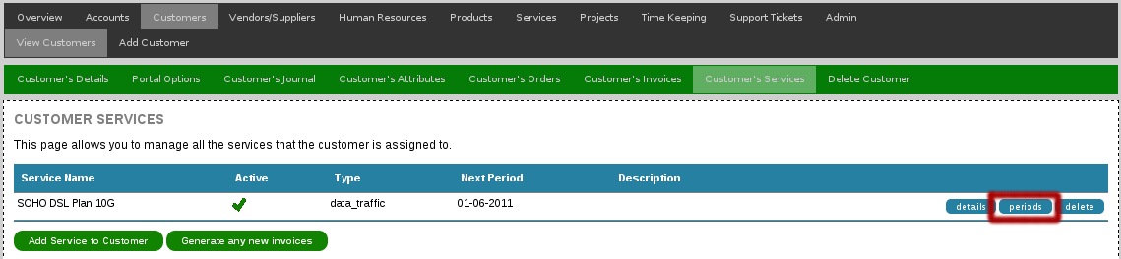

The service period history page shows all periods of the service as well as showing all invoices generated for this service and whether or not the invoice has been paid.

Note that is is normal to have periods which have not yet been billed if the customer's service is set to use monthend or periodend billing modes – the periods will show the date when they are due to be invoiced.
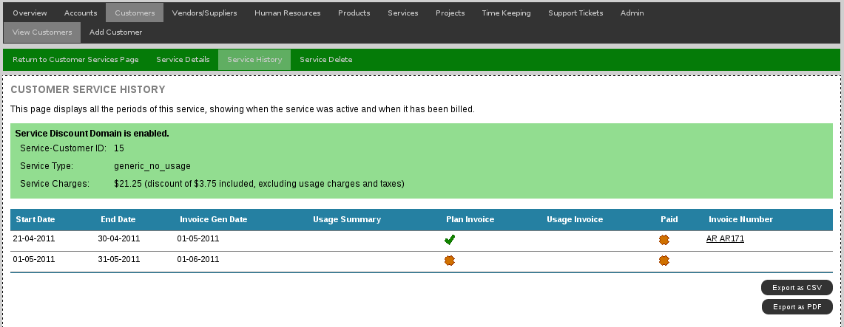
Specific service types will have more information for usage summary, such as total bytes transferred for data_traffic services:

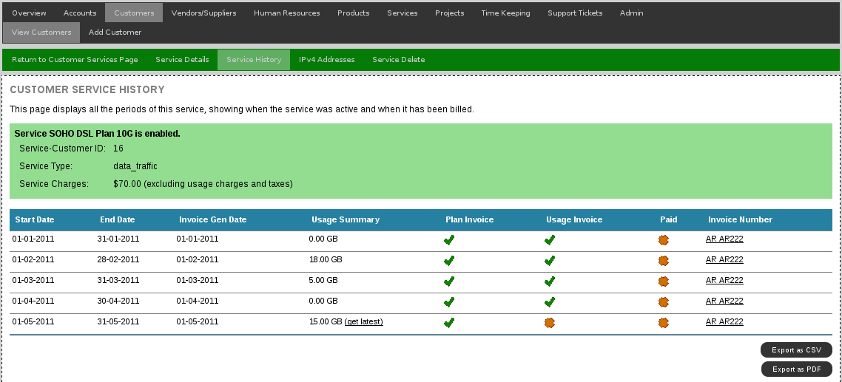
Or a link to the call records for phone_* services , which will expand out to show usage history/records with the ability to export the records for a particular month out as CSV or PDF output.
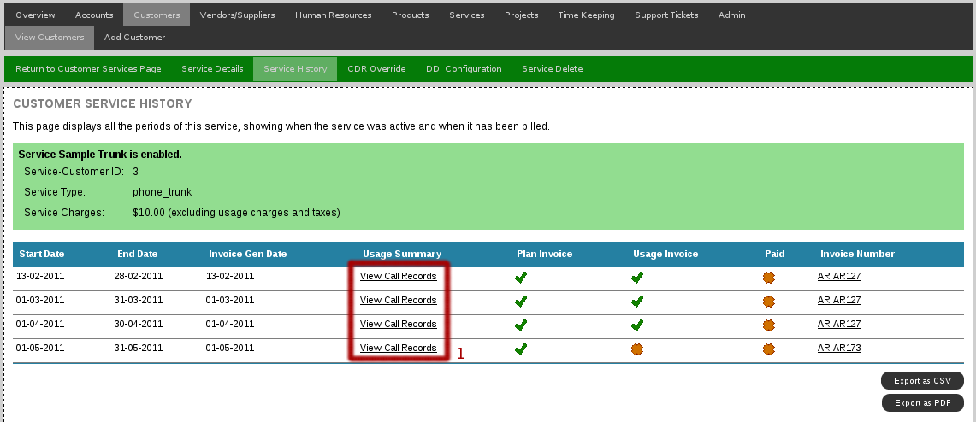

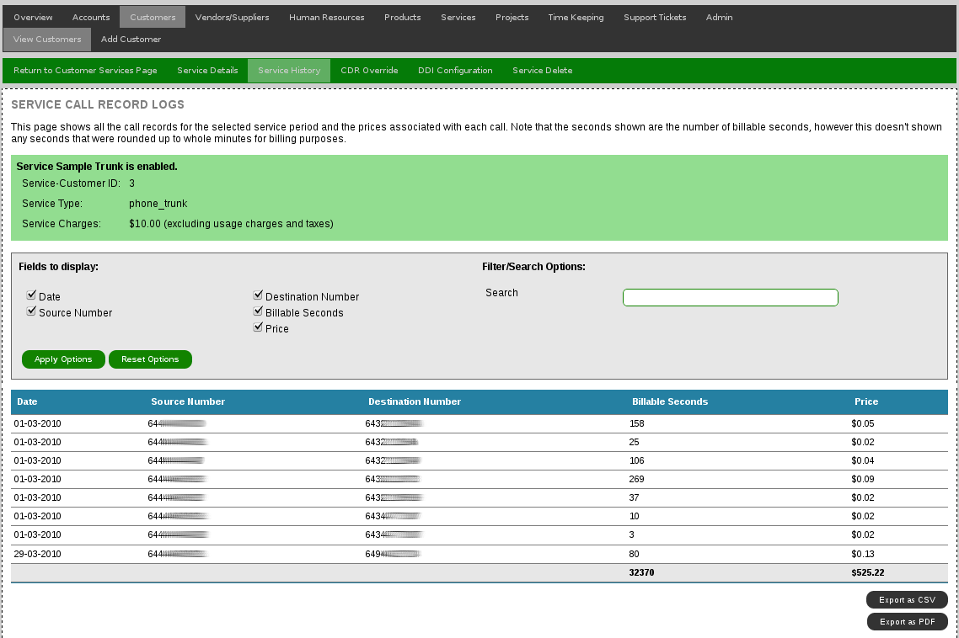

Manually Generating Service Invoices

Customer service invoices are automatically generated when required – a cronjob executes daily and checks what services are due for billing.

Depending on the configured options, services will either be emailed directly to the customer or will sit in the invoicing system waiting for a user to manually send it to the customer.

If you have just subscribed the customer to a new service and wish to create the invoice immediately, use the “Automatically generate any new invoices” option to create any new invoices.

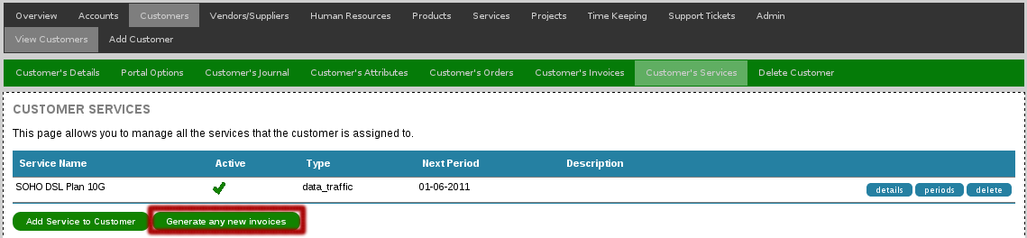

By default, automatically generated invoices will not be emailed to customers. If you wish to enable this feature, login as an administrator and change the “ACCOUNTS_INVOICE_AUTOEMAIL” option on the configuration page to have emails automatically emailed and optionally BCC'd to an internal accounts email address.

Timekeeping
The Amberdms Billing System includes a timekeeping system allowing time record keeping by individual employees.

This feature is ideal for two different uses:
- Keeping track of billable hours for customers (eg: contracting/consulting work).
- Keeping track of the time staff are spending on particular internal tasks.

Staffaccess Permissions
The Amberdms Billing System treats employees and users differently. In order to be able to book time, you need to assign a user access rights to a particular employee.

One advantage of this feature, is that it allows users to have access to multiple employee timesheets and access can be defined as read-only or read-write.

As an example, this makes it easy to allow a secretary access to fill in their manager's timesheet as well as their own, or to allow a project manager to view the hours entered by their team.

It may also be useful to give the accounting/book-keeping staff access to all employee timesheets to allow them to make corrections for billing purposes.

Assigning Staffaccess Rights
To assign staff access rights, you need to login as an administrator and access the user management interface at “Admin -> User Management -> View Users”.

Find the user you wish to configure in the list and then select the “staffaccess” option link.

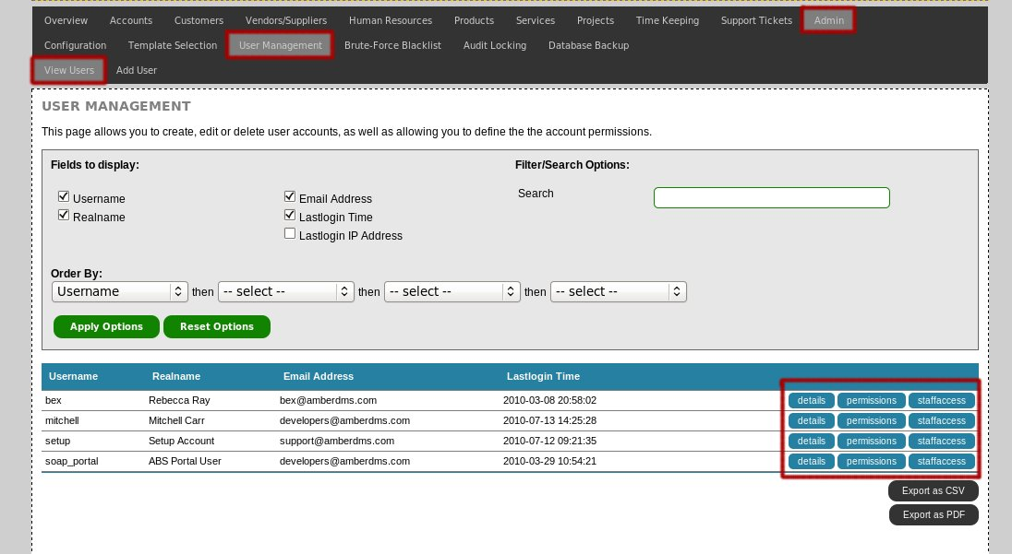

You can then either add new staff access rights or adjust any existing access rights using this interface. Any changes will have affect for the modified user when they next access any of the timekeeping pages.
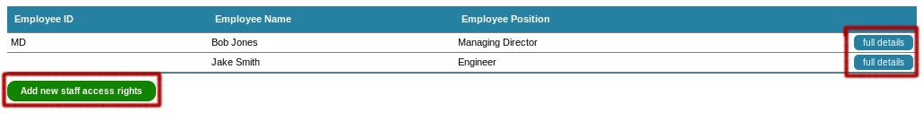

Selecting the correct employee to enter time
When adding time to the timesheet, there is a dropdown to select the employee to enter the time as. If you only have access to a single employee (ie: yourself) then this dropdown will always be selected by default.

If you have access to multiple employees, then you will forced to choose one of them when first accessing the timesheet. Your selection will then be remembered until your logout or change to another employee.

Using the Timekeeping Functions
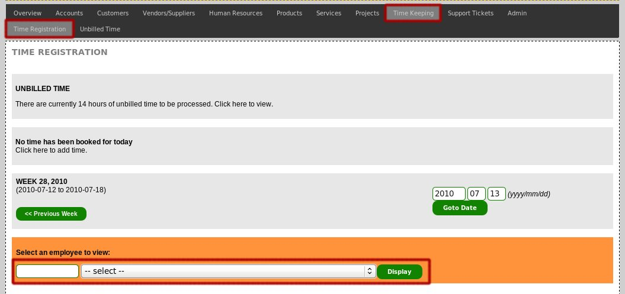
To view the timesheet, access “Timekeeping -> Time Registration” to be taken directly to the timesheet. If you have access to multiple employees, you will be prompted to select the employee you wish to view.
Once done, the page will display the current week of the timesheet and show any time that has been booked to it.

Viewing a Specific Day
If you wish to view a specific day in more detail, click on the date, which will take you to a page with a more detailed list of the time booked to the day which will also show the notes for each time record.

You can then edit or delete any time entries on the page if you have write access for the employee you are viewing.

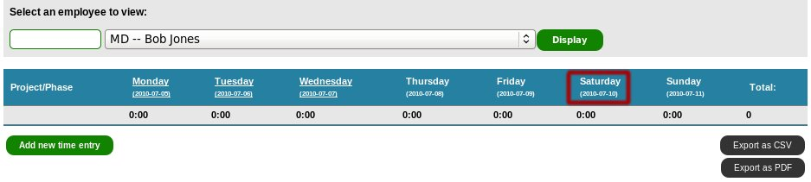

Adding Time
If you are viewing an employee whom you have write access granted, you will see a link at the bottom of the table saying “Add new Time Record”. This will take you to a new page to add a time record for a specified date.

Note: Before you can add time, you must create a project with at least one phase where you can assign the time too. See the projects section of this documentation for more details.

Reoccurring Time
Unfortunately the timesheet does not support adding reoccurring time records, however this is planned to be released in an upgrade in the near future.

Booking Time in the Future
By default users are not permitted to book time to a future date. However this behaviour can be changed by enabling the “TIMESHEET_BOOKTOFUTURE” option on the configuration page.

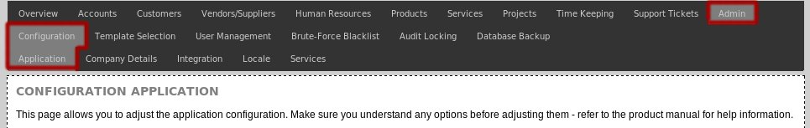

Getting Timesheet Information
The Timekeeping interface is an easy way for entering hours into the Billing System, however it is not usually the best way for getting a report of the data entered.

To assist with reporting requirements, there are a number of different ways of getting time records out of the timesheet in different formats.

Employee Timesheets
You can generate a flexible list of all the time booked for a specific employee by accessing the “Human Resources -> View Staff” page and selecting the “timesheet” option.

The employee timesheet page also allows filtering of the results to specific date periods and also can filter to only unprocessed time.

Project Timesheets
To generate a list of all the time booked to a specific project, access the “Products/Services/Projects -> View Project” page and select the “timebooked” option.

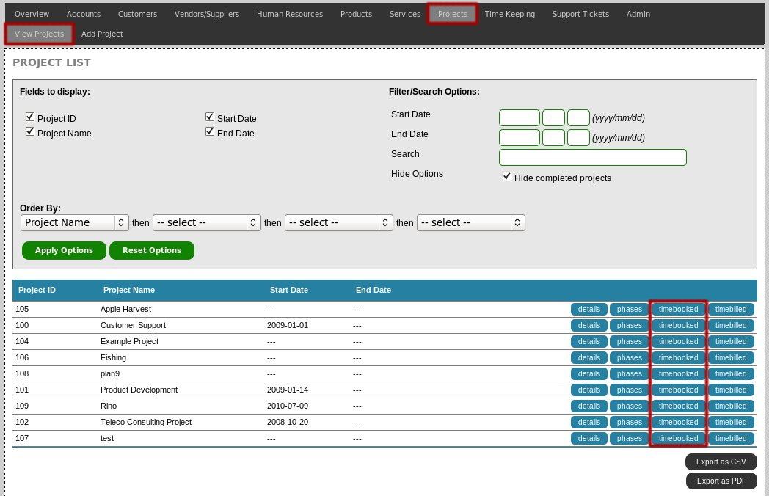
By default this page displays all the time booked to a project and provides various options to filter or search the time records such as only displaying time records for a particular phase or employee.

If you would only like to view time booked to the project which has not yet been processed for billing, enable the “Only show unprocessed time” option in the filter options box.

Unbilled Time Report
Whilst you can view all the unbilled time on a per-project basis, it is easier to be able to view unbilled time for all projects when you want to generate all your invoices.

To do this, use the “Time Keeping -> Unbilled Time” page which provides an adjustable list of all the hours added which have not yet been added to a time group.

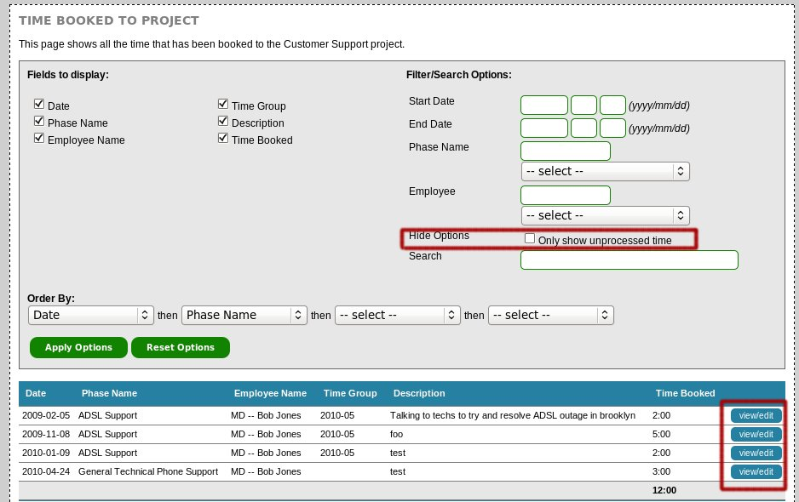
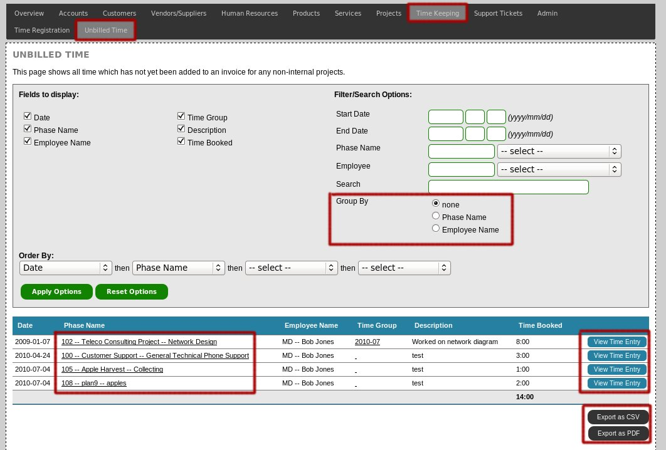
You can adjust various options if you would just like to generate per-project or per-employee totals.

Note: If you have marked a project as being internal-only, then any time booked to the project will not appear on the unbilled time page.

Exporting to CSV
All the Timekeeping pages and other time viewing methods listed above provide an export to CSV option which can be found at the bottom of the table.

Time Groups / Adding Time to Invoices
Rather than requiring accounts staff to manually add all the hours booked to an invoice, the Amberdms Billing System provides a feature called “Time Groups”.

This feature allows time records to be grouped together and then added to an invoice for billing. This has a number of advantages over manually adding time, including:

- Faster & more accurate creation of invoices.

- Easy to view exactly what hours were assigned to what invoice.

- Unbillable hours can be added to the time group but the customer won't be invoiced for them.

Creating a Time Group
To create a new time group, first access the project list page by accessing “Projects/Services/Products -> Projects -> View Projects” and select the “timebilled” option for the desired project.

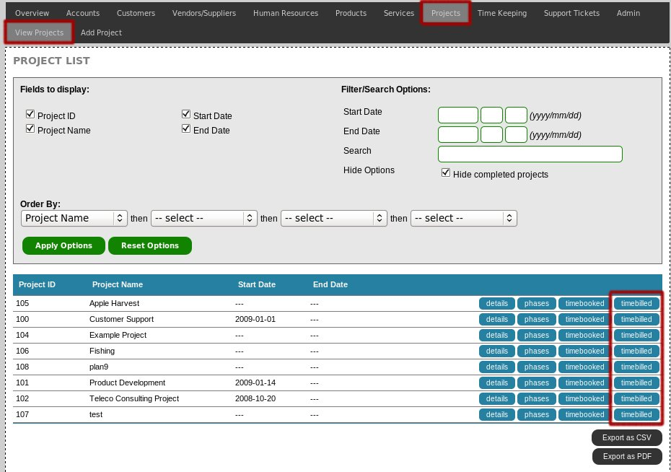
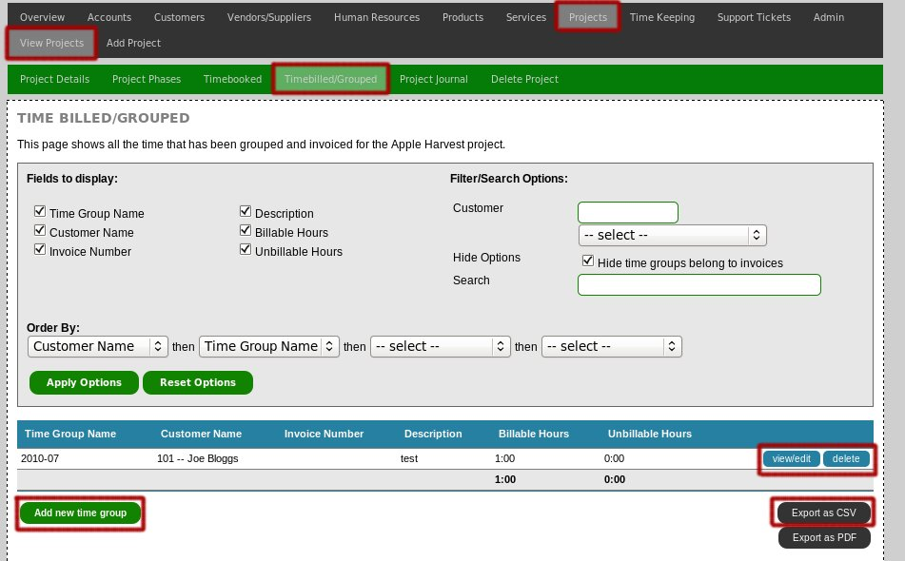
This will display a list of all the time groups which currently exist and provides various filter options.

Click on the “Add new time group” link to create a new time group.

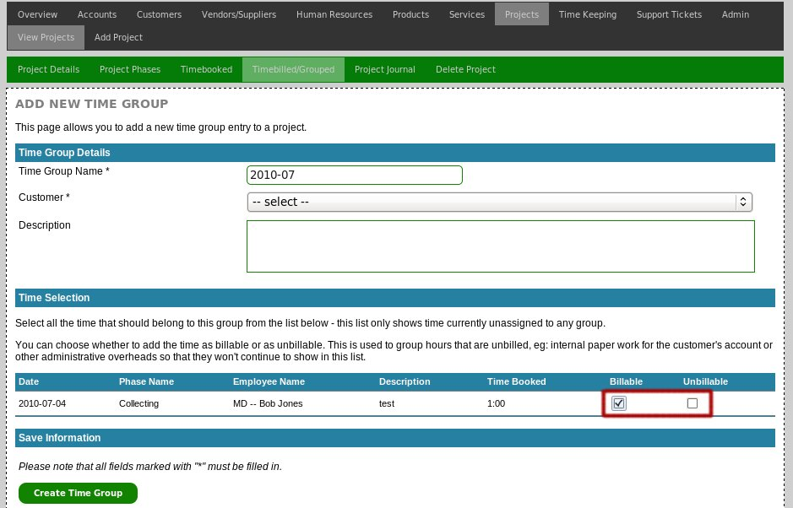

Required Options:
- Time Group Name
  - Human readable name for the group – could be something like “2009-Feb billing period” or “Repair of computer for Bob Jones”.

- Customer
  - Time groups have to belong to a specific customer – once you select a customer, the timegroup will only be available to be added to invoices for that customer.
- Description

Time Selection
A list of all unprocessed time will be displayed below. You can tick which hours are billable, unbillable and leave any time that you don't want as part of the time group unticked.

Click the “Create Time Group” button to add the new time group.

Invoicing a Time Group
Once a time group has been created, you may bill the customer for it by creating an invoice by accessing “Accounts -> Accounts Receivables -> Add Invoice” to create an invoice.

(refer to the invoicing section of this document for full details about creating an invoice)
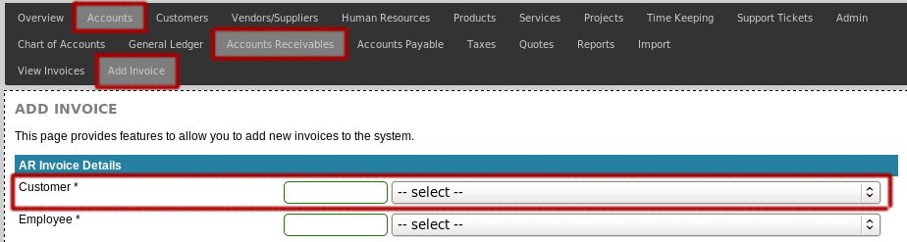
When creating the invoice, make sure you select the same customer as the time group itself.

Upon creation of the invoice you will be directed to the “Invoice Items” page, where you then need to select “Time Item” and then click “Add”.
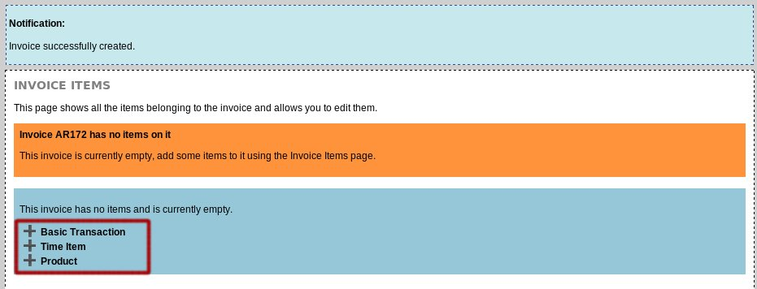

Select the Time Group from the dropdown of available time groups and select the product to bill the hours as – the billable hours in the time group will become the quantity of the invoice and income will be assigned to the income account of the product.

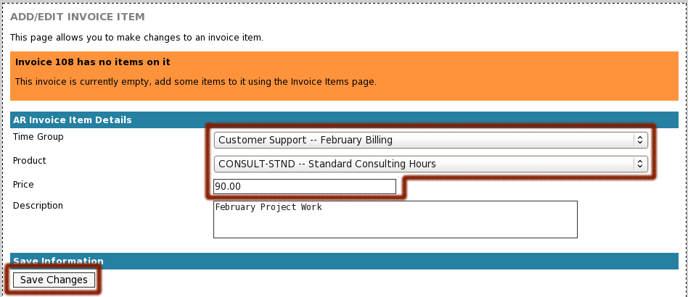

If you do not see the time group you want in the Time Group dropdown, or if you see the message “There are currently no unprocessed time groups belonging to this customer”, it means that the time group you have created is not assigned to the same customer as the invoice you have created.

Projects
In the Amberdms Billing System, projects are used to organise where time is booked and to simplify billing of labour/consulting hours.

This section of the document explains how to create projects & phases, if you are looking for information about how the time keeping features work, or how to add time to a project, please refer to the “Time Keeping” section of this document.

Create a new Project
Select “Products/Services/Projects -> Projects -> Add Project” to add a new project to the billing system.

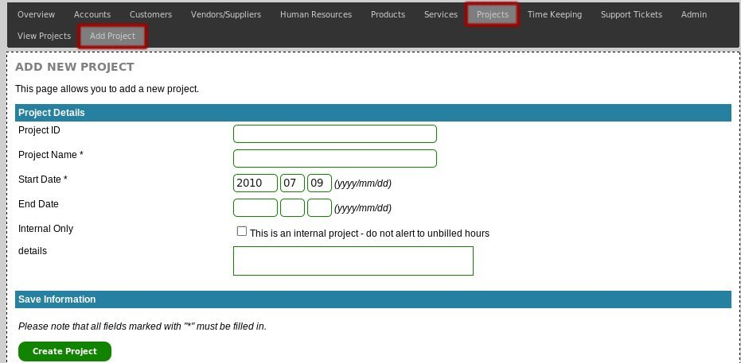

Required Fields:
- Project Name
- Start Date

Once all fields have been entered, click “Create Project” to add the project to the billing system.

To make the project usable, you need to define at least one project phase – to do this, click on the “Project Phases” link in the navigation menu.

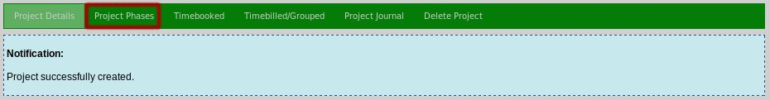

Listing Projects
Select “Products/Services/Projects -> Projects -> View Projects” from the menu to display a list of all projects.

You can use the options at the top of the page to configure any filters or search strings. You can also export the data in alternative formats, which will export the exact same data as currently displayed.

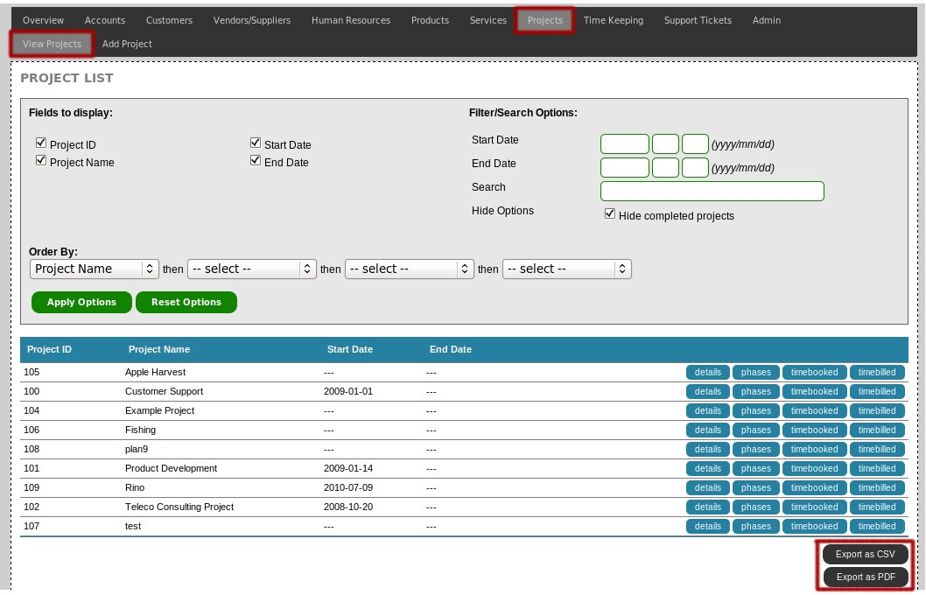

View Projects
There are multiple pages showing different details for the selected project. First, select the project you wish to view, by accessing the project list (see section above) and then select one of the options to the right of the project name.

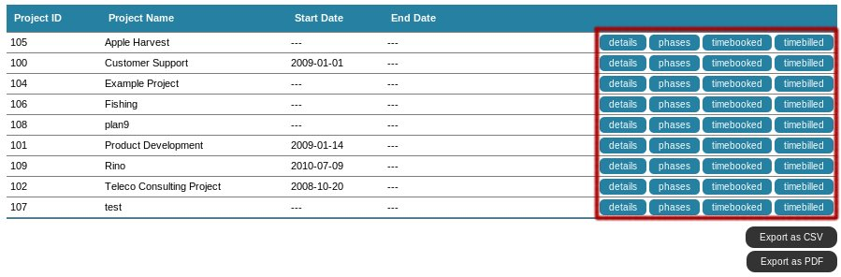
Once you have loaded one of the view pages, you can use the navigation menu to access other view pages.

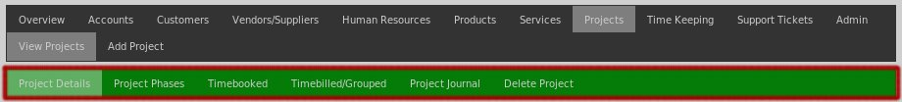

Project Details
The project details page shows all the information and basic details for the selected project.

Project Phases
Project phases are used to book time to the project – all projects must have at least one phase to make them usable.

Timebooked
This page displays all the time booked to a project and provides various options to filter or search the time records such as only displaying time records for a particular phase or employee.

If you would only like to view time booked to the project which has not yet been processed for billing, enable the “Only show unprocessed time” option.

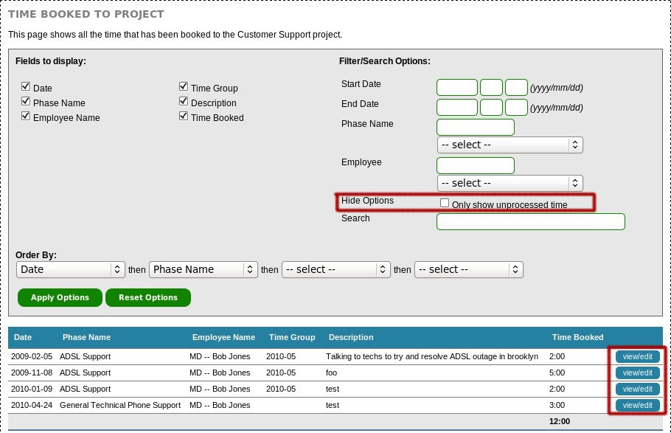

Timebilled/Grouped
This page allows time groups to be configured – for information about time groups, please see the “Time Keeping” section of this document.

Project Journal
The project journal is an area to attach notes and files to a project. These notes are readable by all other users with projects_view permissions - this may be information such as meeting notes relating to the project, attached copies of project plans or other resources.

Deleting Projects
When required, projects can be deleted from the billing system, provided that no time has been booked to the project.

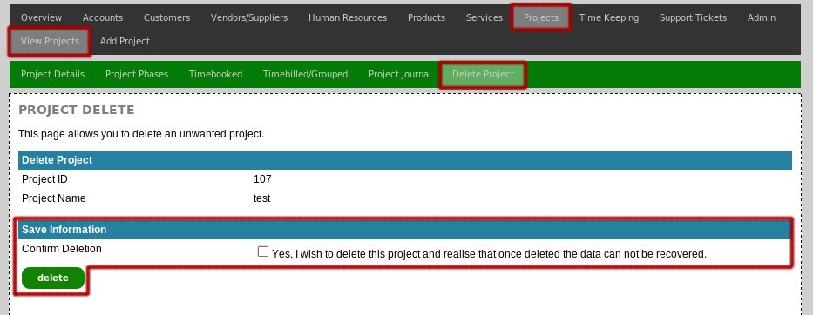

If the project is unable to be deleted, the billing system will inform you of this and instead of deletion, you should set the end date field on the “Project Details” page.

This will not delete the project, but will hide it from the list of active projects.

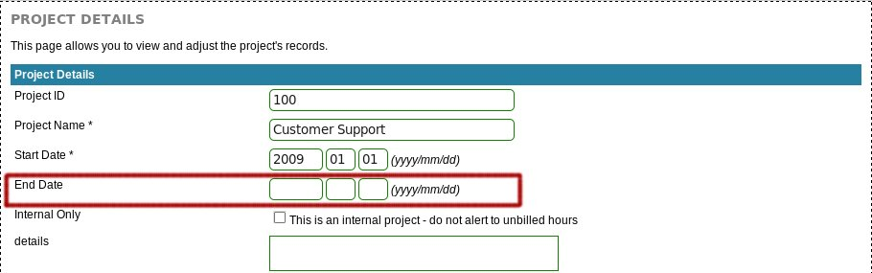

Invoicing
The Amberdms Billing System provides an easy to use invoicing system capable of handling AR invoices, AP invoices, & quotations.

For those unfamiliar with accounting, Account Receivables Invoices (AR Invoices) are the invoices that you create to bill your customers, whereas Accounts Payable Invoices (AP Invoices) are invoices that your vendors/suppliers send to you.

The same interface is used to create AR or AP invoices and quotes, so the documentation below applies to all three unless otherwise noted.

Invoice List
To display a list of all the invoices, use one of the following menus:
- “Accounts -> Accounts Receivables -> View Invoices”
- “Accounts -> Accounts Payable -> View Invoices”
- “Accounts -> Quotes -> View Quotes”

By default only unpaid invoices are displayed, but you can choose to display all invoices including paid invoices.

Creating new Invoices
To create a new invoice use one of the following menus:
- “Accounts -> Accounts Receivables -> Add Invoice”
- “Accounts -> Accounts Payable -> Add Invoice”
- “Accounts -> Quotes -> Add Quote”

Requirements
- Customer
- Employee
- Destination Account (AR/AP only)
  - This is the account that invoices will be assigned to until they are paid.

Once complete, click the “Save Changes” button to create the new invoice. You will then need to add items to the invoice.

Adding items to Invoices
First select the invoice you want from the list page and click the “items” link or select the “Invoice Items” option from the navigation menu if you are already viewing an invoice.

This page will show all items (if any) which have been added to the invoice. To add a new item, use the form at the bottom of the table. This will allow you to add one of the following three item types:

- Basic Transaction.
- Time Item.
- Product.

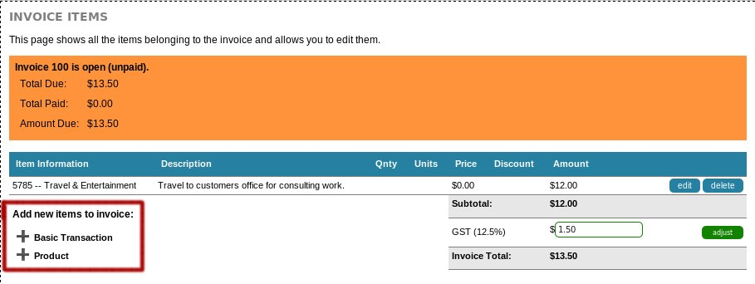

Basic Transactions
Basic transactions are designed for quickly creating basic invoices, such as a taxi fare, where there is a varying amount and you simply wish to allocate the amount to a specific account.

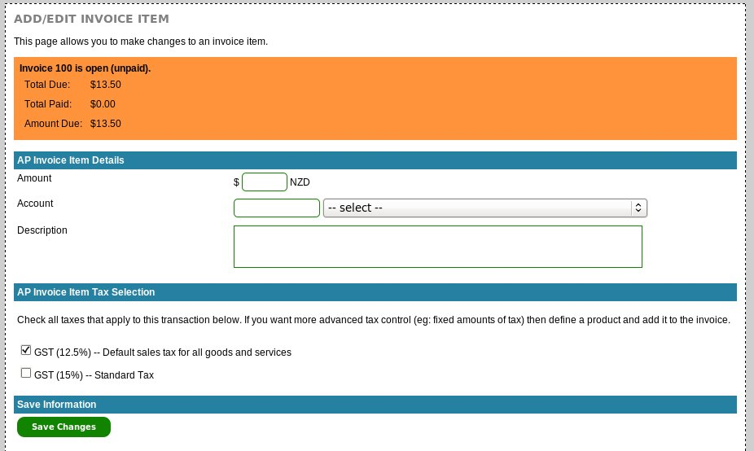

To create a basic transaction item, you require the following information:
- The amount to change
- The account for the transaction income/expense to go to.

You can then select all the taxes that apply to this item – if the customer/vendor the invoice belongs to has a default tax set, then that tax will be already selected.

Once done, click the “Save Changes” button to save the transaction information.

Time Items
(AR Invoices only)

Time items allow you to add a time group to an invoice. See the “Time Keeping” section of this document for more information about time groups.

Product Items
Usually for AR or more advanced AP transactions, you will want to use product items, which allow you to define cost & sale prices, taxes and accounts in advance.

The item add dropdown box will include a list of all available products, sorted by their product ID. Select the product you wish to add and click “Add”.

Taxes for this product will be automatically calculated based on the tax options configured for the product and what taxes are enabled for the customer/vendor.

The default product information will be loaded into the page, which you can adjust before adding the item to the invoice by clicking the “Save Changes” button.

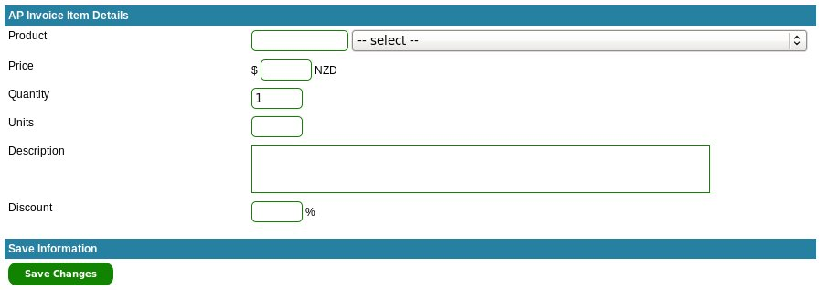

Adding Payments to Invoices
When customers pay an AR invoice or when you pay an AP invoice, you need to create a payment record on the invoice. There are several ways to do this:

- Enter the payment directly against the invoice.
- Enter the payment as part of a bulk payment entry. (see “Bulk Payments” section)
- Enter the payment by importing a bank statement using the Accounts -> Import functionality. (see “Accounts: Import” section)

There is also the forth option to have payments entered automatically via the API, by integrating with payment providers like PayPal or other credit card processors.

To enter a payment directly against an invoice, first select the invoice you want from the list page and click the “payments” link or select the “Invoice Payments” option from the navigation menu if you are already viewing an invoice.

You can then add a new payment to the invoice by clicking on the “Add Payment” link.
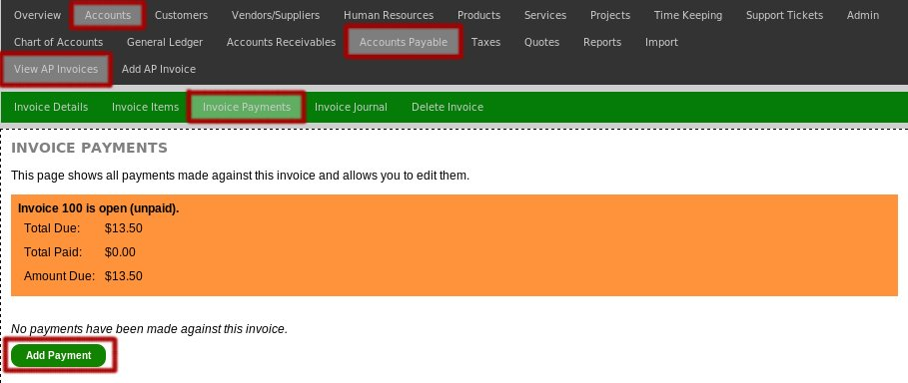

You will then be prompted to enter the payment details – you will need to set the account the payment is going to/from, the date and naturally the amount.

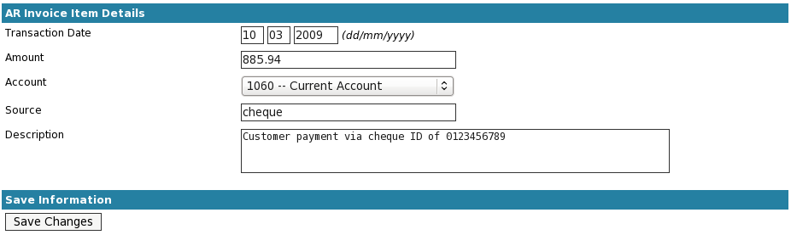

Note that:
- It is perfectly acceptable to have multiple payments on a single invoice – however, the invoice will not appear as closed/paid until exactly the correct amount has been paid to it.
- You can over-pay an invoice, the extra amount will appear and the invoice will not close until it is paid.

Invoice Journal
The invoice journal is an area to attach notes and files to an invoice. This is the ideal location for storing scanned copies of the original AP invoice or just general notes about the invoicing work.

The journal will also contain contents of any messages sent to the customer when exporting the invoice via email, whether done manually or via automated processes.

Export/Email Invoice
(AR Invoices & Quotes only)

Once you have created your invoice/quote, you can export it as a PDF document and optionally email it directly to the customer using the “Export Invoice” page.

When emailing a PDF to a customer, the invoice details will update to show that the invoice has been sent to the customer. If you prefer to download the invoice and then email it to customers, you can optionally choose to mark the invoice as having been sent to the customer manually.

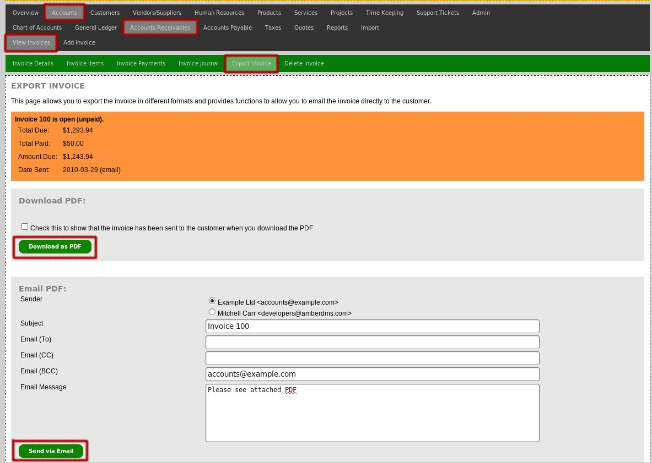

The default email message, company details on the invoice and invoice style are all customisable in the ABS Administration pages – refer to the documentation on configuration information for more details.

Deleting Invoices
Invoices may be deleted provided that they have not yet been locked by the audit locking process. If an invoice has had payments made, it can still be deleted but an additional warning will appear and deleting the invoice will cause that payment record to also be deleted.
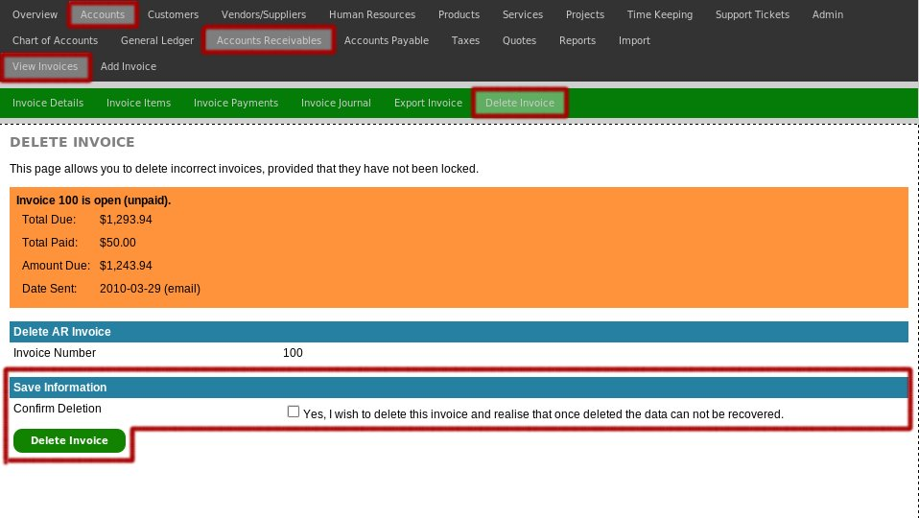

Bulk Payments

Bulk payments can be done by importing bank statements or using the bulk payment tools available for both AR (Accounts -> Accounts Receivables -> Bulk Payment) and AP (Accounts -> Accounts Payable -> Bulk Payment).

Typically bulk payments can be useful when paying a large number of AP invoices or when entering cheques or cash paid by customers, sources of payment that might not have an importable bank statement at this stage.

If you do wish to import from a bank statement/CSV file, refer to the Accounts: Import documentation.

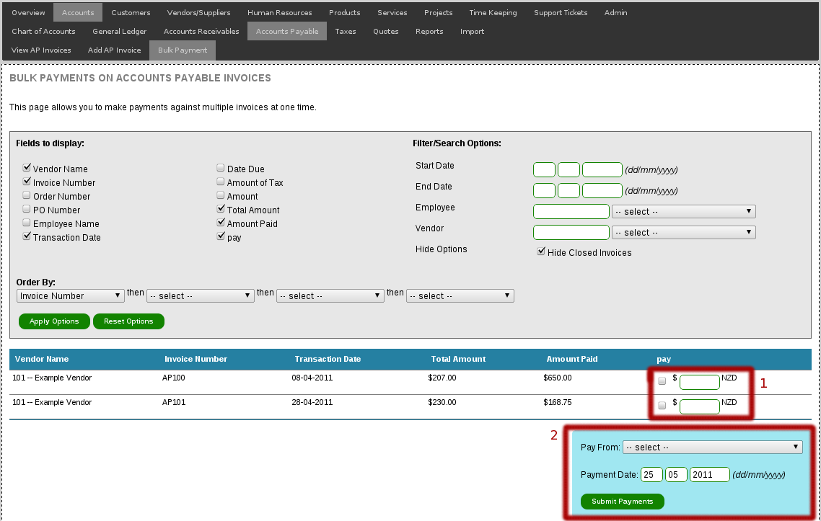
To make bulk payments, check the pay checkbox [1] by each invoice – it will autocomplete the owing amount in the input box next to it, which can then be overridden if a payment other than the outstanding amount is being made.

Once selections have been made, choose the bank account to pay to/from, the payment date [2] and then submit, to have payments entered against the selected invoices.

Account Statements/Reminders

Sadly not all customers will make payments for their invoices when they fall due and it can be necessary to send polite reminders to them to make payment.

To provide this, there is an accounts statement/reminder function at Accounts -> Accounts Receivables -> Account Statements which will display and highlight overdue invoices and provides an easy interface to send reminder emails.

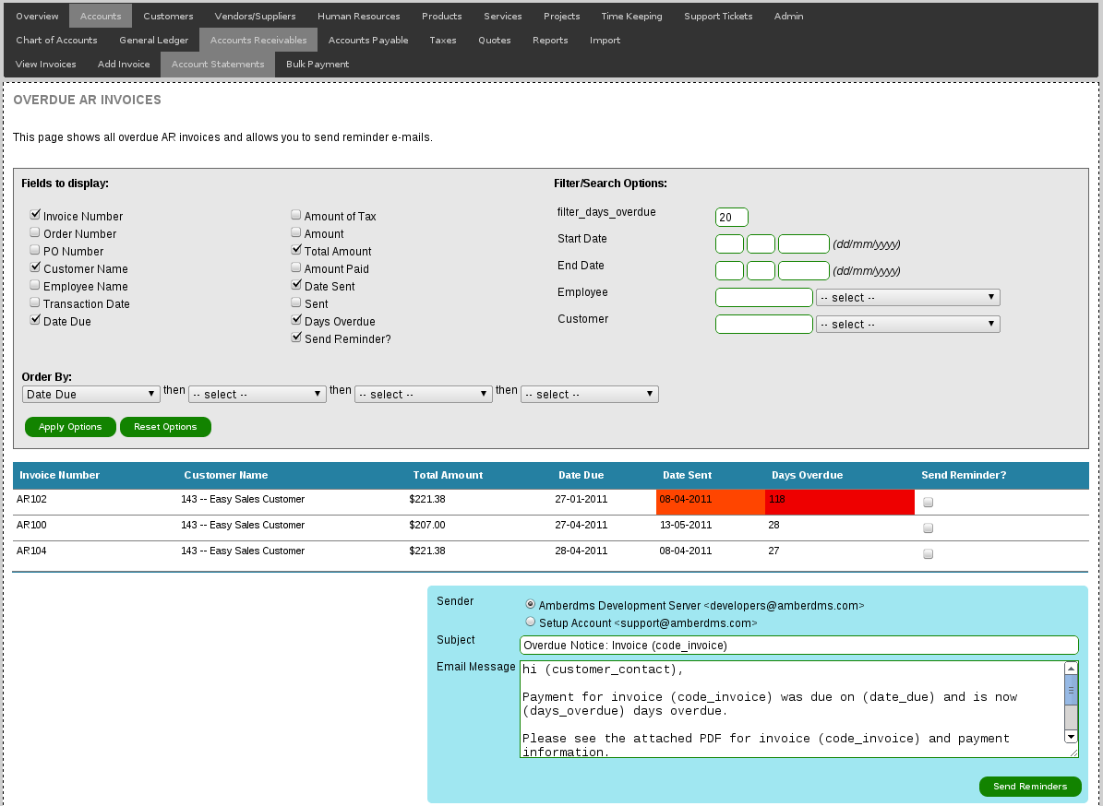
To send reminders, select the “Send Reminder?” checkbox, review the email message and click “Send Reminders” to email the customer a copy of the invoice and a reminder email.

Note that the email message will reference various (variables) which are defined in the template documentation – these variables are replaced before emailing each user with their correct details.

Quotations
Quotations have the same options and user interface as invoices, so refer to the documentation in the invoicing section for full details about creating quotations.

Additional documentation about quote-only features is below:

Converting Quotes to Invoices
To convert a quote to an invoice you first need to select the quote from the quote list and then select the “Convert to Invoice” option.

You will be prompted to add a few more additional fields to satisfy the requirements of an invoice. Once entered, select “Convert to Invoice” to convert the quote to an invoice.

Note: This action can not be reversed – make sure you are converting the correct quotation.

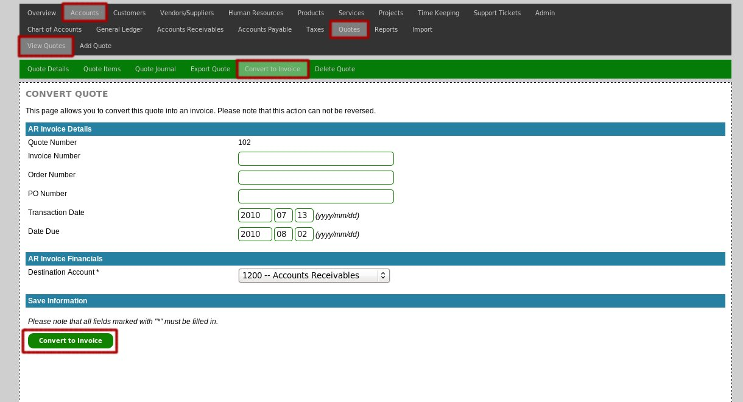

Discounting
The Amberdms Billing System includes the ability to discount items on an invoice. The discounting can be configured in a number of ways:

- Can be set when adding a product or time item to an invoice.
- Can be applied to a particular product.
- Can be applied to a particular customer or vendor.

Note that discounting has no impact on:
- Automated service billing invoices.
- Standard/Basic invoice transactions.

Setting Discount Configuration

Setting Customer Discount
You can configure a customer so that whenever an invoice is created for the customer, their discount will be applied to all product and time items on the invoice.

Select “Customers -> View Customers” from the menu to display a list of all the customers in the billing system. You can filter the customers displayed by using the options at the top of the page.

Find the desired customer and then click the details link in the options to the right:

Now enter the desired discount into the customer's details page, and click “Save Changes” at the bottom of the page.
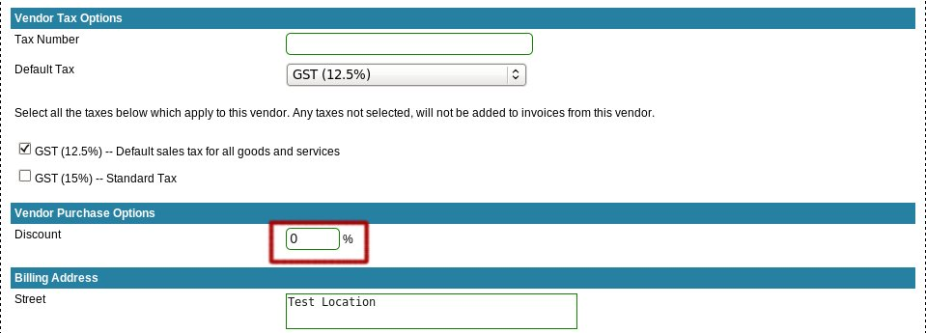

The discount is then saved for the customer – any invoices you create for this customer which have product or time items will have discount automatically entered from the customer's settings.

Setting Vendor Discount
You can configure a vendor so that whenever an invoice is created for the vendor, the discount will be applied to all purchases from that vendor.

Select “Vendors -> View Vendors” from the menu to display a list of all the vendors in the billing system. You can filter the vendors displayed by using the options at the top of the page.

Find the desired vendor and then click the details link in the options to the right:
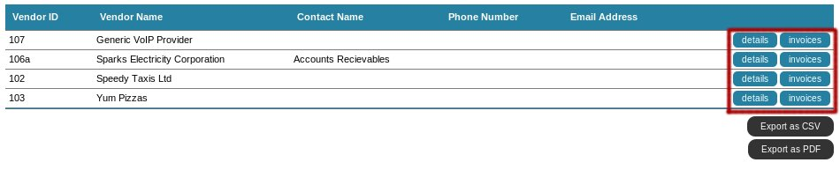
Now enter the desired discount into the vendor's details page, and click “Save Changes” at the bottom of the page.

The discount is then saved for the vendor – any invoices you enter for this vendor containing products will have this discount applied to it.

Setting Product Discount
You can configure a discount on a particular product, which will affect both the sales and purchase price when adding the product to an invoice.

Select “Products/Services/Projects -> View Products” from the menu to display a list of all the products in the billing system. You can filter the products displayed by using the options at the top of the page.

Find the desired product and then click the view link in the options to the right:

Now enter the desired discount into the product's view page, and click “Save Changes” at the bottom of the page.
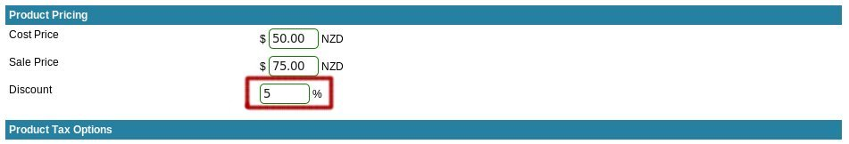

The product will now have the discount applied whenever the product is added to an invoice.

Adding Discounts to Invoices or Quotes
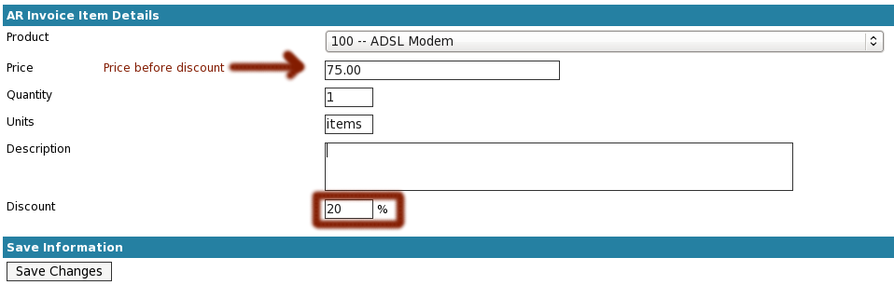
To discount an invoice, first create the invoice the usual way and go to the “Invoice Items” page and add the desired product or time group.

The price field is the price, before the discount is applied. The discount amount will either be taken from the customer/vendor or product's discount configuration – if both have been set, the largest discount is used to fill in the discount field.

You can modify the discount, or set one if no discount has been taken from the configuration.

Once desired discount is set, click “Save Changes” to add it to the invoice and return to the items list. The items list will show the price before discount, discount % and the amount after discount.

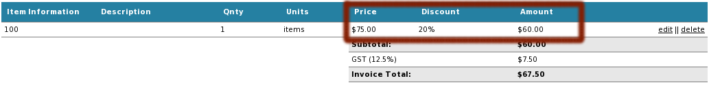
Note: Whilst the web interface shows the item and discount as a single line, the exported PDF invoice will show the discount as a separate line item for clarity.

Once exported, the invoice shows the discount as a separate line item, for example:

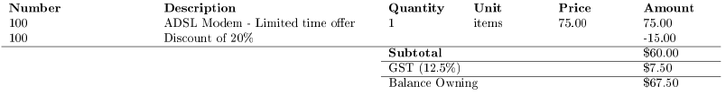

Accounting Reports
Financial reporting is a vital feature allowing businesses to accurately fill in tax documents and declaration as well as being able to forecast company income and expenses.

Sales Tax Reports
Sales tax reports are located on the taxes section of the Amberdms Billing System. To generate tax paid or tax collected reports, first display a list of taxes by accessing “Accounts -> Taxes -> View Taxes”.

Now select either collected or paid options to the right of the desired tax to generate a report for that tax.

You will then be displayed with a tax report, defaulting to the current month and accural/invoice mode.

Accural/Invoice Mode
In this mode, the tax is reported for the period when the invoice was initially created, regardless whether or not the invoice has been paid.

Example:
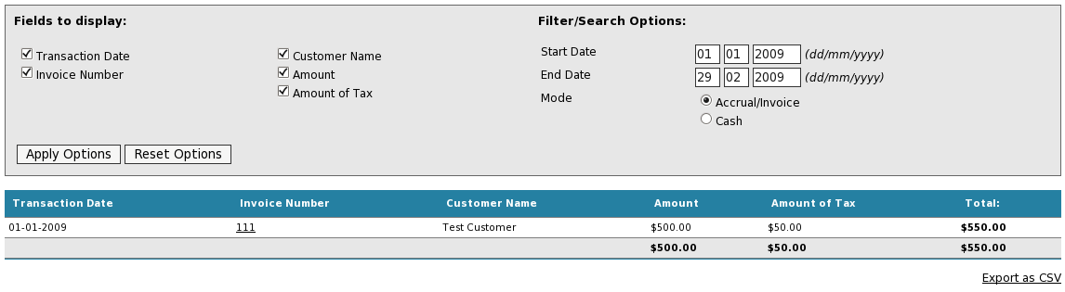

Cash Mode
The cash mode is required by some countries (such as New Zealand) where sales tax can be paid when payment is received, rather than when invoiced – the date of the invoice has no impact on tax payment.

Usually this is reasonably straight forwards, most customers pay their invoices in full with a single payment and the tax report just shows the invoice totals in the tax period that the payment occurred.

However, cash mode reports can also handle situations where customers pay an invoice in multiple parts across different tax periods. – for example, one payment might be in January and the next in March - if paying tax monthly/bimonthly, this would cause the payments to be in different tax periods.

Some countries require that tax must be paid for all payments, regardless whether or not the invoice itself is fully paid, so the cash mode report has been design to calculate the tax belonging to each payment and report the payments in the periods that the payments were made.

Consider the following invoice example:

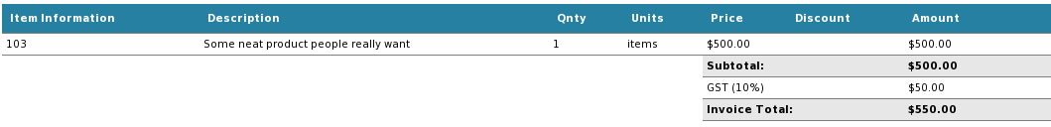

This invoice is paid in two separate payments in different tax periods:

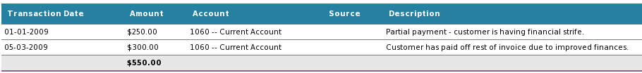

Note that due to the time between the payments, they will not appear in the same tax period and tax will have to be calculated separately for each payment.

The tax report shows the first tax period as:
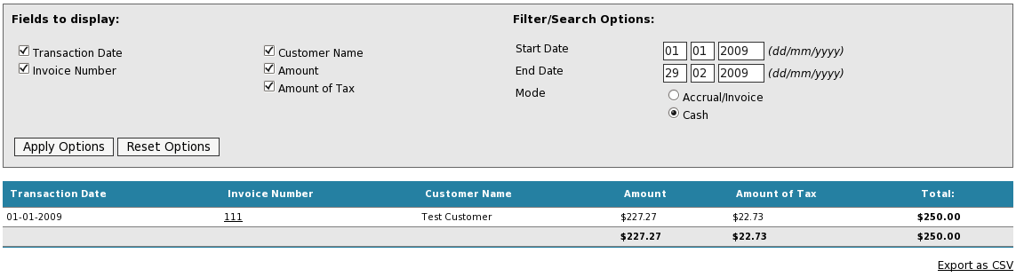
And the second tax period shows as:
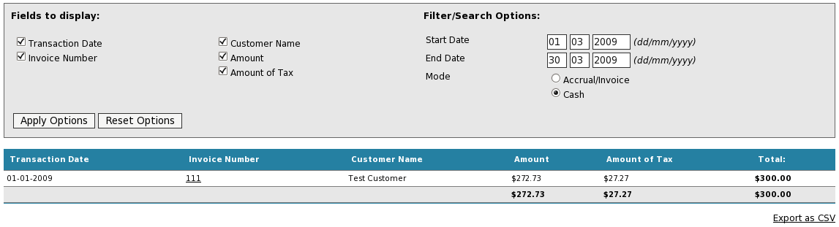
We can see that both tax amounts and payment totals match the invoice.

Important Notes:

- If an invoice has been over-paid, the invoice and it's payments will not appear in the cash mode tax report due to inability to correctly calculate tax on overpayment.

- Multiple payments in one period belonging to the same invoice are automatically merged into a single row.

- The transaction date shown, is the date of the invoice, not the date of the payment. The reason for this, is that multiple payments in the same period are aggregated into a single amount so payment dates can't be used.

- The cash mode report will handle invoices with multiple taxes correctly and will also correctly handle fixed-price taxes.

Trial Balance
This report lists all the accounts which transactions are filed against and provides a basic overview of the current state of the financials.

The report can be exported in the following formats:
- CSV document.
- PDF document (includes company logo).

Income Statement
This report shows income and expenses for the selected time period. The report can either calculate using cash basis or accural basis which calculates using all the data in the billing system.
Note: Cash basis for the income statement only reports using fully paid invoices, this differs from the sales tax report which can handle partially paid invoices.
The report can be exported in the following formats:
- CSV document.
- PDF document (includes company logo).

Balance Sheet
This report shows assets, liabilities and equity for the selected date. The report can either calculate using cash basis or accrual/invoice basic which calculates using all the data in the billing system.
Note: Cash basis for the income statement only reports using fully paid invoices, this differs from the sales tax report which can handle partially paid invoices.
The report can be exported in the following formats:
- CSV document.
- PDF document (includes company logo).

Support Tickets
The support tickets feature is designed for basic tracking of customer enquiries or technical support requests.

Add Support Ticket
Select “Support Tickets -> Add Ticket” to add a new support ticket to the billing system.

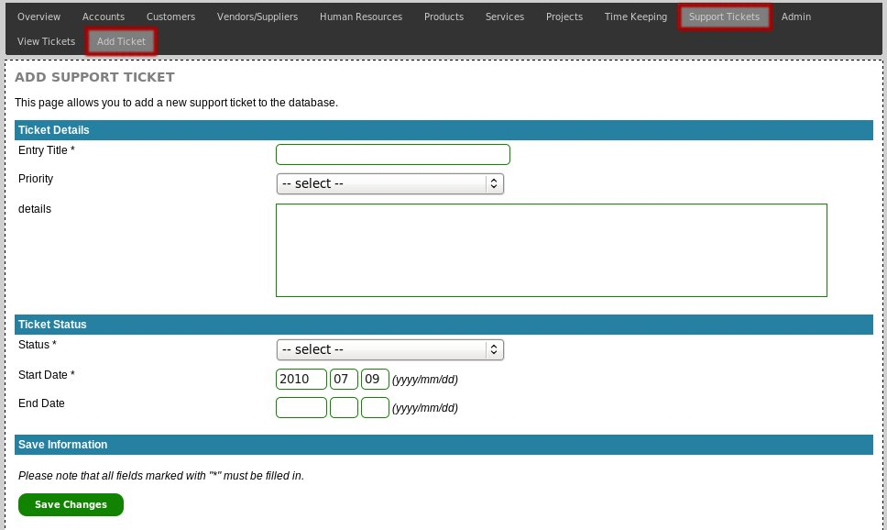

Required Fields:
- Support Ticket Title
- Status
- Start Date

Once all fields have been entered, click “Save Changes” to add the support ticket to the billing system.

Listing Support Tickets
Select “Support Tickets -> View Tickets” from the menu to display a list of all uncompleted support tickets

You can use the options at the top of the page to configure any filters or search strings. You can also export the data in alternative formats, which will export the exact same data as currently displayed.

View Tickets
There are multiple pages showing different details for the selected support ticket. First, select the employee you wish to view, by accessing the ticket list (see section above) and then select one of the options to the right of the support ticket title.
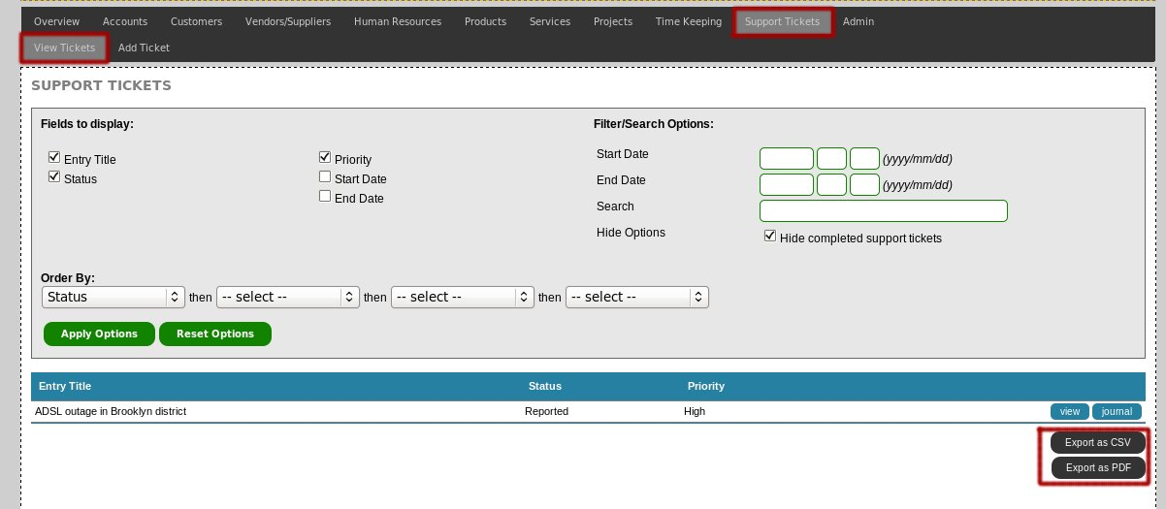
Once you have loaded one of the view pages, you can use the navigation menu to access other view pages.

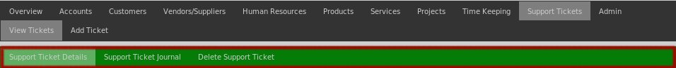

Support Ticket Details
The support ticket details page shows the basic details for the selected ticket and it's current status.

Support Ticket Journal
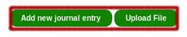
The support ticket journal is an area to attach notes and files to the support tickets. This is the location to record the details and progress reports regarding the ticket.

To add new posts, use the links at the top of the journal.

Journal posts may be adjusted by whomever posted to them until they are locked, which can be configured to occur automatically after a number of days, or manually at the end of the financial year.

Deleting Support Tickets
When required, support tickets can be deleted from the billing system, although is it better to just set the end_date field to hide the support ticket from the list of open tickets, as that way the ticket history can still be found in future.

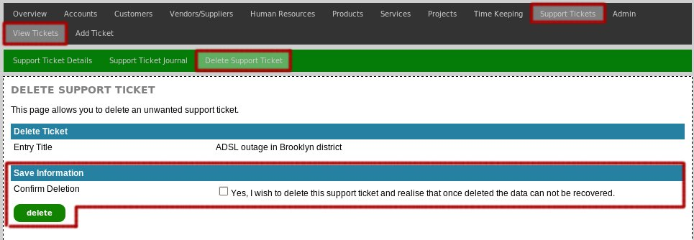

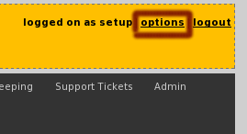
User Preferences
There are various options which users are permitted to make changes to themselves, by clicking the “options” link at the top right corner of the window.

This page allows the user to:
- Change their email account.
- Change their password.
- Configure their current timezone (PHP version 5.2.0+)
- Configure various display preferences.

There are additional per-user options which can only be enabled by an administrator via the user administration section of the program, such as turning on application debugging and concurrent login support.

If you are logged in as an administrator, you will be able to see these additional options on your options page, however they will not appear for non-admin users.

Templates & Emails

ABS features a powerful templating system capable of generating documents from XHTML, Latex into PDF as well as text-based templating for emails.

Templates can be selected/configured under Admin -> Template Selection.

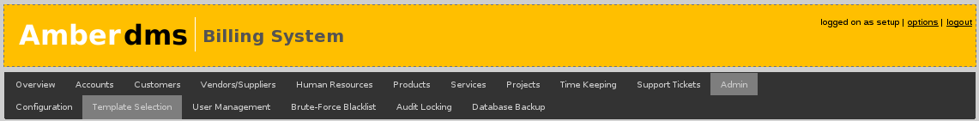

Invoice & Quote Templates
A number of different invoice and quote templates are shipped with ABS, these can be selected on the Template Selection configuration page.

First select “Change” on the AR Invoices entry. Then the full list of available templates will expand out – now select the one that is desired and click “Save Changes”.

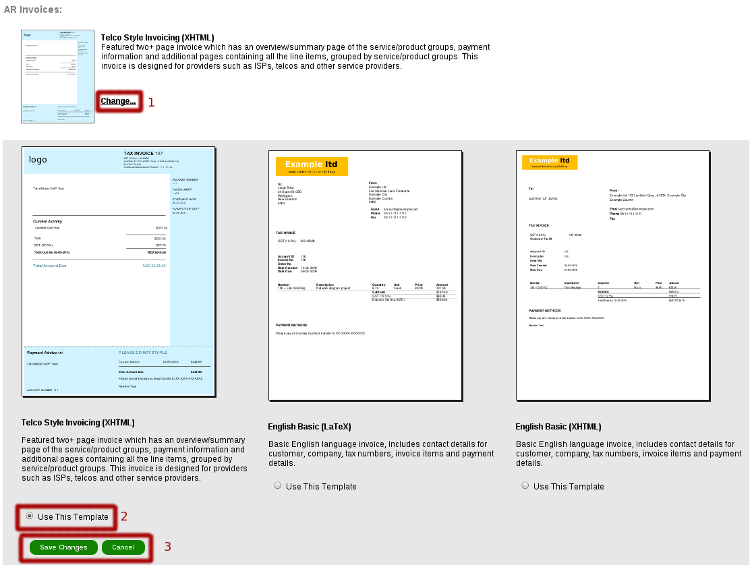

Report Templates
Reports do not currently have selectable templates, but the backend logic is still the same and it is possible to manually add different templates until this feature is completed.

Email Templates
ABS produces a number of emails, such as new invoice notifications, usage reminders and overdue reminder emails. These are customisable to your specific wording.

On certain screens, such as email invoices, the variables in the template will be automatically replaced by the values :

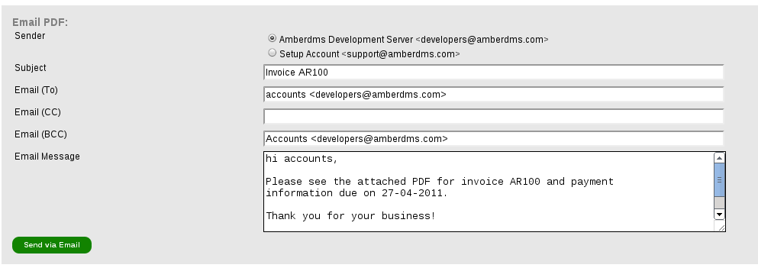
However on a bulk sending form, the original variables will still appear, since ABS will take the text and adjust for each individual customer it emails.

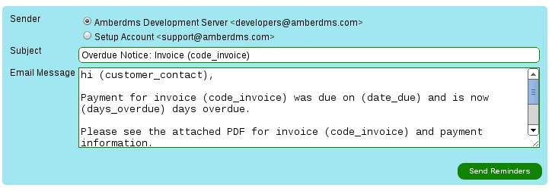

Email templates support a number of different values, these can be referenced as “(value)” in the template text and they will be replaced with the actual values when needed.

code_customer
customer_name
customer_contact
customer_contact_email
customer_contact_phone
customer_contact_fax
customer_address1_street
customer_address1_city
customer_address1_state
customer_address1_country
customer_tax_number
customer_address1_zipcode
company_name
company_contact_email
company_contact_phone
company_contact_fax
company_address1_street
company_address1_city
company_address1_state
company_address1_country
company_address1_zipcode
company_payment_details
code_invoice
code_ordernumber
date_due
code_quote
date_validtill
date_trans
amount
amount_total
amount_currency
amount_paid

To adjust email templates, select the email and select “Change”. The entry will expand and provide a form to edit and update the text template.
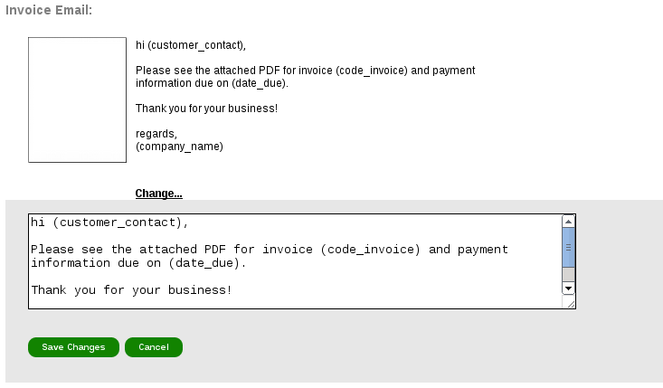

Backend Functionality

ABS supports the following types of template documents:
- PDF using LaTeX templates, using pdflatex command.
- PDF using XHTML/CSS templates, using wkhtmltopdf, a webkit based rendering engine.
- Plain Text, used for emails from ABS.

Amberdms recommend XHTML/CSS for invoice templates, due to the ease for creating complete graphical layouts using commonly available skills that any web developer will have.

If you are interested in developing templates, please refer to the developer documentation at:
https://www.amberdms.com/projects/p/oss-amberdms-bs/page/Developer-Templates/

If the invoice is suitable for general use, please consider submitting it upstream to the project for use and improvements by others.

Audit Locking
It is a common requirement or practice to lock off/sign off all accounting records for a completed financial year to ensure no changes are incorrectly made to the data.

To do this with the Amberdms Billing System, access the Audit Locking page by login in as an administrator and accessing “Admin -> Audit Locking” page.

This will provide you with a date field and a number of options.
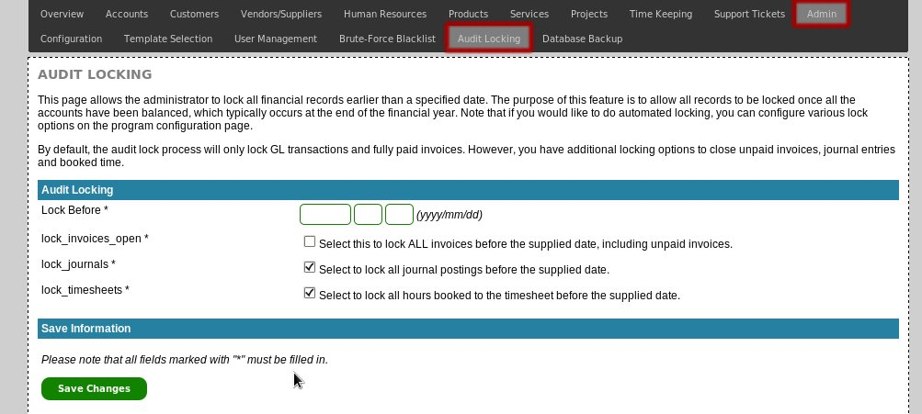

By default, the audit lock process will only lock GL transactions and fully paid invoices. However, you have additional locking options to close unpaid invoices, journal entries and booked time to suit your requirements.
Remember: After locking, items can not be unlocked or adjusted via ABS – only lock for completed financial periods that you do not want adjusted in retrospective.

Database Backup
Amberdms believes in both building with open source components, but also in enabling users to obtain their data out of hosted services – to facilitate this, ABS includes a database backup feature that will export the raw MySQL database out of ABS.

Note: This feature is intended for small size databases (eg: sub-100MB), whilst larger DB exports are possible, server, network and browser limitations may prevent successful backup downloads. In such situations, use command-line MySQL access to export database manually or contact your system administrator.

The backup interface can be accessed at Admin -> Database Backup and will state the estimated download size of the database.

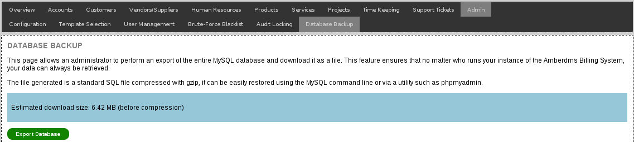

General Application Configuration
The Amberdms Billing System is a very flexible product and provides a number of per-user and system-wide configuration options

To configuration application-wide options, first login as an administrator and access the “Admin -> Configuration” to be provided with a break down of a number of different configuration pages.

- Company Details
- Application
- Locale
- Integration
- Services
- Dependencies (not configuration page, but report on external applications/components).

Company Details
Admin -> Configuration -> Company Details

The Company Details configuration page provides a number of fields for setting details of your company/organisation such as name, contact details, a logo in PNG format to be displayed on PDFs and payment details to append on invoices.

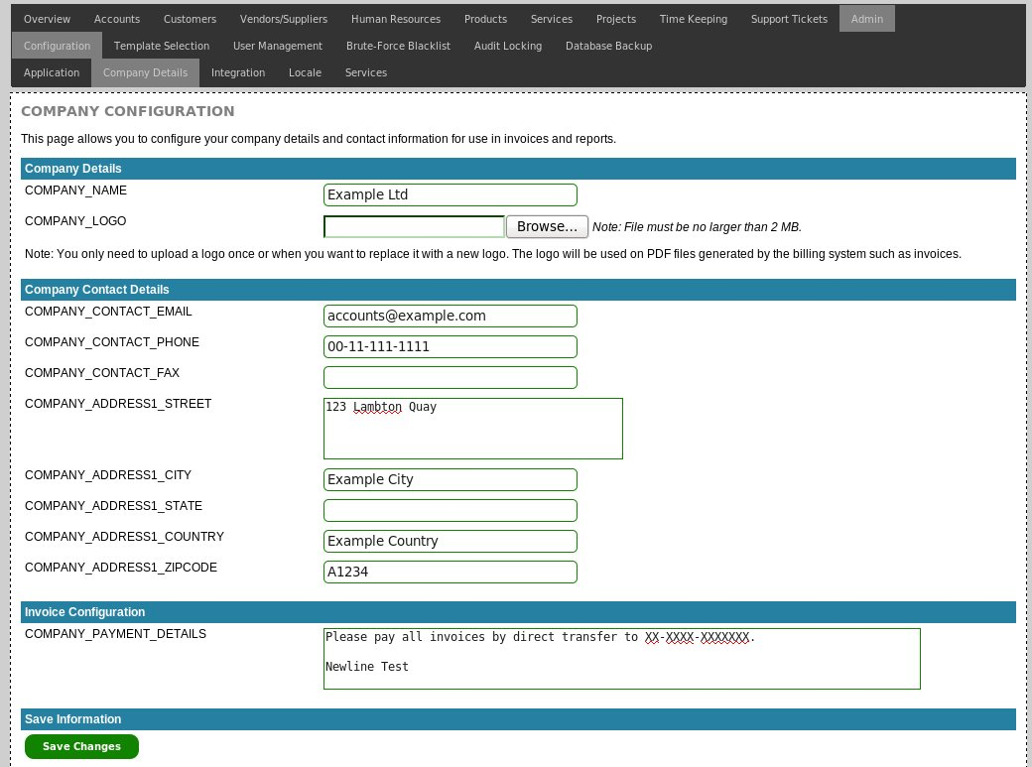

Application
Admin -> Configuration -> Application

The Application configuration options are where ABS defaults, general functionality and other key options are configured.

Default Codes
The various CODE_* options are used to set the default code or ID values when creating new records in the database, in the event that the user has not chosen their own values.

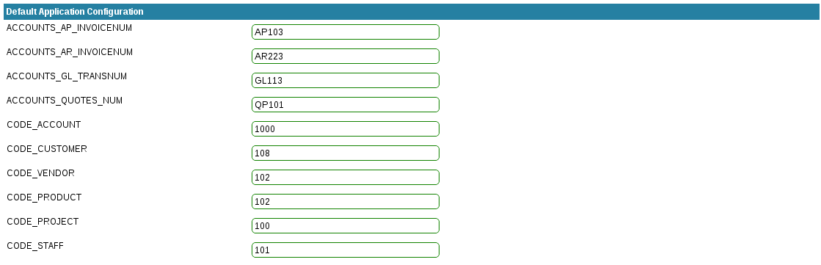
These options are used to generate the unique value assigned to each record – when assigned, these values will increment by +one and will always remain unique.

Accounts Configuration
The accounts configuration options provide the ability to define how long users have to pay invoices and how long before the service expires it should be invoiced.

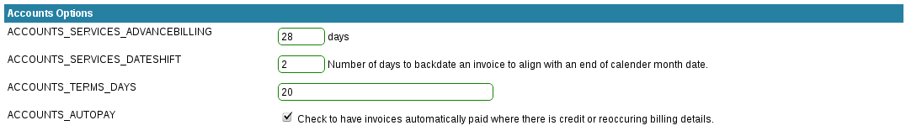
If you are using the monthadvance or periodadvance billing modes, you can configure how many days in advance of the period date to bill the service using the “ACCOUNTS_SERVICES_ADVANCEBILLING” option on the configuration page.

Set this option to the number of days in advance of the service period to bill for. If set to 0, the service will be billed when the period starts.

To set the due date of automatically created invoices, set the “ACCOUNTS_TERMS_DAYS” to the number of days after invoice creation when the invoice is due – typically this is going to be 20 or 28 days.

For situations where billing at the end of a month (typical for telco services), you can set the ACCOUNT_SERVICES_DATESHIFT value to have the invoice date shifted back from the date generated to the end of the previous month date if desired. For example, changing 01-04-2011 to 31-03-2011, so that customers will pay more promptly due to the date being in the previous calender month.

ACCOUNTS_AUTOPAY will define whether any credits or automatic payment facilities configured for a customer should be used when an invoice is generated for a customer. If checked, as much payment/credit will be applied as possible to match the invoice owed amount before the invoice is issued with payments showing to the customer.

Automated Billing
A number of options are provided to control how automated billing takes place, such as the email address to send copies of messages and whether to automatically process orders and invoices.

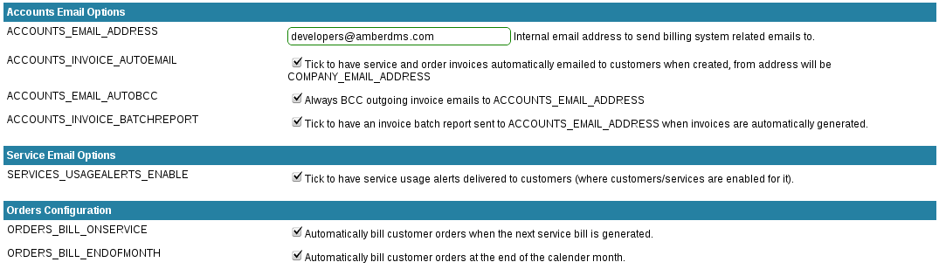

Timekeeping/Timesheet Configuration
If you wish to permit users to be able to book time in the future, enable the TIMESHEET_BOOKTOFUTURE option.

Audit Locking
If you would like to have records automatically locked, use the config_auditlocking options to specify the number of day before records are locked and no longer-editable.

If set to 0, then no automatic locking will take place and the only locking will be performed if an administrator closes off a previous finical year.
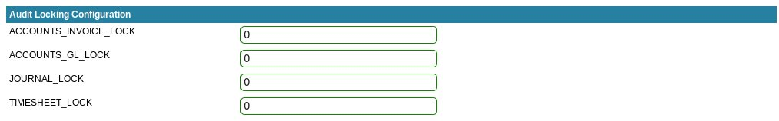

Contributions
If you would to contribute back valuable user base statistics, we would appreciate enabling phone home option for ABS.

The information sent to Amberdms is anonymous and includes application version, PHP version and server platform – this information allows us to determine the environments of choice by our users and better focus developer efforts.

Security
The security section contains blacklisting configuration options as well as misc security settings such as session timeout options.

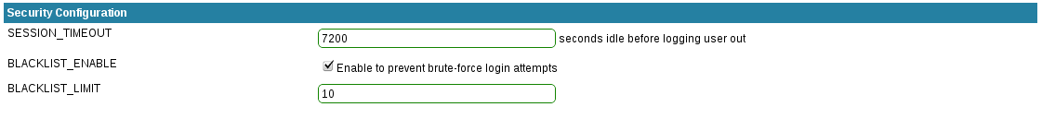

Miscellaneous Configuration
Other infrequently changed options that you may want to use/check:

UPLOAD_MAXBYTES allows an application specific upload limit, however this upload limit can not be any larger than the configured server maximum (as set in php.ini).

API_URL allows the changing of the URL handed out by Amberdms Billing System, this is typically only set once at installation time and only needs changing if you change the path or hostname that the server is running on.

Dangerous Configuration Options

There are a few configuration options which are normally hidden from the configuration screen and can only be shown by enabling an option in the application configuration file.

These options are hidden because changing them is either a potential security risk or could cause problems if changed once the billing system is in use.

These hidden options are:

Option Name | Details
APP_PDFLATEX | The path to the pdflatex program used for processing the generated latex template.
EMAIL_ENABLE | The option to enable or disable the ability to the billing system to send emails. This is classed as a dangerous option as anyone running a public demonstration system will want to have this turned off and not permit anyone to turn it back on for anti-spam reasons.
DATA_STORAGE_METHOD | The method used to store all uploaded files (eg: journal uploads). Can either be the database or the filesystem depending on your requirements.  If you are uploading small files, use load-balancing web servers or have a replicating database, choosing the database method is the simplest and easiest option that also works fine with database replication or load-balancing.  If you are uploading large files or have limited database space available you may prefer to use the filesystem option to save data on the local disk. Be aware that if you are doing load-balancing of your web servers, the location you choose needs to be shared across all your servers.
DATA_STORAGE_LOCATION | If the DATA_STORAGE_METHOD is the filesystem, specify the path for the webserver to store all the files in. Note that this location must be writeable by the webserver.

Note: It is not recommended to change the DATA_STORAGE_METHOD once you have started using the Amberdms Billing System. However, if you do, any existing data will stay in the previous location and any new data will be stored in the new location.

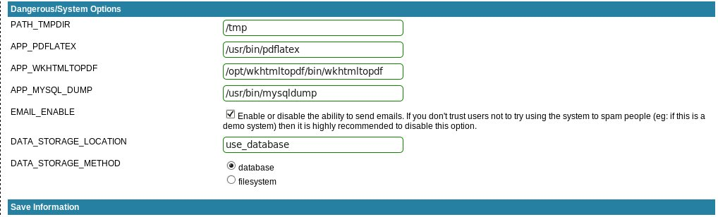
To enable the above options, the server administrator needs to change the following line from “disabled” to “enabled” in the config.php file:

$config["dangerous_conf_options"] = "enabled";

Locale
Admin -> Config -> Locale

The locale configuration page provides options for language and region settings – most of these can be overridden on a per-user basis, but the setting here will apply to new users and to automated processes.

Language
ABS is a multi-lingual capable service, you can set the default language on the locale page.
For information relating to translating the application and importing/exporting languages, please refer to the translation documentation.

Application Appearance
TODO: add details here, further development may take place.

Date Settings
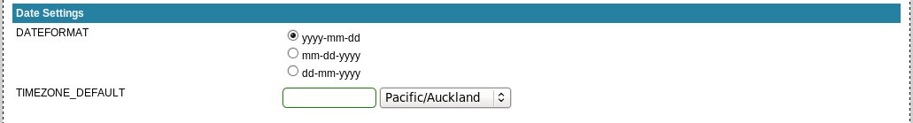

Option Name | Details
UPLOAD_MAXBYTES | Maximum file upload size in bytes – note that PHP has it's own limits on uploads and this option can not allow uploads larger than permitted by PHP.
DATEFORMAT | Default format for displaying dates (can be overridden on a per-user basis)
TIMEZONE_DEFAULT | Default Timezone (can be overridden on a per-user basis)  Note that timezone support is only available with PHP version 5.2.0 and above – if you are running any earlier version of PHP, you are limited to only the “SYSTEM” timezone which simply uses the timezone of the webserver.

Currency Configuration
ABS allows the configuration of the name, symbols and formatting of your selected currency.
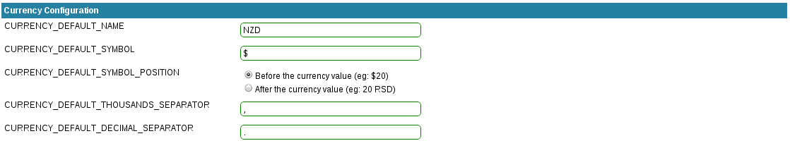

Services
Admin -> Config -> Services

Services has a number of configurable options to impact the behaviour and UI options for services.

Services: UI Options
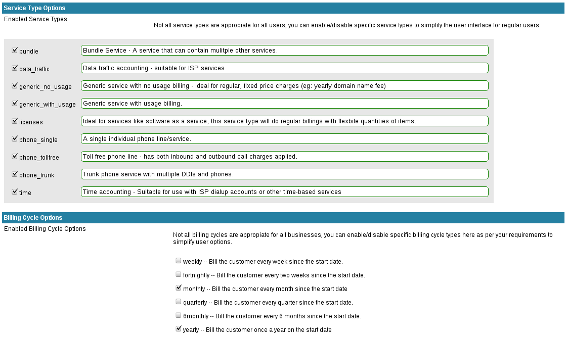
Service user interfaces can be complex, particularly for less technical staff – to help reduce this, the services page has a number of options for reducing and adjusting UI attributes.
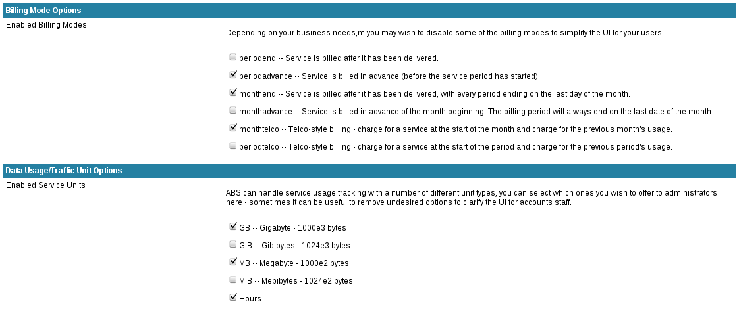

Services: External Data Sources
ABS has the ability to bill services using internal data sources, or by making use of external databases for CDR or data records.

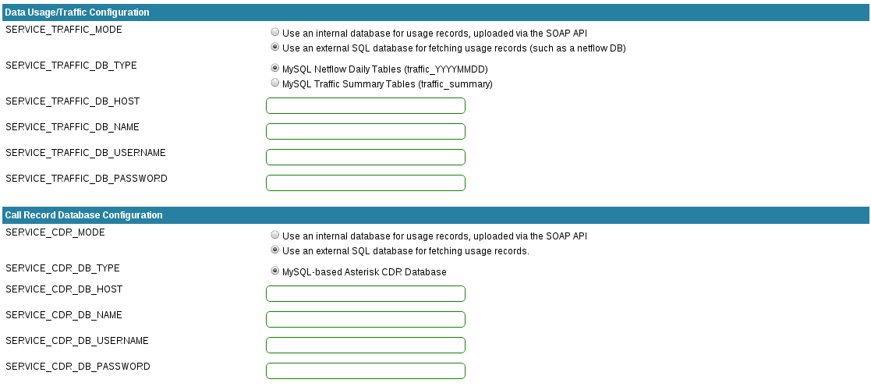

Services: Functionality Options
Various other service functionality and behaviour options are configurable via the services page:

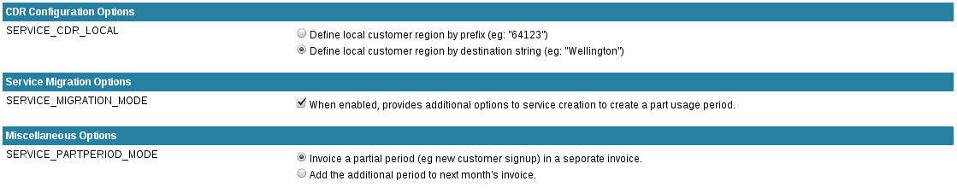

Integration
Admin -> Config -> Integration

The integration configuration page enables/disables the ability to integrate with external components, such as CRM systems or portals.

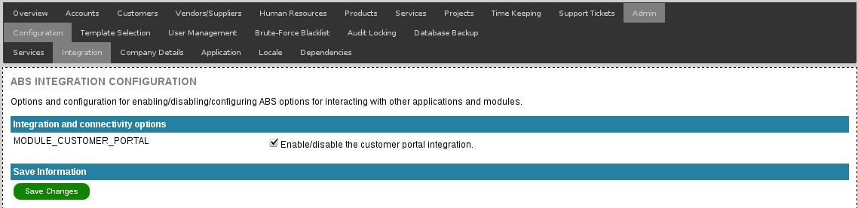

Option Name | Details
MODULE_CUSTOMER_PORTAL | Option to enable or disable the customer portal functionality – enabling this will cause additional UI options to appear on the customer management pages along with various SOAP API functions.

Dependencies
The dependencies page is intended as a debugging tool to display the status of all required external components to ensure that they exist and are accessible.

For more information, please refer to the section in the troubleshooting documentation.

User Authentication Backend
The following information relates to the backend user authentication options as well as security routines like blacklisting.

Authentication Backend
ABS currently only supports local authentication, however LDAP authentication is an available option for consulting customers, with services available for integrating with different types of LDAP directories.

Blacklisting
It is recommended that you limit access to the Amberdms Billing System by using a firewall to lock access to your trusted networks.

However, there are sometimes cases where you need to have the system open to the internet, or you have untrusted hosts on your internal network. To provide you with additional security in these situations, you can use the IP blacklist feature to automatically block anyone trying to brute force their way into user accounts.

Blacklisting can be enabled on the main configuration page, or by visiting the blacklist page at “Admin -> Brute-Force Blacklisting” and enable/displaying the feature as well as defining the maximum number of bad attempts.

All incorrect login attempts are shown in the table on the blacklist page and there are delete links to allow you to clear the block for a specific IP.

Translations & Languages

ABS is primarily developed in English (US/UK) but has the capability for translation into any number of different languages, thanks to it's use of UTF-8 fields and a database of application labels enabling translation.

Supported Languages

- US English [officially supported].

Amberdms is working with the community to obtain additional translations/languages for the application and welcomes contributions.

Contribution
To contribute to the Amberdms Billing System translation efforts, join the mailing list:
http://lists.amberdms.com/mailman/listinfo/amberdms-bs

Troubleshooting

Authentication or User Issues

“I'm only able to login from one computer at any time”
By default all users are configured to only support one login at a time. If you wish to allow a user to login multiple times (ie: from two different computers simultaneously), you need to enable concurrent login support for the user account.

Use the user management interface to enable the concurrent login support for the user. Note that SOAP API users should always have concurrent login support enabled.

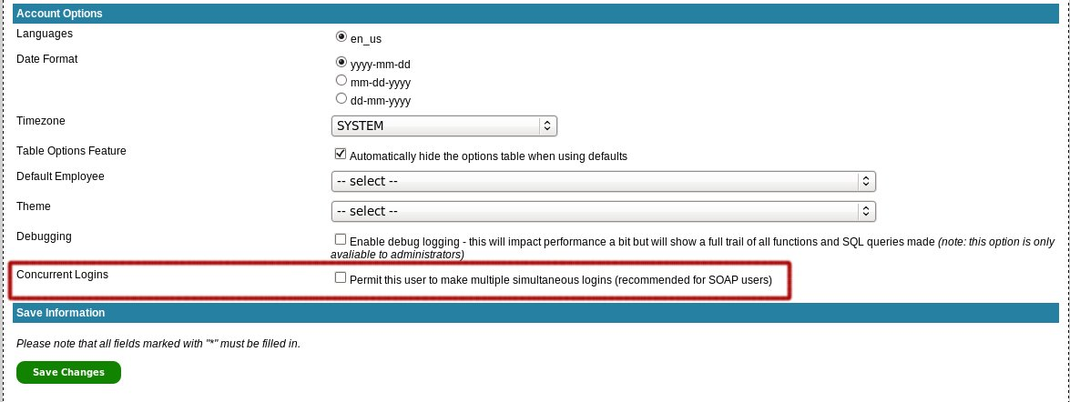

“My SOAP application seems to randomly be denied access despite correct permissions”
This is most likely caused by the SOAP user not being configured for concurrent logins – if they are not and there are multiple concurrent SOAP programs using the account, they will kick each other out.

See the details above to enable concurrent logins.

“Even though I have authenticated, my SOAP applications are still constantly denied access”
There are two likely causes of this issue:

- The user you are using in the SOAP application may not have permissions to access the desired features – check the user permissions page.

- When you authenticate, you are provided with a session ID value to pass to any future calls – make sure you are doing this. (refer to the API developer's manual for details)

Invoice/Report/PDF Generation Failure
One of the most common problems experienced with ABS is the failure of PDF generation – typically resulting from the server environment that the application is running on.

The first step is to always verify that all dependencies are met (as per test below) before enabling debugging to track down the issue further.

Note that XHTML based templates tend to be more reliable than LaTeX ones due to the server environments being more consistent.

Missing Dependencies/Components
ABS makes use of a number of external dependencies – whilst the application will often function without some of these, certain features will be impacted -typically email or PDF generation.

To ensure that all dependencies are met, there is a check page included in ABS at Admin -> Configuration -> Dependencies which displays a table showing location & status of all required features.

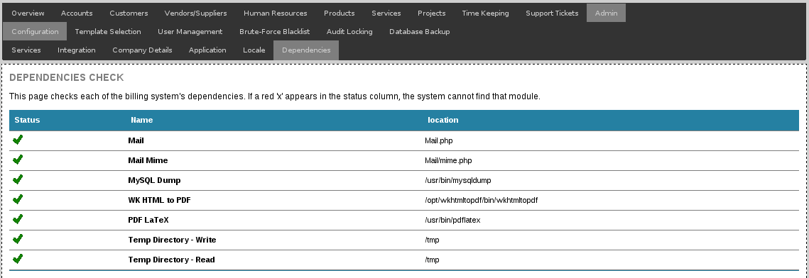

Application Debugging
If you are experiencing any application bugs, Amberdms developers will usually request a copy of the debug log from you.

Debugging can be turned on in a per-user basis, so you can turn on debugging for just a single account and not impact the performance and user-experience of all other users.

Debug logging can be turned on in two ways:

- If you are an administrator, you can turn debug logging on with you user options page. The change will take immediate effect.

- If you want to turn on debug logging for a separate user, go to the “Admin -> User Management” program section, select the desired user and enable debug logging.

The change will only take affect when the user next logs in.

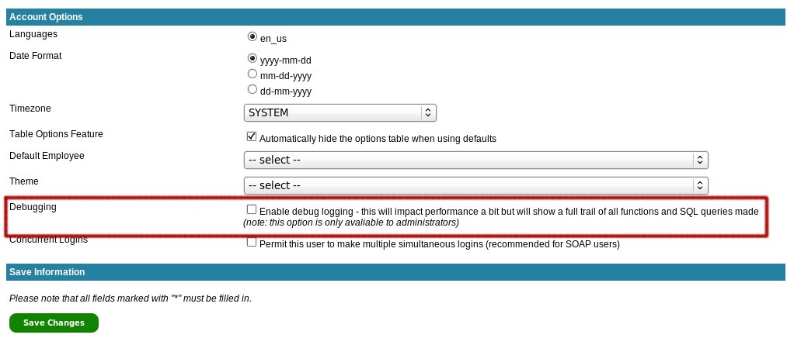

If required, it is possible for force debugging one for all users and all parts of the application including the screens before the users have logged in. This can be enabled by uncommenting the following option in config.php:

// $_SESSION["user"]["debug"] = "on";

Legal & Licensing

Open Source / AGPL
The Amberdms Billing System is licensed under the GNU AGPL version 3 software license, this essentially allows the redistribution and customisation of the source code, as long as those changes are freely available to others to use and contribute back.

This program is free software: you can redistribute it and/or modify
it under the terms of the GNU Affero General Public License as
published by the Free Software Foundation, either version 3 of the
License, or (at your option) any later version.

This program is distributed in the hope that it will be useful,
but WITHOUT ANY WARRANTY; without even the implied warranty of
MERCHANTABILITY or FITNESS FOR A PARTICULAR PURPOSE. See the
GNU Affero General Public License for more details.

You should have received a copy of the GNU Affero General Public License
along with this program. If not, see <http://www.gnu.org/licenses/>.

Trademark Use
The AGPL open source license does not cover the use of Amberdms trademarks, for information about trademark usage, please contact legal@amberdms.com with your enquiry.

Community Links

The open source project and repositories can be found online at:
https://projects.jethrocarr.com/p/oss-amberdms-bs/

The community support and communication mailing list can be found at:
http://lists.amberdms.com/mailman/listinfo/amberdms-bs

Developer mailing lists and issue tracker notifications can be found at:
http://lists.amberdms.com/mailman/listinfo/amberdms-bs-devel

