The first step I took was to use searchsploit to find exploits that apply to qdpm 9.1.

I then located the python scripts actual location in the file system.



Next I copied the exploit to my folder for this attack path.

I then configured the proxychains tool to route traffic through my SOCKS5 proxy connecting to the school network.



After configuring proxychains I performed an nmap to make sure I could access the server and get some more info.

I then tried to run the code from exploitdb and the code from canvas. The code from exploitdb failed to run correctly. The canvas code worked great. Side note, I really look forward to learning to build these kinds of exploits and tools myself.

<http://192.168.168.161:8020//uploads/users/131493-backdoor.php?cmd=whoami>

Using the canvas code I then implanted a backdoor on the qdPM webserver.

Next, I tested and confirmed that the backdoor is working.

I then dumped the user accounts on the OS running the webserver.

Using the backdoor I explored the file system searching for valuable files.

As directed in the course videos I found the above username and password in the database.yml file. This password is for the database also running in the environment.

I then found the users list for the qdPM server. Next, I attempted to find more open ports using nmap. However, I was getting a lot of connection issues.

I therefore used my backdoor to see which ports were open on the server I had access to. The only other service open to me I believe is ssh.

Attempted to use hydra to try known and suspected passwords to get into ssh. However, I was not able to connect.

Port 22 may or may not be open. However, it doesn’t connect to ssh so I suspect it’s down.

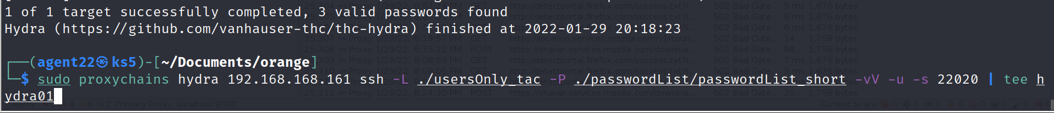

I then remembered the ssh port shown in class. I repeated the hydra request using that port. Before repeating the hydra I added all of the usernames to the password list. The password list also contained all passwords found previously.

This resulted in me obtaining three usernames and passwords.