

**Joulescope JS220 Evaluation Kit 1**

**Quick Start Guide**

This Joulescope™ JS220 Evaluation Kit 1 (EVK) provides a quick and easy way to measure real waveforms with a Joulescope JS220. Power the EVK with the provided USB C to A cable. The EVK plugs directly into the sensor-side of the JS220, and it generates high-dynamic current waveforms for analysis by the JS220.

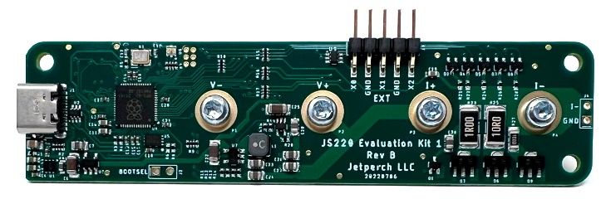 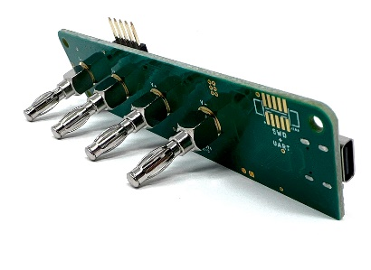

Kit Contents:

* JS220 EVK1 board
* USB A to C cable
* Joulescope sticker

You will need to provide a Joulescope JS220 and a host computer. The host computer must have two available USB A ports, one for the JS220 and one for the EVK.

1. Connect the EVK to the JS220 sensor-side binding posts. Use both hands and avoid the protruding expansion connector header.
2. Use the provided USB cable to connect the EVK to the host computer.
3. Use the JS220’s USB cable to connect the JS220 to the host computer.
4. Launch the Joulescope software to capture and explore!

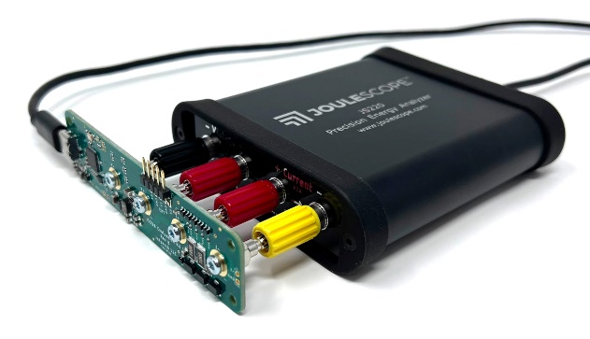 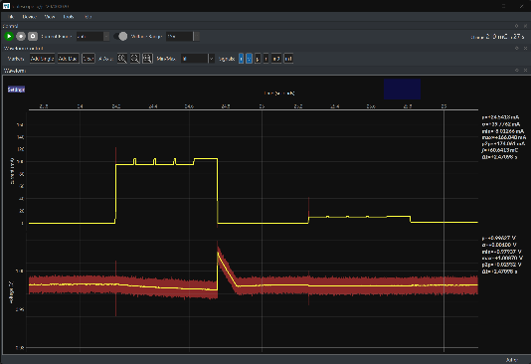

You can easily control the EVK to generate other waveforms and interact with GPIO. The entire hardware and software design is open source using Micropython. For more detailed instructions and information, visit **joulescope.com/js220_evk1**

|  |  |
| --- | --- |
| ⚠️ | The EVK is provided for evaluation only and does not have FCC, CE, or USB certifications. You are responsible for operating the EVK in compliance with any local regulations. |

If you have any questions, please contact support@joulescope.com!