**Autocratica**

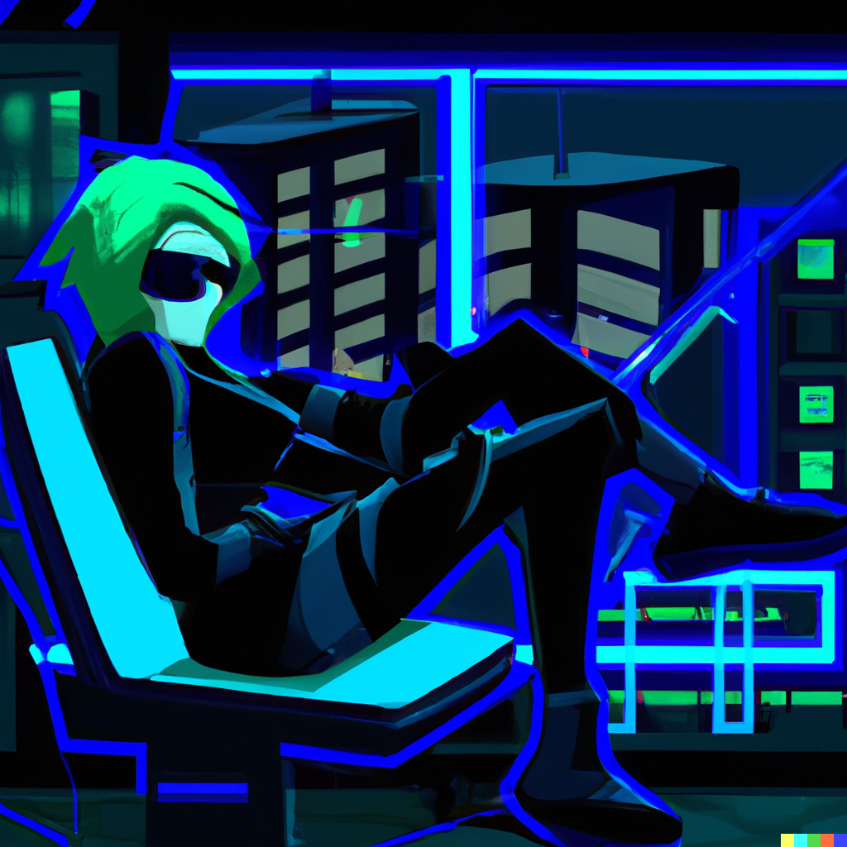

Version 0.1.0

March 28 2023

© 2023 jetScholar Game Designs

Revision List

|  |  |  |  |
| --- | --- | --- | --- |
| Version | Author | Date | Comments |
| 0.1.0 | MXZ | 28.3.23 | Initial version |
|  |  |  |  |
|  |  |  |  |
|  |  |  |  |
|  |  |  |  |

Table of Contents

1. Game Overview
   1. Main Features
   2. Synopsis
2. Story and Narrative
   1. Setting
   2. Characters
   3. Narrative
3. Game Mechanics
4. User Interface and User Experience
5. Art and Design
6. Audio Design
7. Technology
8. Testing and Evaluation
9. References

[Main Soundtrack](https://cgsacteduau.sharepoint.com/:u:/r/sites/cgssharedfolders/Academic/DIGITAL%20INNOVATION/_2023/IT09%202023/Resources/Unity/Game%20Ideas/Autocratia.mp3?csf=1&web=1&e=lCEM3B) [Dark Alleys](https://cgsacteduau.sharepoint.com/:u:/r/sites/cgssharedfolders/Academic/DIGITAL%20INNOVATION/_2023/IT09%202023/Resources/Unity/Game%20Ideas/Dark%20Alleys.mp3?csf=1&web=1&e=YqF7fF) [Hopeful Moment](https://cgsacteduau.sharepoint.com/:u:/r/sites/cgssharedfolders/Academic/DIGITAL%20INNOVATION/_2023/IT09%202023/Resources/Unity/Game%20Ideas/Hopeful%20Moment.mp3?csf=1&web=1&e=Ujqq9A) [Catch me if you can](https://cgsacteduau.sharepoint.com/:u:/r/sites/cgssharedfolders/Academic/DIGITAL%20INNOVATION/_2023/IT09%202023/Resources/Unity/Game%20Ideas/Catch%20Me%20if%20You%20Can.mp3?csf=1&web=1&e=XnYKK7)

[Lurker](https://cgsacteduau.sharepoint.com/:u:/r/sites/cgssharedfolders/Academic/DIGITAL%20INNOVATION/_2023/IT09%202023/Resources/Unity/Game%20Ideas/Lurker.mp3?csf=1&web=1&e=Th3ErV')

Here's a rough concept for a 2D platformer game world based on a character trying to liberate their nation from autocracy:

Setting and Storyline: The game takes place in a fictional nation called Autocratia, which is ruled by a tyrant dictator. The protagonist, Maya Vanguard takes on the role of a young rebel trying to overthrow the regime and bring freedom to her people. The game starts with the player character being recruited into the rebel movement and being given their first mission.

Level Design: The game features a variety of levels, each with its own unique challenges and obstacles. The levels are designed to reflect different aspects of Autocratia, from the grand palaces of the ruling elite to the poverty-stricken slums where the common people live.

Enemies and Bosses: The game includes a range of enemies, from the regular soldiers and police officers of the autocratic regime to elite guards and special forces units. Each level features a boss fight against a key member of the regime, such as a high-ranking general or a corrupt government official.

Power-ups and Upgrades: Throughout the game, the player can collect power-ups and upgrades that enhance their abilities and help them progress through the levels. These might include new weapons, health boosts, or speed upgrades.

Choice and Consequence: The player's choices throughout the game can affect the outcome of the story. For example, choosing to spare an enemy's life might lead to them later defecting to the rebel cause, while killing them might lead to their family seeking revenge against the player. The game also features multiple endings, depending on the player's actions.

Music and Sound: The game features a dynamic soundtrack that changes based on the player's actions and the events of the game. The music is designed to reflect the mood of each level, from tense and suspenseful to triumphant and uplifting.

Art Style: The game features a hand-drawn 2D art style, with detailed backgrounds and character designs. The color palette reflects the dark and oppressive nature of Autocratia, with muted tones and deep shadows.

Overall, the game is designed to be a challenging and engaging platformer that also tells a compelling story about the struggle for freedom and justice in a corrupt and oppressive regime.

The capstone could be a piece of technology that was originally developed by the autocratic regime to track and monitor the movements of its citizens. However, the rebels have managed to hack into the capstone's network and repurpose it for their own use.

As the player progresses through the game, they can use the capstone to scan NPCs in the game world and determine whether they are potential recruits for the rebel cause. These NPCs might be dissatisfied with the current state of affairs in Autocratia, or they might have specific skills that could be useful to the rebels.

Once the player has identified a potential recruit, they can use the capstone to send a message to that NPC, inviting them to join the rebellion. The NPC's response will depend on a variety of factors, such as their personality, their experiences with the regime, and their level of trust in the player.

Successfully recruiting NPCs can have a variety of benefits for the player, such as unlocking new abilities or weapons, or gaining access to secret areas of the game world. Additionally, as the player recruits more and more NPCs, they will build up a network of contacts and allies that can help them in their fight against the autocratic regime.

However, the capstone also comes with risks. The regime is constantly monitoring its citizens' communications, and if the player is caught using the capstone to recruit rebels, they could face dire consequences. As the player progresses through the game, they will need to use their wits and strategic thinking to stay one step ahead of the regime's surveillance efforts, and to recruit as many allies as possible without getting caught.

In "The Moon is a Harsh Mistress," Robert Heinlein portrays a group of rebels fighting for lunar independence from Earth. One of the key tools the rebels use in their struggle is a spy cell network, which allows them to coordinate their activities and keep their plans secret from Earth's authorities.

The spy cell network works by dividing the rebel group into small, independent cells, each with a specific function and a limited number of members. The cells are connected by a small number of trusted individuals, who act as intermediaries and coordinate the actions of the different cells.

Each cell is responsible for a specific task, such as gathering intelligence, providing supplies, or carrying out acts of sabotage. The members of each cell are carefully selected and vetted to ensure that they can be trusted to keep their activities secret and to follow orders.

The intermediaries who connect the different cells are also carefully selected and trained to ensure that they are trustworthy and that they have the skills necessary to coordinate the actions of the different cells. These intermediaries are in constant communication with each other and with the members of the cells they represent, using a variety of communication methods to avoid detection.

Overall, the spy cell network is designed to be highly decentralized and resilient, with each cell operating independently and with a high degree of autonomy. This allows the rebels to continue their activities even if some cells are compromised or captured by Earth's authorities.

Strategic Decisions

Here are a few examples of strategic decisions that the player must make in Autocratia, which affect the course of the rebellion:

Which targets to attack: Maya must choose which targets to prioritize in her attacks against the regime. For example, attacking a military base might cripple the regime's military strength, but attacking a key infrastructure target might cripple the regime's ability to maintain control over the population. Maya must weigh the risks and benefits of each target and make a decision that aligns with the overall goals of the rebellion.

Which recruits to trust: Maya receives information from a network of secret cells, but she must decide which information is reliable and which sources to trust. Maya must consider the motives of each cell, the information they provide, and the consequences of acting on that information. Maya's trust in each cell can affect their loyalty to the rebellion, as well as the quality of the information they provide in the future.

Which allies to ally with: Maya may encounter groups or individuals who share the same goals as the rebellion but have different methods or ideologies. Maya must decide which allies to ally with, and which to keep at arm's length. For example, allying with a more militant group might provide more firepower, but it might also turn public opinion against the rebellion. Maya must consider the long-term consequences of each alliance and make a decision that aligns with the overall goals of the rebellion.

Which missions to prioritize: Maya receives requests from different factions and individuals within the rebellion, each with their own agenda and priorities. Maya must decide which missions to prioritize and which to put on hold. For example, prioritizing a mission to rescue political prisoners might earn the loyalty of a key ally, but it might also put other missions at risk. Maya must consider the potential rewards and consequences of each mission and make a decision that aligns with the overall goals of the rebellion.

Title: Autocratia

Genre: 2D platformer

Overview: Autocratia is a 2D platformer game that follows the story of Maya Vanguard, a college student who discovers a powerful communication device called capstone. Maya uses capstone to recruit members to a rebellion against the autocratic regime that rules over her nation. The game features challenging platforming levels, strategic decision-making, and a deep story that explores the themes of oppression, resistance, and sacrifice.

Gameplay:

The core gameplay of Autocratia is split between platforming and strategic decision-making. The platforming levels are designed to be challenging and require precise timing and quick reflexes. Maya must navigate a variety of obstacles, including traps, enemy soldiers, and environmental hazards, using her acrobatic skills and capstone device.

In addition to platforming, Maya must also make strategic decisions that affect the course of the rebellion. Maya's capstone device allows her to communicate with recruits and gather intelligence from a network of secret cells. Maya must decide which information is reliable and which sources to trust, all while evading the regime's surveillance efforts.

The strategic decision-making aspect of the game is represented through dialogue trees, where Maya must choose the right responses to convince her recruits to join the rebellion and gain their trust. Maya must also make choices that affect the direction and outcome of the rebellion, such as deciding which targets to attack and which allies to ally with.

Story:

The story of Autocratia follows Maya Vanguard as she navigates a world ruled by an oppressive regime. The game is set in a fictional nation, where the ruling government is known for its brutal tactics and suppression of dissent. Maya, a college student, discovers capstone, a powerful communication device that allows her to recruit members to a rebellion against the regime.

As Maya navigates the world of Autocratia, she encounters a variety of characters, including fellow rebels, sympathetic citizens, and corrupt government officials. The story explores themes of resistance, sacrifice, and the human cost of political upheaval. Maya's journey is one of self-discovery and personal growth, as she learns to navigate the dangerous world of rebellion and fight for what she believes in.

Art Style:

The art style of Autocratia is designed to be dark and atmospheric, with a color palette that reflects the oppressive nature of the regime. The game features hand-drawn 2D graphics with intricate backgrounds and detailed character animations. The world is designed to be immersive, with a variety of locations that reflect the different aspects of the regime's control over the population.

Sound Design:

The sound design of Autocratia is designed to enhance the game's atmosphere and immersion. The game features an original soundtrack that combines traditional instruments with modern electronic elements to create a unique and memorable sound. The sound effects are designed to be realistic and reflect the different elements of the game, such as the sound of gunfire or the creaking of metal traps.

Conclusion:

Autocratia is a game that combines challenging platforming with strategic decision-making and a deep story. The game explores themes of oppression, resistance, and sacrifice, and invites players to immerse themselves in a world of political upheaval and personal growth. With its intricate art style, atmospheric sound design, and compelling gameplay, Autocratia is a game that is sure to leave a lasting impression on players.