## Github Repository Link

<https://github.com/jetshaggy85/info5731.git>

## Instllation screenshot

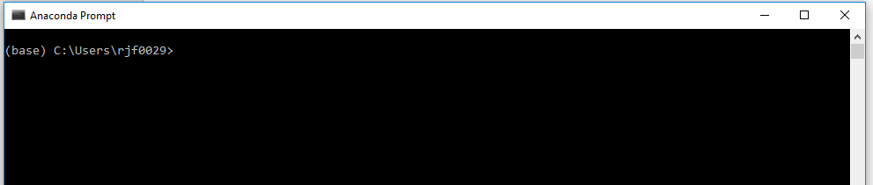

## Chapter 4

* The Turtle
  + 
   