Note: Maintain proper internet connection to do the following process.

1. After the installation of Kali linux (2019), the “sources.list” doesn’t contain any repositories.

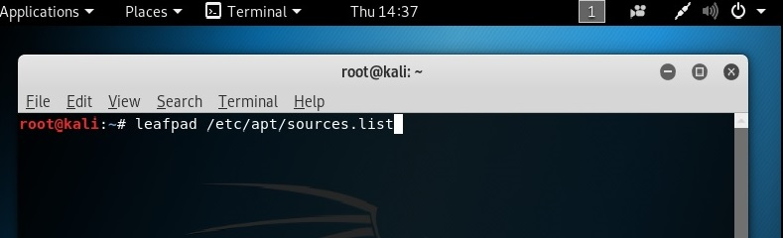

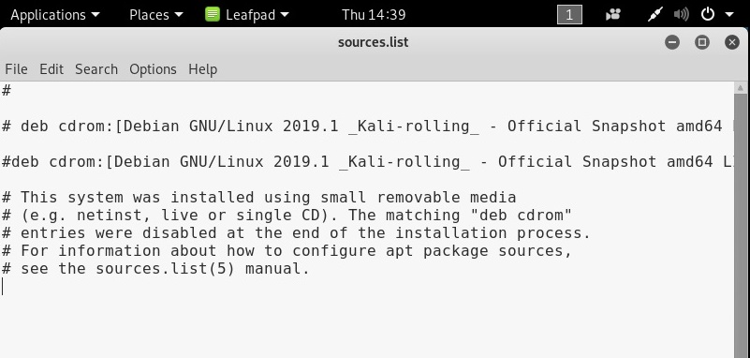

Note: # represents comments.

1. Remove everything from the “sources.list” and add both regular & source repositories to the “sources.list” (/etc/apt).
2. **Regular repository: deb** [**http://http.kali.org/kali**](http://http.kali.org/kali) **kali-rolling main contrib non-free**
3. **Source repository: deb-src** [**http://http.kali.org/kali**](http://http.kali.org/kali) **kali-rolling main contrib non-free**

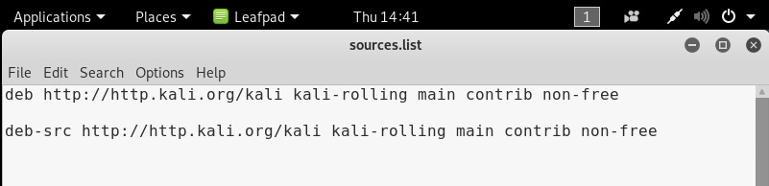

1. We need to update & upgrade the repositories in kali linux.
2. **apt-get update**

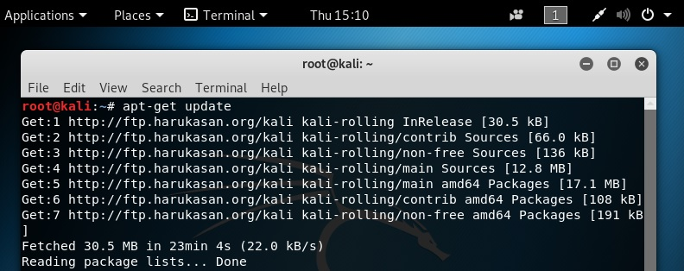

while updating, if there are any key mismatch errors (or) invalid signatures, then add the following:

**apt-key adv --keyserver hkp://keys.gnupg.net --recv-keys 7D8D0BF6**

**(or)**

**wget -q -O - https://archive.kali.org/archive-key.asc | apt -key add**

Note: Before upgrading the repositories on kali linux, make sure that windows defender & firewall is disabled on main operating system. If we don’t disable it, then some of the packages might not be installed on kali linux.

1. **apt-get upgrade**

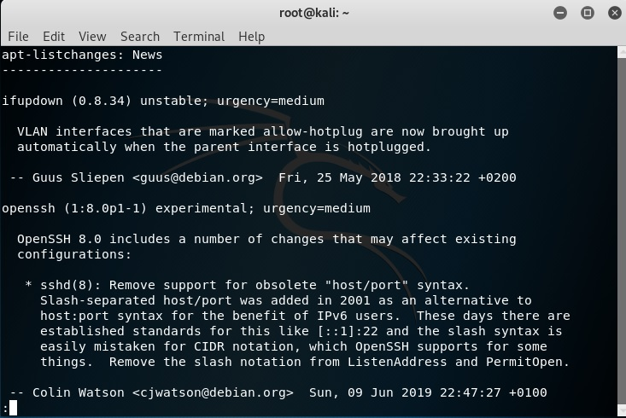

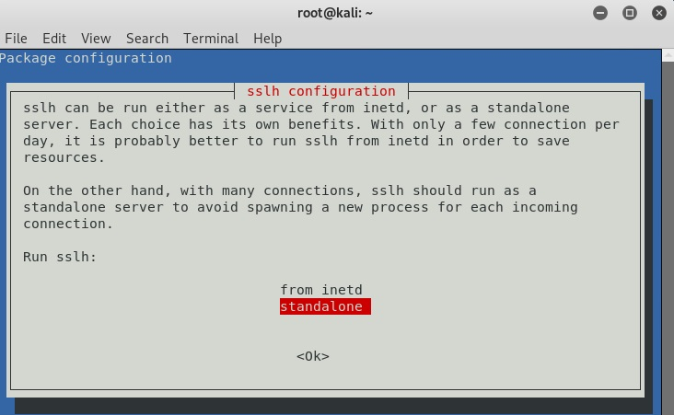

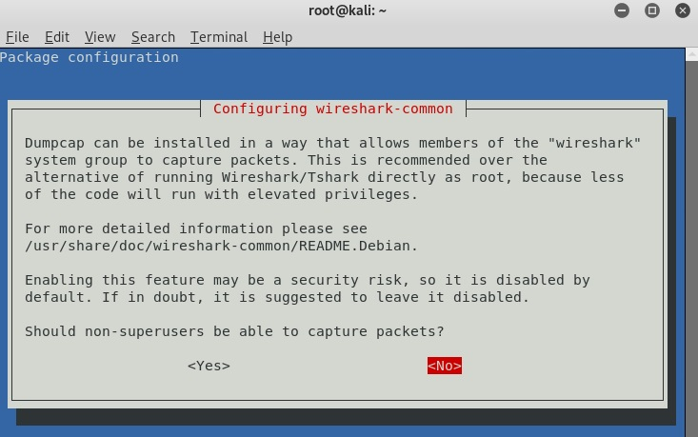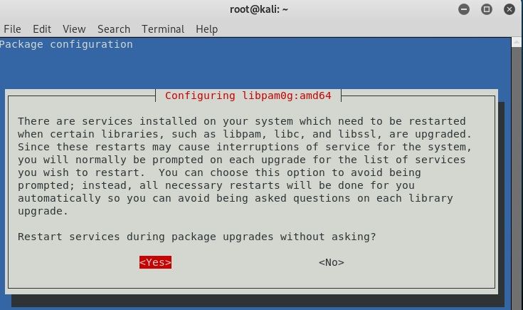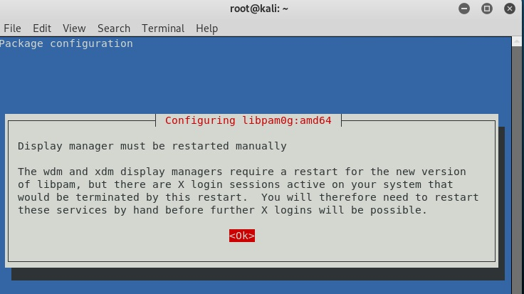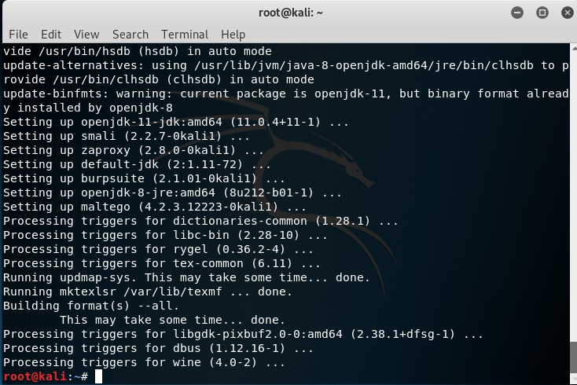

1. Reboot the kali linux:;

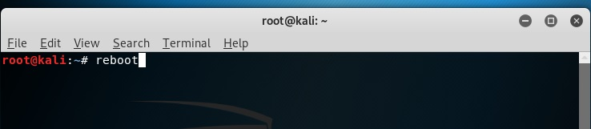

1. Installing Veil-Framework as follows:

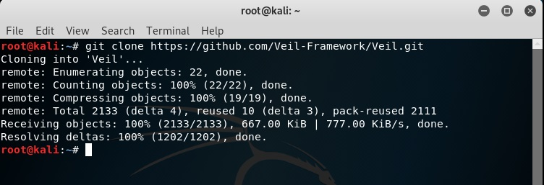

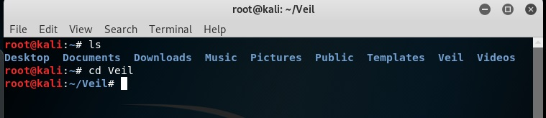

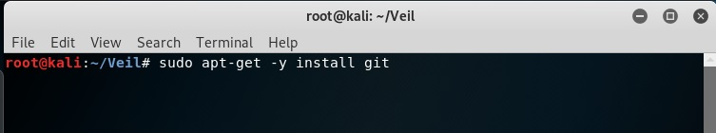

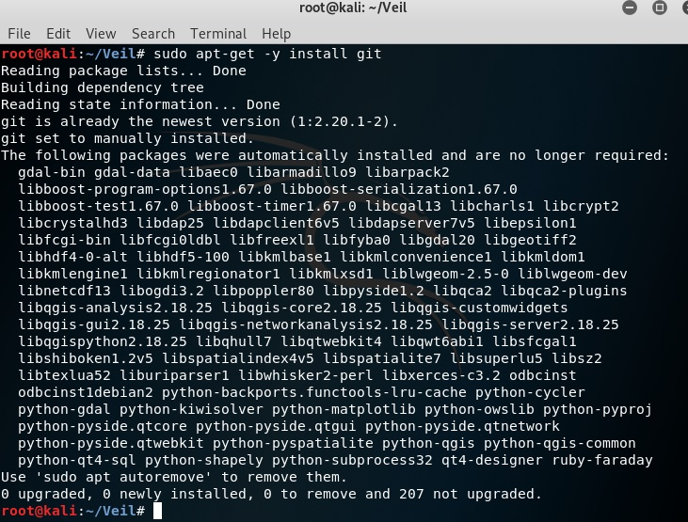

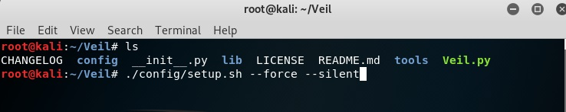

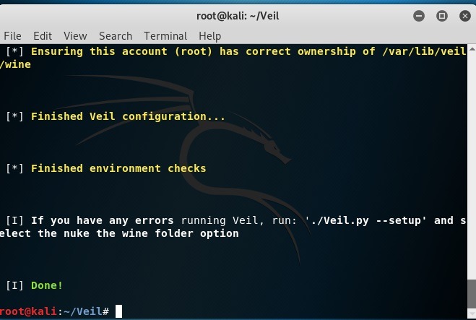

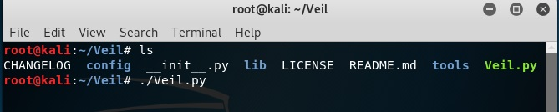

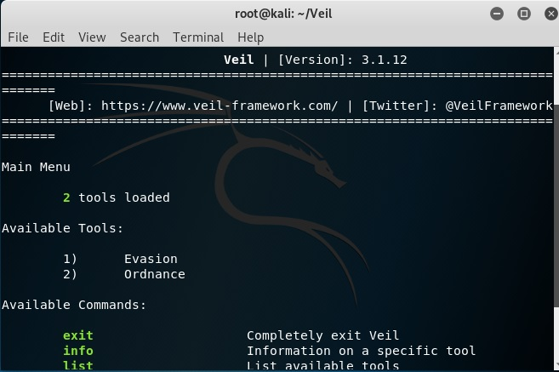

1. Installing VMWare tools as:

