-- Top 20 zip codes (branch_zip) by total transaction value (Cast zip as string so you can see the zipcodes on the visualization)
SELECT CAST(zip AS STRING) AS Zipcode, SUM(c.transaction_value) AS Sum
FROM card c
JOIN branch b
ON c.branch_code = b.code
GROUP BY b.zip ORDER BY sum DESC
LIMIT 20;
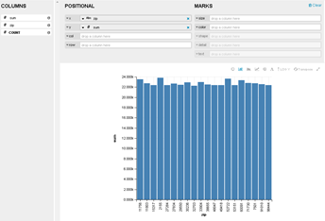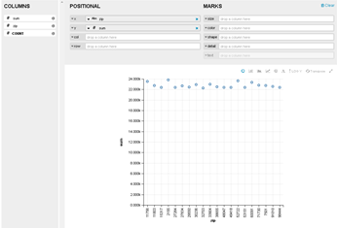

-- Total transaction value for each transction type by quarter in 2018
SELECT SUM(c.transaction_value) AS Total_Transaction_Value,
c.transaction_type AS Transaction_Type, t.quarter AS Quarter
FROM card c
JOIN time t
ON (c.id = t.id)
WHERE t.year = 2018
GROUP BY t.quarter, c.transaction_type;
