@ = check_box

Water differences dashboard analytics

Water differences dashboard analytics

**Waste zone** from a list several or all (show the table value and description)-index_waste_zone

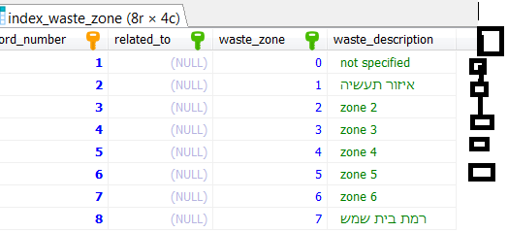

**belongs_to_group**: SELECT FROM A LIST several or all (make select distinct to find) –index_waste_group)

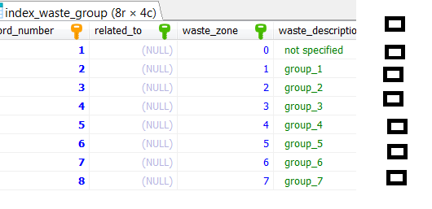

**Mone_av** select from list (according to former selection )

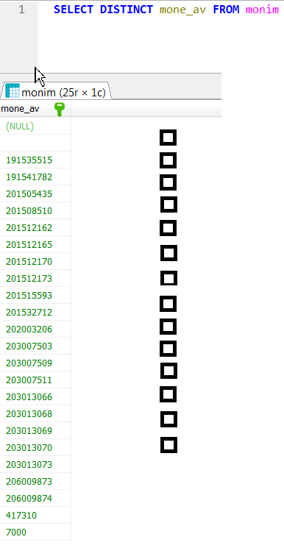

**Dates : min** - max

**Delta** min_ - max

**Per cent**  min - _ max

**X** – exis : date @ ezor @ group @ mone_av@

**Sum**: daily @ weekly @ monthly @ yearly@

**Graph** : pie@ line @ bar @ area @

Y = qty @ real_qty @ ,per_cent @ delta @ all @

Graph header ____________________________________

Here graph

When graph shows:

Zoom , walk right or left

Show table of the data you used for graph , create csv, save picture