JPAS FINANCIAL MODEL
ANALYTICAL REPORT & MODEL WALKTHROUGH
PT Jaminan Pembiayaan Askrindo Syariah (JPAS)
YTD Period: January - Mei 2026 | Reference: Draf 20260612 | Prepared using CFI FMVA Standards

1. Executive Summary
Metric | YTD Mei 2026 | YTD Mei 2025 | Change
IJK Bruto (Revenue) | Rp 405.1B | Rp 283.0B | +43.1%
Net Underwriting Profit | Rp 101.8B | Rp 100.0B | +1.8%
Investment Income | Rp 62.6B | Rp 47.1B | +32.9%
EBIT (Laba Usaha) | Rp 100.7B | Rp 101.2B | -0.5%
Net Income | Rp 74.7B | Rp 76.8B | -2.7%
Total Assets | Rp 3,418.9B | Rp 3,193.5B | +7.1%
Total Equity | Rp 1,206.9B | Rp 1,074.5B* | +12.3%
ROE | 6.2% | 6.4% | -0.2pp
ROA | 2.2% | 2.4% | -0.2pp
Gearing Ratio | 29.65x | N/A | Limit: 40x
*Mei 2025 equity estimated from available data.
Revenue grew 43% year-on-year, driven by higher IJK Bruto across both Mikro and KUR products. Net income fell slightly despite the revenue jump because the equity base expanded faster through retained earnings, compressing return metrics. The business is operationally profitable, with operating cash flow of Rp 99.3B against Rp 0 financing outflows (no dividends declared YTD).
Three integrity checks on the model all pass: the balance sheet closes to zero, CFS ending cash ties to the BS (Rp 80.6B), and IS net income matches the BS equity movement line (Rp 74.7B).

2. Business Model
JPAS is a syariah-compliant guarantee company (penjaminan syariah), not a bank or conventional insurer. The business does not lend money. It sits between partner banks (mitra) and small business borrowers: when a bank extends a loan, JPAS guarantees repayment if the borrower defaults.
Revenue comes entirely from IJK (Imbal Jasa Kafalah), a guarantee fee charged as a percentage of the loan value. When a default occurs, the partner bank calls the guarantee. JPAS pays out (Ta'widh), then pursues the defaulted debtor directly to recover what it can (Recoveries/Subrogasi). JPAS is the syariah arm of Askrindo, a state-owned guarantee company.
2.1 Products (Class of Business)
Product | Description | IJK Bruto (Rp B) | Share of Revenue | Net UW Profit (Rp B) | Share of Profit
Mikro | Micro loans via PT PNM. Smallest loans, highest volume, highest default rate. | 165.8 | 40.9% | 7.6 | 7.5%
KUR | Kredit Usaha Rakyat. Government-subsidized micro-business loans. Largest profit contributor. | 165.1 | 40.7% | 61.9 | 60.8%
KPP | Kredit Program Pemerintah. Other government credit programs. | 46.0 | 11.4% | 3.1 | 3.0%
Konsumtif | Consumer loan guarantees. | 19.3 | 4.8% | 20.6 | 20.2%
Retail & Korporasi | Larger commercial loans. Very low loss ratio (3.2%). | 5.7 | 1.4% | 6.8 | 6.7%
KBG | Other products. | 3.2 | 0.8% | 1.5 | 1.5%
TOTAL |  | 405.1 | 100% | 101.8 | 100%
Mikro and KUR each generate about 41% of total revenue. The split in profitability is the critical insight: Mikro produces 7.5% of underwriting profit while KUR produces 60.8%. KUR's lower gross loss ratio (60.2% vs Mikro's 76.6%) and stronger recovery rates explain the gap. Mikro exists partly as a social mandate product; KUR is the commercial engine.
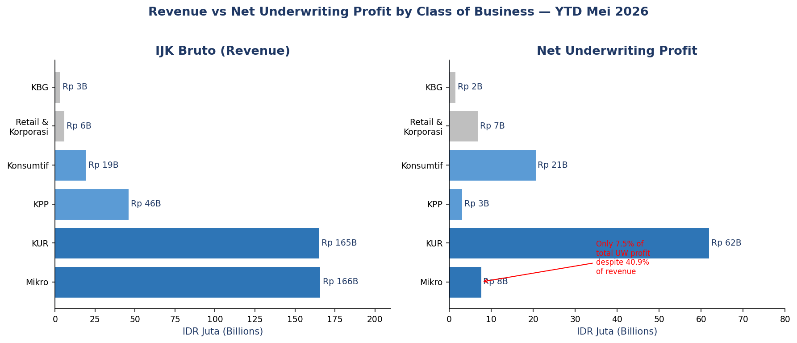
Fig 1: Revenue vs Net UW Profit by Class of Business — YTD Mei 2026

3. Income Statement Analysis
The P&L has two operating income streams: underwriting profit (the core guarantee business) and investment income. Together they drive EBIT.
Line Item | YTD Mei 2026 (Rp B) | YTD Mei 2025 (Rp B) | YoY Change | Margin vs Revenue
IJK Bruto (Gross Revenue) | 405.1 | 283.0 | +43.1% | 100.0%
Less: Beban Penjaminan Ulang (Reinsurance) | (98.8) | (72.2) | +36.8% | (24.4%)
Less: Other UW adjustments | (37.6) | (2.4 est.)
Pendapatan Underwriting Neto | 268.7 | 212.6 | +26.4% | 66.3%
Less: Total Beban Underwriting | (166.9) | (112.6) | +48.2% | (41.2%)
HASIL UNDERWRITING NETO | 101.8 | 100.0 | +1.8% | 25.1%
Hasil Investasi (Investment Income) | 62.6 | 47.1 | +32.9% | 15.4%
Less: Beban Usaha (Operating Expenses) | (63.7) | (58.0) | +9.8% | (15.7%)
LABA USAHA (EBIT) | 100.7 | 101.2 | -0.5% | 24.8%
Non-operating items (Beban Lain-lain, Zakat) | (10.2) | (9.4)
LABA SEBELUM PAJAK (EBT) | 90.5 | 91.9 | -1.5% | 22.3%
Less: Pajak Penghasilan (Income Tax) | (15.8) | (15.1) |  | (3.9%)
LABA SETELAH PAJAK (Net Income) | 74.7 | 76.8 | -2.7% | 18.4%
The effective tax rate is 17.4% (below the 22% statutory rate), indicating JPAS benefits from tax deductions or incentives. The main profit drag year-on-year is higher claims (Beban Underwriting up 48.2%) growing faster than revenue (43.1%). Investment income partially compensated, rising 32.9%.
3.1 Loss Ratio Analysis
The gross loss ratio measures claims paid against gross guarantee fees. It is the primary underwriting performance metric for a guarantee company.
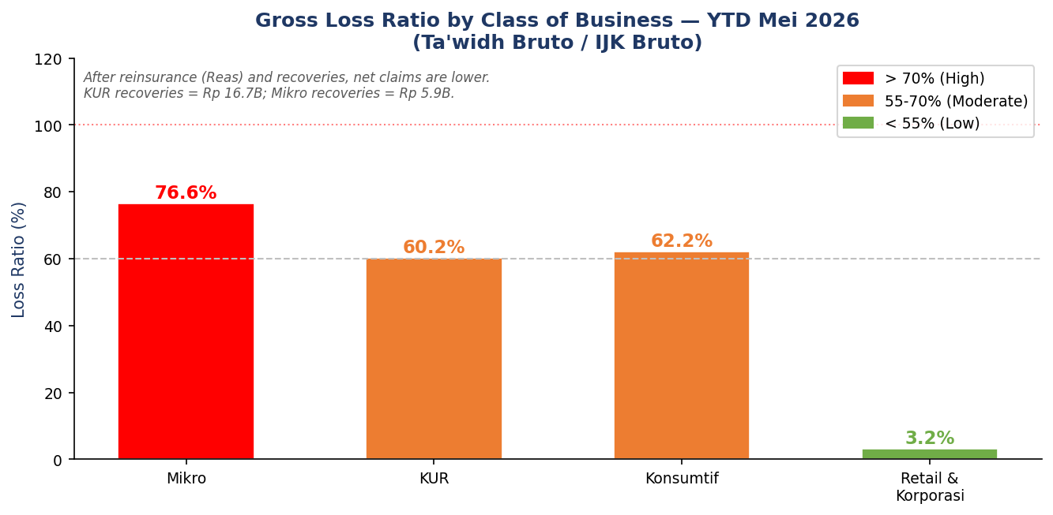
Fig 2: Gross Loss Ratio by Class of Business — YTD Mei 2026
Product | Ta'widh Bruto (Rp B) | Reas Recovery (Rp B) | Net Ta'widh (Rp B) | Recoveries (Rp B) | Gross Loss Ratio
Mikro | 126.9 | 33.9 | 93.0 | 5.9 | 76.6%
KUR | 99.5 | 31.9 | 67.6 | 16.7 | 60.2%
Konsumtif | 12.0 | 10.7 | 1.3 | 0.9 | 62.2%
Retail & Korporasi | 0.2 | 0.1 | 0.1 | 0.2 | 3.2%
TOTAL | 238.5 | 76.6 | 161.9 | 23.9 | 58.9%
KUR's superior recovery rate (Rp 16.7B from KUR vs Rp 5.9B from Mikro, despite Mikro having higher gross claims) reflects the government-sponsored credit structure. KUR borrowers tend to be more traceable and their assets more likely to generate recovery proceeds.

4. Balance Sheet Analysis
Three-statement check: BS closes (Assets - Liabilities - Equity = 0.00), cash ties (Rp 80.6B in both BS and CFS), net income ties (Rp 74.7B in both IS and BS). The structure is typical for a guarantee company: large technical reserve liabilities, substantial investment assets.
Section | Mei 2026 (Rp B) | Mei 2025 (Rp B) | Notes
ASSETS
Kas dan Bank (Cash) | 80.6 | 117.3 | Fell due to deposit placements
Investments (Deposito, Sukuk, Reksadana) | ~2,515.3 | ~2,242.0 | Government sukuk = Rp 1.9T
Piutang IJK (UW Receivables) | est. | est. | IJK fees outstanding from mitra
Piutang Ta'widh Re (Reinsurer Receivables) | est. | est. | Reinsurer's share of claims paid
Other Assets (Fixed assets, prepaid, etc.) | est. | est.
TOTAL ASSETS | 3,418.9 | 3,193.5 | +7.1% YoY
LIABILITIES
Cadangan Teknis (Technical Reserves) | ~2,100+ | est. | Unearned premium + claims reserve
Utang Ta'widh (Claims Payable) | est. | est. | Approved but undisbursed claims
Other Liabilities | est. | est.
TOTAL LIABILITIES | 2,212.1 | ~2,119 | +4.4% est.
EQUITY
Modal Disetor (Paid-in Capital) | 400.0 | 400.0 | Set by Askrindo (owner)
Cadangan Umum (General Reserves) | 590.5 | 476.9 | Retained from prior years
Laba Tahun Berjalan (YTD Net Income) | 74.7 | 76.8 | Ties to IS line 44
Komponen Ekuitas Lainnya (OCI) | (21.5) | (15.1) | Unrealized losses on securities
TOTAL EQUITY | 1,206.9 | 1,074.5 | +12.3%
Technical reserves (Cadangan Teknis) dominate the liability side. These are not debt; they are mandatory reserves for future claims. Cadangan Premi holds unearned IJK fees; Cadangan Ta'widh holds estimated outstanding claim payments. The OCI line (komponen ekuitas lainnya) is negative because JPAS marks government sukuk to market, and rising yields create unrealized mark-to-market losses.

5. Investment Portfolio
JPAS holds a large investment portfolio against its technical reserve liabilities. Total invested assets are Rp 2.52 trillion, generating Rp 62.6B income YTD Mei 2026 (annualized yield approximately 6.0%).
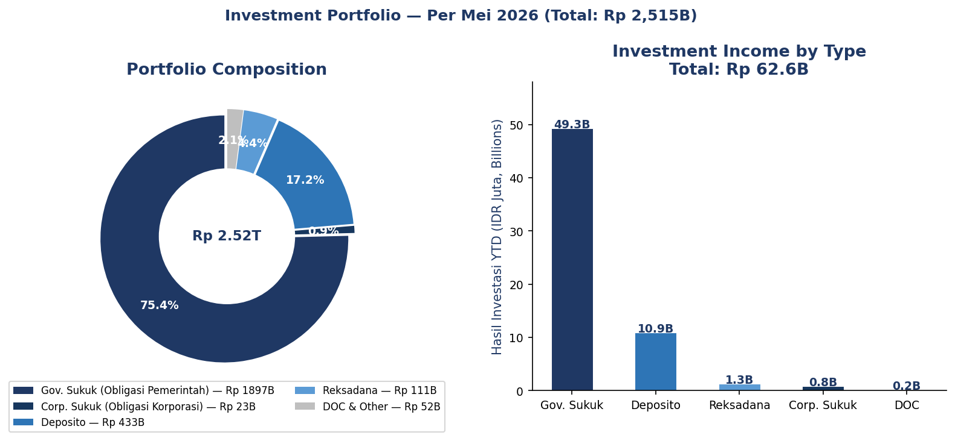
Fig 3: Investment Portfolio Composition and Income by Type — Per Mei 2026
Asset Class | Position (Rp B) | YTD Income (Rp B) | Annualized Yield | Notes
Gov. Sukuk (Obligasi Pemerintah) | 1,896.6 | 49.3 | ~6.2% | 75.4% of portfolio
Corp. Sukuk (Obligasi Korporasi) | 23.3 | 0.8 | ~6.9% | Small position
Deposito (Time Deposits) | 432.6 | 10.9 | ~6.0% | Includes Rp 50B restricted
Reksadana (Mutual Funds) | 110.8 | 1.3 | ~2.8% | Lower return, more liquid
DOC & Other | 52.0 | 0.2 | ~0.9%
TOTAL | 2,515.3 | 62.6 | ~6.0% | Annualized from 5-month data
Government sukuk makes up 75.4% of the portfolio. This creates an inverse relationship with interest rates: when yields rise, the mark-to-market value falls (visible in the negative OCI on the balance sheet). The deposito allocation provides liquidity buffer for near-term claim payments.

6. Operating Expenses
Total Beban Usaha YTD Mei 2026 is Rp 63.7B, running at 36.1% of the annual RKAP budget of Rp 176.5B. At 5 months into the year (41.7% elapsed), expense execution is slightly below budget pace.
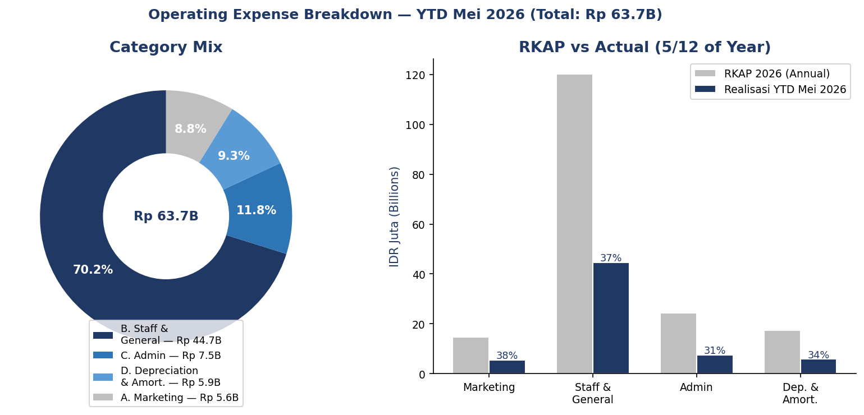
Fig 4: Operating Expense Breakdown and RKAP Achievement — YTD Mei 2026
Category | RKAP Annual (Rp B) | YTD Mei 2026 (Rp B) | % of RKAP | Notes
A. Beban Pemasaran (Marketing) | 14.7 | 5.6 | 38.1% | Business trips, promotions, RAKER
B. Beban Umum (Staff & General) | 120.2 | 44.7 | 37.2% | Salaries Rp 36.3B; benefits Rp 8.4B
C. Beban Administrasi (Admin) | 24.3 | 7.5 | 30.9% | Comms, IT, office, transportation
D. Penyusutan & Amortisasi (D&A) | 17.3 | 5.9 | 34.1% | Fixed assets + right-of-use (lease)
TOTAL | 176.5 | 63.7 | 36.1%
Staff costs (Beban Pegawai) are the single largest expense line at Rp 36.3B YTD. The sub-categories include Board/Commissioner fees, employee salaries, outsourcing fees, benefits, and Pajak Pasal 21. Beban Hak Guna Usaha (right-of-use asset amortization under PSAK 73/IFRS 16) contributes Rp 4.2B of the D&A line.

7. Partner Concentration Risk
The outstanding guarantee book (OS Kafalah) represents JPAS's contingent liability. At Rp 62.4 trillion total, it is not on the balance sheet directly; it generates technical reserve requirements. The distribution across partner banks is heavily concentrated.
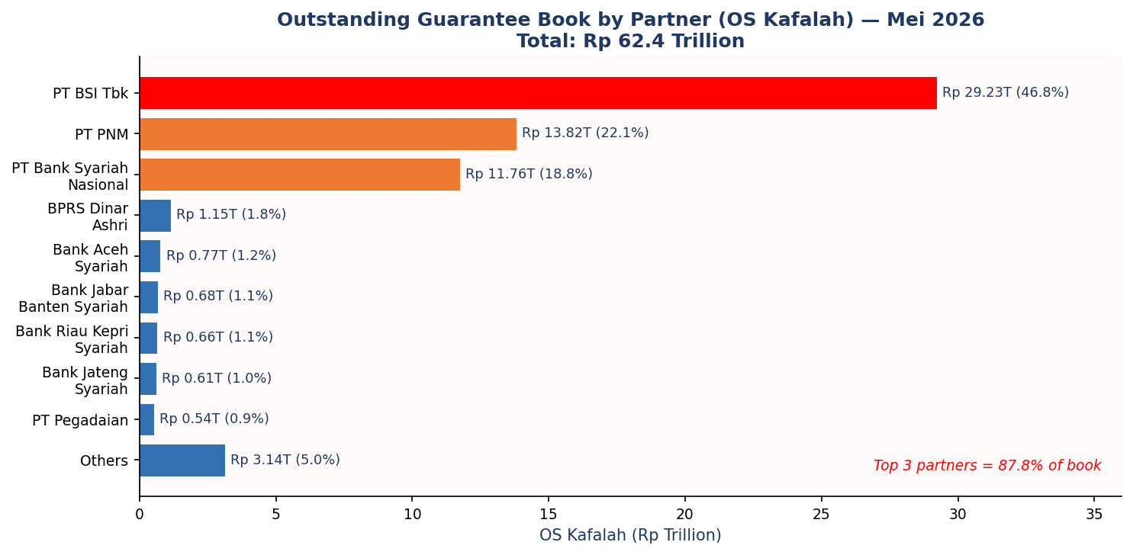
Fig 5: Outstanding Guarantee Book by Partner Bank — Mei 2026
Partner | OS Kafalah (Rp T) | Share | Key COB | Risk Note
PT BSI Tbk | 29.23 | 46.8% | KUR + Mikro | Single largest; 90% of KUR book via BSI
PT PNM | 13.82 | 22.1% | Mikro | Entire PNM book is Mikro (high loss ratio product)
PT Bank Syariah Nasional | 11.76 | 18.9% | Multiple
Top 3 Combined | 54.81 | 87.8% |  | Near-total book concentration
BPRS Dinar Ashri | 1.15 | 1.8%
Bank Aceh Syariah | 0.77 | 1.2%
All Others | 5.63 | 9.0% |  | Remaining 17 partners
GRAND TOTAL | 62.37 | 100%
PT BSI (Bank Syariah Indonesia) alone accounts for 46.8% of the guarantee book. BSI's credit underwriting standards and portfolio quality directly affect JPAS's claim frequency. PNM generates the Mikro book, which has the worst loss ratio in the portfolio. Any deterioration in PNM's borrower pool flows directly into JPAS's Ta'widh payouts.
7.1 Gearing Ratio (Regulatory)
OJK regulations cap the ratio of outstanding guarantee exposure to Net Own Capital (Modal Sendiri Bersih). JPAS's position as of Mei 2026:
Segment | OS Value | Net Own Capital | Gearing Ratio | OJK Limit | Utilization
Usaha Produktif | Rp 21,845B | Rp 1,206.9B | 18.10x | 40x | 45.2%
Usaha Non-Produktif | Rp 13,938B | Rp 1,206.9B | 11.55x | 40x | 28.9%
COMBINED | Rp 35,784B | Rp 1,206.9B | 29.65x | 40x | 74.1%
At 29.65x combined (74% of the 40x limit), JPAS has headroom for approximately Rp 12.4T of additional guarantee exposure before hitting the regulatory ceiling. The equity base is the binding constraint on business growth.

8. Ratio Index
All ratios are live-linked in the CFI_Ratio_Analysis and CFI_DuPont tabs of the JPAS_Analysis_Enhanced.xlsx file. The table below is a static reference as of YTD Mei 2026.
Category | Ratio | Formula | YTD Mei 2026 | YTD Mei 2025 | Benchmark
PROFITABILITY | Net UW Margin | Hasil UW Neto / IJK Bruto | 25.1% | 35.3% | >15% for penjaminan
PROFITABILITY | Net Profit Margin | Net Income / IJK Bruto | 18.4% | 27.1% | 10-20% insurance
PROFITABILITY | EBIT Margin | EBIT / IJK Bruto | 24.8% | 35.8%
PROFITABILITY | EBT Margin | EBT / IJK Bruto | 22.3% | 32.5%
PROFITABILITY | Effective Tax Rate | Tax / EBT | 17.4% | 16.4% | Statutory: 22%
RETURN | ROA | Net Income / Total Assets | 2.2% | 2.4% | >2% = strong
RETURN | ROE | Net Income / Total Equity | 6.2% | 6.4% | >10% target
RETURN | Return on Paid-in Capital | Net Income / Modal Disetor | 18.7% | 19.2%
RETURN | Investment Yield | Hasil Investasi / Total Assets | 1.8% | 1.5% | ~6% annualized
INSURANCE | Gross Loss Ratio (total) | Ta'widh Bruto / IJK Bruto | 58.9% | 55.4% | <70% target
INSURANCE | Gross Loss Ratio (Mikro) | Mikro Ta'widh / Mikro Revenue | 76.6% | N/A | High - mandate product
INSURANCE | Gross Loss Ratio (KUR) | KUR Ta'widh / KUR Revenue | 60.2% | N/A | Acceptable
INSURANCE | Recovery Ratio | Recoveries / Ta'widh Bruto | 10.0% | 26.0% | Higher = better
INSURANCE | Cession Ratio | Beban PJU / IJK Bruto | 24.4% | 25.5% | % ceded to reinsurer
LEVERAGE | D/E Ratio | Total Liab / Total Equity | 1.83x | 1.97x | <2.0x
LEVERAGE | Financial Leverage Multiplier | Total Assets / Total Equity | 2.83x | 2.97x | DuPont factor
LEVERAGE | Equity Ratio | Total Equity / Total Assets | 35.3% | 33.6% | >30%
LEVERAGE | Gearing Ratio (Regulatory) | OS Guarantee / Net Own Capital | 29.65x | N/A | OJK limit: 40x
UTILIZATION | Asset Turnover | IJK Bruto / Total Assets | 0.119x | 0.089x | Low = typical insurance
UTILIZATION | Revenue Growth | (Rev26-Rev25)/Rev25 | +43.1%
UTILIZATION | Net Income Growth | (NI26-NI25)/NI25 | -2.7%

9. DuPont Analysis
The 5-factor DuPont model breaks ROE into its component drivers. Each factor is independent; the product of all five equals ROE exactly.
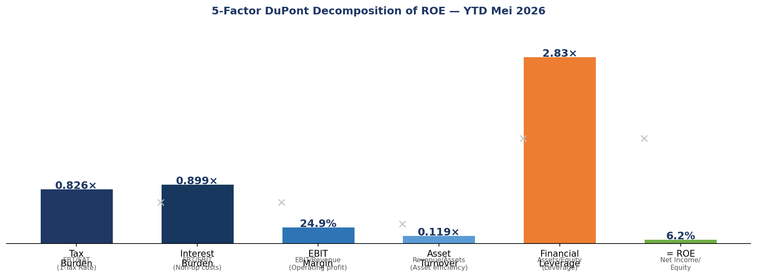
Fig 6: 5-Factor DuPont Decomposition of ROE — YTD Mei 2026
Factor | Formula | Value | What It Measures
1. Tax Burden | Net Income / EBT | 0.826 | 83% of pre-tax profit is retained. Effective rate 17.4% vs statutory 22%.
2. Interest Burden | EBT / EBIT | 0.899 | 90% of EBIT reaches EBT. Non-operating items (beban lain-lain, zakat) consume 10%.
3. EBIT Margin | EBIT / Revenue | 24.9% | Operating margin. Strong but declined from prior year as claims grew faster than revenue.
4. Asset Turnover | Revenue / Total Assets | 0.119x | Each Rp 1 of assets generates Rp 0.12 of revenue. Low ratio is normal for guarantee companies.
5. Financial Leverage | Total Assets / Equity | 2.83x | Assets are 2.83x equity. Leverage amplifies returns but also risk.
= ROE | Product of 1-5 | 6.2% | 0.826 x 0.899 x 24.9% x 0.119 x 2.83 = 6.2%. Verified: no rounding error.
The ROE decline from 6.4% (Mei 2025) to 6.2% (Mei 2026) traces primarily to the EBIT margin drop (revenue grew 43% but claims grew 48%, compressing EBIT margin from ~35.8% to 24.8%). The leverage factor also fell slightly (2.97x to 2.83x) as equity grew faster than assets, diluting returns. Asset turnover improved (0.089x to 0.119x) as revenue grew faster than the asset base, partially offsetting the margin decline.

10. Cash Flow Statement
Section | YTD Mei 2026 (Rp B) | YTD Mei 2025 (Rp B) | Key Drivers
Operating Activities | +99.3 | +13.4 est. | IJK collections outpace claim payments
Penerimaan IJK & Jasa | est. | 285.3 | Guarantee fee collections
Pembayaran Klaim (Ta'widh) | est. | (142.4) | Claim disbursements
Penerimaan Klaim Reasuransi | est. | 52.6 | Reinsurer reimbursements
Beban Usaha paid | est. | (54.8) | Operating expense cash out
Investing Activities | (85.9) | N/A | Net placements into deposits and sukuk
Penerimaan Hasil Investasi | +58.5 | N/A | Coupon and deposit interest
Net Placement Deposito | (45.3) | N/A | Additional time deposits placed
Net Purchase Surat Berharga | (99.1) | N/A | Additional sukuk/bonds purchased
Capex (Perolehan Aset Tetap) | (0.04) | N/A | Minimal fixed asset spending
Financing Activities | 0.0 | 0.0 | No dividends; no new capital YTD
NET CHANGE IN CASH | +6.7 | +13.4
Opening Cash (Jan 2026) | 73.9 | 103.9
CLOSING CASH (MEI 2026) | 80.6 | 117.3 | Ties to BS Kas dan Bank
Operating cash of Rp 99.3B is the primary cash source. The large investing outflow (Rp 85.9B) reflects active portfolio management: JPAS placed Rp 45.3B of additional deposits and Rp 99.1B of additional bonds against Rp 58.5B of investment income received. This is standard behaviour for a guarantee company reinvesting premium reserves into income-generating securities.

11. Model Architecture
The JPAS Data workbook has 28 tabs (including 3 added CFI analysis sheets). The tabs form a four-layer data flow from inputs to outputs.
Layer | Tabs | Purpose | Feeds Into
1. Governance | Model Design | Objective, building blocks, drivers, scenario framework, checklist | Reference only
2. Inputs | Input HUW, Opex | Driver assumptions, RKAP targets by COB and cost category | Hasil Underwriting, Beban Usaha
3. Supporting Schedules | Hasil Underwriting, Investasi Mei 2026, List Deposito, Beban Usaha, Belanja Modal, Listing Accrual, Cadangan Teknis, Subrogasi+SHS, Listing Aset Tetap, Piutang IJK, Piutang Ta'widh Re, Utang Ta'widh, Gearing Ratio, Per Bank Per COB, Plafon Penjaminan, KUR | Detailed source data by business unit, asset, and liability | Three Financial Statements
4. Financial Statements | Summary PL, Summary BS, CASH FLOW | Consolidated P&L, balance sheet, and cash flow statement. Links-only from supporting schedules. | Lap. LR/PK/AK-Kinerja, Anper Final
5. Performance Views | Lap. LR-Kinerja, Lap. PK-Kinerja, Lap. AK-Kinerja | Management dashboard: actual vs RKAP, period-over-period | Anper Final (presentation)
6. CFI Analysis (new) | CFI_Model_Checks, CFI_Ratio_Analysis, CFI_DuPont | 3-statement integrity checks, 18 live-linked ratios, 5-factor DuPont | Standalone analysis layer
Data flow: Input HUW drives Hasil Underwriting, which feeds the IS (Summary PL). Investasi drives both the BS (assets) and IS (Hasil Investasi). Cadangan Teknis drives the BS (liabilities). The BS and CFS reconcile through the operating and investing sections. The Lap. Kinerja tabs are the internal management view. The Anper Final workbook pulls from the Lap. Kinerja tabs to build the board/management presentation.
One gap in the current Model Design tab: all model checks are written as text descriptions rather than live Excel formulas. The CFI_Model_Checks tab fills this gap with three formula-driven checks.

12. Ratio Dashboard
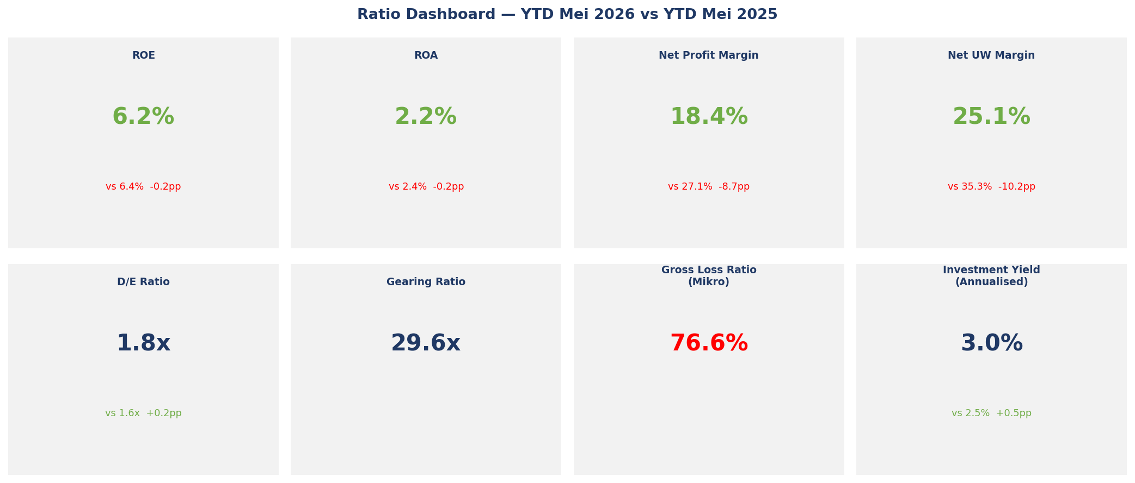
Fig 7: Key Ratio Dashboard — YTD Mei 2026 vs YTD Mei 2025
ROE and ROA both declined slightly despite 43% revenue growth. The cause: equity and assets both grew faster than net income, which fell 2.7%. The 43% revenue increase generated a smaller net income because claims grew 48%. Net UW margin compressed from 35.3% to 25.1%, the sharpest decline in the set. Investment yield improved, partially cushioning the underwriting margin drop.

Appendix: Definitions
Term | Definition
IJK (Imbal Jasa Kafalah) | Guarantee fee income. The primary revenue line. Charged as a percentage of the guaranteed loan value.
Ta'widh | Claim payment. The amount JPAS pays to the partner bank when a guaranteed borrower defaults.
Ta'widh Reasuransi | The portion of Ta'widh reimbursed by the reinsurer under JPAS's reinsurance treaty.
Recoveries / Subrogasi | Amounts recovered from defaulted debtors after JPAS has paid the Ta'widh to the bank.
Beban Penjaminan Ulang (PJU) | Reinsurance premium paid to the reinsurer.
Cadangan Teknis | Technical reserves. Two types: Cadangan Premi (unearned premium reserve) and Cadangan Ta'widh (outstanding claims reserve).
Hasil Underwriting Neto | Net underwriting profit. Revenue minus all UW expenses (claims, reinsurance, commissions, reserves).
KUR (Kredit Usaha Rakyat) | Government-subsidized micro-business loan program. JPAS guarantees KUR loans made by partner banks.
Mikro | Micro-loan product. Very small loans mainly through PT PNM. High default frequency; social mandate product.
Gearing Ratio | Outstanding guarantee exposure divided by Net Own Capital. OJK caps this at 40x.
SHS (Sisa Hasil Subrogasi) | Residual recovery amount still outstanding from defaulted debtors.
RKAP | Rencana Kerja dan Anggaran Perusahaan. The annual corporate work plan and budget.
Mitra | Partner banks and financial institutions that channel guaranteed loans.
OS Kafalah | Outstanding guarantee exposure. The total value of loans currently under JPAS guarantee.

