**Name ___________________**

Create a folder in Dropbox folder [LastName]Quiz1Lab (ex: IoninQuiz1Lab) and share it with me. You will put your lab projects in this folder.

**Lab1 (20 points)**

Draw the following:

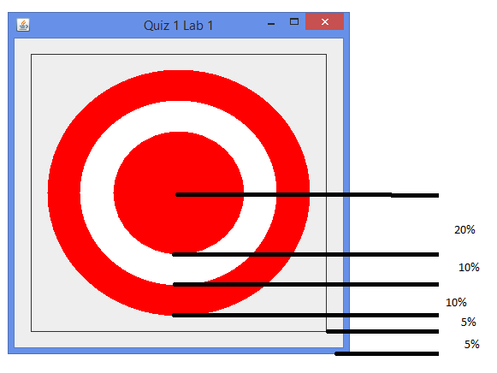

1. Name your project [LastName]Quiz1Lab1 (ex: IoninQuiz1Lab1)
2. Make sure your frame has the correct title
3. Use the right layout manager
4. Use the given dimensions. They should stay true no-matter the size of frame.
5. Make sure program stops when frame is closed
6. Extend JFrame and JPanel the way you’ve been shown

**Extra credit (5 points)**

1. Use font metrics to ensure text is always centered

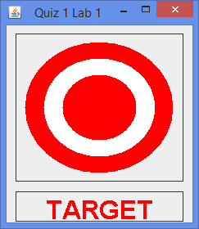

**Lab 2 (20 points)**

**Implement the following interface (15 points):**

Name your project [LastName]Quiz1Lab2 (ex: IoninQuiz1Lab2)

public interface SimpleFileManager {

// this method saves a string of text to a specified file

// if file exists and shouldOverwrite is false, throw an exception

// if file exists and shouldOverwrite is true, overwrite the file

// return true on successful save, return false if saving failed for whatever reason

// make sure no matter what happens, file gets closed

boolean SaveToFile(String textToSave, String fileName, boolean shouldOverwrite);

// same as above, except takes a File object instead of filename string

boolean SaveToFile(String textToSave, File file, boolean shouldOverwrite);

// this method reads and returns first string from specified file

// if the file does not exist, throw an exception

// make sure no matter what happens, file gets closed

String ReadFromFile(String fileName);

}

**Create a “tester” class that (5 points)**

1. **Writes a string to a file**
2. **Writes another string to same file with shouldOverwrite = false (should throw)**
3. **Writes another string to same file with shouldOverwrite = true (should not throw)**
4. **Reads the string from the file**

**Extra credit (5 points)**

**Change methods to save/read String[]. Change “tester” to save a String[], read it back, and compare the two to make sure it worked properly.**