AWS Deployment Project — Flask + Express
Student name: Your Name (replace before submission)
Date: 2026-10-19
Application URL: NOT_DEPLOYED_YET — fill in after deployment
GitHub repository: PASTE_YOUR_GITHUB_REPOSITORY_URL_HERE

Objective
Deploy a Flask backend and Express frontend using three architectures: a single EC2 instance, separate EC2 instances, and Docker containers published to ECR and run on ECS in a VPC.

Application overview
The Express frontend serves a contact form on port 3000. On submission, it sends JSON to Flask on port 5000. Flask validates required fields and email format, processes the request, and returns JSON. Express redirects to a success page after HTTP 201; failures remain on the form page with an error message.
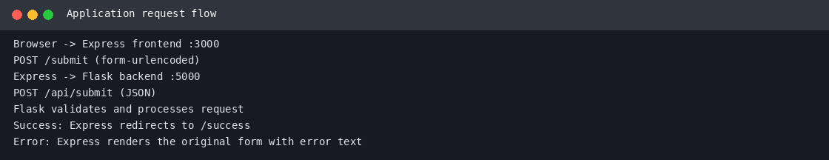

Source folder structure
- app/frontend: Express server, EJS templates, CSS, package.json, Dockerfile
- app/backend: Flask API, requirements.txt, Dockerfile
- deploy/single_ec2: setup script for a single Ubuntu EC2
- deploy/separate_ec2: separate-instance networking notes
- deploy/ecs: ECR/ECS task-definition templates and VPC instructions
- scripts/push-to-ecr.sh: builds, tags, and pushes images to ECR
- .gitignore: excludes secrets, keys, node_modules, IDE settings, and caches

Task 1 — Single EC2 instance
Run both services on one Ubuntu EC2 instance. Install Python and Node.js, install backend/frontend dependencies, run Flask on loopback port 5000 and Express on port 3000. For a demo, allow TCP 3000 only from your IP. For a more secure deployment, use Nginx on port 80/443 and keep Flask bound to localhost. Use systemd to keep services managed after SSH disconnects.
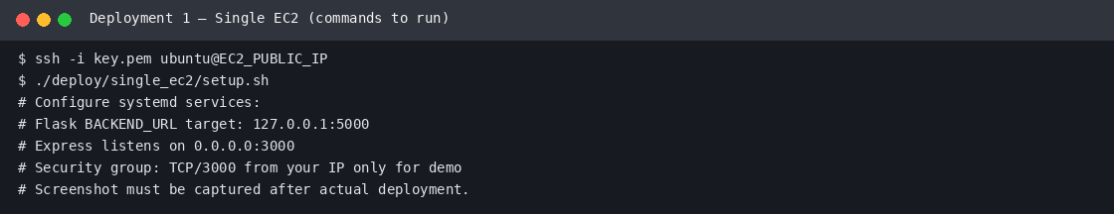

Task 2 — Separate EC2 instances
Run Flask on the backend EC2 and Express on the frontend EC2. Set BACKEND_URL on the frontend to the backend instance's private IP or private DNS name. The backend security group should allow TCP 5000 only from the frontend instance's security group. Do not open backend port 5000 to the entire internet.
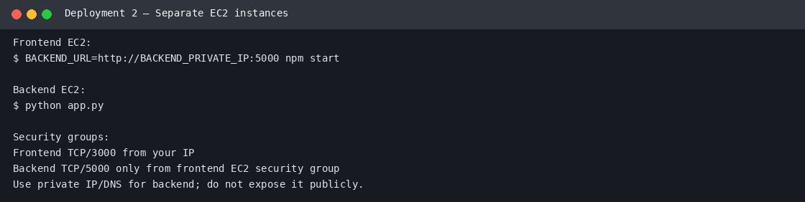

Task 3 — ECR, ECS, Docker, and VPC
Build separate Docker images for frontend and backend, push both to Amazon ECR, and run them as ECS Fargate services in a VPC. Recommended design: public Application Load Balancer and frontend tasks in public subnets; backend tasks in private subnets; backend security group accepts port 5000 only from the frontend task security group. Configure task execution IAM role, CloudWatch logs, health checks, and private service discovery. The JSON task definitions are templates and require real account, region, role ARN, and service DNS values.
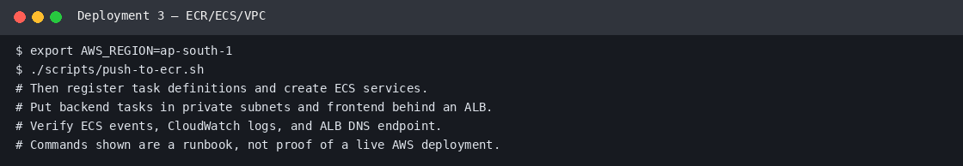

Commands and verification
- python -m py_compile app/backend/app.py
- node --check app/frontend/server.js
- AWS_REGION=ap-south-1 ./scripts/push-to-ecr.sh (after AWS CLI credentials and Docker are configured)
- aws ecs describe-services --cluster YOUR_CLUSTER --services YOUR_FRONTEND_SERVICE YOUR_BACKEND_SERVICE --region ap-south-1
- Test GET /health on each service and submit a form through the frontend.
- Record screenshots of terminal output, ECS service health, ECR image tags, and the live application URL.
The included evidence images are illustrative runbook captures, not proof of deployment. Run the commands in your AWS account and replace or supplement these with genuine terminal/browser/console screenshots showing your own resource IDs and results.

Links
Deployed application URL: NOT_DEPLOYED_YET
GitHub repository: PASTE_YOUR_GITHUB_REPOSITORY_URL_HERE
ECR repositories: add your real AWS account/region repository URIs after pushing.

Cost and cleanup warning
AWS costs depend on region, instance type, storage, data transfer, NAT Gateway, load balancer, public IPv4, and other resources. Stop EC2 instances when idle, but remember that EBS volumes, Elastic IP/public IPv4 allocations, load balancers, NAT Gateways, and some ECS networking resources may continue to incur charges. For full cleanup, delete unused services, load balancers, NAT Gateways, EIPs, and volumes after saving evidence. Check the current AWS pricing page and Billing console.

Submission checklist
- Replace YourName and student name.
- Deploy all three configurations and test the form end-to-end.
- Capture genuine screenshots of terminal commands, app behavior, EC2/ECS/ECR resources.
- Push the source code to GitHub and paste the repository URL.
- Paste the real deployed application URL.
- Keep instances stopped when not in use and remove resources you no longer need.
- Compress the folder as AWS_YourName.zip and upload only the ZIP.

Updated Package Notes — Docker and ECS Task Definition Rendering
This revision includes Dockerfiles at app/backend/Dockerfile and app/frontend/Dockerfile, container health checks, and docker-compose.yml for local container testing. Run docker compose up --build, test the frontend at http://localhost:3000, then run docker compose down. Docker was not available in the generation environment, so an image build is not claimed as completed.
ECS task-definition JSON files now use environment placeholders and include CloudWatch logging and health checks. Run deploy/ecs/render-task-definitions.sh after setting AWS_REGION, ECS_TASK_EXECUTION_ROLE_ARN, BACKEND_URL, and FRONTEND_ORIGIN. The script derives the account ID from the AWS CLI identity, validates the rendered JSON, and can register task definitions when REGISTER_TASKS=1 is set. It does not create VPC, ALB, ECS cluster/services, or deploy by itself.
Live deployment status: NOT DEPLOYED in this environment. AWS CLI, Docker, and AWS credentials were not available. Replace placeholder links and include genuine screenshots from your AWS account before submission.

