**Q & A for The Gateway effect of Alcohol, Tobacco, and Marijuana:**

**Does the Use of Legal Drugs Increase the Risk of Illegal Drug Addiction?**

1. What other models did you test in this study?

I tested linear regression, K-Nearest Neighbor, and random forest.

1. In what states is marijuana legal?

At the time of this study, cannabis is illegal on the federal level, but states have their own laws with varying degrees of legality (Legality of cannabis by U.S. jurisdiction, 2020).

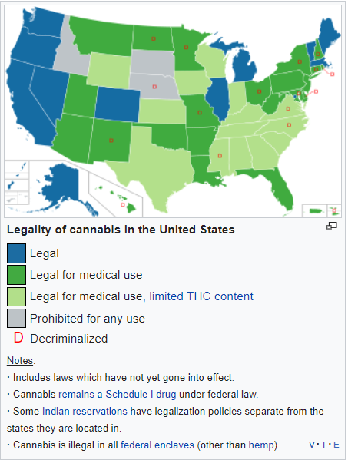

1. How did you handle N/A responses?

The data source included imputed fields that had yes or no answers only. The codebook encourages the use of the imputed fields over the raw data in statistical analysis. (Center for Behavioral Health Statistics and Quality, 2014).

1. How were the imputed fields created?

Some fields were filled in using common sense based on other answers given by each respondent (logically assigned). Others were filled in using statistical imputation (predictive mean neighborhood (PMN) or modified PMN) (Center for Behavioral Health Statistics and Quality, 2014).

1. How can health insurance companies use the results of this study?

Health insurance companies can use data collected from their members about smoking, alcohol, and drug use to target members for education and incentive programs.

1. How did you create the HARDFLAG field?

I used questions about cocaine, heroin, and methamphetamines. If any of these fields had a yes answer, then the HARDFLAG field would have a yes answer.

1. What are the 11 criteria for substance use disorder?

According to Hartney, these are the 11 criteria for substance abuse (2020):

1. Taking the substance in larger amounts or for longer than you're meant to.
2. Wanting to cut down or stop using the substance but not managing to.
3. Spending a lot of time getting, using, or recovering from use of the substance.
4. Cravings and urges to use the substance.
5. Not managing to do what you should at work, home, or school because of substance use.
6. Continuing to use, even when it causes problems in relationships.
7. Giving up important social, occupational, or recreational activities because of substance use.
8. Using substances again and again, even when it puts you in danger.
9. Continuing to use, even when you know you have a physical or psychological problem that could have been caused or made worse by the substance.
10. Needing more of the substance to get the effect you want (tolerance).
11. Development of withdrawal symptoms, which can be relieved by taking more of the substance.
12. How are these criteria used?

Medical professionals can specify the severity of a substance abuse disorder by the number of criteria met. Two to three is mild; four to five is moderate; six or more is severe (Hartney, 2020).

1. What sampling method did you use to create a balanced data set?

I used random under-sampling by randomly removing samples from the majority class (respondents who had not tried hard drugs).

1. Which of the drugs had the highest chance to be a gateway drug?

Marijuana was the strongest gateway drug in this study (66.7% of cannabis users also use harder drugs), followed by tobacco (52.2% also used harder drugs) then alcohol (41.5% also used harder drugs).

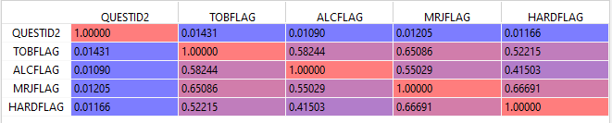

**References**

Center for Behavioral Health Statistics and Quality. (n.d.). National Survey on Drug Use and Health 2015 (NSDUH-2015-DS0001). Retrieved August 29, 2020, from <https://www.datafiles.samhsa.gov/study-dataset/national-survey-drug-use-and-health-2015-nsduh-2015-ds0001-nid16894>

Center for Behavioral Health Statistics and Quality. (2014). 2015 National Survey on Drug Use and Health (NSDUH): CAI Specifications for Programming (English Version). Substance Abuse and Mental Health Services Administration, Rockville, MD.

Hartney, E. (2020, March 21). The Symptoms Used to Diagnose Substance Use Disorders. Retrieved September 26, 2020, from https://www.verywellmind.com/dsm-5-criteria-for-substance-use-disorders-21926

Legality of cannabis by U.S. jurisdiction. (2020, September 21). Retrieved September 26, 2020, from https://en.wikipedia.org/wiki/Legality_of_cannabis_by_U.S._jurisdiction