**Testing Document**

The first test will be to attempt to allocate a volume of name josh and total volume size of 100000bytes. Then we will mount this volume. Once mounted Create a file on the drive called joshE then unmount the drive and exit the program.

The expected result should be that the file will contain josh and 4 null spaces, followed by 100000 two nulls and then the files on the volume and 4 nulls. Then directly after this will be joshE and the properties of the file.

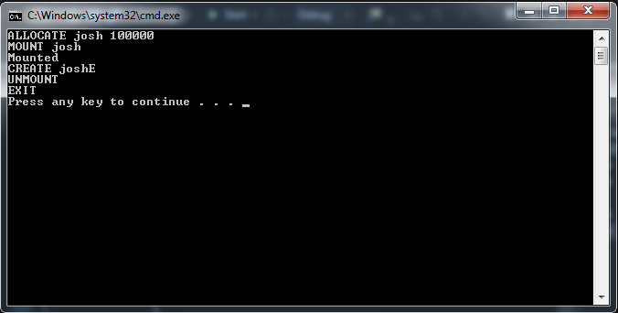



The above figures show the commands entered and the final image is of the data contained within file created.

**Test 2**

Mount previously created josh volume. Then do Vinfo command to show the values of the mounted volume. These should be Volume Name: josh Total Size of Volume: 100000 and finally Total Files: 1.

Then do command FileInfo with filename joshE. This will display the size of file, read only value, and all other properties of the file. Delete the file FileName

