**Department of Computer Science and Engineering**



Report on Mini Project

Foodism.com

#### Course Code : 20CSE41 Course Name : Web Programming

##### Semester:V SEM Section:A

**Submitted To:**

Ms. Shruti M

Assistant Professor Gd-II

## Department of Computer Science and Engineering

**Submitted By:**

Aaron Jevil Nazareth – 4nm20cs005

Aaron Francis Dsouza – 4nm20cs004

**Date of submission:10.12.2022**

#### Signature of Course Instructor

# ABSTRACT

A standardized recipe produces a specific quality and quantity of food. Once a recipe standardized recipe is created it becomes one of the most powerful documents in a foodservice operation. They also provide consistency and food cost control. Recipes also help consumers with dietary concerns and allergies. Our webpage – Foodism.com helps serve all these purposes by storing quality recipes on the web with their nutrition values and also allows users to share their knowledge of different recipes from around the world.

# TABLE OF CONTENTS

TitlePage i

Abstract ii

TableofContents iii

Introduction 4

Problem Statement 4

Objectives 5

Hardware/Software Requirement 5

Methodology 6

Implementation Details 6

Results 11

Conclusion and Future Scope 11

References 12

# INTRODUCTION

# Foodism.com contains a vast scalable collection of recipes which are classified under various contexts. Usually, finding recipe web pages that provide nutritional values, tagged searching and location wise data is difficult. Foodism.com aims at solving all these issues by providing a top end user friendly interface that makes it easy for users to find recipes bases on their specific needs.

# Since being able to share your skill to the world is an important asset, foodism.com also allows its users to add their own recipes to showcase to the world.

# PROBLEM STATEMENT

# Creating a webpage that allows users to select dishes based on its location of origin. Providing users with nutritional facts and servings of a dish so that they can eat while also being able to keep track of their health. Option to upload personal recipes.

# OBJECTIVES

# Choose recipes based on location

# Choose recipes based on tags

# Obtain detailed nutritional values on recipes

# Add your own recipes

# 

# HARDWARE / SOFTWARE REQUIREMENTS:

Software:

* HTML
* CSS
* BOOTSTRAP
* JAVASCRIPT
* NODEJS
* EXPRESSJS
* HANDLEBARS
* MONGODB
* FONT AWESOME
* FAVICON
* NORMALIZE CSS
* VS CODE

**HARDWARE:**

* Laptop(Any operating system)

# 

# METHODOLOGY AND IMPLEMENTATION:

1. Our home page is designed using HTML, CSS and JavaScript. The page lets you chose various locations from a world map and shows recipes based on the location chosen. You can also navigate to other pages through the navbar present here.

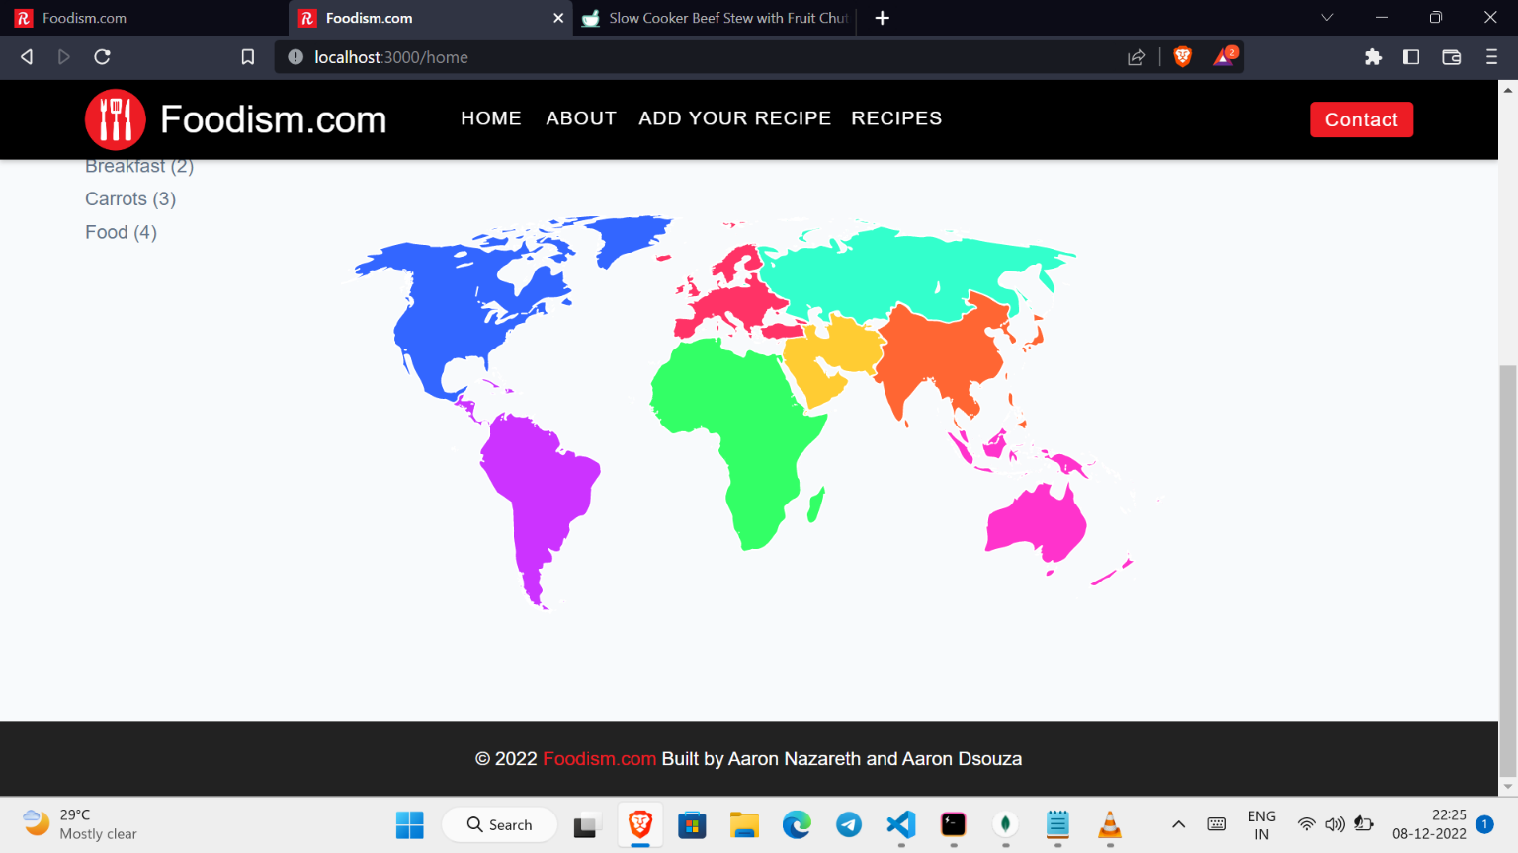

2.All the recipes are stored in a Mongo Database. To get the recipes based on each continent and tag, we have used mongo dB queries. The queries are as follows.

The query runs on 5 different tables that we have created.

Once the queries are executes, the recipes are fetched and displayed as follows:

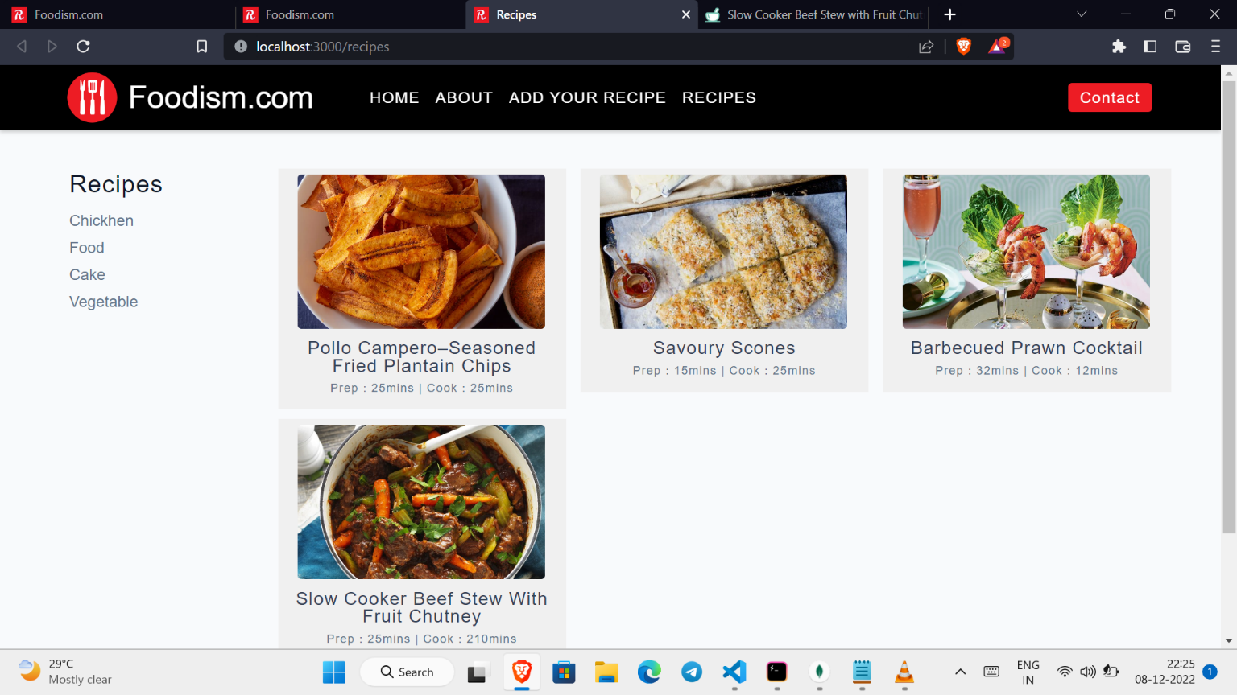

3.Each individual recipe can be viewed by clicking on the recipe card which runs a respective mongo db query and gives you recipe details such as image, ingredients, prep time, steps and nutrition values.

Nutrition details include:

1. Calories
2. Fat
3. Carbohydrates
4. Protein

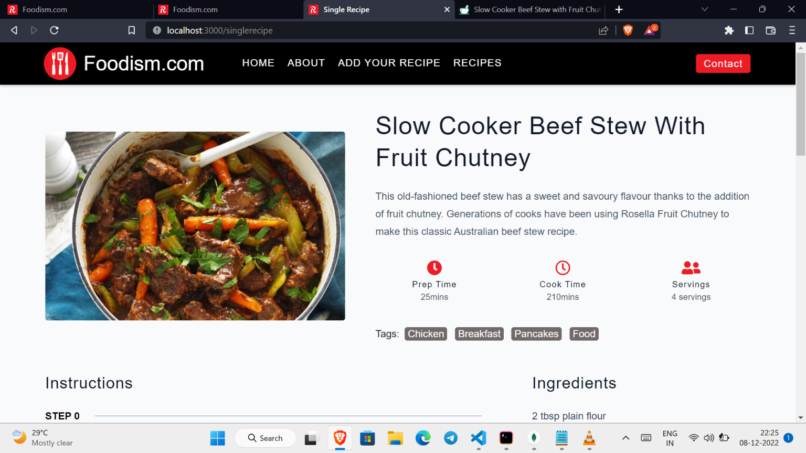

4.’Add your recipe’ option allows users to enter their own recipe along with nutritional values and steps. This recipe is then stored in the database and can be viewed by anyone who visits the webpage.

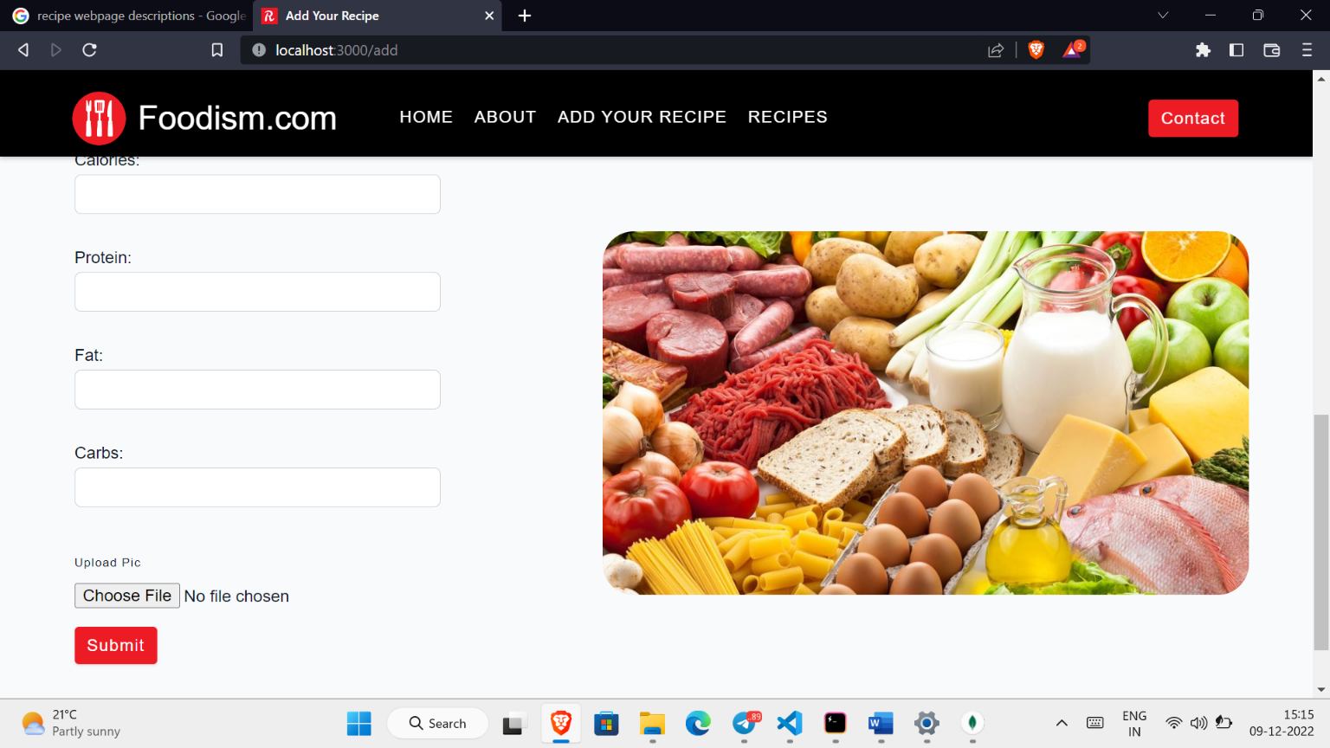

# 

# The webpage is available on our GitHub repository:

# <https://github.com/jevil25/Recipe-webpage>

# 1.You can clone it using command “git clone <https://github.com/jevil25/Recipe-webpage> “ on your terminal.

# 2.You can download nodejs from the official website. Then install the dependencies using npm install command.

# 3.Then run the server file using “nodemon server.js” command

**RESULTS AND DISCUSSIONS**

As of 10.12 .2022 Foodism.com is a self-sufficient recipe webpage that provides users with location-based recipes and precise nutritional facts. It also makes searching for new recipes user friendly and interactive.

**CONCLUSION AND FUTURE SCOPE**

The website has been successful in solving some of the major issues with recipe webpages. It also has implemented unique attractive ideas such as choosing recipes on a map. Since it makes adding new recipes a cakewalk for its users, the website is highly scalable. Future scope includes searching recipes based on ingredients available at the user’s disposal. Overall, it’s a successful recipe webpage.

# REFERENCES:

1. Freecodecamp YouTube channel.
2. Nodejs official webpage: <https://nodejs.org/en/>
3. Bootstrap webpage

<https://getbootstrap.com/docs/5.2/getting-started/introduction/>

1. Create your map webpage
2. Stack overflow