

VIBRANT Graphs Blog Contact

Activity Trends Network Local SWOT

(Dropdown box: Austin, Tupelo, Detroit)

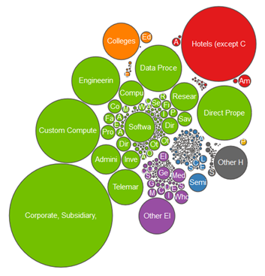





Size by #

Employees

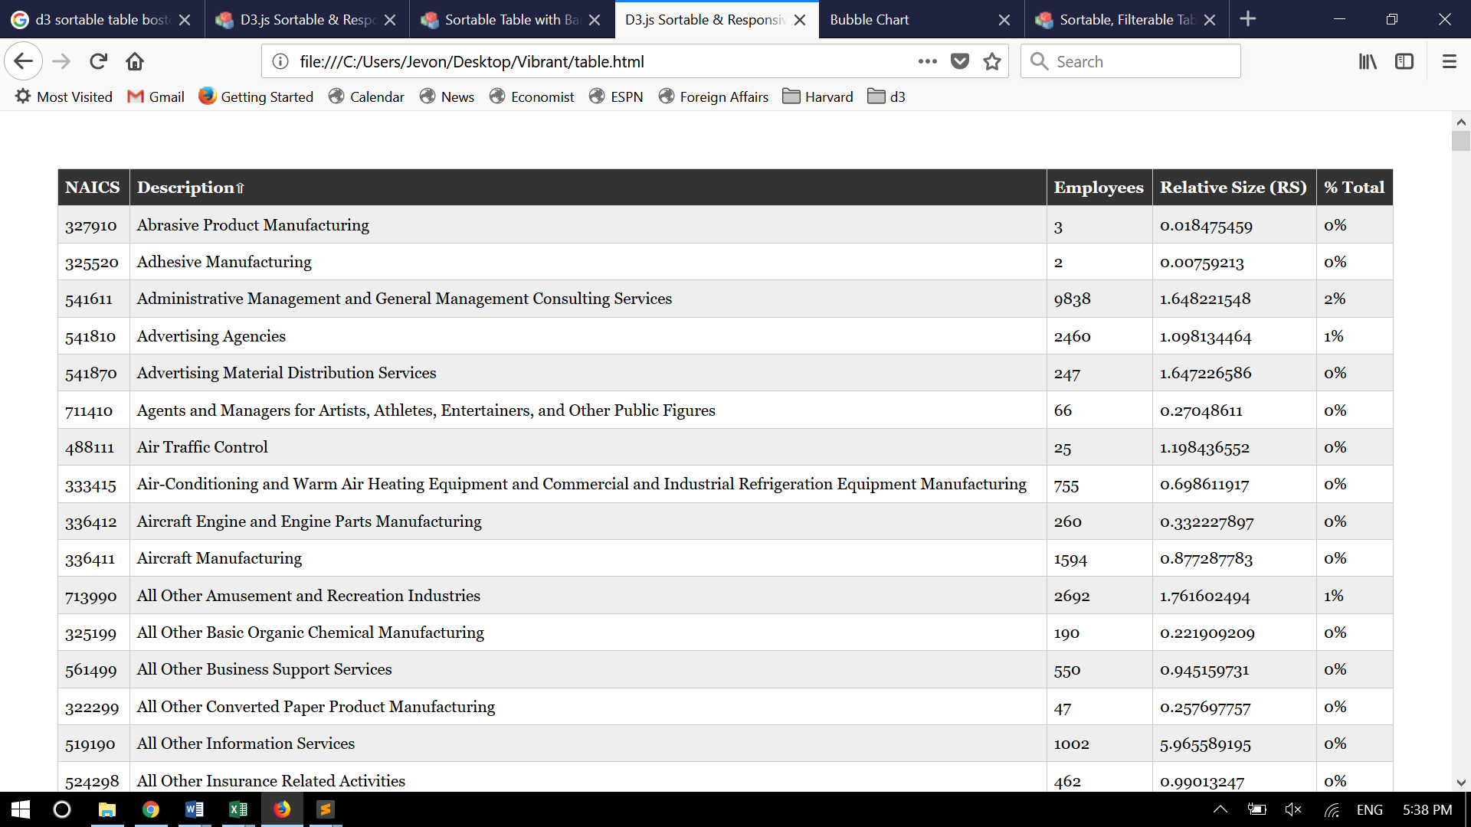

© 2018, Vibrant