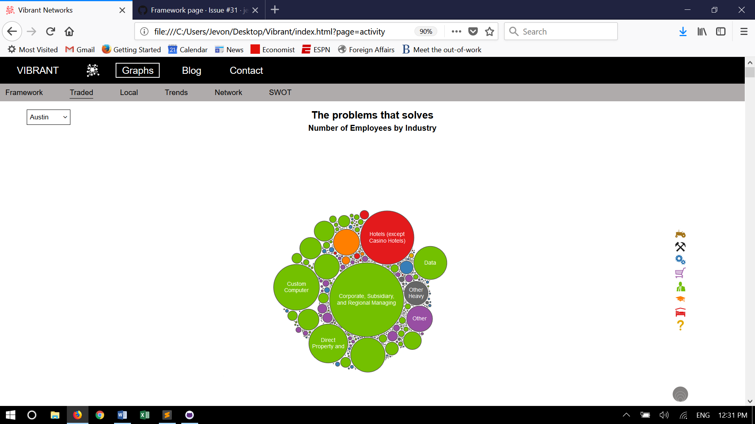

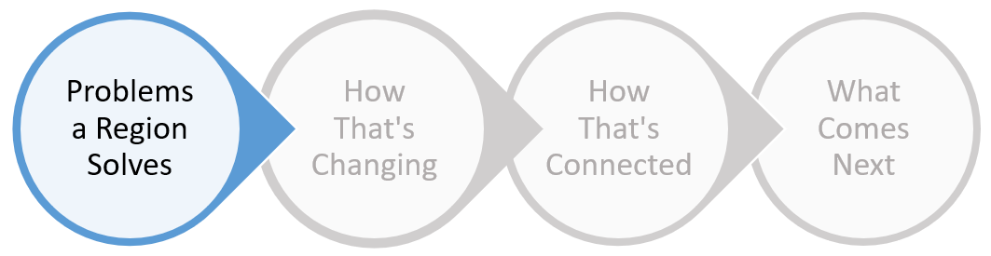

**1a) Activity in traded industries**

How many words do I need to type to see whether this line will go beneath the image above. How does this look? Do I like it? How many words do I need to type to see whether this line will go beneath the image above. How does this look? Do I like it?

