

VIBRANT Graphs Blog Contact

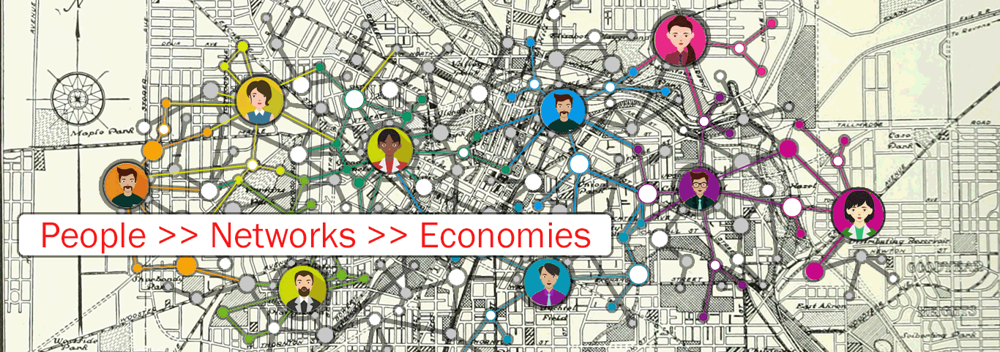

Strengthening communities by improving productivity, opportunity, and the connections between us all.

How does a community create inclusive economic growth? Many people are trying to answer this question as their communities experience increased inequality and stagnant incomes. Increased productivity – output per working hour – is an obvious part of the answer. Increased opportunity – measured in terms of absolute and relative economic mobility – plays a less obvious, but equally important role. To increase productivity and opportunity, though, we need to understand how communities might grow, and how individuals relate to that growth.

Vibrant Networks uses network analysis and basic machine learning to understand how individuals combine to create companies, how companies combine to create industries, industries create clusters, clusters create networks, and how networks relate to each other.

[more text­]



|  |  |  |
| --- | --- | --- |
| Austin, Texas | Tupelo, Mississippi | Detroit, Michigan |

[this text will be the same for every city]

We define (city) using the counties below:

­­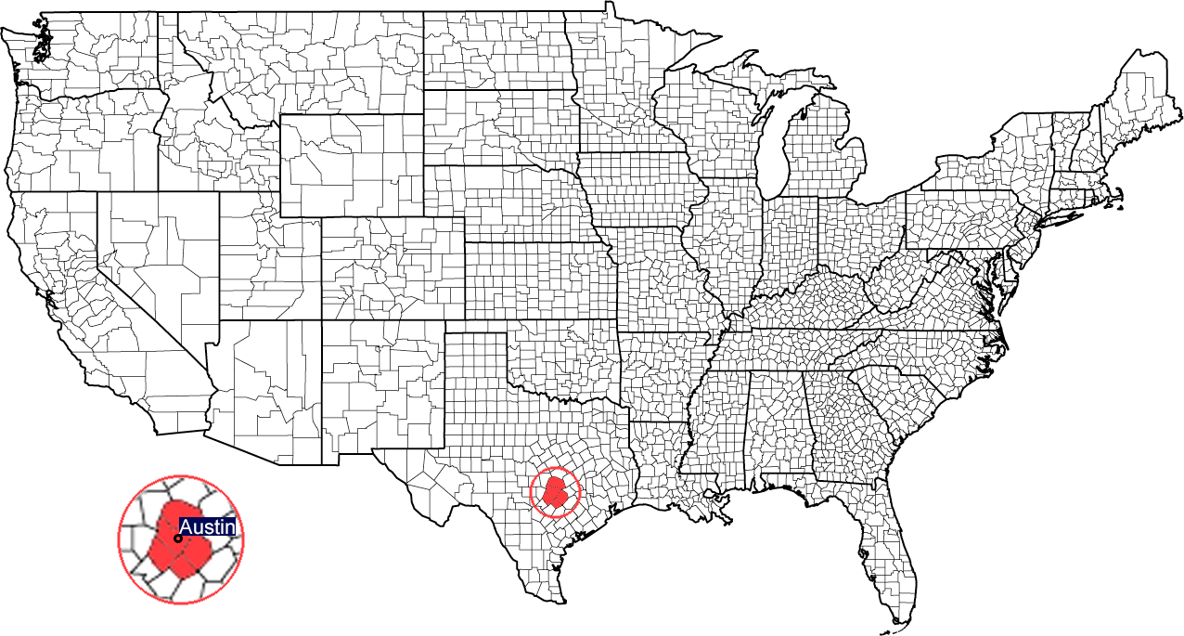

[this text will be different for each city] This text is about (city)…

**What Austin does**

Number of Employees by Industry

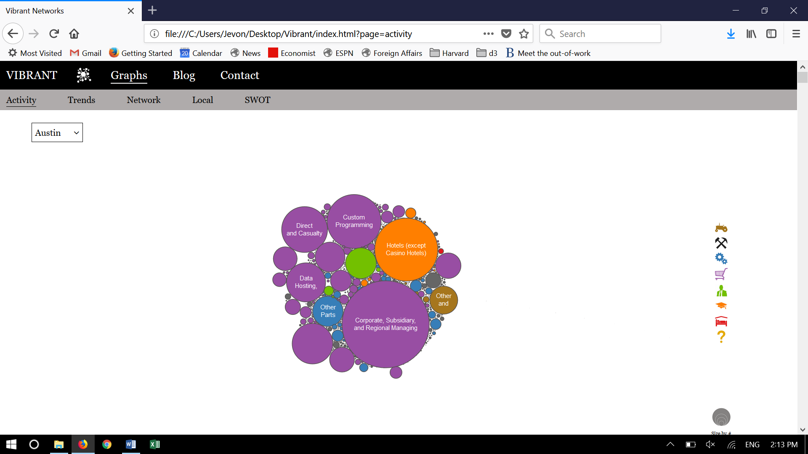

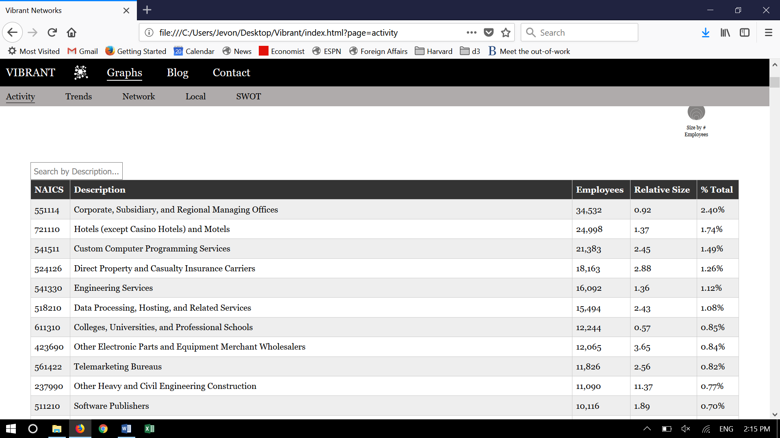

[different text for each city] This text is about (city)…

**How Austin is changing**

Percent Change in Number of Employees by Industry Over Time

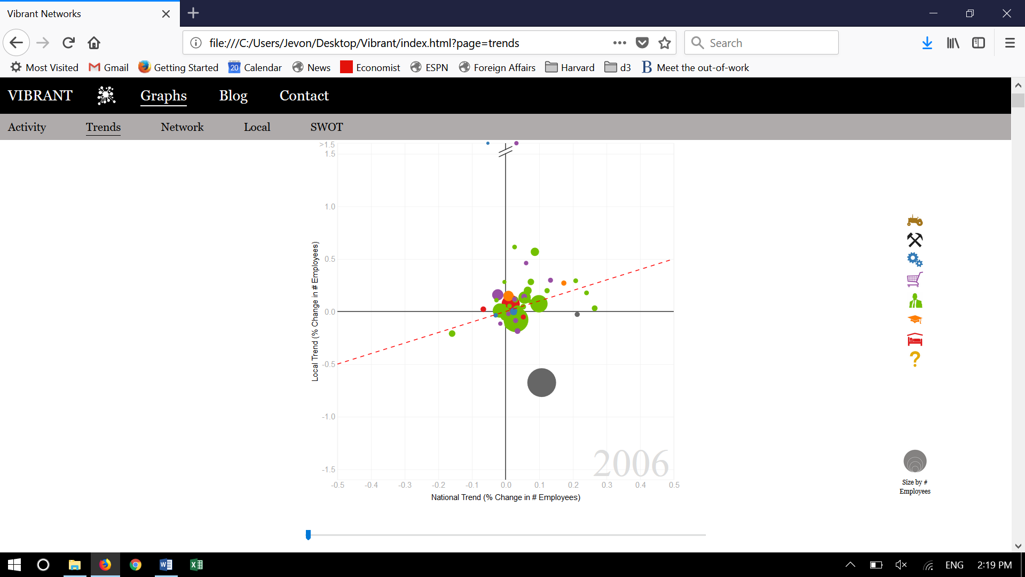

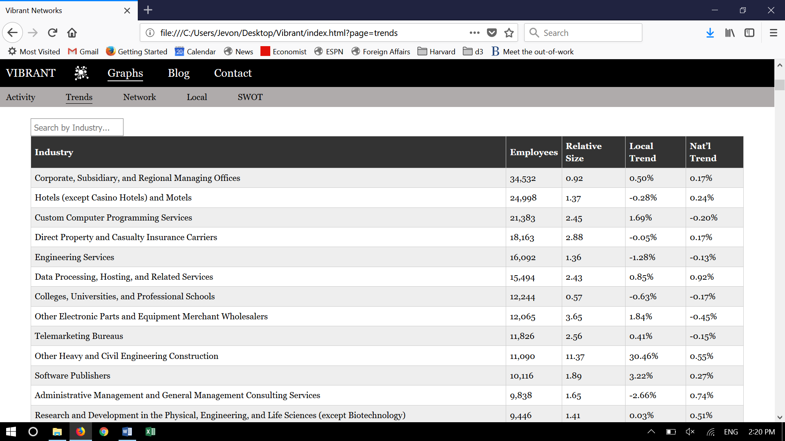

[different text for each city] This text is about (city)…

**How Austin’s industries relate to each other**

A network map that positions industries and clusters based on similarity

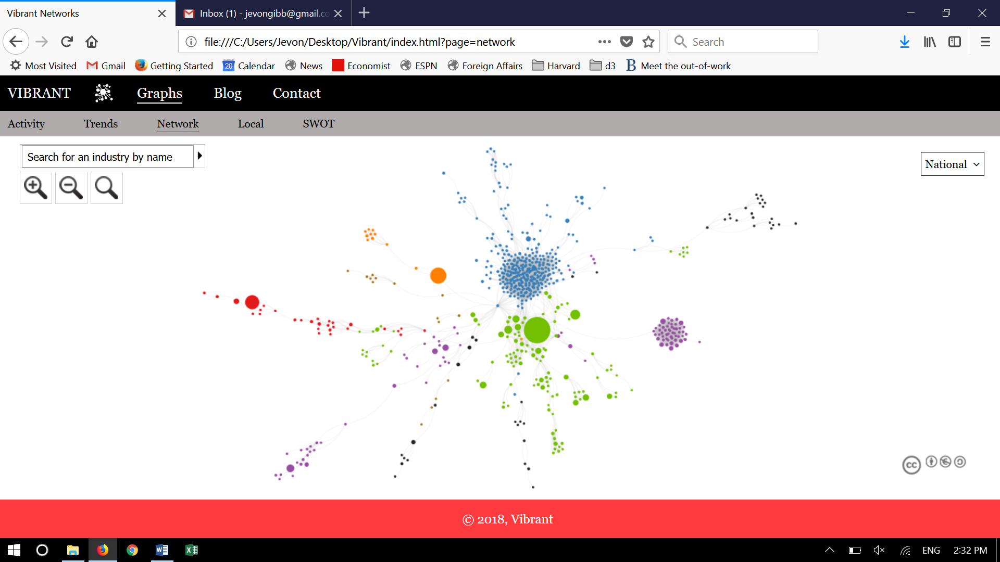

National view

Local view

[different text for each city] This text is about (city)…

**How Austin’s local industries compare to what we would expect**

Difference in number of employees from the average size nationally

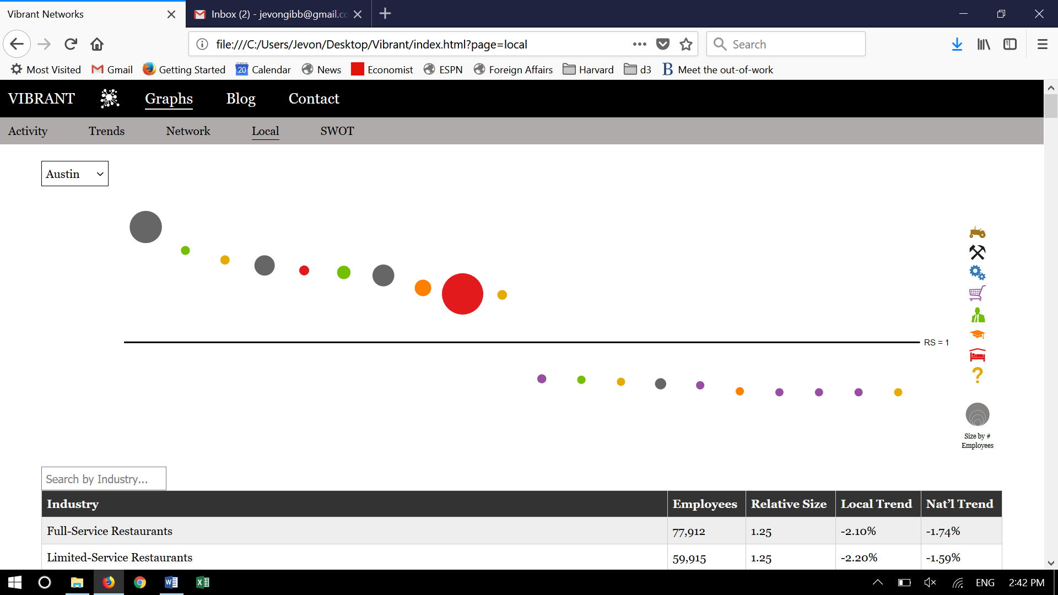

[different text for each city] This text is about (city)…

**Positive and negative trends for Austin’s economy**

Comparing predictions based on historical data and network analysis

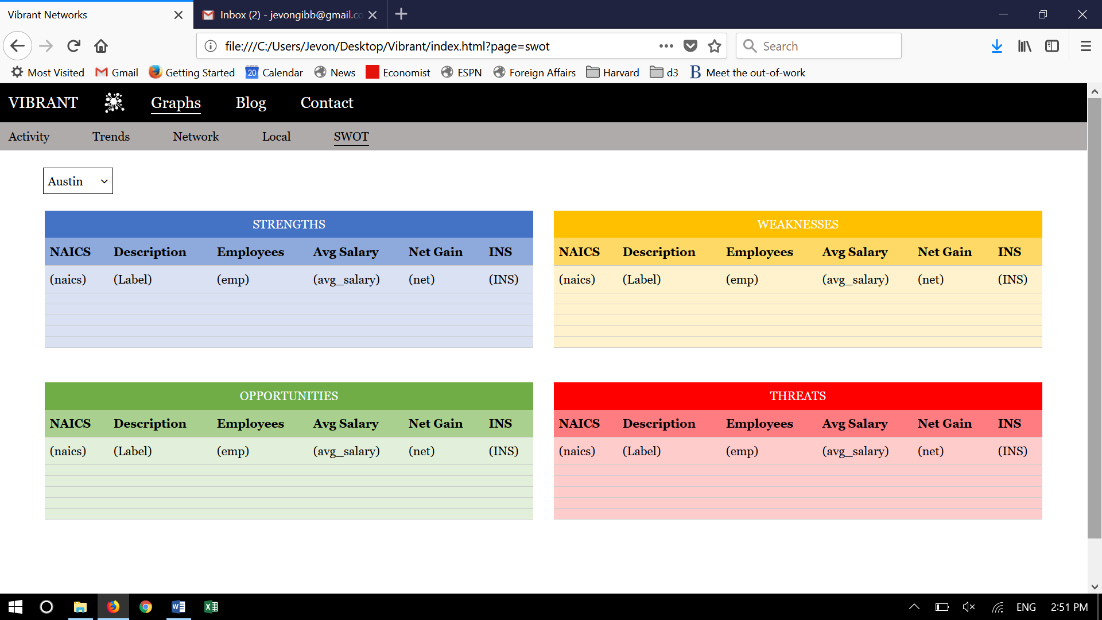

[different text for each city] This text is about (city)…

[text that is same for each city]

© 2017, DevGPS