

VIBRANT Graphs Blog Contact

Activity Trends Network Local SWOT

(Dropdown box: Austin, Tupelo, Detroit)

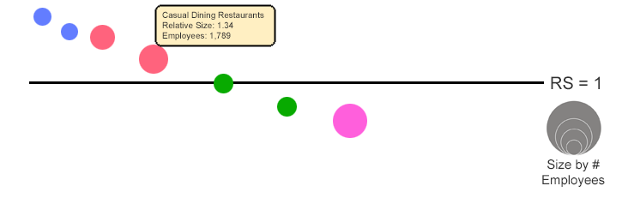

RS = 1



Size by #

Employees

|  |  |  |  |  |  |
| --- | --- | --- | --- | --- | --- |
| Industry | Distance from Average | Employees | Relative Size (RS) | Local Trend | Nat’l Trend |
| (name) | -.75 | 1,745 | 1.4 | +3.4% | -2.4% |
|  |  |  |  |  |  |
|  |  |  |  |  |  |
|  |  |  |  |  |  |
|  |  |  |  |  |  |

© 2018, Vibrant