

VIBRANT Graphs Blog Contact

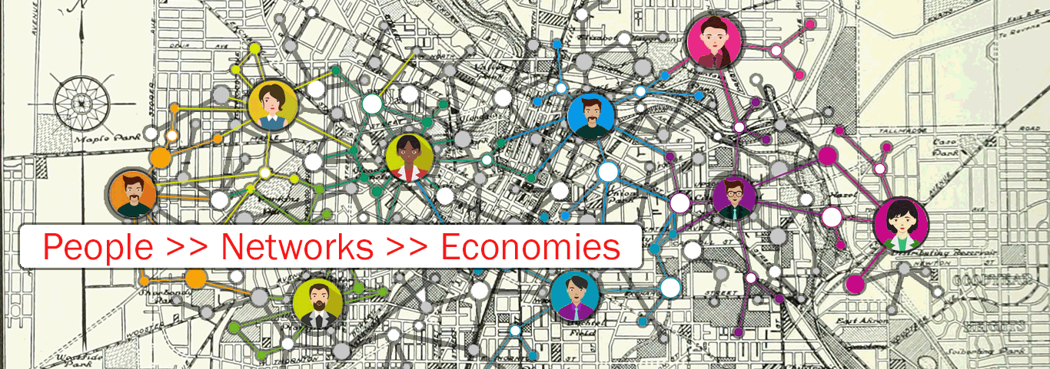

Coming Soon!

© 2017, DevGPS