

VIBRANT Graphs Blog Contact

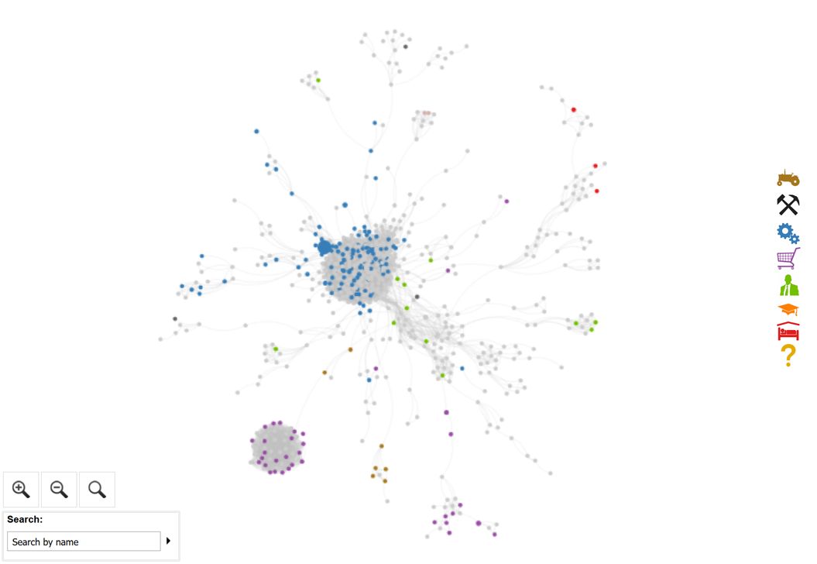

Activity Trends Network SWOT LFPR Mobility Spatial Education

© 2018, Vibrant