

VIBRANT Graphs Blog Contact

Activity Trends Network Local SWOT

(Dropdown box: Austin, Tupelo, Detroit)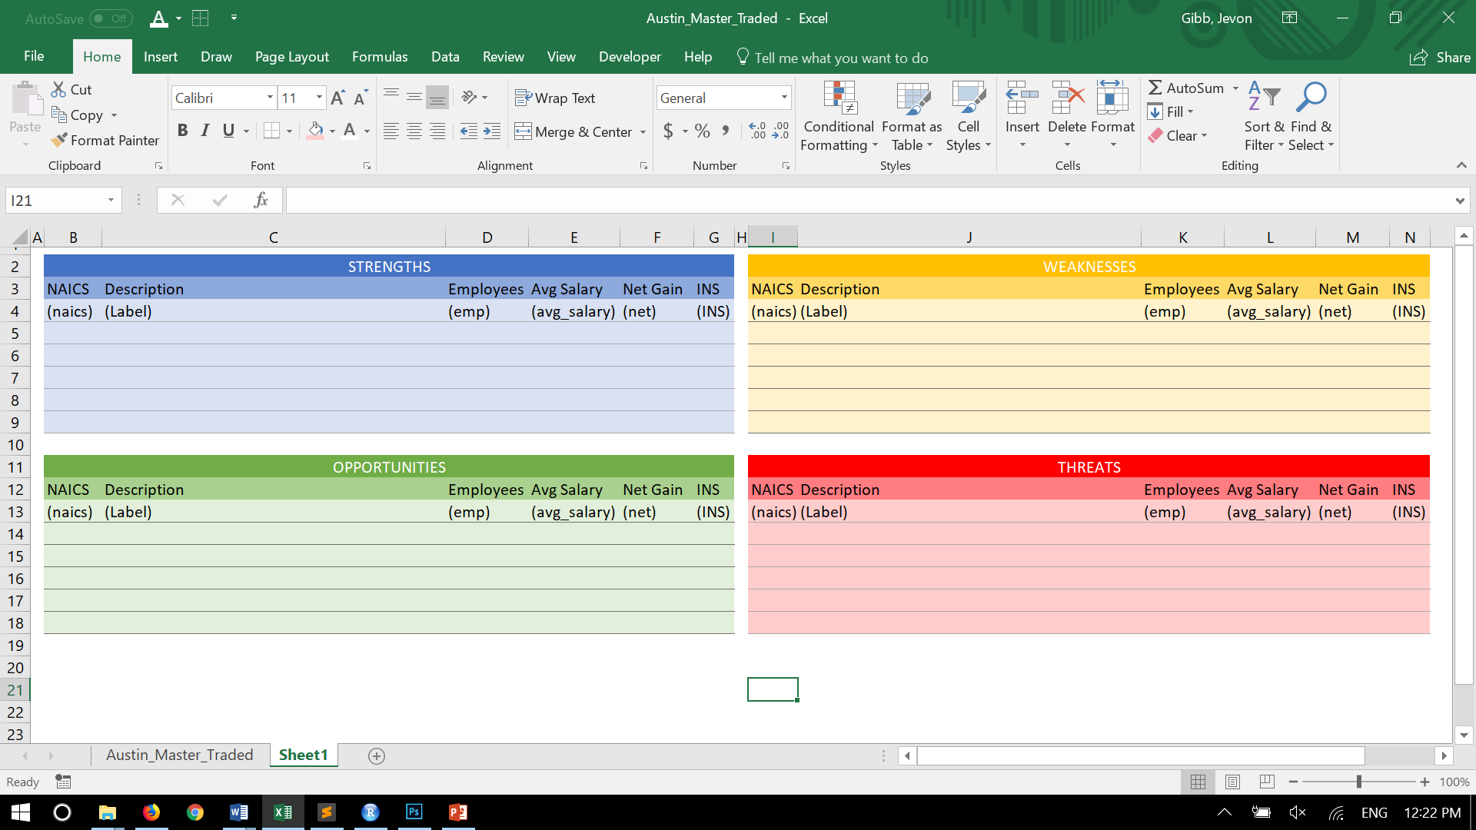

© 2018, Vibrant