QUESTIONS TO UNDERSTAND AND IMPROVE THE SYSTEM

NOTE:
THE SYSTEM THAT WILL BE PRESENTED WILL BE BASED ON THE ASSUMPTION WITH THE BASIS OF FEEDBACK FROM THE FIRST PROTOTYPE

CONTENTS OF THE DOCUMENT

- QUESTIONS TO IMPROVE THE SYSTEM

- SNIPPETS OF IN-DEVELOPMENT SYSTEM

- LOGO FOR ATA & LTA

- FORMAT

  - Billing Invoice/Voucher
  - Disbursement Voucher
  - Transmittal format

- TRANSMITTAL MENU

  - Additional information about transmittal menu
  - What button to expect in transmittal menu
  - Other expected to see in transmittal

- WHO CAN VIEW WHAT

SIDE BAR MENU TEMPLATE
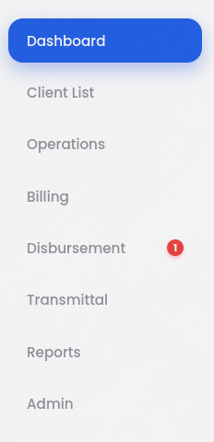

SIDE BAR MENU LIST | CODE
DASHBOARD | 1
CLIENT LIST | 2
BILLING | 3
DISBURSEMENT | 4
TRANSMITAL | 5
REPORT | 6
ADMIN | 7

ACCOUNT LIST | WHAT SIDEBAR THEY CAN SEE
Admin
Manager
Accounting
Operations
Documentation

EX.
IF

Admin | 1234567

THEN
- Admin can view the dashboard to admin

- WHO CAN ACCESS WHAT

LIST OF ACTIONS

SIDE BAR MENU | ACTIONS
Dashboard
Client List | - Add/Edit Client
Operations | - Add work request  - Add work request template  - View work request details  INSIDE WORK REQUEST DETAILS  - Cancel work request  - Route to next status  - Add task
Billing | - Create Invoice  - Create new Invoice template  - Invoice Mark as Sent  - Edit/View Invoices
Disbursement | - Add file expenses  - Add disbursement template  - View disbursement
Transmittal | - Create transmittal  - View transmittal  Inside transmittal view  - Mark as acknowledged
Report
Admin | - Add/Edit user  - Pending Approval

ACCOUNT LIST | MAIN ROLE IN THE SYSTEM / WHAT THEY CAN ACCESS
Administration | Client List
 | Operations
 | Billing
 | Disbursement
 | Transmittal
 | Admin
Manager | Client List
 | Operations
 | Billing
 | Disbursement
 | Transmittal
 | Admin
Accounting | Client List
 | Operations
 | Billing
 | Disbursement
 | Transmittal
 | Admin
Operation | Client List
 | Operations
 | Billing
 | Disbursement
 | Transmittal
 | Admin
Documentation | Client List
 | Operations
 | Billing
 | Disbursement
 | Transmittal
 | Admin

EX.
IF
Administration | Client List  - Add Client
Operations
- Add Work Request
Billing
- Create Invoice
Disbursement
- Add File Expenses
Transmittal
- Create Transmittal
Admin
- Add/Edit Users

- WORKFLOW
Can we have a step by step narrative workflow of each task, an iteration of a common task encountered. To better understand the workflow from start to finish if possible

EXAMPLE:
Common Task #1: WORK REQUEST

- The manager logs into the ERP system and creates a new work request by filling in the client name, priority, and due date

- The manager then adds a list of tasks under that request, each with a description, deadline, and category such as bookkeeping, tax filing, or audit

- Once the task list is complete, the manager assigns each task to a staff member and submits the work request

- The assigned staff member receives a notification, opens the work request, and can view all tasks, deadlines, and manager notes before beginning work.

IV. COMMON DEPENDENCY

Relationships where one task or system relies on another to function or proceed.

EXAMPLE:
Common Dependency #1: OPERATION

STATUS
Draft | Pre-processing | Processing | Billing | Disbursement | Completed | Cancelled

- Draft → requires Manager action
- Pre-processing → requires Admin availability
- Processing → requires Admin approval decision
- Billing → requires client payment
- Disbursement → requires Manager to record payment
- Completed → system confirms closure
- Cancelled → can occur at step 3 if Admin rejects

DOCUMENTATION IMAGES OF THE SYSTEM IN PROGRESS

ADMIN ACCOUNT

- DASHBOARD
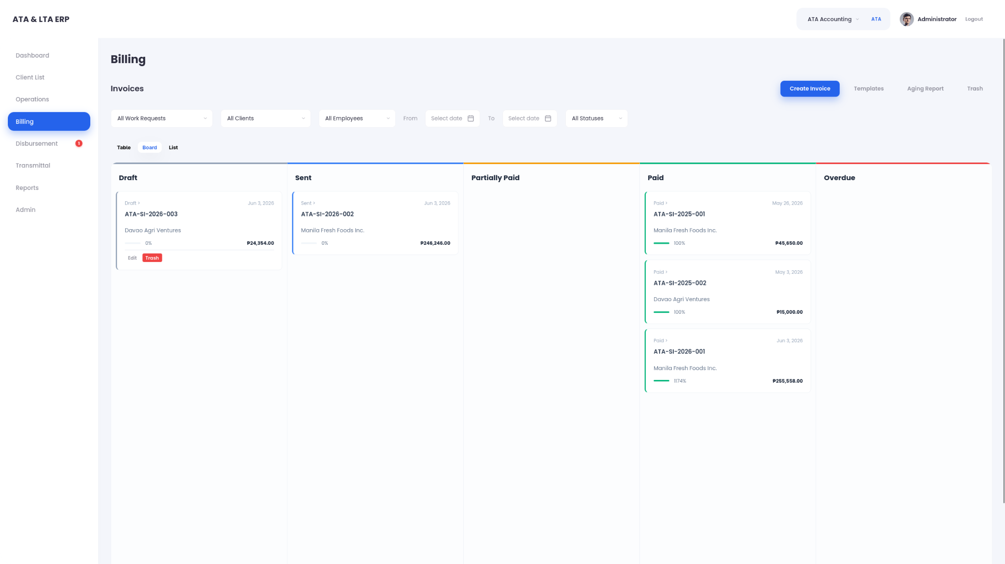
- CLIENT LIST
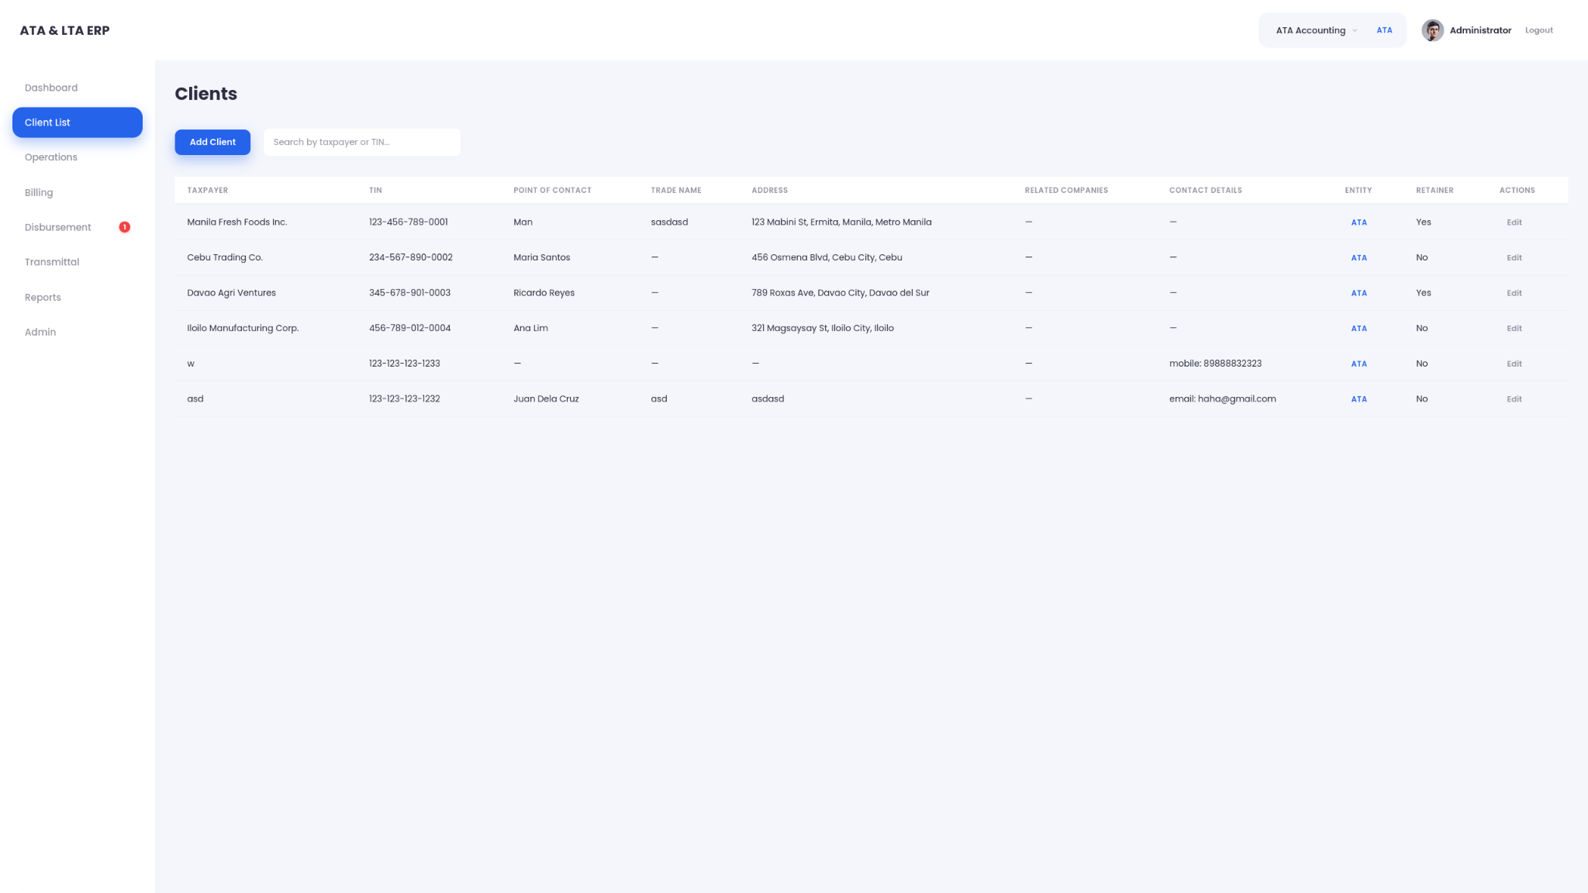
- ADD CLIENT
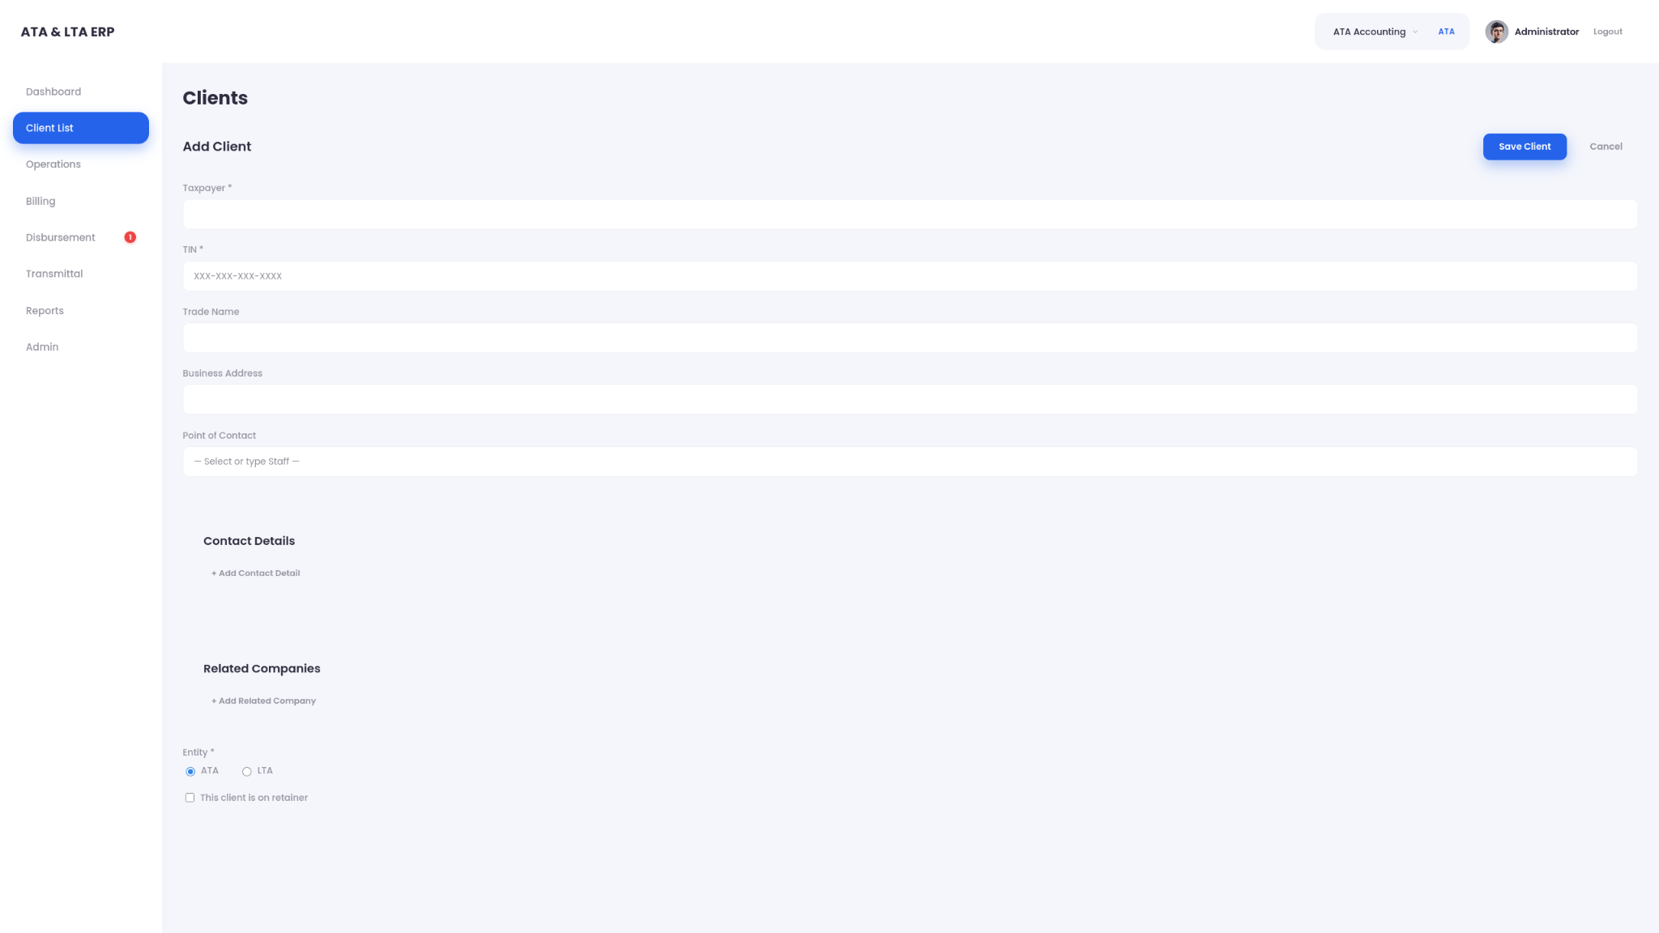
- EDIT CLIENT

- OPERATIONS
- BILLING
- DISBURSEMENT
- TRANSMITTAL
- REPORTS
- ADMIN

