Setting up VSCode and WPILib on Computers

1. Go to <https://github.com/wpilibsuite/allwpilib/releases>
2. Download 64 bit version for windows
3. Select All Users
4. Select Select/Download VSCode

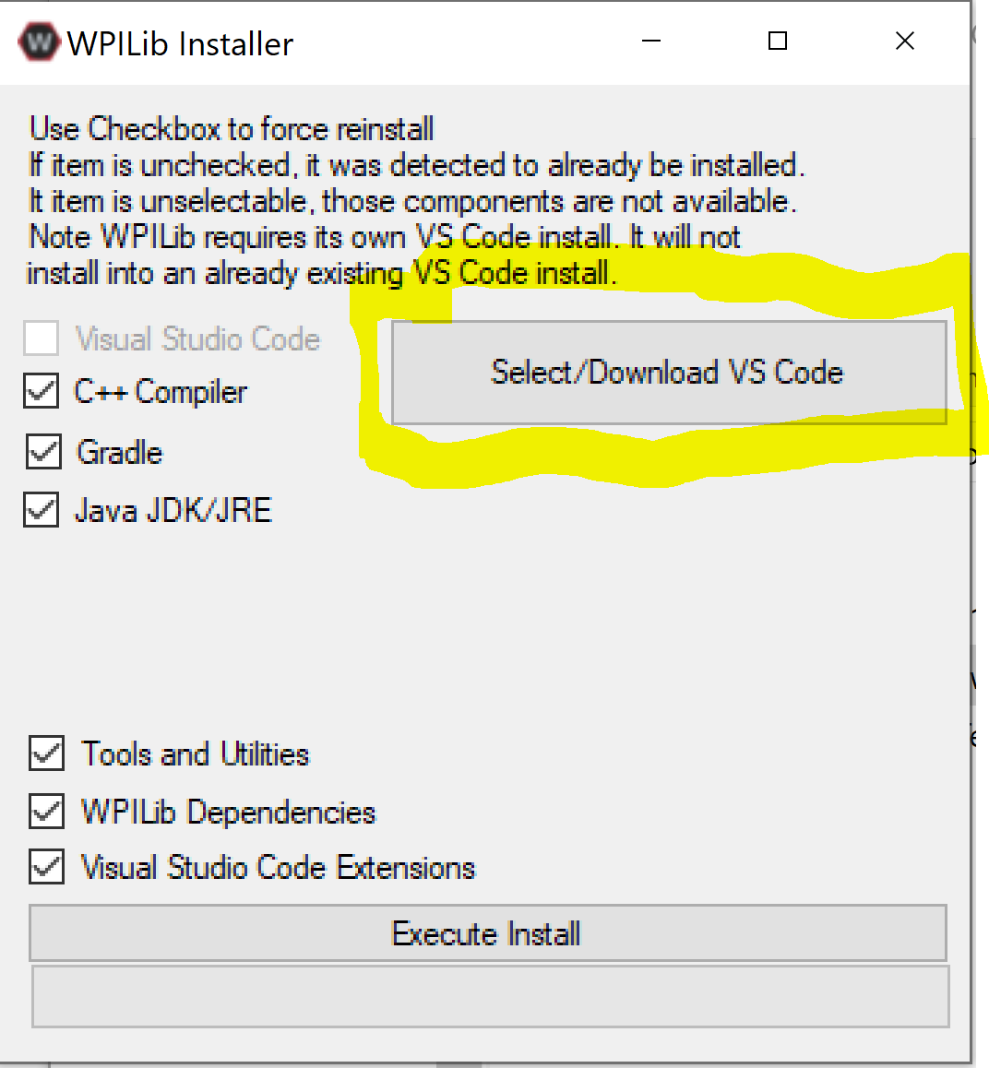

1. Download current version of VS Code
2. Select Execute Install
3. This should download the version of VS Code needed for programming the robot
4. Once installed, need to grab folder for 2020 robot code
   1. This year we will start to use GitHub for our robot code. This software allows multiple users to work on the same code at the same time from different computers
5. If the computer does not already have git, install it by going to <https://git-scm.com/download> and select windows
   1. When I installed this I went with the standard set up. Click next until it says finish.
   2. We will learn a little more about git this year but for now we will use simple commands to get the code library set up.
6. First command we will use it ls. This lists the contents of the folder you are in. If you see stuff like “My Documents” you are in the right place.
7. Type in cd “My Documents”
   1. Note the quotations. This is used because it is two words.
8. Next copy the command “git clone <https://github.com/jew211/3936CodeRepo.git>” This will grab the repository set up for the team.
   1. Now that we have some code, let’s go back to VS Code.
9. In VS Code open the file tab and select “open folder…”
10. Navigate to My Documents\3936CodeRepo\2020RobotCode and choose on of the two folders and press select folder.
11. The CAN speed controllers that come in the Kit of Parts are now controlled by a 3rd party system so in order to control them we need to download the tuner.
12. Go to <http://www.ctr-electronics.com/hro.html#product_tabs_technical_resources> and select CTRE Phoenix Framework Installer 5.17.3.1 (.zip) from the installer section and install.
13. Finally go into VS Code and Right click build.gradle and select “Manage Vendor Libraries” 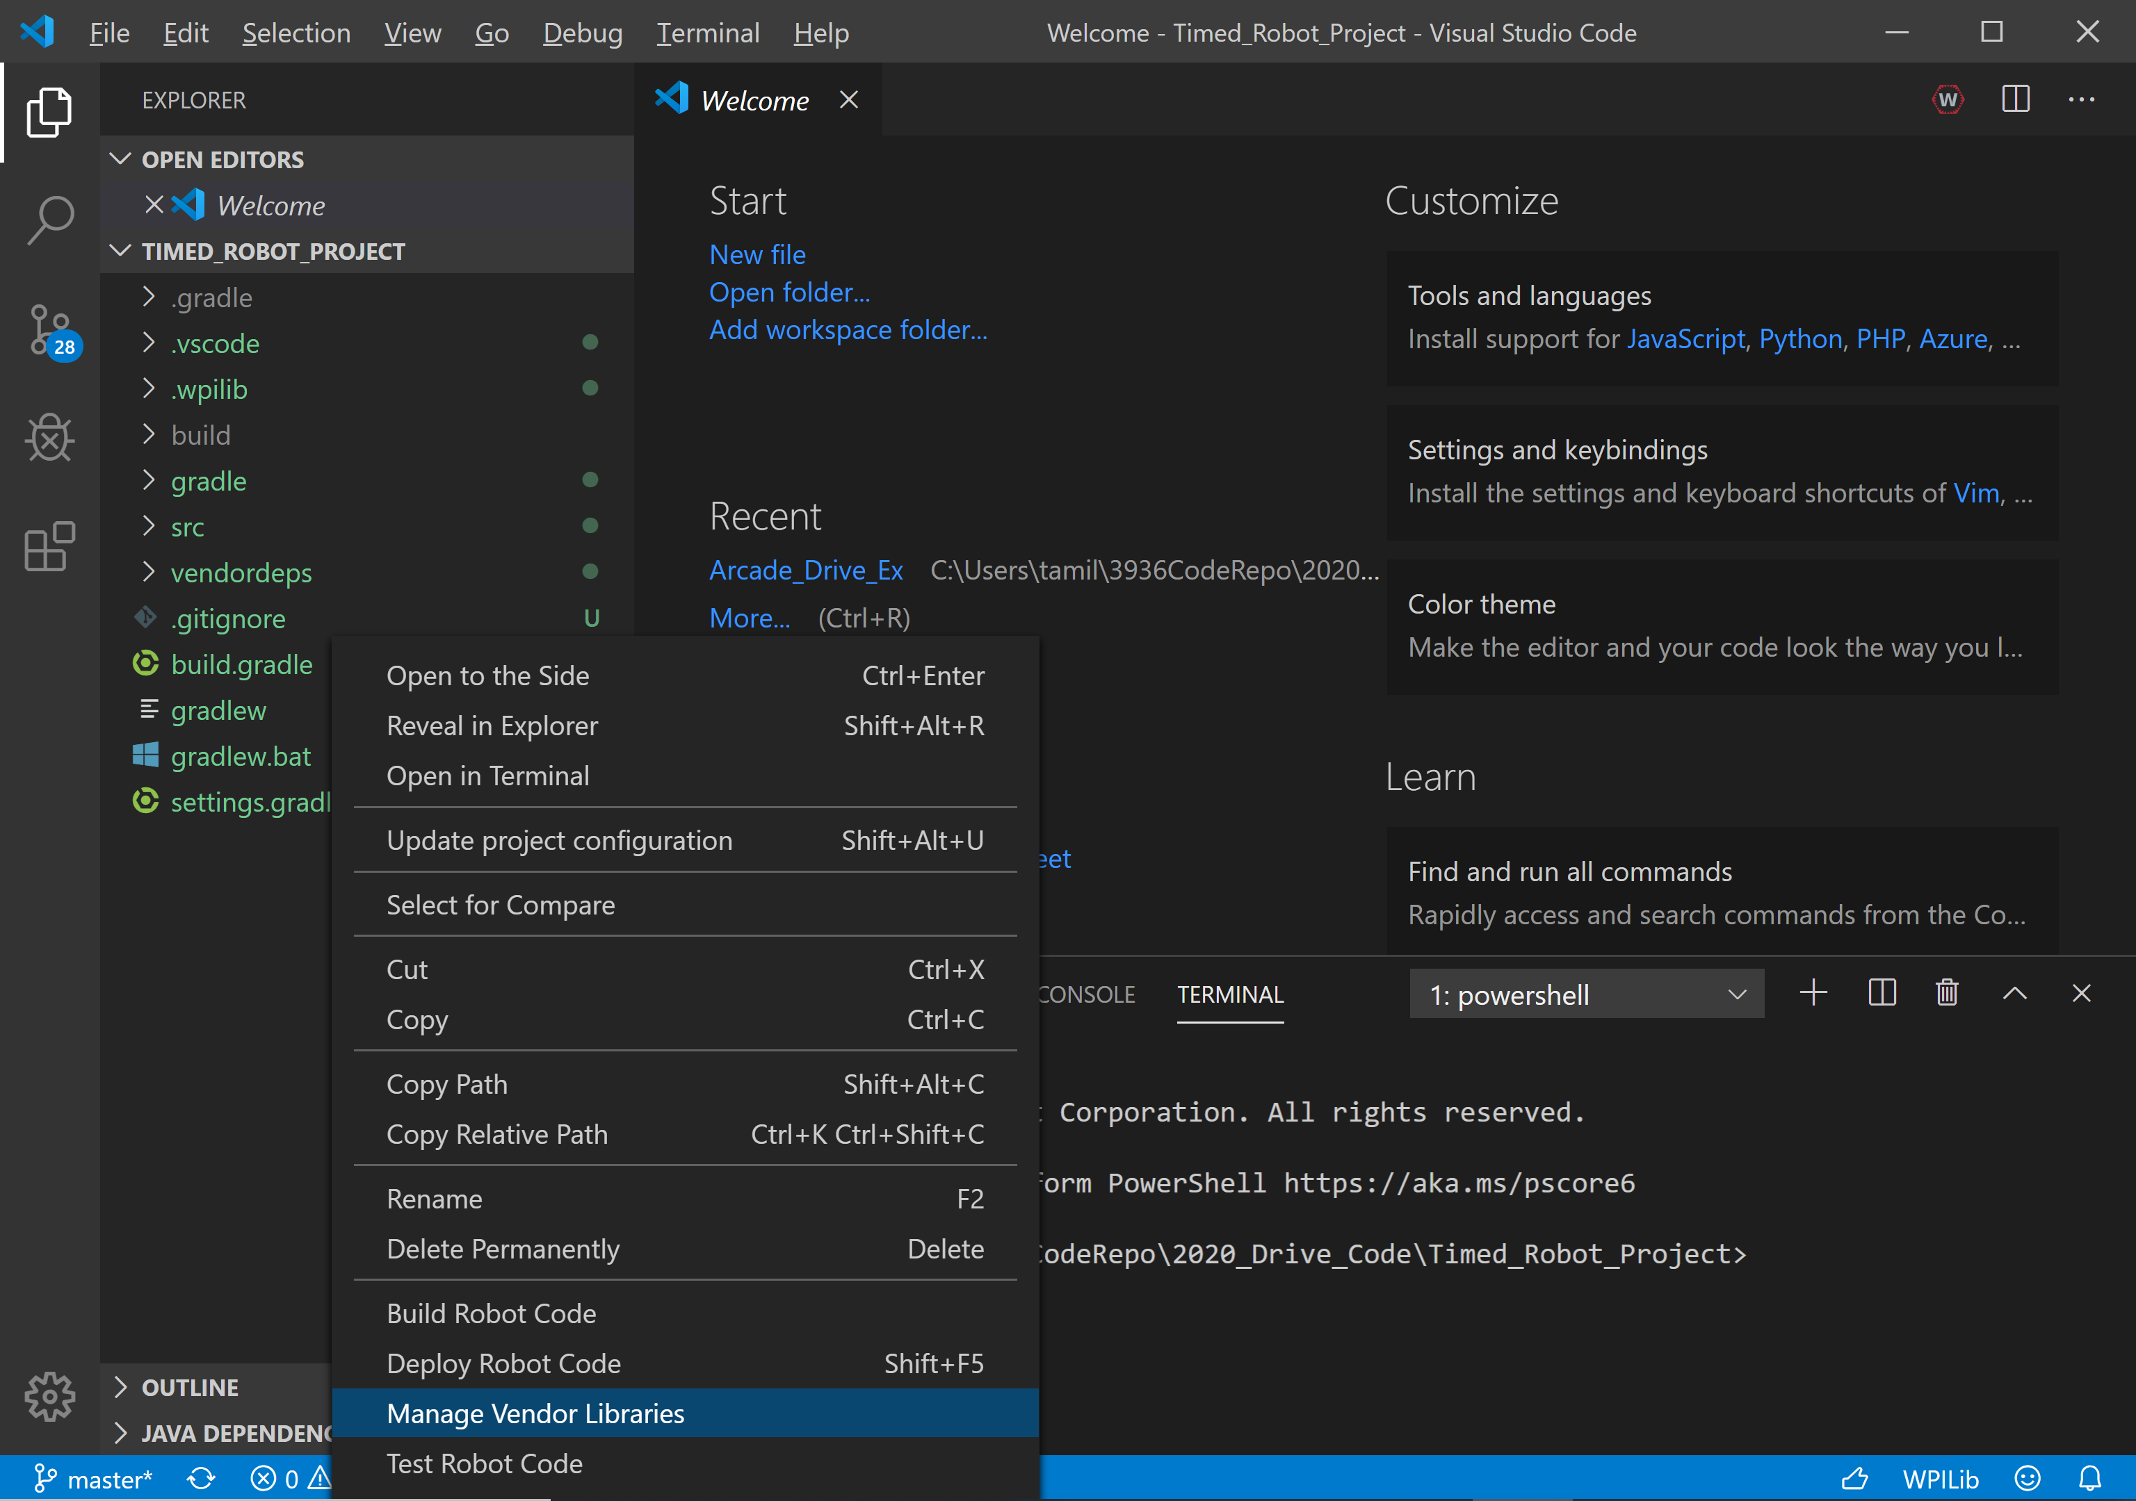
14. Select Install new libraries(Offline) 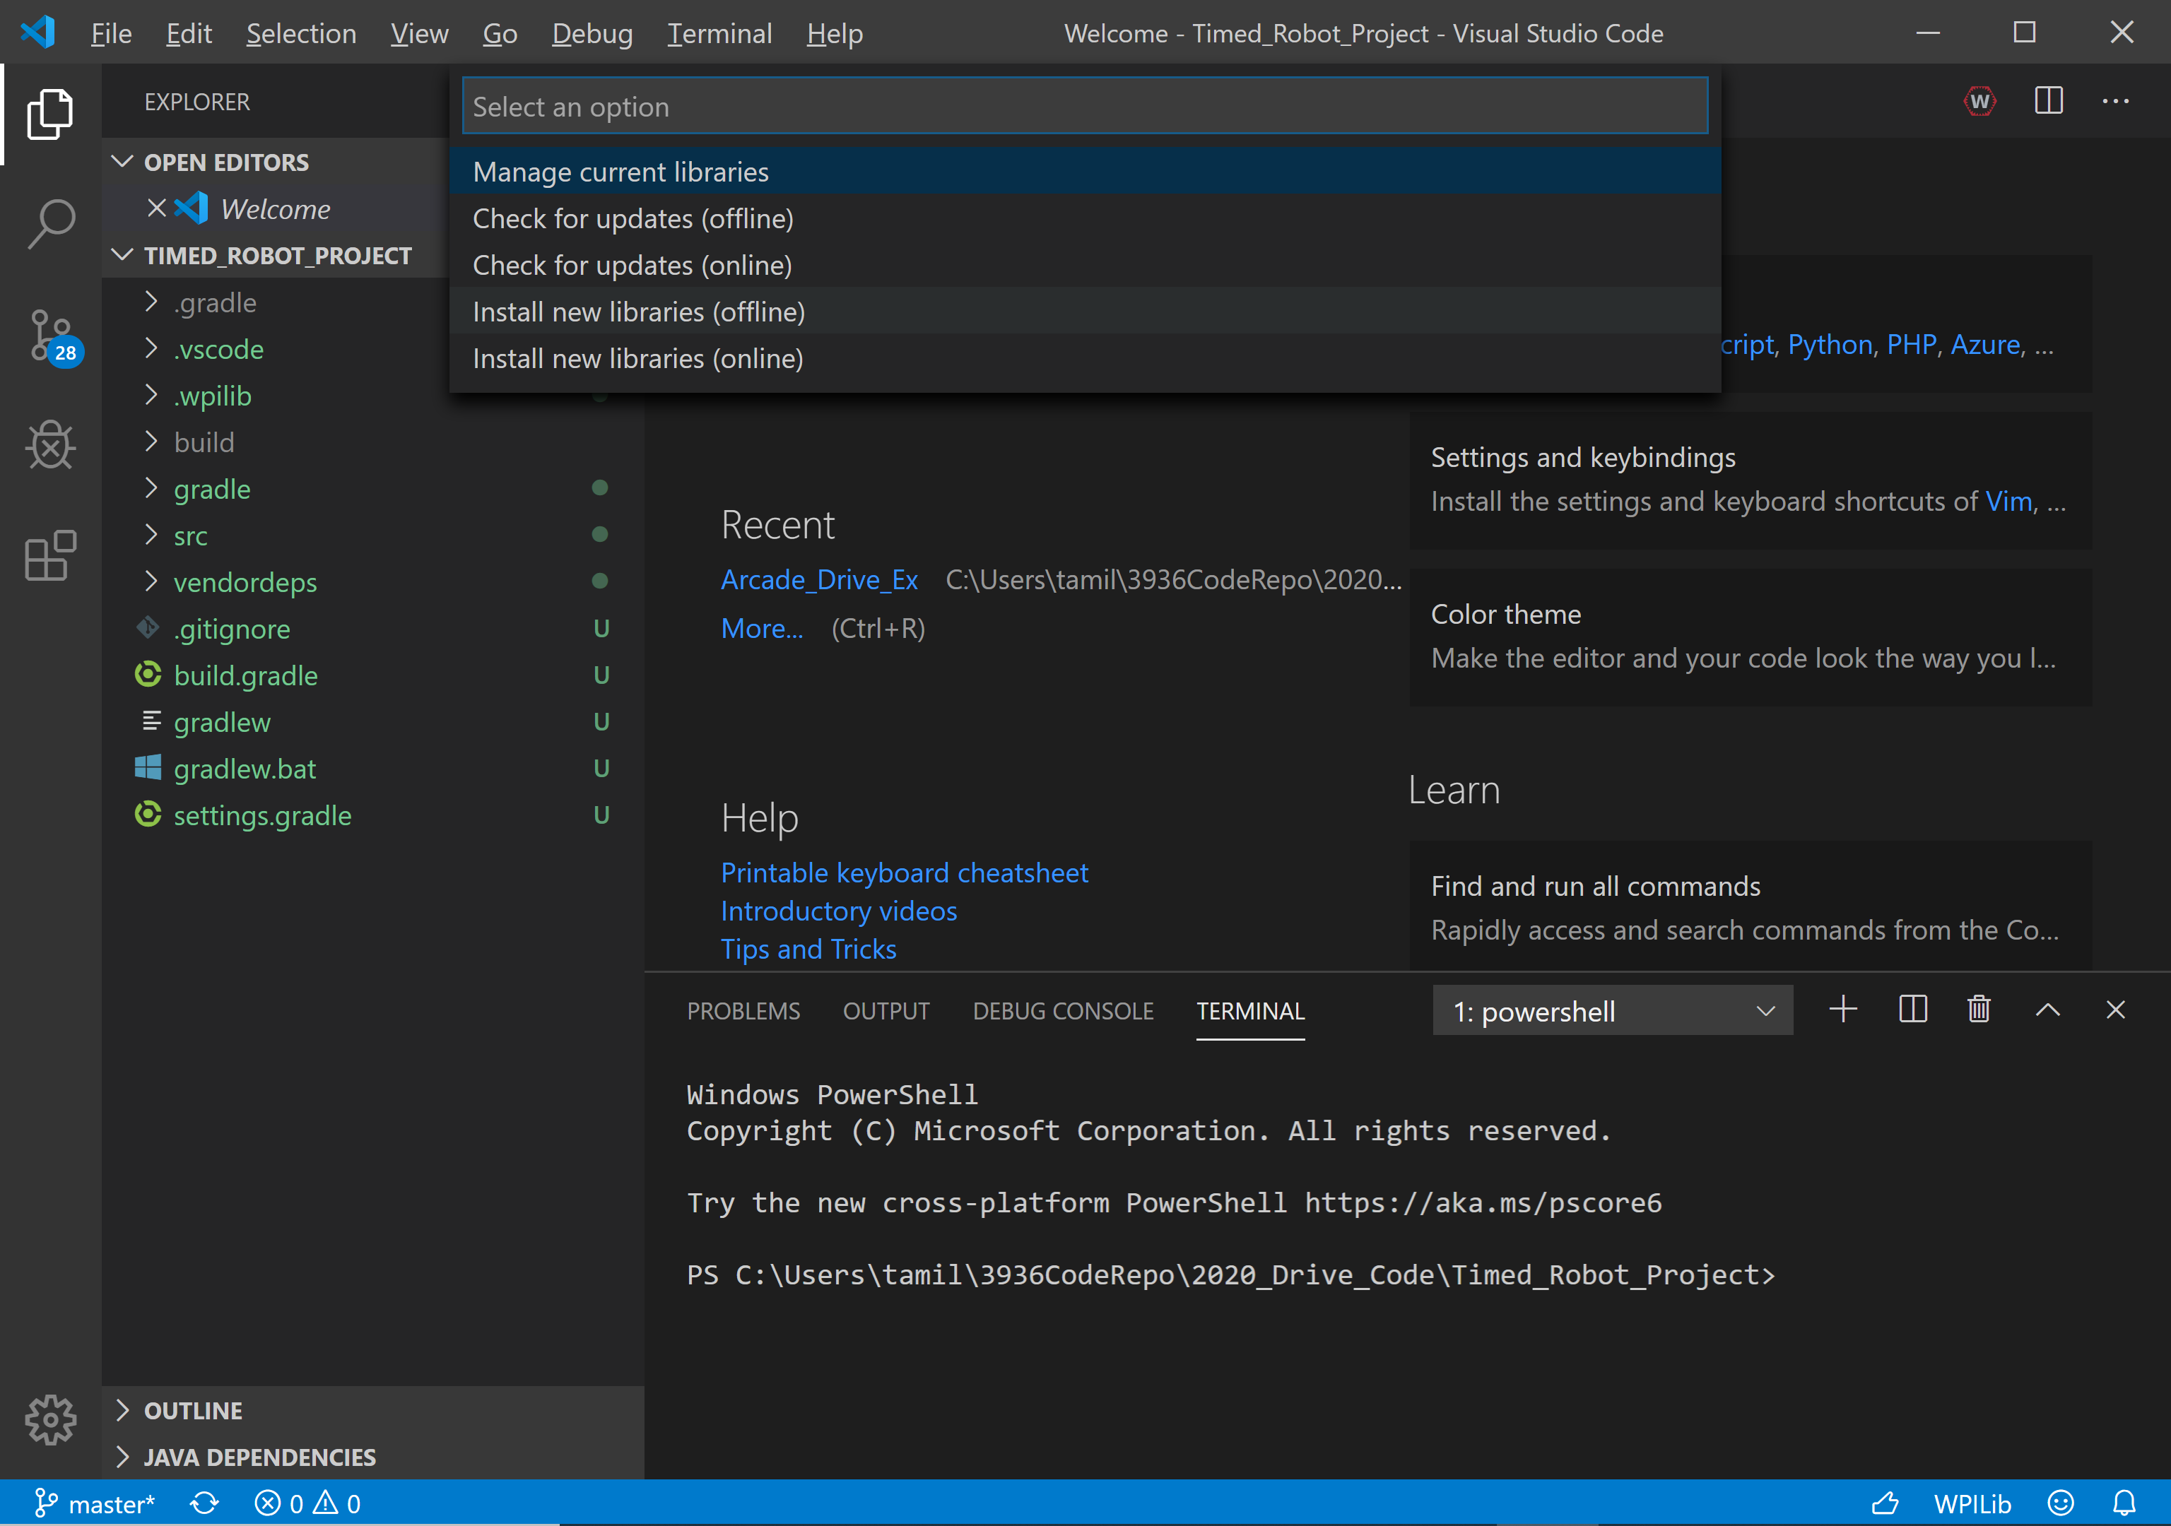
15. Select CTRE to be able to use the CAN motor controllers.
16. Now you are set up to program in java.