Save the file license.dat to the directory C:\FLEXlm\ on the server and save it to directory where you installed the software for the client (usually C:\Program Files\Metrowerks\CodeWarrior\license.dat).
If the license files contain valuable license information, you can simply add the new information using a text editor like Notepad or the CodeWarrior text editor. You may have to adapt the hostname (1st argument in SERVER line) to your license server's hostname in both license.dat files by using a text editor.
Install the FLEXlm License Manager on your license server.
If your CD-ROM does not contain the License Manager, you may download the License Manager for Windows from
http://www.metrowerks.com/MW/Support/flex
The License Manager installation contains all the deamons you need for your license.
To configure a license server as a service, you must have Administrator privileges:
- Run LMTOOLS.
- Click the Configuration using Services radio button, then click the Config Services tab.
- In the Service Name, type the name of the service that you want to define, for example, Myvendor License Manager.
- In the Path to the lmgrd.exe file field, enter or browse to lmgrd.exe for this license server.
- In the Path to the license file field, enter or browse to the license file for this license server.
- In the Path to the debug log file, enter or browse to the debug log file that this license server writes. Prepending the debug log file name with the + character appends logging entries.
To configure a license server as a service, you must have Administrator privileges:
- Run LMTOOLS.
- Click the Configuration using Services radio button, then click the Config Services tab.
- In the Service Name, type the name of the service that you want to define, for example, Myvendor License Manager.
- In the Path to the lmgrd.exe file field, enter or browse to lmgrd.exe for this license server.
- In the Path to the license file field, enter or browse to the license file for this license server.
- In the Path to the debug log file, enter or browse to the debug log file that this license server writes. Prepending the debug log file name with the + character appends logging entries.
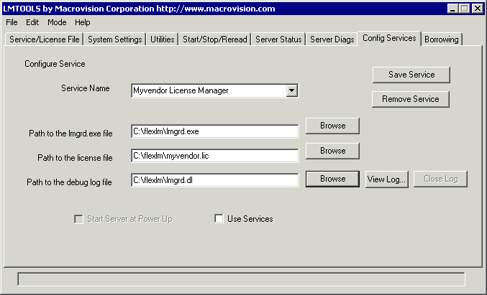

- To save the new Myvendor License Manager service, click the Save Service button.
A graphical user interface to the license manager tools is provided called LMTOOLS. Some of the functions LMTOOLS performs include:
- starting, stopping, and configuring FLEXlm license servers
- getting system information, including hostids
- getting server status
In order to control the operation of lmgrd from the LMTOOLS user interface, you first must configure it as a license manager service.
Once the license manager service is configured, lmgrd is started by starting the service from the LMTOOLS interface:
- Start LMTOOLS.
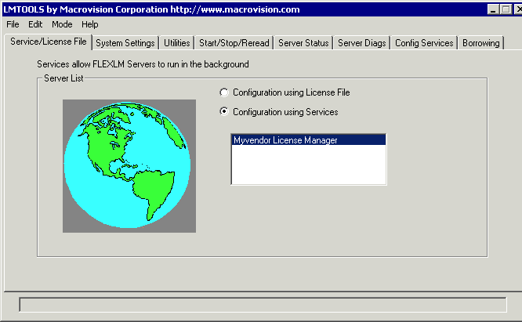

LMTOOLS appears with the Service/License File tab open.
- Click the Configuration using Services radio button.
- Select the service name from the list presented in the selection box. In this example, the service name is Myvendor License Manager.
- Click the Start/Stop/Reread tab.
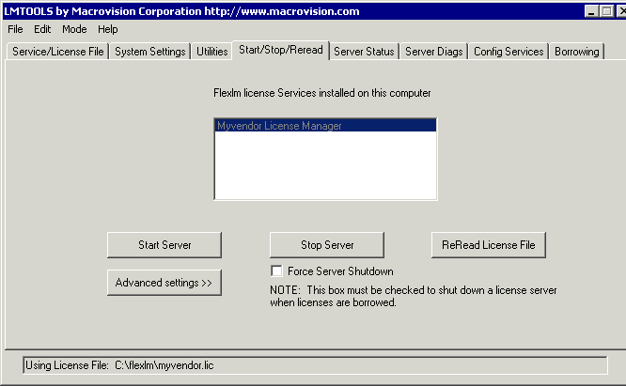

- Start Myvendor License Manager by clicking the Start Server button.
Myvendor License Manager license server starts and writes its debug log output to c:\flexlm\lmgrd.dl.

In order for lmgrd, and hence the license server, to start up automatically at system start up time, you first must configure it as a license manager service. Then continue:
- With LMTOOLS started and the desired service name selected, click the Config Services tab.

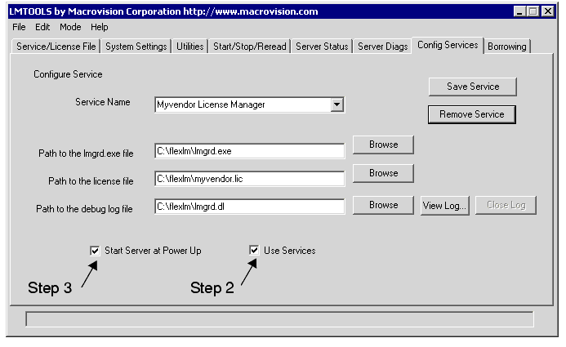
- Make this license manager a Windows service: check the Use Services check box (otherwise, it becomes a FLEXlm service).
- Configure it to start at system startup time by checking the Start Server at Power Up check box.
From now on, when the machine is rebooted, this license manager starts automatically as a Windows service.

