ERP Integration Guide
Step-by-Step Configuration & Setup Instructions

Overview
This guide provides a complete walkthrough for integrating the ERP system with your platform. Following these steps in sequence will ensure a successful configuration, from initial activation through to Sale Order creation.
Please complete each step in the order presented. All screenshots included in this guide reflect the current system interface

STEP  1 | Activate the ERP Integration

How to activate:
1. Navigate to the Settings menu from the main navigation panel.
2. Locate and open the Integrated Applications section.
3. Find the ERP option and toggle it to Active.
4. Save your settings before proceeding to the next step.

Reference screenshots:
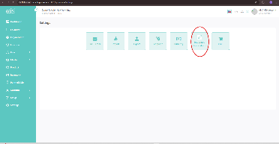
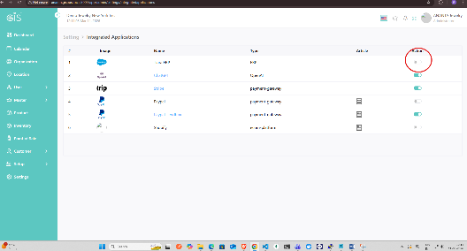

STEP  2 | Create a Location on the ERP Platform

Important:
1. On the ERP platform, create a new location entry.
2. This location must exactly match the corresponding location defined in the GIS system.
3. Verify that the location name, coordinates, and identifiers are consistent across both platforms before continuing.

The ERP platform location should be configured to match the following:
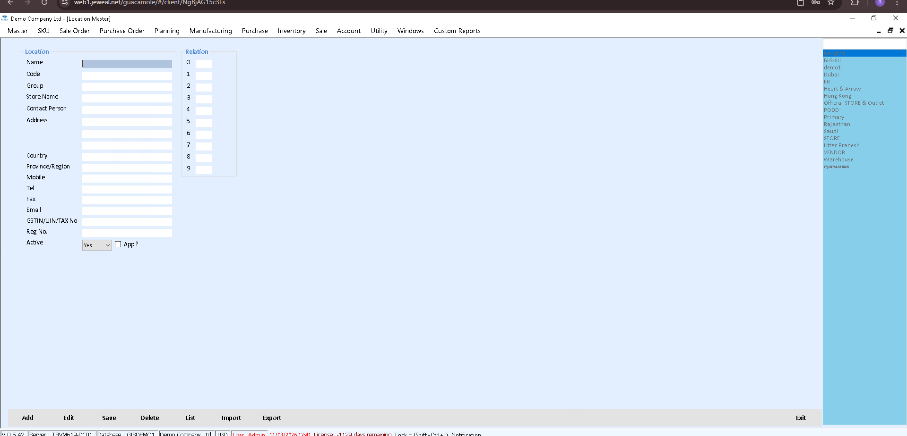
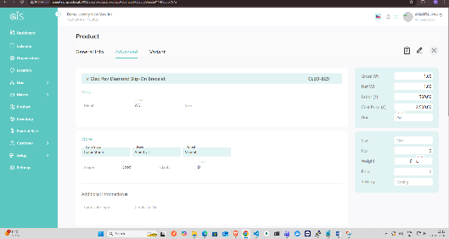

STEP  3 | Post a Product to the ERP

How to post a product:
1. Navigate to the Product section and open the Advanced Settings screen for the desired product (e.g., a Stone product).
2. Edit the product name or relevant fields as required.
3. Save the changes. The product will be automatically posted to the ERP.
4. Each product is classified using a code. Refer to the table below for the Stone ERP classification codes.

Stone ERP Product Classification Codes:
Code | Category | Description
C | Non-Variants | Standard products with no variant options
T | Variants | Products with multiple variant options
P | Design | Custom-designed or bespoke products

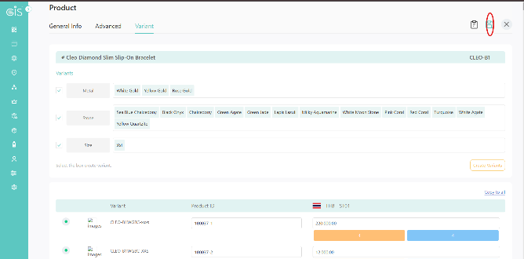

STEP  4 | Post Product Variants to the ERP

How to post variants:
1. The process for posting variants follows the same procedure as posting a standard product.
2. Open the desired variant from the product screen and edit any required field.
3. Upon saving, all associated variants for that product will be automatically posted to the ERP simultaneously.

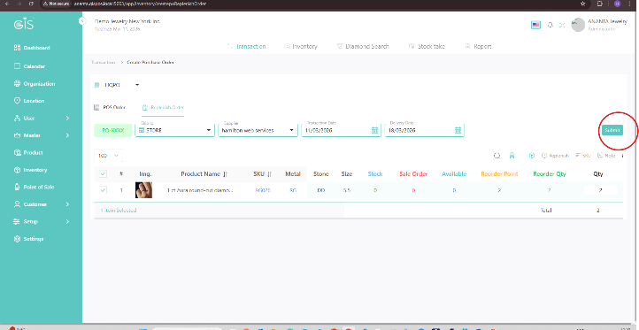

STEP  5 | Create a Vendor on the GIS Platform

Why this is required:
A Vendor (Supplier) record must exist in the system before a Sale Order can be created. Follow the steps below to create one.
How to create a Vendor:
1. From the main navigation panel, go to Master → Vendor.
2. Click the + Create button in the top-right corner of the Vendor list screen.
3. A creation panel will open on the right side. Fill in the required fields:
• Organization — Name of the vendor or supplier company.
• Vendor Type — Select the appropriate type (e.g., STORE).
• Contact Person — Name of the primary contact.
• Tax ID, Address, Country, Province/State — Fill in as applicable.
4. Ensure the Active toggle is enabled, then save the record before proceeding to create a Sale Order.

GIS Platform — Master → Vendor screen:
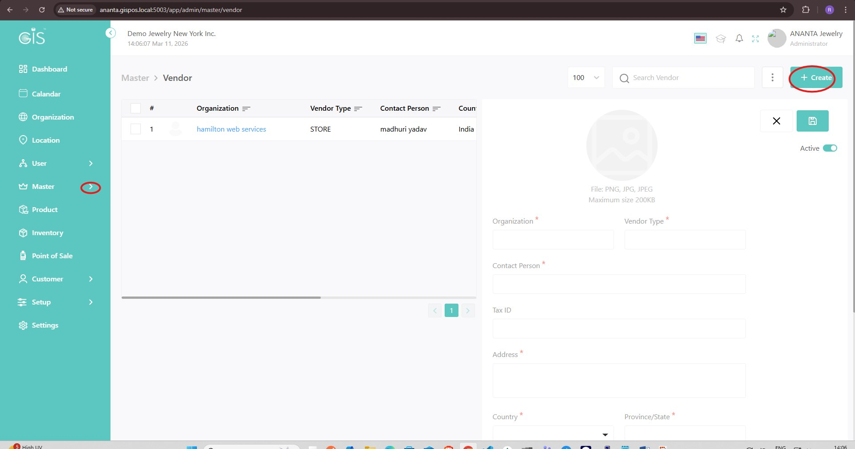

STEP  6 | Create a Sale Order on the ERP

How to create a Sale Order:
1. Before creating a Sale Order in the ERP, you must first generate a Voucher.
2. When creating the voucher, ensure the voucher type is set to:
SO (Sale Order)
3. Once the voucher is created with the correct type, proceed to generate the Sale Order on the ERP platform.

STEP  7 | Create a POS Sale and Sync to ERP

How to create a POS Sale:
1. Before proceeding, create a new voucher on the ERP with the following voucher type:
POS-SALE
2. Once the voucher is created, navigate to the GIS Point of Sale (POS) screen.
3. From the POS Menu, select the POS option (highlighted with a red circle on the screen below).
4. Process and complete any sale transaction through the POS interface.
5. Once the sale is completed, it will be automatically posted and synced to the ERP system.

GIS Point of Sale — POS Menu Screen:
