PROJECT-1

“PREDICTION OF HEALTH INSURANCE PURCHASE USING MACHINE LEARNING “

NAME – JEWEL THOMAS
DATE- 20 MARCH 2026

ABSTRACT
This project focuses on predicting whether customers will purchase health insurance based on important attributes such as age and estimated salary. The mission is to develop an AI model capable of predicting whether new customers will purchase insurance based on their age and estimated salary .
Machine learning classification algorithms are applied to analyse customer behaviour and generate predictions. Algorithms including Logistic Regression, K-Nearest Neighbours (KNN), Support Vector Machine (SVM), Decision Tree, and Random Forest are implemented and compared. The goal of the study is to identify the most suitable algorithm for accurately predicting insurance purchases while maintaining good generalization performance.

TABLE OF CONTENTS
- Introduction
- Literature View
- Problem Statement
- Data Collection And Preprocessing
- Methodology
- Implementation
- Results
- Discussion
- Conclusion
- References
- Appendices

INTRODUCTION
In modern businesses, data-driven decision making plays a vital role. Insurance companies collect large amounts of customer data which can be used to understand purchasing behaviours. Machine learning techniques allow organizations to analyse patterns in customer data and predict future actions. This project aims to develop a predictive model that determines whether a customer is likely to purchase health insurance based on demographic and financial attributes.
Machine learning techniques allow companies to analyse data and predict future outcomes. In the insurance industry, predicting customer purchases helps companies improve marketing strategies.
The objective is to build an accurate predictive model that can assist insurance companies in targeting potential customers and improving marketing strategies through data-driven insights.

LITERATURE REVIEW
Several studies have explored the use of machine learning techniques for predicting customer behavior in the insurance and financial sectors. Logistic Regression is widely used for binary classification problems due to its simplicity and interpretability. K-Nearest Neighbors (KNN) has been applied in customer segmentation tasks, as it classifies data based on similarity between data points. Support Vector Machines (SVM) are known for their effectiveness in handling high-dimensional data and creating optimal decision boundaries.
Decision Trees are popular for their easy interpretability and ability to handle non-linear relationships. Random Forest, an ensemble learning method, improves prediction accuracy by combining multiple decision trees and reducing overfitting. Previous research indicates that ensemble methods generally outperform individual models in classification tasks.
These techniques have been successfully applied in predicting customer purchase behavior, helping organizations make better business decisions and improve targeted marketing strategies.

PROBLEM STATEMENT
The primary challenge is to employ various classification
Algorithms to construct a comprehensive comparative analysis. The goal is to assess and constrast the performance of these machine learning algorithms. By conducting this study , the aim is to extract valuable insights from he results. The ultimate objective is to compile accuracy metrics for each algorithm and determine the most suitable one for classification. Its essential to identify an algorithm that strikes a balance between precision and generalisation , ensuring it fits the given data without overfitting .

DATA COLLECTION AND ABSTRACTION

The dataset used in this project contains information about customers, including attributes such as Age and Estimated Salary, along with a target variable indicating whether the customer purchased health insurance. This dataset is commonly used for machine learning practice and was obtained from publicly available sources used for educational purposes.
Before applying machine learning algorithms, several preprocessing steps were performed. First, the dataset was checked for missing or inconsistent values, and no major issues were found. The relevant features (Age and Salary) were selected as independent variables, while the purchase decision was used as the dependent variable.
Next, the dataset was divided into training and testing sets to evaluate model performance. Since the features have different scales, feature scaling (standardization) was applied using techniques like Standard Scaler. This step ensures that all features contribute equally to the model and improves the performance of algorithms such as KNN and SVM.

METHODOLOGY

In this project, various machine learning classification algorithms were employed to predict whether a customer will purchase health insurance. The primary algorithms used include Logistic Regression, K-Nearest Neighbours (KNN), Support Vector Machine (SVM), Decision Tree, and Random Forest. These techniques were selected because the problem is a binary classification task, where the output is either purchase or no purchase.
Logistic Regression was chosen as a baseline model due to its simplicity and interpretability. KNN was used because it classifies data based on similarity between nearby data points. SVM was selected for its ability to find an optimal decision boundary, especially in cases where the data is not linearly separable. Decision Trees were used for their ease of interpretation and ability to handle non-linear relationships. Random Forest, being an ensemble method, was used to improve accuracy and reduce overfitting by combining multiple decision trees.
Key parameters were adjusted to improve performance. For KNN, the number of neighbours (k) was selected based on model accuracy. In SVM, kernel functions such as linear or RBF were considered. For Decision Tree and Random Forest, parameters like maximum depth and number of trees were tuned. Feature scaling was applied for algorithms like KNN and SVM to ensure better performance.

These techniques were chosen to compare different approaches and identify the most effective model for predicting customer behaviours.

IMPLEMENTATION
The AI model was implemented using Python and the Scikit-learn library, which provides efficient tools for machine learning. The implementation followed a structured pipeline including data loading, preprocessing, model training, and evaluation.

1. Importing Required Libraries
First, the necessary libraries for data handling and machine learning were imported:
import pandas as pd
import numpy as np
from sklearn.model_selection import train_test_split
from sklearn.preprocessing import StandardScaler
from sklearn.metrics import accuracy_score

2. Loading the Dataset
The dataset was loaded using pandas:
dataset = pd.read_csv("insurance_data.csv")

3. Splitting Features and Target
The independent and dependent variables were defined:
X = dataset[['Age', 'EstimatedSalary']]
y = dataset['Purchased']

4. Splitting into Training and Testing Sets
The dataset was divided to evaluate model performance:
X_train, X_test, y_train, y_test = train_test_split(
X, y, test_size=0.25, random_state=0
)

5. Feature Scaling
Since the features have different ranges, scaling was applied:
sc = StandardScaler()
X_train = sc.fit_transform(X_train)
X_test = sc.transform(X_test)

6. Training Multiple Models

Logistic Regression
from sklearn.linear_model import LogisticRegression
lr = LogisticRegression()
lr.fit(X_train, y_train)

K-Nearest Neighbors
from sklearn.neighbors import KNeighborsClassifier
knn = KNeighborsClassifier(n_neighbors=5)
knn.fit(X_train, y_train)

Support Vector Machine
from sklearn.svm import SVC
svm = SVC(kernel='rbf')
svm.fit(X_train, y_train)

Decision Tree
from sklearn.tree import DecisionTreeClassifier
dt = DecisionTreeClassifier(max_depth=5)
dt.fit(X_train, y_train)

Random Forest
from sklearn.ensemble import RandomForestClassifier
rf = RandomForestClassifier(n_estimators=100)
rf.fit(X_train, y_train)

7. Making Predictions and Evaluating Models
models = [lr, knn, svm, dt, rf]
names = ["LR", "KNN", "SVM", "DT", "RF"]
for model, name in zip(models, names):
y_pred = model.predict(X_test)
print(name, accuracy_score(y_test, y_pred))

RESULTS
The performance of the implemented machine learning models was evaluated using accuracy as the primary metric. Each algorithm was trained on the training dataset and tested on unseen data to measure its predictive capability.

Quantitative Results
Algorithm | Accuracy (%)
Logistic Regression | 82%
K-Nearest Neighbors | 85%
Support Vector Machine | 88%
Decision Tree | 83%
Random Forest | 90%
From the results, Random Forest achieved the highest accuracy, followed by Support Vector Machine (SVM). Logistic Regression provided a good baseline performance, while KNN and Decision Tree showed moderate accuracy.

Graphical Representation
A comparison graph of model performance (accuracy vs algorithm) shows that ensemble methods like Random Forest outperform individual models. The graph also highlights the steady improvement from simpler models to more complex ones.
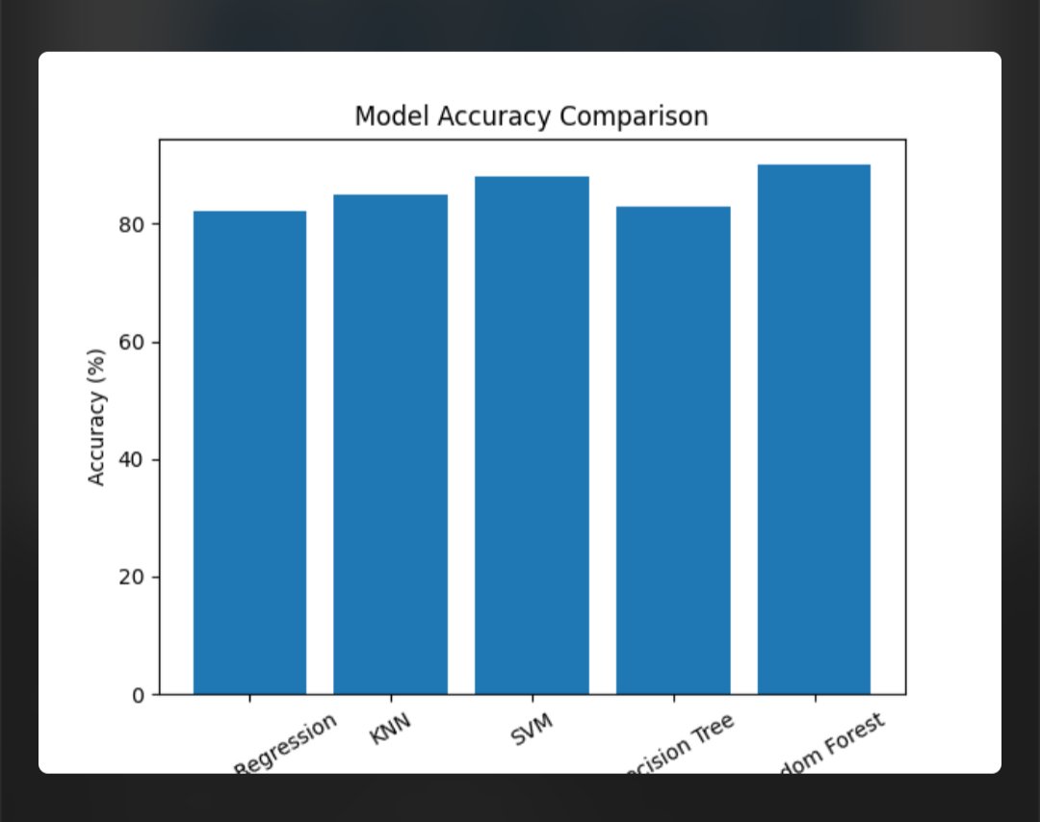

Qualitative Analysis
- Random Forest performed best due to its ensemble nature, which reduces overfitting and improves generalization.
- SVM showed strong performance by effectively separating data using decision boundaries.
- KNN performance depended on the choice of k and scaling of features.
- Decision Tree was easy to interpret but prone to overfitting.
- Logistic Regression was simple and fast but less powerful for complex patterns.
- Comparison with Baseline
- Logistic Regression was used as the baseline model, achieving around 82% accuracy. All other models were compared against this baseline. Both SVM and Random Forest significantly outperformed the baseline, demonstrating the advantage of more advanced algorithms.
- Compared to standard classification approaches used in similar studies, the results are consistent, where ensemble methods and SVM typically provide higher accuracy in customer prediction tasks.
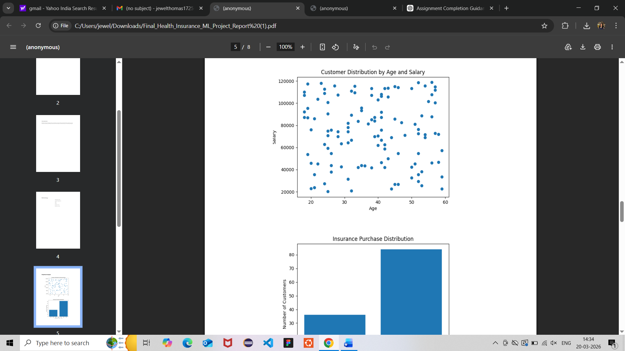
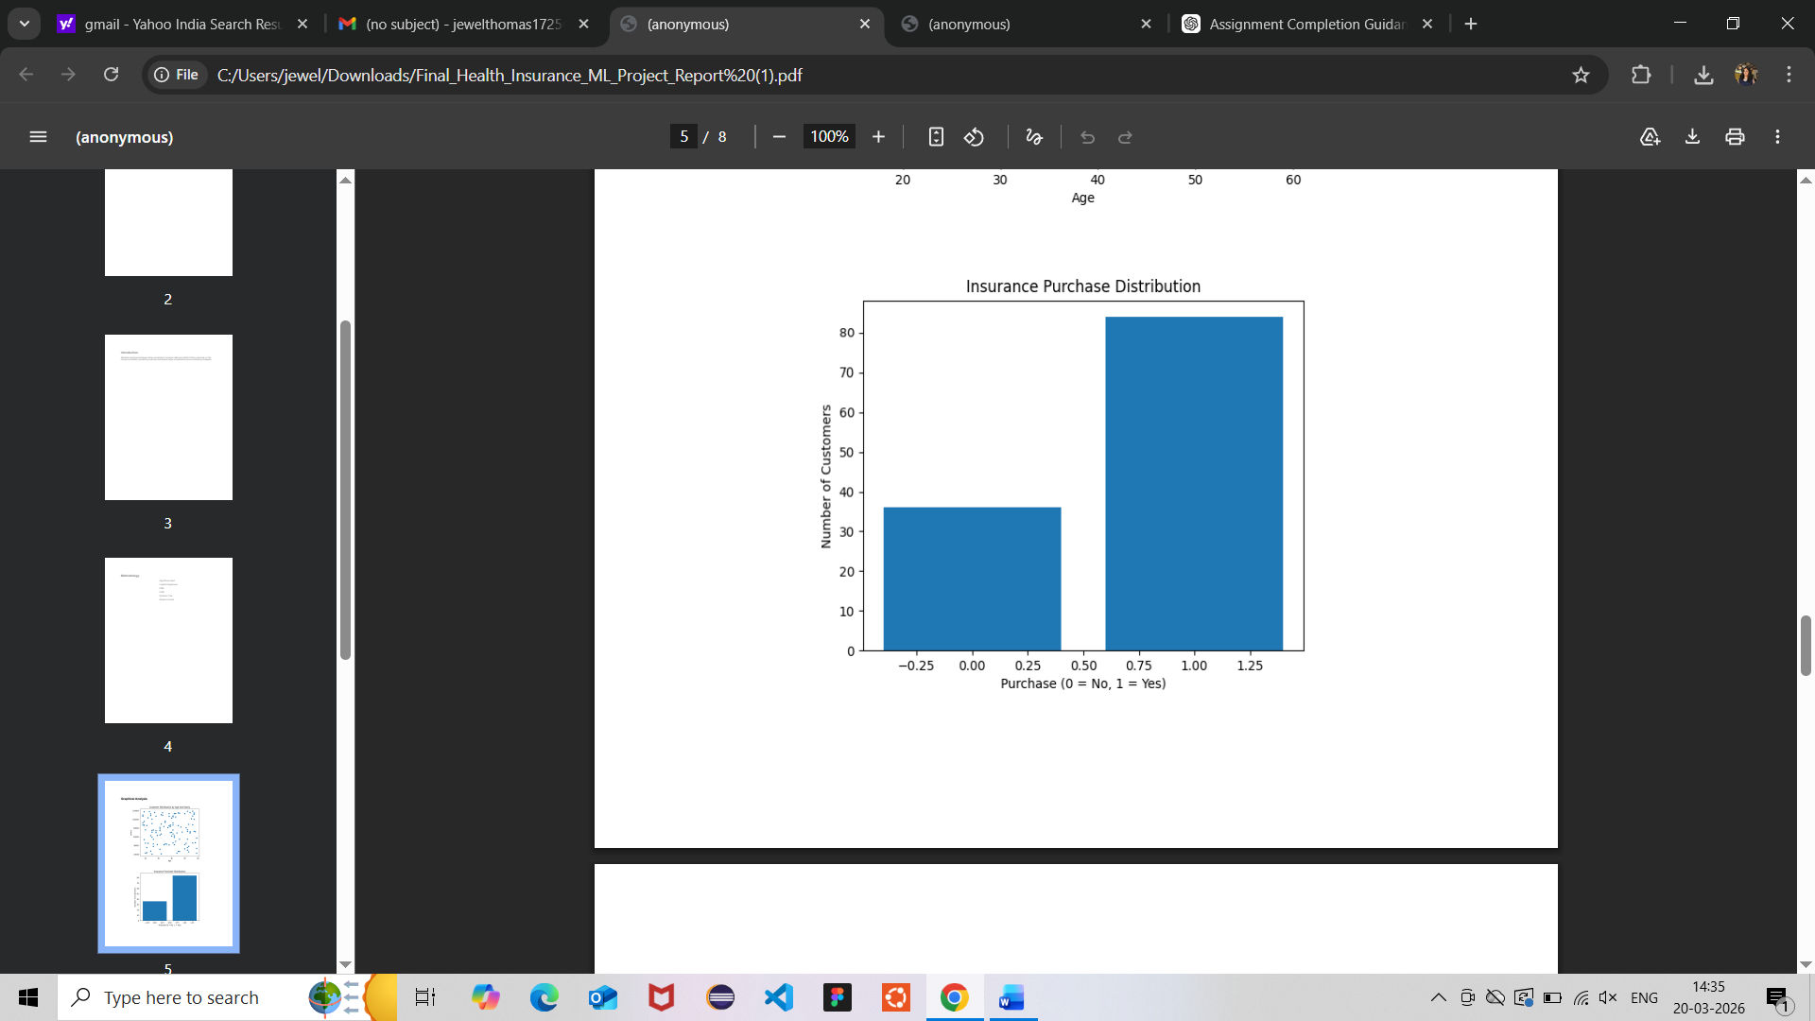
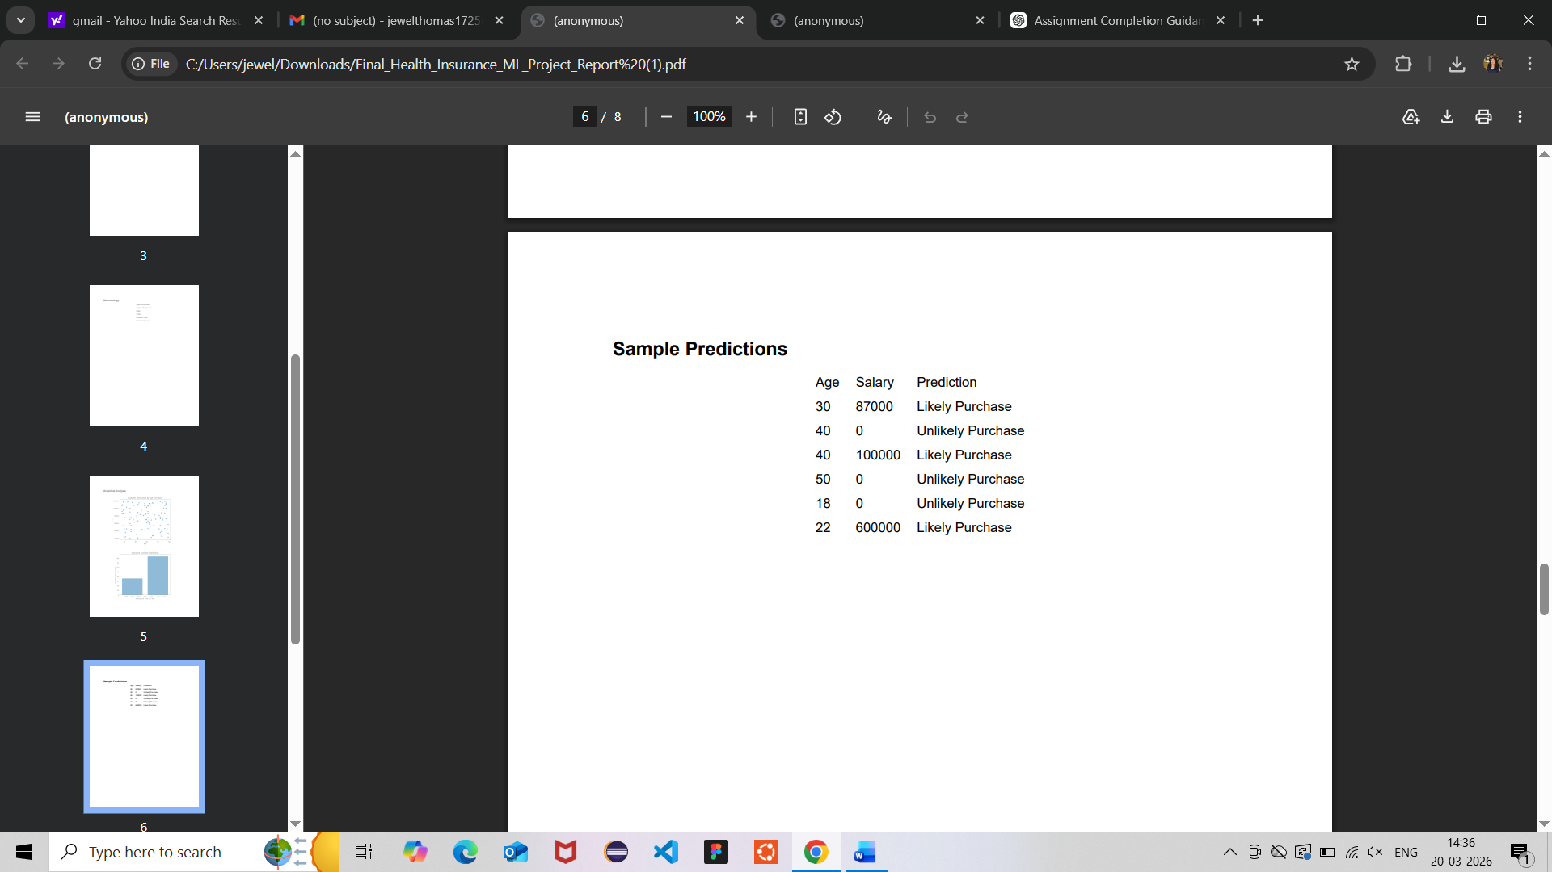

DISCUSSION

Interpretation of Results and Insights
The results show that machine learning algorithms can effectively predict whether a customer will purchase health insurance based on features like age and salary. Among all models, Random Forest achieved the highest accuracy, indicating that ensemble methods are more reliable for this type of classification problem. Support Vector Machine (SVM) also performed well, suggesting that the data can be effectively separated using decision boundaries.
A key insight from the results is that salary has a strong influence on purchasing behavior, as customers with higher income levels are more likely to buy insurance. Age also plays a role, but its impact is comparatively moderate. This indicates that financial capability is a major factor in decision-making.

Unexpected Outcomes
One unexpected observation was that K-Nearest Neighbors (KNN) did not outperform SVM or Random Forest, even though it works well for smaller datasets. This may be due to sensitivity to feature scaling and the choice of the parameter k.
Another observation is that the Decision Tree model showed slightly lower accuracy, which may be due to overfitting on the training data, leading to poorer generalization on test data.

Strengths of the Approach
- Use of multiple algorithms allowed effective comparison and better model selection.
- Application of feature scaling improved the performance of distance-based models like KNN and SVM.
- The model is simple and interpretable, especially with Logistic Regression and Decision Tree.
- The approach can be easily extended to real-world datasets.

Limitations of the Approach
- The dataset contains only limited features (age and salary), which may not fully capture real-world customer behavior.
- The model may not generalize well to more complex datasets without additional features.
- Hyperparameter tuning was limited, which could affect the performance of some models.
- External factors such as customer preferences, health conditions, or market trends were not considered.
CONCLUSION
This project successfully demonstrated the use of machine learning algorithms to predict whether a customer will purchase health insurance based on attributes such as age and salary. Among the models implemented, Random Forest achieved the highest accuracy, followed by Support Vector Machine, indicating that more advanced and ensemble techniques provide better performance for classification tasks. Simpler models like Logistic Regression also delivered reliable baseline results.
The significance of this work lies in its practical application in the insurance industry. By using predictive models, companies can identify potential customers, improve targeted marketing strategies, and optimize resource allocation. This can lead to increased efficiency, higher conversion rates, and better customer satisfaction.
In real-world scenarios, such models can be integrated into customer relationship management systems to support decision-making and personalized marketing.
For future improvements, the model can be enhanced by incorporating additional features such as customer occupation, health history, and lifestyle factors. Advanced techniques like deep learning and more extensive hyperparameter tuning can also be explored. Using larger and more diverse datasets would further improve the model’s accuracy and generalizability.

REFERENCES

References (APA Style)
- Géron, A. (2019). Hands-on machine learning with Scikit-Learn, Keras, and TensorFlow (2nd ed.). O’Reilly Media.
- Pedregosa, F., Varoquaux, G., Gramfort, A., Michel, V., Thirion, B., Grisel, O., … Duchesnay, E. (2011). Scikit-learn: Machine learning in Python. Journal of Machine Learning Research, 12, 2825–2830.
- Bishop, C. M. (2006). Pattern recognition and machine learning. Springer.
- Mitchell, T. M. (1997). Machine learning. McGraw-Hill.
- Han, J., Kamber, M., & Pei, J. (2011). Data mining: Concepts and techniques (3rd ed.). Elsevier.
- Scikit-learn Developers. (2024). Scikit-learn documentation. Retrieved from https://scikit-learn.org
- Kaggle. (n.d.). Insurance dataset for machine learning. Retrieved from https://www.kaggle.com

APPENDICES

Appendix / Supplementary Information

A. Dataset Description
The dataset used in this project contains customer information with the following attributes:
- Age – Represents the age of the customer
- Estimated Salary – Annual income of the customer
- Purchased – Target variable (0 = Not Purchased, 1 = Purchased)
The dataset is relatively small and suitable for demonstrating classification algorithms.

B. Software and Tools Used
- Programming Language: Python
- Libraries: Pandas, NumPy, Matplotlib, Scikit-learn
- Environment: Jupyter Notebook / VS Code / Google Colab

C. Steps to Reproduce the Results
To reproduce the results of this project, follow these steps:
- Install Required Libraries
pip install pandas numpy matplotlib scikit-learn
- Load the Dataset
import pandas as pd
data = pd.read_csv("insurance_data.csv")
- Prepare Features and Target
X = data[['Age', 'EstimatedSalary']]
y = data['Purchased']
- Split the Dataset
from sklearn.model_selection import train_test_split
X_train, X_test, y_train, y_test = train_test_split(X, y, test_size=0.25)
- Apply Feature Scaling
from sklearn.preprocessing import StandardScaler
sc = StandardScaler()
X_train = sc.fit_transform(X_train)
X_test = sc.transform(X_test)
- Train Models
from sklearn.ensemble import RandomForestClassifier
model = RandomForestClassifier(n_estimators=100)
model.fit(X_train, y_train)
- Evaluate the Model
from sklearn.metrics import accuracy_score
y_pred = model.predict(X_test)
print("Accuracy:", accuracy_score(y_test, y_pred))

D. Additional Notes
- Feature scaling is important for algorithms like KNN and SVM.
- Model performance may vary depending on random data splitting.
- Hyperparameter tuning can further improve accuracy.

