Task -1
Project Seva
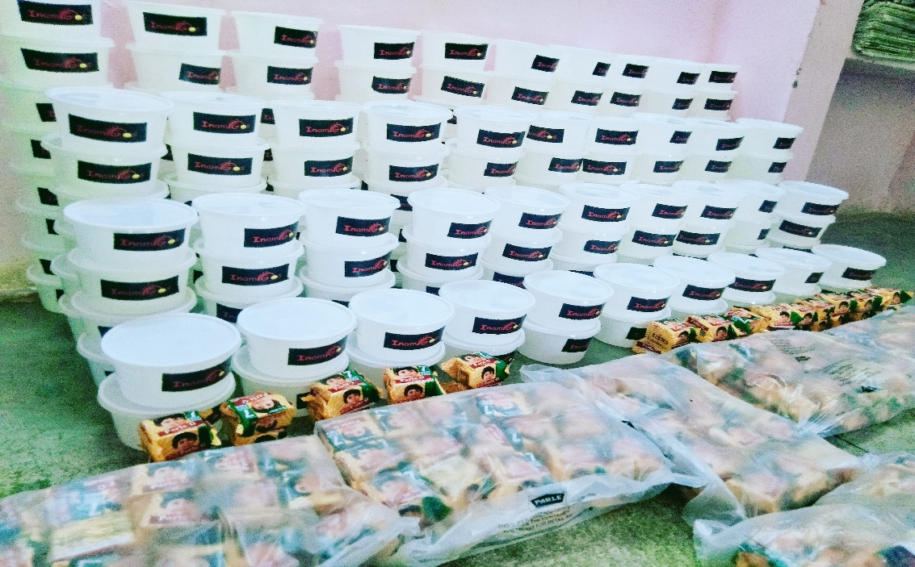
“Where empty plates once held silent cries,
A hand of kindness now softly replies.
In threads of care and meals that heal,
Hope is served -warm, simple , real”
In a world moving at a fast pace, it is easy to overlook the silent struggles of those who lack even the most basic necessities. For many, a proper meal is a luxury, and suitable clothing is a distant dream. This is where Project SEVA by InAmigos Foundation steps in.
Project SEVA is more than just a charity initiative; it is a movement driven by empathy and humanity. The core idea behind this initiative is simple: no individual should suffer from hunger or lack the dignity of basic living. By focusing on food and clothing distribution, the foundation is addressing two of the most essential human needs.
“Feed a soul, fuel a dream”
Hunger is not just a physical condition—it is an emotional and psychological burden. Through organized food distribution drives, Project SEVA ensures that nutritious meals reach those who need them the most. Whether it is daily wage workers struggling to make ends meet, homeless individuals without access to food, or families facing financial hardships, this initiative provides them with a sense of relief and hope. A single meal may seem small, but for someone in need, it can mean everything.

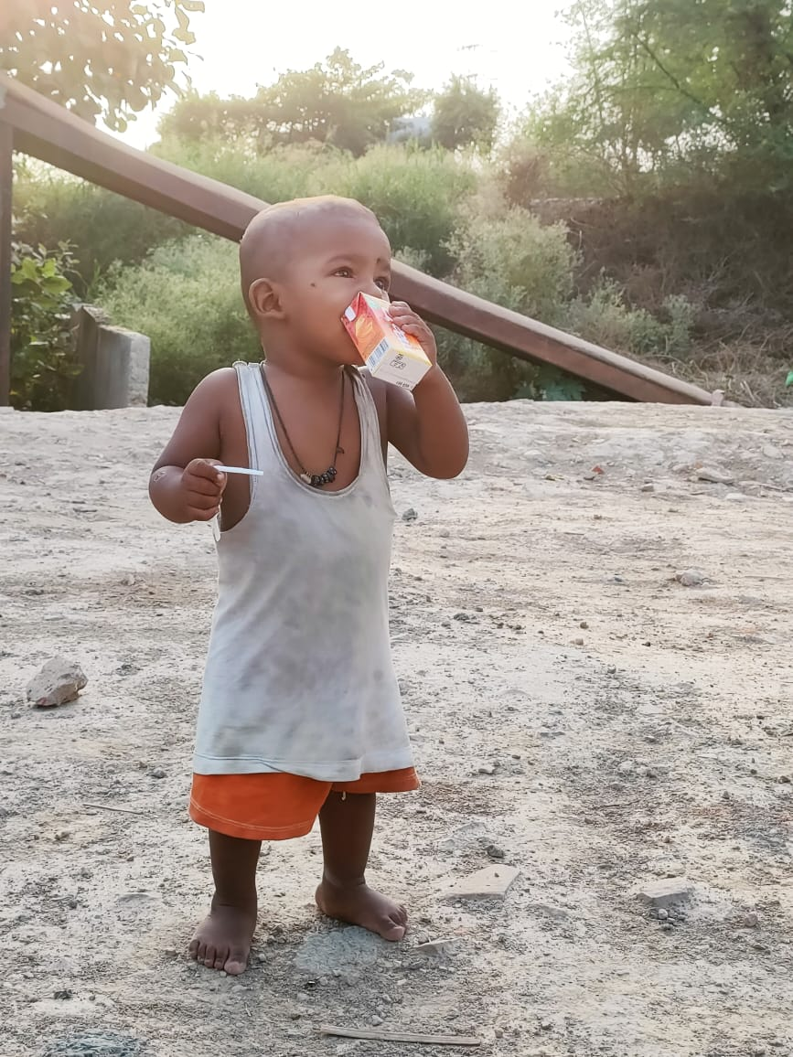
“Clothing bodies, restoring dignity”
Imagine facing harsh weather conditions without proper clothing—it is not just uncomfortable, but also unsafe. Project SEVA conducts clothing drives where wearable garments are collected and distributed to the underprivileged. These efforts ensure that people not only stay protected but also regain a sense of confidence and self-worth.
What makes Project SEVA truly impactful is the spirit of community involvement. Volunteers, donors, and supporters come together with a shared purpose—to make a difference. Every contribution, no matter how small, adds value to the mission. Whether it is donating clothes, sponsoring meals, or spreading awareness, each act becomes a step towards a kinder society.
Moreover, such initiatives highlight an important truth: real change begins with collective effort. Governments and organizations alone cannot solve every problem. It requires individuals to come forward, contribute, and take responsibility for the community around them. Project SEVA provides the perfect platform for people to do exactly that.
InAmigos Foundation, through this initiative, is not just providing temporary relief—it is restoring hope. It shows that even in difficult times, there are people who care, who are willing to help, and who believe in making the world a better place.

Call to Action
We have the power to make a difference. Support Project SEVA by donating food, clothes, or your time. Share the message, spread awareness, and become a part of this mission to fight hunger and bring dignity to lives.
Because in the end, it’s not about how much we give—it’s about how many lives we touch.
The beauty of this initiative lies in its ability to inspire others. It reminds us that kindness is contagious. When one person takes a step to help, it encourages many more to follow. Project SEVA is not just changing lives directly—it is creating a ripple effect of compassion and responsibility.

#FoodForNeedy #ClothingDrive #HelpingHands #SupportTheCause #DonateForGood #CharityMatters #EndHunger #InAmigosFoundation #IAF #ProjectSEWA #IAFHelpingHands

