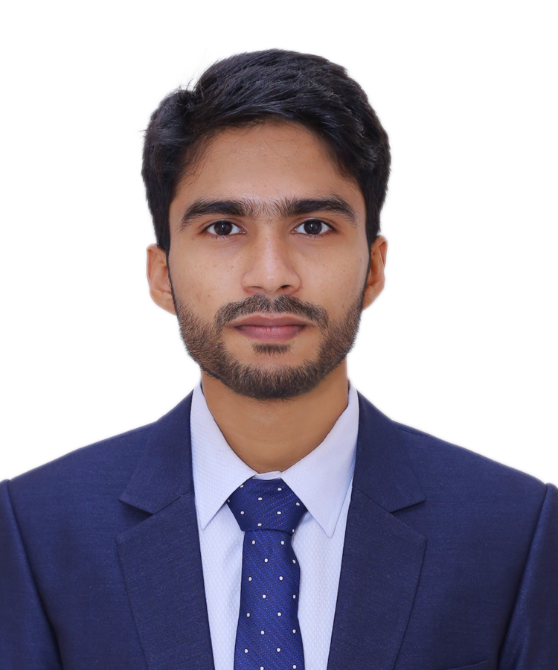
Resume

of

Md. Ariful Islam

Current & Permanent Address: Paloan Bari, Guli Nobipur Road, Ward 9, Dhonia Union, Bhola Sadar, Bhola-8300.

Contact No.:

+8801718501456

+8801811113456

Email: arifbusoc@gmail.com

islamarif1971@gmail.com

LinkedIn Link: https://www.linkedin.com/in/islam-md-ariful/

Objective:

Look forward to establishing myself in a vibrant organization where I will be able to fully utilize my knowledge skills and abilities through challenges, hard work, and dynamism.

Education:

Master of Social Science (MSS)

• | Subject | : Sociology
• | Session | : 2018-2019
• | Result | : CGPA- 3.26
• | Institution | : University of Barishal

Bachelor of Social Science (BSS)

• | Subject | : Sociology
• | Session | : 2014-2015
• | Result | : CGPA- 3.06
• | Institution | : University of Barishal

Higher Secondary Certificate (HSC)

• | Group | : Business Studies
• | Passing year | 2013
• | Result | : GPA- 5.00
• | Board | : Barishal

Secondary School Certificate (SSC)

• | Group | : Business Studies
• | Passing year | 2011
• | Result | : GPA- 4.69
• | Board | : Barishal

Personal Skills:

- Have the ability to work under pressure. 
- Able to work independently as a team member. 

- Good interpersonal communication skills. 
- Ability to work in a stressful outdoor working environment 

Writing Skills:

- Have writing experience in several Bengali and English dailies. 

Computer Skills:
- MS Word, MS Excel, SPSS, and Internet Browsing.

Work Experiences:

- I have worked with Spectra Engineers Limited, SM BK Project in the capacity of Store Keeper for the period of two months from April 2021 to May 2021.

- I have worked with Argus Metals (Pvt.) Ltd. in the capacity of Junior Officer for a period of one year and three months from July 2013 to October 2014.

- I have worked as a fellow researcher on The Perception against Gender-based Violence of Boys and Men: A Sociological Study to Establish Gender Justice and Violence Free environment for Women and Children in Barishal Zone. The fellowship was delivered by the collaboration of BRAC and Protiki Jubo Sangsad.

- I have worked as Campus Coordinator of YRF (Young Researchers Fund) a project designed and executed by OSO (Organization for Social Orientation).

- I have Collected data as a volunteer with Dr. Tareq Mahamud Abir on his article

Understanding the Situations of ‘Climate Refugees’ in the Coastal Areas of Bangladesh in the Chandpur district region under the thesis program of Central China Normal University, Hubei, China.

- I have worked as a Qualitative Research Assistant & data enumerator in mid-line evaluation on The Development of Demand Creation Strategy for the WASH Alliance International sub-programme WASH SDG conducted by Userhub in the Barguna district region.

- I have successfully completed my research monograph on Sorry Tale of Guava Cultivators at Barishal: A Study on Livelihood Assets in 2019.
Training and workshops:

- I have participated in a Workshop on the Climate Game, organized by mekateam and EMK center, held on January 29 & 30, 2022.

- I have been trained up on Law Appreciation Course: Basic Training for Paralegals from December 10th to December 12^{th,} 2018. The course was hosted by the MOVE (Motivate and Organize Voluntary Engagement) Foundation in collaboration with the Center for Peace & Justice of BRAC University at BRAC LearningCentre, Barishal.

- I have participated in Zero Hunger, Zero Emissions University Workshop from September 1st to September 3^{rd,} 2018. The workshop was hosted by International Centre for Climate Change and Development (ICCCAD) as part of a project organized by the Environmental Change Institute at the University of Oxford, Oxfam GB, Oxfam BD, and ICCCAD.

- I have completed the training course on Entrepreneurship Development Programme held from 29-12-2019 to 31-12-2019 Organized by Industrial Service Centre BSCIC, Barishal.

- I have participated in the International Conference on Sustainable Blue Economy for the Development of Bangladesh organized by the Department of Oceanography, University of Dhaka, GreenTech Foundation Bangladesh, Blue Economy Cell, Ministry of Energy, Power & Mineral Resources, and Bangladesh Institute of Maritime Research & Development (BIMRAD), at Nawab Ali Chowdhury Senet Bhaban, University of Dhaka, on April 24, 2019.

- I have participated as a Delegate in the UNYSAB Diplomatic Assembly 2018, University of Barishal representing Pakistan in the United Nations Educational, Scientific and Cultural Organization.

- I have participated in the Bangladesh Youth Symposium held at Bangladesh University of Engineering and Technology (BUET) organized by Youth School for Social Entrepreneurs (YSSE) on 9th November 2018.

- I have participated in the Deshtake Porishkar Kori Dibos 2016 as a volunteer at Barishal City Corporation area organized by Poriborton Chai on 6th February 2016.

Language skill:

Language |  | Reading |  | Writing |  | Speaking
English |  | High | Standard |  |  | Standard
Bangla |  | High | Standard |  |  | High

Hobbies:

- Gardening, playing indoor and outdoor games, Watching movies & Television series.

Personal Details:

• | Father’s Name | : Abdul Barek
• | Mother’s Name | : Rehana Begum
• | Date of Birth | : 21st February 1996.
• | Religion | : Islam
• | Nationality | : Bangladeshi

- Νατιοναλ ΙΔ Νο. : 554 388 4570
• | Passport No. | : A00163942
• | Blood Group | : A+
• | Sex | : Male
• | Marital Status | : Married

Declaration:

I do honorably declare that the above information is true and correct to the best of my knowledge.
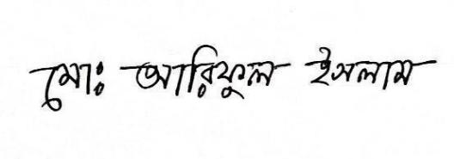

References:

Dr. Tareq Mahamud Abir | Eashrat Jahan Eyemoon
Chairman and Assistant Professor, | Lecturer,
Department of Sociology, | Department of Sociology,
University of Barishal. | University of Dhaka.
Cell Phone: +8801677746247 | Cell phone: +8801927473817

Email: abirsocbu2016@yahoo.com _{Email: eyemoonsoc@du.ac.bd}

