Training Syllubus_C++

- Difference between procedural oriented programming and object oriented programming
- Tokens, expressions and control structures in C++
  - Built in data types and user defined data types
  - Reference variables - example to demonstrate call by reference and return by reference.
  - Operators
- Functions
  - Functions
  - Overloading
  - Default arguments
  - Constant arguments
  - Inline functions
  - Brief about static and Virtual functions
- Learn OOPS concepts with examples (learn benefits and application of each concept).
  - Classes and Objects
  - Data abstraction
  - Encapsulation
  - Inheritance
  - More on Class
    - Constructor and Destructor
    - Use of Copy constructor
    - Use of new and delete
    - this pointer concept
    - Static members and Static methods
    - Array of objects
Create a class to hold “n” number of employee details and display it based on the designation. The properties for employee are name, age, designation and salary (Hint: Array of objects)
  - Polymorphism
    - Compile Time / Static polymorphism
      - Method overloading
Create a class to calculate the volume of Circle, Cube and Rectangle (Hint: The method “Volume” should be overloaded).
      - Constructor overloading
Modify the above program using constructor overloading
      - Operator overloading
Create a class called Complex (which holds the real and imaginary part as properties) to hold a complex number. Overload the operator “+” so that we can add two Complex instance like C3 = C1 + C2, C1 + C2

    - Runtime / Dynamic polymorphism
      - About virtual functions
      - An example to demonstrate Runtime polymorphism
Create a base class “IShape” with should have a pure virtual functions ‘ReadData() and DrawShape()’.
Derive three classes “CTriangle”, “CCircle” and “CRectangle” from “IShape”.
Three of them need to implement the ReadData() and DrawShape() methods.
ReadData() should read the dimensions to compute area of the shape.

Design a menu driven program to select items and display shapes.
- Menu shall have following options
        - Exit
        - Triangle
        - Circle
        - Rectangle
        - Draw selected shapes
- Up on selecting any shape, it should ask for the dimensions for area calculation. And store it in to an array.
- After selecting a number of objects, when user choose 4th option. It should display all the selected shapes with its area
Eg :
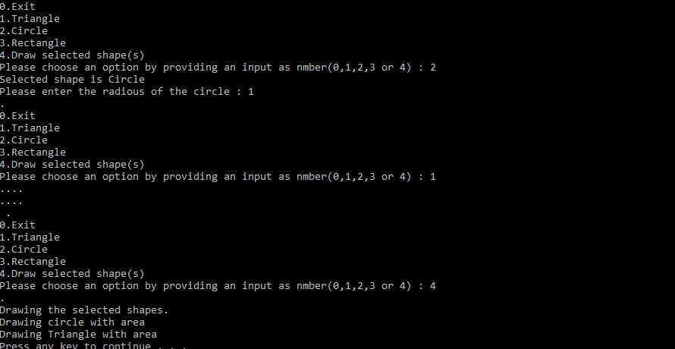
Hint :
        - Pointer to object
        - Array of pointers to object
        - Use of this pointer
        - Base pointer

- More about classes and functions
  - Friend functions
  - Friend class

- Consider a bank maintains two types of account “Savings” and “Current”. The Saving account provides compound interest and withdrawal facilities; the current account has no interest facilities. Current account holder should also maintain a min balance. Any withdrawal less than the limit will be imposed additional charge.
Create a class “Account” which stores customer name, account number, account type.
Derive classes “Savings” and “Current” from Account to make them more specific to requirement. (Hint: Inheritance, use constructors for initializing etc). Following features should be there
  - Accept deposit and update balance.
  - Display balance
  - Calculate interest
  - withdrawal
- Working with files. (Hint: file operations must be executed from a class)
Write a program to hold the details of students details.
Student – Name, Gender, Course, DateOfJoin
- Provide option to Enter the details
- View
- Save the details
- Retrieve them back when application restarts.

- Learn Templates in C++.
- Learn Exception handling and implement proper exception handling in question 17.

