Chapter 4: Results and Discussion
This chapter reports every result obtained so far on the Weather Adaptive ANPR System. It follows the pipeline: plate detection, weather restoration, plate recognition, and video and real-time operation. All experiments were run on a laptop with an NVIDIA RTX 4060 GPU. Accuracy on plates was judged against hand-checked plate text; for traffic videos the true plate text was read by eye from the saved crops of each tracked plate, so these figures are manual counts, not an automatic benchmark.

4.1 Data and Metrics
Table 4.1 lists the data used in each stage.
Table 4.1: Data used in each stage
Data | Size | Used for
Licence-plate detection set (Kaggle, YOLO format) | 15,000+ images | Training and validating the plate detector
Foggy-Hazy License Plates (Mendeley) | 1,001 clear/hazy pairs | Comparing DCP, neural network and CLAHE; fine-tuning the dehazing network
Foggy Cityscapes | 8,925 training and 200 validation pairs | Training the learned dehazing network
RESIDE-β OTS | 2,061 clear images, 72,136 hazy variants | Fine-tuning the dehazing network
NH-HAZE | 55 real fog pairs | Fine-tuning the dehazing network
Hand-labelled plate scenes (project dataset) | 218 scenes, about 197 distinct plates, about 1,930 pairs | EasyOCR baseline; LPRNet training
CCPD2019 | 355,013 images extracted, 40,000 used | LPRNet pretraining
Zenodo plate set | about 1,355 plate pairs | LPRNet fine-tuning
Own Kerala photos and traffic videos | photo sets, 5 videos (set 14), 12 videos (set 15: 6 train, 6 test) | Training, labelling and testing the reader
Labelled video crops | 4,926 crops (114 plates) and 1,850 crops (93 plates) | Training the reader on real traffic footage

Metrics. Detection is reported as precision, recall and mAP at IoU 0.5 (mAP@50) and 0.5–0.95. Dehazing quality is reported as PSNR against the clear image. Recognition is reported as exact-match accuracy (the whole plate is correct) and character error rate (CER, the edit distance between prediction and truth divided by plate length). Real-time performance is reported in frames processed per second.

4.2 Plate Detection
A YOLOv11n detector was trained on the 15,000-image licence-plate set for 100 epochs. Training and validation losses fell steadily and the validation metrics levelled off (Figure 4.1). The final model reached a precision of 98.5 %, a recall of 99.0 %, a mAP@50 of 99.2 % and a mAP@50–95 of 85.6 % on the validation set (Table 4.2). The normalised confusion matrix (Figure 4.2) shows that 99 % of plates were found and about 1 % of background regions were wrongly detected.
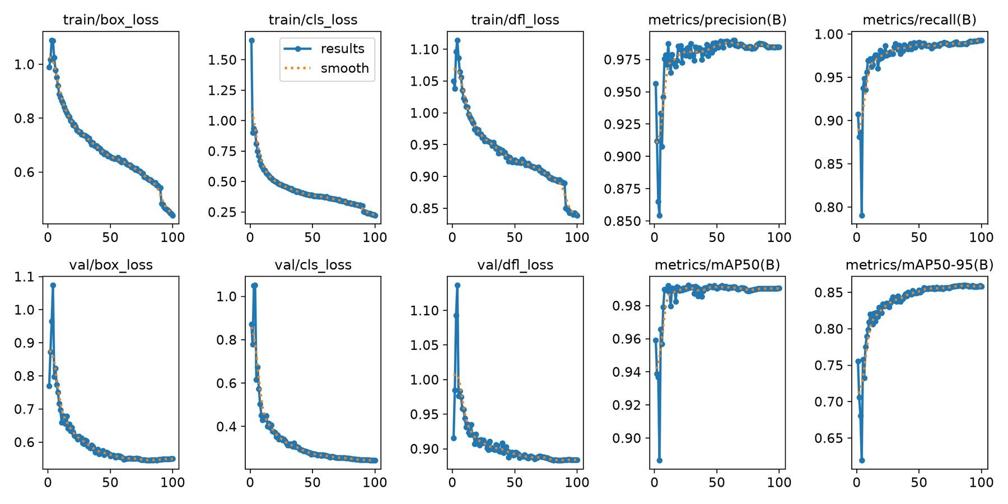
Figure 4.1: Training and validation curves of the YOLOv11n plate detector
Table 4.2: Plate detector results
Metric | Validation result
Precision | 98.5 %
Recall | 99.0 %
mAP@50 | 99.2 %
mAP@50–95 | 85.6 %

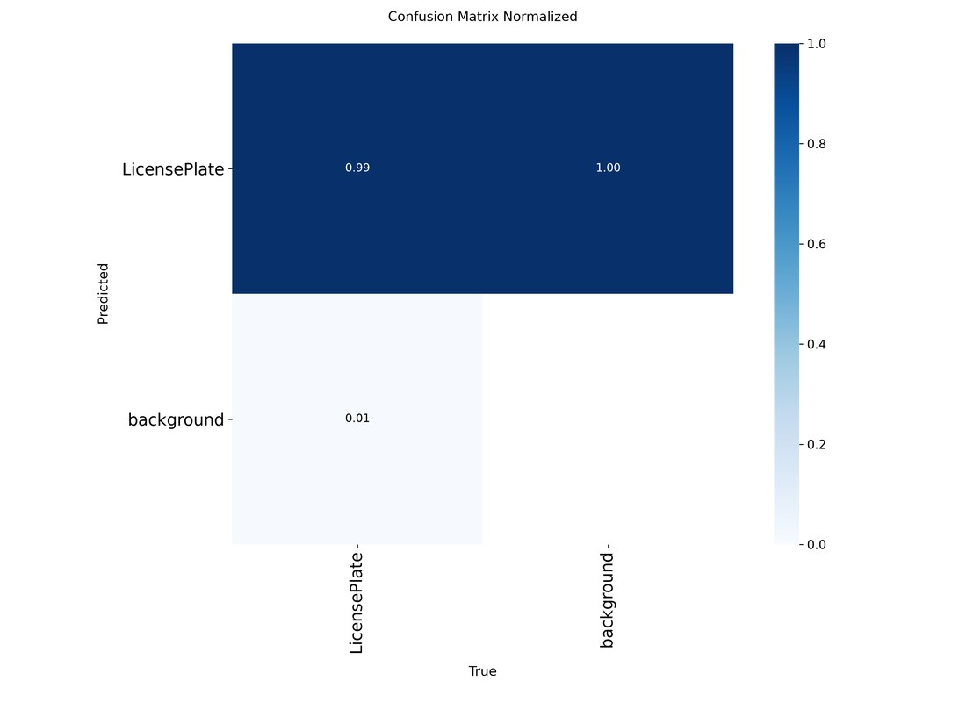
Figure 4.2: Normalised confusion matrix of the plate detector
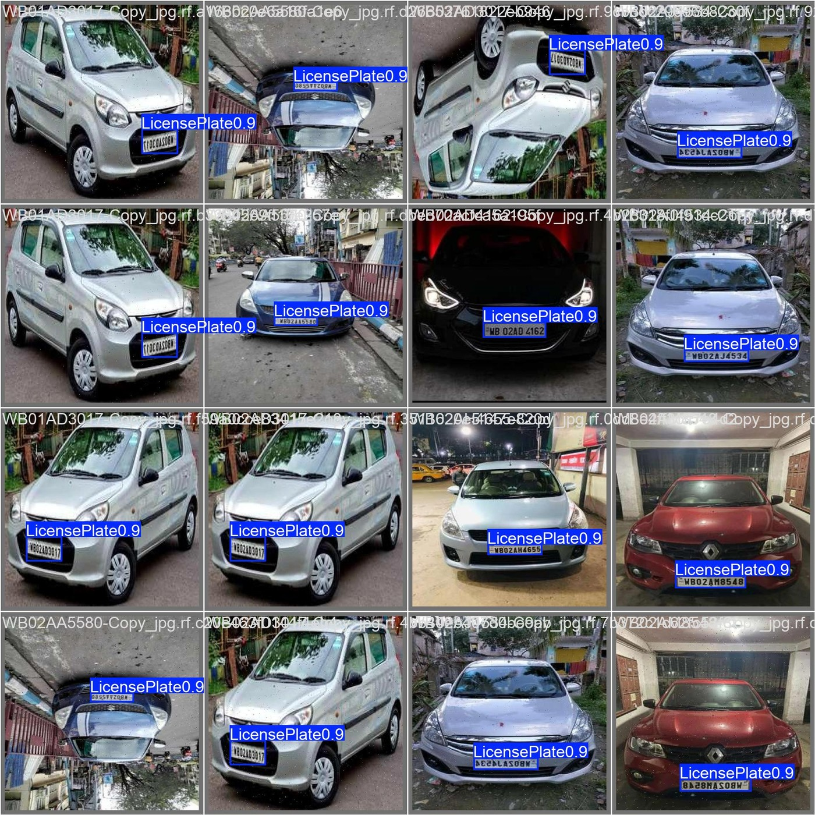
Figure 4.3: Detector predictions on validation images (confidence about 0.9 on every plate)
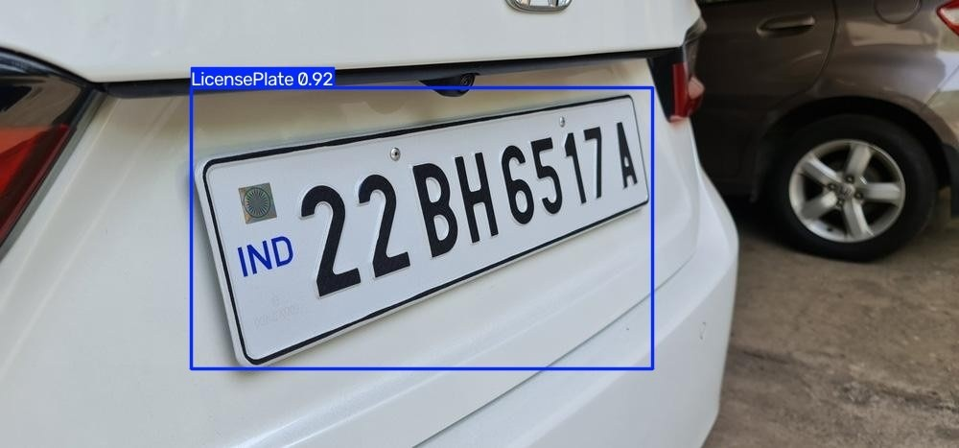
Figure 4.4: Detection of an Indian plate on a clear photograph (confidence 0.92)

Detector fine-tuning on traffic footage
On roadside video the plates are much smaller than in the training set, so a second model was fine-tuned at 1280 px for 30 epochs on 65 hand-corrected traffic frames, 3,000 images of the original set and a 525-image small-plate set. On 23 hand-labelled frames of one test video its recall rose from 74 % to 87 % at 640 px (the original model at 1280 px reached 84 %), and 13 of 20 small plates were found against 9 before; precision stayed at 94 % at confidence 0.5. It was not adopted, because the recognition network read fewer plates correctly with its boxes (15 of 27, against 20 of 27 with the original detector). The original detector therefore remains in use.

4.3 Weather Restoration

4.3.1 Comparison of DCP, the neural network and CLAHE
Three restoration methods were compared on the 1,001-image Foggy-Hazy plate set and on one real foggy road photograph. Every result is the actual EasyOCR reading of the output, not a visual impression.
Dark Channel Prior (DCP). On mild haze DCP helped: the confidence of the plate reading rose from 0.227 to 0.336 (about 48 % relative) and the text came out cleaner (Figure 4.5). On dense, nearly uniform fog it failed. With gentle settings the output was identical to the input (mean confidence 0.326 for both), and with stronger settings (ω = 0.6, t_min = 0.10) the whole frame collapsed to white (Figure 4.6).
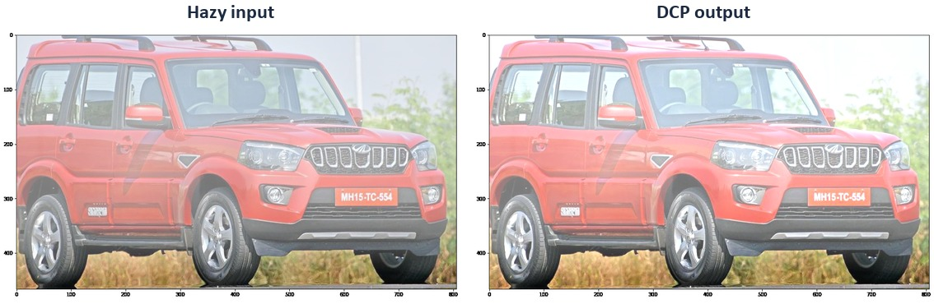
Figure 4.5: DCP on mild haze: plate reading “Mh1s TC 554” (0.227) became “Mh1s-TC 554” (0.336)
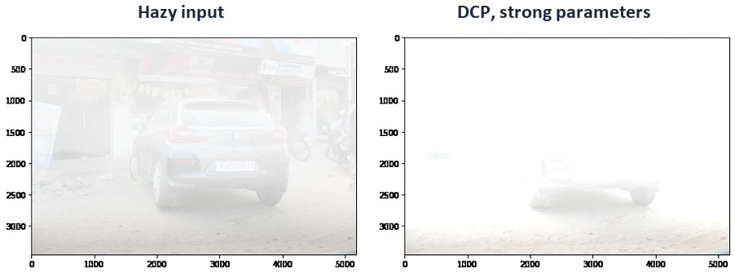
Figure 4.6: DCP on dense haze with strong settings collapses the frame to white
Neural network. A transformer U-Net trained on synthetic hazy/clear pairs gave the cleanest-looking reconstruction of the car, but it smoothed away the fine edges that OCR needs. Its mean OCR confidence was 0.104 against 0.326 for the hazy input, and its readings were fragments such as “Wui” and “Www” (Figure 4.7).
CLAHE. Contrast-limited adaptive histogram equalisation was the only method that recovered a plate where the input and DCP gave nothing: “KL 55R 2473” at confidence 0.774 (Figure 4.8). It was not consistent: on the mild-haze photograph it made the plate reading worse (0.227 to 0.097, Figure 4.9), and on the real foggy road photograph the scene contrast improved but the plate, only about 33 px tall and optically blurred, stayed unreadable (Figure 4.10).
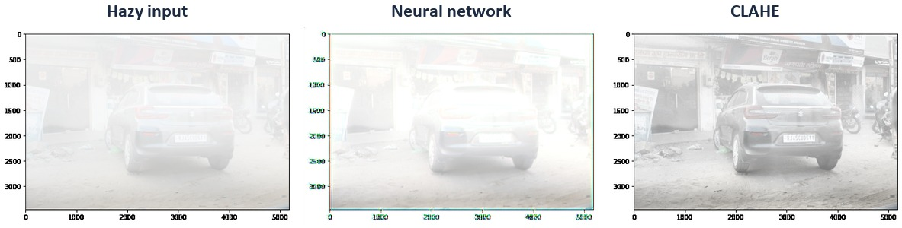
Figure 4.7: The same dense-haze frame: hazy input, neural network output and CLAHE output
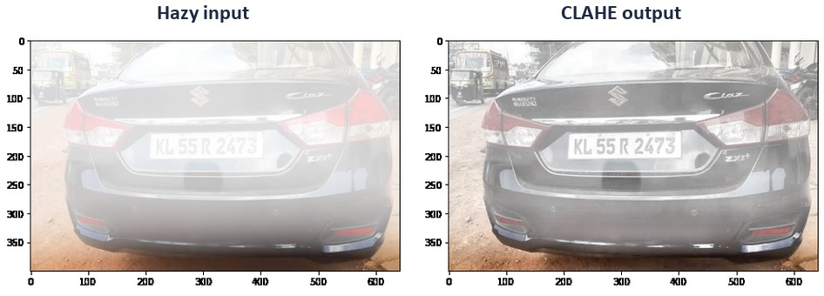
Figure 4.8: CLAHE recovered the plate “KL 55R 2473” (confidence 0.774); the input and DCP found no plate
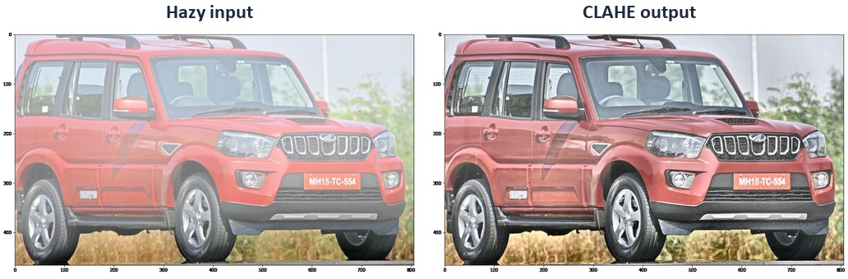
Figure 4.9: CLAHE made the plate reading worse (0.227 to 0.097)
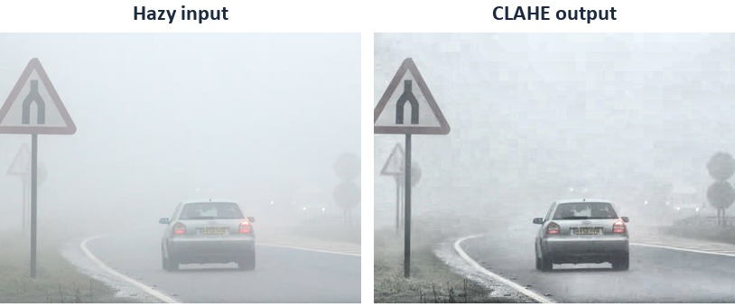
Figure 4.10: Real foggy road photo: scene contrast improves, the plate remains unreadable
Table 4.3: OCR confidence of the plate reading (mean confidence where no plate was found)
Example | Input | DCP | Neural | CLAHE
Mild haze (plate) | 0.227 | 0.336 | – | 0.097
Dense haze (mean) | 0.326 | 0.326 | 0.104 | 0.313
Moderate haze (plate) | not found | not found | – | 0.774
Heavy fog, other scene | not found | not found | – | not found
Real photo (heavyfog2) | not found | – | – | not found

Over 20 randomly sampled images (all detected text) the mean OCR confidence was 0.309 for the hazy input, 0.326 for DCP, 0.114 for the neural network and 0.320 for CLAHE. No method was best on every image. CLAHE was the fastest (about 1.3 ms per image against about 17 ms for DCP), needed no tuning (the same clip limit and tile size were used on every example) and never failed catastrophically, so it was chosen for the batch pipeline. Failures that come from low resolution or optical blur cannot be fixed by any contrast method.

4.3.2 Learned dehazing network (UVMNet)
A Mamba-based U-Net dehazing network (UVMNet) was trained in stages. Pre-training on 8,925 Foggy Cityscapes pairs for 50 epochs raised the validation PSNR from 22.95 dB to a best of 32.96 dB (epoch 42), with no sign of overfitting. On domain-matched validation images the output had no colour cast (brightness ratio 0.98 against the ground truth, PSNR 28.08 dB over 100 images). On out-of-domain real photographs it produced a green tint and kept only about 46 % of the true brightness. Fine-tuning on plate crops with a combined loss (Charbonnier, gradient and residual regularisation) and a physically exact haze-density augmentation raised brightness retention on real Foggy Driving photographs from 46 % to 70 %. Fine-tuning on a mixture of plate photographs, RESIDE-β OTS and NH-HAZE gave the final checkpoint (Table 4.4); 9 of 10 real test photographs came out clean with legible plates (Figures 4.11 and 4.12).
Table 4.4: Training runs of the learned dehazing network (PSNR is measured on different validation sets)
Run | Data | Best validation PSNR | Outcome
Pre-training | Foggy Cityscapes, 50 epochs | 32.96 dB | Healthy convergence; green cast out of domain
Plate fine-tune | Plate crops with density augmentation | about 22 dB | Brightness retention 46 % to 70 %
Combined, first run | OTS + plates + NH-HAZE (NH-HAZE repeated 20×) | 28.99 dB (epoch 9) | Validation broke after a BatchNorm corruption bug
Combined, final | OTS + plates + NH-HAZE (repeated 8×) | 27.22 dB (epoch 32) | Production checkpoint
Low-light augmentation | Final data plus synthetic dusk | 26.33 dB (epoch 33) | Did not fix the dusk photo
CLAHE then network | CLAHE-preprocessed input | 16–19 dB | Did not converge; abandoned

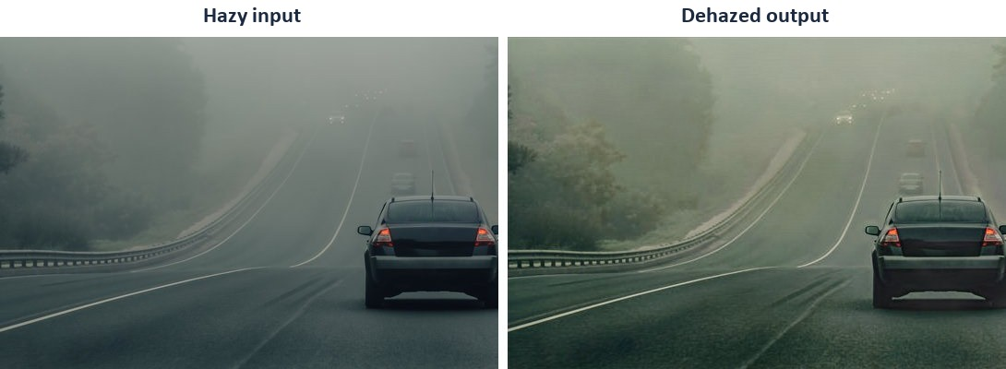
Figure 4.11: Foggy road scene before and after the learned dehazing network
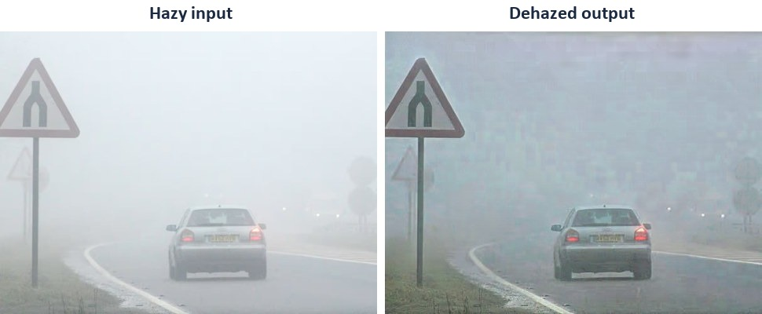
Figure 4.12: Dense fog: the sign, road markings and car are recovered
Several problems were found and fixed during these runs: slow dataset indexing over the Windows file system, visible seams between tiles (fixed by feathered blending), tiny images being padded to a full tile (fixed by padding only to a multiple of 16), validation turning to NaN from a single unstable batch (fixed by restoring BatchNorm statistics and validating in full precision), and training slowdowns caused by cloud-folder syncing (fixed by moving the project off the synced folder). A final dispatcher routes each image by its local contrast: images with a grey-level standard deviation below 24 go to CLAHE and all others to the network. On the 1,006 unique images of the collection, 1,005 were routed to the network and one to CLAHE. One dusk photograph with dense uniform fog remained unrecoverable by every method, because its plate region holds no signal.

4.4 Plate Recognition

4.4.1 EasyOCR baseline
EasyOCR was first used to read the plates. On the 218 hand-labelled scenes, with weather added in four strengths each for fog and rain, it read only 16.5–25.2 % of plates exactly in fog and 5.9–11.0 % in rain, with character error rates up to 0.61 in fog and 0.74 in rain (Table 4.5, Figure 4.13). It also confused characters such as 1 and I, and 7 and Z, even on clear, undistorted plates, and misread a plate “BKWL324” as “JBKHL:324” under light fog (Figure 4.14). Dehazing could not fix this, which is why a plate-specific reader was built.
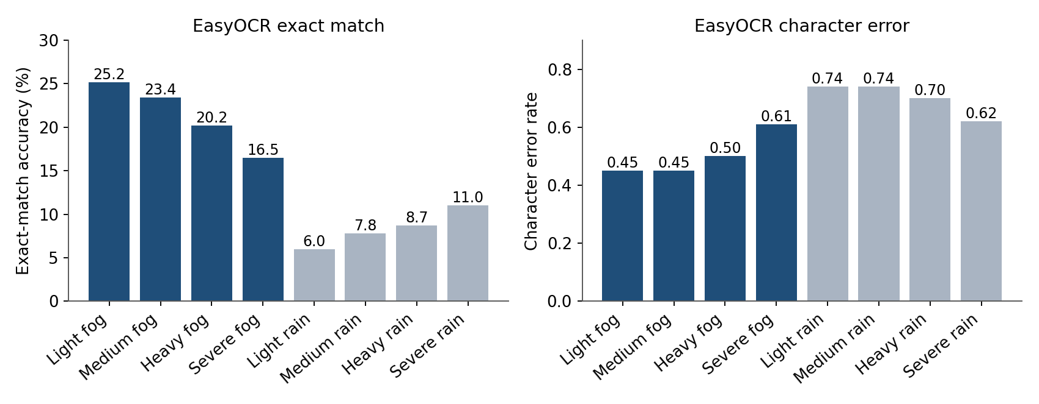
Figure 4.13: EasyOCR accuracy and character error by weather condition (218 plates per condition)
Table 4.5: EasyOCR baseline
Condition | Exact match | Character error | Plates
Light fog | 25.2 % | 0.45 | 218
Medium fog | 23.4 % | 0.45 | 218
Heavy fog | 20.2 % | 0.50 | 218
Severe fog | 16.5 % | 0.61 | 218
Light rain | 6.0 % | 0.74 | 218
Medium rain | 7.8 % | 0.74 | 218
Heavy rain | 8.7 % | 0.70 | 218
Severe rain | 11.0 % | 0.62 | 218

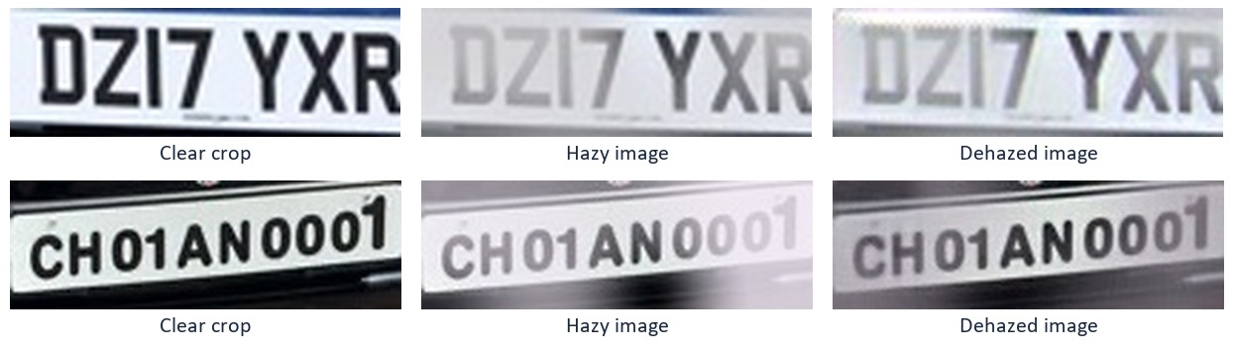
Figure 4.14: Clear, hazy and dehazed crops used to examine EasyOCR misreadings

4.4.2 LPRNet training
LPRNet, a convolutional network with CTC loss that reads the whole plate in one pass from a 200 × 24 input, was trained on the alphabet A–Z and 0–9. Trained from scratch on the 218 labelled scenes it overfitted badly: the training loss fell to 0.32 but the validation exact match stayed at 0–6 % with a character error of 0.70, because the data held only about 197 distinct plates. Pretraining on synthetic plates (30,000 random plates per epoch) raised the synthetic validation accuracy from 78.5 % to 99.5 %, which showed that the network itself was sound and that data diversity was the limit. Fine-tuning from the pretrained weights on the real plates gave 34–37 % exact match and a character error of 0.32. Mixing synthetic plates into fine-tuning and adding 40,000 CCPD images reduced the character error to 0.249 (44 % exact match) (Figure 4.15, Table 4.6).
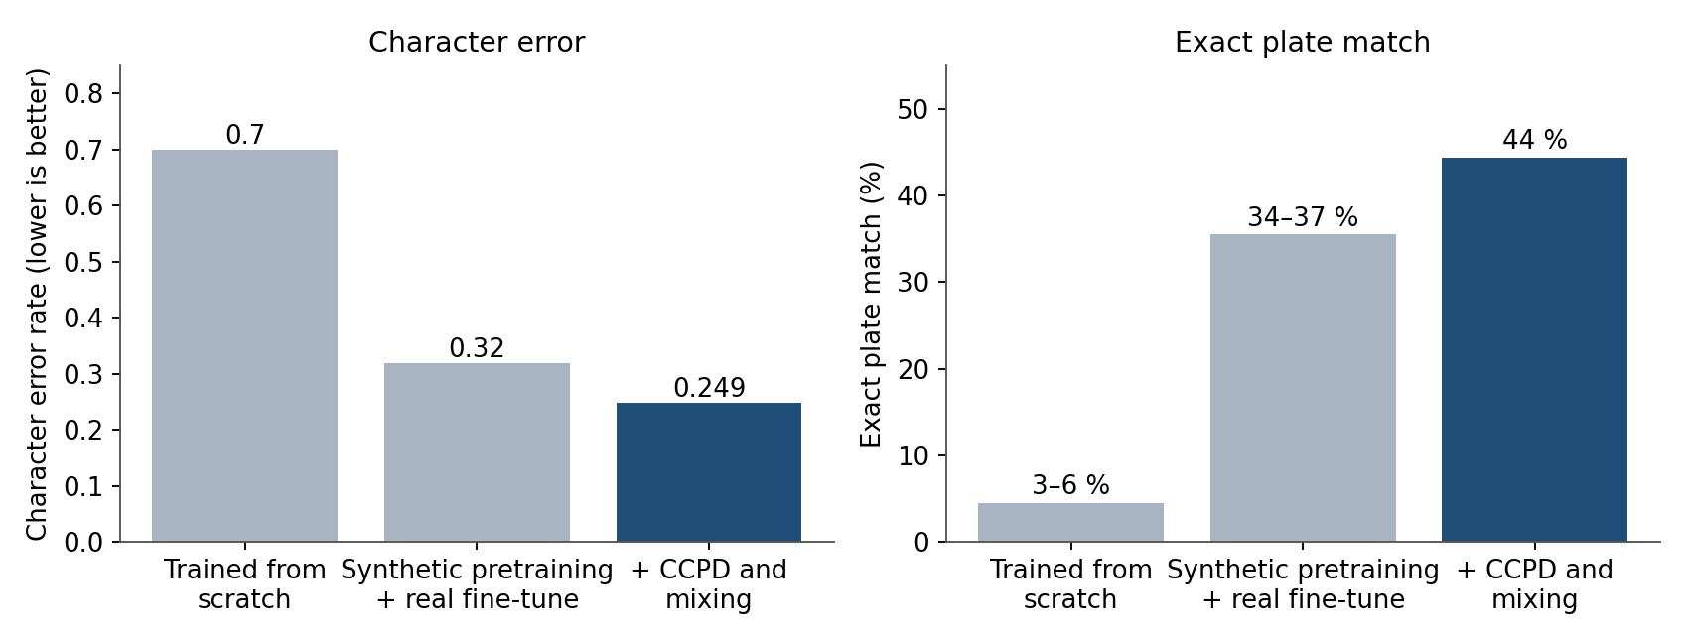
Figure 4.15: LPRNet character error and exact match on 21 held-out scenes
Table 4.6: LPRNet progress on the held-out scenes
Training stage | Exact match | Character error | Validation set
Trained from scratch | 3–6 % | 0.70 | 21 scenes
Synthetic pretraining, then real fine-tune | 34–37 % | 0.32 | 21 scenes
+ synthetic mixing and CCPD | 44 % | 0.249 | 21 scenes

4.4.3 Effect of dehazing on recognition
The full pipeline was tested on the held-out scenes under three input conditions (Table 4.7). Reading the raw hazy crop gave 40.5 % exact match, higher than reading the dehazed crop (36.3 %). The reader had been trained only on raw crops, so dehazed images were an unfamiliar input. Dehazing on its own therefore does not raise recognition accuracy; the reader must also be trained on the images it will see.
Table 4.7: Recognition with and without dehazing
Input to LPRNet | Images | Exact match | Character error
Raw hazy crop | 168 | 40.48 % | 0.3121
Dehazed crop | 168 | 36.31 % | 0.3276
Clear ground-truth crop | 21 | 38.10 % | 0.3034

4.4.4 Real Indian plates and format rules
On real photographs of Kerala plates the reader showed specific faults: a repeated letter was dropped (KL21AA2696 read with one A), O and 0 were confused, Q was read as O and V as Y. A format constraint was added to the decoder: a plate has two letters, two digits, one to three letters and four digits (with 9- and 10-character layouts and a Delhi layout). It uses the network's own per-position probabilities instead of a fixed swap table, so it can recover characters such as Q. Two-line plates, common on autos and two-wheelers, are flattened into one row before reading (Figure 4.16).
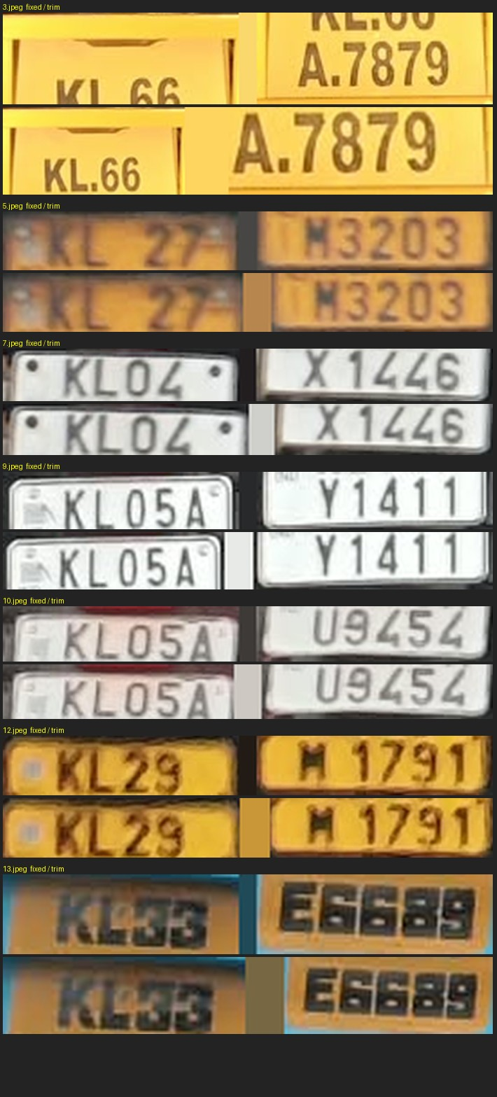
Figure 4.16: Two-line plates (left, original) flattened to one row (right) for reading
The real-data training steps and their measured effects are summarised in Table 4.8. Training on real labelled plates helped; most synthetic tricks did not.
Table 4.8: Experiments on the plate reader
Experiment | Result
Fine-tune on real plate set (CAPTCHA-style junk, about 10 %, removed); multi-seed weight averaging | Stable results across retrains; fewer plates breaking between runs
Add the public Zenodo plate set (about 1,355 pairs) | Exact reads on 16 held-out Kerala plates rose from a mean of 6.7 to 9.0 (3 seeds)
Add 10 hand-labelled other-state plates | No gain (mean 2.0 of 6 against 3 of 6 for the default)
Triple-repeat synthetic text | Did not fix plates such as DL1ZC8889
Degradation training (shrink to 12–30 px, blur, motion, JPEG) | Character error on small video plates fell from about 0.50 to 0.31
Repeated-character synthetic data with degradation (heavy recipe) | Per-frame exact reads on one bus plate rose from 14 % to about 46 %; the vote became correct
Sharpening or upscaling before reading | Made recognition worse
Multi-frame image averaging | Only a slight gain

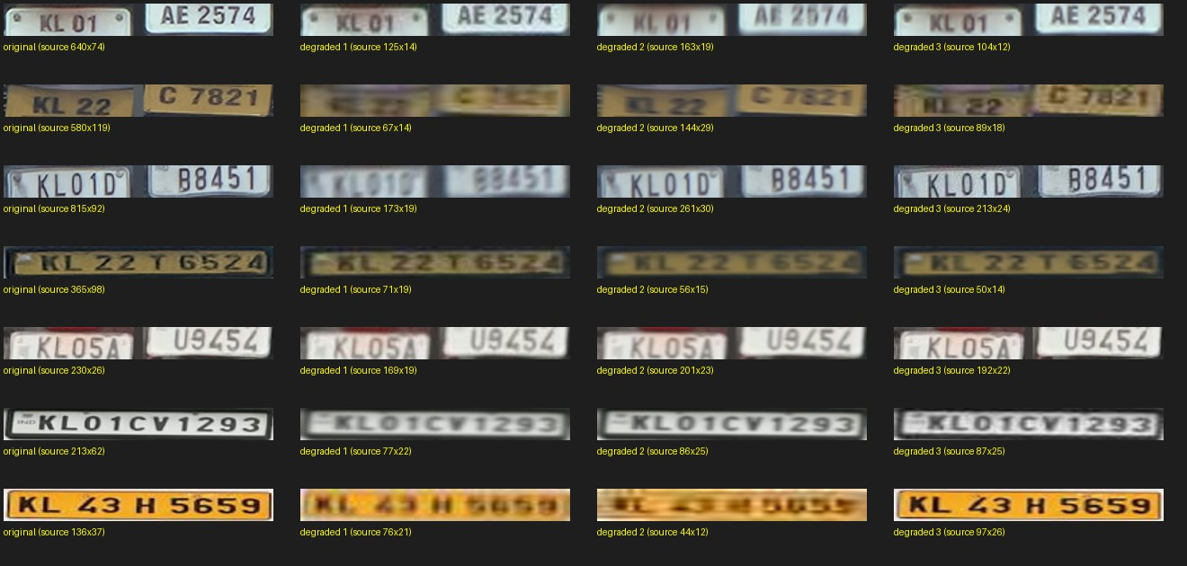
Figure 4.17: Plates before and after the degradation used in training (small size, blur, compression)
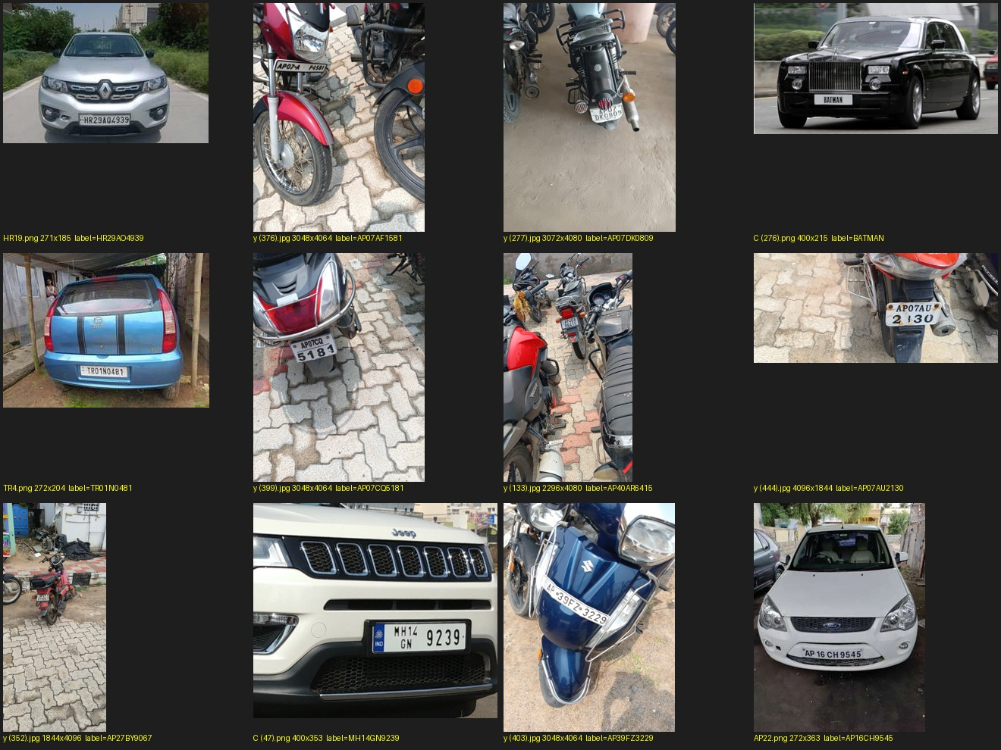
Figure 4.18: Samples of the public Zenodo plate set used for fine-tuning

4.5 Video and Real-Time Operation

4.5.1 Reading plates from video
A video reader detects plates in every frame, tracks each plate, reads it repeatedly and takes a vote over the readings, preferring readings that match the strict plate format. A track is called reliable when at least five reads agree and they make up at least 4 % of its reads. Tested on five traffic videos, the detector did find the two-wheeler and auto plates at a low confidence of 0.1 and a minimum size of 14 × 8 px, but these plates are only about 22–39 px wide and mostly two-line, and the reader could not read them reliably. Higher-resolution footage is the main remaining lever for them.

4.5.2 Real-time pipeline
The offline reader took about 10 minutes for a 45 s, 1080p clip, which is not usable for a system that must show a plate as the vehicle passes. Profiling showed that recognition took 30 % of the time, detection 27 %, video writing 18 % and the per-frame vote 15 %. The real-time version updates the vote incrementally over the most frequent readings, reads each plate on every frame at first and then every third frame, stops reading a plate once its vote is stable, runs the detector in half precision and skips frames when it falls behind. It processed the 45 s clip in 44 s, about 55 frames per second at 1080p, and about 17–30 frames per second on 4K video with the detector at 1280 px (Table 4.9, Figure 4.19). Its accuracy matched the offline reader (20 of 27 plates on the benchmark video). Plates that stay in view for only a few frames are announced when they leave, if the reading is well formed and most reads agree.
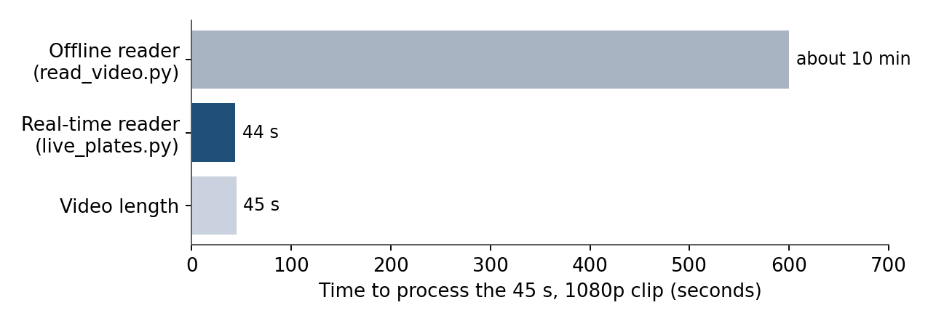
Figure 4.19: Processing time for a 45 s, 1080p clip
Table 4.9: Real-time processing speed
Source video | Processing speed | Remark
1080p, 60 fps (45 s) | about 55 frames/s | Plates shown live; 44 s for 45 s of video
4K, 60 fps | about 17–30 frames/s | Detector run at 1280 px; frames skipped to stay live

4.5.3 Training on labelled real-video crops
Because synthetic data had stopped helping, plates were labelled from real traffic video. The tracked plates of a video were exported and shown on a review page, where one typed plate labelled all the crops of a track; the crops (up to 40 per plate) were added to the training set, leaving out plates within one edit of any test plate. Two rounds were run, always keeping separate test videos that were never used for training (Table 4.10, Figure 4.20).
Table 4.10: Training on real-video crops
Round | Training data added | Test | Result
Round 1 | 114 plates, 4,926 crops from 4 videos | Unseen video 4 (27 plates) | 19 to 22 of 27 plates exact
Round 1 | same | Frames read correctly | 52 % to 66–71 %
Round 2 | 93 plates, 1,850 crops from 6 training videos | Six test videos (51 plates) | 38 to 41 of 51
Round 2 | same | Unseen video 4 again | 22 to 23 of 27

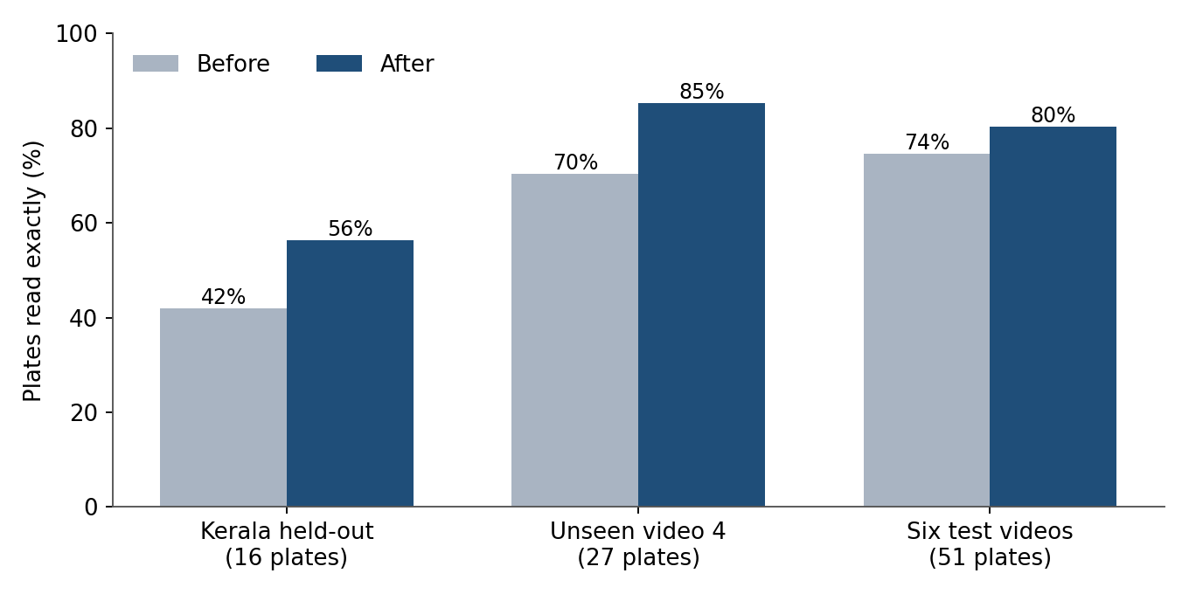
Figure 4.20: Plates read exactly before and after real-data training
The first round cost a little on the original-style validation crops (character error 0.245 to 0.277) and on a few clear photographs (6 of 7 clear plates and 14 of 16 Kerala plates were still read exactly), a trade accepted for the gain on video; after the second round all 16 Kerala plates were read exactly again.

4.5.4 Tests on unseen videos
4K video, set 15 (video 7). The reader confirmed 40 plates. Checked by eye, about 31 were right, 6 wrong and 3 uncertain, and about 3 real vehicles were never confirmed because their plates were blurred or faded. Reading every frame for a plate's first ten reads and announcing short passes on exit were added after this test to catch fast vehicles.
First test video (1.MOV, 4K). Thirteen plates were announced. Ten of the twelve real plates were read exactly (Figure 4.21 and Table 4.11). One plate lost a digit (KL2C6050 for KL20C6050), one plate partly hidden by a shadow could not be verified, and a phone-number sign on a scooter was announced as a plate (BP20OB9200). One yellow-plate vehicle was not announced because the readings of its bottom-line letter split between several characters.
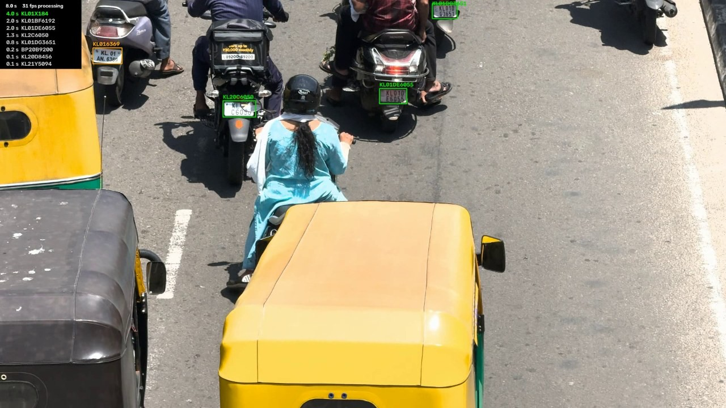
Figure 4.21: Live output: plate boxes with readings and the list of confirmed plates with their times (top left)
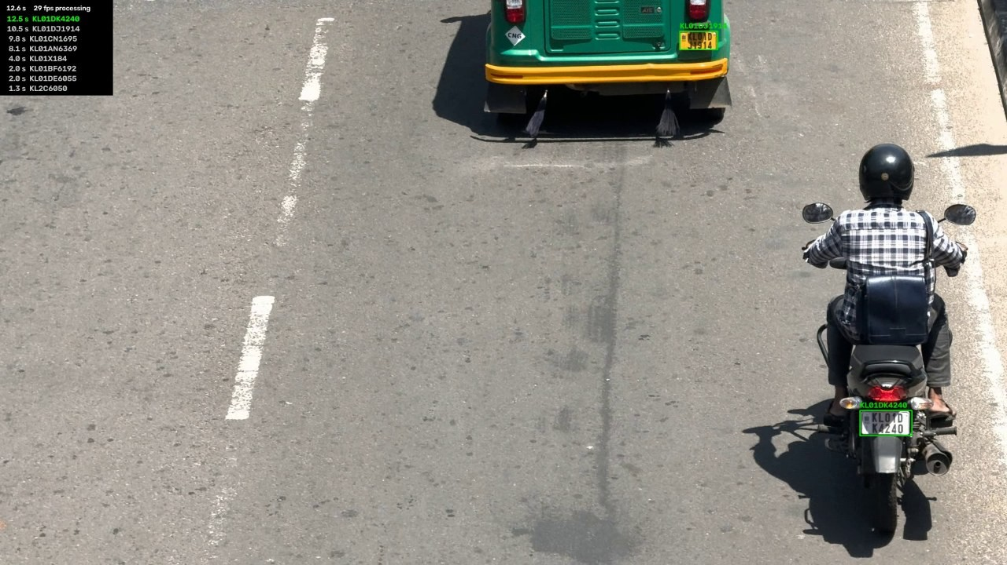
Figure 4.22: Live output a few seconds later; each new plate is added to the list
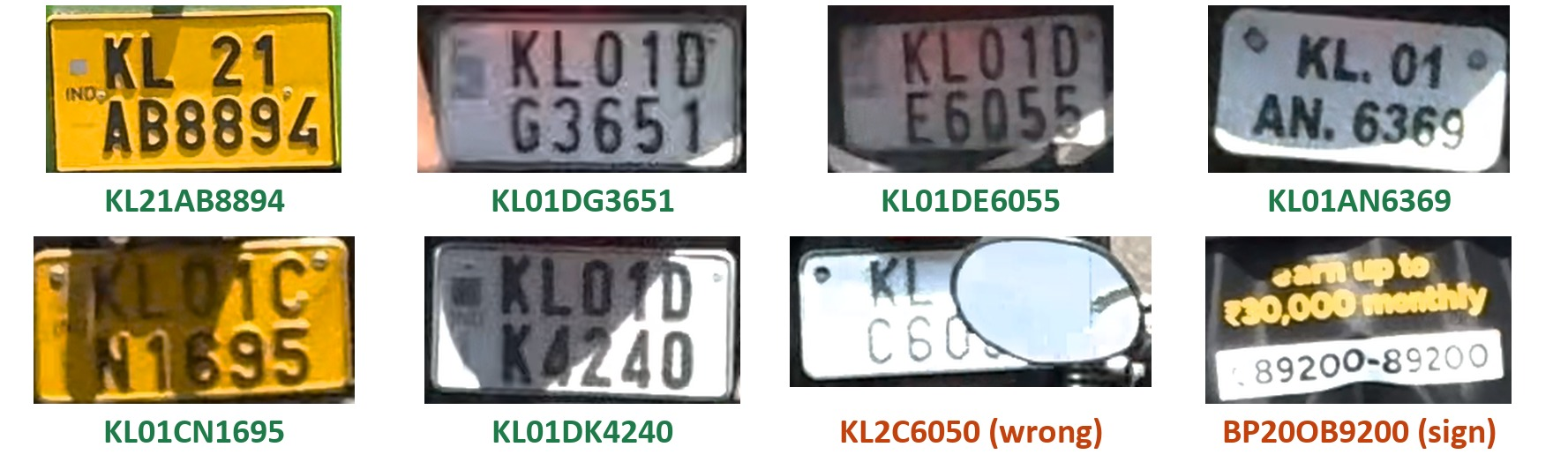
Figure 4.23: Plate crops and the readings announced (six correct; one dropped digit; one sign read as a plate)
Table 4.11: Results on the first test video
Outcome | Plates | Detail
Read exactly | 10 of 12 | KL21AB8894, KL21Y5094, KL20D8456, KL01DG3651, KL01DE6055, KL01BF6192, KL01AN6369, KL01CN1695, KL01DJ1914, KL01DK4240
Wrong | 1 | KL2C6050 (true KL20C6050)
Not verifiable | 1 | KL01X184 (plate partly hidden by a shadow)
Not a plate | 1 announcement | BP20OB9200 (phone-number sign)
Not announced | 1 vehicle | Yellow plate KL01C ?7591, bottom-line letter unclear

4.5.5 Remaining failure cases
- Repeated digits. Three equal digits are shortened to two in every model tried (KL01CH4448 read as CH448, TN72AF2999 as AF299).
- Other states. Non-Kerala series such as MP44ZF9601 are read less reliably, because most training plates are from Kerala.
- Dropped letters. For example KL01CA7005 read as KL01C705.
- Image quality. Blurred, overexposed or faded green plates, and two-wheeler plates only 22–39 px wide, stay unreliable.
- False plates. Signs and boards (a phone-number sign, STOP and TAXI boards) can pass the format check; a state-code check is planned.
- Dense dusk fog. When the plate region holds no signal, no single-frame method can recover it.

4.6 Summary of Results
Table 4.12: Summary of results
Stage | Measure | Result
Plate detection | YOLOv11n on the validation set | P 98.5 %, R 99.0 %, mAP@50 99.2 %
Restoration (classical) | OCR confidence, 20 images | Hazy 0.309, DCP 0.326, neural 0.114, CLAHE 0.320
Restoration (learned) | Best validation PSNR | 32.96 dB (traffic); 27.22 dB (final combined)
EasyOCR baseline | Exact match | 16.5–25.2 % (fog), 5.9–11.0 % (rain)
LPRNet | Character error, held-out scenes | 0.70 to 0.249
Dehazing before reading | Exact match | Raw 40.5 %, dehazed 36.3 %
Real-video training | Exact plates on test videos | 19 to 23 of 27 (video 4); 38 to 41 of 51
Real-time speed | 1080p / 4K | about 55 / about 17–30 frames per second
Unseen 4K test video | Real plates read exactly | 10 of 12

In summary, the plate detector is reliable, and a plate-specific reader trained on real Indian plates and video crops replaced EasyOCR, reading most plates exactly in real time. Weather restoration clears fog visually, but it improves recognition only when the reader is trained on restored images. The vehicle database, alerts, dashboard and multi-node correlation have not yet been built and remain for the next stage.

