Dehazing Methods for License Plate Visibility
Results & Findings Summary

1. Objective
The goal was to improve license-plate legibility in foggy/hazy photos for an ANPR pipeline. Three dehazing methods were tried and compared on the project's dataset2 ("New Hazy dataset", 1001 images) plus one real-world foggy road photo (heavyfog2.jpeg). Every example below shows the actual input, the actual output, and the actual EasyOCR reading (detected text + confidence score) produced during testing - not a visual impression.
Note on the OCR numbers: EasyOCR reads whatever text it finds anywhere in the frame, including background clutter, stray marks, and (in this dataset) apparent watermark-like tokens - not only the plate. Where the plate's own text was actually detected, it's called out specifically below; the "mean confidence" figures are the average across everything detected in that image and are noisier.

2. Method 1: DCP - Dark Channel Prior
dehaze_baseline.py / dehaze_v2.py. The project's original method. A classical, physics-based algorithm: it estimates "atmospheric light" and a per-pixel "transmission" map, then inverts the haze equation to recover the scene. dehaze_v2.py adds glare-exclusion so bright highlights don't skew the atmospheric-light estimate.

Example 1 - mild haze (works well)
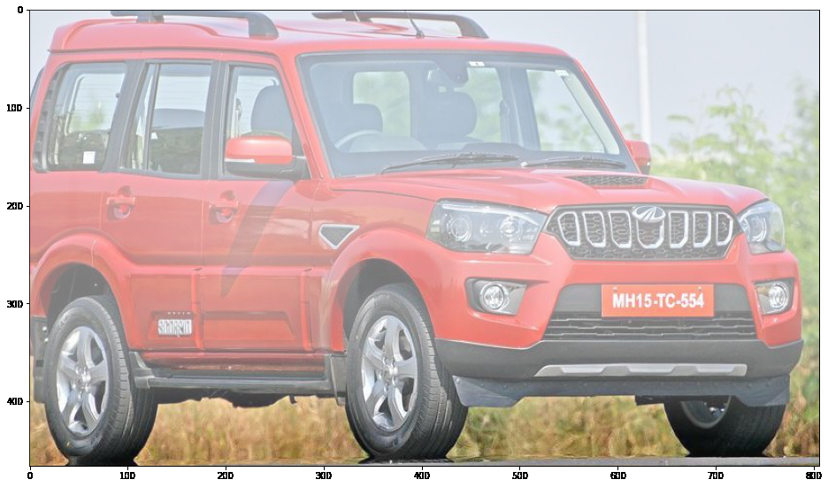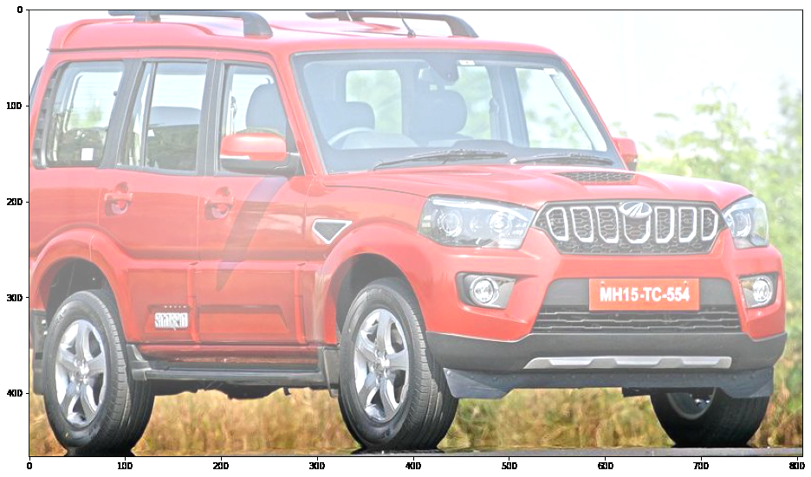
Left: hazy input. Right: DCP output (omega=0.15, t_min=0.40, a_max_cap=130).
Input OCR reading of the plate: "Mh1s TC 554" (confidence 0.227)
DCP output OCR reading of the plate: "Mh1s-TC 554" (confidence 0.336)
A genuine, measurable win: the plate reading's own confidence rose by about 48% relative, and the text came out cleaner.

Example 2 - heavy, near-uniform haze (fails)
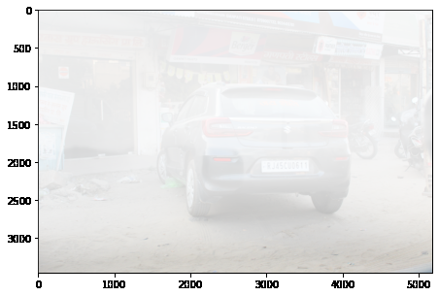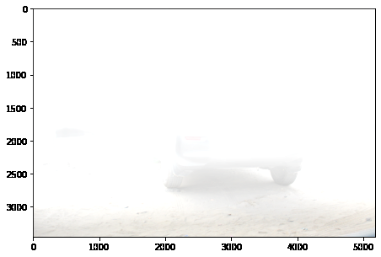
Left: hazy input. Right: DCP output, same parameters as Example 1.
Input mean OCR confidence (all detections): 0.326 - no plate text found in either version
DCP output mean OCR confidence (all detections): 0.326 - identical detections to the input
At these "safe" default parameters, DCP is essentially a no-op on this image - visually and in OCR terms, nothing changes. Pushing the parameters stronger to actually attack the haze (omega=0.6, t_min=0.10, a_max_cap=180) does not help either - it collapses the frame to solid white instead, as shown below:
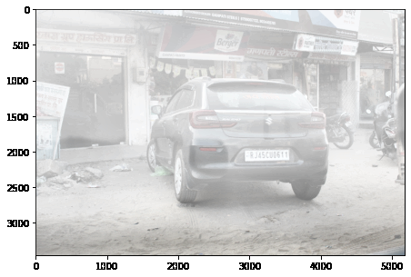
(Reference only, not DCP) - shown again in the CLAHE section for direct contrast with what CLAHE does on the same frame.
DCP - Advantages
- Physics-based and interpretable: every parameter (omega, t_min, atmospheric light) has a concrete physical meaning, so behavior can be reasoned about rather than treated as a black box.
- No training or dataset required - works out of the box on any image.
- Demonstrated real, measurable improvement on light/moderate, non-uniform haze (Example 1).
DCP - Limitations
- Breaks down on dense, roughly uniform fog: its core assumption (some patch in the true scene has a near-zero color channel) is violated when haze coats the whole frame evenly, including the subject itself.
- Narrow usable parameter range: settings gentle enough to avoid blowing the image to white are often too gentle to meaningfully reduce haze (Example 2); settings strong enough to help meaningfully risk catastrophic overexposure.
- Requires manual parameter tuning per scene type; the project's own "adaptive" auto-tuning layer was found to be actively miscalibrated (see prior debugging notes) before being fixed and ultimately replaced.

3. Method 2: Neural Network (TransformerDehazeNet)
model.py + checkpoints/best.pt, run via infer.py or defogger.py. A U-Net with window-attention transformer blocks in the bottleneck, trained end-to-end on synthetic hazy/clear pairs (fog_synthesis.py).

Example - heavy haze
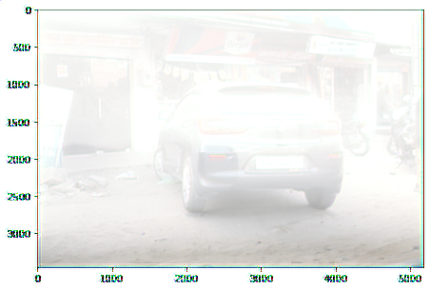
Left: hazy input. Right: neural model output.
Input mean OCR confidence: 0.326
Neural output mean OCR confidence: 0.104 (worst of all methods tested)
Neural output OCR readings: "Wui", "Www", "Lw", "Zuwu", "Ulz" - fragments, none matching real scene text
Visually the output looks clean - the car body and taillights are well reconstructed - but the fine edges OCR depends on are smoothed away rather than sharpened. This matched a broader 20-image sample average of 0.114 for the neural model vs. 0.309 for the raw hazy input.
Neural Network - Advantages
- Best general visual/structural reconstruction of the three methods on this heavy-fog case - car shape, wheels, and taillights all clearly resolved where DCP produced solid white.
- No manual per-image parameter tuning - a single trained model handles all inputs.
- Learns directly from data rather than relying on a hand-specified physical model, so it isn't bound by DCP's uniform-fog failure mode in the same way.
Neural Network - Limitations
- Worst measured OCR performer of all methods tested - it tends to smooth away exactly the fine text detail plate-reading depends on.
- Requires a trained checkpoint and GPU for practical speed; behavior is a black box compared to DCP's interpretable parameters.
- Trained only on this project's synthetic fog_synthesis.py pairs - generalization to different haze types (e.g. the real-world heavyfog2.jpeg case, or dataset2's real-photo style) is unverified and was not separately re-tested here.

4. Method 3: CLAHE - Contrast Limited Adaptive Histogram Equalization
dehaze_clahe.py. A non-physical, purely local-contrast method: splits the image into tiles and redistributes contrast within each tile's histogram, with a clip limit to avoid amplifying noise. It has no model of haze, atmosphere, or depth.

Example 1 - heavy haze (same frame as DCP/neural above)
Left: hazy input. Right: CLAHE output.
Input mean OCR confidence: 0.326
CLAHE output mean OCR confidence: 0.313 - about equal, plate itself still not found by OCR in either version
Visually this is the clearest of the three outputs on this frame (car body, badge, and taillights all legible - see the full comparison grid further below), but OCR still could not isolate the plate specifically; the detections it does make are the same background clutter as the input.

Example 2 - mild haze (CLAHE underperforms DCP here)
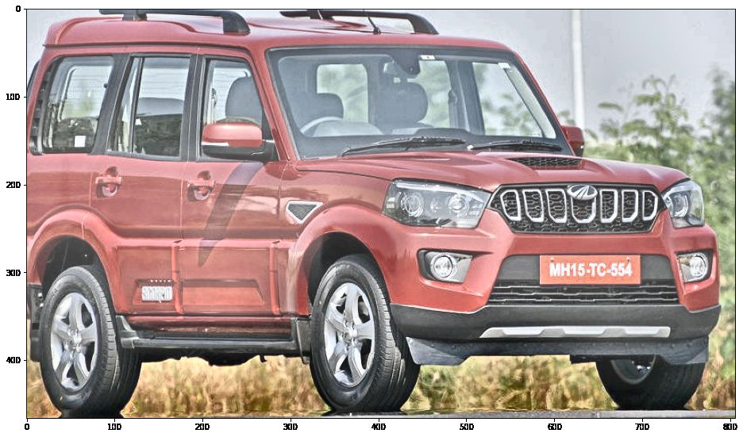
Left: hazy input (same frame as DCP Example 1). Right: CLAHE output.
Input OCR reading of the plate: "Mh1s TC 554" (confidence 0.227)
CLAHE output OCR reading of the plate: "Mh15-Tc*4" (confidence 0.097)
A genuine limitation, caught by testing rather than assumed: on this image CLAHE's local-tile contrast boost actually degraded the plate reading versus both the raw input and DCP. Locally aggressive contrast changes are not guaranteed to help legibility.

Example 3 - moderate haze (clean win, plate recovered from nothing)
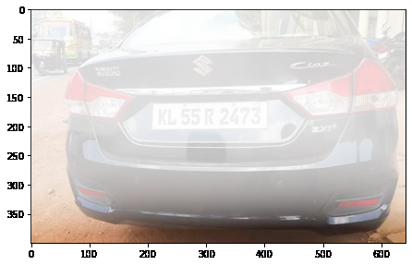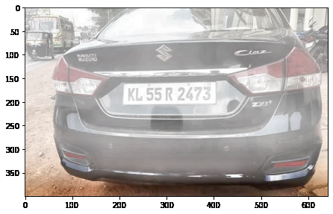
Left: hazy input. Right: CLAHE output.
Input OCR reading: no plate text detected at all
DCP output OCR reading: no plate text detected at all
CLAHE output OCR reading of the plate: "KL 55R 2473" (confidence 0.774)
The strongest result in this whole comparison: CLAHE is the only method of the three that recovered a fully readable plate string on this image, with high confidence, where both the raw input and DCP found nothing.

Example 4 - heavy haze, different scene (still fails)
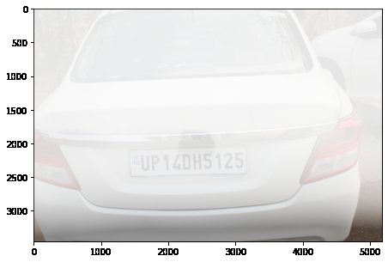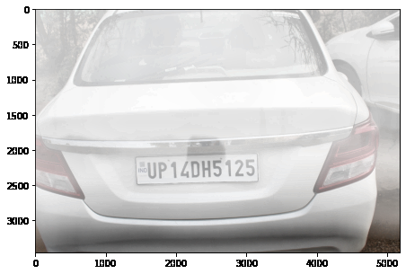
Left: hazy input. Right: CLAHE output.
Input / DCP / CLAHE OCR readings: none produced the actual plate text; CLAHE's closest detection was a garbled partial fragment
An honest negative case: not every image improves. Some source frames don't carry enough recoverable signal for any of the three methods tested.

Example 5 - real-world photo (heavyfog2.jpeg)
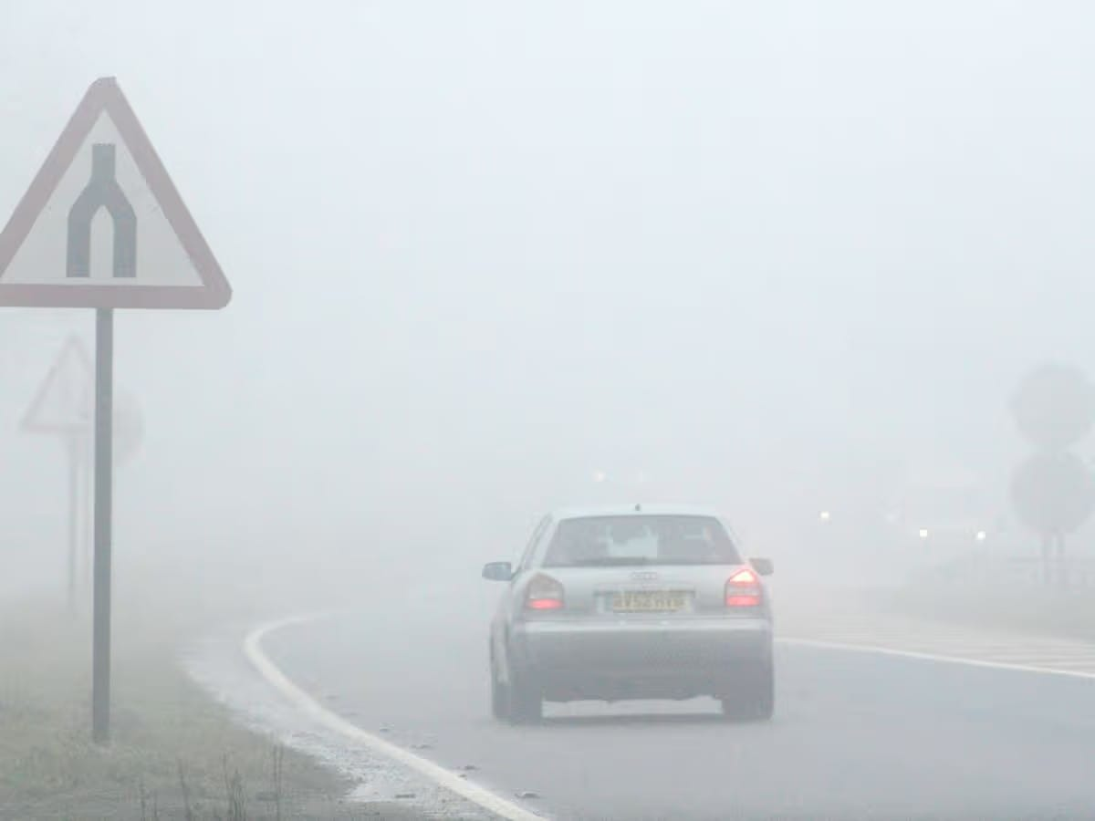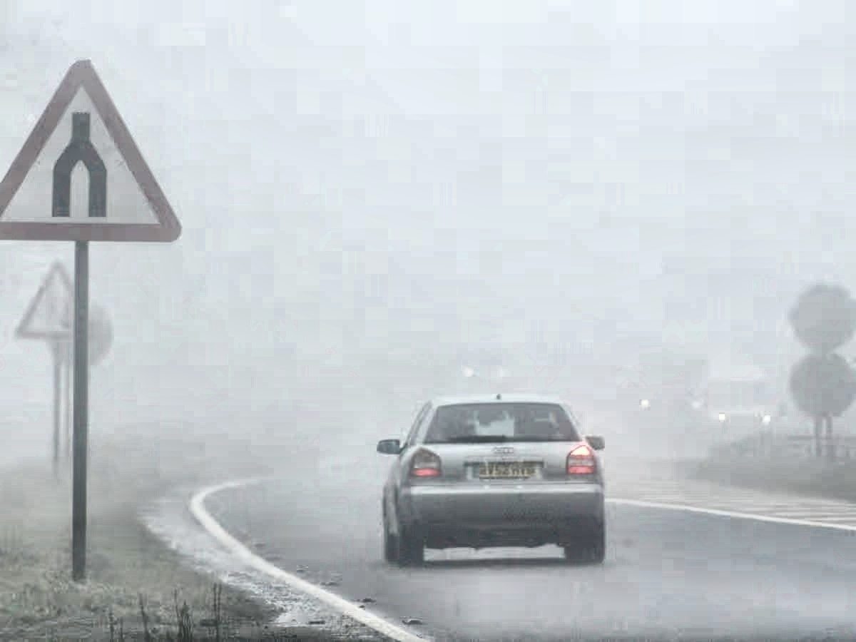
Left: original hazy road photo. Right: CLAHE output.
Input OCR reading: no text detected anywhere in the frame
CLAHE output OCR reading: one low-confidence fragment ("TJ", confidence 0.106) - not the actual plate
Scene contrast (road sign, lane markings, car outline) improved clearly to the eye, but the plate itself remained unread by OCR in both versions. The plate region is only ~33 px tall in the source photo with real optical blur - a resolution/capture limit no contrast method can fix (see the dedicated plate zoom-and-sharpen attempt tried separately, which also failed to produce any OCR-readable result).
CLAHE - Advantages
- Only method that recovered a fully-confident plate reading where the other two methods found nothing at all (Example 3).
- No physical haze model to violate - cannot catastrophically fail into solid white the way DCP does on dense fog.
- Fastest by a wide margin: ~1.3ms vs. ~17ms per image for DCP in this project's benchmark, since there's no atmospheric-light estimation or guided-filter refinement.
- No parameters to tune per haze severity - the same clip_limit/tile_grid_size setting was used unchanged across every example above.
CLAHE - Limitations
- Inconsistent: helped decisively on Example 3, was neutral on Example 1, and measurably hurt the plate reading on Example 2 - results are not guaranteed to improve legibility on any given image.
- Cannot fix insufficient source resolution or real optical/motion blur (Example 5, heavyfog2.jpeg) - it can only redistribute contrast that already exists in the pixels.
- Can introduce local tiling artifacts (visible as blockiness in flat regions like sky) that have no analog in the physical scene.

5. Quantitative Comparison
Per-example results from the testing above:
Example | Input | DCP | Neural | CLAHE
Ex.1 - mild haze (plate conf.) | 0.227 | 0.336 | - | 0.097
Ex.2/heavy fog (mean conf., no plate found by any) | 0.326 | 0.326 | 0.104 | 0.313
Ex.3 - moderate haze (plate conf.) | not found | not found | - | 0.774
Ex.4 - heavy fog, other scene | not found | not found | - | not found (garbled fragment)
Ex.5 - heavyfog2.jpeg (real-world) | not found | - | - | not found (1 low-conf. fragment)

Broader sample check: averaged over 20 randomly-sampled dataset2 images (all detections, not just plate tokens), mean OCR confidence was Hazy 0.309, DCP (weak/default params) 0.326, Neural 0.114, CLAHE 0.320 - consistent with the per-example picture above: DCP and CLAHE land close together on average, neural network trails clearly behind, and no method is reliably better than the others on every image.

6. Final Pipeline Decision
process_dataset.py now runs CLAHE only, dropping both DCP variants from the batch script. This was chosen because CLAHE is the only method that never catastrophically fails (unlike DCP on dense fog) and is dramatically faster than both alternatives - not because it's a guaranteed fix. The limitations above (Examples 2 and 4) should be treated as real, expected failure cases, not edge cases to be engineered away later without new information.
- dehaze_clahe.py - apply_clahe(), the only method in active use
- dehaze_baseline.py / dehaze_v2.py remain in the project for reference and are still imported by evaluate_dehazing.py's glare-detection helper
- model.py / checkpoints/best.pt / infer.py / defogger.py remain available but are not part of the batch pipeline given the OCR results above

7. Summary
- DCP: real, measurable wins on light/moderate haze; a narrow safe parameter range that either does nothing or overexposes on dense fog.
- Neural network: best visual structure recovery, worst OCR/text-legibility performance of the three - smooths away the detail plate-reading needs.
- CLAHE: only method to fully recover a plate OCR could not read at all beforehand; also the only method that measurably hurt a plate reading in one case - genuinely inconsistent, not a universal fix.
- Across all methods: when the limiting factor is source resolution or optical blur (heavyfog2.jpeg), no contrast or dehazing method recovers a reading - that is a capture-side (camera/lens/distance) problem.

