Name:S.Jewel Reddy
Reg No:22MID0161
Docker

Index.html
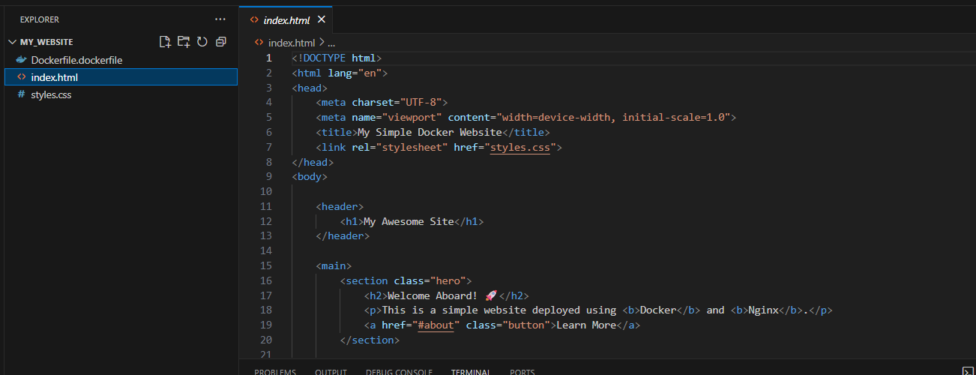
Styles.css
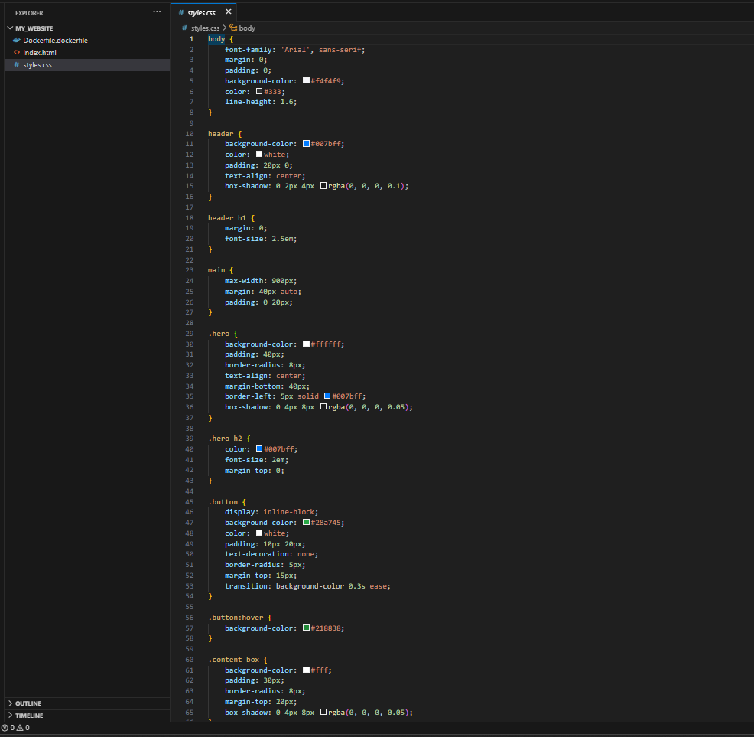
Dockerfile
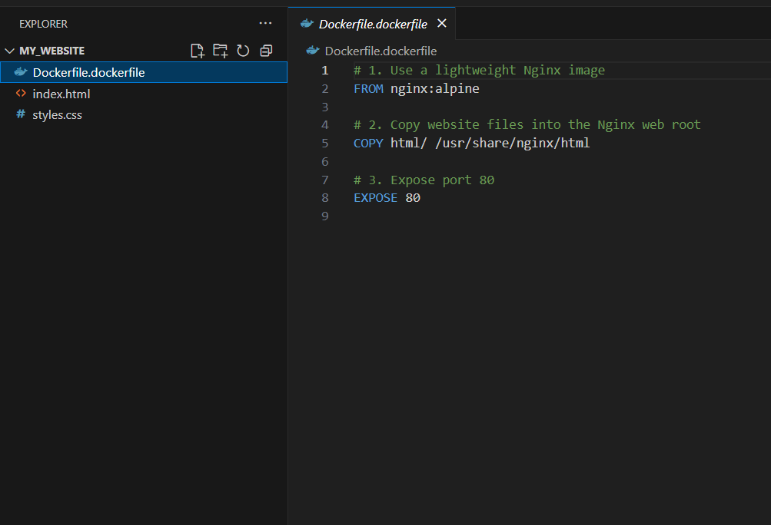
Commands:
docker login
docker build -t my-website-image .

docker run -d -p 8080:80 --name my-website-container my-website-image

docker tag my-website-image your-username/my-website-image:latest

docker push your-username/my-website-image:latest
http://localhost:8080
