**Chapter I**

**Introduction**

In our modern world of technology, computers are only going to get bigger and better, to make bigger and better things for you to enjoy. Computers began from a wild imaginative idea to the world’s highly prioritized tool. “Computers today are now used as a substitute to manual processes and other past inventions. Technology has never stopped from advancing through the years.” (Ana Luna Loberio, 2013). Many people use computers in their daily lives. Some use it for transactions, some use it for educational purposes and others use it for data storage. Through it might sound unnecessary but in some cases when storing a file for such a big company; organizing, finding a file, etc. With computers, it can help you simplify the process of storing and managing the files you need for future use and make finding files easier than the manual process.

“Computers have both positive and negative impact in our daily life as well as in our social life, the work can be done in very less time. More information can be stored in small space, multitasking, multiprocessing capabilities of data and Easy to access data, However, it has also a negative side and it includes the increased of unemployment, data piracy, highly expensive and the fast changing computer technology.” (Aakar Anil, 2017). Without computers, maybe our life would probably pretty dull, still using the manual processes and it would be a lot harder to get our work done.

Some hospitals today are not already engaged in technology in terms of its processing for some parts of the hospital specifically, their inventory process. Governor Valeriano M. Gatuslao Memorial Hospital (GVMGMH) is a public hospital that located at Himamaylan City. The said hospital is currently using a manual method to record their inventory, list the expenses of supplies they purchased or used and record of all the equipment and supplies of the hospital. The proponents have observed that the admin and supply officer have a hard-time for monitoring their supplies and equipment, especially in their expenses because some files in papers are lost or being missed place, so they’re going print lot of papers again. Therefore, the proponents proposed a system to their Admin and it aims to make their manual process of inventory into a computerized and easy way of managing and monitoring their supplies. The manual process is now considered obsolete after the discovery of computerized systems. It is more attractive to the clients considering it can save time and considered hassle-free.

The hospital is an institution providing medical and surgical treatment and nursing care for sick or injured people. It desires a lot of medical supplies, equipment, etc. Due to this needs, as they undergo their inventory, technically, GVMGMH is only using a manual system that may cause to duplication of documents and work redundancy. Once the inventory is done, the supply officer will give the result in papers and the admin will check it all and it is much time consuming to scan all those papers. Therefore, by means of this system, it will properly accommodate the needs of the hospital staffs in making their inventory. It will provide stress-free way of managing the equipment and supplies, and a secured storage of the data. It can also provide easy and firm way to access the data and view the result of the inventory and to avoid any difficulty in scanning the data result.

The proponents conducted an interview to gather some information in order to minimize the manual process of inventory or human effort and to make a user-friendly system. The proponents will create an inventory system which notifies the user through SMS when the supplies reach its minimum amount. Advanced system on inventory provide more reliable recording of inventory of the supplies and equipment. It can be easily generated and can easily access in the system as they record their inventory reports. This system promotes effective inventory control which ensures stocking the in-demand and correct items in the correct quantities. Through this system, it can help the said hospital to avoid or prevent any data loss or data redundancy for them to avoid any conflict on their supplies and equipment in terms of re-stocking and financial matters.

**General Objective**

The main objective of the study is to developed an monitoring and inventory system of the GVMGMH Plant Property Equipment and Supply Management that provides accurate information that will help the process.

**Specific Objectives**

* To design a system with the following features:

1. To notify the user if the supply or equipment is out of date.
2. To develop a system that can manage the inventory reports.
3. To provide reports of locating/searching the equipment.
4. To provide monthly or yearly reports.

**Scope and Limitation**

This system will be focuses only on managing the outgoing and the incoming of the supplies and equipment. The system can inquire product availability and can notify the user through SMS if supply and equipment are running out or reached its minimum amount. It will provide fast and easy access to the inventory reports stored in the database, and provide security in the inventory records.

**Significance of the Study**

Property Equipment and Supplies Management System is intended for the inventory process, and keeping track of its stocks. The following are the significance of the study:

1. **The Admin**

The one that manages the inventory reports of each respective supply of the hospital. By using the system, the admin will not be having a hard time in managing inventory reports manually. For the security of the system, the admin has to input a username and password to use the system.

1. **The Supply Officer**

The one that manages the outgoing and incoming of all the supplies and equipment of the said hospital. They are responsible for the security of the records of all the supplies, and by this system, they can have more secured storage for their records.

1. **The Researcher**

The researchers can carefully study that is done to find and report new knowledge about the project.

1. **The Future Researcher**

The future researchers can also use this study as their sample study guide for their future research that is also related to their system programming project, and it would see the possibilities for upgrading the system.

**Definition of Terms**

These terminologies were gathered by the researcher for better and clearer understanding of the study.

***Inventory* –** in this study, this term refers to the available stocks that are stored in GVMGMH.

***Manage*** *–* in dictionary, it refers to have control of (something, such as a business, department, sports team, etc.), but in this study,

* it refers to the systematic process of handling the supply and equipment, and the inventory reports.

***Monitoring*** *–* in dictionary, it refers to watch, observe, listen to, or check (something) for a special purpose over a period of time, but in this study,

* it refers to checking the status of the supply and equipment.

***Nurse* –** in dictionary, it refers to a person who is trained to care for sick or injured people and who usually works in a hospital or doctor’s office, but in this study,

* it refers to a person who have transaction to the Supply Officer which who requesting a supply.

***Reports***– in dictionary, it refers to give information about (something) in a newspaper or on television or radio, but in this study,

* it refers to the records of the supply and equipment, the month or yearly expenses and the inventory records.

***Supply Officer* –** it refers to the people employed in an organization or engaged in an organized undertaking such as military service, but in this study,

* it refers to the staff and employee in charge in the inventory of a specific supply or equipment of the GVMGMH.

**CHAPTER II**

**REVIEW OF RELATED LITERATURE AND PRIOR ARTS**

This chapter presents the reviews of related works and studies that deals in creating schedules. The scope of this concepts provides multiple articles from different sources were used to familiarize and to authenticate the needed data for study.

**Related Concepts**

The proponents conducted a research with the use of books and internet to provide related literature and prior arts system that are applicable in the development of the system.

**Review of Related Literature and System**

This chapter includes some existing projects that are related to the proposed project. This will serve as the basis on how the proponents developed their system. It will give the overview of earlier studies that helped the proponents gather insight from the related systems which guides them to enhancement of the existing system.

**Related Concepts**

**Foreign Related Studies**

Foreign Related Literature includes some existing projects that are related to the proposed system. These related studies can be found in previous thesis, and web articles. These references will be used as proponents’ guide to achieve a successful and efficient output.

**Hardware Inventory System (**Edwin Bello, 2014)

According to the study of Edwin Bello (2014) and his fellow researchers, it will track all working hardware devices that the system can understand it can also give additional information that the hardware inventory system cannot understand but it will show a sign of hardware detection but unknown brand or known brand but unusable. Devices that cannot be detected by the system may not be installed correctly or it may be physically installed but it may not be detected by the computer system itself or the hardware may be physically damage or broken. You may also ask why is there a need to have a hardware inventory system installed on your computer or is it ever important at all. First and foremost, it may sound odd for non techie and it may take a while to understand its importance but a hardware inventory system does not only detect the parts of your computer, technician find it easy to use this system to easily identify the reason why a certain part of your computer and why it is not working.

This system may similar to the current system which also aims to have fast access to the system by checking the product availability.

**Plex Inventory Management System (**Jayce Marin, 2015)

According to Marin, this study is a [cloud-based](https://www.pcmag.com/article2/0,2817,2498107,00.asp) subscription-based service that enables companies to [manage inventory](https://www.pcmag.com/article2/0,2817,2491993,00.asp), automate inventory tasks, and have access to real time inventory tracking for a monthly or yearly fee. It offers [genealogy](https://www.pcmag.com/article2/0,2817,2403077,00.asp)and traceability features that enable administrators to know what’s on hand and available for use at any given moment. Traceability features take into account orders, receipts, what orders are currently in progress and being filled, and what has already been shipped. Plex Inventory Management also helps streamline tasks associated with inventory. It offers integrated scanning features that can be used to capture incremental data automatically. It can be used to automatically print shipping labels, as well as perform other inventory tasks.

It is similar to the proposed system in terms of having a cloud-based service to manage and have access to the inventory every time.

**Pharmacy Inventory Management System (**Al Muallem Y., 2015),

According to the study of Al Muallem Y. (2015), the objective of this study is to report the preliminary findings of the implementation process of a pharmacy inventory management system at a local Saudi hospital. Meeting documents, key information interviews, and experience of the researcher were part of the data collection sources used in the study. A thematic analysis of the data was conducted. Preliminary findings show that the implementation process of the pharmacy inventory management system needs the involvement and support of senior management and experienced technical expertise. Future research will focus on investigation the impacts of the pharmacy inventory management system on workflow and medication errors.

This system is similar to the current system in terms of monitoring and better control for all the supply and less paperwork.

**Local Related Literature**

Local Related Literature includes some existing projects that are related to the proposed system. These related studies can be found on web articles and previous thesis. These will be used as proponents’ guide to achieve a successful and efficient output.

**Computerized Inventory System for Anthony's General Merchandise and Construction Supply (**Kentwatak, Jan 2014)

The study aims to lighten works and solve the problems involving strict and complex recording and calculations. According to this study, with computers, it can help you simplify the process of storing and managing the files you need for future use and make finding files easier than the manual process. Computerized Inventory System is a product of human knowledge with a use of technology so why not use technology as an advantage and benefit ourselves.

This study relates to the proposed system which also aims to lighten works and to simplify the process of storing and managing the files you need for future use and finding files easier than manual process.

**Philippine Computer Company Inventory System** (2015)

According to the study of Christian Bernese, Jayce Marin, Regie Millan, and Heavenlyn Porcado (2015), it is used to plan and track inventory balances and activities. Inventory is basically the total amount, number of stocks and records of supply or materials of a store and other business. Philippine Computer Company (PhilCom) is specialized in buying and selling computer parts and offers brand new and second hand computer materials. They also offer computer services like computer check-up, assembling and formatting. Point of Sale (POS) is an electronic system designed to help business maintain and analyze inventory and transaction occurs in exchange for goods and services.

Inventory System is somewhat similar to the proposed system that also aims to have a secured data and to designed a system that would help to make an easy way of calculating the number of stocks and the total amount or number they used. To help business maintain, analyze inventory and transaction data on a continuous basis. It helps the system to review the stored data.

**Related Prior Arts**

The given related prior arts below show the relative concepts to the proponents’ proposed system which help the proponents achieve the specific goal for a successful software.

**Feature Comparison of Local and Foreign Related Literature System**

The comparison table below shows the different feature of the system that was compared to the GVMGMH Plant Property Equipment and Supply Management System for the Himamaylan Hospital. This table of comparison composed of feature possessed by every system on the internet and books.

|  |  |  |  |  |  |  |
| --- | --- | --- | --- | --- | --- | --- |
| Application Name | Features | | | | | |
| Login Security Support | Notification | Connectivity | Support Update | Database Support Availability | Platform |
| **Sales and Inventory Monitoring Systems** | Yes | Yes | LAN | Yes | Yes | Desktop |
| **Hardware Inventory System** | Yes | Yes | LAN | Yes | Yes | Desktop |
| **Plex Inventory Management System** | Yes | Yes | Online | Yes | Yes | Desktop / Android |
| **Computerized Inventory Management System** | Yes | Yes | LAN | Yes | Yes | Desktop |
| **Pharmacy Inventory Management System** | Yes | Yes | LAN | Yes | Yes | Desktop |
| **Automated Sales and Inventory System** | Yes | Yes | LAN | Yes | Yes | Desktop |
| **Inventory Ordering System** | Yes | Yes | Online | Yes | Yes | Desktop / Android |
| **LC Pc Net Sales and Inventory System** | Yes | Yes | LAN | Yes | Yes | Desktop |
| **Inventory System** | Yes | Yes | Online | Yes | Yes | Desktop / Android |
| **Computerized Sales and Inventory System** | Yes | Yes | LAN | Yes | Yes | Desktop |

*Table 1: Comparison of Related Systems*

Table 1 shows the comparison of the different system. The table above is the summary of the different features of the different system. It also contains description of every system and comparison of our system that enable us to identify strength and weaknesses of our project that being develop.

**CHAPTER III**

**Design and Methodology**

In this chapter presents about the research methodology for how the system will be develop by gathering information to serve as the foundation of the system, the discussion about analysis, quick design, the process on the prototype cycle that take place, and lastly, the testing and implementation of the prototype system.

**System Development Life Cycle**

The System Development Life Cycle (SDLC) is a conceptual model used to know the system requirements in hardware and software that window can adopt. In this system analysis and design the proponents use Rapid Application Development (RAD). RAD describes a method of software development which heavily emphasizes rapid prototyping. This may also help us to know of what are the procedures that are going to use in developing our system. Design and Methodology stress the use of brainstorming to come with the idea and arrive at the best solution. The main concern of design and methodology are the needs and wants of the end user.

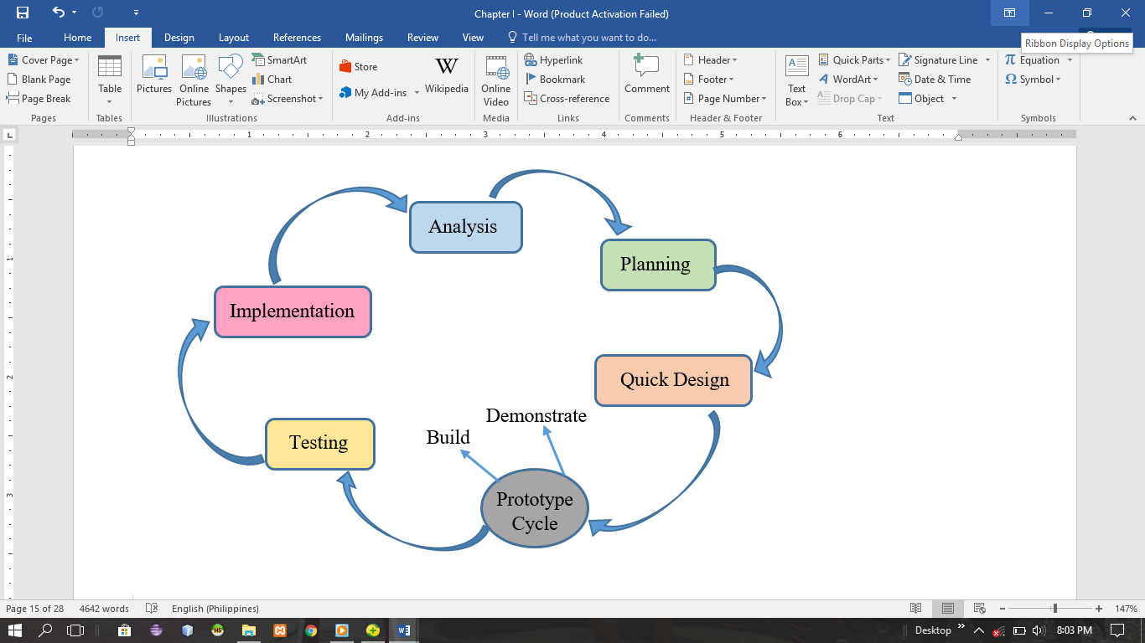

*Figure 1: Rapid Application Development (RAD)*

Figure 1: Shows the Rapid Application Development Diagram used by the proponents as their model for the system. It shows how the research and process is being implement from the start of the process until it has been finished. Rapid Application Development is easy to use as a methodology; the diagram shows the step by step so that the problems that might encountered can be polished by reviewing every step. In RAD, the functions are developed as the prototype is being integrated to make the complete process quicker, it makes it easier to incorporate and understand the changes within the development. The advantage of RAD model from the other methodologies is that it can consume your time to implement the system.

**Analysis**

In analysis, the proponents conduct series of research and interviews to the hospital, observe their manual process of inventory, and conduct interviews to the employee in-charge. The proponents gathered some data and information from the admin and personnel of the hospital. The hospital is currently using a manual system in recording their inventory and it will take time for them in securing and monitoring their stocks.

**Planning**

After conducting an interview and with the data gathered, the proponents start a plan on how they going to start the system making. The proponents use the information and the data that they gathered from the hospital during the interview in order to make an ease of access, can obtain accuracy, and lessen the time consuming process of inventory.

**Quick Design**

The system design should be a user-friendly so that the user can easily access the system and follow the process on how to use the system. First, the proponents just create a sample design and consults to the client if there’s any suggestions to the design so that

the proponents could provide and cope up with the lacking requirements.

**Prototyping**

In prototyping process have the processes also: build and demonstrate. In the phase of build, the proponents will use the information gathered to create an efficient and user-friendly interface. By the use of development tools were going to start to create the structure and function of the system. The proponent will also do the coding so that the proponent can test if there is some instance that will be polished or errors that might be encountered. Then, after designing, the prototype of the system should be demonstrating to the user on how the process in using the system so that they can easily manage and know how to use it.

**Testing**

This phase involves the testing of the system if it’s already functional and meet that desired requirements of the end-user. The proponents will use a beta testing which carried out to ensure that there are no major failures in the software and it satisfies the business requirements from an end-user perspective. It is successful when the hospital accepts the software or the system.

**Implementation**

After the testing, implementation of the system follows, during this phase the proposed system will be installed in the production process; the user will be trained or will be guided on how the system works.

**Context Diagram**

The context diagram shows the general flow of processes of the developed system where an entity concerned is connected to a one main process. It also portrays the general input requirements and its processed output.

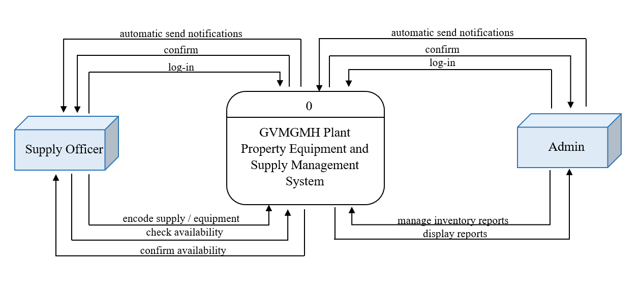

*Figure 2: Context Diagram of the Proposed System*

Figure 2 shows the general processes of the developed system. It also demonstrates the input requirements needed to be filled-up by the Supply Officer and the expected processed output from the system

**Data Flow Diagram**

Figure 2: Data Flow Diagram of Proposed Solution shows the concept and flows of each Entities, it shows all the process in the proposed system solution. Showing this flow, may help to the reader to identify which process begins.

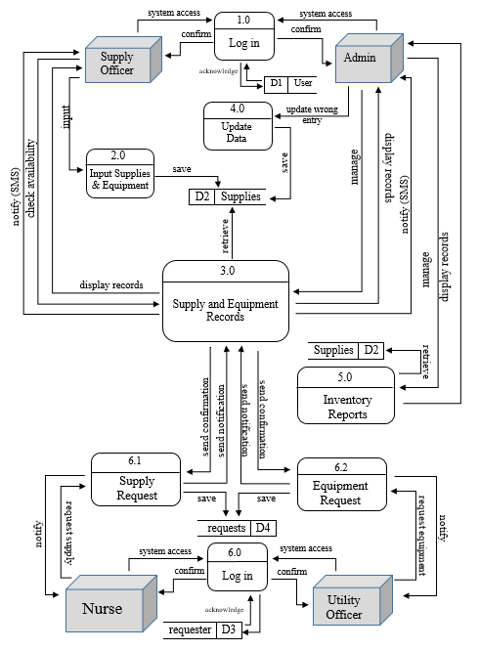

*Figure 3: Data Flow of the Proposed System*

Figure 3 shows the Data Flow Diagram of the GVMGMH Plant Property Equipment and Supplies Management System for the Governor Valeriano M. Gatuslao Memorial Hospital which show the flow of the data of the system. It also provides a sequential process of the action performed by the admin, supply officer and the nurse or the utility officer. Input and output of the data are being store and retrieved in the database including all information needed for the system to execute the process and the result made by the user on how the supply officer processes the information.

**Use Case Diagram**

The Use Case Diagram shows the action done by doing the process of the system. It illustrate the work of each user their function in the system.

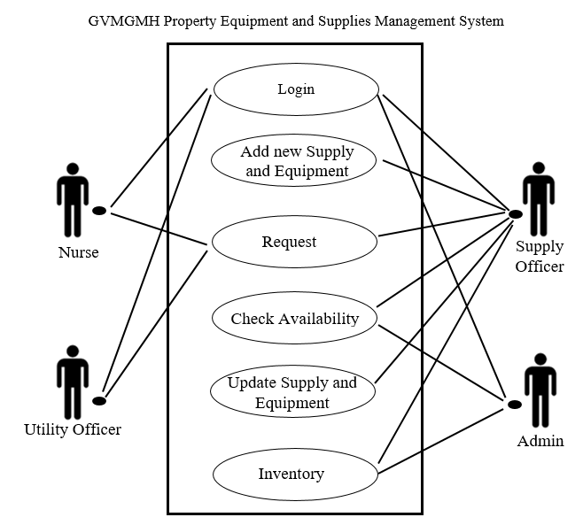

*Figure 3: GVMGMH Property Supplies and Equipment Management System Use Case Diagram*

**Actors:** Nurse, Utility Officer, Supply Officer, Admin

The corresponding use case descriptions for the above actors are:

* *Nurse and Utility Officer:* Nurse and the utility officer are the one who get or request some supplies and equipment from the Supply Officer.
* *Supply Officer:* The one who accommodate and process transactions of the nurse and utility officer, transactions such as receive and give the request, update the inventory data and the expenses.
* *Admin:* Manage the data and information of the supply and equipment as well as the systems configuration.

**Activity Diagram**

The figure below is the Activity Diagram of GVMGMH Plant Property Equipment and Supply Management System for the hospital of the Himamaylan for Login Button.

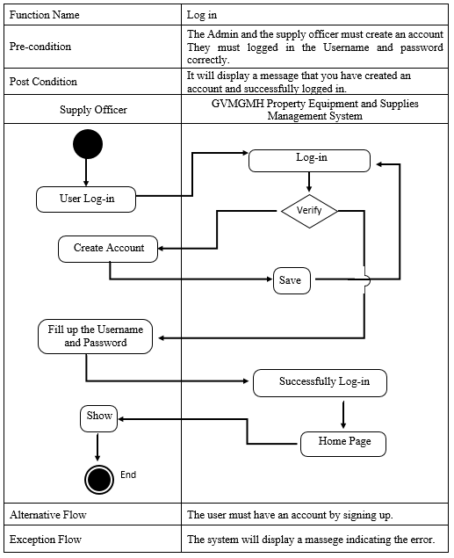

*Figure 4: Activity Diagram for Log-in*

Figure 4 shows the execution of the activities in log-in button of GVMGMH Plant Property Equipment and Supply Management System for the hospital of Himamaylan. The Supply Officer must first sign up to create her/his account and then the supply officer will log in by inputting the username and password, so then, he encodes the supply and equipment, as well as the admin he will do the same in order to manage the data and inventory of the supply and equipment. Then the system will check the database whether there is an existing account. If the system confirms the username and the password, it is going to show an information dialog whether he/she successfully login or it will show an error dialog showing that he/she entered an invalid information during the login process.

Activity Diagram of GVMGMH Plant Property Equipment and Supply Management System for the hospital of the Himamaylan for Add Supply and Equipment button.

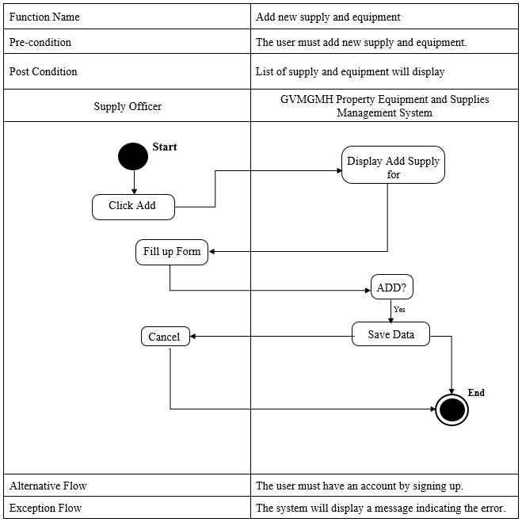

*Figure 5: Activity Diagram for Add New Supply and Equipment*

Figure 5 shows the execution for adding new supply and equipment of the system of the GVGMH Plant Property Equipment and Supply Management System for Himamaylan City Hospital. The user will click the Add button then the system will display the Add Supply and Equipment Form and the user will input the information needed. Then it will save in database. If the user wants to update the information, then the user will click the update button and now the user will change the information needed and then save.

Activity Diagram of GVMGMH Plant Property Equipment and Supply Management System for the hospital of the Himamaylan for Request Supply and Equipment.

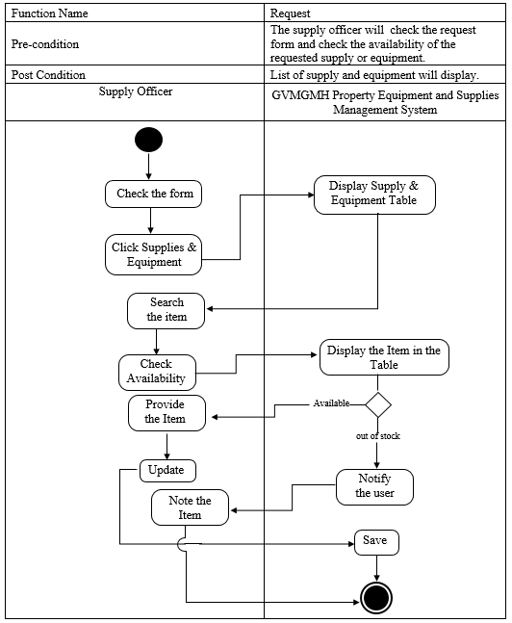

*Figure 6: Activity Diagram for Request*

Figure 6 shows the execution for requesting item of the system of the GVGMH Plant Property Equipment and Supply Management System for Himamaylan City Hospital. The user will check the form and click the supply and equipment tab, the system will display the supply and equipment table, the supply officer can search the item, then check the availability and provide the needed item if available.

Activity Diagram of GVMGMH Plant Property Equipment and Supply Management System for the hospital of the Himamaylan for Update Supply and Equipment.

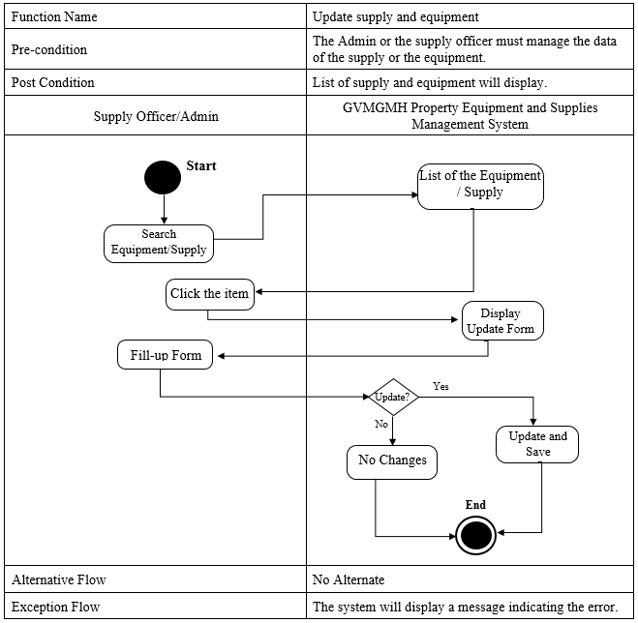

*Figure 7: Activity Diagram for Updating Supply and Equipment*

Figure 7 show the execution of the system for GVGMH Plant Property Equipment and Supply Management System for Himamaylan City Hospital. The user will search the equipment or supply and the system will be going to display the list of the equipment and supplies, and the then user will click the name and the update form will display.

Activity Diagram of GVMGMH Plant Property Equipment and Supply Management System for the hospital of the Himamaylan for the inventory.

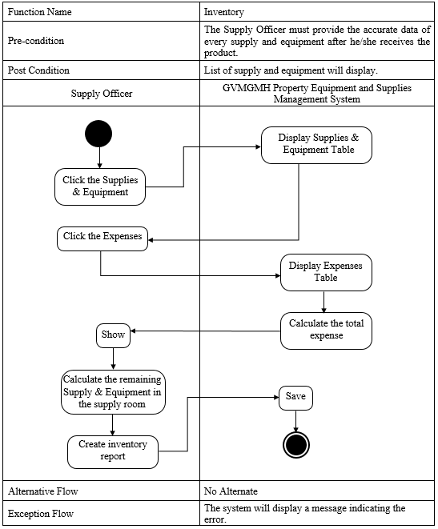

*Figure 8: Activity Diagram for the Inventory*

Figure 8 show the execution for the inventory of the system for GVGMH Plant Property Equipment and Supply Management System for Himamaylan City Hospital. The user will first click the supplies and equipment tab, the system will then display the indicating table, check the expenses and the system will display automatically the total expense per month or quarterly.

**Decomposition Diagram**

Decomposition Diagram is generalized diagramming technique that can be used to supplement the formalized structure analysis and design methodologies in a variety of ways.

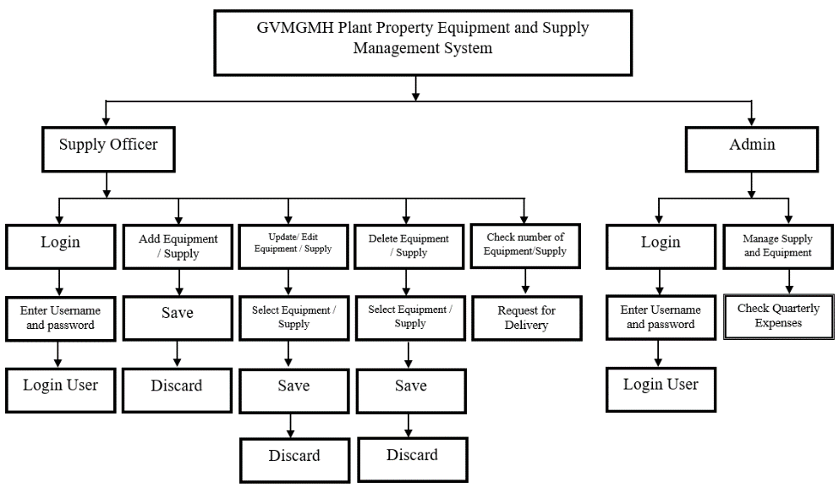

*Figure 9: Decomposition Diagram*

Figure 7 shows the Decomposition Diagram of the GVMGMH Plant Property Equipment and Supply Management System. The composition chart categorized according two users which is the admin and the supply officer. Authentication modules involves in logging in all users in the system. It determines the specific user that can access the system. The admin focuses only in managing the supply and equipment, the quarterly expenses and approving the delivery request. Also the supply officer focuses for the inventory of the supply and equipment such as adding, updating, deleting supply and equipment and monitoring the quarterly expenses. It starts from the high level process and the breakdown this process into sub-processes.

**Operational Frameworks**

As every step is done, the proponents review the information, inputs and the processes in the proposed system, for us to know what we could change, remove or add certain functionality or feature.

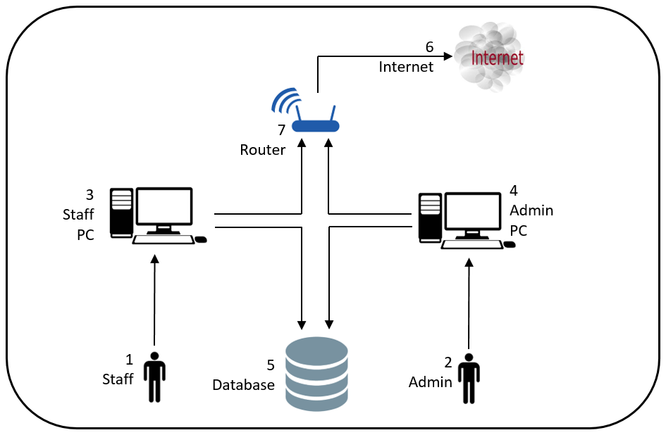

*Figure 10: Operational Framework*

Figure 8 shows the Operational Framework of the system was composed of a Staff Pc, Database, Admin PC, Internet, and Router. It will start with the admin or the staff, they will log in their specific user and password of their account in order to access the data stored in the database.

**Hardware and Software Development Specification**

In the developing system, the proponents use both hardware and software recommended.

**Recommended Hardware Specification**

For the Governor Valeriano M. Gatuslao Memorial Hospital Plant Property Equipment and Supply Management System is develops and run in a perfect function, but first the client must use the following hardware and software specifications:

* RAM : 2 GB DDR3
* Processor : Core i3
* Hard Drive : 500GB
* Monitor : 32 inches
* Resolution : 1024 x 768
* Keyboard
* Mouse

**Recommended Software Specification**

* Windows 8
* HeidiSQL
* NetBeans
* XAMPP

**Data Dictionaries**

The tables show the list of the conceptual databases based on the computerized inventory system for the Governor Valeriano M. Gatuslao Memorial Hospital. It provides the attributes, data types and also the description for each fieldnames so that the information needed will be ensured to capture by the different databases.

Table 2: User Table

|  |  |  |  |
| --- | --- | --- | --- |
| **Entity Name** | **Description** | **Type** | **Length** |
| user_num | User Number | int | 5 |
| fname | First Name | varchar | 50 |
| mname | Middle Name | varchar | 50 |
| lname | Last Name | varchar | 50 |
| b_date | Birth Date | varchar | 20 |
| gender | Gender | varchar | 20 |
| address | Address | varchar | 50 |
| username | Username | varchar | 30 |
| password | Password | varchar | 50 |

Table 3: Equipment / Supply Table

|  |  |  |  |
| --- | --- | --- | --- |
| **Entity Name** | **Description** | **Type** | **Length** |
| itemno | Item No. | int | 5 |
| description | Description | varchar | 50 |
| unit | Unit of the item | varchar | 50 |
| quant | Quantity | int | 200 |
| ucost | Unit Cost | int | 200 |
| result | Total Amount of the Item | int | 200 |
| date_s | Date Saved | DATE |  |

Table 4: Request Table

|  |  |  |  |
| --- | --- | --- | --- |
| **Entity Name** | **Description** | **Type** | **Length** |
| req_no | Request Number | int | 5 |
| department | Department | varchar | 50 |
| name | Name | varchar | 50 |
| item_desc | Item Description | varchar | 200 |
| quant | Quantity | int | 200 |
| date_req | Date Requested | DATE |  |

**Entity Relationship Diagram**

ERD or Entity Relationship Diagram show the relationship of tables in the database. Figure 9: Entity Relationship Diagram show the connection of each table. The created database models were based on the specification of the system requirements or it means that the tables that have been created from the database are all based on what was required by the system. The database of the GVMGMH Plant Property Equipment and Supply Management System is defined using the SQL language because of using the SQL language; it keeps the record totally safe.

DBMS or Database Management System designs the interface of the program that will manage the processing of the database and the tables that are being designed Data Dictionaries.

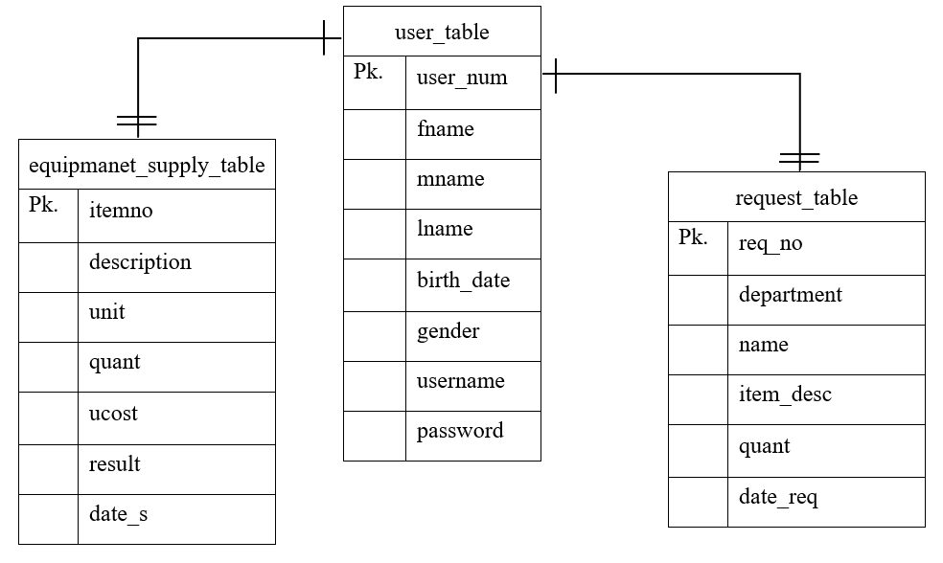

*Figure 11: Entity Relationship Diagram*

An entity relationship diagram (ERD) is a graphical representation of an information system that shows the relationship between the user, the equipment and the requests within the system. An ERD is a data modeling technique to define business processes and can be used as the foundation for a relational database.

**Gantt Chart**

The Gantt chart assess the proponents with the effective project management throughout the whole process. It stated there of how long process will take the needs an efficient and effective time management. The Gantt chart also figured out the minimum developing time of the proposed project.

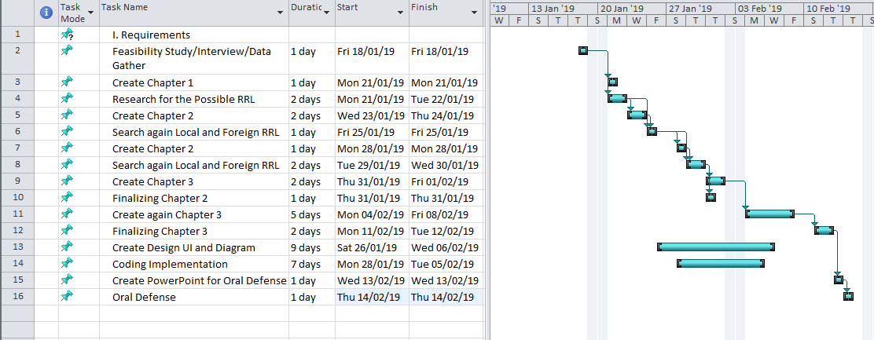

*Figure 12: Gantt Chart*

Figure 10 Gantt Chart shows the project team started June 11, 2018. This was follow by the series of activities in regards to the system development. The process was aligned with the system development life cycle phase which are analysis, planning, design, implementation, evaluation and testing. This tool guides the project team on the different activity that needs to be done in succeeding days.

**Time Table**

The Time Table 5 shows the task taken by the proponents.

|  |  |  |  |
| --- | --- | --- | --- |
| Task | Date started | Date finish | Assigned member |
| Feasibility Study/Interview/Data Gather | 18/01/19 | 18/01/19 | Cagalitan, Esmayan, Junsay |
| Create Chapter 1 | 21/01/19 | 21/01/19 | Cagalitan, Esmayan, Junsay |
| Research for the Possible RRL | 21/01/19 | 22/01/19 | Cagalitan, Esmayan, Junsay |
| Create Chapter 2 | 23/01/19 | 24/01/19 | Cagalitan, Esmayan, Junsay |
| Search again Local and Foreign RRL | 25/01/19 | 25/01/19 | Cagalitan, Esmayan, Junsay |
| Create Chapter 2 | 28/01/19 | 28/01/19 | Cagalitan, Esmayan, Junsay |
| Search again Local and Foreign RRL | 29/01/19 | 30/01/19 | Cagalitan, Esmayan, Junsay |
| Create chapter 3 | 24/01/19 | 25/01/19 | Cagalitan, Esmayan, Junsay |
| Finalizing Chapter 2 | 26/01/19 | 26/01/19 | Cagalitan, Esmayan, Junsay |
| Create again Chapter 3 | 26/01/19 | 31/01/19 | Cagalitan, Esmayan, Junsay |
| Create Diagrams | 28/01/19 | 01/02/19 | Cagalitan, Esmayan, Junsay |
| Create Design UI/coding | 01/02/19 | 13/02/19 | Cagalitan, Esmayan, Junsay |
| Finalize Chapter 3 | 25/02/19 | 27/02/19 | Cagalitan, Esmayan, Junsay |
| Coding | 18/02/19 | 22/02/9 | Cagalitan, Esmayan, Junsay |
| Create PowerPoint for Oral Defense | 03/03/19 | 03/03/19 | Cagalitan, Esmayan, Junsay |
| Oral Defense | 06/03/19 | 06/03/19 | Cagalitan, Esmayan, Junsay |

The table 5 shows the time duration of the given task for every proponent to accomplish the study.