**Chapter I**

**Introduction**

**“**Computers began from a wild imaginative idea to the world’s highly prioritized tool. Computers today are now used as a substitute to manual processes and other past inventions like radio, television, etc. Technology has never stopped from advancing through the years. Many people use computers in their daily lives. Some use it for transactions, some use it for educational purposes and others use it for data storage. Through it might sound unnecessary but in some cases when storing a file for such a big company; organizing, finding a file, etc.” (Ana Luna Loberio, 2013). With computers, it can help you simplify the process of storing and managing the files you need for future use and make finding files easier than the manual process.

In our modern day worlds, computers are only going to get bigger and better, to make bigger and better things for you to enjoy. As you observe around you, lot of what you see and used are programmed or made by a computer. “Computers have both positive and negative impact in our daily life as well as in our social life. With the help of computer, the work can be done in very less time. More information can be stored in small space, multitasking and multiprocessing capabilities of data. Easy to access data, documents can be kept secret and can be used for various purposes. i.e. It can be used in any type of work. However, it has also a negative side and it includes the increased of unemployment, data piracy, highly expensive and the fast changing computer technology. Sometimes, huge data and information can be lost.” (Aakar Anil, 2017). Without computers, maybe our life would probably pretty dull, still using the manual processes and it would be a lot harder to get our work done.

Some hospitals today are not already engaged in technology in terms of its processing for some parts of the hospital specifically, their inventory process. Governor Valeriano M. Gatuslao Memorial Hospital (GVMGMH) is a public hospital located at Himamaylan City. The said hospital is currently using a manual method to record their inventory, list the expenses of supplies they purchased or used and record of all the equipment and supplies of the hospital. But, the proponents are engaged in highly computerized technology aiming to enhance individual lifestyle. The manual process is now considered obsolete after the discovery of computerized systems. It is more attractive to the clients considering it can save time and considered hassle-free.

The proponent conducted an interview to gather some information in order to minimize the manual process of inventory or human effort and to make a user-friendly system. The proponent will create an inventory system which has a mobile app, so the admin of the said hospital can visit and manage anytime and anywhere using the app. Advanced system on inventory provide more reliable recording of inventory of the supplies and equipment. It can be easily generated and can easily access in the system as they record their inventory reports. This system promotes effective inventory control which ensures stocking the in-demand and correct items in the correct quantities. Through this system, it can help the said hospital to avoid or prevent any data loss or data redundancy for them to avoid any conflict on their supplies and equipment in terms of re-stocking and financial matters.

**General Objective**

The main objective of the study is to develop and implement a system that provides accurate data, computerized inventory system for GVMGMH that will enhance the inventory process and efficient way of managing the equipment and supplies of the said hospital.

**Specific Objectives:**

1. To develop and implement a generated system that will keep and manage the inventory reports.
2. To provide a fast transaction between the staff and the client.
3. To have an easy way of locating or searching the supply or equipment.
4. To design a system that the user can also view it through mobile app.

**Scope and Limitation**

The system will focus only in the development of the inventory system which will be conducted at GVMGMH. The system can manage the outgoing and ingoing of the supply. The system can inquire product availability, and can notify the user if the supply and equipment reached its minimum amount. The system can be viewed through an Android App which will be used only by the Admin in some purpose; he/she is not in the office or in the area of the hospital. The system will also provide fast access to the inventory reports stored in the database, create accurate records and provide security in the inventory records.

**Significance of the Study**

Property Equipment and Supplies Management System is intended for the inventory process, and keeping track of its stocks. The following are the significance of the study:

1. **The Admin**

The one that manages the inventory reports of each respective supply of the hospital. By using the system, the admin will not be having a hard time in managing inventory reports manually. For the security of the system, the admin has to input a username and password to use the system.

1. **The Supply Officer**

The one that manages the outgoing and incoming of all the supplies and equipment of the said hospital. They are responsible for the security of the records of all the supplies, and by this system, they can have more secured storage for their records.

1. **The Future Researcher**

The future researchers can also use this study as their sample study guide for their future research that is also related to their system analysis and design project, and it would see the possibilities for upgrading the system.

1. **The Researcher**

The researchers can carefully study that is done to find and report new knowledge about the project.

**Definition of Terms**

These terminologies were gathered by the researcher for better and clearer understanding of the study.

**Nurse –** a person who have transaction to the Supply Officer.

**GVMGMH**– or **Governor Valeriano M. Gatuslao Memorial** Hospital; in this study, it refers to the hospital located at Himamaylan City that provides a medical treatment and nursing care for sick or injured people and it also refers to a place where the inventory process was conducted.

**Inventory –** in this study, this term refers to the available stocks that are stored in GVMGMH.

**Inventory System –** it refers to the current inventory operation of the hospital.

**Supply Officer –** in dictionary, it refers to the people employed in an organization or engaged in an organized undertaking such as military service, but in this study, it refers to the staff and employee in charge in the inventory of a specific supply or equipment of the GVMGMH.

**Chapter II**

**Background of the Study**

The hospital is an institution providing medical and surgical treatment and nursing care for sick or injured people. It needs lots of medical supplies, equipment, etc. Due to this needs, as they undergo their inventory, technically, GVMGMH is only using a manual system that may cause to duplication of documents and work redundancy. Once the inventory is done, the personnel will give the result in papers and the admin will check it all and it is much time consuming to scan all those papers. Therefore, using this system, it will properly accommodate the needs of the hospital personnel in making their inventory. It will provide easy way of managing the equipment and supplies, and a secured storage of the data. It can also provide easy and fast way to access the data and view the result of the inventory and to avoid any hassle in scanning the data result.

**Review of Related Literature**

This chapter deals with a review of publication and investigation related to the present study that is related to our proposed system. By the use of this study we can easily understand other and develop a more advanced and effective system for the inventory system.

**Local Related Literature**

**Automated Sales and Inventory System**

According to Jayson Tamayo (2014), to overcome the deficiencies of manual system, many companies have automated their inventory system. This system is used to track or monitor the merchandise and goods of a retail store with an automated Sales and Inventory System, business rely on computers to do task that were once performed manually, such as inventory check and products sales. Automated Sales and Inventory System these processes can be handled in a timely manner and also be more accurate and reliable than ever before (Hartman, n.d.). It provides greater accuracy and more flexibility in the types of information and reports than can be generated by the system.

The Automated Sales and Inventory System is may similar to the proposed system in which it also aims to monitor or track all of their stocks and provides greater accuracy in their inventory reports.

**Inventory Ordering System**

According to the Globe Business Philippines, the Inventory Ordering System gives you better control over your supply chain, affording you the convenience of being able to place orders online or via SMS. And because the system automatically generates inventory and sales reports, your employees will have less paperwork to file and more time to focus on operations. Perfect for businesses with franchise operations, this user-friendly inventory management system can be customized for any multi-site company, commissary, or warehouse backend ordering operation.

This system may similar to the current system by also aiming for a better control over your supply and to have a less paperwork to file and to make a computerized inventory.

**Computerized Sales and Inventory System for Anthony's General Merchandise and Construction Supply**

Based on the study of Kentwatak (Jan 2013), many people use computers in their daily lives. Some use it for transactions, some use it for educational purposes and others use it for data storage. Though it might sound unnecessary but in some cases when storing a file for such a big company, can you manage it properly? Organizing, finding a file, etc. With computers, it can help you simplify the process of storing and managing the files you need for future use and make finding files easier than the manual process. Computerized Sales and Inventory System is a product of human knowledge with a use of technology so why not use technology as an advantage and benefit ourselves. This proposed system aims to lighten works and solve the problems involving strict and complex recording and calculations.

This study relates to the proposed system which also aims to lighten works and to simplify the process of storing and managing the files you need for future use and finding files easier than manual process.

**Inventory System**

According to the study of Christian Bernese, Jayce Marin, Regie Millan, and Heavenlyn Porcado (2013), Inventory System is a specific implementation of an inventory service and it is used to plan and track inventory balances and activities. Inventory is basically the total amount, number of stocks and records of supply or materials of a store and other business. Philippine Computer Company (PhilCom) is specialized in buying and selling computer parts and offers brand new and second hand computer materials. They also offer computer services like computer check-up, assembling and formatting. Point of Sale (POS) is an electronic system designed to help business maintain and analyze inventory and transaction occurs in exchange for goods and services.

It is somewhat similar to the proposed system that also aims to have a secured data and to designed a system that would help to make an easy way of calculating the number of stocks and the total amount or number they used.

**LC Pc Net Sales and Inventory System**

According to study of Irish R. Banayat, Ana Luna Loberio, Jasper Amiel R. Magnaye and Mhelieza R. Magnaye (October 2013), nowadays there are so many companies using technical system to improve the quality of service of their company, but there are some companies still using manual computing for their product inventory like LC Pc Net Sales & Services. LC Pc Net Sales & Services is owned by Mr. Leo Boongaling. It is established on April 2013. It is the first company that he built in order to apply his knowledge and skills in his past schooling, together with his friends as employee. And it is located at 2nd floor L. Boongaling Commercial Complex # 2 Rizal Street Poblacion Candelaria, Quezon. Their products are such peripherals. And in the ground floor they have Louis and Nathalie Computer Shop.

This is similar to the current system that aiming to have an easy and efficient process of inventory and to change the manual process into a computerized way.

**Foreign Related Literature**

**Sales and Inventory Monitoring Systems (**January 2014)

According to the study of Audra Bianca and Demand Media, using this type of system, a company makes strategic business decisions regarding raw material purchases, production scheduling, pricing, logistics and other decisions in the supply chain. Sales and inventory data enables the company to increase or decrease production in the factory so the company won't have too many finished goods stored in its warehouses. A sales and inventory monitoring system collects data to aid in production scheduling. For example, some systems use recent sales data to forecast how many of a type of product will be needed to meet consumer demand in the near future. This includes monitoring the levels of a product at all locations. A good example is a global company with customers all over the world. The customer may live in Japan, but the system must see if the warehouse in Canada has a product available to ship to Japan.

This system relates the current system by also aiming to monitor the products every time and to know if how may type of products is going to be re-stock or in-demand.

**Hardware Inventory System**

According to the study of Edwin Bello and his fellow researchers, it is a software that you need to install on your computer to detect most of the hardware in your PC or Mac. It will track all working hardware devices that the system can understand it can also give additional information that the hardware inventory system cannot understand but it will show a sign of hardware detection but unknown brand or known brand but unusable. Devices that cannot be detected by the system may not be installed correctly or it may be physically installed but it may not be detected by the computer system itself or the hardware may be physically damage or broken. You may also ask why is there a need to have a hardware inventory system installed on your computer or is it ever important at all. First and foremost, it may sound odd for non techie and it may take a while to understand its importance but a hardware inventory system does not only detect the parts of your computer, technician find it easy to use this system to easily identify the reason why a certain part of your computer and why it is not working.

This system may similar to the current system which also aims to have fast access to the system by checking the product availability.

**Plex Inventory Management System**

Plex Inventory Management is a [cloud-based](https://www.pcmag.com/article2/0,2817,2498107,00.asp) subscription-based service that enables companies to [manage inventory](https://www.pcmag.com/article2/0,2817,2491993,00.asp), automate inventory tasks, and have access to real time inventory tracking for a monthly or yearly fee. It offers [genealogy](https://www.pcmag.com/article2/0,2817,2403077,00.asp)and traceability features that enable administrators to know what’s on hand and available for use at any given moment. Traceability features take into account orders, receipts, what orders are currently in progress and being filled, and what has already been shipped. Plex Inventory Management also helps streamline tasks associated with inventory. It offers integrated scanning features that can be used to capture incremental data automatically. It can be used to automatically print shipping labels, as well as perform other inventory tasks.

It is similar to the proposed system in terms of having a cloud-based service to manage and have access to the inventory every time.

**Computerized Inventory Management System**

According to Thomas M. McHugh (2014) computerized inventory management systems provide many benefits that are hard to obtain using paper methods or an in-house spreadsheet. Systems that are specific to the lab can be used relatively quickly without a significant learning curve or system customization. The ability to analyze the inventory, item usage, purchasing history, and the areas (e.g., lot numbers, equipment) are important improvements to spreadsheet and paper systems. If the system includes equipment tracking, it can be used to determine the capital asset as well as track the service history and lifespan or equipment. The ability to streamline and automate many of the inventory control tasks will be increasingly important to reduce hands-on time while improving the analysis of trends, reducing stock-outs, and avoiding expiring reagents in the right quantity is present at the right time is critical to laboratory operations. Given that reagents are approximately one-half of most labs’ operating budgets, a continued focus on this expense will assist the laboratory in continuing to provide accurate and timely laboratory testing ate the lowest cost.

**Pharmacy Inventory Management System**

According to the study of Al Muallem Y. (2015), the objective of this study is to report the preliminary findings of the implementation process of a pharmacy inventory management system at a local Saudi hospital. Meeting documents, key information interviews, and experience of the researcher were part of the data collection sources used in the study. A thematic analysis of the data was conducted. Preliminary findings show that the implementation process of the pharmacy inventory management system needs the involvement and support of senior management and experienced technical expertise. Future research will focus on investigation the impacts of the pharmacy inventory management system on workflow and medication errors.

This system is similar to the current system in terms of monitoring and better control for all the supply and less paperwork.

**Chapter III**

**Methodology**

In this chapter presents about the research methodology for how the system will be develop by gathering information to serve as the foundation of the system, the discussion about analysis, quick design, the process on the prototype cycle that take place, and lastly, the testing and implementation of the prototype system.

**System Development Life Cycle**

The System Development Life Cycle (SDLC) is a conceptual model used to know the system requirements in hardware and software that window can adopt. In this system analysis and design the proponents use Rapid Application Development (RAD). RAD describes a method of software development which heavily emphasizes rapid prototyping. This may also help us to know of what are the procedures that are going to use in developing our system. Design and Methodology stress the use of brainstorming to come with the idea and arrive at the best solution. The main concern of design and methodology are the needs and wants of the end user.

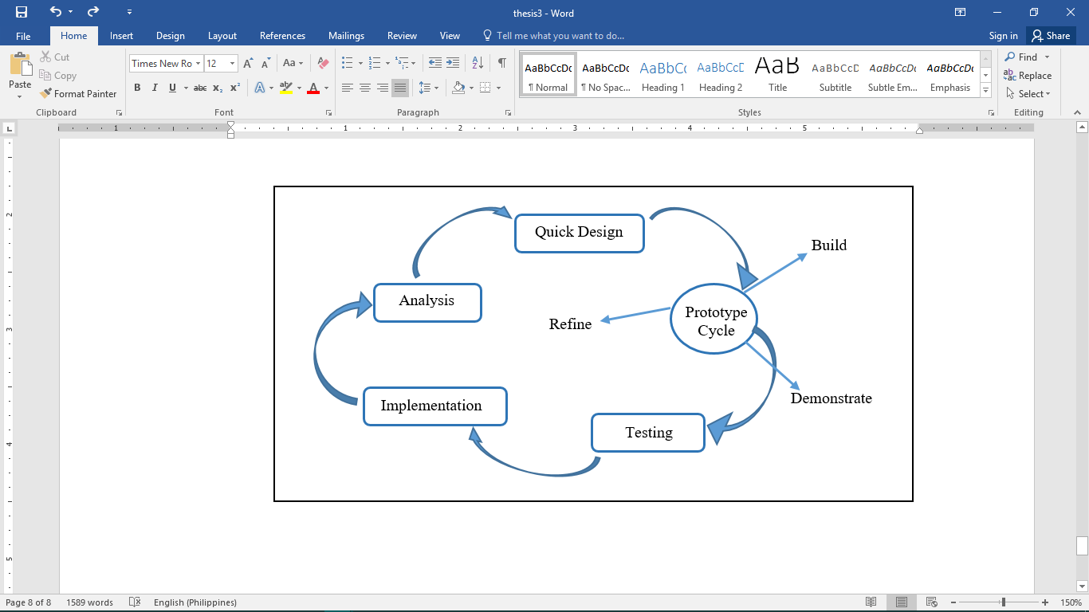

Analysis/ Planning

*Figure 1: Rapid Application Development (RAD)*

Figure 1: Shows the Rapid Application Development Diagram used by the proponents as their model for the system. It shows how the research and process is being implement from the start of the process until it has been finished. Rapid Application Development is easy to use as a methodology; the diagram shows the step by step so that the problems that might encountered can be polished by reviewing every step. In RAD, the functions are developed as the prototype is being integrated to make the complete process quicker, it makes it easier to incorporate and understand the changes within the development. The advantage of RAD model from the other methodologies is that it can consume your time to implement the system.

**Analysis**

In analysis, the proponents conduct series of research and interviews to the hospital, observe their manual process of inventory, and conduct interviews to the employee in-charge. The proponents gathered some data and information from the admin and personnel of the hospital. The hospital is currently using a manual system in recording their inventory and it will take time for them in securing and monitoring their stocks.

**Planning**

After conducting an interview and with the data gathered, the proponents start a plan on how they going to start the system making. The proponents use the information and the data that they gathered from the hospital during the interview in order to make an ease of access, can obtain accuracy, and lessen the time consuming process of inventory.

**Quick Design**

The system design should be a user-friendly so that the user can easily access the system and follow the process on how to use the system. First, the proponents just create a sample design and consults to the client if there’s any suggestions to the design so that the proponents could provide and cope up with the lacking requirements.

**Prototyping**

In prototyping process have the processes also: build and demonstrate. In the phase of build, the proponents will use the information gathered to create an efficient and user-friendly interface. By the use of development tools were going to start to create the structure and function of the system. The proponent will also do the coding so that the proponent can test if there is some instance that will be polished or errors that might be encountered. Then, after designing, the prototype of the system should be demonstrating to the user on how the process in using the system so that they can easily manage and know how to use it.

**Testing**

This phase involves the testing of the system if it’s already functional and meet that desired requirements of the end-user. The proponents use a beta testing which carried out to ensure that there are no major failures in the software and it satisfies the business requirements from an end-user perspective. It is successful when the hospital accepts the software or the system.

**Implementation**

After the testing, implementation of the system follows, during this phase the proposed system will be installed in the production process; the user will be trained or will be guided on how the system works.

**Architectural Diagram Interface of Hardware**

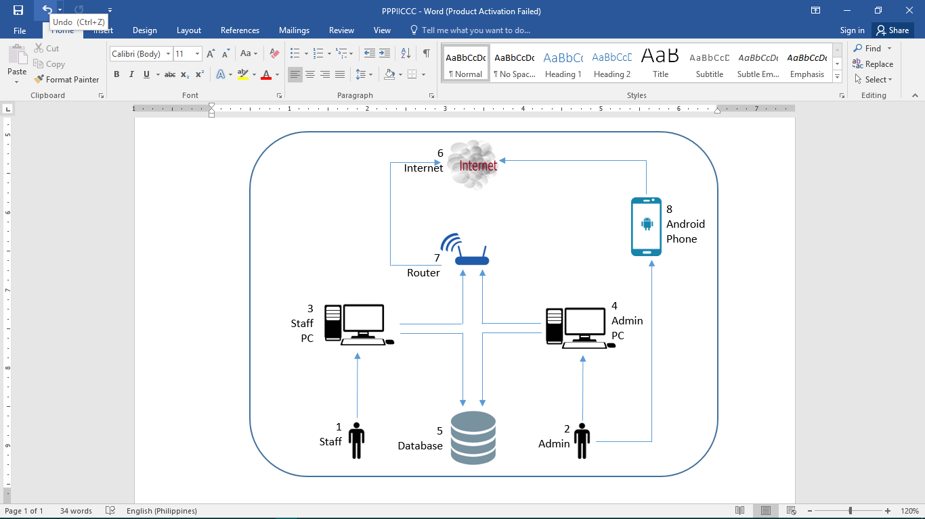 Architectural Diagram shows the process of the interaction between the user and the hardware.

*Figure 2: Architectural Diagram of Property Equipment*

*and Supplies Management System*

Figure 2: Shows the Architectural Diagram of the system was composed of a Staff Pc, Database, Admin PC, Android Phone, Internet, and Router. It will start with the admin or the staff, they will log in their specific user and password of their account in order to access the data stored in the database. The Android Phone may only be use by the Admin in case of he/she is not around in the hospital or he/she is out of town as long as his/her Android Phone is connected to the Internet; so he/she can still manage the inventory reports.

**System Testing and Implementation**

As every step is done and in order to prove that the system is really reliable. In producing of information given by the system, this should be tested so that the user or the proponent will see if it is effective in terms of its purpose and uses so the user can make him/her satisfy. The proponents select some of the students to act as the admin so that we can visualize if the process is correct as well as storing of data during the inventory. The system is only designed to provide the needs of the hospital and also to make the inventory process easy and accurate.

**Recommended Hardware Specification**

For Property Equipment and Supplies Management System is develops and run in a perfect function, but first the client must implement the following hardware and software specifications:

* RAM : 4 GB DDR4
* Processor : Core i7
* Hard Drive : 500GB
* Monitor : 32 inches
* Resolution : 1024 x 768
* Keyboard : Standard PS/2 Keyboard
* Mouse : PS/2 Compatible Mouse

**Recommended Software Specification**

* Windows 8
* HeidiSQL

**GVMGMH**

**(**Governor Valeriano M. Gatuslao Memorial Hospital**)**

**Property Equipment**

**and Supplies**

**Management System**

**Members:**

**Junsay, Jewel Rose M.**

**Cagalitan, Kennette**

**Esmayan, Renan**

**(BSIT III-1)**

3.0

confirm

system access

Supply Officer

Analysis

Planning

Implementation

Quick Design

Demonstrate

Build

Testing

Prototype Cycle

|  |  |
| --- | --- |
| D3 | request |

|  |
| --- |
|  |

|  |  |
| --- | --- |
| Supplies | D2 |

|  |  |
| --- | --- |
| D1 | User |

|  |  |
| --- | --- |
| D2 | Supplies |

|  |  |
| --- | --- |
| requester | D3 |

|  |  |
| --- | --- |
| requests | D4 |

Equipment Request

Supply Request

retrieve

save

save

acknowledge

notify

notify

send confirmation

send confirmation

acknowledge

send notification

send notification

request equipment

request supply

confirm

confirm

system access

Utility Officer

system access

Nurse

Log in

6.0

6.1

6.2

Log in

Inventory Reports

5.0

notify (SMS)

9SMS)

input

manage

display records

manage

display records

confirm

system access

system access

confirm

1.0

notify (SMS)

9SMS)

check availability

Supply Officer

update wrong entry

save

retrieve

4.0

Update Data

save

display records

Supply and Equipment

Records

3.0

Input Supplies & Equipment

2.0

Admin

|  |  |
| --- | --- |
| D3 | request |

|  |  |
| --- | --- |
| D3 | request |

|  |  |
| --- | --- |
|  |  |

START

The admin will manage and monitor the inventory.

The Department inquire for a supply/equipment.

Staff will provide the needing supply/ equipment.

Staff receives the supply and equipment

END

Admin

Department

Supplier

Staff

|  |
| --- |
| **Staff** |
| ID Number: int  Name: String  Address: String  Contact Number: int  Position: String |
| + logIn();  + inputSupply();  + request(); |

|  |
| --- |
| **Admin** |
| ID Number: int  Name: String  Address: String  Contact Number: int  Position: String |
| + logIn();  + expense();  + request(); |

1

1

Input

manage

1…*

|  |
| --- |
| **Supply** |
| ProNumber: int  Description: String  Unit: String  Quantity: int  Type: String  Total Cost: int  Cost: int |
| + addSupply(); |

|  |
| --- |
| **Expense** |
| ExpenseNumber: int  Equipment Total: int  Supply Total: int  Date Recorded: DATE |
| + addSupply();  + addEquipment();  + expense(); |

|  |
| --- |
| **Equipment** |
| ProNumber: int  Description: String  Unit: String  Quantity: int  Type: String  Total Cost: int  Cost: int |
| + addEquipment(); |

1

1…*

|  |
| --- |
| **Request** |
| RcptNumber: int  ID Number: int  Name: String  Product: String  Quantity: int |
| + request(); |

Input

1…*

manage

1…*

|  |
| --- |
| **Inventory** |
| IntNumber: int  ProNumber: int  Description: String  Quantity: int  Supply Total Cost: int  Equipment Total Cost:int  Date Recorded: DATE |
| + expense();  + addSupply();  + addEquipment(); |

1…*

1…*

1…*

request

request

1…*

1…*

GVMGMH Property Equipment and Supplies Management System

Login

Add new Supply and Equipment



Nurse

Supply Officer

Request

Check Availability



Update Supply and Equipment

Utility Officer

Admin

Inventory

Start

Computer

Staff

Staff will record the received supply and equipment manually

Record Book

The staff will the encode to the computer

The data will then be printed

Printed Output

The printed output will be managing by the admin.

END

Admin

manage

display inventory

print

encode manually

view data

view details

record

Printed Ouput

Computer

4

3

Admin

5

Supplier

receives

deliver

3

Supply/

Equipment

deliver

receives

Microsoft Excel

Staff

using

Record Book

|  |  |  |
| --- | --- | --- |
| ENCODE | | |
|  | Supplier | Supply Officer |
| Provide lacking of supply & equipment  Deliver the Supply and Equipment.  Re-check the supply & equipment | Encode in Computer  Record details on the record book  Verify?  Check the Supply & Equipment  Receives the Supply & Equipment  correct  incorrect |

|  |  |  |
| --- | --- | --- |
| Request | | |
|  | Nurse | Supply Officer |
| Take the item  Fill-up form  Request | Check the availability of the item  Order to the Supplier  Update the record of the stock  available  Provide the item  out of stock  Check the form |
| Inventory | | |
|  | Supply Officer | Admin |
| Generate Inventory Report  correct  Check the records from record book  Verify?  incorrect  Count the remaining supplies in the stock room  Update the record  Record the incoming & outgoing of the items | Check and manage the inventory report |

|  |  |  |
| --- | --- | --- |
| Function Name | | Request |
| Pre-condition | | The supply will check the request form and check the availability of the requested supply or equipment. |
| Post Condition | | List of supply and equipment will display. |
| Supply Officer | | GVMGMH Property Equipment and Supplies Management System |
|  | Fill-up Form  Click the item  Search Equipment/Supply  **Start** | **End**  No Changes  Update and Save  No  Update?  Yes  Display Update Form  List of the Equipment / Supply |
| Alternative Flow | | No Alternate |
| Exception Flow | | The system will display a message indicating the error. |

|  |  |  |
| --- | --- | --- |
| Function Name | | Request |
| Pre-condition | | The supply officer will check the request form and check the availability of the requested supply or equipment. |
| Post Condition | | List of supply and equipment will display. |
| Supply Officer | | GVMGMH Property Equipment and Supplies Management System |
|  | Click Supplies & Equipment  Note the Item  Provide the Item  Update  Check Availability  Search the item  Check the form | Save  Notify the user  out of stock  Available  Display the Item in the Table  Display Supply & Equipment Table |

|  |  |
| --- | --- |
| Function Name | Inventory |
| Pre-condition | The Supply Officer must provide the accurate data of every supply and equipment after he/she receives the product. |
| Post Condition | List of supply and equipment will display. |
| Supply Officer | GVMGMH Property Equipment and Supplies Management System |
| Create inventory report  Calculate the remaining Supply & Equipment in the supply room  Show  Click the Expenses  Click the Supplies & Equipment | Save  Display Expenses Table  Calculate the total expense  Display Supplies & Equipment Table |
| Alternative Flow | No Alternate |
| Exception Flow | The system will display a message indicating the error. |

|  |  |  |
| --- | --- | --- |
| Display Inventory | | |
|  | Admin | GVMGMH Property Equipment and Supplies Management System |
| no  Fill up form  Click update  yes  update?  Check the inventory  Click inventory records | Save  Display update form  Display Records |

Check Quarterly Expenses

Manage Supply and Equipment

Login

Login User

Enter Username and password

Discard

Discard

Save

Save

Discard

Request for Delivery

Select Equipment / Supply

Select Equipment / Supply

Save

Check number of Equipment/Supply

Delete Equipment / Supply

Update/ Edit Equipment / Supply

Add Equipment / Supply

Login User

Enter Username and password

Login

Admin

Supply Officer

GVMGMH Plant Property Equipment and Supply Management System

|  |  |
| --- | --- |
| user_table | |
| Pk. | user_num |
|  | fname |
|  | mname |
|  | lname |
|  | birth_date |
|  | gender |
|  | username |
|  | password |

|  |  |
| --- | --- |
| equipmanet_supply_table | |
| Pk. | itemno |
|  | description |
|  | unit |
|  | quant |
|  | ucost |
|  | result |
|  | date_s |

|  |  |
| --- | --- |
| request_table | |
| Pk. | req_no |
|  | department |
|  | name |
|  | item_desc |
|  | quant |
|  | date_req |

|  |  |
| --- | --- |
| Function Name | Log in |
| Pre-condition | The Admin and the supply officer must create an account They must logged in the Username and password correctly. |
| Post Condition | It will display a message that you have created an account and successfully logged in. |
| Supply Officer | GVMGMH Property Equipment and Supplies Management System |
| End  Show  Fill up the Username and Password  Create Account  User Log-in | Home Page  Successfully Log-in  Save  Verify  ify  Log-in |
| Alternative Flow | The user must have an account by signing up. |
| Exception Flow | The system will display a massege indicating the error. |