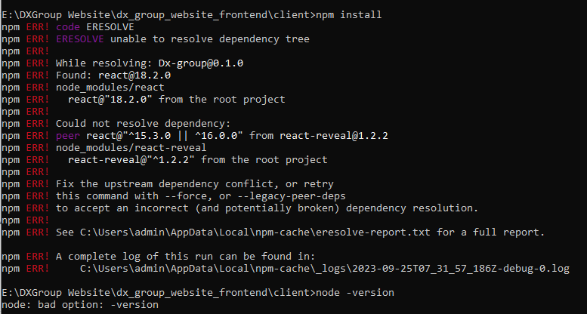

E:\DXGroup Website\dx_group_website_frontend\client>npm install

npm ERR! code ERESOLVE

npm ERR! ERESOLVE unable to resolve dependency tree

npm ERR!

npm ERR! While resolving: Dx-group@0.1.0

npm ERR! Found: react@18.2.0

npm ERR! node_modules/react

npm ERR! react@"18.2.0" from the root project

npm ERR!

npm ERR! Could not resolve dependency:

npm ERR! peer react@"^15.3.0 || ^16.0.0" from react-reveal@1.2.2

npm ERR! node_modules/react-reveal

npm ERR! react-reveal@"^1.2.2" from the root project

npm ERR!

npm ERR! Fix the upstream dependency conflict, or retry

npm ERR! this command with --force, or --legacy-peer-deps

npm ERR! to accept an incorrect (and potentially broken) dependency resolution.

npm ERR!

npm ERR! See C:\Users\admin\AppData\Local\npm-cache\eresolve-report.txt for a full report.

npm ERR! A complete log of this run can be found in:

npm ERR! C:\Users\admin\AppData\Local\npm-cache\_logs\2023-09-25T07_31_57_186Z-debug-0.log

E:\DXGroup Website\dx_group_website_frontend\client>node --version

v16.18.0

E:\DXGroup Website\dx_group_website_frontend\client>npm config set legacy-peer-deps true

E:\DXGroup Website\dx_group_website_frontend\client>npm install

added 463 packages, and audited 464 packages in 2m

I found the problem, you must put this command in the terminal => npm config set legacy-peer-deps true

**npm install --legacy-peer-deps vs --force**

I wanted to share some insights about two powerful flags for the "npm install" command: "--legacy-peer-deps" and "--force". These flags can be extremely helpful in managing dependencies in your Node.js projects. Let's dive into their functionalities and when to use them:

1️⃣ **npm install --legacy-peer-deps:**

The "--legacy-peer-deps" flag is used when you encounter compatibility issues with peer dependencies while installing packages. Peer dependencies are required by a package but aren't automatically installed alongside it. In some cases, when a package has not been updated to support the latest version of its peer dependency, the installation may fail due to conflicting versions. Adding the "--legacy-peer-deps" flag allows npm to use an older, compatible version of the peer dependency, ensuring a successful installation.

2️⃣ **npm install --force:**

The "--force" flag is a more drastic option and should be used with caution. It instructs npm to forcefully install packages, even if it encounters errors or conflicts. This can be useful in situations where you want to override any version or compatibility checks and forcibly install packages. However, it is important to note that using "--force" may lead to unexpected issues, such as breaking dependencies or introducing incompatibilities, so it should be used sparingly and with a good understanding of its consequences.

💡 Keep in mind the following recommendations when working with these flags:

✅ "--legacy-peer-deps" is generally safer and should be the preferred option when dealing with peer dependency conflicts. It ensures compatibility by falling back to older versions.

⚠️ "--force" should be used as a last resort, and only when you fully understand the implications. It can potentially introduce breaking changes or cause package inconsistencies.

📣 Remember, it's essential to maintain a clean and reliable dependency tree. Regularly updating packages and resolving compatibility issues will help ensure a stable and secure development environment.

I hope this post sheds some light on the differences between "--legacy-peer-deps" and "--force" flags in the npm install command. Let's continue to share knowledge and empower each other as we build amazing software! 💪✨

<https://www.linkedin.com/pulse/npm-install-legacy-peer-deps-vs-force-shaharyar-saleem>

<https://stackoverflow.com/questions/69817939/issue-installing-react-reveal>