NuxtJS

The Intuitive Vue  
Framework

Build your next Vue.js application with confidence using Nuxt.  
An open source framework making web development simple and powerful.

# <https://www.youtube.com/watch?v=eE-f8LLazFg&list=PLXuHNPzyZJcHgqxdy3PY9MyEZ7jy9feOv&ab_channel=Codeshikhi-%E0%A6%95%E0%A7%8B%E0%A6%A1%E0%A6%B6%E0%A6%BF%E0%A6%96%E0%A6%BF>

# Create Nuxt App

Nuxt.js has an official scaffolding tool (create-nuxt-app), that you can use from your package manager.

npx create-nuxt-app nuxt-fundamentals

[npx](https://www.npmjs.com/package/npx) (´npx´ is shipped by default since NPM ´5.2.0´)

What is Jamstack hosting?

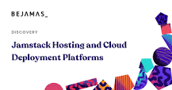

Jamstack hosting options **utilize the concept of serverless architecture (a system of running websites and applications without infrastructure management)**. They rely on third-party cloud-hosted services, like AWS, Google Cloud Platform, etc. The hosts carry out all server management, as the users pay a provision.

<https://www.thisdot.co/blog/nuxt-js-for-complete-beginners>

For running the App:

cd my-first-nuxt

npm run dev

## Solve - Cannot find module 'axios' Error in TypeScript [#](https://bobbyhadz.com/blog/typescript-cannot-find-module-axios#solve---cannot-find-module-axios-error-in-typescript)

**To solve the "Cannot find module axios or its corresponding type declarations" error, install the module by running the command npm install axios. You can then import axios with the following line of code import axios from 'axios'**

Install axios:

Npm install axios

Details: <https://axios.nuxtjs.org/setup>

For api work background

Inspect:

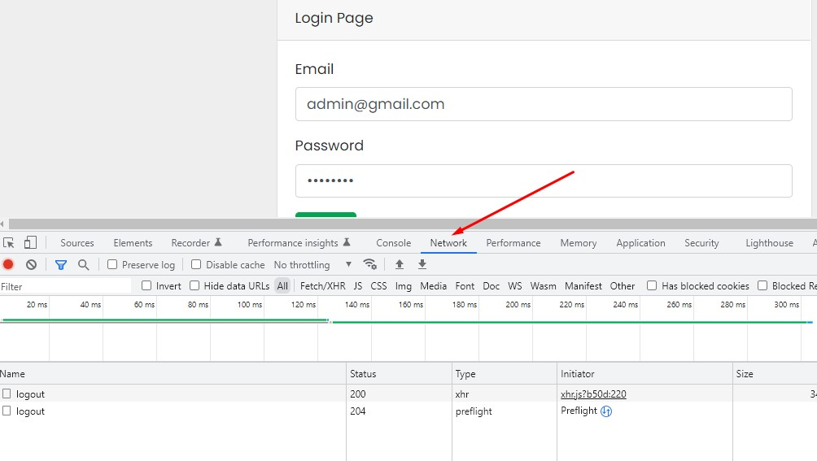

Install vue devtool chrome extension for background data set

Browser DevTools extension for debugging Vue.js applications.

Chrome devtools extension for debugging Vue.js applications.

<https://chrome.google.com/webstore/detail/vuejs-devtools/nhdogjmejiglipccpnnnanhbledajbpd?hl=en>

** Need to activate store for login process successfully

<https://nuxtjs.org/docs/directory-structure/store/>

//API from nuxt website

<https://api.nuxtjs.dev/>

Install nuxt auth package

<https://auth.nuxtjs.org/guide/setup/>

npm install --save-exact @nuxtjs/auth-next

npm install @nuxtjs/axios

Then, add @nuxtjs/auth-next to the modules section of nuxt.config.js:

{

modules: [

'@nuxtjs/axios',

'@nuxtjs/auth-next'

],

auth: {

// Options

}

}

Then go to Schemes > Local

Use the template form local usage

**Plugin vform:**

vform is a tiny library for Vue 2/3 to help with forms and validation when using Laravel as a back-end.

npm install axios vform

npm install vform // worked for me

<https://github.com/cretueusebiu/vform/>

<https://vform.vercel.app/>

Fixing plugin code for vform

<https://github.com/cretueusebiu/vform/issues/30>

Axios – Show data from api

For simple like

return response()->json($products);

this.productlist = (await this.$axios.$get('/products'))  // One line code done

**\*\* Multiple Variables returned with axios in Vue/Nuxt**

$products = Product::all();

return response()->json([

'status' => 'success',

'products' => $products

]);

 await this.$axios.$get('/products')

            .then(resp => {

                //console.warn(resp.products);

                this.productlist = resp.products;

                console.log(resp.status);

                this.msg = resp.status;

            })

//controller code

return response()->json(['object1' => ['one', 'two'], 'object2' => ['three', 'four']]);

axios.get('url/to/route').then((res) => {

this.object1 = res.data.object1

this.object2 = res.data.object2

})

<https://laracasts.com/discuss/channels/vue/multiple-variables-returned-with-axios-in-vue>

<https://www.youtube.com/watch?v=i3TktIsq47U&ab_channel=CodeStepByStep>

For more knowledge

<https://blog.logrocket.com/using-axios-all-make-concurrent-requests/>

<https://www.atatus.com/blog/how-to-perform-http-requests-with-axios-a-complete-guide/>

\*\***cxlt-vue2-toastr** is a non-blocking notifications for Vue2

<https://github.com/chengxulvtu/cxlt-vue2-toastr/blob/master/README.en.md>

<https://github.com/chengxulvtu/cxlt-vue2-toastr>

<https://chengxulvtu.github.io/toastr/index.html>

npm install cxlt-vue2-toastr –save

**Plugin config Code**

import Vue from 'vue'

import CxltToastr from 'cxlt-vue2-toastr'

import 'cxlt-vue2-toastr/dist/css/cxlt-vue2-toastr.css'

//Vue.use(CxltToastr)

var toastrConfigs = {

  position: 'top right',

  showDuration: 5000

}

Vue.use(CxltToastr, toastrConfigs)

LARAVEL

<https://laravel.com/docs/9.x>

Before creating your first Laravel project, you should ensure that your local machine has PHP and [Composer](https://getcomposer.org/) installed. If you are developing on macOS, PHP and Composer can be installed via [Homebrew](https://brew.sh/). In addition, we recommend [installing Node and NPM](https://nodejs.org/).

After you have installed PHP and Composer, you may create a new Laravel project via the Composer create-project command:

composer create-project laravel/laravel example-app

After the project has been created, start Laravel's local development server using the Laravel's Artisan CLI serve command:

cd example-app

php artisan serve

Laravel Authentication

1 . Laravel Jetstream

--- Session management

---Multiple Auth Account

---QR Code

2. Laravel UI pack (Bootstrap Framework using)

3. Laravel Breeze (Tailwind Framework)

<https://laravel.com/docs/9.x/starter-kits>

composer require laravel/breeze –dev

php artisan breeze:install

php artisan migrate

npm install

npm run dev

<https://packagist.org/packages/laravel/ui>

//Install laravel UI package using composer

$ composer require laravel/ui

$ php artisan //list of all command list

$ php artisan ui bootstrap --auth

//Bootstrap scaffolding installed successfully.

//Please run "npm install && npm run dev" to compile your fresh scaffolding.

//Authentication scaffolding generated successfully.

//Run this for the next

npm install && npm run dev // Facing problem so apply 1 by 1 npm install then npm run dev

Next need to install laravel jwt package

<https://jwt-auth.readthedocs.io/en/docs/>

//What is jwt-auth?

JSON Web Token Authentication for Laravel & Lumen

https://jwt-auth.readthedocs.io/en/docs/laravel-installation/

Install jwt-auth as the official documentation and then go to quick start and make the controller model and other changes as the official documentation. Fix the api router as modern laravel

Example:

    Route::post('login', [AuthController::class, 'login']);

    Route::post('register', [AuthController::class, 'register']);

Forget Password:

<https://www.youtube.com/watch?v=5IUR4-SkpH0&list=PLXuHNPzyZJcHgqxdy3PY9MyEZ7jy9feOv&index=14&ab_channel=Codeshikhi-%E0%A6%95%E0%A7%8B%E0%A6%A1%E0%A6%B6%E0%A6%BF%E0%A6%96%E0%A6%BF>

php artisan make:notification ResetPassword

php artisan vendor:publish –tag=laravel-notifications

php artisan vendor:publish --tag=laravel-notifications

**Mailtrap** is a testing tool and is not designed to deliver emails to real addresses. However, you can forward some messages to your colleagues, customers, or

** Free smtp server for testing

<https://mailtrap.io/>

Account created with email : [jewel@dx360.com.bd](mailto:jewel@dx360.com.bd) pass: same

php artisan cache:clear

php artisan config:clear

php artisan route:clear